Supplementary Figures

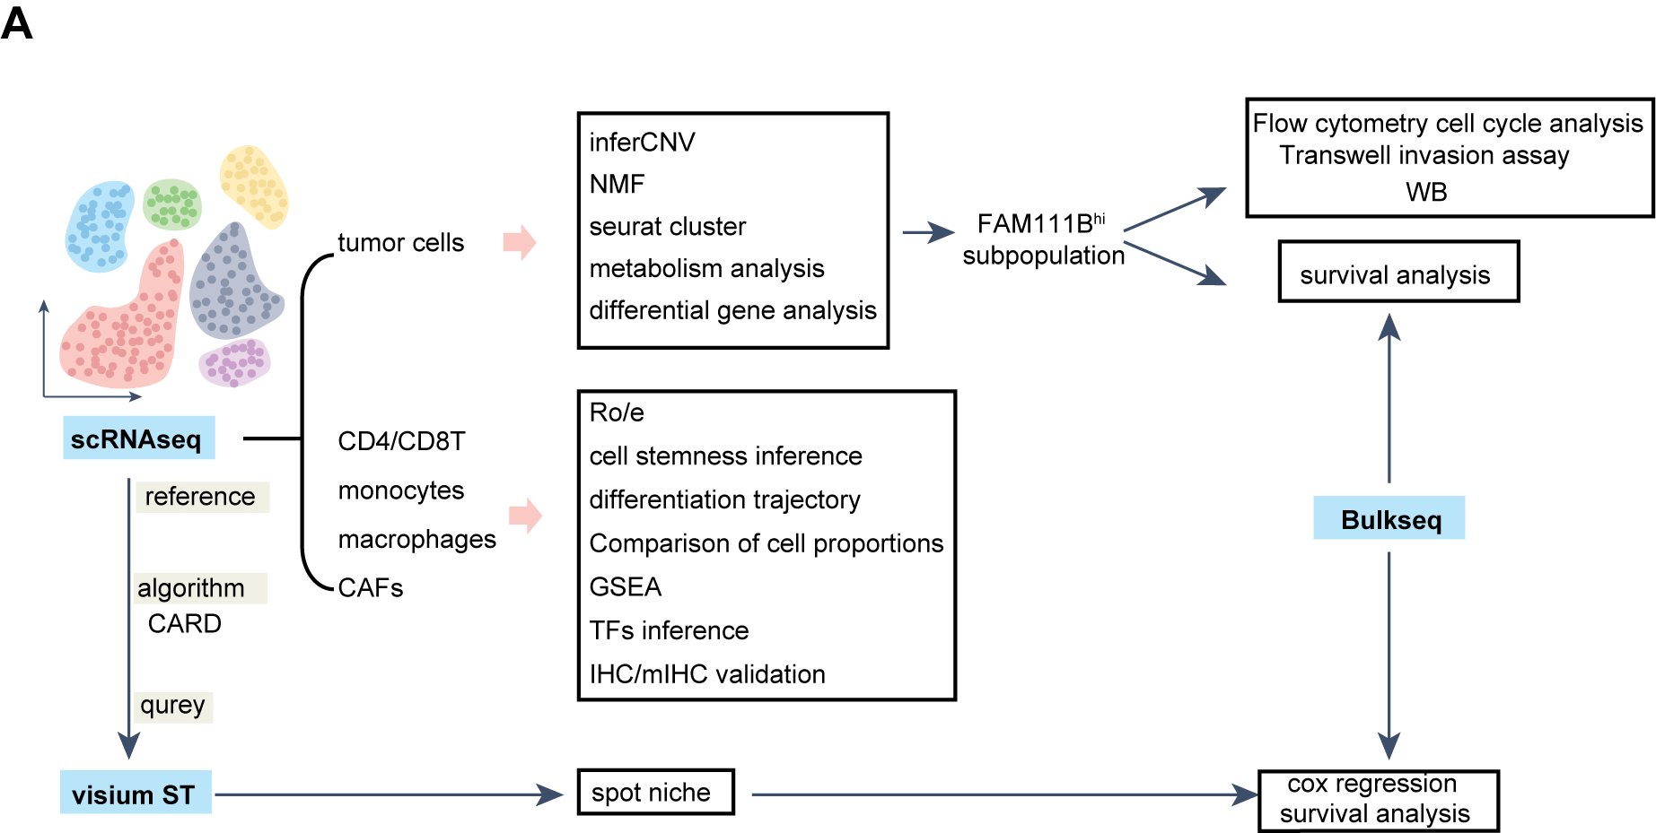
Figure S1. Research flowchart.
A: The flowchart illustrates the overall design of the study.

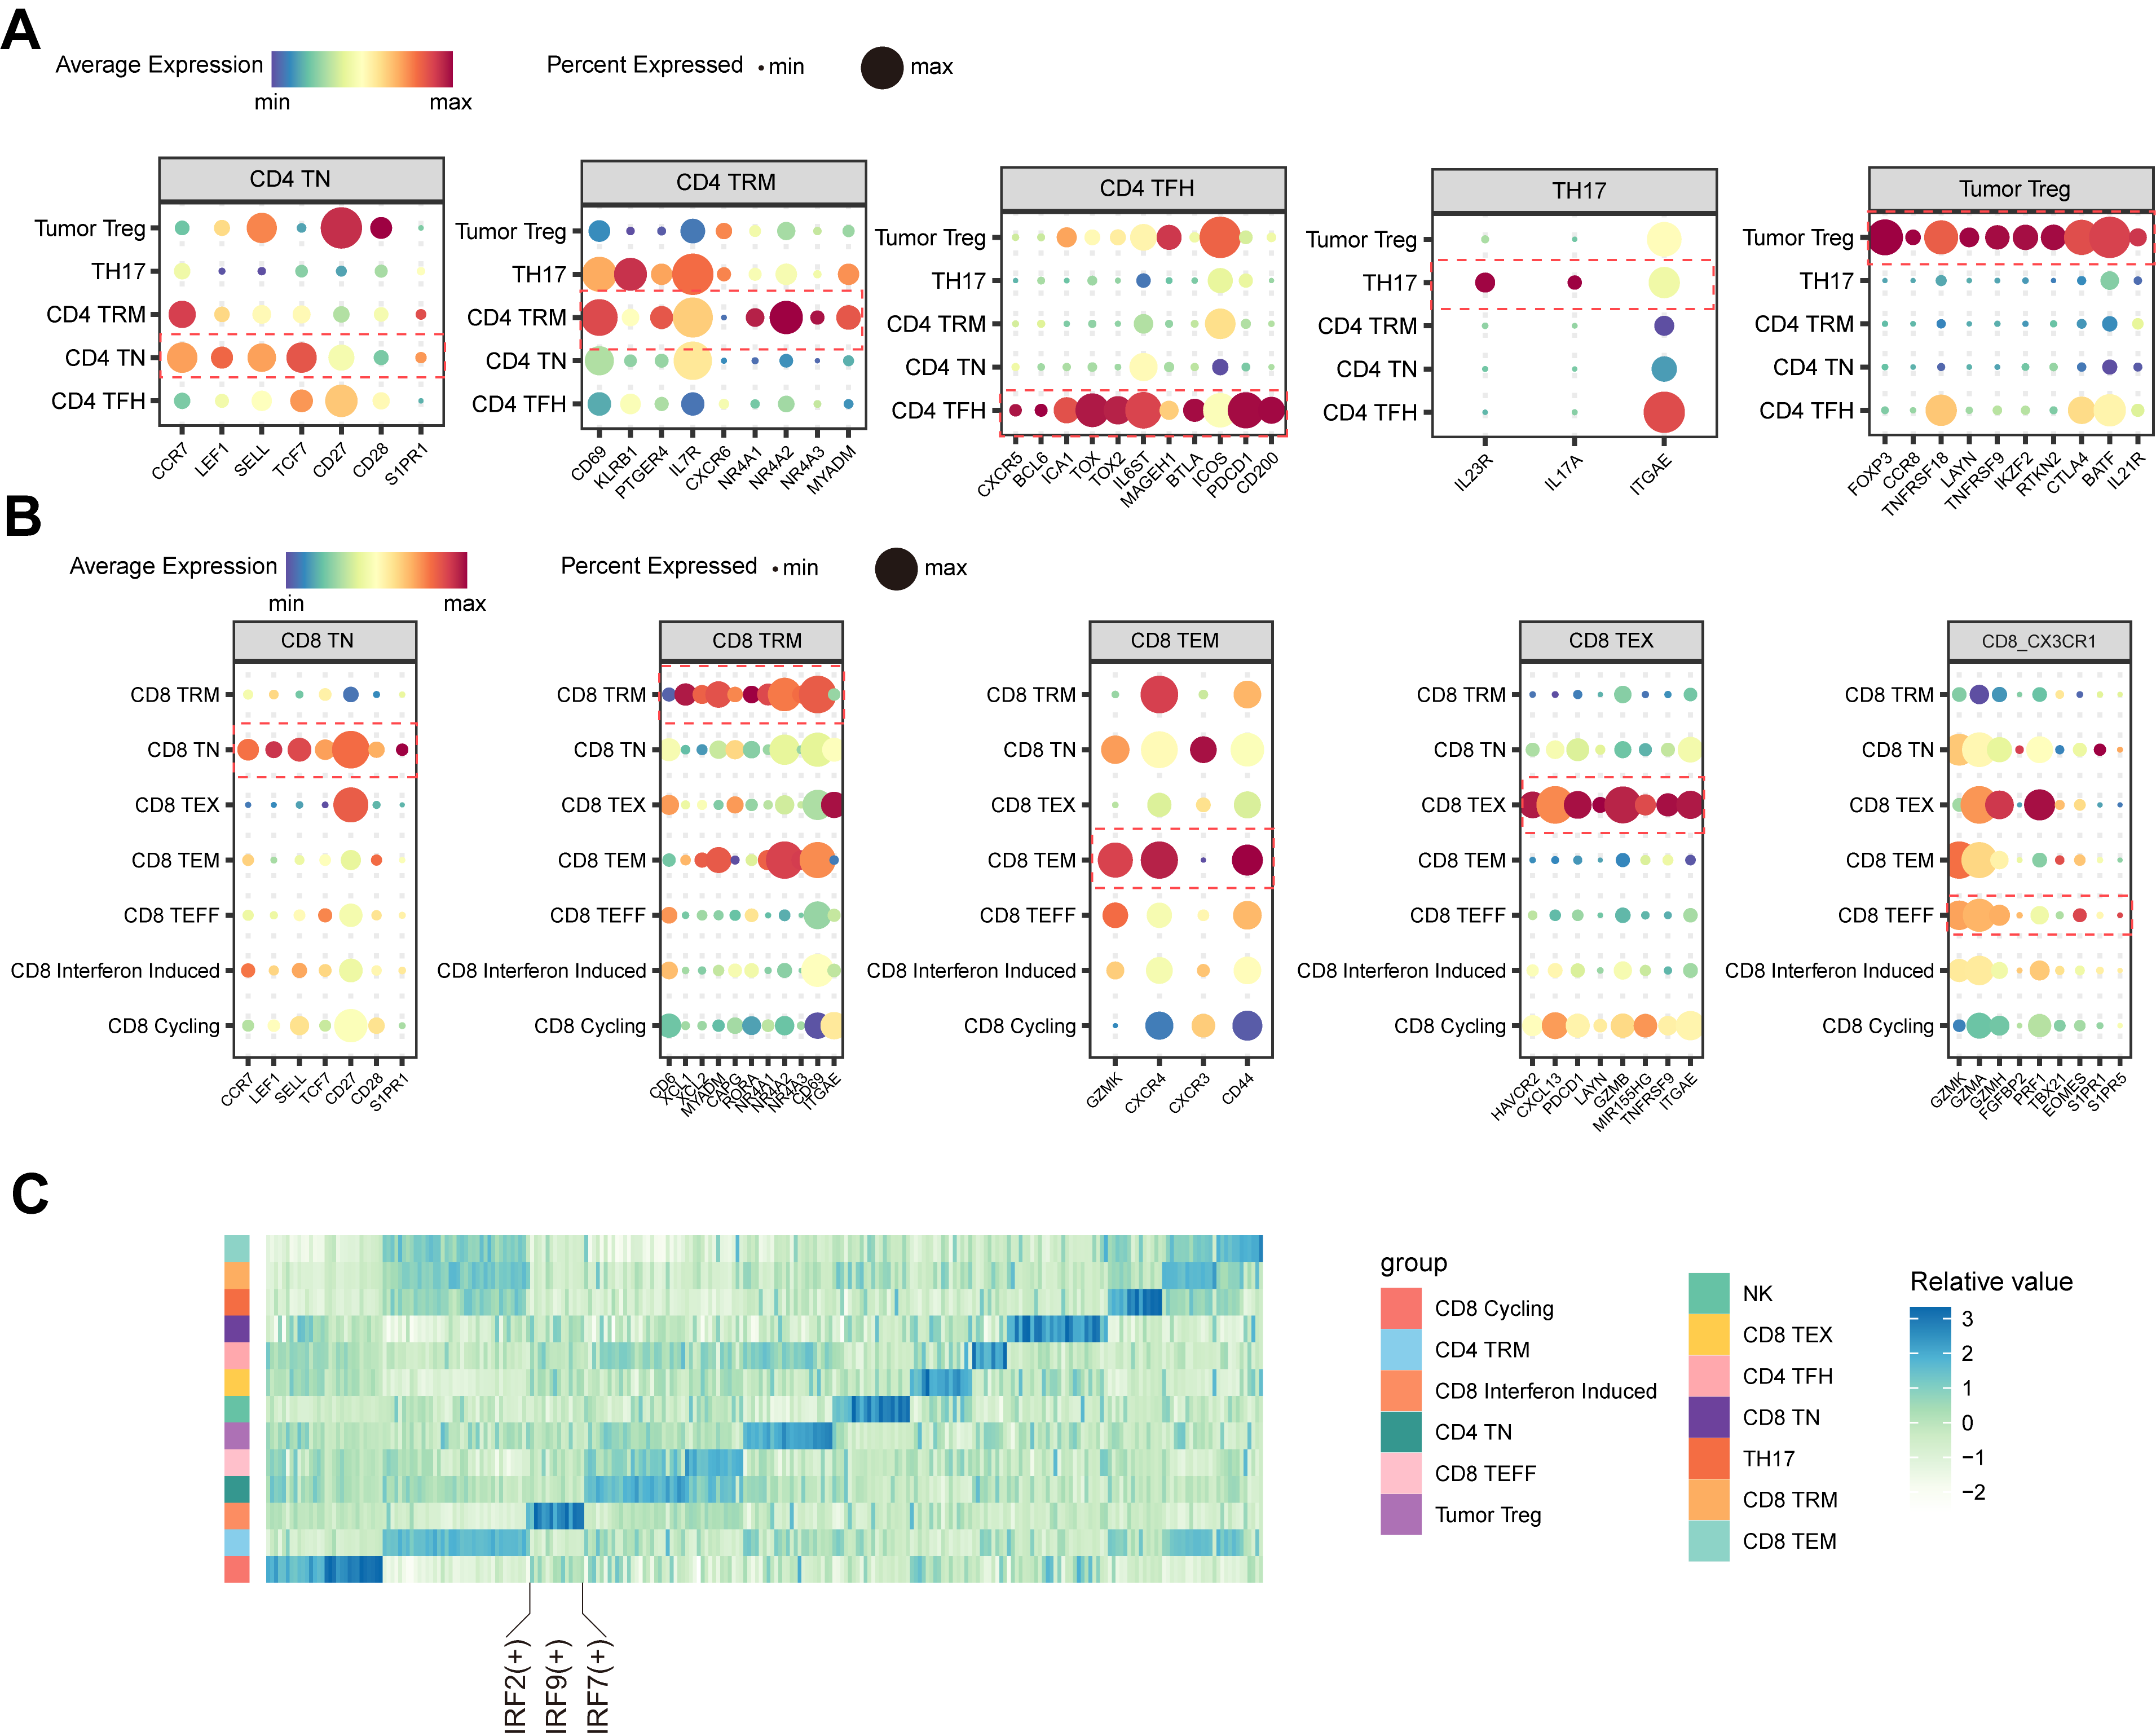
Figure S2. Marker genes and regulators of T cell subpopulations
A: The dot plot illustrates the expression of typical marker genes for CD4 T cells. The color depth represents the average expression value, and the dot size indicates the proportion of expressing cells in each cluster. B: The dot plot illustrates the expression of typical marker genes for CD8 T cells. The color depth represents the average expression value, and the dot size indicates the proportion of expressing cells in each cluster. C: The heatmap displays the major regulators of T cell subgroups enriched by Pyscenic.

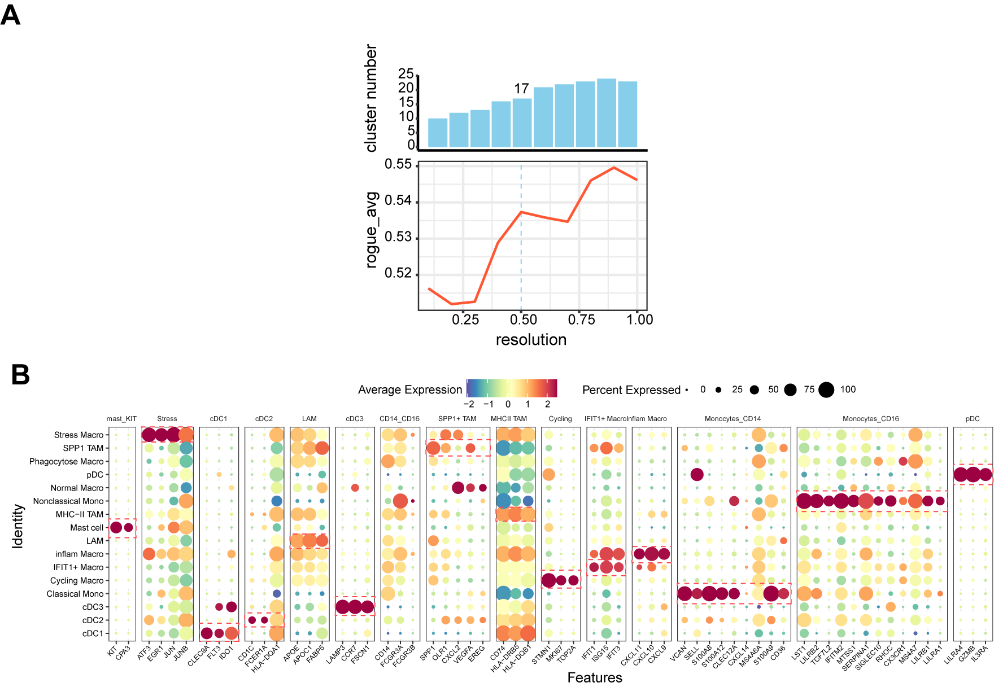
Figure S3. Clustering resolution of myeloid cells and marker expression profiles.
A: The Rogue algorithm was used to assess the heterogeneity of cell subpopulations across different clustering resolutions, revealing that a resolution of 0.5 achieved good clustering performance. A B: The dot plot shows the expression of typical marker genes in subpopulations of myeloid cells. The color depth indicates the average expression level, while the size of the dots represents the proportion of cells expressing the gene in each cluster.

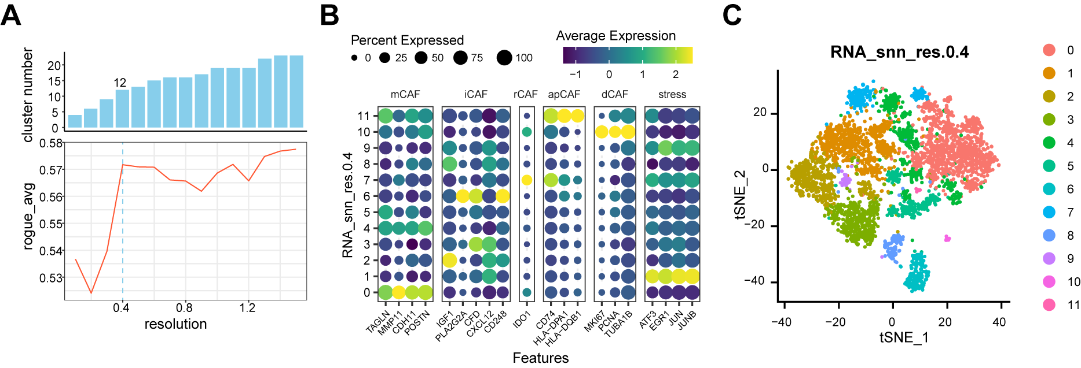
Figure S4. Clustering resolution and marker expression of CAFs.
A: The Rogue algorithm was used to evaluate the heterogeneity of CAF subpopulations at different clustering resolutions, showing that a resolution of 0.4 yielded optimal clustering performance. B: The dot plot shows the marker expression of 12 subpopulations of CAFs at a clustering resolution of 0.4. C: The t-SNE plot of CAFs at a clustering resolution of 0.4.

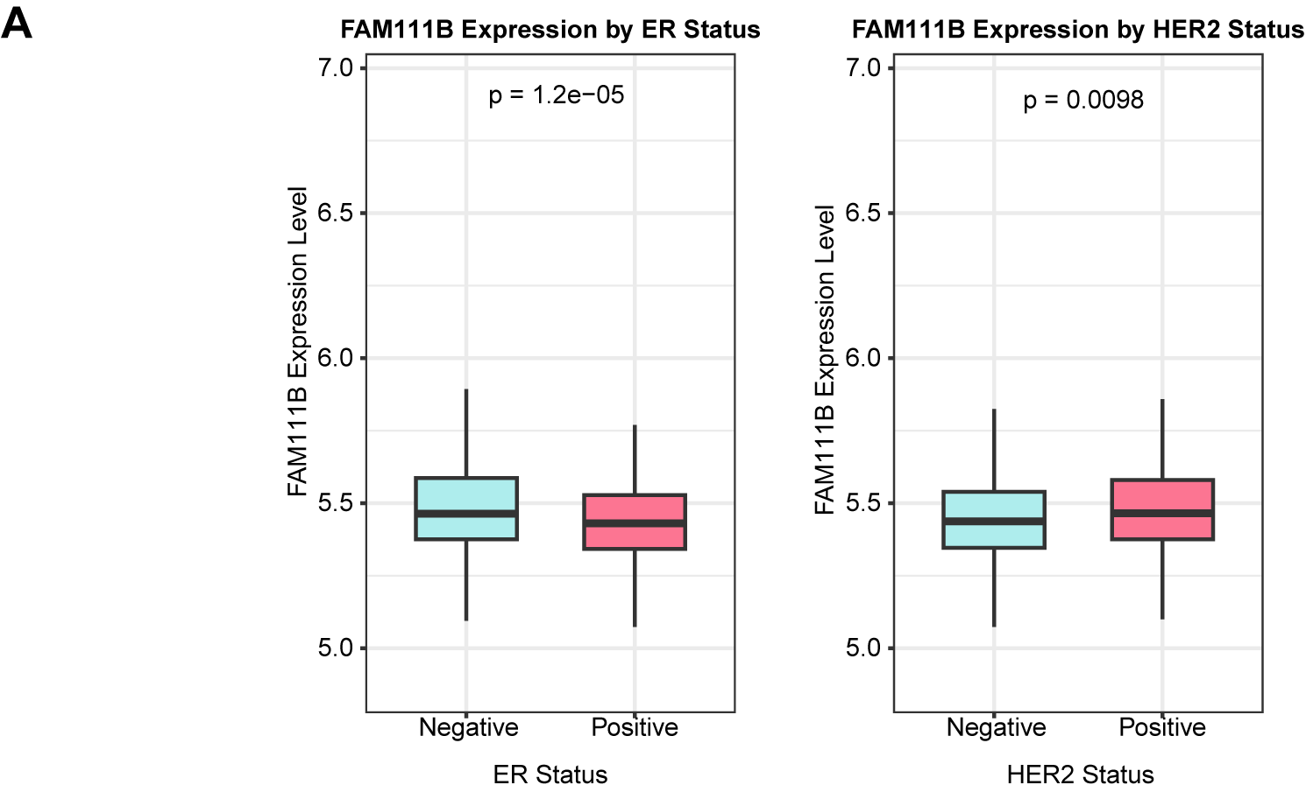
Figure S5. The expression of FAM111B in different subtypes of ER and HER2.
A: The box plot shows that FAM111B is highly expressed in ER-negative and HER2-positive groups (Student's t-test).

