Additional File 2: Supplementary Figures

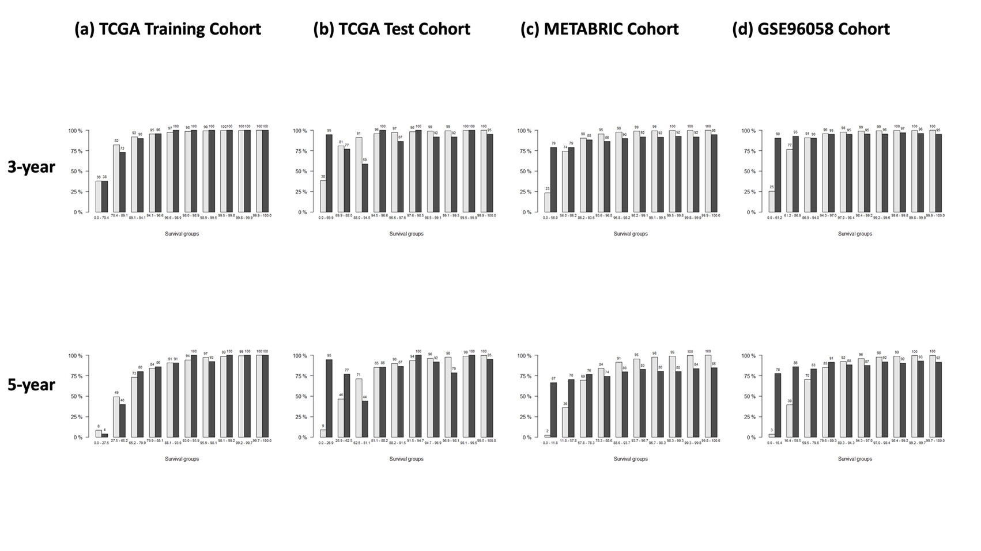
Figure S1: Calibration plots showed moderate performance of our 43-gene model. This figure shows the calibration plots of predicted vs observed survival at 3 and 5 years using our 43-gene model, evaluated on the (a) TCGA training, (b) TCGA test, (c) METABRIC and (d) GSE96058 cohorts. The dark grey bars represent observed survival frequencies, while the light grey bars denote predicted survival.

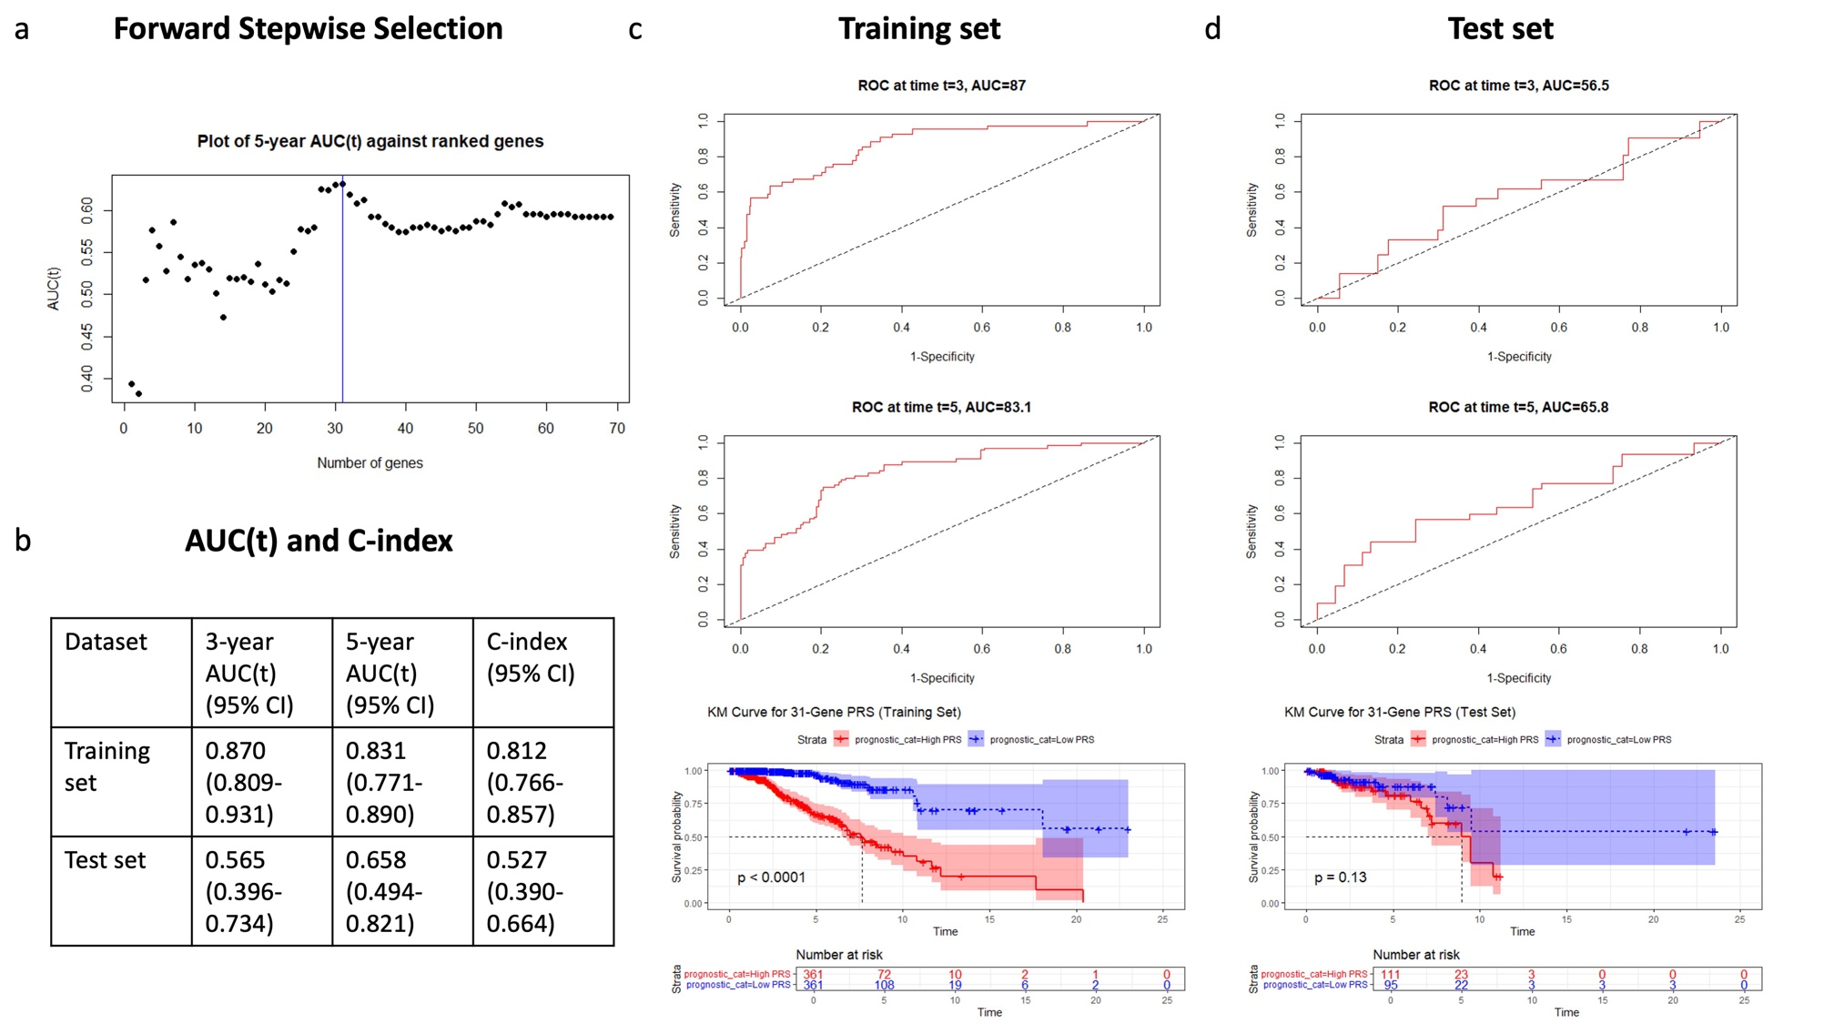

Figure S2: The 31-gene non-machine learning PRS model showed poorer performance. (a) Forward stepwise selection plot for the 31-gene model based on five-year AUC(t) scores. (b) Three- and five-year time-dependent AUC scores as well as the C-index for the PRS in the training and test sets. (c-d) Time-dependent ROC curves and KM survival analysis in the training (c) and test (d) sets. The Log-Rank test compared survival between risk groups.

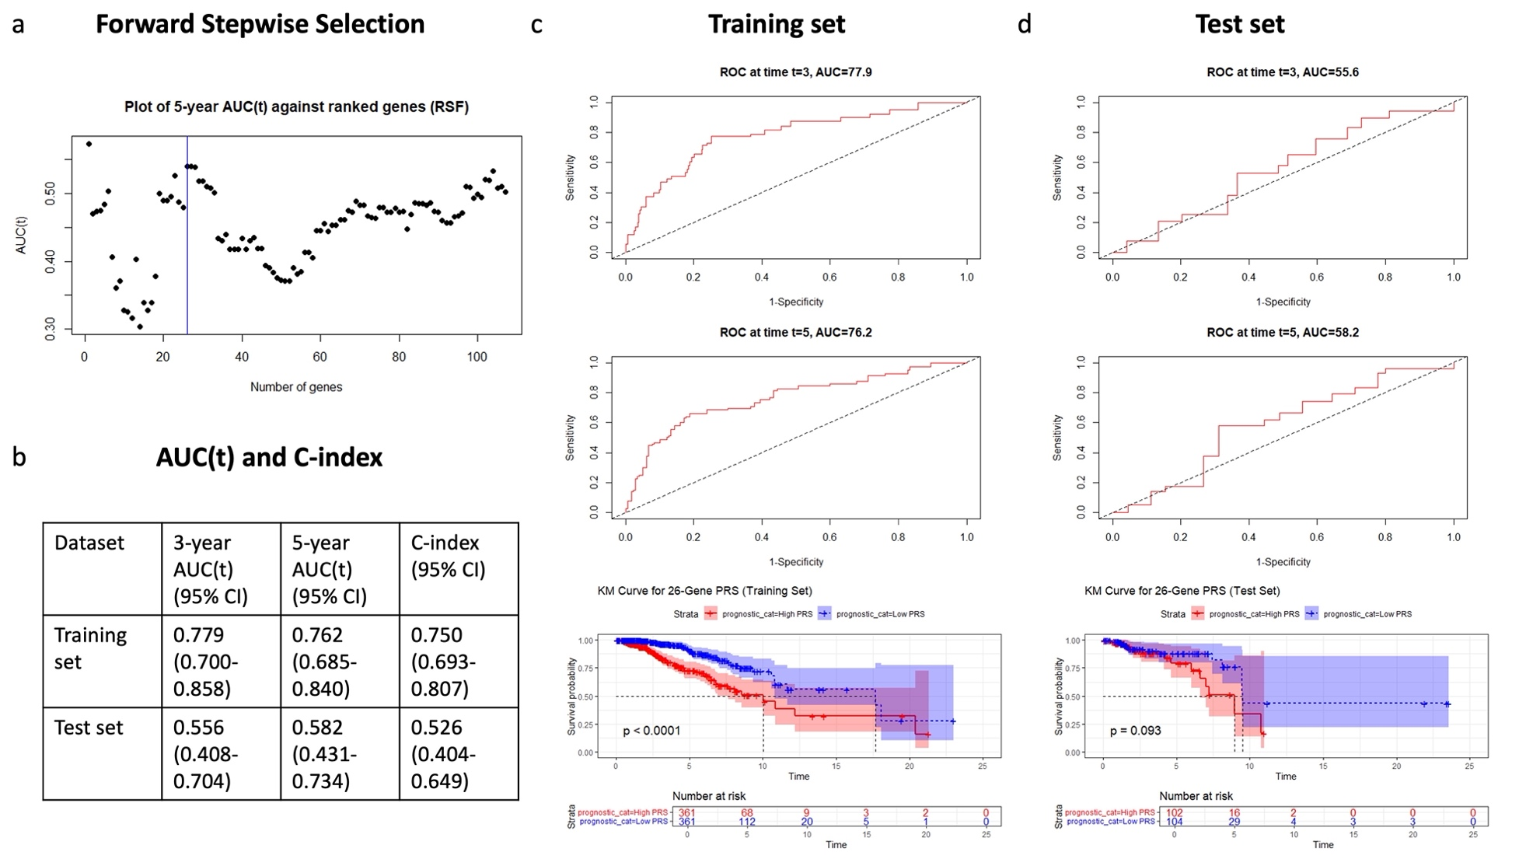
Figure S3: The 26-gene PRS model constructed using random survival forest showed poorer performance. Instead of ranking based on multivariate Cox p values as in our proposed pipeline, ranking of genes was done based on random survival forest variable importance scores. (a) Forward stepwise selection plot for the 26-gene model based on five-year AUC(t) scores. (b) Three- and five-year time-dependent AUC scores as well as the C-index for the PRS in the training and test sets. (c-d) Time-dependent ROC curves and KM survival analysis in the training (c) and test (d) sets. The Log-Rank test compared survival between risk groups.

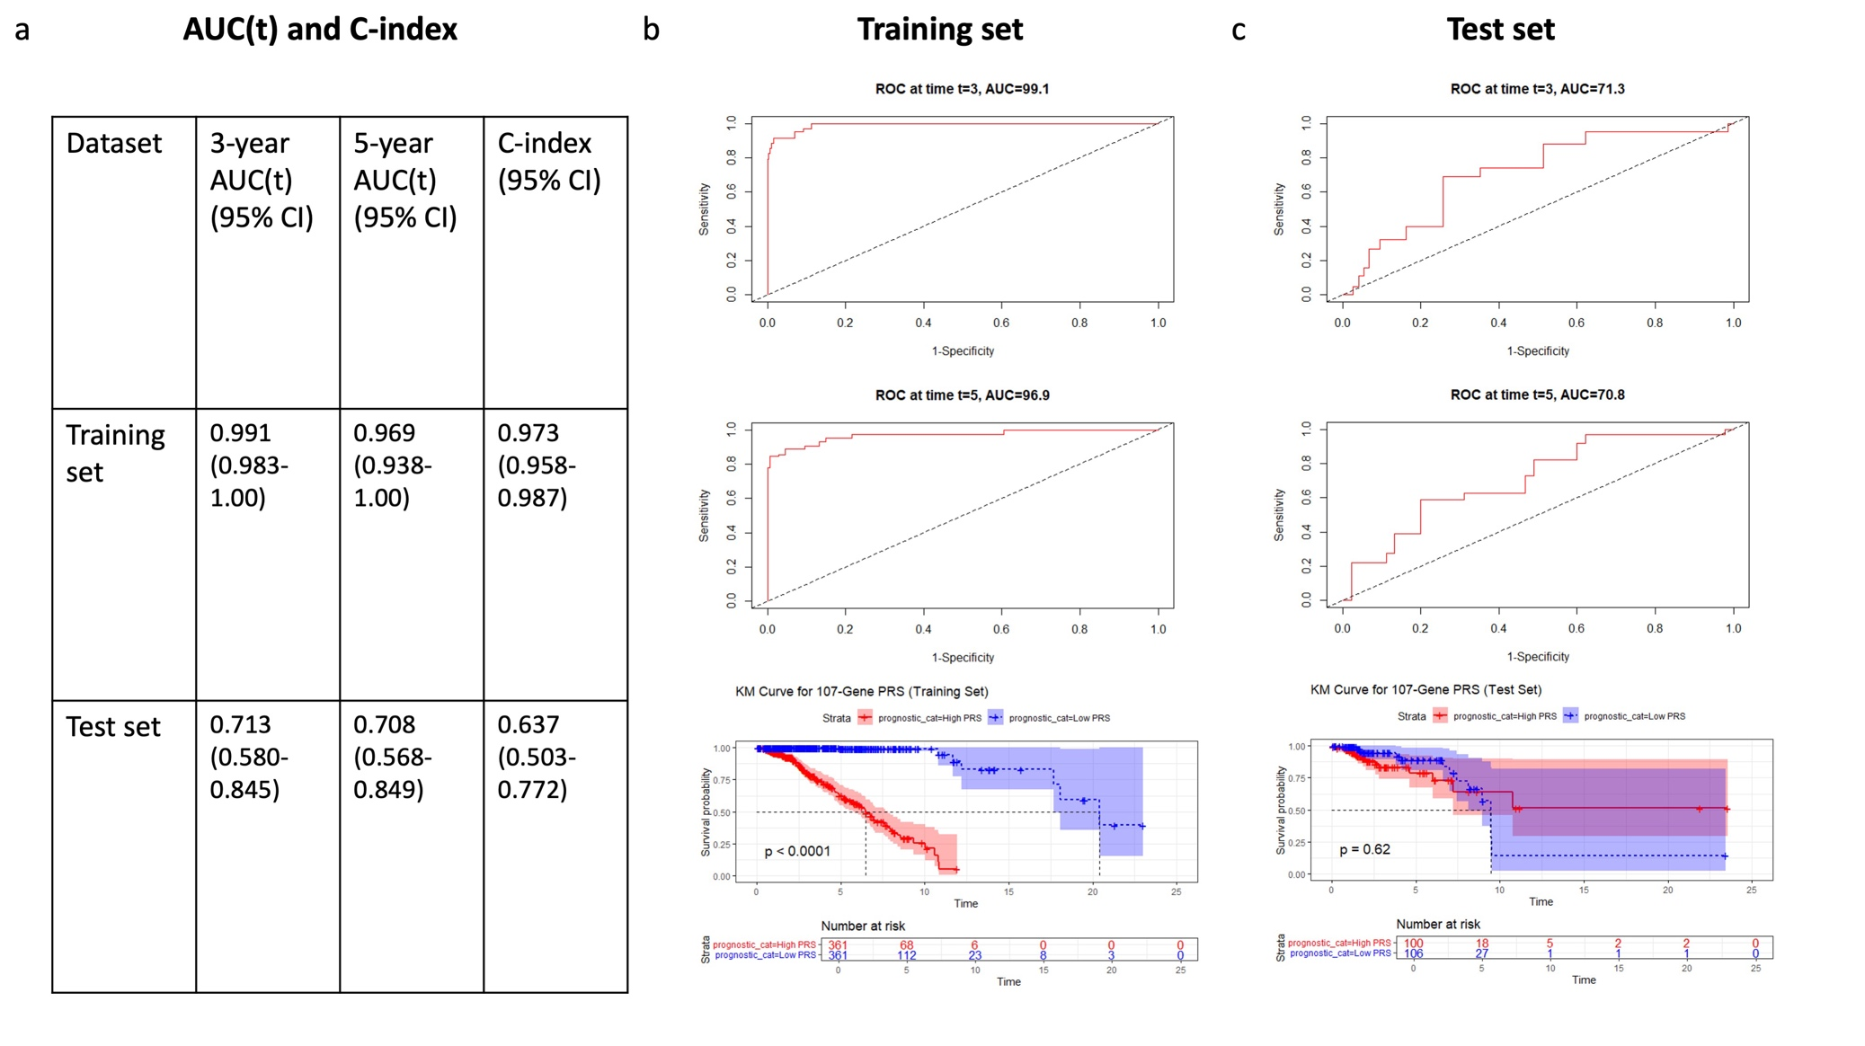
Figure S4: The 107-gene PRS model constructed without forward stepwise selection showed poorer performance. (a) Three- and five-year time-dependent AUC scores as well as the C-index for the PRS in the training and test sets. (b-c) Time-dependent ROC curves and KM survival analysis in the training (b) and test (c) sets. The Log-Rank test compared survival between risk groups.

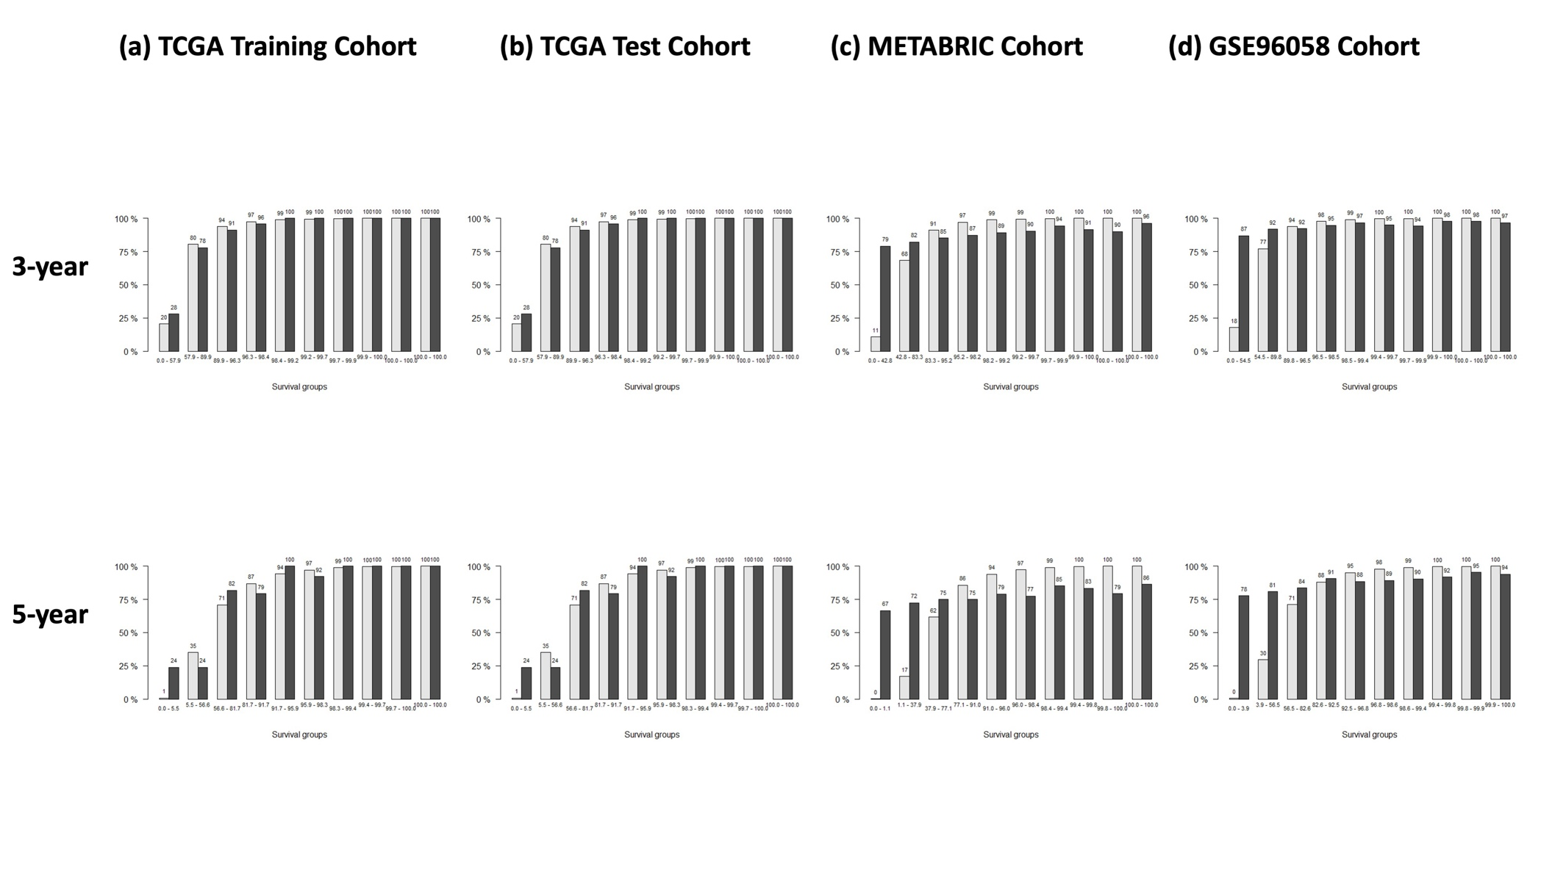
Figure S5: Calibration plots showed moderate performance of our 43-gene + clinical model. This figure shows the calibration plots of predicted vs observed survival at 3 and 5 years of BRCAGenie, evaluated on the (a) TCGA training, (b) TCGA test, (c) METABRIC and (d) GSE96058 cohorts. The dark grey bars represent observed survival frequencies, while the light grey bars denote predicted survival.

