Integrated clinical and single-cell profiling of BCMA CAR-T therapy in relapsed/refractory multiple myeloma

Chuling Fang^{1#}, Lixin Wang^{1, 3#}, Weiqiang Zhao¹, Lei Wang¹, Wenfa Huang¹, Ziren Chen¹, Yiran Wang¹, Kun Tan¹, Xiao Guo¹, Yuanyuan Xu¹, Shuhong Wang¹, Lijun Wang¹, Jingqiao Qiao¹, Xiangyu Meng¹, Ziqian He¹, Chuan Yu^{2, 3}, Junhui Mei¹, Hongxin Wang¹, Yisheng Li^{2, 3*}, Li Yu^{1, 3*}

¹Department of Hematology and Oncology, Shenzhen University General Hospital, Shenzhen Key Laboratory, Hematology Institution of Shenzhen University, Shenzhen Clinical Research Center for Hematologic Disease, International Cancer Center, Shenzhen University Health Science Center, Shenzhen University, Xueyuan AVE 1298, Shenzhen 518055, China.
²Shenzhen Haoshi Biotechnology Co., Ltd, 155 Hong Tian Rd, Bao An District, Shenzhen 518125, China.
³Shenzhen University - Haoshi Cell Therapy Institute, 155 Hong Tian Rd, Bao An District, Shenzhen 518125, China.
# Contributed equally.
* Correspondence author: Li Yu, Ph.D, Department of Hematology and Oncology, Shenzhen University General Hospital, Shenzhen University, Shenzhen 518055, China. Email: yuli@szu.edu.cn. Yisheng Li, Ph.D, Shenzhen Haoshi Biotechnology Co., Ltd, Shenzhen 518125, China. Email: ysli@haoshibio.com.

Methods
Subject inclusion and exclusion criteria
Inclusion criteria:
1. Patients aged ≥18 and ≤75 years with relapsed or refractory multiple myeloma (MM).
2. Performance status (ECOG) between 0 and 2.
3. Expected survival ≥ 12 weeks.
4. Histologically confirmed BCMA expression.
5. Relapsed or refractory disease after at least three lines of previous standard treatment (including chemotherapy, proteasome inhibitors, and immunomodulatory drugs) and had measurable disease (at least one):
- Serum monoclonal protein ≥ 5 g/L
- Urine monoclonal protein ≥ 200 mg/24 h
- Involved serum free light chain (FLC) ≥ 50 mg/L with abnormal FLC ratio
- An evaluable plasmacytoma
- Bone marrow plasma cells ≥ 10% of total bone marrow cells
6. Adequate organ function:
- absolute neutrophil count (ANC) ≥1 x 10⁹ cells per L, platelet count ≥ 30 x 10⁹ cells per L and hemoglobin ≥ 80 g/L
- alanine aminotransferase (ALT), aspartate aminotransferase (AST) < 2.5 x upper limit of the normal (ULN) and alkaline phosphatase < 2.5 x ULN, total bilirubin <1.5mg/dl
- Creatinine clearance ≥ 30 mL/min
- New York Association (NYHA) classification I or II and Cardiac ejection fraction ≥50%
- had oxygen saturation greater than 92%
7. No contraindications for apheresis.
8. Able and willing to provide informed consent.
9. Able to receive lymphodepleting chemotherapy.
10. Agree to use effective birth control throughout the study period.
11. Female patients with the potential capacity for pregnancy had a negative urine pregnancy test at screening.

Exclusion criteria:
1. Pregnant or lactating women, male subjects or female subjects have a pregnancy plan during the study period, and are unwilling to use an effective contraceptive measure during the test period.
2. Central nervous system (CNS) involvement.
3. Requirement for urgent therapy due to tumour progression or tumour mass effects such as spinal cord compression.
4. Had previous therapy with any investigational drugs or systemic anticancer treatment within 4 weeks, had previous therapy with any antibody drugs within 2 weeks.
5. Had previous therapy with immunosuppressive drugs (systemic corticosteroid therapy exceeding 5 mg per day prednisone or its equivalent physiological dose) within 2 weeks.
6. Prolonged QT interval, clinically significant arrhythmia, unstable angina, acute myocardial infarction, or other clinically significant cardiac disorder within 12 months.
7. Class III/IV cardiovascular disability according to the New York Heart Association Classification and a cardiac ejection fraction < 50%.
8. Uncontrolled hypertension for those with grade 3 hypertension.
9. Active hepatitis B or hepatitis C infection, positive human immunodeficiency virus antibody, or positive syphilis serology.
10. Uncontrolled active infection.
11. With plasma cell leukemia.
12. Concurrent active malignancy requiring therapy or intervention.
13. A history of another primary malignancy within 3 years.
14. A history of autoimmune disease or immunodeficiency.
15. A history of traumatic brain injury, disturbance of consciousness, epilepsy, severe cerebral ischemia or cerebral hemorrhage.
16. Had a history or present active bleeding disease within 6 months.
17. Received autologous stem cell transplantation within 8 weeks or planned to undergo autologous HSCT during the study.
18. Received allogeneic HSCT.
19. Any previous use of CAR-T cell products or other genetically modified T cell therapies.
20. Were hypersensitive or had a history of hypersensitivity to any excipient or to study related drugs.
21. Live vaccination was administered within 4 weeks.
22. History of alcohol, drug use, or mental illness.
23. Those who need long-term anticoagulation (warfarin or heparin).
24. Those who received radiotherapy within 4 weeks.
25. Those who have participated in other clinical trials within 3 months.
26. Subjects considered unlikely to complete all protocol-required study visits or procedures, including follow-up visits, or to comply with the study requirements for participation according to the investigator’s judgement.
27. Had a history or evidence of any condition or disease that could confound the results of the study,
28. It was the opinion of investigators that it was not in the best interest of the patient to participate.

Supplementary Table S1. Detailed baseline characteristics of patients.

Patient ID | Age, year | Sex | Time since diagnosis, months | ISS stage | Type of myeloma | Extramedullary disease | ECOG | Cytogenetics | Previous treatment lines | Proteasome inhibitors | Anti-CD38 monoclonal antibodies | auto HSCT
1 | 67 | M | 6.7 | III | Light chain only (κ) | Y | 1 | t(11;14) | 4 | Y | N | N
2 | 67 | M | 37.6 | II | IgG | N | 1 | t(4;14) | 4 | Y | Y | Y
3 | 53 | M | 33.5 | II | IgG | Y | 1 | High risk | 9 | Y | Y | Y
4 | 64 | F | 18.0 | III | Light chain only (λ) | Y | 1 | 1q21+, RB1+, IGH/FGFR3+ | 3 | Y | Y | N
5 | 69 | F | 24.0 | III | IgA | Y | 2 | 1q21+, IGH+, IGH/FGFR3+, RB1+ | 9 | Y | Y | N
6 | 49 | M | 33.0 | II | IgG | Y | 1 | 1q21+, IGH+, IGH/FGFR3+, RB1+ | 10 | Y | Y | Y

Supplementary Figure S1. Schematic diagram of the anti-BCMA CAR construct. The anti-BCMA CAR was constructed by integrating the BCMA single-chain variable fragment (scFv) with the hinge and transmembrane domains of CD8 and the cytoplasmic domains of 4-1BB and CD3 zeta signaling domains.

Supplementary Figure S2. Differentially expressed genes (DEGs) in persistent CAR-T clones across different time points in patient 2. A: Identification of DEGs between day 17 (D17) and day 25 (D25) within “across” clones. B: Identification of DEGs between day 53 (D53) and day 94 (D94) within “across” clones. x-axis: difference between the percentage of cells highly expressing one certain gene in the designated cluster; y-axis: log2 fold-change (FC) of the average expression between the two groups.

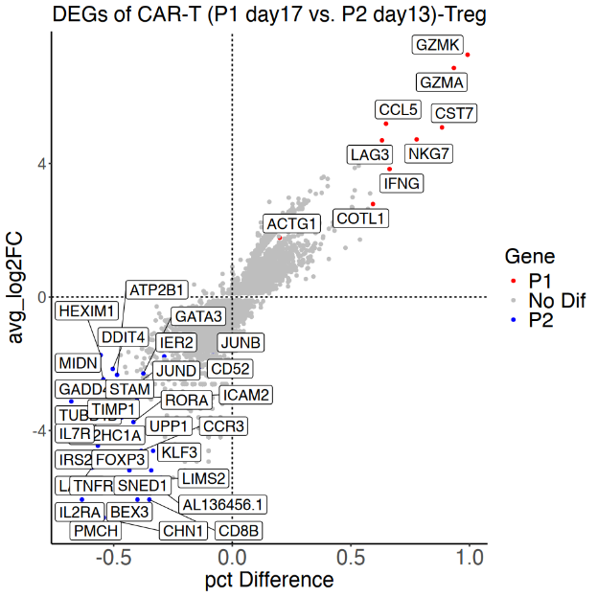

Supplementary Figure S3. Identification of differentially expressed genes (DEGs) in CAR⁺ Regulatory T (Treg) cells between patient 2 at day 17 (D17) and patient 3 at day 13 (D13).

