Supplementary Materials

Table S1. Wilkes Stage

Stage | Clinical features | Imaging
- Early | Painless jaw clicking;  unrestricted function | Mild disc displacement;  normal condyle
- Early/intermediate | Intermittent painful jaw clicking  and locking | Mild disc displacement and deformity;  normal condyle
- Intermediate | Frequent joint pain and locking;  painful restricted function;  chewing difficulties | Moderate disc displacement and deformity;  normal condyle
- Intermediate/late | Chronic pain and restricted  mandibular function | Severe disc displacement and deformity;  abnormal condyle
- Late gross | Severe joint dysfunction (crepitus)  with variable pain | Severe disc displacement with perforation and deformity;  degenerative condylar changes

Table S2. Scores of the Outcome Variables at Different Evaluation Times

Variable | Time | Values |  | p value
VAS score, Mean ± SD | preoperation |  | 5.2 ± 0.7
VAS score, Mean ± SD | 1 month postoperation |  | 1.8 ± 1.3 | < 0.0001
VAS score, Mean ± SD | 6 months postoperation |  | 0.9 ± 0.8 | < 0.0001
AMMO, Mean ± SD (cm) | preoperation |  | 2.2 ± 0.6
AMMO, Mean ± SD (cm) | 1 month postoperation |  | 3.3 ± 0.5 | < 0.0001
AMMO, Mean ± SD (cm) | 6 months postoperation |  | 4.0 ± 0.3 | < 0.0001
PMMO, Mean ± SD  (cm) | preoperation |  | 2.6 ± 0.8
PMMO, Mean ± SD  (cm) | 1 month postoperation |  | 3.6 ± 0.5 | < 0.001
PMMO, Mean ± SD  (cm) | 6 months postoperation |  | 4.2 ± 0.3 | < 0.0001
Clinical outcome, n (%) | effective |  | 16 (88.9%)
Clinical outcome, n (%) | ineffective |  | 2 (11.1%)
VAS: visual analog scale; AMMO: active maximum mouth opening; PMMO: passive maximum mouth opening. The test of significance was one-way ANOVA (n = 18).

Table S3. Modified Mankin scoring criteria

 | Score
Structure
Intact surface | 0
Surface fissures | 1
Surface fissures to mid zone | 2
Surface fissures to deep zone | 3
Complete disorganization | 4
Cells
Normal | 0
Clusters/cloning | 1
Some hypercellularity | 2
Hypocellularity | 3
Stain: hematoxylin and eosin with Safranin-O
Normal | 0
Slight reduction | 1
Moderate reduction | 2
Severe reduction | 3
No dye noted | 4

A B C
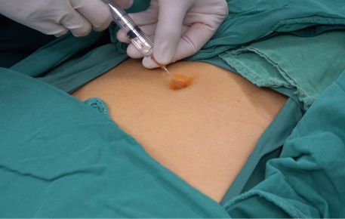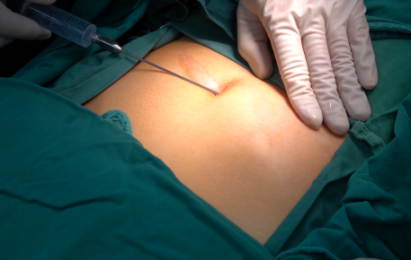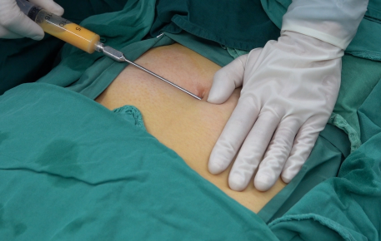
D E F
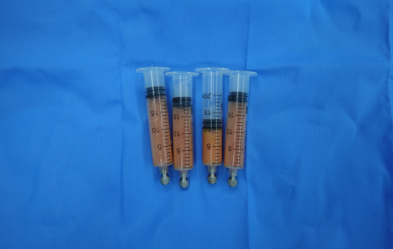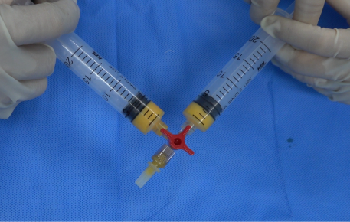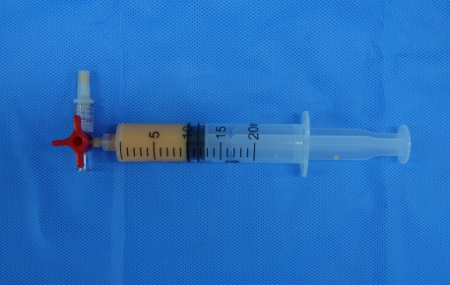
G H I
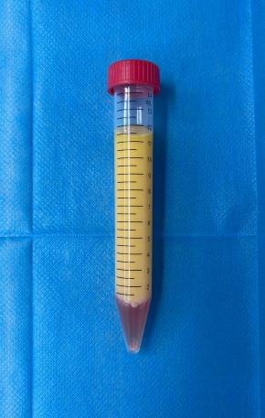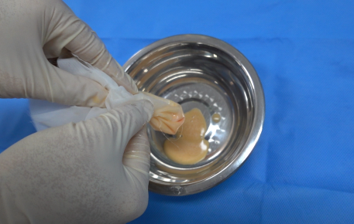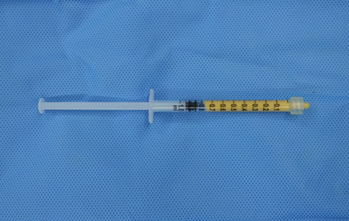

Figure S1. Clinical preparation protocol of ARDE.
A) Local anesthesia administration.
B) Injection of tumescent solution into the subcutaneous fat layer.
C) Negative-pressure aspiration of abdominal adipose tissue.
D) Adipose tissue aspirate (containing tumescent solution).
E) Following removal of the tumescent solution via centrifugation, the adipose tissue was mechanically emulsified using syringes connected via a three-way valve.
F) Adipose tissue after 60 emulsification cycles.
G) The emulsified adipose tissue was separated into three distinct layers after low-speed centrifugation. Upper layer: semifluid adipose tissue containing adipose debris; intermediate layer: residual liquid components; lower layer: stromal vascular fraction (SVF) pellet.
H) The postcentrifugation upper layer components were filtered through 0.5 mm sterile nylon mesh to remove adipose debris, yielding liquid adipose.
I) One milliliter of the filtered liquid adipose fluid was mixed with the SVF pellet to prepare the ARDE for clinical injection.

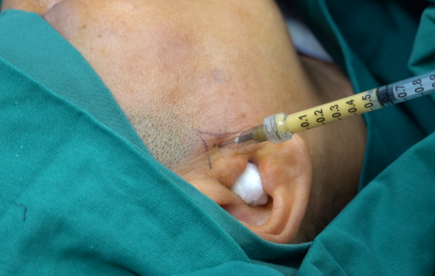

Figure S2. ARDE (0.8 ml) was injected into the upper joint compartment of each patient.

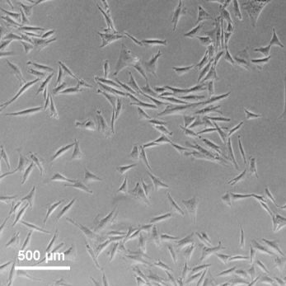

Figure S3. Optical microscopy images of the SVF after three passages of adherent culture.
Owing to their adherent growth properties, ADSCs are selectively retained during serial passaging, whereas other cellular components are progressively removed and eventually eliminated. Scale bar: 500 μm.

A B
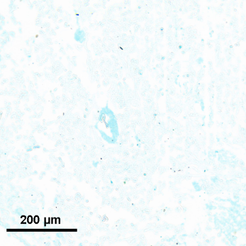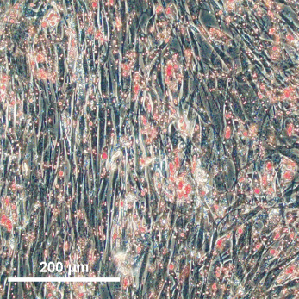

Figure S4. Adipose-derived stem cells isolated from the SVF exhibit multidirectional differentiation potential.
- Representative image of Alcian blue staining showing chondrogenic differentiation of ADSCs, with induced cartilage matrix deposition stained blue.
B) Representative image of Oil Red O staining showing adipogenic differentiation of ADSCs, with lipid droplets stained red. Scale bar: 200 μm.

A B

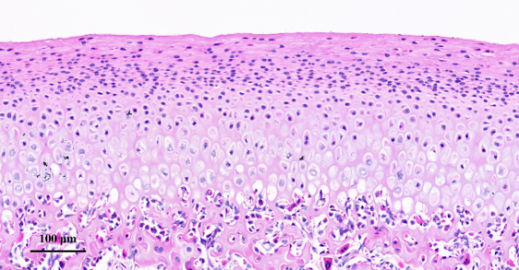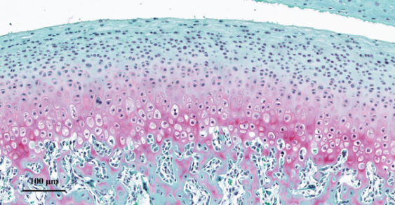

Figure S5. Representative images of mandibular condylar cartilage from a normal New Zealand rabbit.
A) Representative image of HE-stained mandibular condylar cartilage from a normal New Zealand rabbit.
B) Representative image of safranin O/fast green-stained mandibular condylar cartilage from a normal New Zealand rabbit. Scale bar: 100 μm.

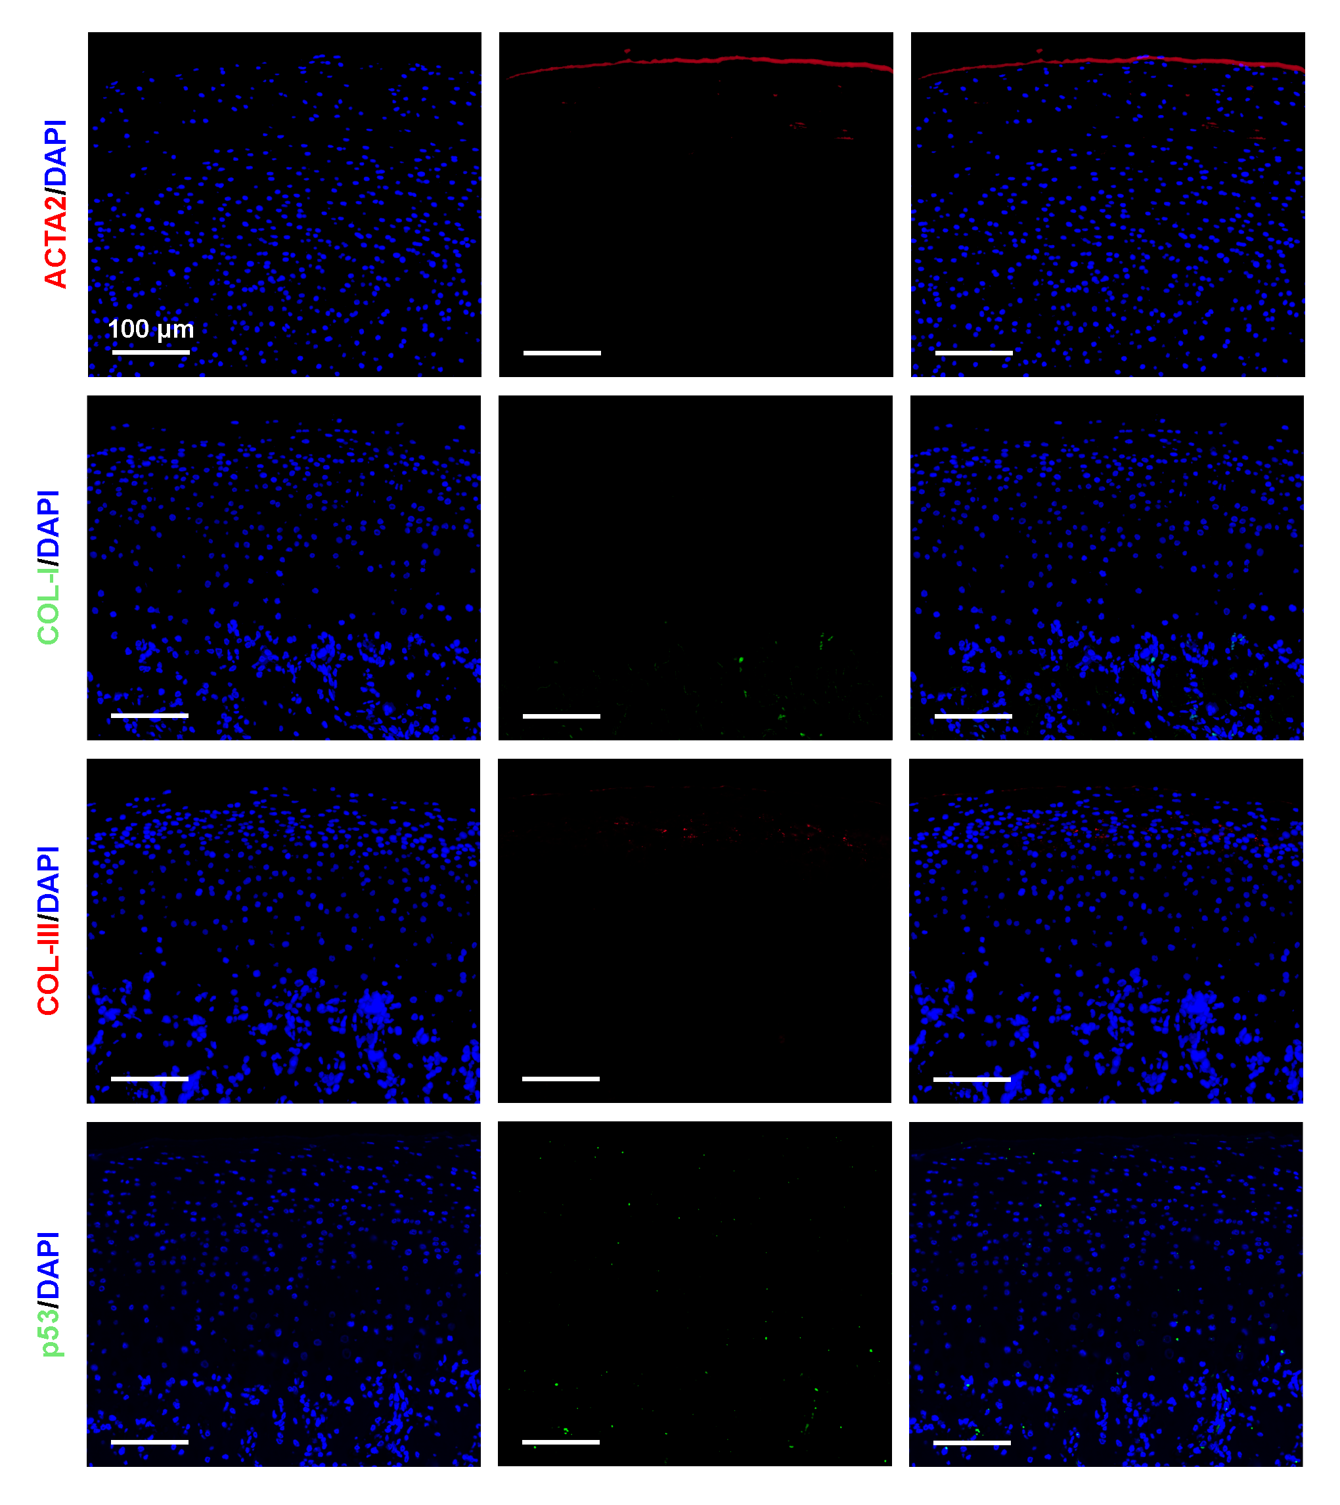
Figure S6. Immunofluorescence images of the fibrosis markers ACTA2 (red), COL-I (green), and COL-III (red) and the senescence marker p53 (green) in the mandibular condylar cartilage of a normal New Zealand rabbit. DAPI (blue) indicates nuclei. Scale bar: 100 μm.

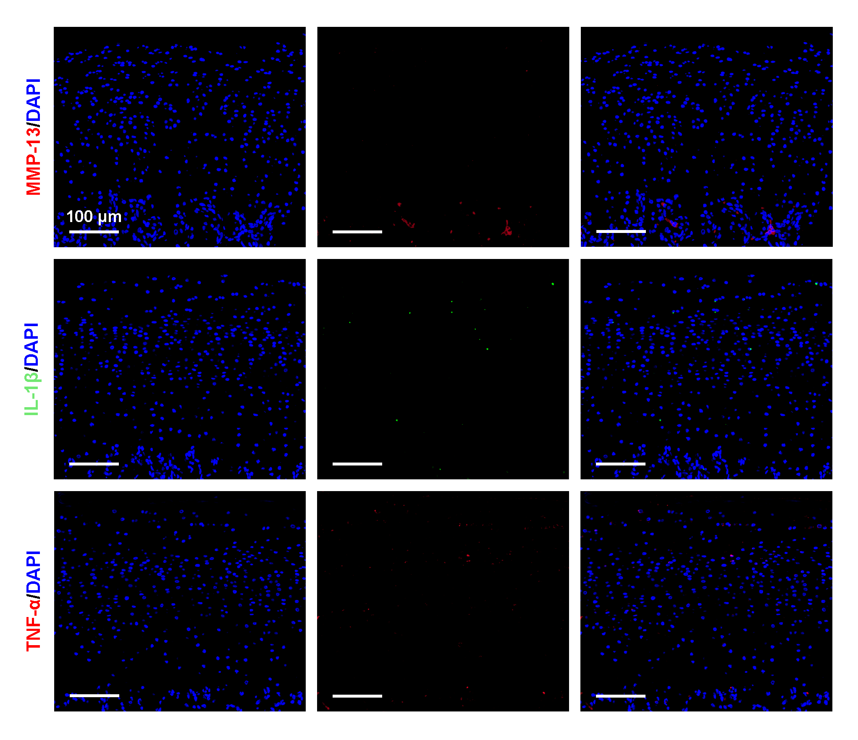
Figure S7. Immunofluorescence images of the inflammation-related factors MMP-13 (red), IL-1β (green), and TNF-α (red) in the mandibular condylar cartilage of a normal New Zealand rabbit. DAPI (blue) indicates nuclei. Scale bar: 100 μm.

A
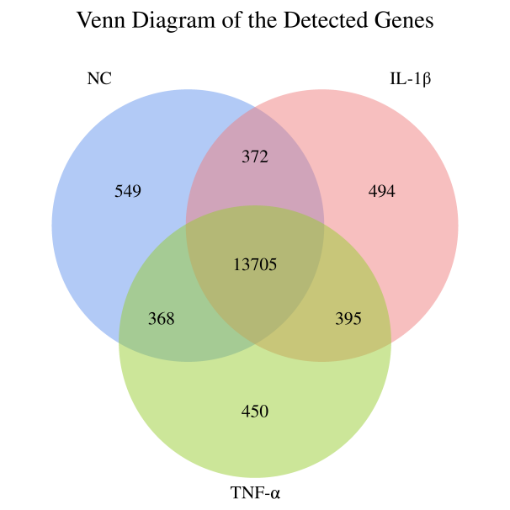

B C
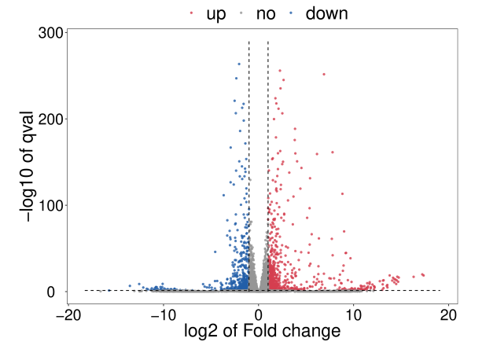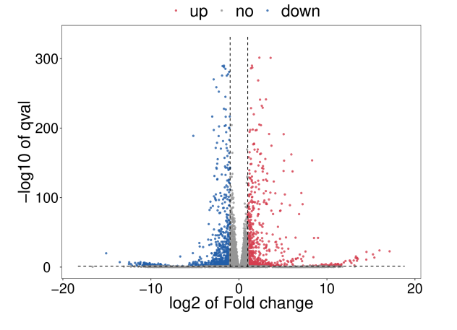

Figure S8. Differential gene expression between inflammatory cytokine-induced chondrocytes and normal chondrocytes.
- Venn diagram showing the number of genes detected by transcriptomic sequencing and gene comparisons among different groups.
- Volcano plot displaying the distribution of up- and downregulated differentially expressed genes in the IL-1β-induced group compared with the control group.
C) Volcano plot illustrating the distribution of up- and downregulated differentially expressed genes in the TNF-α-induced group compared with the control group.

A B
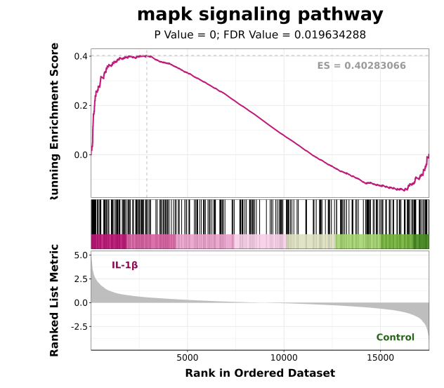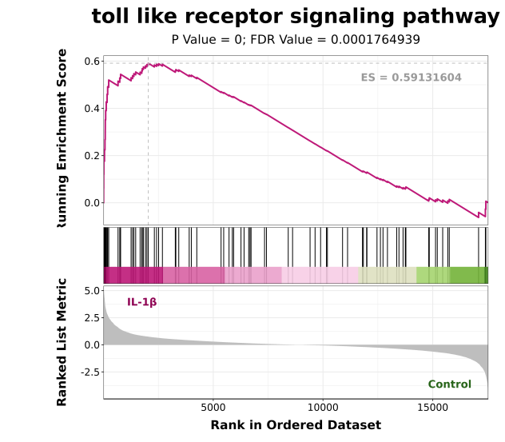
C D
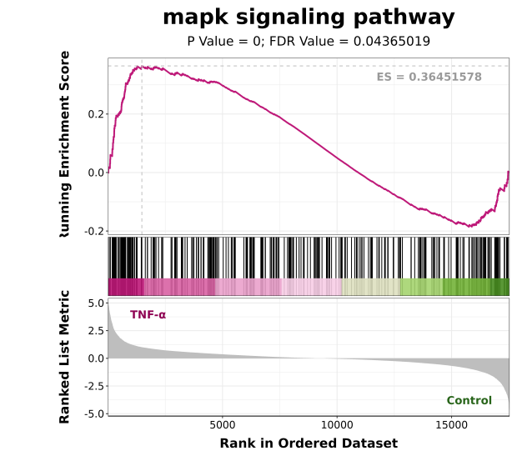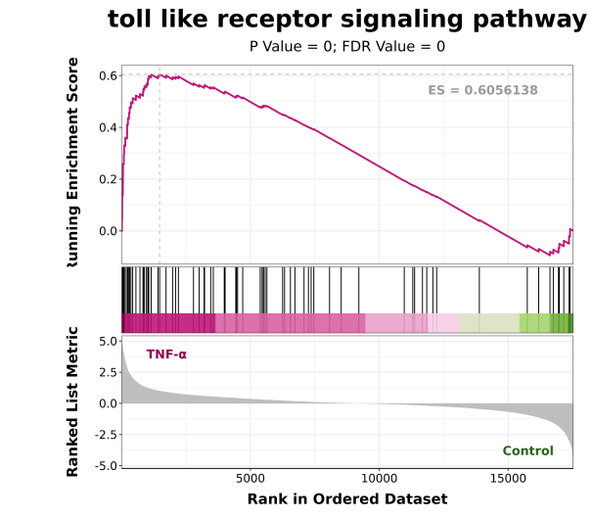

Figure S9. Fibrosis-related gene sets tended to be upregulated in inflammatory cytokine-induced chondrocytes.
A, B) GSEA of fibrosis-related gene sets between IL-1β-induced chondrocytes and normal chondrocytes.
C, D) GSEA of fibrosis-related gene sets between TNF-α-induced chondrocytes and normal chondrocytes.

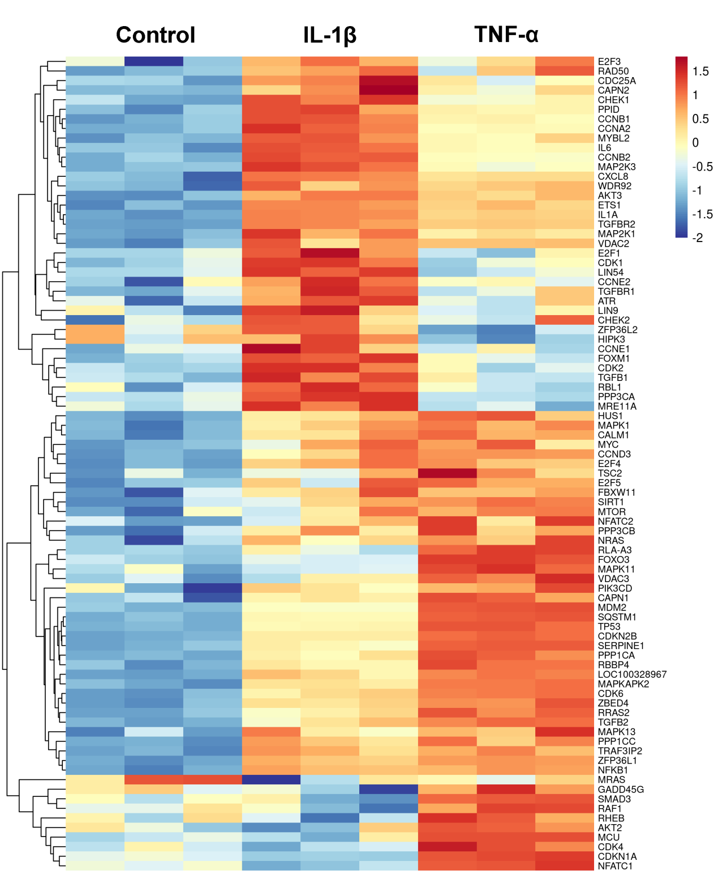

Figure S10. Heatmap of senescence-associated gene expression in mandibular condylar chondrocytes from the control, IL-1β-induced, and TNF-α-induced groups.

A
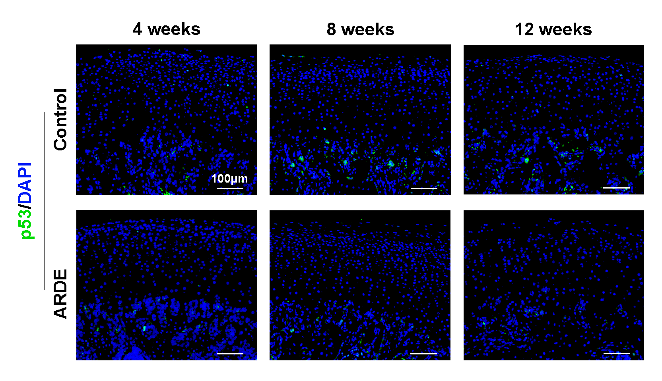
B
Figure S11. ARDE injection reduces the expression levels of cartilage senescence markers in TMJOA model animals.
- Representative images of p53 immunofluorescence staining in mandibular condylar cartilage.
B) Quantification of p53 expression levels according to the mean fluorescence intensity. Scale bar: 100 μm. All the data are presented as the means ± SDs. Statistical significance was determined by two-tailed Student’s t test (n=5; **p < 0.01, ***p < 0.001; ns, not statistically significant).

