Supporting Information
A single-cell digital PCR method tailored for quantification of HBV DNA positive cells in liver biopsy tissues
Jingmei Li ^{1, §}, Hui Li ^{2, §}, Xin Zhang ^{1, §}, Xueyan Liu ¹, Zumi Zhou ³, Jia Wei ², Rujuan Zhao ², Tai-Cheng Zhou ^{2,} *, Zijie Zhang ^{1,4,5,} *, Chunmei Li ^{1,} *

¹ Bio-X Center for Interdisciplinary Innovation, Yunnan University, Kunming, Yunnan 650091, China.
² Central Lab and Infectious Disease Department, the Affiliated Hospital of Yunnan University, Yunnan University, Kunming, Yunnan 650091, China.
³ Yunnan Genvoo Biomedicals Ltd., Yunnan 650031, China.
⁴ Southwest United Graduate School, Yunnan, China.
⁵ Yunnan Vaccine Laboratory, Yunnan, China.

Correspondence author:
Email: licm89@126.com

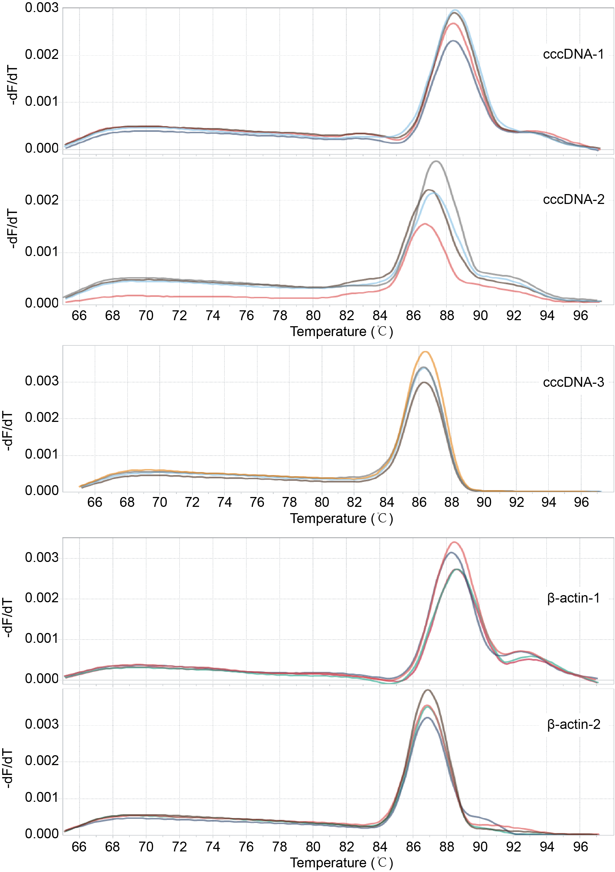
Figure S1. the melting curves of amplification products for cccDNA and β-actin primers. The peaks showed in the figures is the melting temperature (Tm) of the products, at which 50% of the DNA is double-stranded and 50% is dissociated into single-stranded DNA. The melting curve of a single amplification product displays a single peak at the Tm of the product (cccDNA-3 and β-actin-2). Multiple peaks in a melting curve indicate additional amplification products, usually from non-specific amplification (cccDNA-1, cccDNA-2 and β-actin-1).

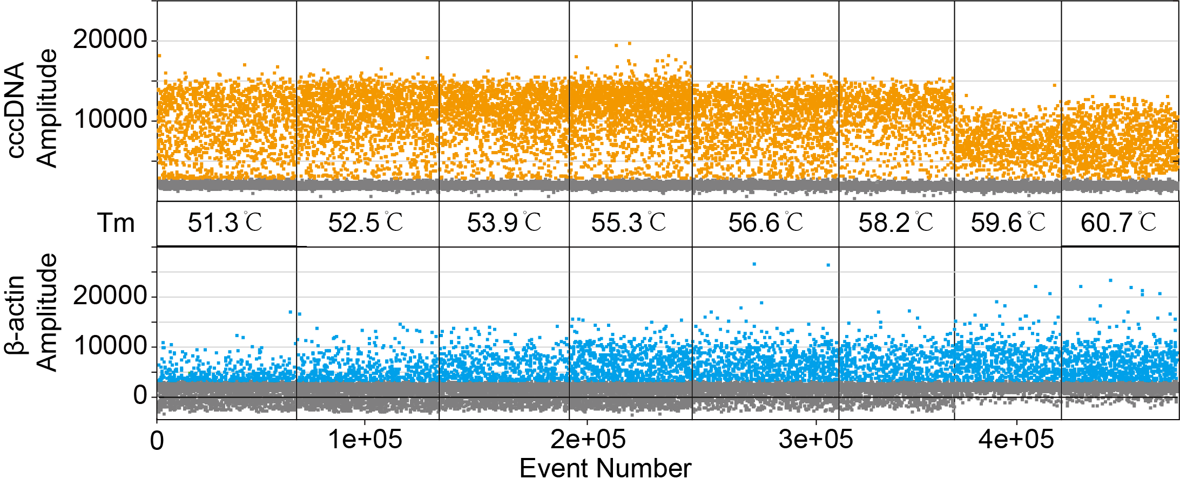

Figure S2. The results of different annealing temperature for the β-actin2 and cccDNA3 primer-probe pairs under the scID-PCR system. The PCR template inputs were HepG2.2.15 cells. The above figure shows the results of cccDNA detection, and the figure below shows the results of β-actin gene detection; The X-axis is the total number of droplets (event number), the Y-axis is the fluorescence signal intensity. Droplets with fluorescence signal intensity greater than the threshold are positive droplets, i.e., yellow/blue droplets; Droplets with fluorescence signal intensity less than the threshold are negative droplets, i.e., gray droplets; PBS as a blank control.

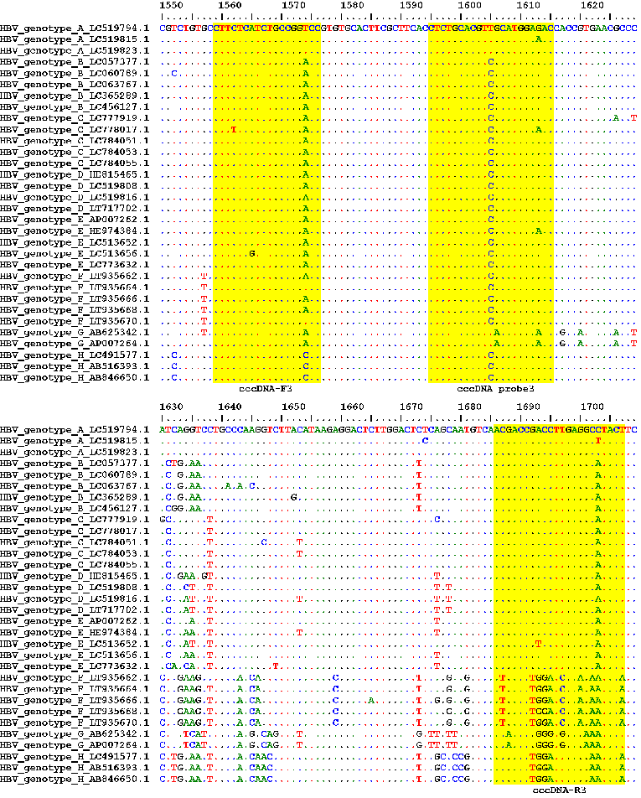
Figure S3. Multiple sequence alignment results for cccDNA-3 primer-probe pairs with HBV DNA sequences from genotypes A-H. HBV DNA sequences were downloaded from NCBI and aligned using the MUSCLE program in MEGA with default parameters.

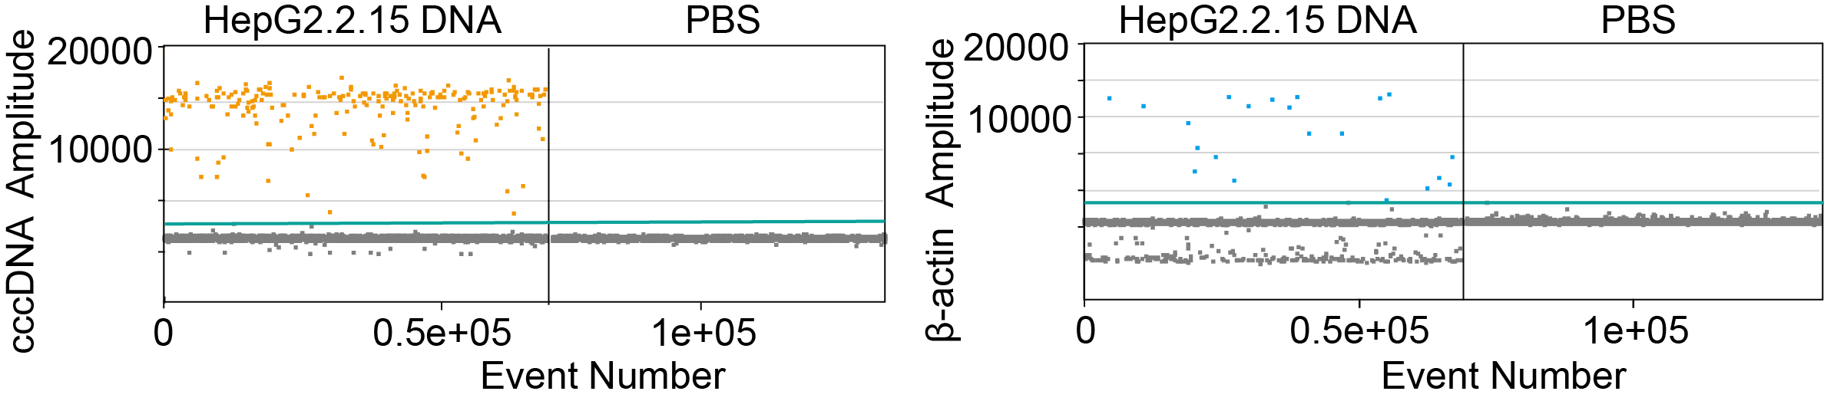
Figure S4. The results of DNA input for the scID-PCR system. The above figure shows the results of cccDNA detection, and the figure below shows the results of β-actin gene detection; The X-axis is the total number of droplets (event number), the Y-axis is the fluorescence signal intensity. Droplets with fluorescence signal intensity greater than the threshold are positive droplets, i.e., yellow/blue droplets; Droplets with fluorescence signal intensity less than the threshold are negative droplets, i.e., gray droplets; PBS as a blank control.

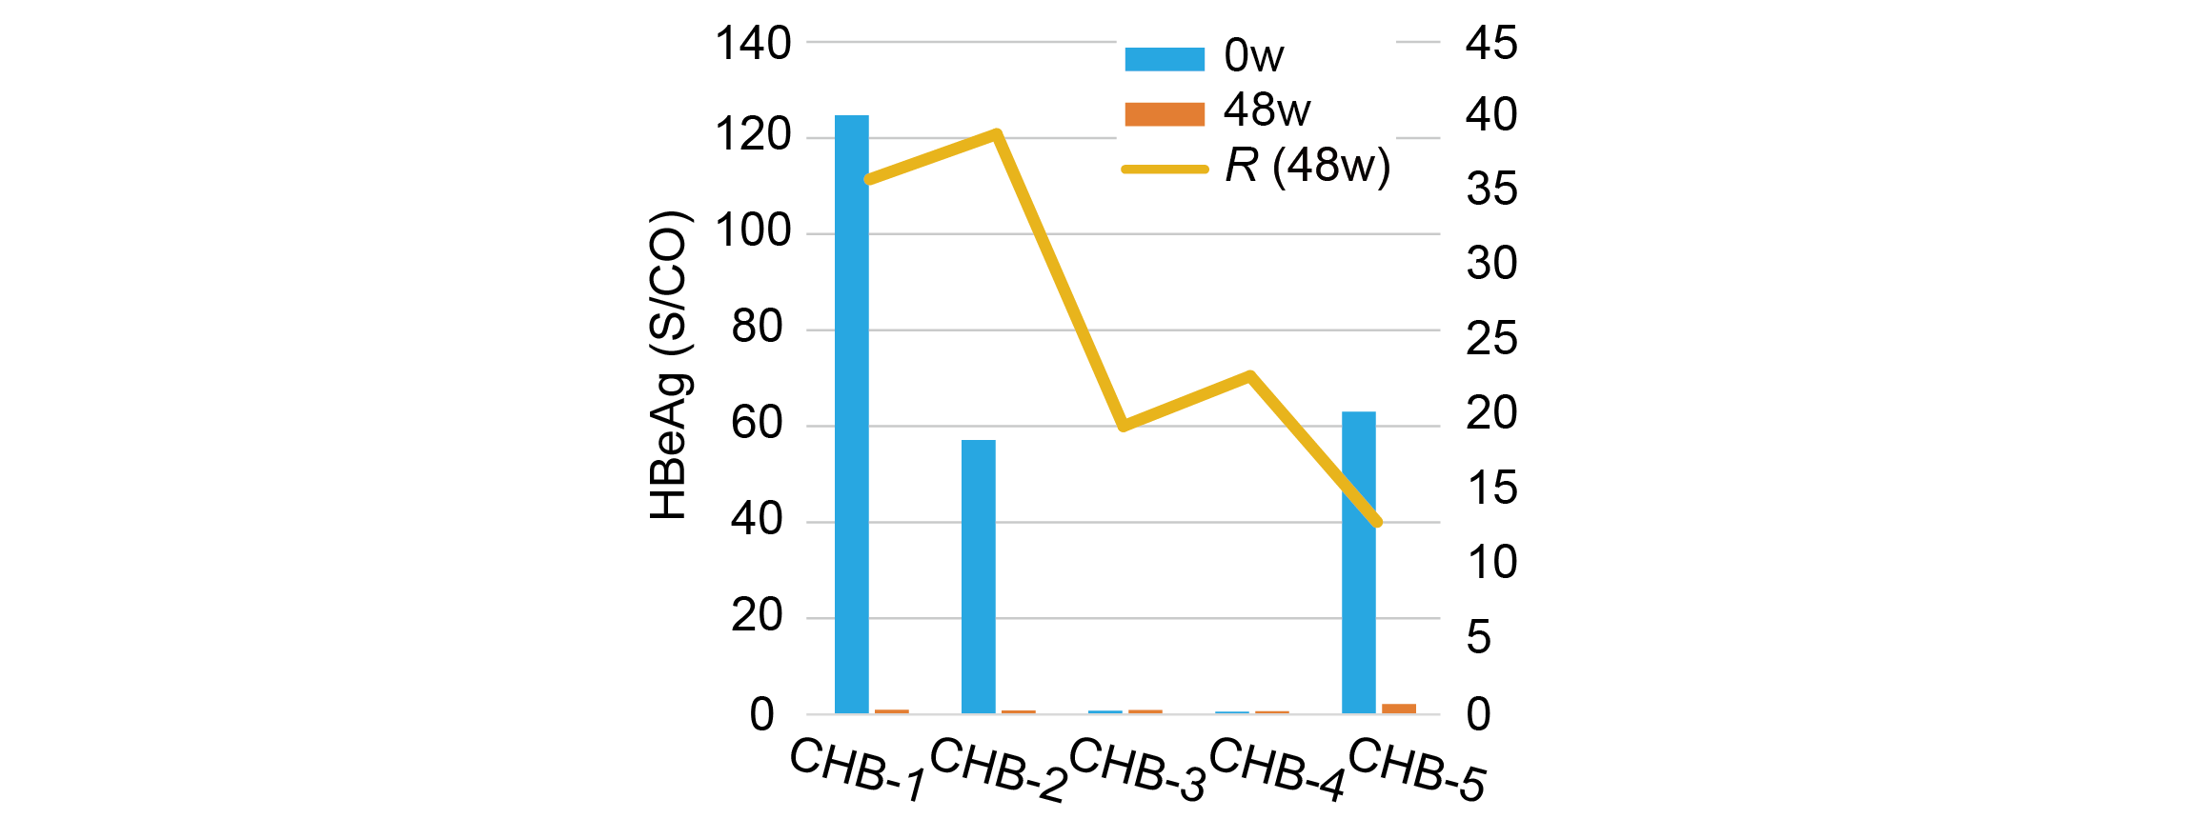
Figure S5. The change of HBeAg between 0 week (0w) and 48 weeks (48w), with the proportion of cccDNA+ cell (R) in liver at 48 weeks of anti-HBV therapy.

Table S1. the probability distribution for encapsulating 2000, 4000, and 8000 cells into 20000, 50000, and 100000 droplets, based on the Poisson distribution.
x | 2000 cells to 20000 droplets | 2000 cells to 50000 droplets | 2000 cells to 1e+05 droplets | 4000 cells to 20000 droplets | 4000 cells to 50000 droplets | 4000 cells to 1e+05 droplets | 8000 cells to 20000 droplets | 8000 cells to 50000 droplets | 8000 cells to 1e+05 droplets
0 | 0.9048 | 0.9608 | 0.9802 | 0.8187 | 0.9231 | 0.9608 | 0.6703 | 0.8521 | 0.9231
1 | 0.0905 | 0.0384 | 0.0196 | 0.1637 | 0.0738 | 0.0384 | 0.2681 | 0.1363 | 0.0738
2 | 0.0045 | 0.0008 | 0.0002 | 0.0164 | 0.0030 | 0.0008 | 0.0536 | 0.0109 | 0.0030
3 | 0.0002 | 1.02E-05 | 1.31E-06 | 0.0011 | 7.88E-05 | 1.02E-05 | 0.0072 | 0.0006 | 7.88E-05
4 | 3.77E-06 | 1.02E-07 | 6.53E-09 | 5.46E-05 | 1.58E-06 | 1.02E-07 | 0.0007 | 2.33E-05 | 1.58E-06
5 | 7.54E-08 | 8.20E-10 | 2.61E-11 | 2.18E-06 | 2.52E-08 | 8.20E-10 | 5.72E-05 | 7.45E-07 | 2.52E-08
6 | 1.26E-09 | 5.47E-12 | 8.71E-14 | 7.28E-08 | 3.36E-10 | 5.47E-12 | 3.81E-06 | 1.99E-08 | 3.36E-10
7 | 1.80E-11 | 3.12E-14 | 2.49E-16 | 2.08E-09 | 3.84E-12 | 3.12E-14 | 2.18E-07 | 4.54E-10 | 3.84E-12
8 | 2.24E-13 | 1.56E-16 | 6.22E-19 | 5.20E-11 | 3.84E-14 | 1.56E-16 | 1.09E-08 | 9.08E-12 | 3.84E-14
9 | 2.49E-15 | 6.94E-19 | 1.38E-21 | 1.16E-12 | 3.41E-16 | 6.94E-19 | 4.84E-10 | 1.61E-13 | 3.41E-16
10 | 2.49E-17 | 2.78E-21 | 2.77E-24 | 2.31E-14 | 2.73E-18 | 2.78E-21 | 1.94E-11 | 2.58E-15 | 2.73E-18
x: the cell number in one droplet.

Table S2. Primer and probe sequences for HBV cccDNA quantification.
Gene | primers and probes | Sequence（5'-3'） | Length
β-actin-1 | Forward | ACTGTGCCCATCTACGAGG | 19
β-actin-1 | Reverse | CAGGCAGCTCGTAGCTCTT | 19
β-actin-1 | Probe | VIC-CGGGAAATCGTGCGTGAC-BHQ1 | 18
β-actin-2 | Forward | GCTAAGTCCTGCCCTCATTTC | 21
β-actin-2 | Reverse | ATCTTCATTGTGCTGGGTGCC | 21
β-actin-2 | Probe | VIC-TGACGTGGACATCCGCAAAGAC-BHQ1 | 22
cccDNA-1 | Forward | GGGGCGCACCTCTCTTTA | 18
cccDNA-1 | Reverse | AGGCACAGCTTGGAGGC | 17
cccDNA-1 | Probe | FAM-TCACCTCTGCCTAATCATCTC-BHQ1 | 21
cccDNA-2 | Forward | CGTCTGTGCCTTCTCATCTGC | 21
cccDNA-2 | Reverse | GCACAGCTTGGAGGCTTGAA | 20
cccDNA-2 | Probe | FAM-CTGTAGGCATAAATTGGTCTGCGAA-BHQ1 | 25
cccDNA-3 | Forward | CTTCTCATCTGCCGGACC | 18
cccDNA-3 | Reverse | AGTATGCCTCAAGGTCGGTCGT | 22
cccDNA-3 | Probe | CTCTGCACGTCGCATGGAGAC | 21

Table S3. The Ct results of 5 pairs of primers.
sample | Ct value
sample | β-actin-1 | β-actin-2 | cccDNA-1 | cccDNA-2 | cccDNA-3 | H₂O
sample 1 | 22.40 | 24.59 | 22.83 | 23.35 | 19.49 | -
sample 2 | 21.47 | 22.96 | 22.50 | 22.37 | 18.47 | -
sample 3 | 26.25 | 28.64 | 25.85 | 25.8 | 22.54 | -
sample 4 | 25.03 | 27.33 | 25.52 | 25.55 | 21.98 | -

Table S4. Demographic information of study participants
Variable | CHB patients  (n =5) | HCC patients  (n = 1)
Age, years | 37.4 | 50
Males/females | 4/1 | 1/0
Treated with anti-HBV therapy | 5 | 0
HBsAg positive | 1 | 0
Cirrhosis | 0 | 0

Table S5. Serological markers and the proportion of the cccDNA⁺ cells in liver for 5 CHB patients.
Patient | HBsAg  (0w)  (IU/mL) | HBsAg  (48w)  (IU/mL) | HBeAg  (0w)  (S/CO) | HBeAg (48w)  (S/CO) | HBV-DNA (48w)  (IU/mL) | ALT  (48w)  (U/L) | AST  (48w)  (U/L) | R  (%)
CHB-1 | 791.12 | 0.00 | 124.71 | 0.45 | 25.30 | 27.00 | 30.00 | 35.81
CHB-2 | 1184.78 | 0.00 | 57.13 | 0.30 | 30.00 | 51.00 | 35.00 | 38.83
CHB-3 | 0.40 | 0.96 | 0.27 | 0.43 | 0.00 | 21.00 | 22.00 | 19.29
CHB-4 | 0.23 | 0.00 | 0.07 | 0.66 | 0.00 | 34.00 | 23.00 | 22.64
CHB-5 | 700.75 | 0.00 | 63.02 | 2.13 | 0.00 | 51.00 | 46.00 | 12.88
HCC | NA | NA | NA | NA | NA | NA | NA | 0.00
 |  |  |  |  |  |  |  | 0.00

Table S6. Single-cell suspensions quality of liver biopsy tissues.
Patient | Cell viability (%) | Cell concentration | Cell counts
CHB-1 | 96.72 | 1.00E+06 | 5.00E+05
CHB-2 | 98.46 | 1.85E+06 | 9.25E+05
CHB-3 | 98.2 | 7.47E+05 | 3.74E+05
CHB-4 | 97.41 | 6.36E+05 | 1.91E+05
CHB-5 | 97.89 | 4.25E+05 | 1.28E+05
HCC-Tumor | 96.73 | 1.01E+07 | 1.01E+07
HCC-Adjacent | 94.35 | 3.15E+06 | 3.15E+06

