Supplementary Figure 1.STK19 deficiency significantly increases cisplatin inhibition of DNA synthesis capacity in Tscc cells；(A-B)Cisplatin significantly inhibits DNA synthesis in STK19-deficient Tscca cells;(C-D)Cisplatin significantly inhibits DNA synthesis in STK19-deficient Scc-9 cells;
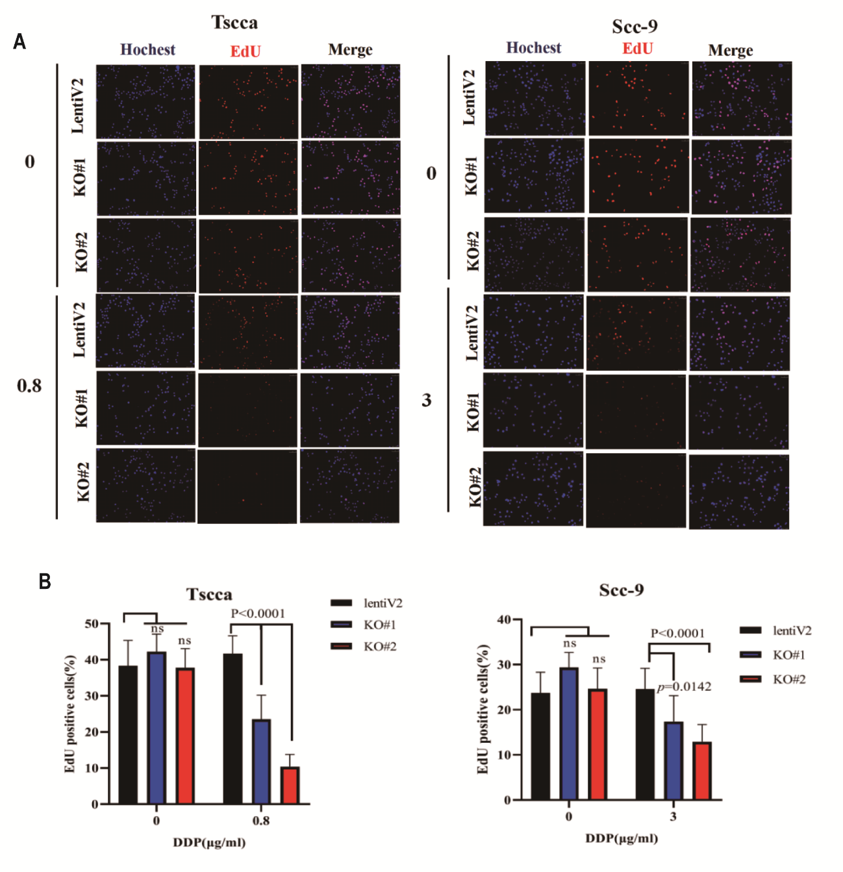

Supplementary figure 2: STK19 inhibition increases the sensitivity of Scc-9 cells to other platinum-based agents;(A-B) The combined effects of STK19 inhibitor and Carboplatin on Scc-9 cell growth as shown by CCK8 assay, and on apoptosis through flow cytometry analysis. (C-D) The combined effects of STK19 inhibitor and Nedaplatin on Scc-9 cell growth as shown by CCK8 assay, and on apoptosis analyzed by flow cytometry. (E) Comparison of Carboplatin IC50 values in STK19 KO and control Scc-9 cells. (F) Comparison of Nedaplatin IC50 values in STK19 KO and control Scc-9 cells.
