Supplementary tables and figures

Table S1: Descriptive characteristics of intervention and control groups

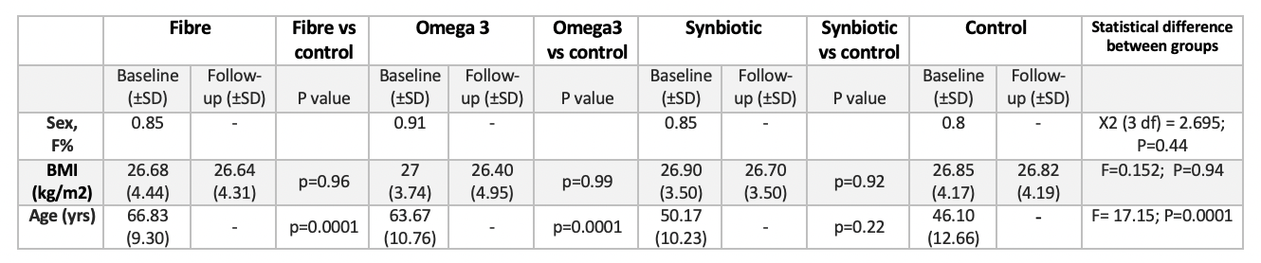

Table S2: Cardiometabolic markers in the intervention (synbiotic) and control arms

 | Synbiotic (n=20) |  |  | Control (n=20)
 | Baseline | Follow-up |  | Baseline | Follow-up
 | Mean  (Std dev) | Mean  (Std dev) | P value | Mean  (Std dev) | Mean  (Std dev) | P value
Total cholesterol (mmol/L) | 5.74 (1.31) | 5.38 (1.25) | 0.040 | 4.75 (1.01) | 4.72 (0.81) | 0.964
Triglycerides (mmol/L) | 1.17 (0.91) | 1.06 (0.85) | 0.168 | 1.04 (0.42) | 0.99 (0.43) | 0.978
HDL (mmol/L) | 1.87 (0.43) | 1.81 (0.46) | 0.654 | 1.71 (0.39) | 1.75 (0.39) | 0.188
LDL (mmol/L) | 3.98 (1.35) | 3.62 (1.28) | 0.018 | 3.06 (0.95) | 2.98 (0.75) | 0.577
Non-HDL (mmol/L) | 3.87 (1.35) | 3.58 (1.25) | 0.014 | 3.04 (0.92) | 2.94 (0.65) | 0.791
Glucose (mmol/L) | 5.36 (0.48) | 5.37 (0.39) | 0.953 | 5.12 (0.52) | 5.11 (0.39) | 0.992
Insulin (mIU/L) | 8.65 (5.69) | 8.20 (5.25) | 0.242 | 8.29 (3.76) | 8.88 (4.59) | 0.277
HOMA IR | 2.14 (1.66) | 2.01 (1.48) | 0.409 | 1.909 (0.90) | 1.973 (1.02) | 0.430

Table S3: Glucose, insulin and HOMA IR levels in the Omega 3 and Inulin fibre intervention arms

 | Omega 3 |  |  | Fibre
 | Baseline (SD) | Follow up (SD) | P value | Baseline (SD) | Follow-up (SD) | P value
Glucose (mmol/l) | 4.07 (0.58) | 4.04 (0.62) | 0.982 | 4.29 (0.64) | 3.97 (0.37) | 0.263
Insulin (mIU/L) | 6.86 (3.88) | 7.03 (3.61) | 0.575 | 7.31 (3.23) | 6.53 (3.37) | 0.009
HOMA IR | 1.22 (0.65) | 1.24 (0.70) | 0.608 | 1.43 (0.62) | 1.18 (0.62) | 0.077

Table S4: Post hoc power analysis for the intervention groups

Intervention group | Variable | Effect size with 95%CI  (Cohen’s d) | Post hoc power | FDR adjusted p value (α)
Synbiotic | SIRT2 | -1.50 (-2.17 to -0.77) | 95.4% | <0.003
Synbiotic | IL6 | -0.88 (-1.36 to -0.17) | 91.9% | <0.003
Omega 3 | TNFα | -0.61 (-0.73 to -0.09) | 91.5% | <0.003
Omega 3 | IL-17 | -0.41 (-0.98 to -0.14) | 83.0% | <0.003
Fibre | IL-12 | -1.14 (-1.81 to -0.47) | 92.9% | <0.003
Fibre | IL-7 | -0.30 (-0.69 to -0.11) | 50.9% | <0.003

Figure S1:
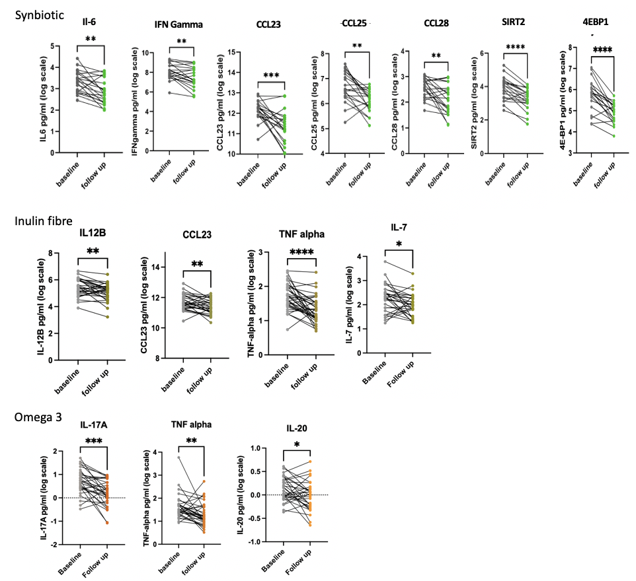

Change in significant inflammatory markers between baseline and follow-up in the different dietary supplementation interventions. Statistically significant differences are indicated by asterisks: (*p < 0.05, **p < 0.01,***p < 0.001,****p < 0.0001).

Figure S2:

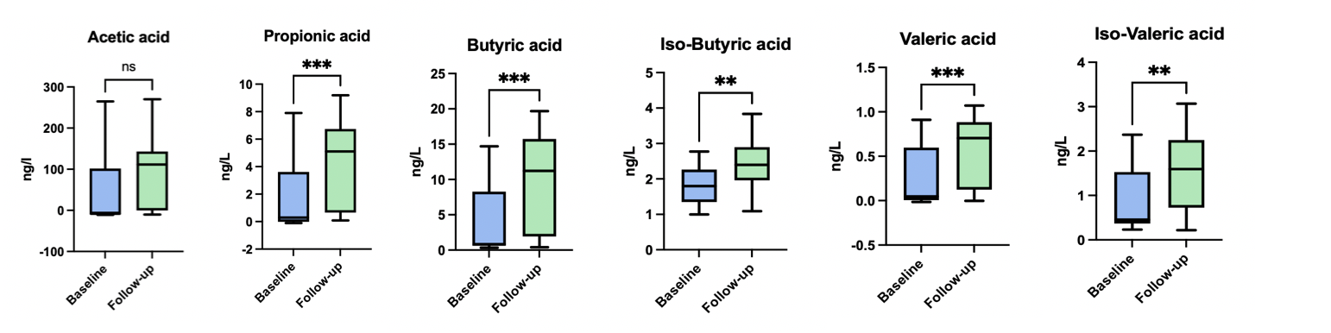

Change in SCFA concentrations between baseline and follow-up in the intervention group. Statistically significant differences are indicated by asterisks: (*p < 0.05, **p < 0.01,***p < 0.001,****p < 0.0001).
Figure S3:
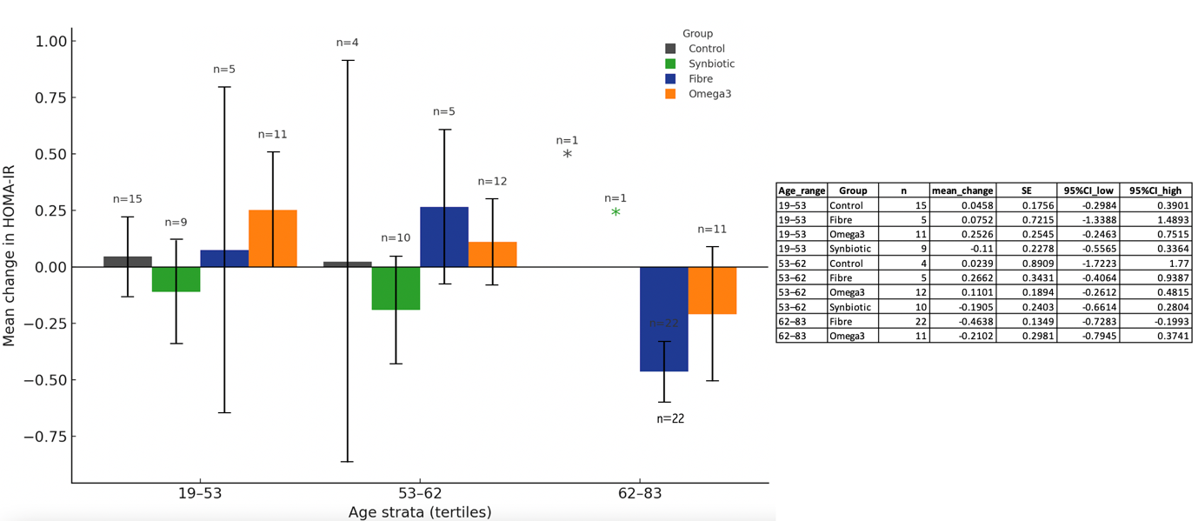

Mean change in HOMA-IR by age tertile and intervention. Bars show the group mean change from baseline to follow-up; error bars denote the standard error of the mean (SE) and are shown only when n ≥ 2. The value above each bar is the sample size; categories with n = 1 are marked with an asterisk. Summary table listing n, mean change, SE and 95% CI used to derive the error bars.

