Figure S1 Violin plots of nFeature,nCount, and percent.m

Figure S2 Pseudotime distribution.

Figure S3 Developmental trajectory of key cells.
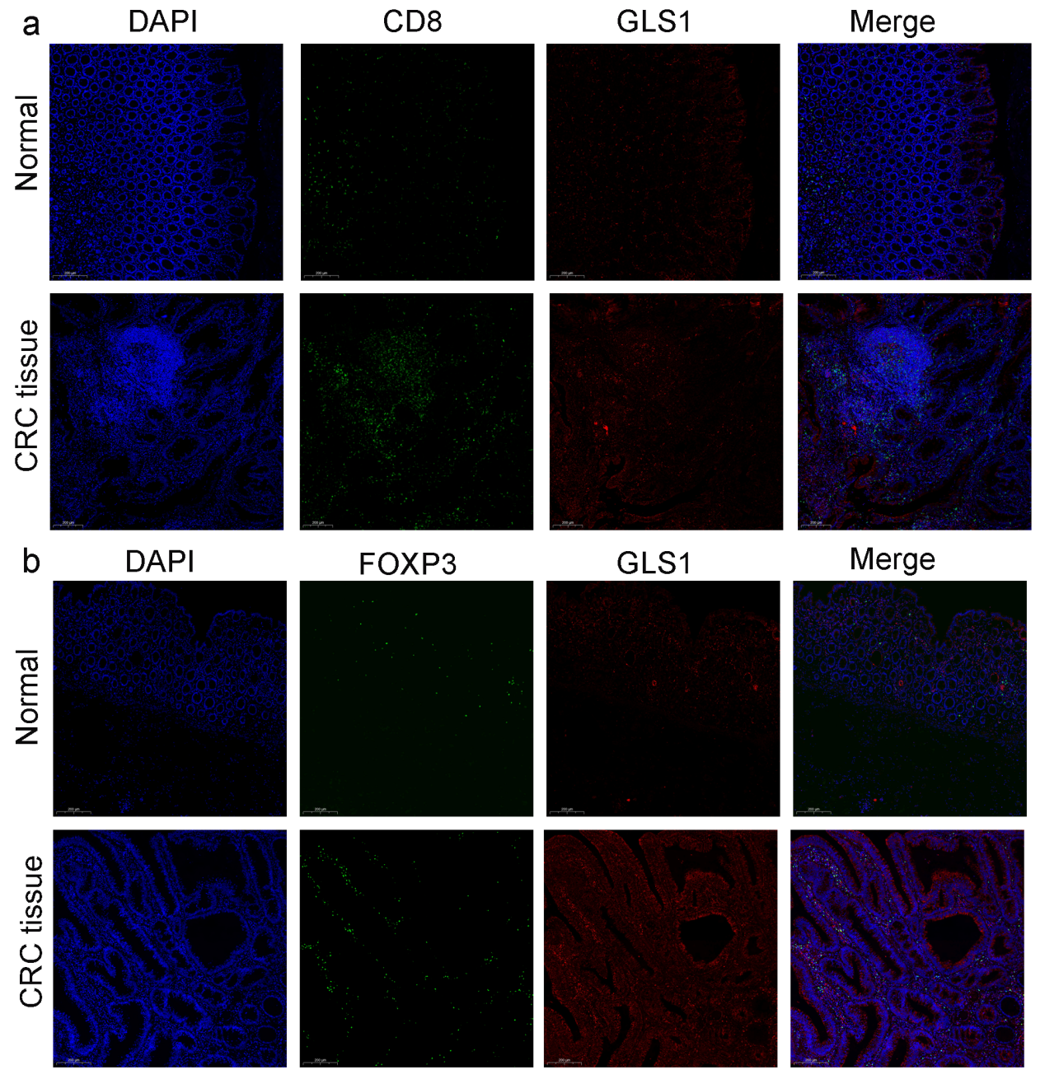
Figure S4 Immunofluorescence results. a Both CD8 and GLS1 showed high fluorescence intensity in CRC tissues. b Both FOXP3 and GLS1 exhibited high fluorescence intensity in CRC tissues.
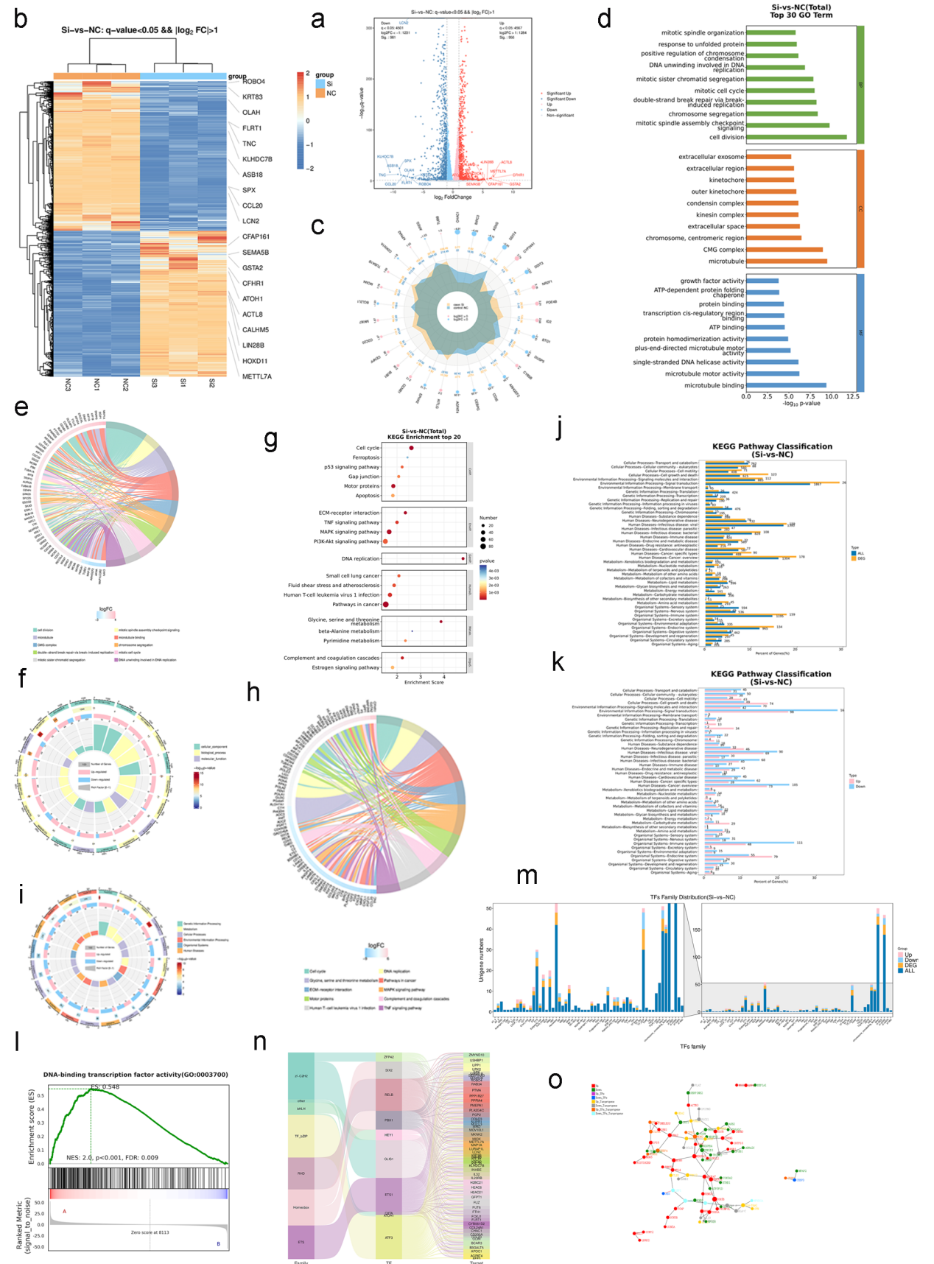
Figure S5 Transcriptome Sequencing Analysis of PCOLCE2. a Volcano plot showing the distribution of DEGs. b Clustered heatmap of DEGs. c Radar chart of DEGs. d, e, f GO analysis bar charts, chord diagrams, and circle diagrams. g, h, i KEGG enrichment analysis bubble plots, chord diagrams, and circle diagrams. j, k Distribution map of DEGs at the KEGG Level2 level. l GSEA Enrichment Plot. m Differential Transcription Factor Family Distribution Chart. n Sankey Diagram of Differential Transcription Factors and Target Genes. o PPI Network Diagram.
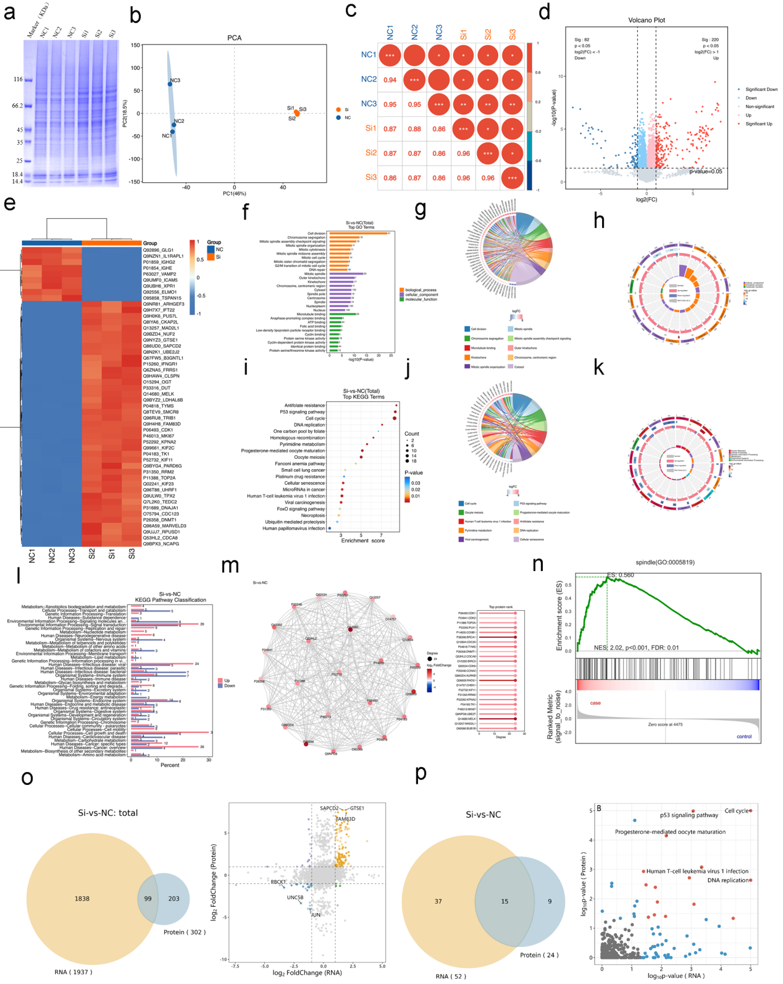
Figure S6. Proteomics Analysis. a SDS-PAGE electrophoresis image. b PCA plot. c Sample correlation plot. d Volcano Plot.e heatmap of top 50 protein clusters. f, g, h GO enrichment analysis bar charts, chord diagrams, and circle diagrams. i, j, k KEGG enrichment analysis bar charts, chord diagrams, and circle diagrams. l DEPs distribution at KEGG Level 2. m PPI network Diagram. n GSEA enrichment plot. o Transcriptomic-proteomic intersection Venn diagram and differential degree quadrant distribution. p KEGG pathway intersection Venn diagram and pathway scatter plot.

