Additional Data
Table S1
Primer | Sequence
rpl13a_F | TCTGGAGGACTGTAAGAGGTATGC
rpl13a_R | AGACGCACAATCTTGAGAGCAG
ncam3_F | AAAGGGATTGACGAGGAGGC
ncam3_R | CGTGACCTCTGAATGAACGC
cxcl13_F | CCTGCATGAAAATTCCAGCTCAC
cxcl13_R | GTCTGACAGGGGAGGCATTT
rig1_F | TGTGGAGTGCAAACACGACT
rig1_R | ACTCTCGTATGGCGAACGTC
rad54b_F | ATATGACCCGAACGCACCAG
rad54b_R | CCACGCCCTCTTTCTGATGT
fosb_F | GGCCTTTTGCTTGCCTATCG
fosb_R | TGAAGTCGCACAGACGCTAA
hmox1a_F | GGACTTGGAGCACTTCTTCG
hmox1a_R | GGACTGCTCTTGCCAATCTC
il6_F | CACTCAGAGACGAGCAGTTTG
il6_R | TCAGGACGCTGTAGATTCGC
il1b_F | GATCCGCTTGCAATGAGCTAC
il1b_R | TCAGGGCGATGATGACGTTC

Additional Supplementary Figures
Figure S1
Figure S1: Zebrafish brain regeneration upon telencephalic stab-wound injury. A) Quantification of PCNA levels (Fig. 1 (B)) in uninjured control and regenerating brains (1 dpl, 4dp, 7dpl and 14 dpl) (n=4). Significance is represented as * for P-value<0.05, ** for p-value<0.01 and *** for p-value<0.001 for all the quantifications. dpl: days post-lesion. B-D) Immunostaining of the regenerating zebrafish brain (where right telencephalic hemisphere was lesioned/injured) using antibodies against BrdU (B1-B9) at 4dpl, 7 dpl and 14 dpl, NeuroD1 (C1-C6) at 7 dpl and 14 dpl, and GFAP (D1-D6) at 7 dpl and 14 dpl. Counterstaining was done with DAPI. Scale bar is 100µm. dpl: days post-lesion.

Figure S2

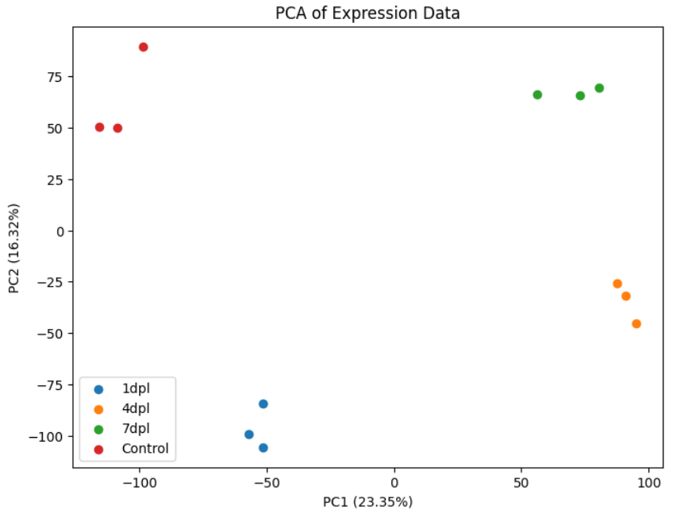
Figure S2: PCA plot visualizing the variance in gene expression data across different brain regeneration samples (control, 1 dpl, 4 dpl and 7 dpl). Each point signifies an individual biological replicate from one of four categories: 1-day post-lesion (1dpl, blue), 4 days post-lesion (4dpl, orange), 7 days post-lesion (7dpl, green), and uninjured controls (red). The first two principal components (PC1 and PC2) explain 23.35% and 16.32% of the variance, respectively, and demonstrate a clear distinction between the experimental groups, highlighting the unique transcriptomic profiles linked to each time point and the control condition.

Figure S3

Figure S3: Activation dynamics of inflammation response across different time points. A) Heatmaps showing the expression of inflammation related genes that are upregulated. B) Heatmaps showing the expression of inflammation related genes that are downregulated. C-E) qRT-PCR of hmox1a, il6 and il1b at 1 dpl, 4 dpl and 7 dpl compared to the uninjured control. Results are shown as mean ± SEM (n=4; 5 brains pooled for each sample). Significance is represented as * for P-value<0.05, ** for p-value<0.01 and *** for p-value<0.001 for all the quantifications. dpl: days post-lesion

Figure S4
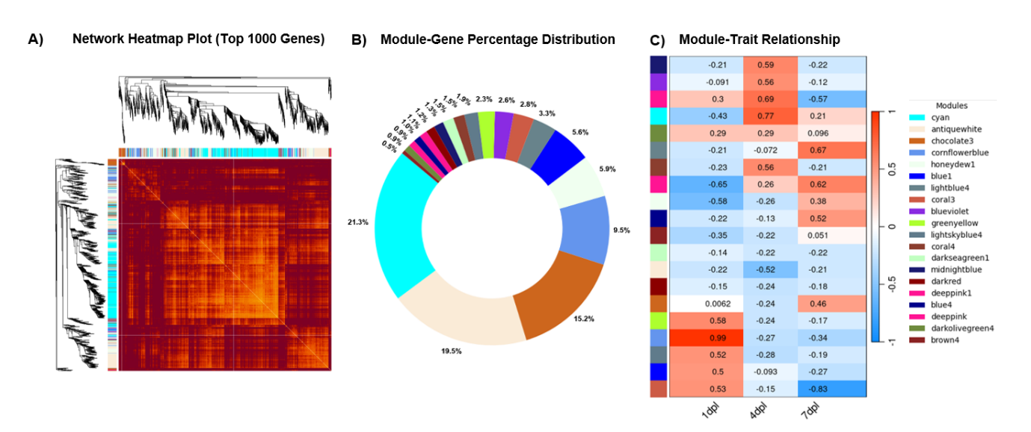
Figure S4: A) The heatmap depicts the topological overlap matrix among the top 1000 genes in the analysis. B) The donut chart represents the percentage of genes per module. C) The correlation matrix for the module and (samples) traits. The red lattice represents a positive correlation between the traits of the module, while the blue lattice represents a negative correlation. dpl: days post-lesion

Figure S5
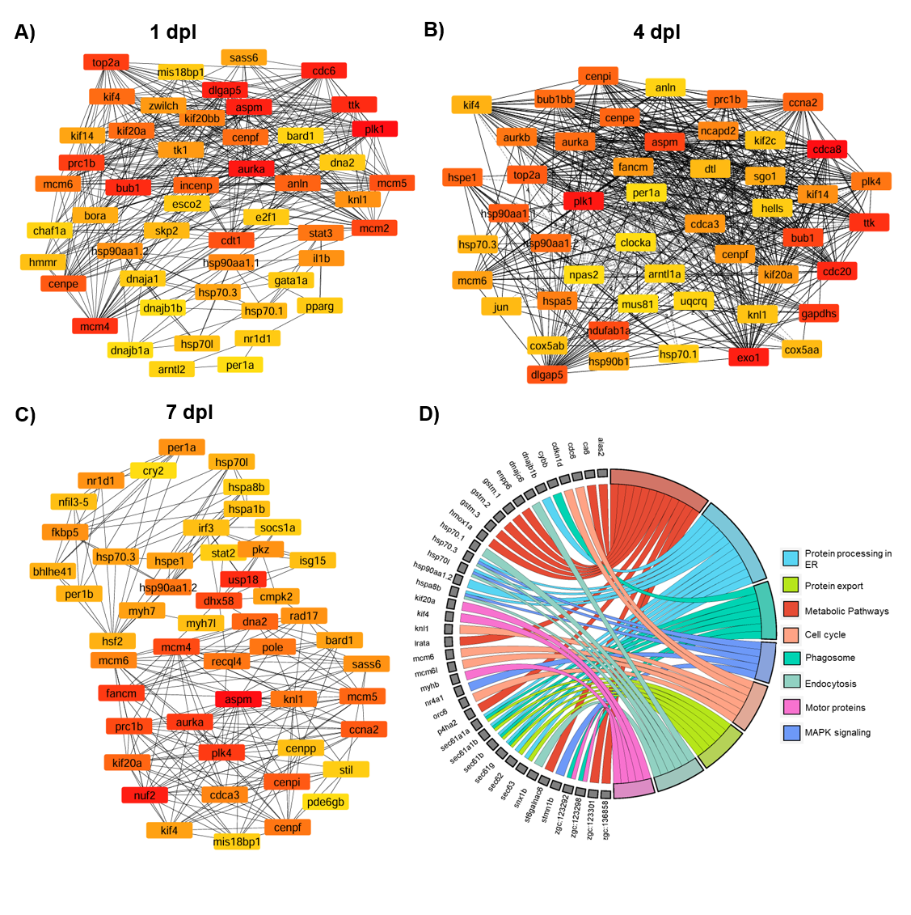
Figure S5: Identification and functional enrichment of hub genes: The hub genes were identified using the model-Degree for A) Day1 B) Day4 and C) Day7 with the Cytoscape plug-in CytoHubba. The darker the color of the node, the more critical the gene, indicating the gene is more important in the network. D) Chord plot shows the common hub genes across the three time points and their associated functions. The picture is illustrated using SR plot. dpl: days post-lesion

Figure S6
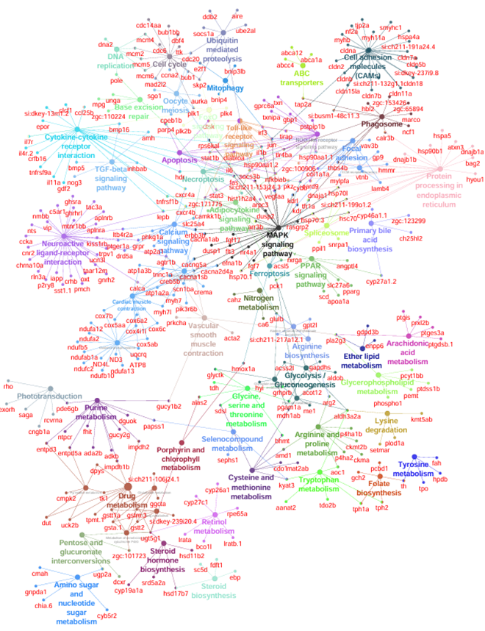
Figure S6: Network representation of DEG’s combined across all the time points. The cytoscape ClueGO and Cluepedia plugin was used to identify enriched KEGG pathways amongst all statistically significant proteins across all the time points. Nodes containing proteins from related KEGG terms are colored the same.

Figure S7
A)
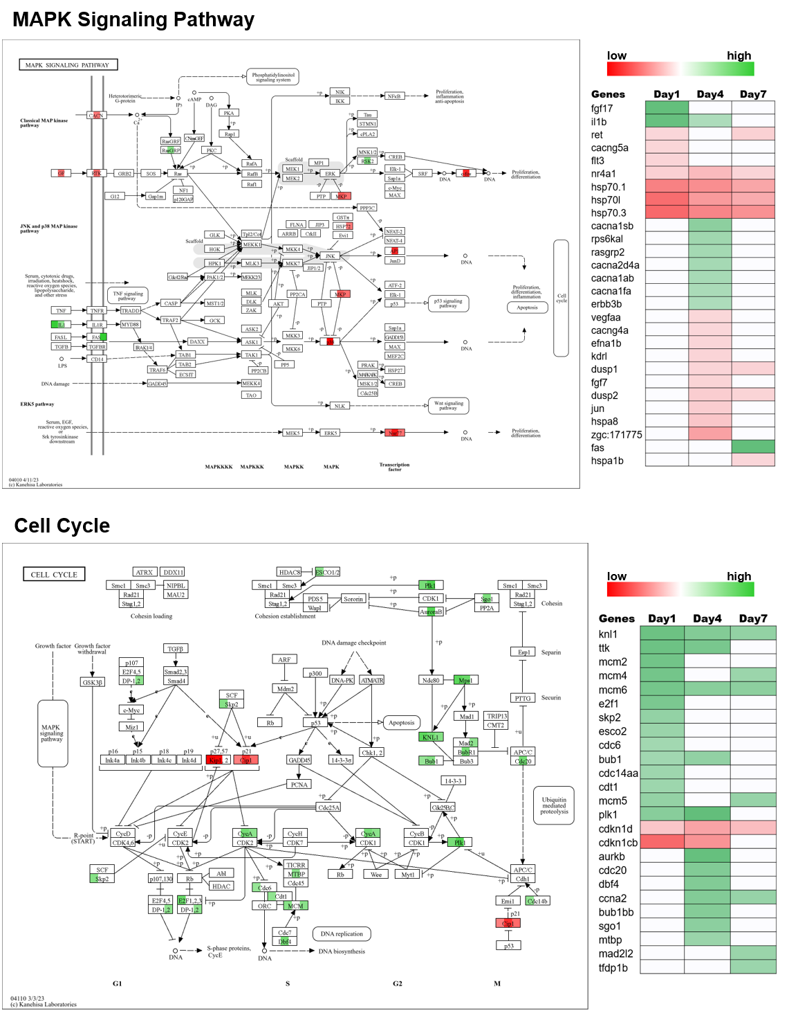

B)
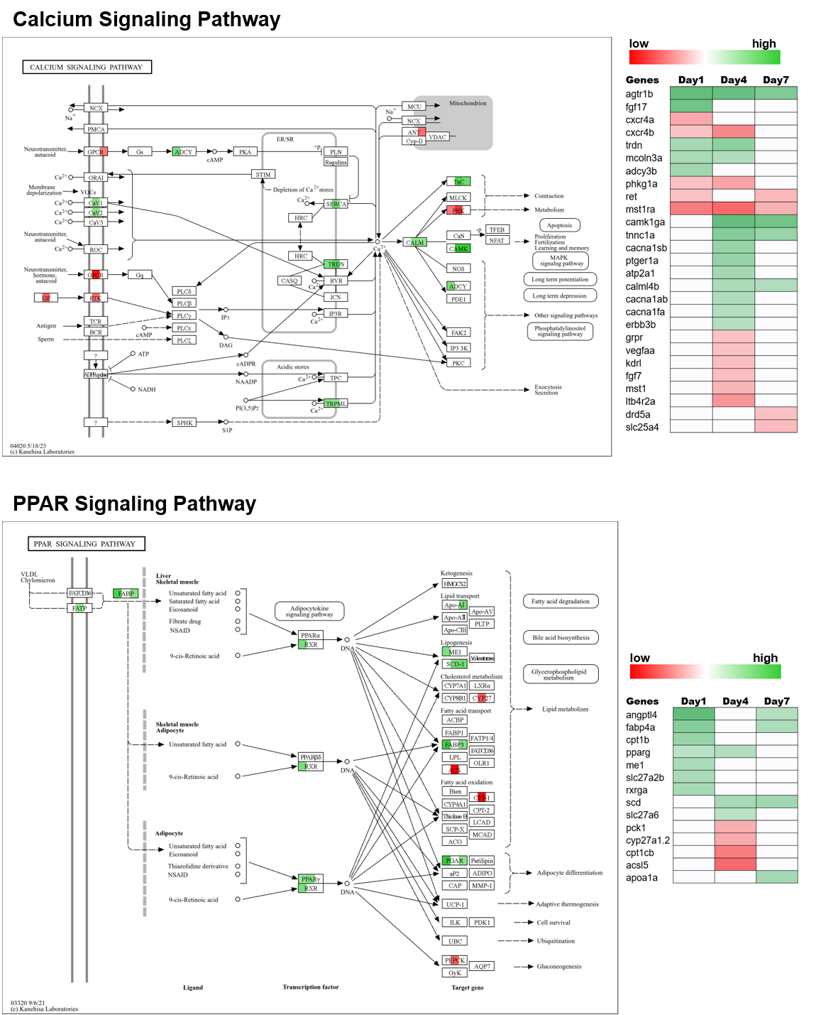
Figure S7: Visualization of Identified KEGG Pathway Routes: KEGG Pathway visualization for A) MAPK signaling Pathway and Cell Cycle B) Calcium Signaling Pathway and PPAR signaling pathway. Each node is represented by three squares corresponding to day 1, day 4, and day 7 post-injury. The gene boxes are colored based on their expression levels at each respective day. The color scale is illustrated on the right: greener shades indicate higher expression levels, while redder shades signify lower expression levels.

Figure S8
Figure S8: Inhibition of MAPK14a appears to hinder successful regenerative response post traumatic brain injury. Immunofluorescence staining of 4 dpl zebrafish brains treated with DMSO (control) or 1 μM BIRB796 immediately after lesion induction and maintained until sacrifice at 4 dpl, with anti-Olig2 antibody to label oligodendrocyte progenitors. Top row: DMSO control, Bottom row: BIRB796 treatment. Scale bar = 100 μm. C. TUNEL staining of 4 dpl zebrafish brains treated with DMSO (control) or 1 μM BIRB796 to assess cell death. Top row: DMSO control, Bottom row: BIRB796 treatment. Scale bar = 10 μm. Anatomical regions are indicated: Dc (central zone of dorsal telencephalic area), Dp (posterior zone of dorsal telencephalic area), Dm (medial zone of dorsal telencephalic area), Dl (lateral zone of dorsal telencephalic area), Vd (dorsal nucleus of ventral telencephalic area), and Vv (ventral nucleus of ventral telencephalic area).

Figure S9
Figure S9: Dynamics of β-catenin and AKT signaling during zebrafish brain regeneration and their modulation by p38α MAPK inhibition. A) Immunoblot showing temporal changes in β-catenin protein levels in the zebrafish brain at different days post-lesion (dpl): 1, 4, 7, and 14 dpl, compared to uninjured control. B) Immunoblot showing levels of phosphorylated (active) AKT (p-AKT) and total AKT across the regeneration time course. C) Effect of p38 MAPK inhibition using BIRB796 on β-catenin levels at 4 dpl. Zebrafish brains were treated with DMSO (vehicle control), or BIRB796 at 0.5 µM and 1 µM. D) Immunoblot showing the effect of BIRB796 on phosphorylated (active) and total AKT levels at 4 dpl. Zebrafish brains were treated with DMSO (vehicle control), or BIRB796 at 0.5 µM and 1 µM. DMSO was used as the vehicle control. β-Actin was used as the loading control for all panels. dpl: days post-lesion

Figure S10

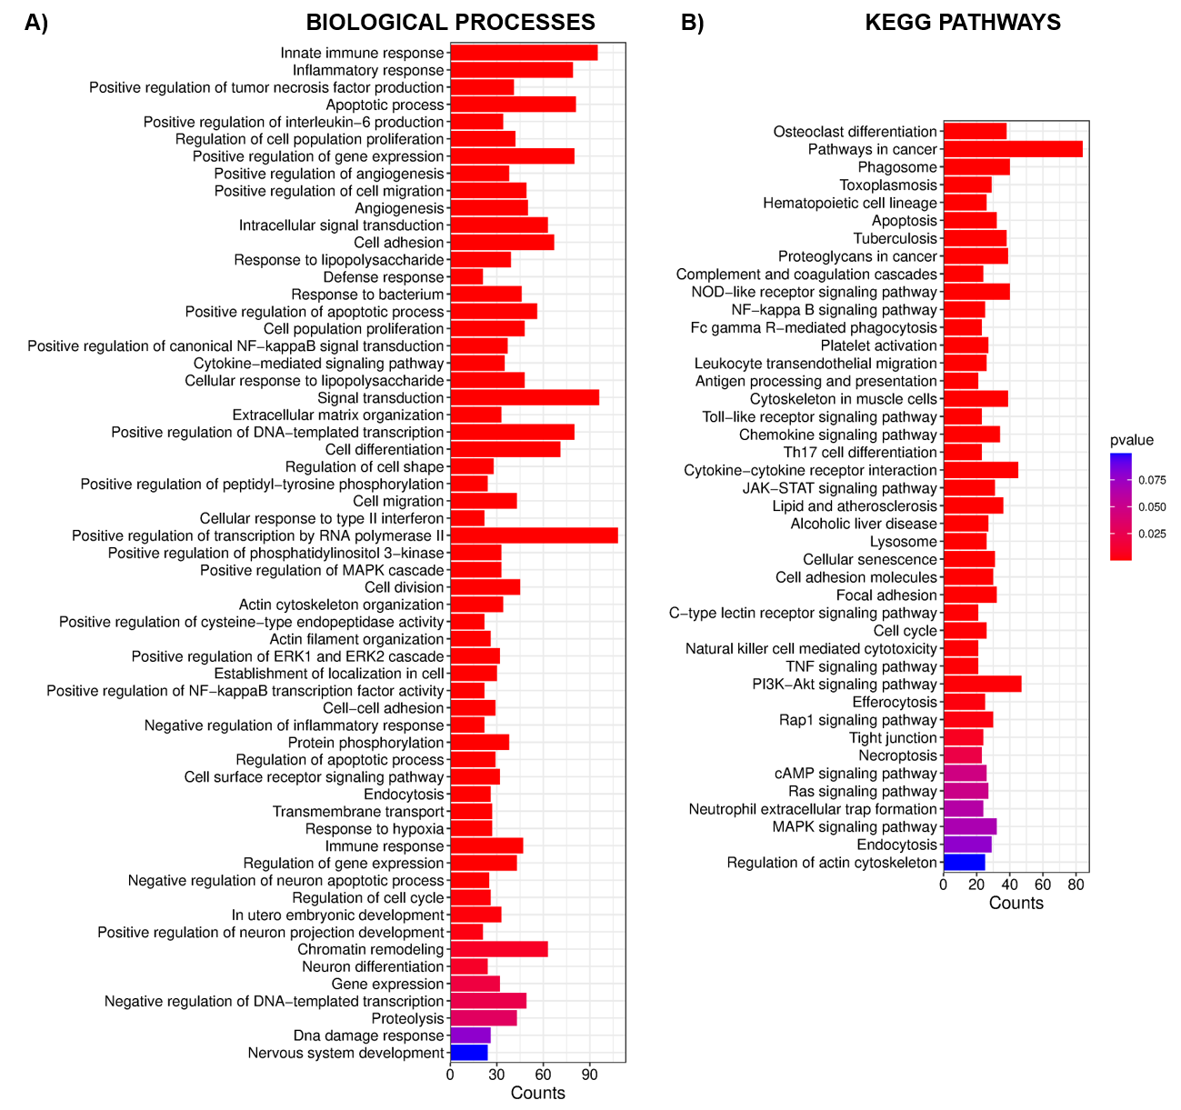
Figure S10: Transcriptomic analysis of a mouse model of traumatic brain injury. A) Gene Ontology (GO) enrichment analysis of biological processes significantly upregulated in a transcriptomic dataset from a mouse model of TBI. B) KEGG pathway enrichment analysis from the same dataset. Color intensity represents p-values and bar length indicates the number of genes associated with each term or pathway.

Additional Information
Additional Table S1: List of primers used in the study
Additional Figure S1: Zebrafish brain regeneration upon telencephalic stab-wound injury.
Additional Figure S2: PCA plot visualizing the variance in gene expression data across different brain regeneration samples (control, 1 dpl, 4 dpl and 7 dpl).
Additional Figure S3: Activation dynamics of inflammation response across different time points
Additional Figure S4: Network and module-trait relationships: Topological overlap, module composition, and trait correlations.
Additional Figure S5: Identification and functional enrichment of hub genes
Additional Figure S6: Network representation of DEG’s combined across all the time points
Additional Figure S7: Visualization of Identified KEGG Pathway Routes for A) MAPK signaling and Cell Cycle, B) Calcium Signaling and PPAR signaling.
Additional Figure S8: Inhibition of MAPK14a appears to hinder successful regenerative response post traumatic brain injury
Additional Figure S9: Dynamics of β-catenin and AKT signaling during zebrafish brain regeneration and their modulation by p38α MAPK inhibition
Additional Figure S10: Transcriptomic analysis of a mouse model of traumatic brain injury.
Additional File 1: List of dysregulated genes at different timepoints across brain regeneration in Zebrafish
Additional File 2: Gene Set Enrichment Analysis (GSEA): Enriched GO and KEGG terms across different timepoints in brain regeneration in Zebrafish
Additional File 3: List of genes in each module obtained from WGCNA
Additional File 4: Module-wise gene enrichment
Additional File 5: List of dysregulated genes in mouse traumatic brain injury and their functional enrichment

