Supplementary Materials
Table 1. Optimal performance metrics and parameters of the support vector machine (SVM) classifier, utilizing deep learning features extracted from the deep multiple instance learning (DSMIL) framework
C | gamma | kernel | Accuracy | AUC | F1 | Sensitivity | Specificity
0.001 | 0.01 | sigmoid | 0.57 | 0.27 | 0.72 | 1 | 0
0.001 | 0.01 | rbf | 0.57 | 0.31 | 0.72 | 1 | 0
0.001 | 0.1 | sigmoid | 0.57 | 0.29 | 0.72 | 1 | 0
0.001 | 0.1 | rbf | 0.57 | 0.31 | 0.72 | 1 | 0
0.001 | 1 | sigmoid | 0.57 | 0.3 | 0.72 | 1 | 0
0.001 | 1 | rbf | 0.57 | 0.5 | 0.72 | 1 | 0
0.001 | 10 | sigmoid | 0.57 | 0.3 | 0.72 | 1 | 0
0.001 | 10 | rbf | 0.57 | 0.5 | 0.72 | 1 | 0
0.001 | 100 | sigmoid | 0.57 | 0.3 | 0.72 | 1 | 0
0.001 | 100 | rbf | 0.57 | 0.5 | 0.72 | 1 | 0
0.01 | 0.01 | sigmoid | 0.7 | 0.27 | 0.79 | 1 | 0.32
0.01 | 0.01 | rbf | 0.57 | 0.31 | 0.72 | 1 | 0
0.01 | 0.1 | sigmoid | 0.64 | 0.71 | 0.72 | 0.84 | 0.37
0.01 | 0.1 | rbf | 0.57 | 0.3 | 0.72 | 1 | 0
0.01 | 1 | sigmoid | 0.61 | 0.7 | 0.7 | 0.8 | 0.37
0.01 | 1 | rbf | 0.57 | 0.5 | 0.72 | 1 | 0
0.01 | 10 | sigmoid | 0.61 | 0.7 | 0.7 | 0.8 | 0.37
0.01 | 10 | rbf | 0.57 | 0.5 | 0.72 | 1 | 0
0.01 | 100 | sigmoid | 0.61 | 0.7 | 0.7 | 0.8 | 0.37
0.01 | 100 | rbf | 0.57 | 0.5 | 0.72 | 1 | 0
0.1 | 0.01 | sigmoid | 0.59 | 0.7 | 0.64 | 0.64 | 0.53
0.1 | 0.01 | rbf | 0.57 | 0.31 | 0.72 | 1 | 0
0.1 | 0.1 | sigmoid | 0.57 | 0.65 | 0.58 | 0.52 | 0.63
0.1 | 0.1 | rbf | 0.57 | 0.3 | 0.72 | 1 | 0
0.1 | 1 | sigmoid | 0.59 | 0.62 | 0.61 | 0.56 | 0.63
0.1 | 1 | rbf | 0.57 | 0.5 | 0.72 | 1 | 0
0.1 | 10 | sigmoid | 0.59 | 0.6 | 0.61 | 0.56 | 0.63
0.1 | 10 | rbf | 0.57 | 0.5 | 0.72 | 1 | 0
0.1 | 100 | sigmoid | 0.55 | 0.61 | 0.55 | 0.48 | 0.63
0.1 | 100 | rbf | 0.57 | 0.5 | 0.72 | 1 | 0
1 | 0.01 | sigmoid | 0.55 | 0.66 | 0.57 | 0.52 | 0.58
1 | 0.01 | rbf | 0.66 | 0.69 | 0.69 | 0.68 | 0.63
1 | 0.1 | sigmoid | 0.52 | 0.57 | 0.43 | 0.32 | 0.79
1 | 0.1 | rbf | 0.57 | 0.3 | 0.72 | 1 | 0
1 | 1 | sigmoid | 0.43 | 0.54 | 0.39 | 0.32 | 0.58
1 | 1 | rbf | 0.57 | 0.48 | 0.72 | 1 | 0
1 | 10 | sigmoid | 0.48 | 0.55 | 0.44 | 0.36 | 0.63
1 | 10 | rbf | 0.57 | 0.5 | 0.72 | 1 | 0
1 | 100 | sigmoid | 0.43 | 0.53 | 0.39 | 0.32 | 0.58
1 | 100 | rbf | 0.57 | 0.5 | 0.72 | 1 | 0
10 | 0.01 | sigmoid | 0.59 | 0.65 | 0.61 | 0.56 | 0.63
10 | 0.01 | rbf | 0.7 | 0.72 | 0.75 | 0.76 | 0.63
10 | 0.1 | sigmoid | 0.48 | 0.57 | 0.41 | 0.32 | 0.68
10 | 0.1 | rbf | 0.57 | 0.3 | 0.72 | 1 | 0
10 | 1 | sigmoid | 0.41 | 0.53 | 0.32 | 0.24 | 0.63
10 | 1 | rbf | 0.57 | 0.48 | 0.72 | 1 | 0
10 | 10 | sigmoid | 0.5 | 0.55 | 0.48 | 0.4 | 0.63
10 | 10 | rbf | 0.57 | 0.5 | 0.72 | 1 | 0
10 | 100 | sigmoid | 0.57 | 0.59 | 0.56 | 0.48 | 0.68
10 | 100 | rbf | 0.57 | 0.5 | 0.72 | 1 | 0
100 | 0.01 | sigmoid | 0.61 | 0.66 | 0.62 | 0.56 | 0.68
100 | 0.01 | rbf | 0.7 | 0.72 | 0.75 | 0.76 | 0.63
100 | 0.1 | sigmoid | 0.45 | 0.58 | 0.4 | 0.32 | 0.63
100 | 0.1 | rbf | 0.57 | 0.3 | 0.72 | 1 | 0
100 | 1 | sigmoid | 0.41 | 0.53 | 0.32 | 0.24 | 0.63
100 | 1 | rbf | 0.57 | 0.48 | 0.72 | 1 | 0
100 | 10 | sigmoid | 0.41 | 0.56 | 0.35 | 0.28 | 0.58
100 | 10 | rbf | 0.57 | 0.5 | 0.72 | 1 | 0
100 | 100 | sigmoid | 0.48 | 0.58 | 0.38 | 0.28 | 0.74
100 | 100 | rbf | 0.57 | 0.5 | 0.72 | 1 | 0

Table 2. Optimal performance metrics and parameters of the support vector machine (SVM) classifier, utilizing deep learning features extracted from the deep multiple instance learning (DSMIL) framework and clinical variables
C | gamma | kernel | Accuracy | AUC | F1 | Sentivity | Specificity
0.001 | 0.01 | sigmoid | 0.57 | 0.27 | 0.72 | 1 | 0
0.001 | 0.01 | rbf | 0.57 | 0.31 | 0.72 | 1 | 0
0.001 | 0.1 | sigmoid | 0.57 | 0.29 | 0.72 | 1 | 0
0.001 | 0.1 | rbf | 0.57 | 0.33 | 0.72 | 1 | 0
0.001 | 1 | sigmoid | 0.57 | 0.29 | 0.72 | 1 | 0
0.001 | 1 | rbf | 0.57 | 0.5 | 0.72 | 1 | 0
0.001 | 10 | sigmoid | 0.57 | 0.29 | 0.72 | 1 | 0
0.001 | 10 | rbf | 0.57 | 0.5 | 0.72 | 1 | 0
0.001 | 100 | sigmoid | 0.57 | 0.29 | 0.72 | 1 | 0
0.001 | 100 | rbf | 0.57 | 0.5 | 0.72 | 1 | 0
0.01 | 0.01 | sigmoid | 0.7 | 0.27 | 0.79 | 1 | 0.32
0.01 | 0.01 | rbf | 0.57 | 0.31 | 0.72 | 1 | 0
0.01 | 0.1 | sigmoid | 0.64 | 0.71 | 0.72 | 0.84 | 0.37
0.01 | 0.1 | rbf | 0.57 | 0.32 | 0.72 | 1 | 0
0.01 | 1 | sigmoid | 0.64 | 0.71 | 0.71 | 0.8 | 0.42
0.01 | 1 | rbf | 0.57 | 0.5 | 0.72 | 1 | 0
0.01 | 10 | sigmoid | 0.64 | 0.71 | 0.71 | 0.8 | 0.42
0.01 | 10 | rbf | 0.57 | 0.5 | 0.72 | 1 | 0
0.01 | 100 | sigmoid | 0.64 | 0.71 | 0.71 | 0.8 | 0.42
0.01 | 100 | rbf | 0.57 | 0.5 | 0.72 | 1 | 0
0.1 | 0.01 | sigmoid | 0.59 | 0.7 | 0.64 | 0.64 | 0.53
0.1 | 0.01 | rbf | 0.57 | 0.31 | 0.72 | 1 | 0
0.1 | 0.1 | sigmoid | 0.57 | 0.62 | 0.58 | 0.52 | 0.63
0.1 | 0.1 | rbf | 0.57 | 0.32 | 0.72 | 1 | 0
0.1 | 1 | sigmoid | 0.59 | 0.61 | 0.61 | 0.56 | 0.63
0.1 | 1 | rbf | 0.57 | 0.5 | 0.72 | 1 | 0
0.1 | 10 | sigmoid | 0.59 | 0.61 | 0.61 | 0.56 | 0.63
0.1 | 10 | rbf | 0.57 | 0.5 | 0.72 | 1 | 0
0.1 | 100 | sigmoid | 0.61 | 0.63 | 0.64 | 0.6 | 0.63
0.1 | 100 | rbf | 0.57 | 0.5 | 0.72 | 1 | 0
1 | 0.01 | sigmoid | 0.55 | 0.66 | 0.57 | 0.52 | 0.58
1 | 0.01 | rbf | 0.66 | 0.69 | 0.69 | 0.68 | 0.63
1 | 0.1 | sigmoid | 0.45 | 0.59 | 0.4 | 0.32 | 0.63
1 | 0.1 | rbf | 0.57 | 0.32 | 0.72 | 1 | 0
1 | 1 | sigmoid | 0.5 | 0.55 | 0.5 | 0.44 | 0.58
1 | 1 | rbf | 0.57 | 0.5 | 0.72 | 1 | 0
1 | 10 | sigmoid | 0.45 | 0.58 | 0.4 | 0.32 | 0.63
1 | 10 | rbf | 0.57 | 0.5 | 0.72 | 1 | 0
1 | 100 | sigmoid | 0.45 | 0.56 | 0.4 | 0.32 | 0.63
1 | 100 | rbf | 0.57 | 0.5 | 0.72 | 1 | 0
10 | 0.01 | sigmoid | 0.55 | 0.62 | 0.55 | 0.48 | 0.63
10 | 0.01 | rbf | 0.68 | 0.71 | 0.73 | 0.76 | 0.58
10 | 0.1 | sigmoid | 0.45 | 0.6 | 0.4 | 0.32 | 0.63
10 | 0.1 | rbf | 0.57 | 0.32 | 0.72 | 1 | 0
10 | 1 | sigmoid | 0.48 | 0.56 | 0.47 | 0.4 | 0.58
10 | 1 | rbf | 0.57 | 0.5 | 0.72 | 1 | 0
10 | 10 | sigmoid | 0.45 | 0.59 | 0.4 | 0.32 | 0.63
10 | 10 | rbf | 0.57 | 0.5 | 0.72 | 1 | 0
10 | 100 | sigmoid | 0.48 | 0.58 | 0.47 | 0.4 | 0.58
10 | 100 | rbf | 0.57 | 0.5 | 0.72 | 1 | 0
100 | 0.01 | sigmoid | 0.61 | 0.65 | 0.62 | 0.56 | 0.68
100 | 0.01 | rbf | 0.68 | 0.71 | 0.73 | 0.76 | 0.58
100 | 0.1 | sigmoid | 0.45 | 0.6 | 0.4 | 0.32 | 0.63
100 | 0.1 | rbf | 0.57 | 0.32 | 0.72 | 1 | 0
100 | 1 | sigmoid | 0.48 | 0.55 | 0.47 | 0.4 | 0.58
100 | 1 | rbf | 0.57 | 0.5 | 0.72 | 1 | 0
100 | 10 | sigmoid | 0.43 | 0.56 | 0.36 | 0.28 | 0.63
100 | 10 | rbf | 0.57 | 0.5 | 0.72 | 1 | 0
100 | 100 | sigmoid | 0.48 | 0.58 | 0.47 | 0.4 | 0.58
100 | 100 | rbf | 0.57 | 0.5 | 0.72 | 1 | 0

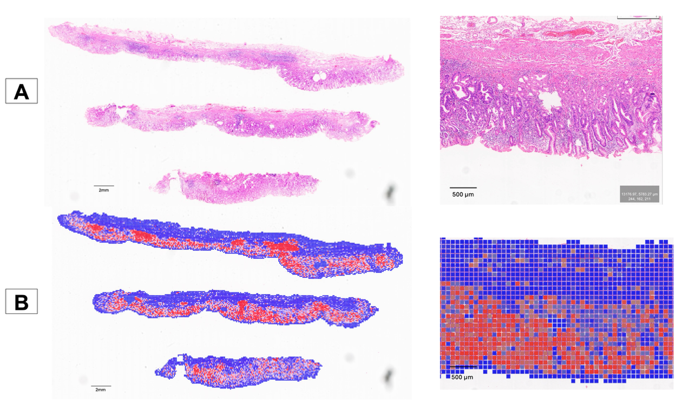
Figure 1. Heatmap visualization of tumor detection model on external validation HiESD dataset. A. H&E slide showing the tumor area. B. Model automatically detects the tumor area, visualized in red (Heatmap).

