Isoliquiritigenin Ameliorates Parkinson’s Disease via Gut Microbiota Remodeling: Potential Mediating Role of Parabacteroides distasonis

Mengyun Li^{1†}, Xiaobing Zhang^{1†}, Jiafeng Lu², Junjie Xiang³, Jie Wu³, Matao Zheng⁴, Siwei Yang³, Lingyan He^{5*}, Xian Shao ^{2*}
¹ Department of Neurosurgery, Shaoxing People’s Hospital, Zhejiang University Shaoxing Hospital, Shaoxing, Zhejiang 312000, China
² Department of Medical Research Center, Shaoxing People’s Hospital, Shaoxing, Zhejiang 312000, China
³ School of medicine, Shaoxing University, Shaoxing, Zhejiang 312000, China
⁴ Second Clinical Medical College, Zhejiang Chinese Medical University, Hangzhou, Zhejiang 310053, China
⁵ Department of Traditional Chinese Medicine, Shaoxing People’s Hospital, Shaoxing, Zhejiang 312000, China

† These two authors contributed equally to this work.
*Corresponding authors at: Department of Medical Research Center, Shaoxing People’s Hospital, No. 568, Zhongxing North Road, Shaoxing, 312000, P. R. China
E-mail address: rmyy03575@usx.edu.cn (X. Shao) and Lingyanh_1223@usx.edu.cn (L. He).

Supplementary Figure legends
Supplementary Figure 1. ISL alone does not alter locomotor behavior or TH-related pathology. (A) Representative movement tracks in the open field test. Quantification of total distance (B) and average velocity (C) in the open field test; (n=6). (D) Forelimb grip strength test;(n=6). (E) Western blot of TH in the striatum. (F) Quantification of TH protein expression normalized to GAPDH; (n=3). Data are shown as mean ± SEM. *p<0.05, **p<0.01, ***p<0.001, ****p<0.0001; ns: not significant.

Supplementary Figure 2. Tight-junction proteins in the colon. (A) Western blot of Occludin in the colon. (B) Quantification of Occludin protein expression normalized to GAPDH; (n=3). (C) Western blot of Claudin1 in the colon. (D) Quantification of Claudin1 protein expression normalized to GAPDH; (n=6). Data are presented as mean ± SEM. *p<0.05, ***p<0.001.

Supplementary Figure 3. P. distasonis improves dopaminergic neuron loss in a dose-dependent manner. (A) Western blot of TH in the striatum. (B) Quantification of TH protein expression normalized to GAPDH; (n=6). Data are presented as mean ± SEM. *p<0.05, ***p<0.001, ****p<0.0001.

Supplementary Figure 4. 16S rRNA gene sequencing of the gut microbiota in mice after administration of P. distasonis. (A) Alpha diversity analysis using Simpson index; (n=6). Violin plots with median line; Kruskal–Wallis test. ns: not significant. (B) PCoA of β-diversity. (C) Heatmap of genus level microbial abundance.

Supplementary Figure 5. P. distasonis treatment reshapes serum metabolomic profile in MPTP-induced mice. (A) PLS-DA plot shows distinct clustering between P. distasonis-treated and MPTP groups, indicating significantly altered serum metabolite profiles. (B) Volcano plot of differential metabolites between P. distasonis and MPTP groups. Pink and blue dots represent significantly upregulated and downregulated metabolites, respectively. (C) Heatmap of representative differential metabolites. Red indicates higher abundance, blue indicates lower abundance. (D) KEGG pathway enrichment analysis of differential metabolites reveals enrichment in ferroptosis, efferocytosis, bile secretion, ABC transporters, and amino acid metabolism.

Supplementary Figure 1.
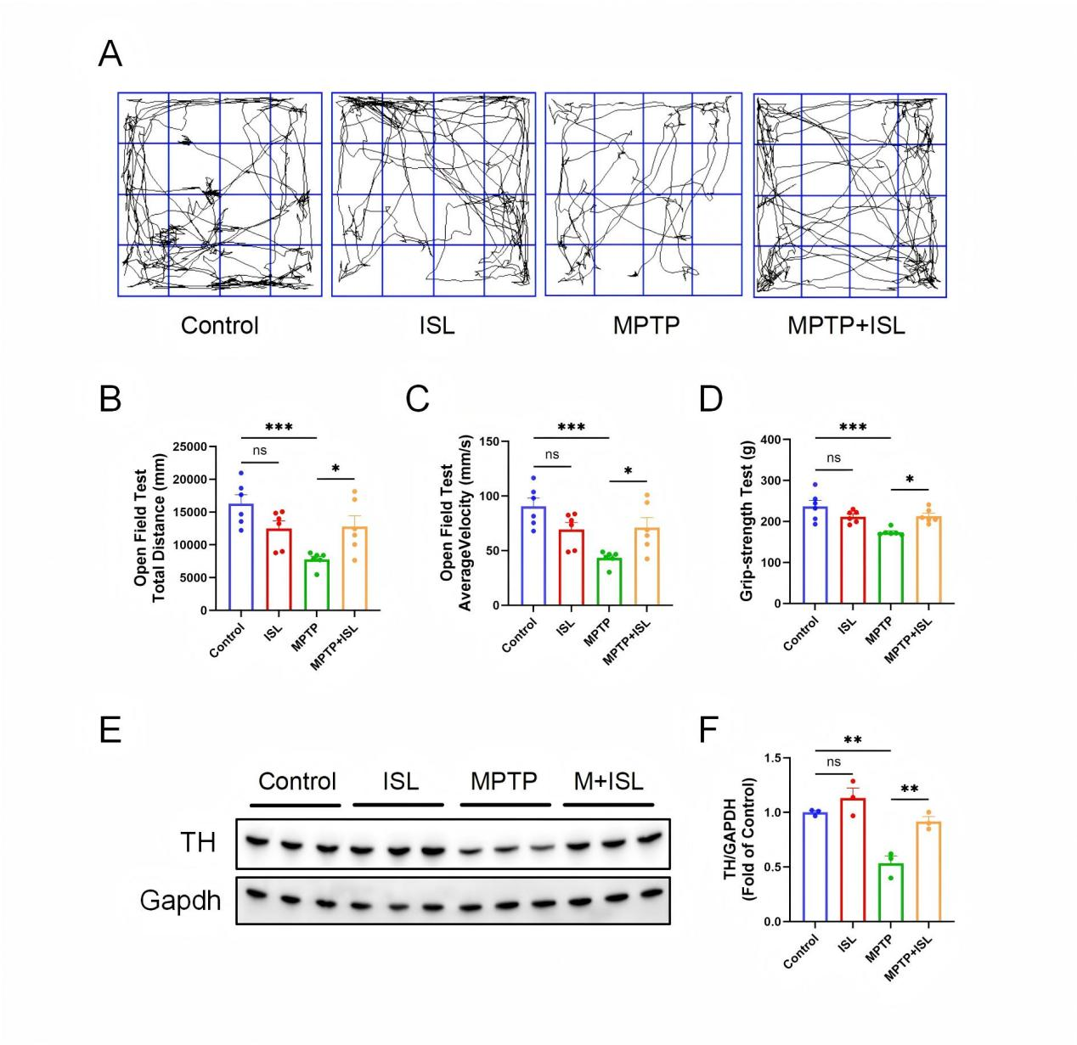

Supplementary Figure 2.
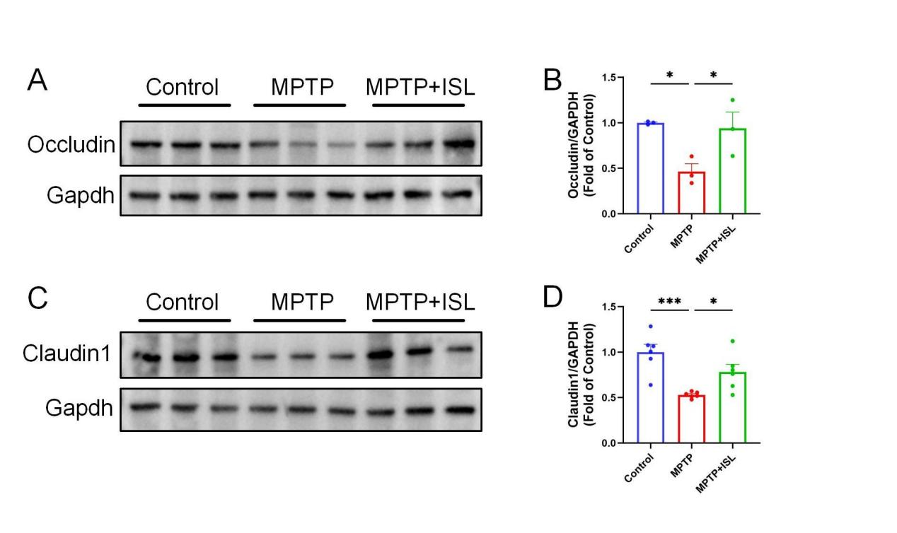

Supplementary Figure 3.
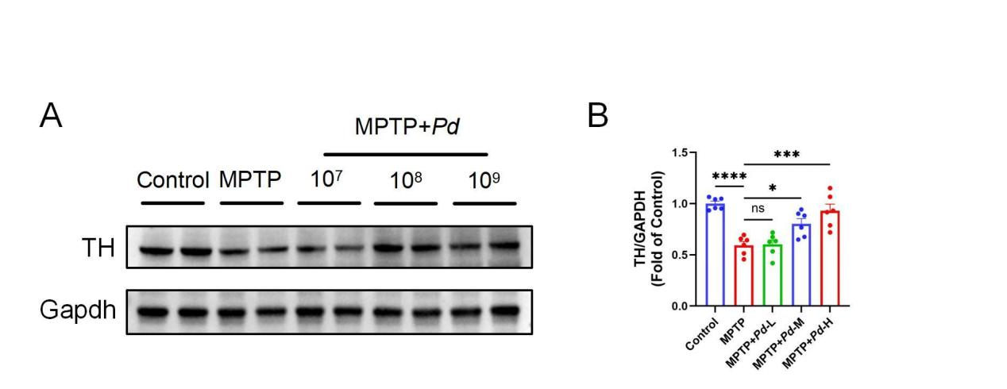

Supplementary Figure 4.
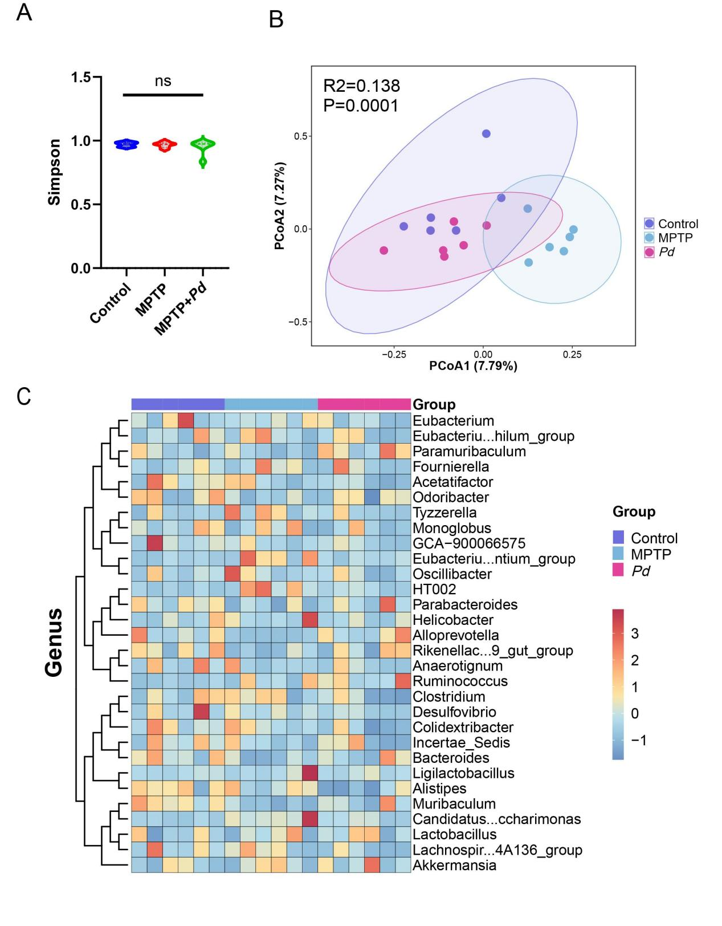

Supplementary Figure 5.
