Title: IL-1β–induced STAT3 activation drives IL-17–producing CD8⁺ tissue-resident memory T cells and exacerbates chronic psoriasis
TaeHo Kim, Chae Rim Lee, Seon-Yeong Lee, A Ram Lee, Young Joon Lee, Chul-Hwan Bang and Mi-La Cho

Supplemental Methods

Animals
10-week-old male Balb/c (Balb/cAnNCrlCrlj) were obtained from Orient Bio Inc. Gyeonggi-do, South Korea, and IL-1Receptor antagonist KO mouse (Balb/c background, obtained from the Pohang University of Science and Technology) were bred and housed under specific pathogen-free conditions. All experimental procedures were approved by the Institutional Animal Care and Use Committee (IACUC), Department of Laboratory Animals, College of Medicine, Catholic University of Korea, and complied with the guidelines of the National Institutes of Health. (Permit Number: 2023-0110-04)

Psoriasis Induction and Treatment Administration
Psoriasis was induced by 5% Imiquimod (NDC 45802-368-62, Dong-A ST, Seoul, South Korea) in 10-week-old male Balb/c, IL-1Receptor antagonist KO mouse by topical treatment on whole back skin to compare disease activity. In the case of acute psoriasis model, 62.5mg of imiquimod is applied continuously for 6 days starting the day after shaving and sacrificed on the 7th day. In the case of chronic psoriasis model, 62.5mg of imiquimod is applied for 6 consecutive days after shaving, and the recovery process is performed without any treatment for 14 days. After 14 days, 62.5mg of imiquimod is again applied for 6 consecutive days and sacrificed on the 28th day. Phosphorylated STAT3 inhibitor, STA21(SML2161-5MG.Sigma-Aldrich, Missouri, USA) was injected intraperitoneally at a concentration of 0.5 mg/kg three times a week from 7 days during the recovery period of the chronic psoriasis model until the sacrifice schedule. We conducted six psoriasis animal model experimental groups: Control (WT), Acute model of Balb/c, Chronic model of Balb/c, Acute model of IL-1RaKO, Chronic model of IL-1RaKO and STA21 with chronic IL-1RaKO psoriasis model, each group consisted of n=5 samples and was repeated 3 times. During in vivo experiments, blinding was carefully ensured by labeling cage groups with numbers known only to one investigator within each pair. This partial blinding strategy, together with both investigators jointly performing psoriasis induction and drug administration, was implemented to minimize observer bias and promote consistency and reliability in outcome evaluations across all experimental groups.

Clinical assessment of psoriasis
The clinical score of the psoriasis mouse model is measured similarly to the phenotype of an actual patient. Clinical indicators briefly consist of redness, scaling, and thickness, and each indicator is defined as a PASI score. The score range is evaluated on a scale of 0-4. As follows: 0, no psoriatic phenotype, 1, Mild red and ~1mm thickness on back skin, 2, Medium red and visible ridges and 1~2mm thickness and flaking along crevices occurrence on back skin, 3, Medium dark red and visible ridges are loose and >2mm thickness and moderate flaking a large surface area on back skin, 4, Severe dark red and visible ridges are tight and severe flaking a large surface area. Psoriatic PASI scores are defined as naked measurements for each index and were measured by two independent observers. Two observers independently assessed the scores, with only one aware of group allocations, and the final score was determined by averaging both evaluations to enhance accuracy and reduce bias.

Preparation of Single-Cell Suspensions from Mouse Skin
Mouse dorsal skin was harvested, washed with ice-cold PBS, and finely minced. The minced tissue was digested in 10 mL serum free RPMI1640 medium (Thermo Fisher, Cat. No. 11875093) containing Dispase II (1 mg/mL, Sigma-Aldrich, Cat. No. D4693-1G), Collagenase Type IV (2 mg/mL, Gibco, Cat. No. 17104-019 1g), and DNase I (50 µg/mL, Sigma-Aldrich, Cat. No. 11284932001) at 37°C with shaking at 200 rpm for 60 minutes. The digestion was monitored periodically for completeness. Following digestion, 10 mL of ice-cold PBS was added, and the cell suspension was centrifuged at 1500 rpm for 5 minutes at 4°C. The supernatant was discarded, and the pellet resuspended in 10 mL ice-cold PBS and centrifuged again under the same conditions. The final cell pellet was passed through a 70 µm cell strainer and subsequently through a 40 µm cell strainer to obtain a single-cell suspension.
Histopathological analysis
After sacrificing the acute and chronic psoriasis mouse models (Acute: 1 week; 7 days, Chronic: 4 weeks: 28 days), their spleen and skin tissues were dissected out, immediately fixed with 10% formalin for 2 days, and embedded in paraffin. Embedded skin blocks were sectioned at 5-μm thickness using a microtome (Leica Biosystems, Seoul, South Korea), and basic staining was performed with Hematoxylin (S2-5, Youngdong Pharmaceutical Co., Ltd. South Korea.) and Eosin (32002. MUTO PURE CHEMICALS CO., LTD, Tokyo, JAPAN) (H&E). The histological score was determined by taking three pictures per slide of the average area of ​​stained skin tissue, measuring the thickness of the epidermis 6 times, and averaging it to define the histological score.

Phenotypic profiling of tissue-resident memory CD8⁺ T cells (Confocal Microscopy)
Spleen and skin tissue embedded in paraffin was sectioned at 5 μm. To stain specific tissue resident memory CD8 T cells in spleen and skin tissue. Stained tissues were analyzed using a confocal microscope (LSM700 and LSM900w/AiryscanII, Carl Zeiss, Germany). Quantitative analysis of the expression pattern of each marker in skin tissue and merged cells where dermis-epidermis is connected was conducted through cell count using ZEISS ZEN Microscopy Software.
Marker (Primary Ab) | Company | Catalog No. | 2nd Antibody fluorochrome
anti-CD8 | Novus Biologicals | NBP1-49045 | FITC
anti-CD103 | R&D Systems | AF1990 | PE
Anti-IL-17 | Abcam | ab79056 | APC
Anti-SOCS3 | Abcam | ab236519 | APC
Anti-Phospho-NF-κB p65 Serine 536 | Cell Signaling Technology | #3033S | APC
Anti-Phospho-STAT3 Tyrosine 705 | Abcam | ab76315 | APC
Anti CD69 | Invitrogen | 12-0691-82 | PE
Anti CXCR6 | Invitrogen | 151104 | PE
4′,6-diamidino-2-phenylindole (DAPI) | Invitrogen | D3571 | DAPI

Immunohistochemistry (IHC)
Paraffin embedded skin and spleen tissue was sectioned at 5 um thickness, and primary monoclonal antibodies 18hours (Over Night, ON) incubation was carried out. Incubating the secondary antibody against the primary antibody was performed for 30 minutes at room temperature using Dako Envision+ System- HRP Labelled Polymer Anti-Rabbit. Afterwards, positive cells were confirmed using DAB substrate system. Afterwards, two pictures were taken per stained slide (400x), and quantitative analysis was performed by counting positive cells at the average position where the epidermis and dermis are connected using image J.
Marker (Primary Ab) | Company | Catalog No. | 2nd Antibody
anti-CD8 | Biosciences | BS-0648R | Anti-Rabbit
anti-IL 17 | Abcam | ab79056 | Anti-Rabbit
anti-SOCS3 | Abcam | ab236519 | Anti-Rabbit
Anti-phospho-NF-κB p65 Serine 536 | Cell Signaling | #3033S | Anti-Rabbit
Anti-Phospho-STAT3  Tyr705 | Abcam | ab76315 | Anti-Rabbit

Western blot (WB)
The spleen in the psoriasis-induced mouse model (Acute, Chronic) was ground and separated into single cells, and protein lysate was prepared by diluting it in 50µl of RIPA Lysis and Extraction Buffer (89901, Illinois, ThermoFisher Scientific, USA). Protein concentration was quantified using bicinchoninic acid assay (23235; Illinois, ThermoFisher Scientific). Quantified protein samples were separated on 10-12% sodium dodecyl sulfate-polyacrylamide gels and transferred to nitrocellulose membranes (Amersham Pharmacia, Uppsala, Sweden). Primary antibodies: pSTAT3 Y705, pSTAT3 s727, STAT3, pNF-κB p65 s536, NF-kB, SOCS3, IRAK4 and GAPDH were diluted in 0.4% skim milk in 1X Tris-buffered saline plus Tween-20 (TBS-T). and incubated for 35 minutes at room temperature. After the incubating, 1X TBS-T wash was performed, and horseradish peroxidase-conjugated secondary antibody was used to incubated for 20 minutes at room temperature using SNAP i.d. (Protein Detection System; Merck Millipore, Danvers, MA, USA). Band visualization for each target was carried out through image development and quantitative graph was produced with the primary target/ GAPDH after quantifying the band signal through image J.
Marker (Primary Ab) | Company | Catalog No. | 2nd Antibody
Anti- Phospho-STAT3 serine727 | Cell Signaling | #9134 | Anti-Rabbit
Anti-Phospho-STAT3 tyrosine 705 | Cell Signaling | #9131 | Anti-Rabbit
anti-STAT3 | Cell Signaling | #9139 | Anti-Mouse
Anti-phospho-NF-κB p65 serine 536 | Cell Signaling | #3033S | Anti-Rabbit
anti-NF-κB | Abcam | ab16502 | Anti-Rabbit
anti-SOCS3 | Abcam | ab236519 | Anti-Mouse
STAT5 | Cell Signaling | 94205S | Anti-Rabbit
Anti-phospho-STAT5 tyrosine 694 | Cell Signaling | 9359S | Anti-Rabbit
anti-IRAK4 | Cell Signaling | 4363S | Anti-Rabbit
anti-GAPDH | Abcam | ab181602 | Anti-Rabbit

Flow cytometry (FACs)
The blood, spleens and skins of animal models with induced acute and chronic psoriasis were ground, separated into single cells, and seeded at 1x10⁶ per well (24well). After seeding, it was incubated with PMA (P8139, Sigma-Aldrich, Germany) and Ionomycin (I0634, Sigma-Aldrich, Germany) for 4 hours Stained cells were analyzed by flow cytometry using FORTESSA (BD Biosciences, San Jose, CA, USA).
Target cell | Marker | Fluorochrome | Company | Catalog No.
effector T | CD4 | PerCP-Cy5.5 | BD Biosciences | 45-0042-82
effector T | CD8 | PB 450 | BD bioscience | 566096
effector T | IFNγ | APC | BioLegend | 557649
effector T | IL-17 | FITC | BioLegend | 506910
effector T | IL-4 | PC7 | eBioscience | 25-7041-82
Treg | CD4 | PerCP-Cy5.5 | BD Biosciences | 45-0042-82
Treg | FoxP3 | PE | eBioscience | 12-5773-82
Treg | CD25 | APC | BioLegend | 102012
TRM | CD4 | PerCP-Cy5.5 | BD Biosciences | 45-0042-82
TRM | CD8 | PB 450 | BD bioscience | 566096
TRM | CXCR6 | APC | BioLegend | 151106
TRM | CD103 | APC-A700- | eBioscience | 56-1031-82
TRM | CD103 | PE | BioLegend | 121406
TRM | CD69 | PE | eBioscience | 12-0691-82
TRM | IFNγ | APC | BD Biosciences | 557649
TRM | IL-17 | FITC | BioLegend | 506910
Central memory and Effector memory | CD8 | PB 450 | BD bioscience | 566096
Central memory and Effector memory | CCR7 | PE | eBioscience | 12-1971-82
Central memory and Effector memory | CD62L | FITC | eBioscience | 11-0621-82
Central memory and Effector memory | IFNγ | APC | BioLegend | 557649

In vitro evaluation of CD8⁺ T cell response
CD8⁺ T cells were isolated from splenocytes of IL-1RaKO mice using CD8a (Ly-2) MicroBeads (130-117-044; Miltenyi Biotec, North Rhine-Westphalia, Germany).

In vitro evaluation
Splenocytes or isolated CD8 T cells from IL-1RaKO mice were cultured and stimulated for 72 h with Resiquimod (SML0196-50MG; Sigma-Aldrich; 200 ng/mL), IL-1β (401-ML; R&D Systems; 10 ng/mL), and IL-6 (406-ML-025; R&D Systems; 10 ng/mL) to induce psoriatic phenotypes via IL-1 signaling. To inhibit STAT3 hyperactivation, cells were treated with STA-21 (5 µM). After stimulation, both cells and culture supernatants were collected for transcriptional and protein expression analyses.

Patient-derived specimens analysis
PBMCs(n=6) were isolated from anticoagulated whole blood samples of psoriasis patients (n=6, Mean PASI ≥ 15, body surface area >10%) treated at St. Mary’s Hospital Seoul, Republic of Korea (KC17TNSI0237). Isolation was performed using Ficoll-Paque PLUS density gradient centrifugation (#17-1440-03; Cytiva, MA, USA). Freshly isolated PBMCs were subjected to immunophenotyping for characterization of disease-associated immune cell profiles. Skin biopsy samples were collected from psoriatic lesions of patients (Moderate to severe psoriasis: n=4, PASI 10–12; severe psoriasis: n=5, PASI 16–24). Healthy control skin samples (n=1) were also included, who underwent diagnostic skin biopsies at St. Mary’s Hospital in Seoul, Republic of Korea (KC25SISI0528). Patient samples were meticulously selected by dermatologist based on disease severity, while flow cytometric and histological analyses were conducted independently without knowledge of patient identities to minimize bias. Confirmation of patient information was performed solely by dermatologist after data analysis to preserve the integrity of the blinded assessment. All procedures performed in studies involving human participants were in accordance with the ethical standards of the institutional and/or national research committee and with the 1964 Helsinki declaration and its later amendments or comparable ethical standards.
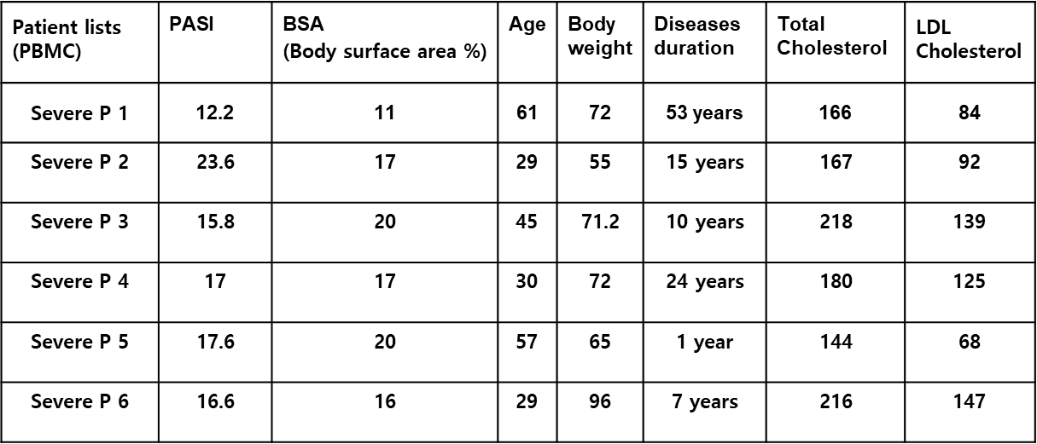
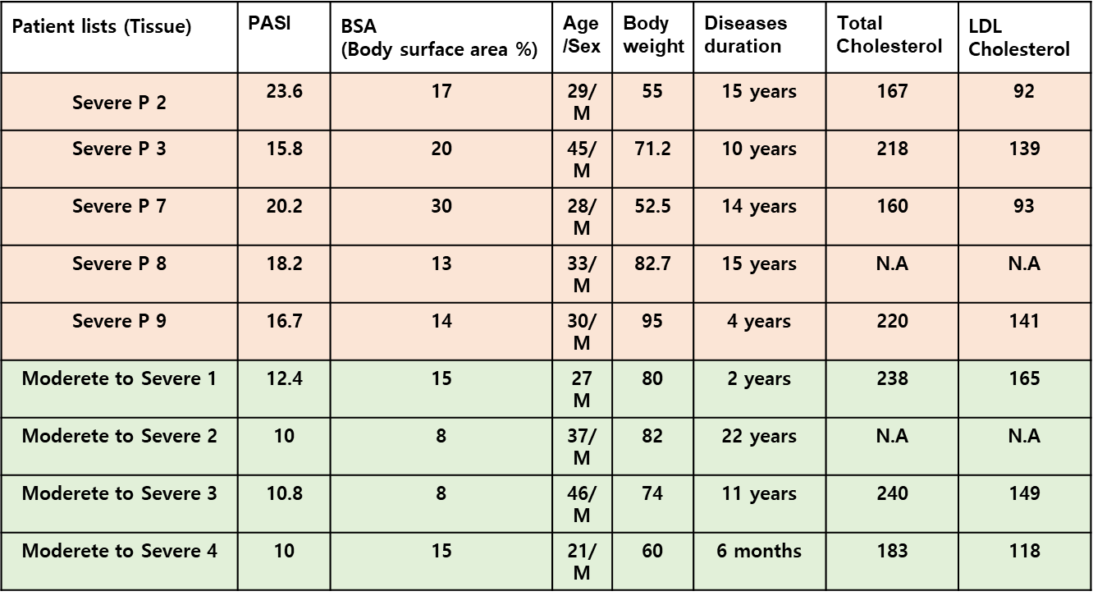
Patients FACs table
Target cell | Marker | Fluorochrome | Company | Catalog No.
effector T | CD4 | PC7 | BioLegend | 300512
effector T | CD8 | APC-A750 | BD Biosciences | 557834
effector T | IFNγ | ECD | BD Biosciences | 562392
effector T | IL-17 | APC | ebioscience | 17-7179-42
TRM | CD4 | PC7 | BioLegend | 300512
TRM | CD8 | APC-A750 | BD Biosciences | 557834
TRM | CD103 | PE | eBioscience | 56-1031-82
TRM | CD69 | FITC | ebioscience | 11-0699-42
TRM | IFNγ | ECD | BD Biosciences | 562392
TRM | IL-17 | APC | ebioscience | 17-7179-42
Central memory and Effector memory | CD8 | APC-A750 | BD Biosciences | 557834
Central memory and Effector memory | CCR7 | Alexfluor 700 | BD Biosciences | 561143
Central memory and Effector memory | CD45RA | BV510 | BD Biosciences | 563031

Statistical analysis
Statistical analyses were performed using GraphPad Prism 8. Two-tailed p-values less than 0.05 were considered statistically significant. For comparisons involving more than two groups, two-way ANOVA was performed, followed by Bonferroni test to adjust for multiple comparisons. For non-parametric multiple-group comparisons, the Kruskal–Wallis test was used with Dunn’s post hoc correction. Two-group comparisons were conducted using the Mann–Whitney U test. Statistical significance was indicated as*P < 0.05, **P < 0.01, ***P < 0.001, and ****P < 0.0001.

