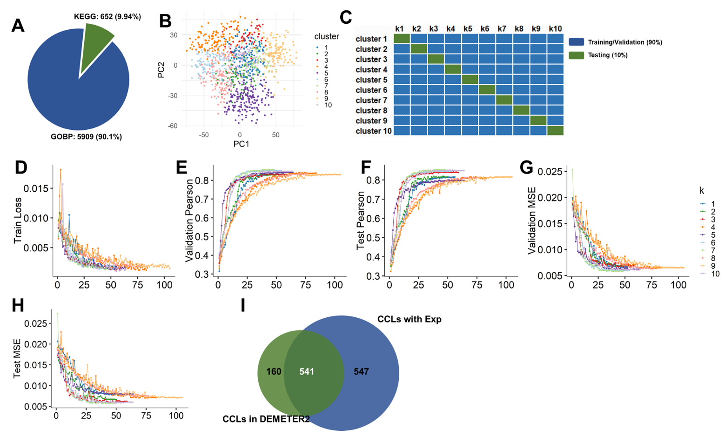
Supplementary Figure 1 Overview of gene set composition, clustering, model training, and dataset coverage
A, Distribution of curated gene sets used in GSVA feature construction. KEGG pathways and Gene Ontology Biological Processes (GOBP) comprise the majority of included gene sets, reflecting a focus on functionally annotated biological processes.
B, Results of k-means clustering (k = 10) based on GSVA-derived pathway activity scores across 1,088 cancer cell lines. Each color represents a distinct molecular subtype used for downstream leave-one-out cross-validation (LOOCV) and subtype-specific analysis.
C, Schematic illustration of the LOOCV procedure. In each iteration, one sample is held out for testing while the remaining samples are used for model training, enabling robust assessment of generalization across molecular subtypes.
D–H, Training curves of the GATDep model across five representative folds during 10-fold cross-validation. Each plot shows the dynamics across epochs, illustrating model convergence and early stopping behavior.
I, Coverage of cell lines with available gene expression data within the DEMETER2 project. The intersection with the DepMap expression dataset supports cross-platform validation and model applicability to alternative CRISPR screening resources.

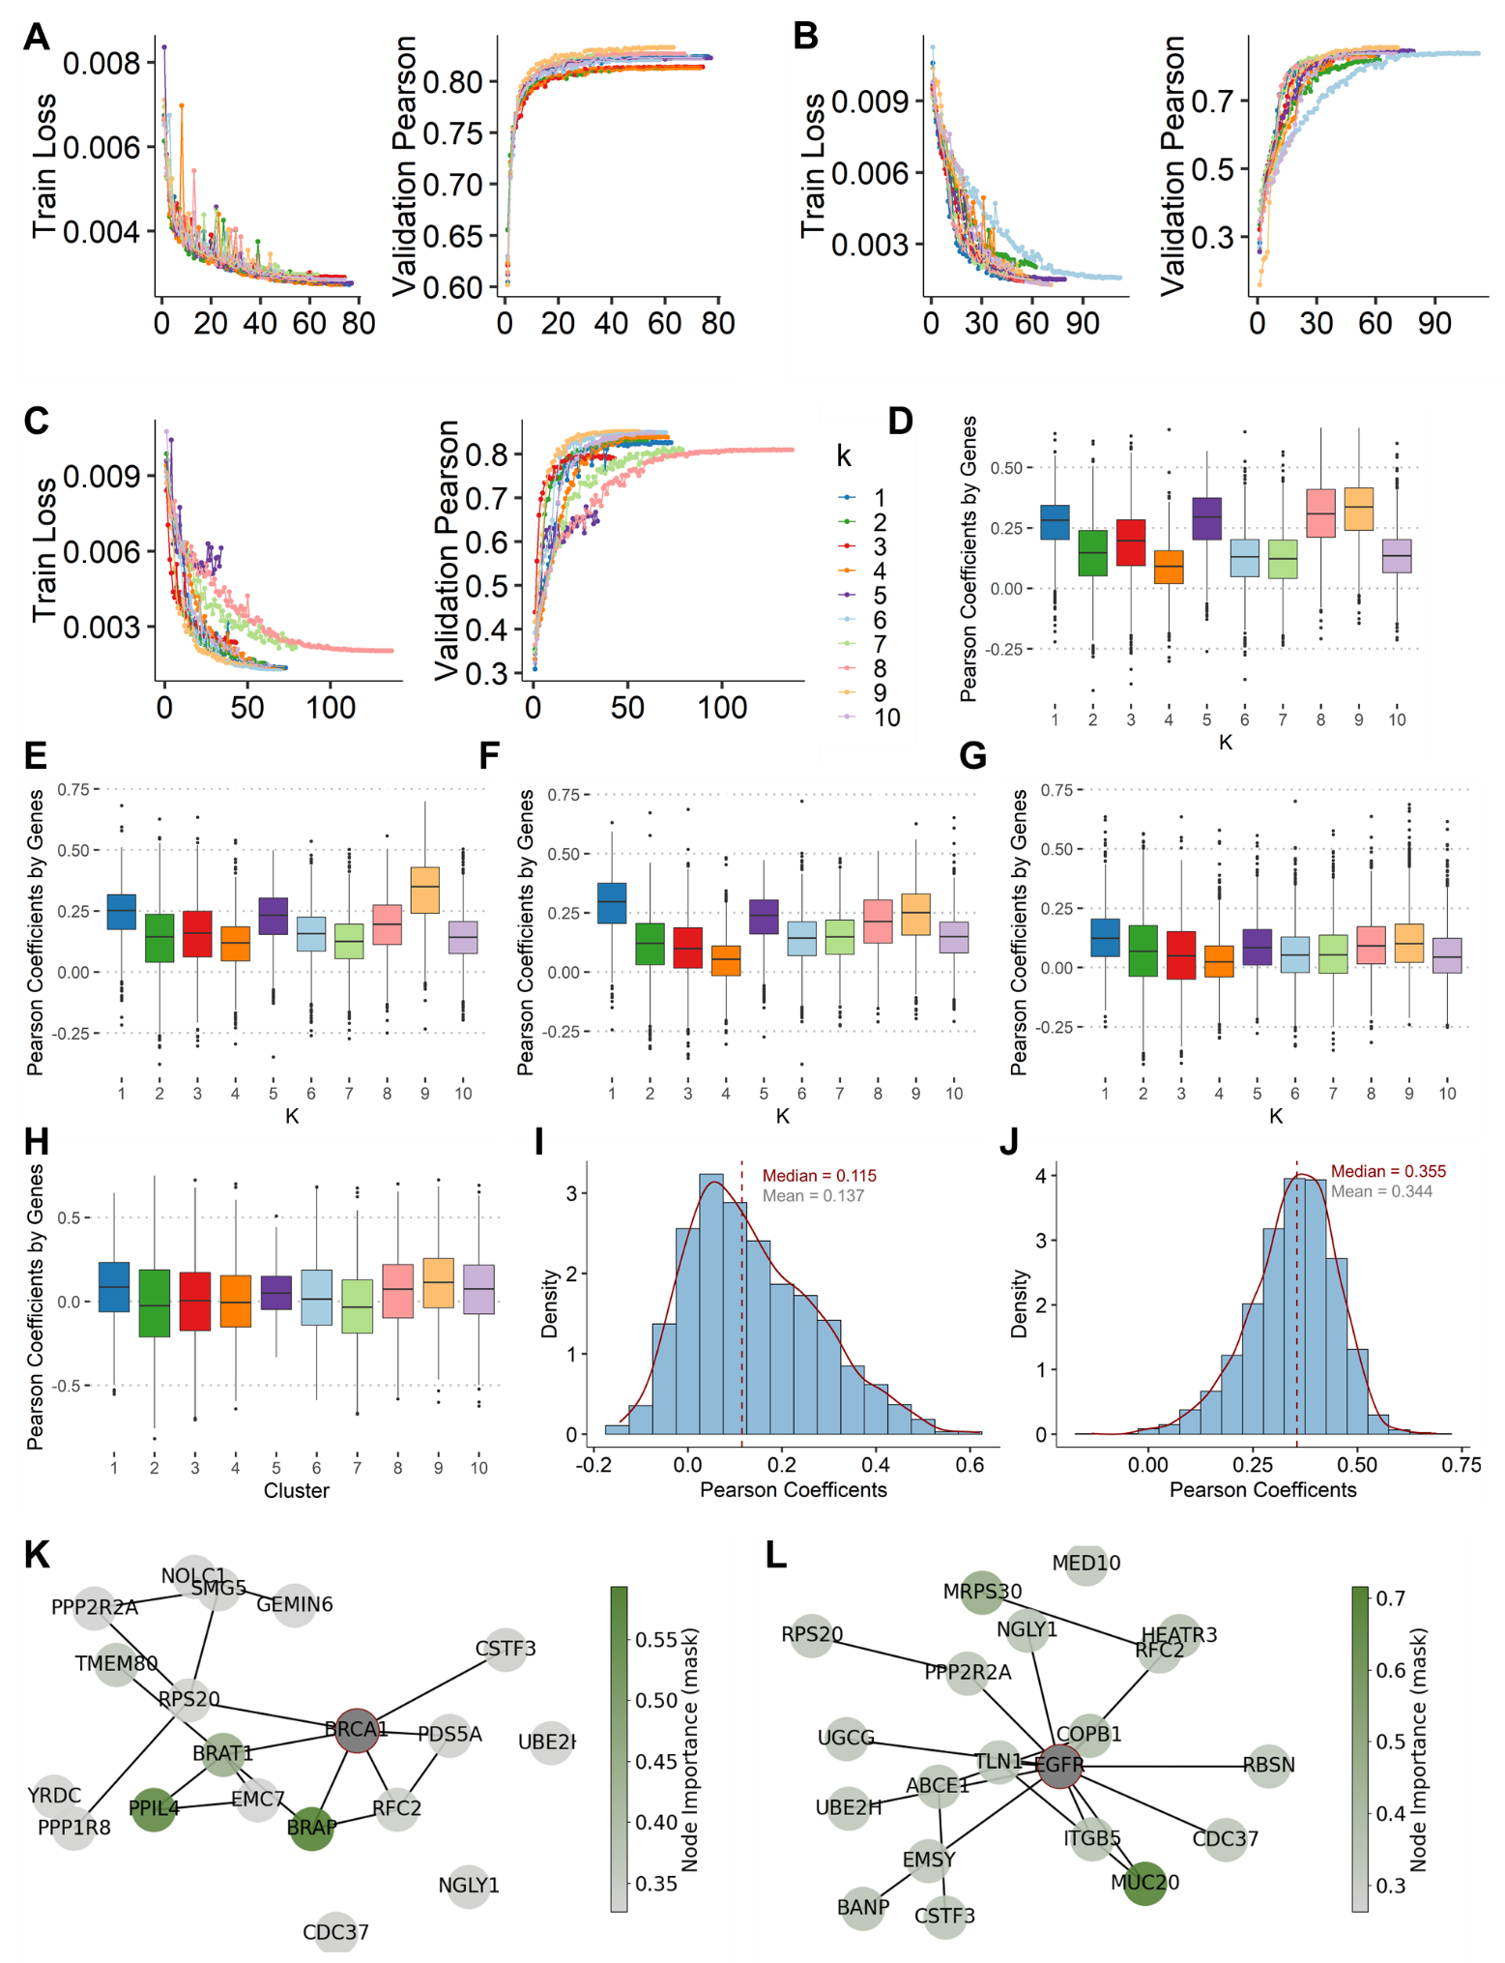
Supplementary Figure 2 Benchmarking performance of GATDep and comparative models across multiple configurations and evaluation settings
A, Training dynamics of the DNN model across 10 folds, showing convergence of training loss (left) and increase in validation Pearson correlation (right), indicating stable model fitting.
B, Performance curves of the GAT_EXP_MUT model (transcriptome + mutation input), depicting fold-wise training loss and validation Pearson correlation across epochs.
C, Training performance of the GAT_EXP_MUT_CNV model (transcriptome + mutation + CNV input), showing moderate improvement in validation metrics over time.
D–H, Gene-level Pearson correlation distributions between predicted and true dependency scores in the test sets during 10-fold cross-validation:
D, GAT_EXP model (expression-only);
E, GAT_EXP_MUT model;
F, GAT_EXP_MUT_CNV model;
G, DNN baseline model.
H, DeepDR model
Each boxplot summarizes fold-wise variation in gene-level prediction accuracy, with results grouped by validation fold (k = 1 to 10).
I, Distribution of gene-wise Pearson correlation coefficients across 1,298 genes predicted by the DeepDEP model, showing a mean of 0.137 and median of 0.115.
J, Distribution of Pearson correlations across 2,350 genes predicted by the GATDep model, demonstrating improved overall performance with a mean of 0.344 and median of 0.355.
K, GNNExplainer-derived subgraph illustrating key contributors to BRCA1 dependency prediction in a representative cell line. Edge structure and node coloring reflect contextual importance in model decision-making.
L, Interpretable dependency subnetwork centered around EGFR, with highlighted interacting nodes contributing to the dependency score. Node intensity indicates relative feature importance derived from GAT attention and explanation mask.

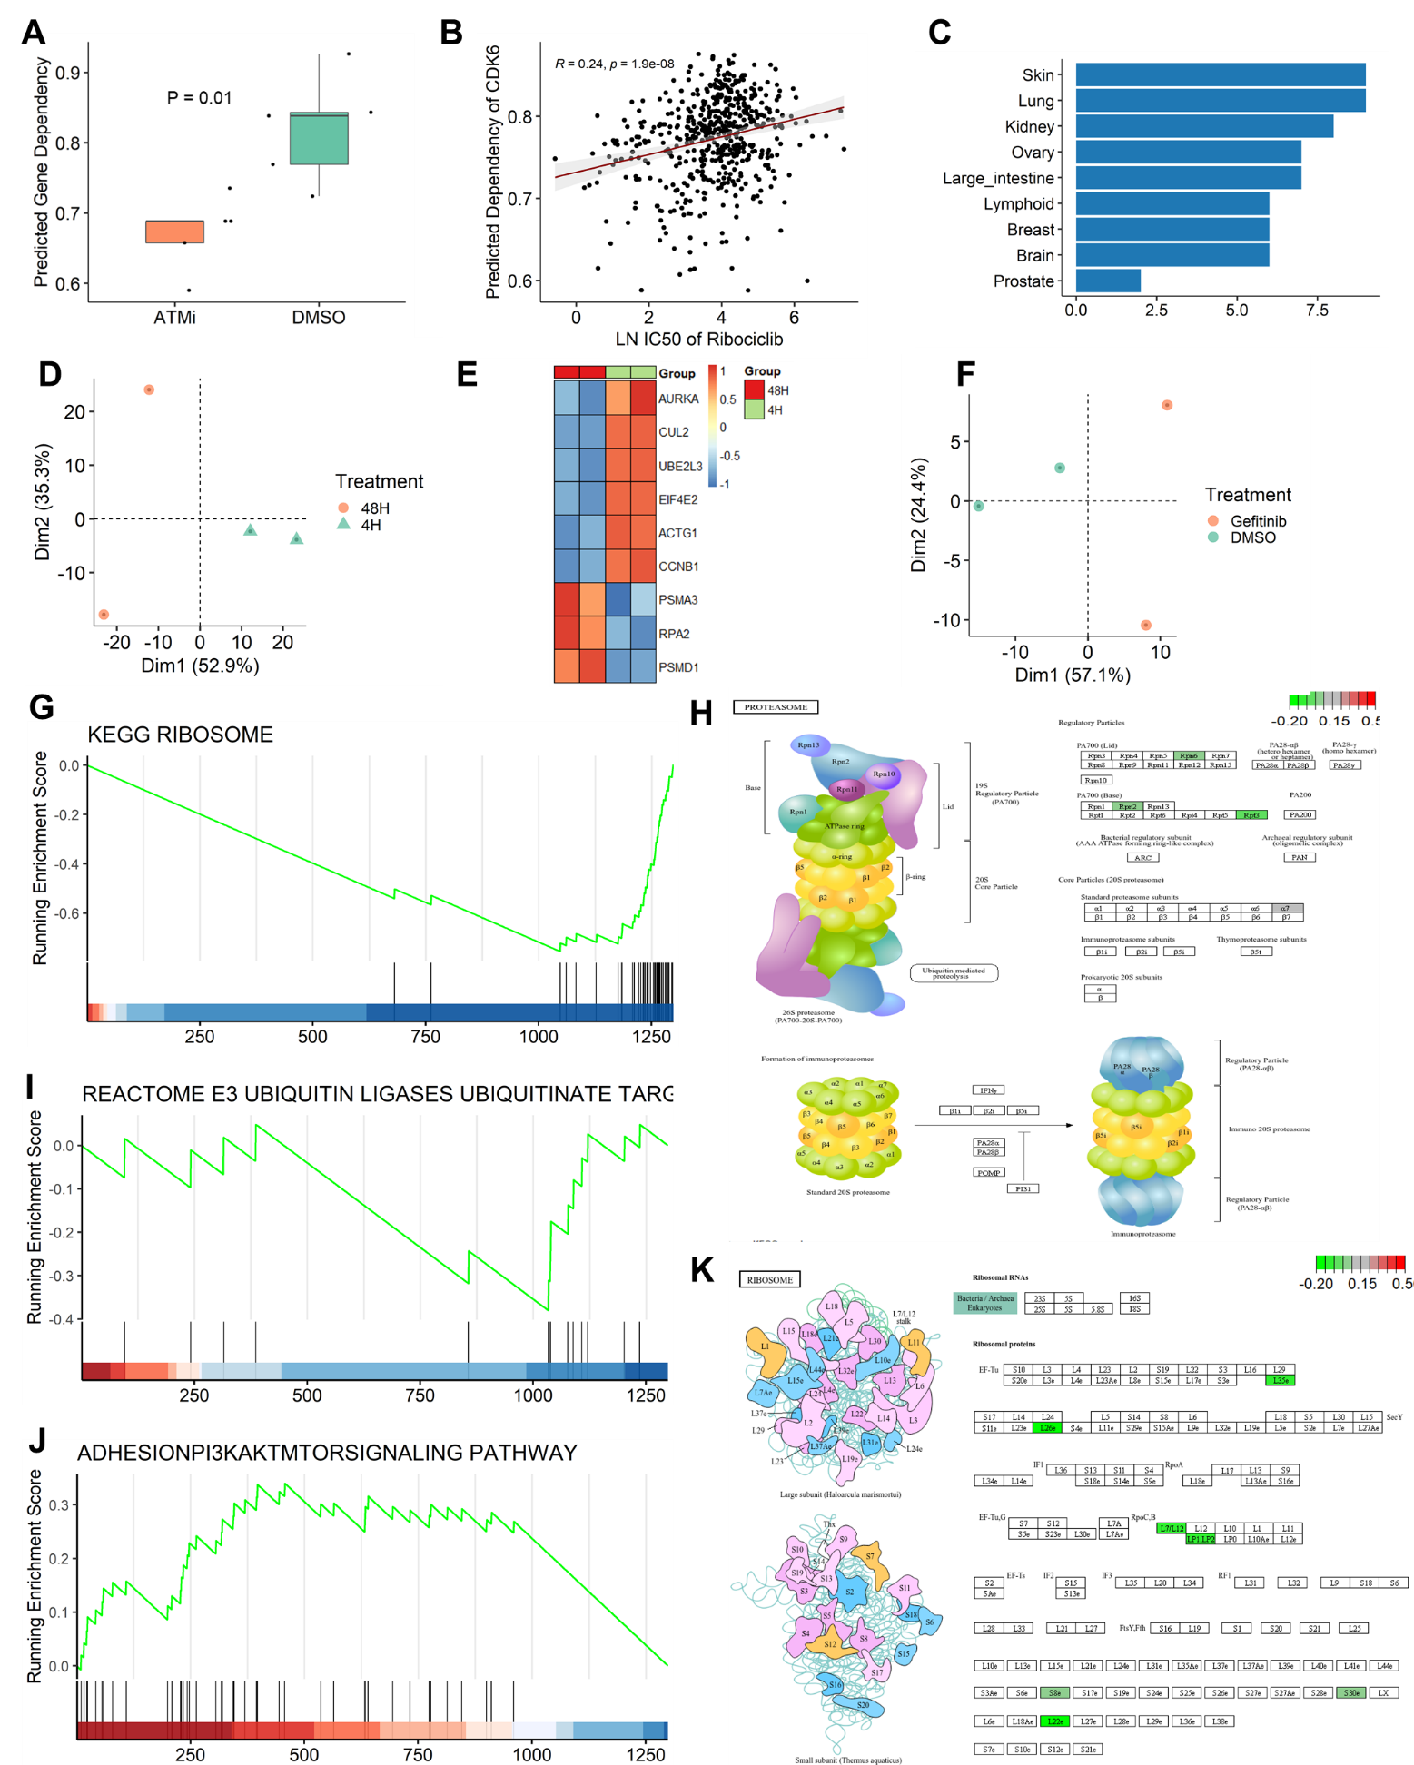

Supplementary Figure 3 Functional profiling of drug-induced gene dependency changes and enriched biological pathways.
A, PRDX1 predicted gene dependency scores significantly decreased upon ATM inhibitor (ATMi) treatment compared to DMSO control, indicating enhanced reliance on PRDX1 under ATM inhibition (P = 0.01).
B, Across 523 cancer cell lines, the predicted dependency score of CDK6 exhibits a significant positive correlation with the natural log-transformed IC50 of Ribociclib (a CDK4/6 inhibitor), suggesting functional relevance of the model’s dependency output in predicting drug sensitivity (Pearson r = 0.24, p = 1.9×10⁻⁸).
C, Tumor type distribution of 60 cell lines curated from DrugComb for drug perturbation studies, highlighting representation across major cancer types such as skin, lung, and kidney cancers.
D, Principal component analysis (PCA) of transcriptomic profiles from K562 cells treated with Vorinostat for 4 and 48 hours reveals clear separation along Dim1, indicating time-dependent transcriptional reprogramming.
E, Heatmap of gene dependency scores after 48-hour Vorinostat treatment in K562 cells. Notably, multiple genes involved in the ubiquitination and proteasome pathways (e.g., UBE2L3, CUL2, ACTG1) show increased dependency, suggesting heightened vulnerability.
F, PCA of MDA-MB-231 cells treated with Gefitinib versus DMSO control demonstrates strong transcriptional shift induced by EGFR inhibition (Dim1 = 57.1%).
G, GSEA plot showing that Vorinostat-induced top dependency genes are significantly enriched in the KEGG Ribosome pathway, reflecting cellular stress and translational vulnerability.
H, Top dependency genes post-Vorinostat treatment also significantly enrich the KEGG Proteasome pathway, implicating protein degradation machinery in drug response adaptation.
I, Enrichment of top-ranked genes in the “E3 Ubiquitin Ligases Ubiquitinate Target Proteins” Reactome pathway, reinforcing the role of proteostasis regulation under targeted therapy.
J, Bottom-ranked dependency genes (less essential under Gefitinib) are enriched in the PI3K-AKT-mTOR signaling pathway, suggesting reduced reliance on this axis under EGFR inhibition context.
K, KEGG pathway visualization of the Ribosome pathway highlights specific ribosomal protein genes (e.g., RPL12, RPLP0, RPS3A) that show elevated dependency scores in the Vorinostat-treated K562 cells, consistent with pathway-level enrichment results.

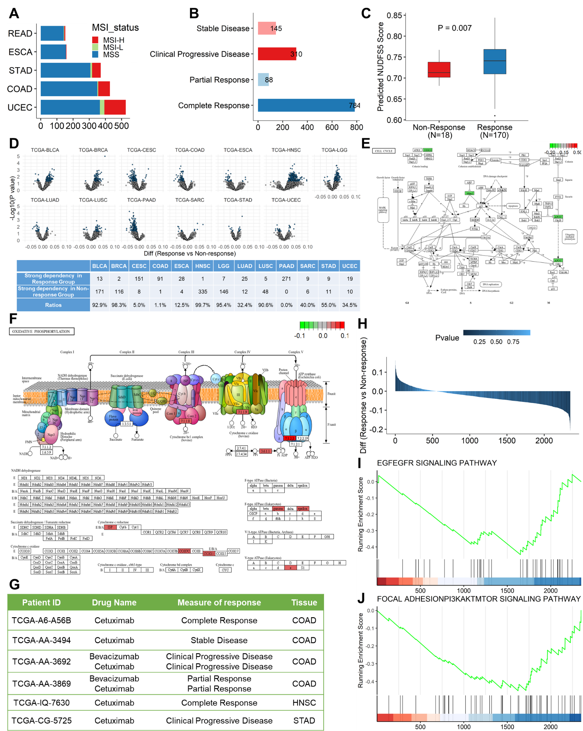

Supplementary Figure 4 Context-specific gene dependency profiles correlate with therapeutic response in TCGA tumors.
A, Distribution of microsatellite instability (MSI) status across five TCGA cancer types, showing subtype-specific prevalence of MSI-H, MSI-L, and MSS classifications, providing a molecular basis for stratifying gene dependency analysis.
B, Summary of chemotherapy response categories in TCGA patients, showing relative proportions of complete response (CR), partial response (PR), stable disease (SD), and progressive disease (PD) in annotated clinical cohorts.
C, Boxplot of NUDFS5 dependency scores in breast cancer (TCGA-BRCA) patients, demonstrating significantly higher scores in non-responders compared to responders, suggesting NUDFS5 as a candidate resistance-associated gene.
D, Tumor type–specific landscape of drug response–associated dependency genes across multiple TCGA cohorts, highlighting the context specificity of gene dependencies in relation to clinical chemotherapeutic sensitivity.
E, KEGG pathway mapping of strong dependency genes associated with treatment response in TCGA-COAD (colon adenocarcinoma) patients. These genes are significantly enriched in the cell cycle pathway, implicating proliferative control mechanisms in treatment efficacy.
F, KEGG pathway mapping of strong dependency genes enriched in oxidative phosphorylation in TCGA-HNSC (head and neck squamous cell carcinoma) patients showing non-response, indicating metabolic vulnerabilities linked to resistance.
G, Clinical profiles of six TCGA patients treated with cetuximab, showing targeted therapy context used to investigate EGFR pathway dependencies.
H, Comparison of gene dependency scores between cetuximab responders and non-responders, identifying predictive markers associated with anti-EGFR treatment outcome.
I, GSEA analysis reveals that top-ranked dependency genes in cetuximab responders are significantly enriched in the EGFR signaling pathway, consistent with known drug mechanisms.
J, Additional GSEA results show enrichment of the PI3K-AKT-mTOR signaling pathway among top dependency genes, suggesting a co-dependency or compensatory mechanism activated under cetuximab treatment pressure.

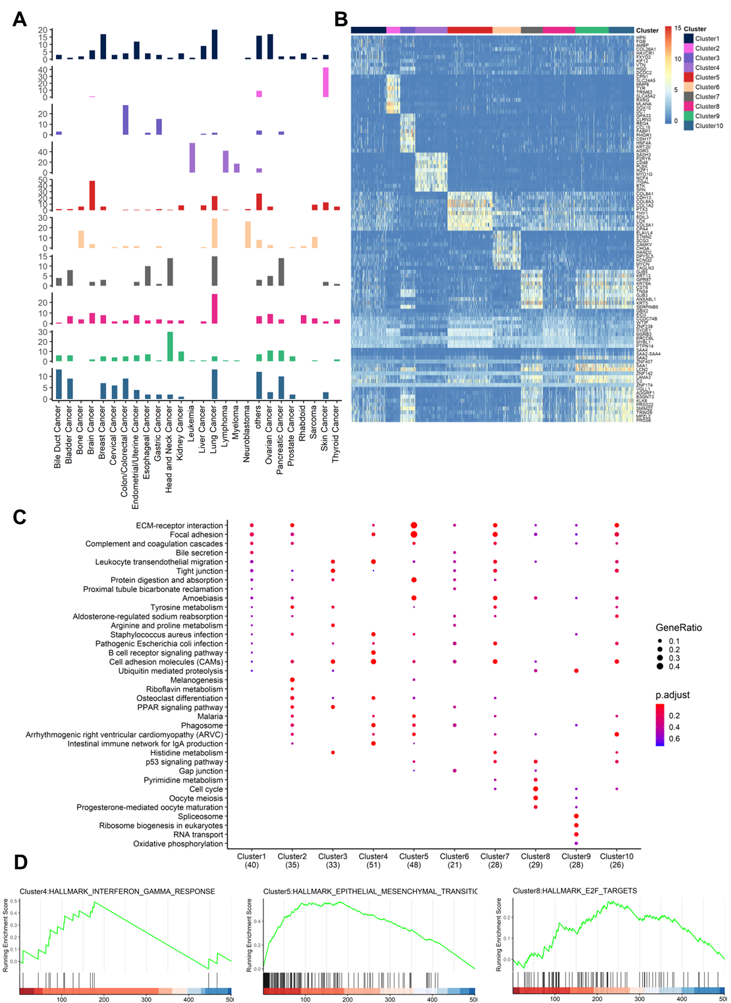
Supplementary Figure 5 Tumor-type composition and functional heterogeneity across 10 cell clusters.
A, Distribution of tumor types across clusters. Distinct clusters were enriched for specific cancer types: Cluster 2 was predominantly composed of skin cancer cell lines, Cluster 3 mainly of colon cancer, Cluster 4 of hematologic malignancies (including leukemia, lymphoma, and myeloma), Cluster 5 of brain cancer, Cluster 6 of lung cancer and neuroblastoma, Cluster 8 of lung cancer, and Cluster 9 of head and neck cancer.
B, Distinct transcriptional programs were observed among clusters. For instance, Cluster 2 exhibited elevated expression of SLC24A5 and SOX10, genes associated with pigmentation and cell proliferation; Cluster 4 was characterized by high expression of immune-related genes such as BTK and CD48; and Cluster 3 showed upregulation of CLRN3 and REG4, which are implicated in intestinal function and inflammatory bowel disease.
C-D, Functional enrichment analyses based on hypergeometric testing and GSEA of cluster-specific upregulated genes further revealed that each cluster displayed unique biological processes and signaling pathways, highlighting the functional heterogeneity across the cellular landscape.

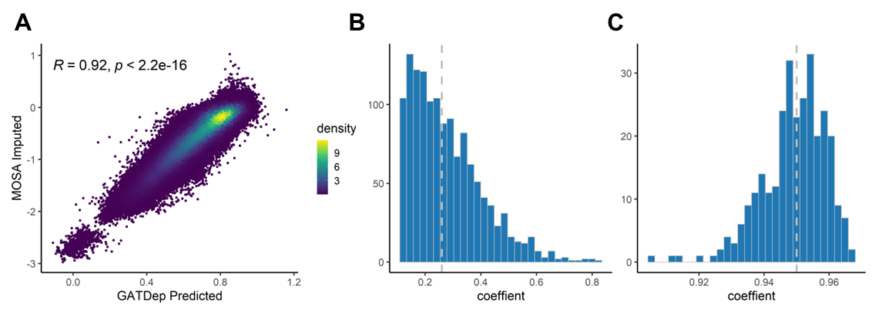
Supplementary Figure 6 Evaluation of the GATDep model using imputed CRISPR dependency data.
A, The GATDep model was applied to predict CRISPR dependency scores across 297 cell lines. A strong overall correlation (R = 0.92) was observed between predicted and observed values, indicating that GATDep accurately captures gene dependency patterns, consistent with the MOSA-imputed results.
B, At the gene level, correlation analysis yielded a median Pearson’s r of 0.26, which is comparable to that observed in the independent test dataset used during model training.
C, Within-sample consistency analysis showed that CRISPR dependency scores derived from GATDep were highly concordant with MOSA-imputed scores, with correlation coefficients exceeding 0.9 (median = 0.95).

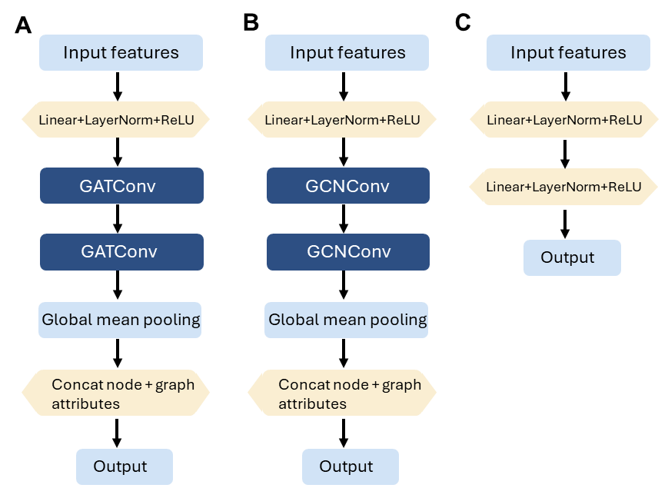
Supplementary Figure 7 Architecture details of GAT/GNN/DNN
A, GATDep first transforms the input GSVA-based pathway features through a linear embedding layer (512 units, LayerNorm, ReLU activation), followed by two stacked graph attention layers (hidden size = 64, heads = 2, dropout = 0.2). Node-level outputs are integrated with global graph embeddings using a mean-pooling operation, and the concatenated features are passed to a regression head to predict individual gene essentiality scores.
B, GCN first transforms the input GSVA-based pathway features through a linear embedding layer (512 units, LayerNorm, ReLU activation), followed by two stacked convolution layers. Node-level outputs are integrated with global graph embeddings using a mean-pooling operation, and the concatenated features are passed to a regression head to predict individual gene essentiality scores.
C, The deep neural network (DNN) model structured as follows: the input features, with a dimension of 6561, are first transformed through a linear embedding layer with 64 units. This is followed by a LayerNorm operation and a Tanh activation function. A dropout layer with a rate of 0.2 is then applied to prevent overfitting. The transformed features are then passed through another linear layer with 64 units, followed by LayerNorm and Tanh activation. Finally, the output is passed through a linear layer that reduces the dimensionality to 1, producing the final output of the network.

