Supplementary

1A. Habitat Generation Process
Our methodology for delineating tumor habitat regions was multifaceted and involved several complex steps:
- Comprehensive Radiomic Feature Extraction: This process involved extracting detailed local features from each voxel in the dataset using a $5×5$ moving window. These features encompass a variety of measurements and attributes, including intensity, texture, and other statistical properties, which are crucial for understanding the intricate details of the dataset. Such detailed insights enable more precise modeling and analysis.
- In this study, 19 radiomic features were extracted from each voxel, offering a multidimensional characterization of each subregion. These features included a range of shape descriptors, textural features, and first-order statistical attributes. The specific features extracted were: firstorder_Entropy, firstorder_MeanAbsoluteDeviation, firstorder_Median, glcm_DifferenceAverage, glcm_DifferenceEntropy, glcm_DifferenceVariance, glcm_Imc1, glcm_Imc2, glcm_InverseVariance, glcm_JointEnergy, glcm_JointEntropy, glcm_SumEntropy, glrlm_LongRunEmphasis, glrlm_RunEntropy, glrlm_RunVariance, glszm_SizeZoneNonUniformityNormalized, glszm_SmallAreaHighGrayLevelEmphasis, ngtdm_Contrast, and ngtdm_Strength.
- In-depth Clustering Analysis: The K-means algorithm was utilized to analyze the multidimensional feature space derived from the radiomic features. The algorithm was applied with varying numbers of cluster centers, ranging from 3 to 9, to categorize distinct habitat regions within the tumor. The performance of the clustering was evaluated using the Calinski-Harabasz score, ensuring the selection of the most statistically significant clustering arrangement.
- The K-means algorithm functions by partitioning data into K distinct clusters. It iteratively updates the centroids of these clusters to minimize the sum of squares within each cluster. The central component of the K-means algorithm is the objective function, which is optimized to achieve effective clustering.
$$J=\sum_{i=1}^{N}{\sum_{k=1}^{K}{w_{ik}}}×∥x_{i}-μ_{k}∥^{2}$$
  - $J$ is the objective function.
  - $N$ is the number of data points.
  - $K$ is the number of clusters.
  - $w_{ik}$ is a binary indicator (1 if data point $i$ is in cluster $k$, 0 otherwise).
  - $x_{i}$ is the ith data point.
  - $μ_{k}$ is the centroid of cluster $k$.
  - $∥x_{i}-μ_{k}∥^{2}$ is the squared Euclidean distance between data point $i$ and centroid $k$.
- Habitat Region Synthesis: Following the clustering analysis, subregions with identical cluster IDs were amalgamated. This synthesis resulted in the formation of comprehensive habitat regions, each representing a unique microenvironmental characteristic within the tumor.

2A. Details of Clinical Model
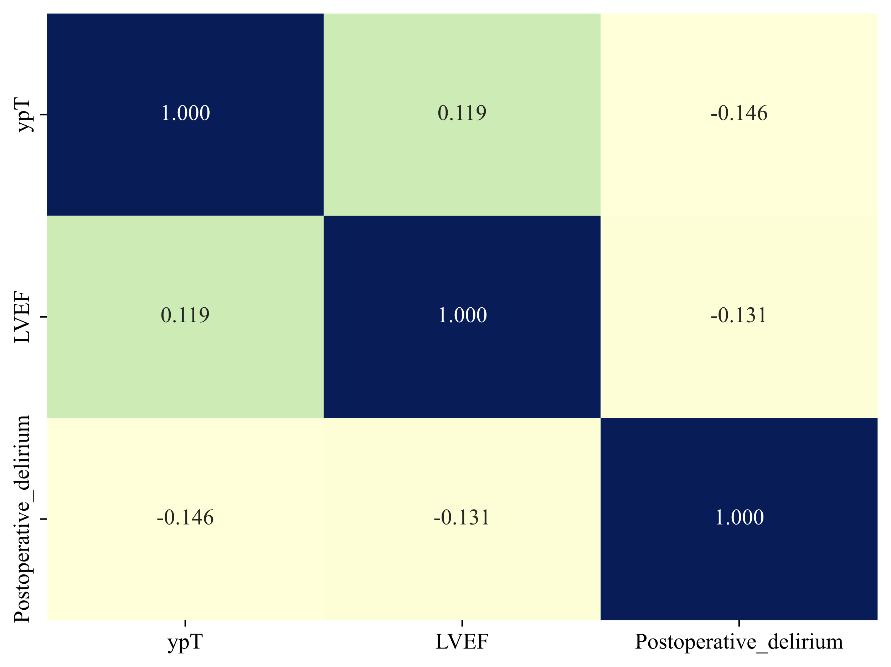
Fig. Correlation of Clinical Features
model_name | Accuracy | AUC | 95% CI | Sensitivity | Specificity | PPV | NPV | Cohort
SVM | 0.458 | 0.691 | 0.575 - 0.807 | 0.828 | 0.321 | 0.312 | 0.833 | train
SVM | 0.489 | 0.620 | 0.457 - 0.783 | 0.727 | 0.280 | 0.471 | 0.538 | val
SVM | 0.450 | 0.556 | 0.448 - 0.663 | 0.868 | 0.275 | 0.333 | 0.833 | test1
SVM | 0.259 | 0.584 | 0.419 - 0.749 | 0.789 | 0.097 | 0.211 | 0.600 | test2
RandomForest | 0.654 | 0.717 | 0.607 - 0.827 | 0.759 | 0.615 | 0.423 | 0.873 | train
RandomForest | 0.511 | 0.553 | 0.385 - 0.721 | 0.818 | 0.240 | 0.486 | 0.600 | val
RandomForest | 0.426 | 0.511 | 0.397 - 0.625 | 0.684 | 0.319 | 0.295 | 0.707 | test1
RandomForest | 0.420 | 0.611 | 0.460 - 0.761 | 0.789 | 0.306 | 0.259 | 0.826 | test2
ExtraTrees | 0.607 | 0.667 | 0.551 - 0.783 | 0.655 | 0.590 | 0.373 | 0.821 | train
ExtraTrees | 0.596 | 0.564 | 0.400 - 0.728 | 0.500 | 0.680 | 0.579 | 0.607 | val
ExtraTrees | 0.504 | 0.562 | 0.457 - 0.668 | 0.553 | 0.484 | 0.309 | 0.721 | test1
ExtraTrees | 0.617 | 0.612 | 0.448 - 0.777 | 0.526 | 0.645 | 0.312 | 0.816 | test2
XGBoost | 0.645 | 0.711 | 0.601 - 0.821 | 0.690 | 0.628 | 0.408 | 0.845 | train
XGBoost | 0.489 | 0.538 | 0.374 - 0.702 | 0.727 | 0.280 | 0.471 | 0.538 | val
XGBoost | 0.488 | 0.525 | 0.412 - 0.638 | 0.658 | 0.418 | 0.321 | 0.745 | test1
XGBoost | 0.420 | 0.601 | 0.454 - 0.747 | 0.789 | 0.306 | 0.259 | 0.826 | test2
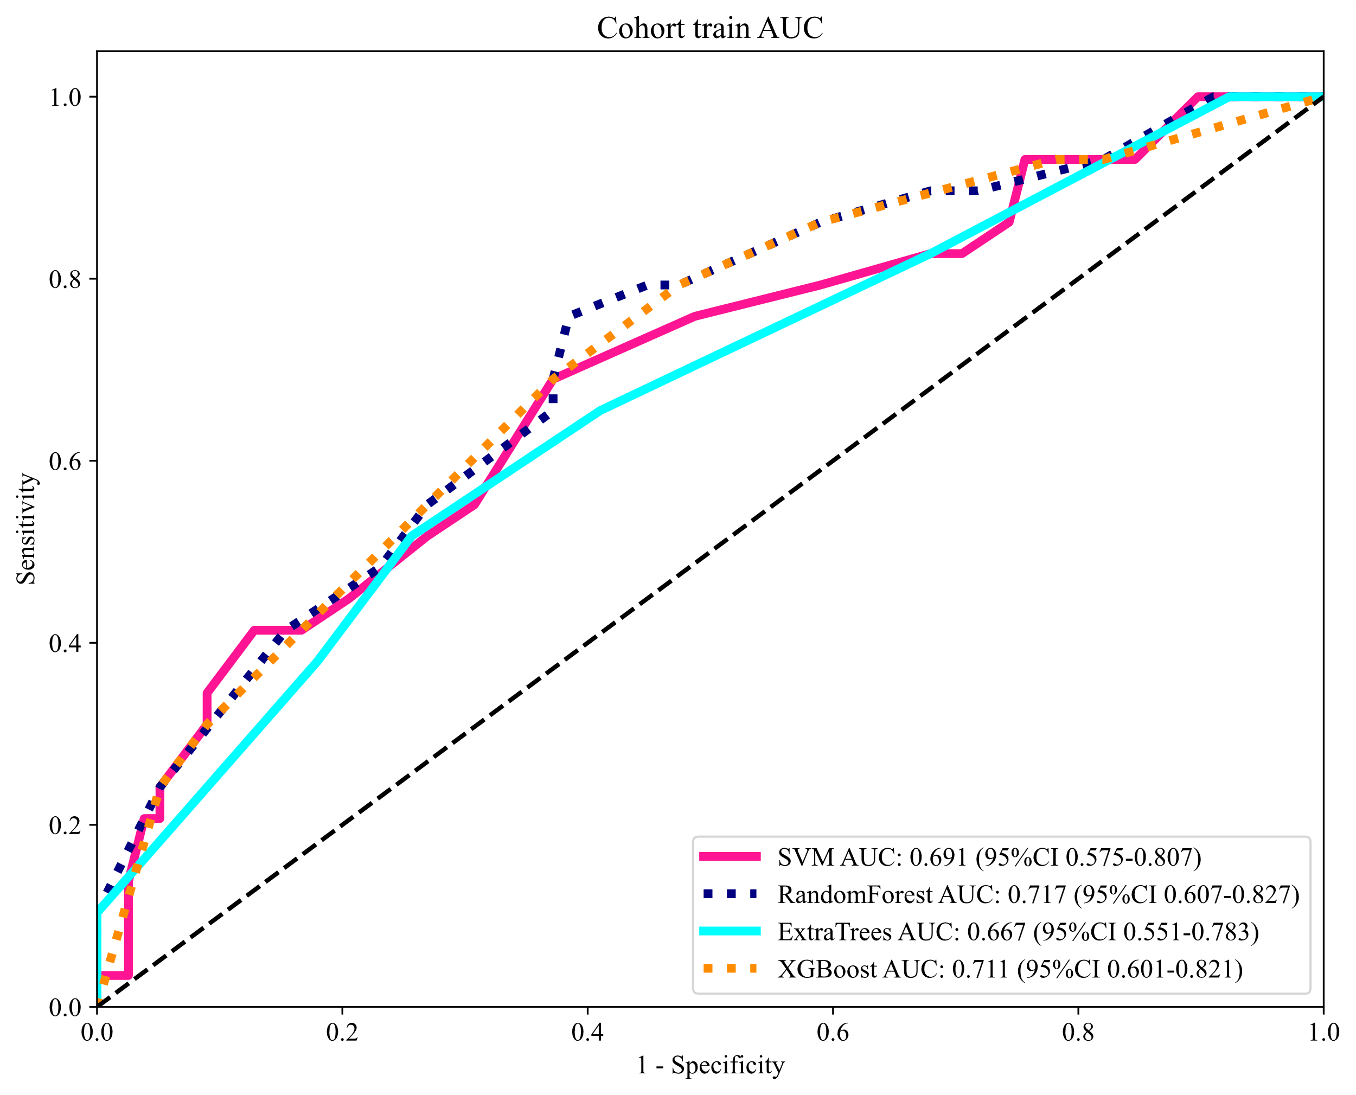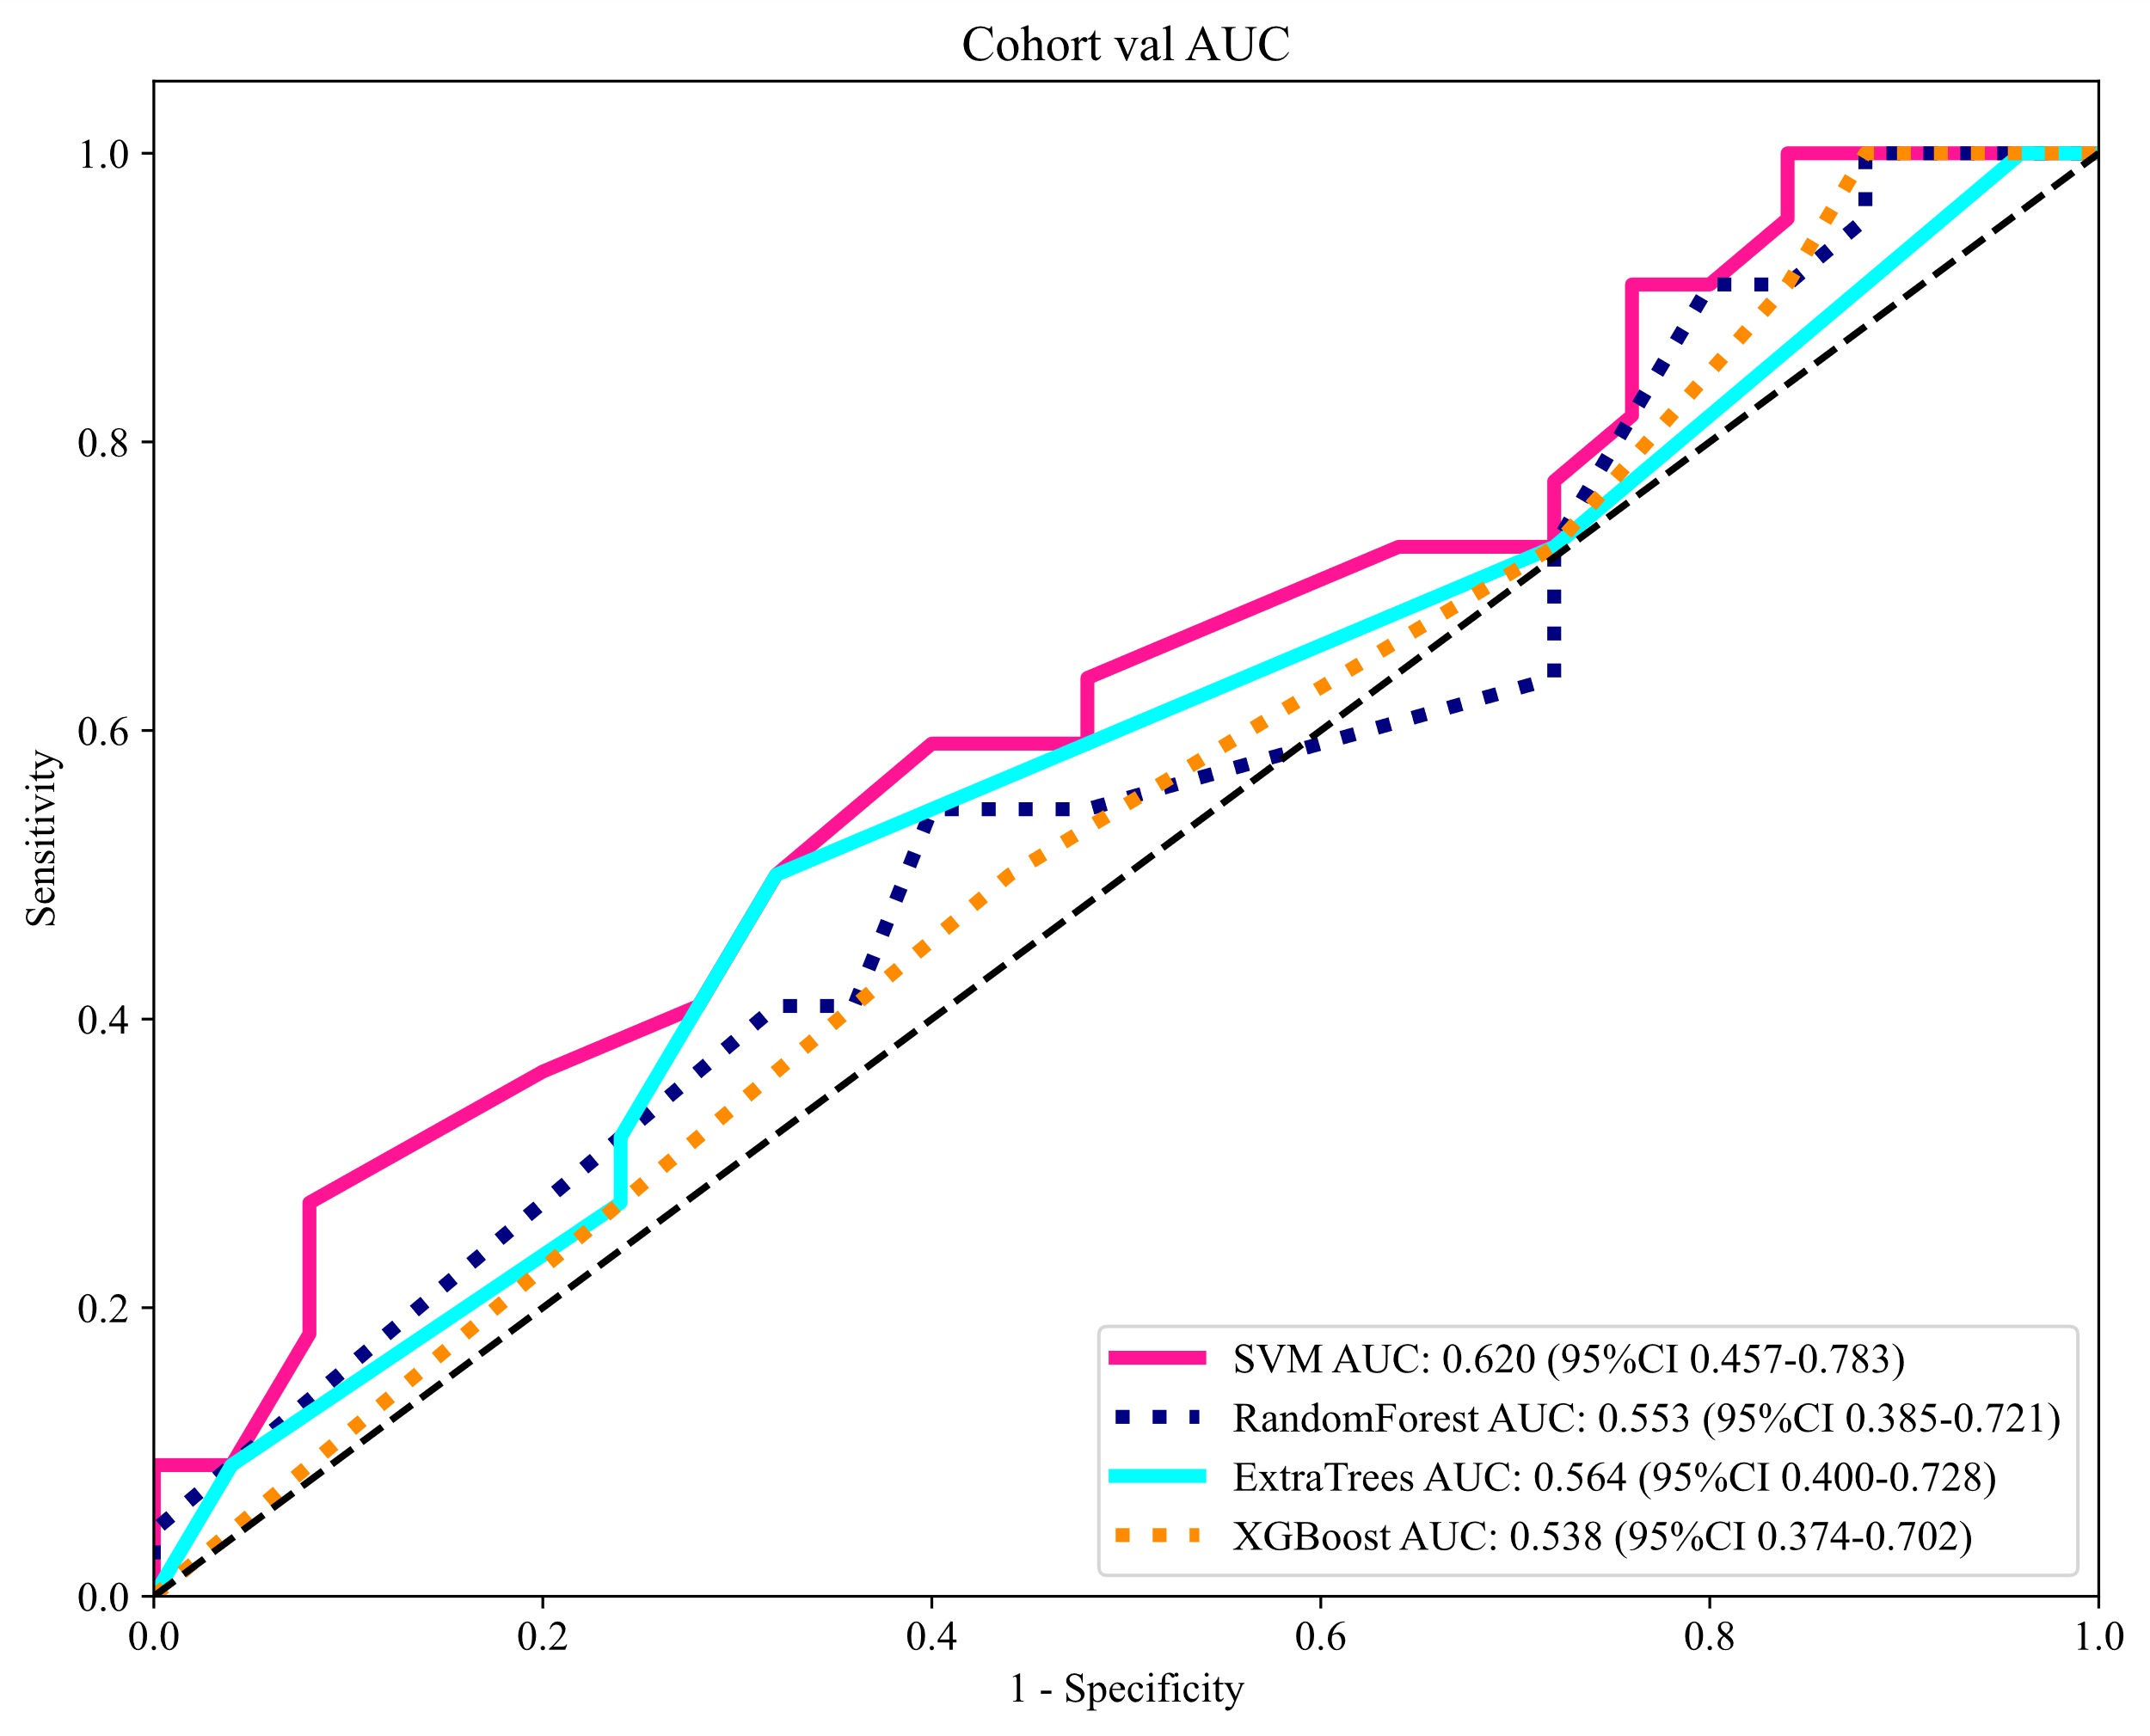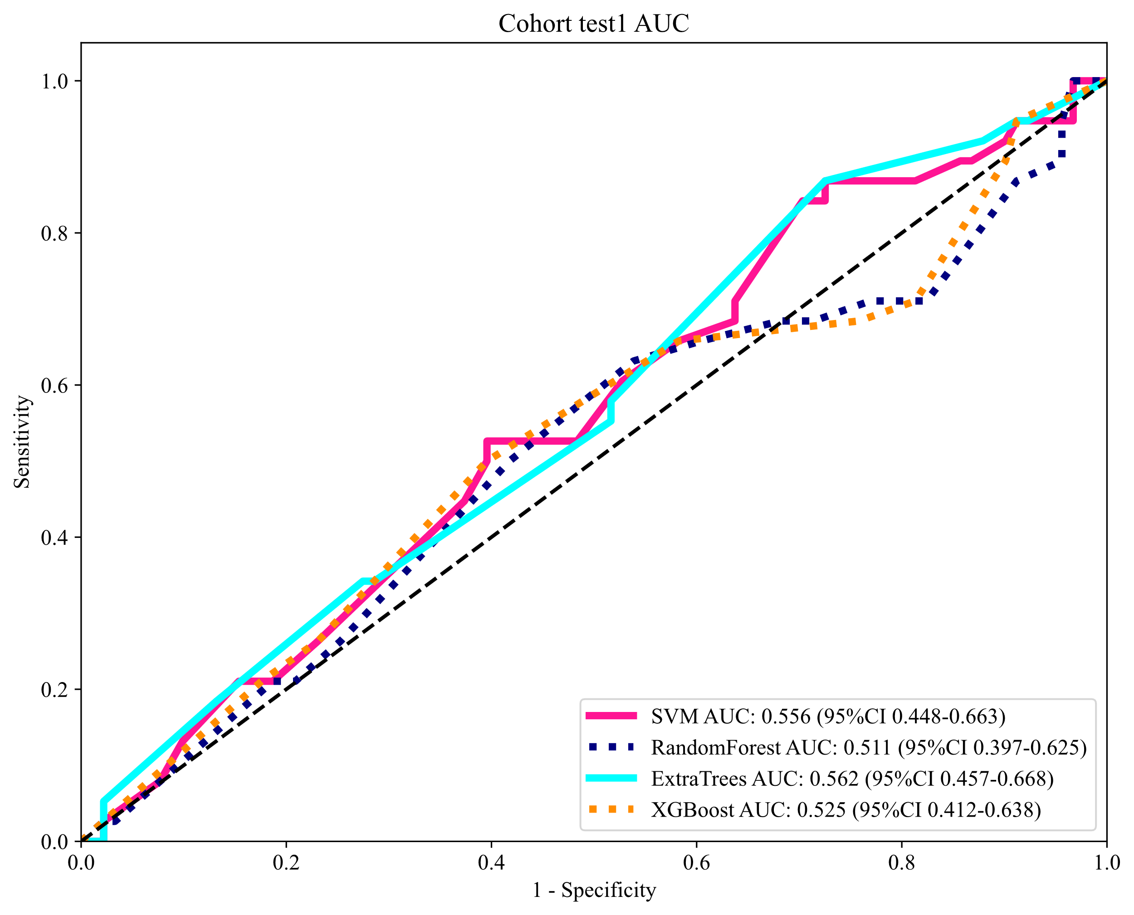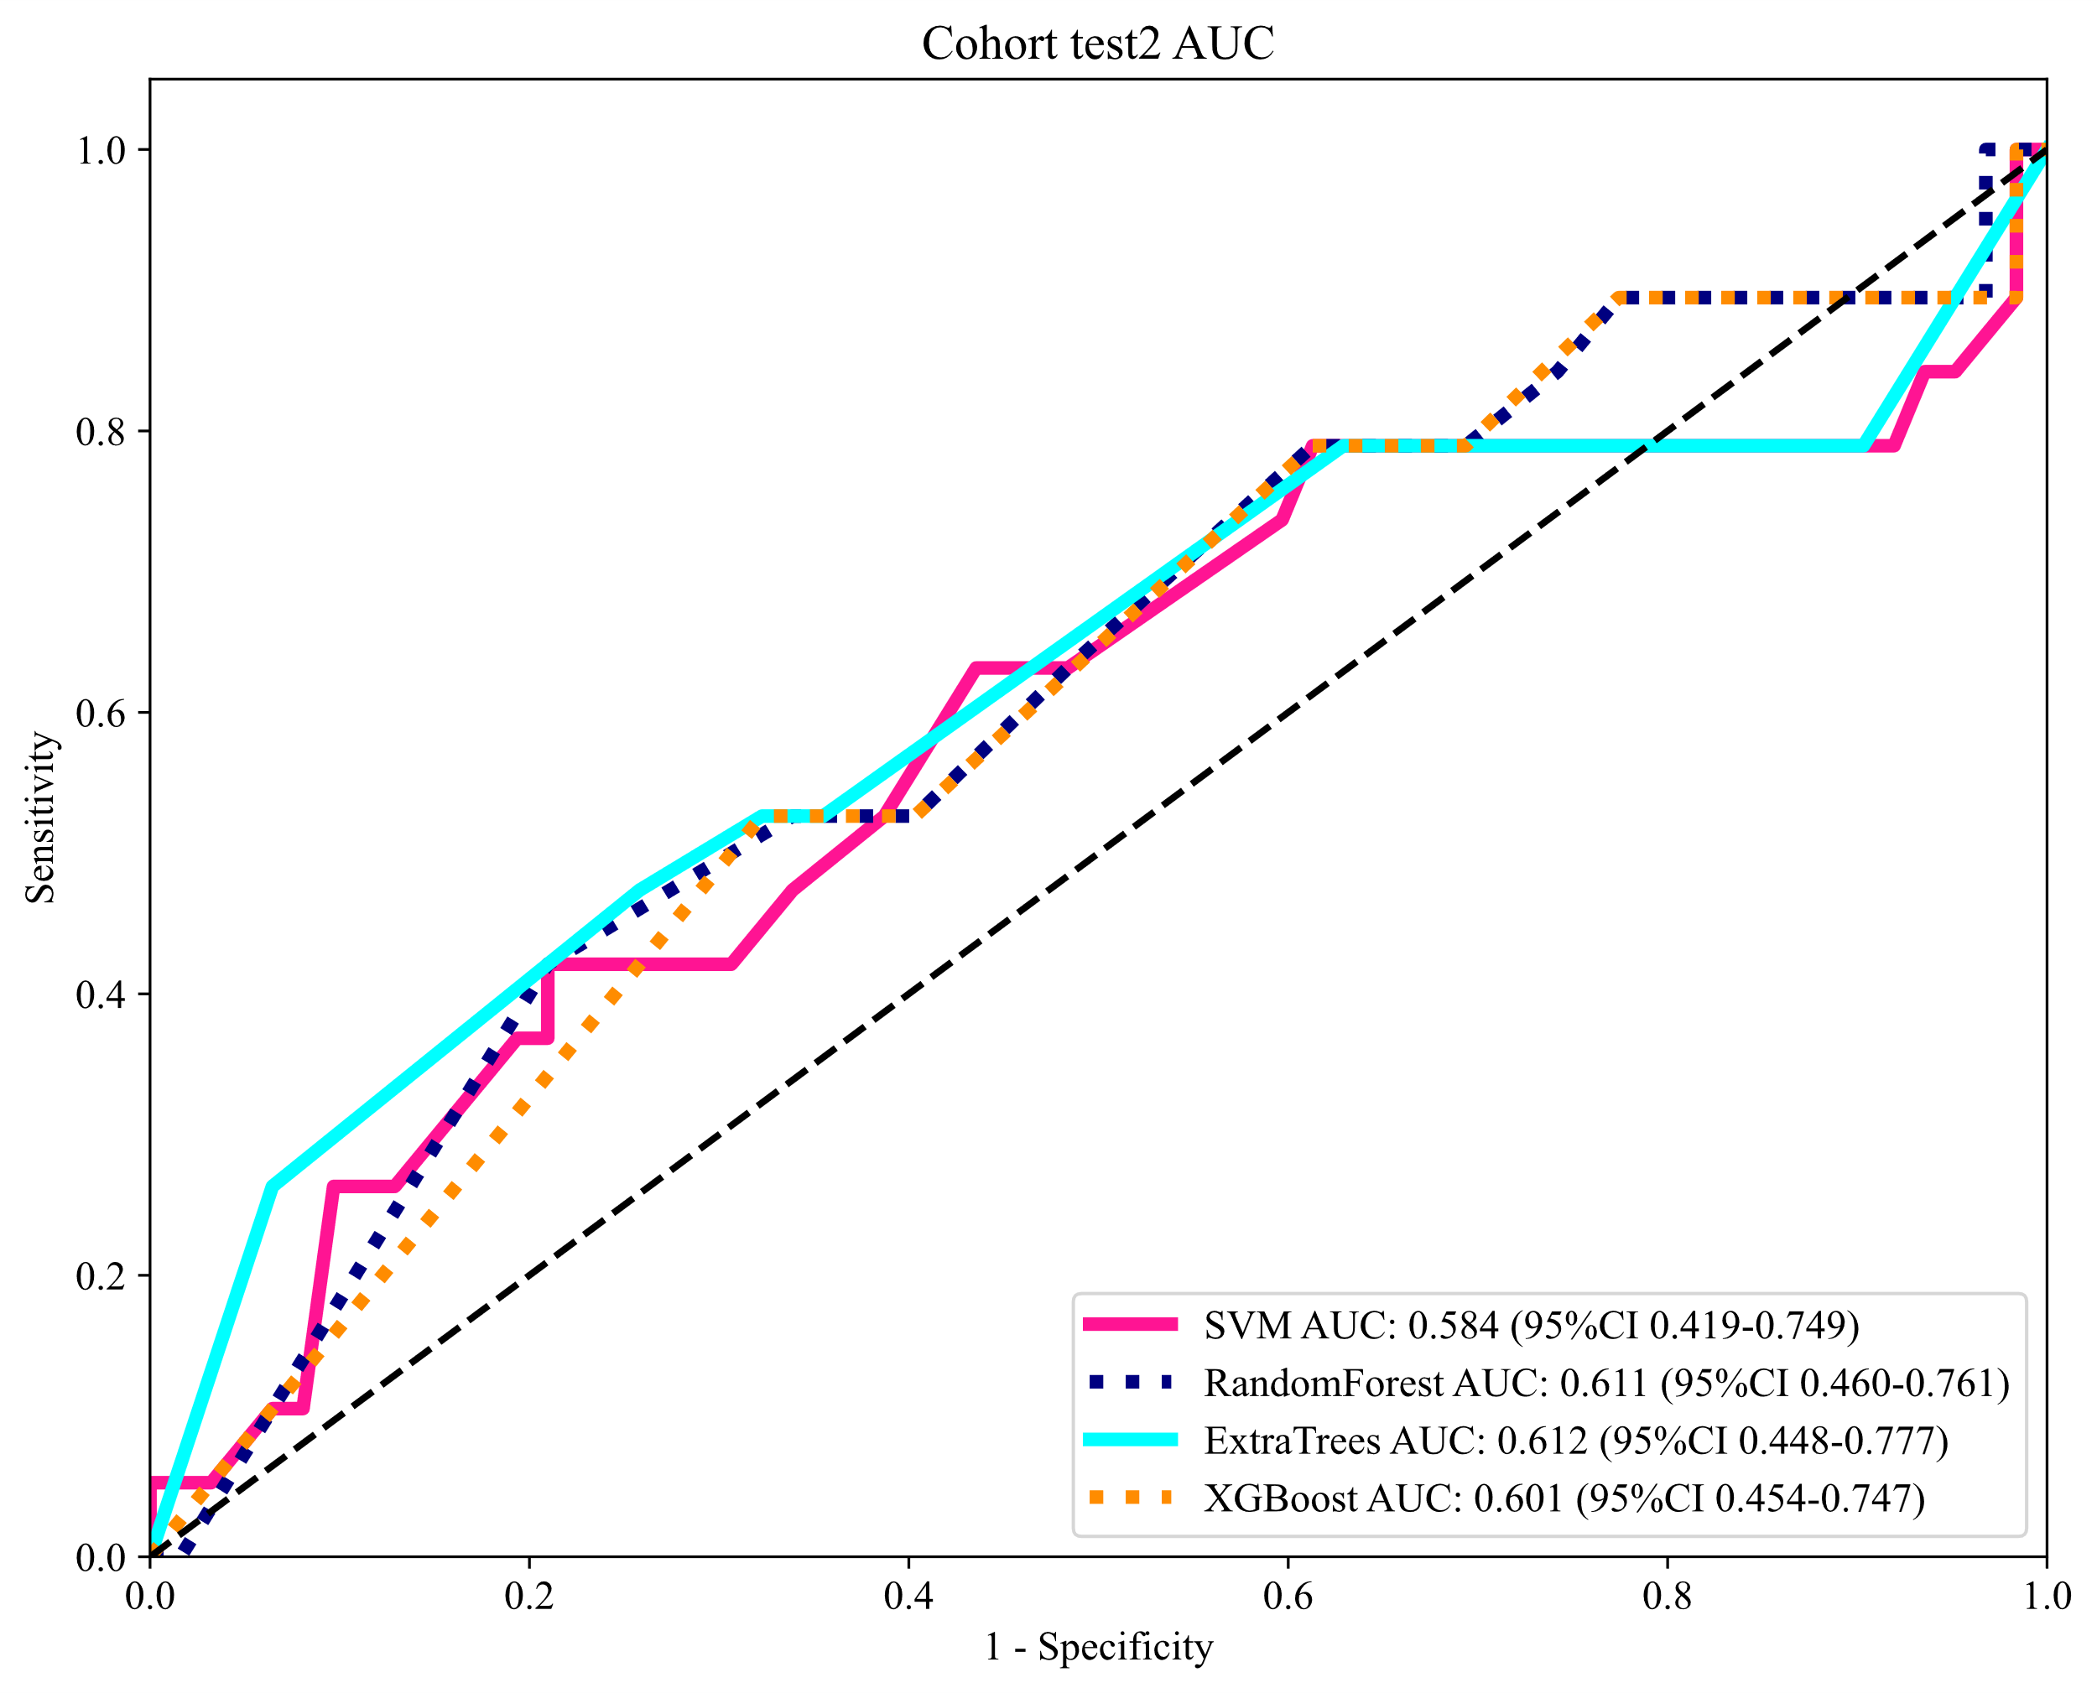

2B. Details of Radiomics Signature
model_name | Accuracy | AUC | 95% CI | Sensitivity | Specificity | PPV | NPV | Cohort
SVM | 0.935 | 0.970 | 0.934 - 1.000 | 0.931 | 0.936 | 0.844 | 0.973 | train
SVM | 0.787 | 0.825 | 0.704 - 0.946 | 0.864 | 0.720 | 0.731 | 0.857 | val
SVM | 0.713 | 0.776 | 0.699 - 0.854 | 0.921 | 0.626 | 0.507 | 0.950 | test1
SVM | 0.568 | 0.612 | 0.467 - 0.757 | 0.737 | 0.516 | 0.318 | 0.865 | test2
RandomForest | 0.804 | 0.863 | 0.787 - 0.939 | 0.793 | 0.808 | 0.605 | 0.913 | train
RandomForest | 0.766 | 0.745 | 0.598 - 0.892 | 0.636 | 0.880 | 0.824 | 0.733 | val
RandomForest | 0.798 | 0.795 | 0.713 - 0.877 | 0.711 | 0.835 | 0.643 | 0.874 | test1
RandomForest | 0.691 | 0.781 | 0.690 - 0.873 | 1.000 | 0.597 | 0.432 | 1.000 | test2
ExtraTrees | 0.888 | 0.941 | 0.890 - 0.993 | 0.897 | 0.885 | 0.743 | 0.958 | train
ExtraTrees | 0.809 | 0.845 | 0.732 - 0.957 | 0.909 | 0.720 | 0.741 | 0.900 | val
ExtraTrees | 0.744 | 0.796 | 0.712 - 0.880 | 0.684 | 0.769 | 0.553 | 0.854 | test1
ExtraTrees | 0.802 | 0.729 | 0.570 - 0.888 | 0.737 | 0.823 | 0.560 | 0.911 | test2
XGBoost | 0.832 | 0.836 | 0.752 - 0.920 | 0.862 | 0.821 | 0.641 | 0.941 | train
XGBoost | 0.766 | 0.760 | 0.628 - 0.892 | 0.727 | 0.800 | 0.762 | 0.769 | val
XGBoost | 0.643 | 0.749 | 0.668 - 0.831 | 0.921 | 0.527 | 0.449 | 0.941 | test1
XGBoost | 0.667 | 0.747 | 0.634 - 0.860 | 0.842 | 0.613 | 0.400 | 0.927 | test2
Table 1. Model Performance of Different Machine Learning Algorithms in the Training, Validation, and Testing Sets.
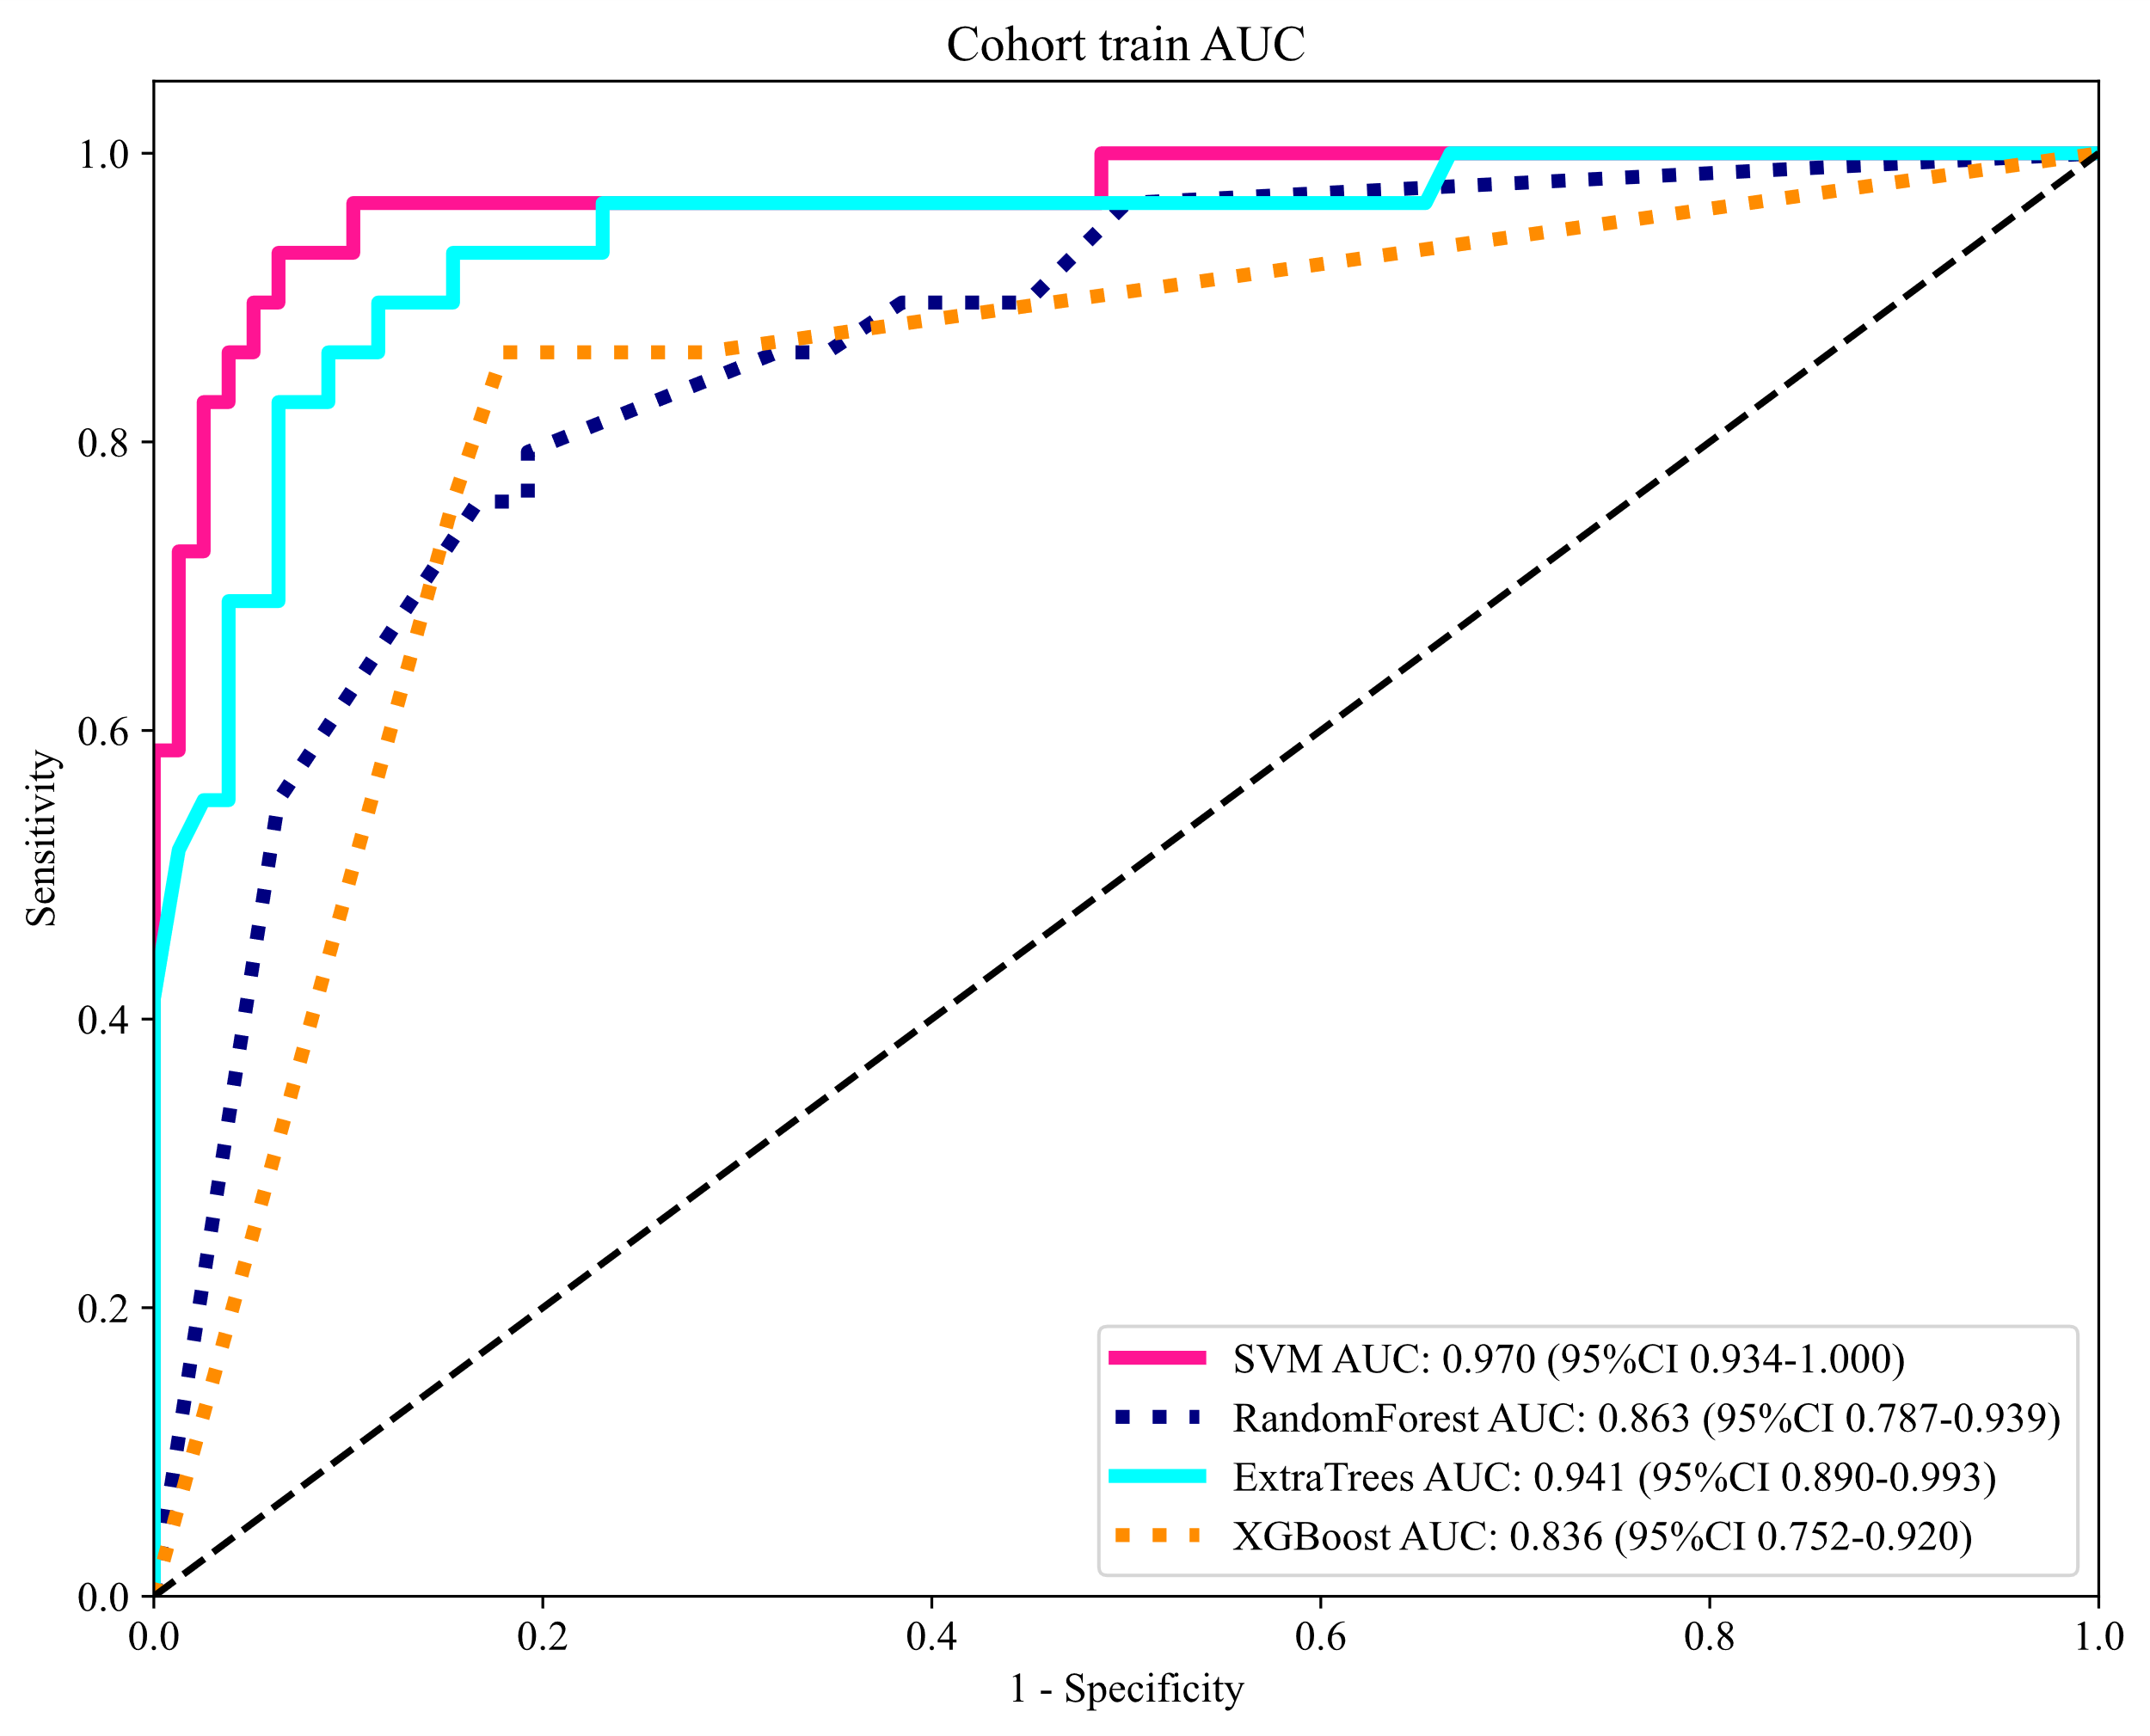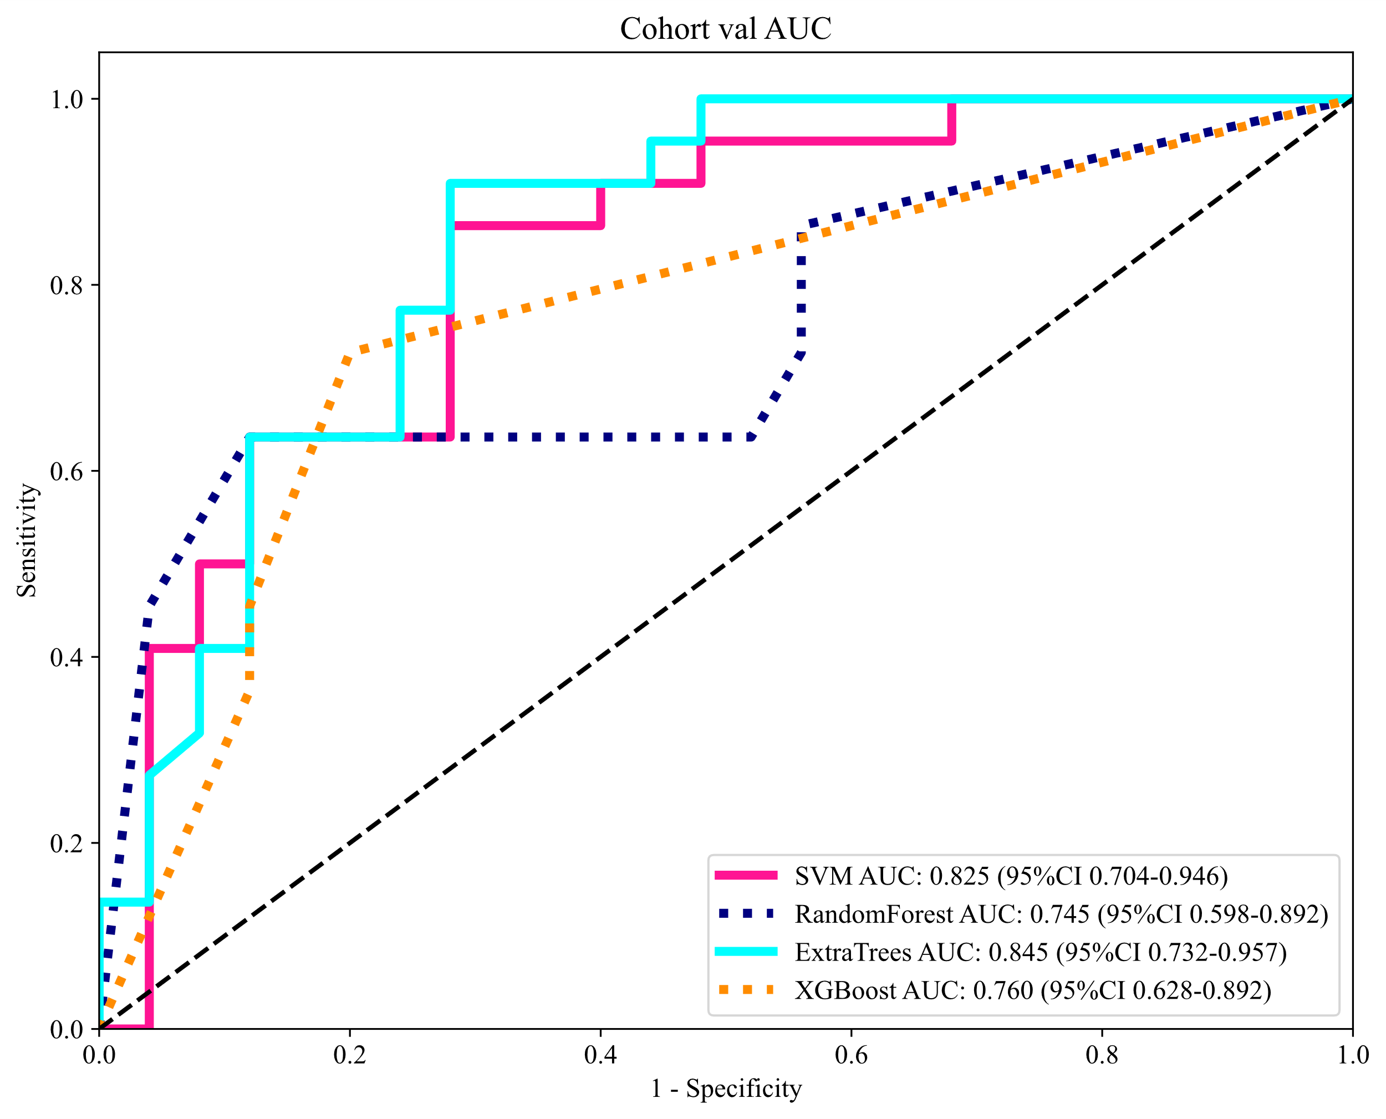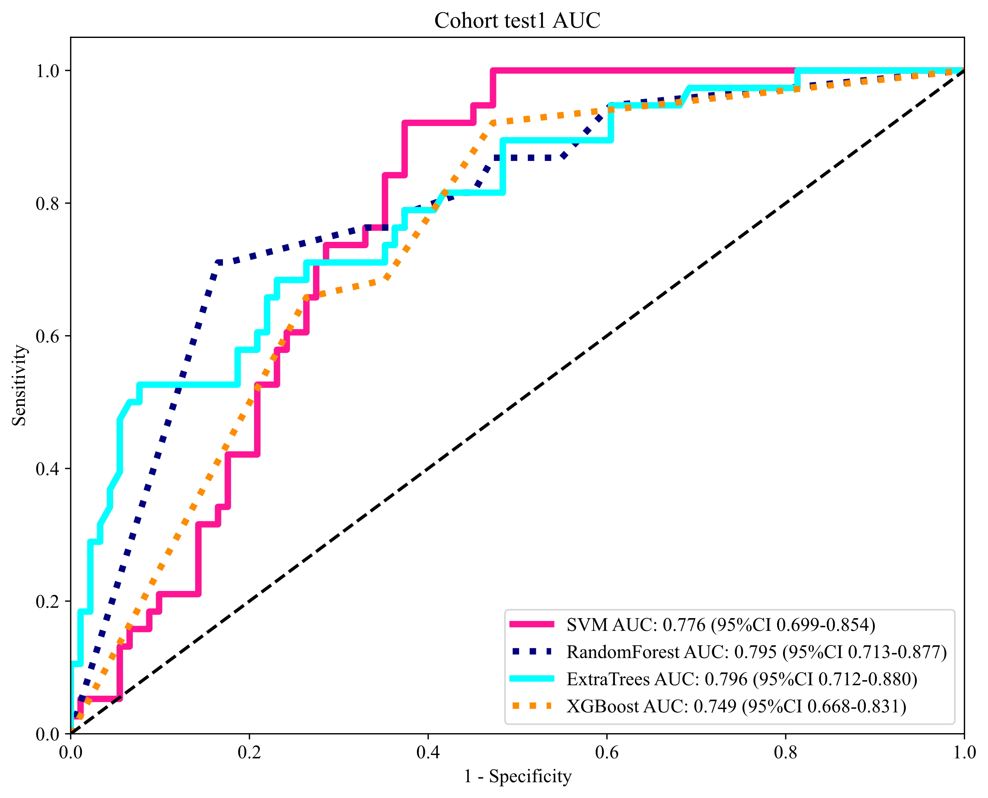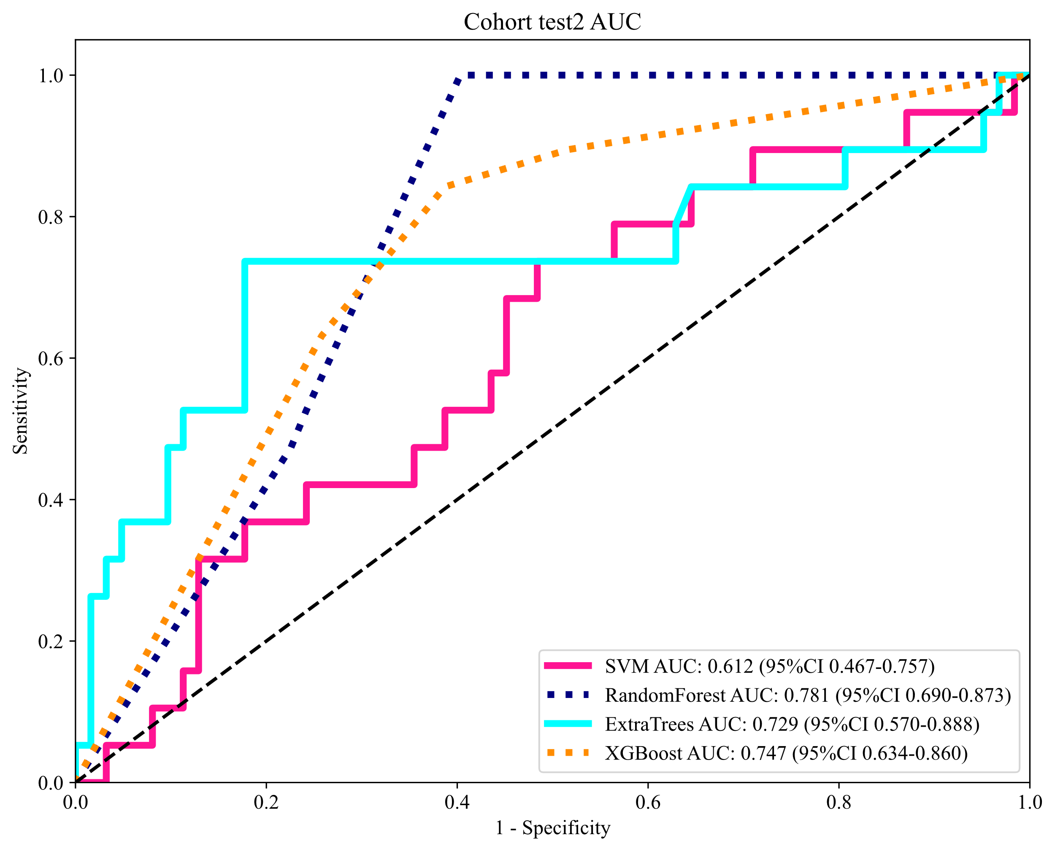
Figure 1. ROC Curves of Different Models in the Training, Validation, and Testing Sets.

