Supplementary Figures
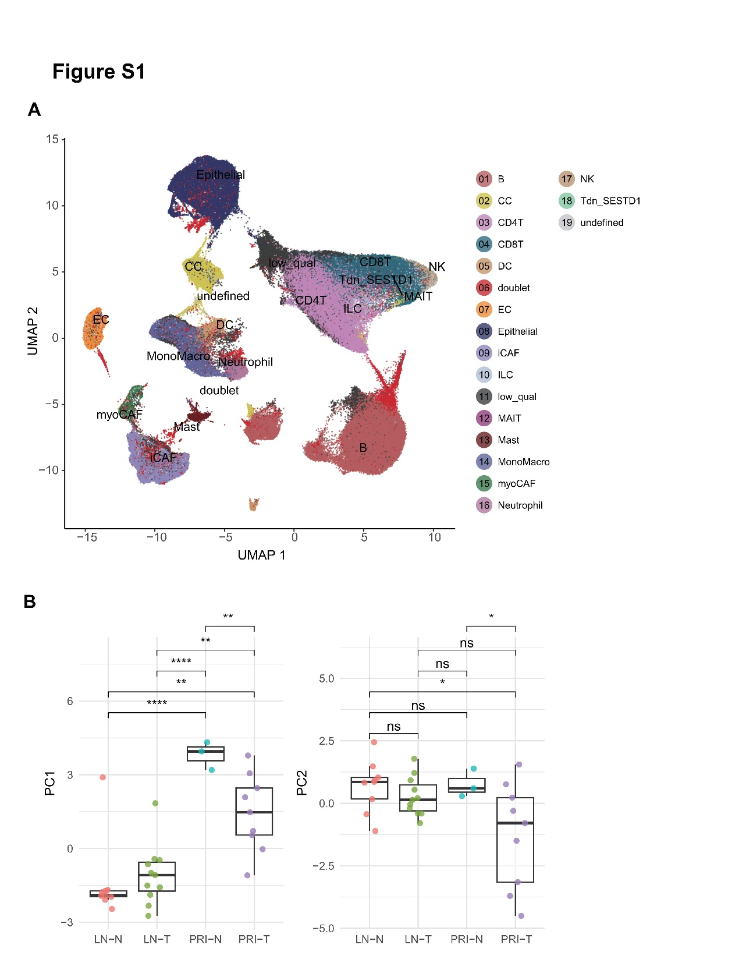
Figure S1. A. Integrated single-cell atlas of bladder cancer (n = 32). Major cell lineages were defined based on the expression of canonical marker genes, as shown in Figure 1B; B. Boxplots display the PC1 and PC2 scores across different tissue types, with pairwise comparisons performed using the Wilcoxon test. The PCA was performed based on the relative abundance matrix of the major cell types defined in Figure 1A, excluding the epithelial compartment. ns, p > 0.05; * p ≤ 0.05; ** p ≤ 0.01; *** p ≤ 0.001; **** p ≤ 0.0001.
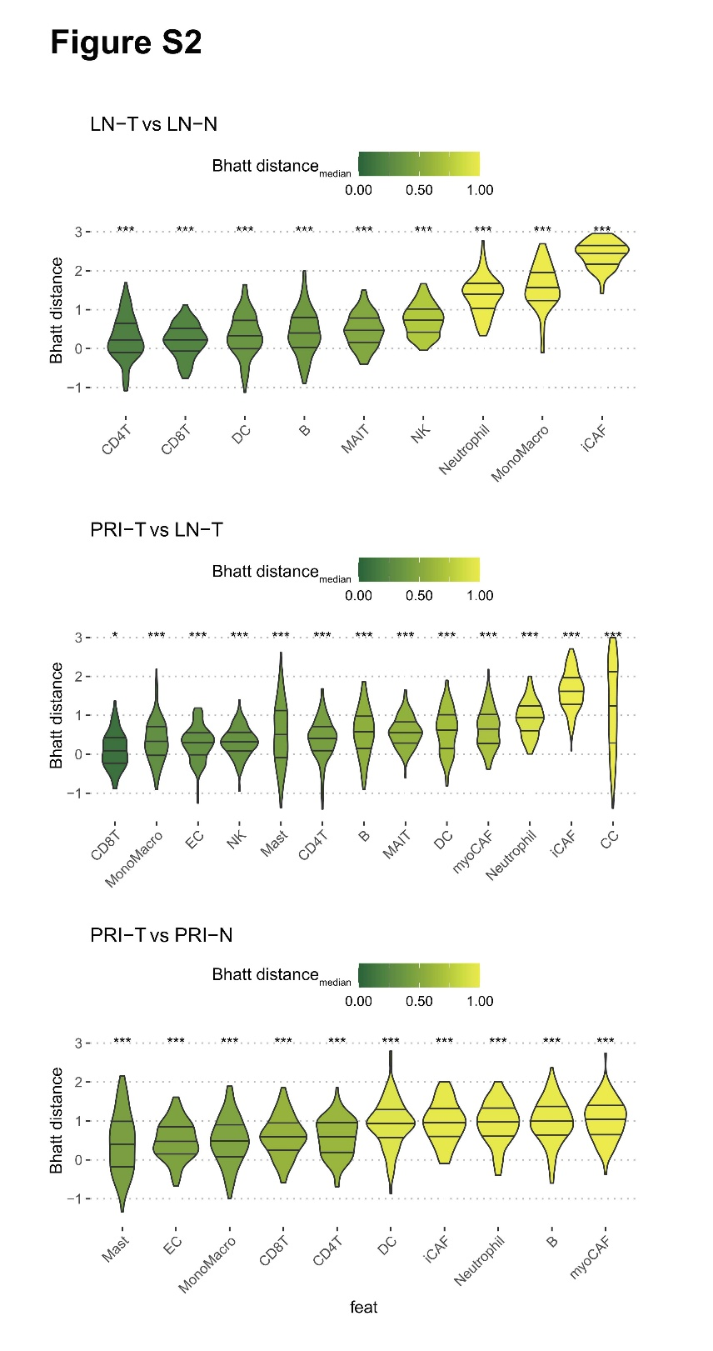
Figure S2. Bhattacharyya distances of the same major cell populations across different tissue types. A statistical test was performed to assess whether the mean of the Bhattacharyya distance distribution is significantly different from zero.
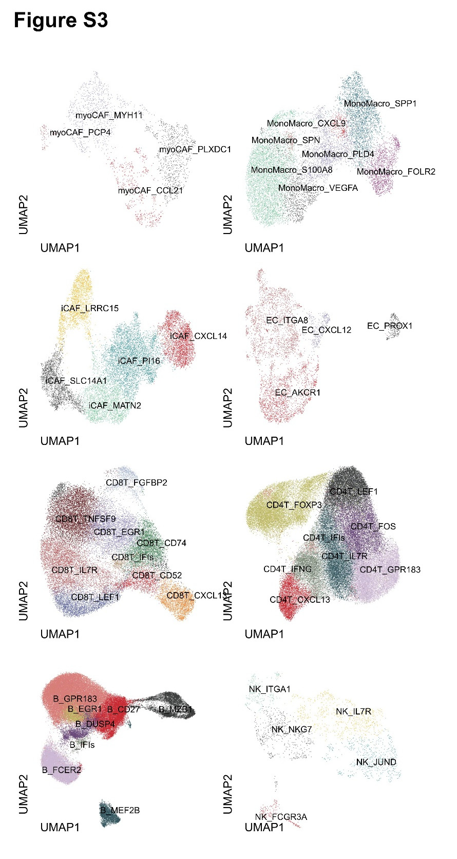
Figure S3. UMAP plots of integrated single-cell data illustrating the major subpopulations of myoCAFs, iCAFs, CD8+ T cells, B cells, monocytes/macrophages, endothelial cells, CD4+ T cells, and NK cells, displayed from top to bottom and left to right, respectively, along with subcluster annotations.
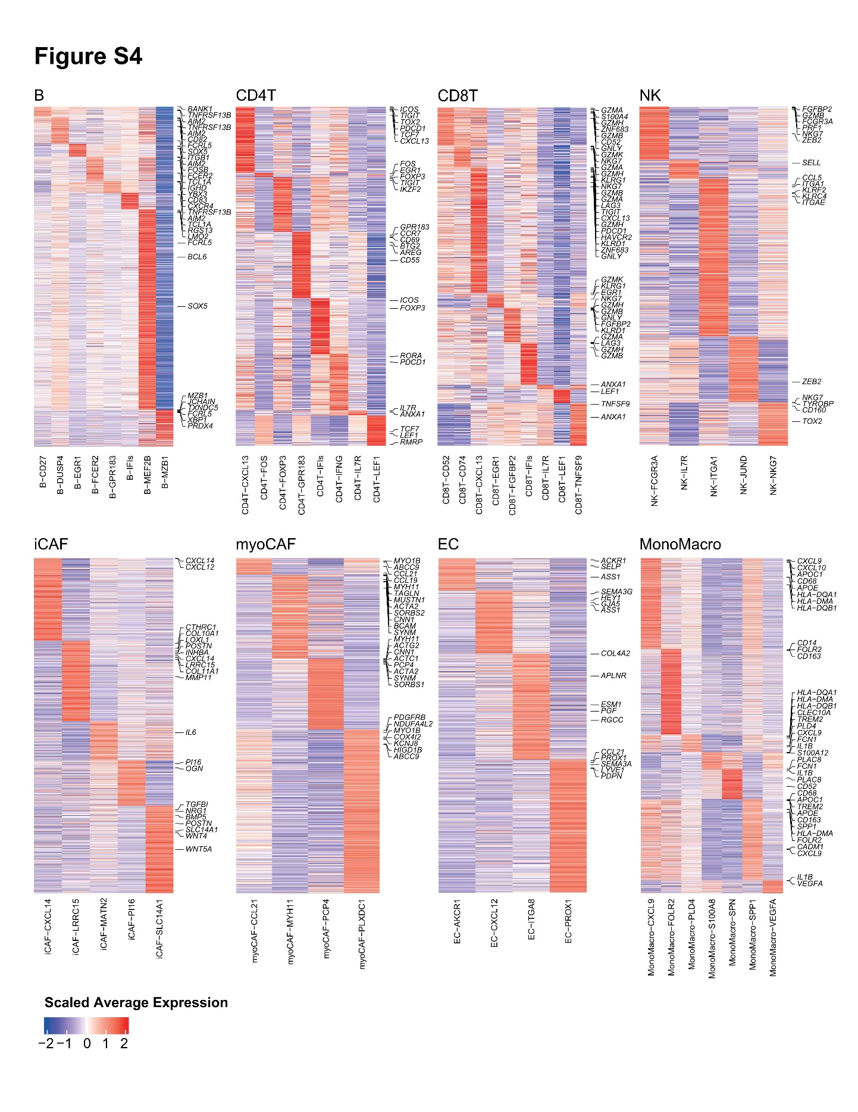
Figure S4. Scaled average expression of DEGs within each cell subtype is shown; genes indicative of cellular function was selected and annotated alongside the heatmap. Genes were identified according to the Methods section and ordered by significance level. Genes identified as marker genes in multiple cell subtypes are allowed to appear multiple times in the heatmap. DEG, differentially expressed gene.
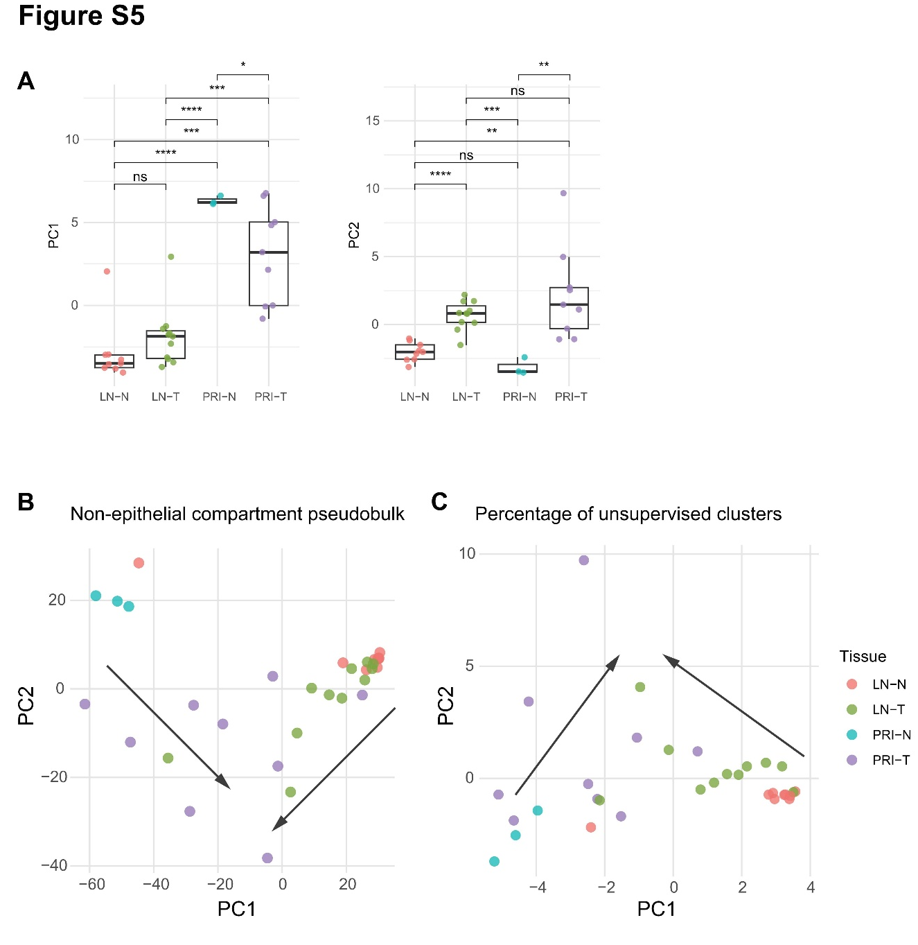
Figure S5. A. Boxplots display the PC1 and PC2 scores across different tissue types, with pairwise comparisons performed using the Wilcoxon test. The PCA was performed based on the relative abundance matrix of the cell subtypes defined in Figure 2A, excluding the epithelial compartment. B. PCA based on pseudobulk profiles excluding epithelial compartment; C. PCA based on the abundance matrix derived from unsupervised clustering. ns, p > 0.05; * p ≤ 0.05; ** p ≤ 0.01; *** p ≤ 0.001; **** p ≤ 0.0001.
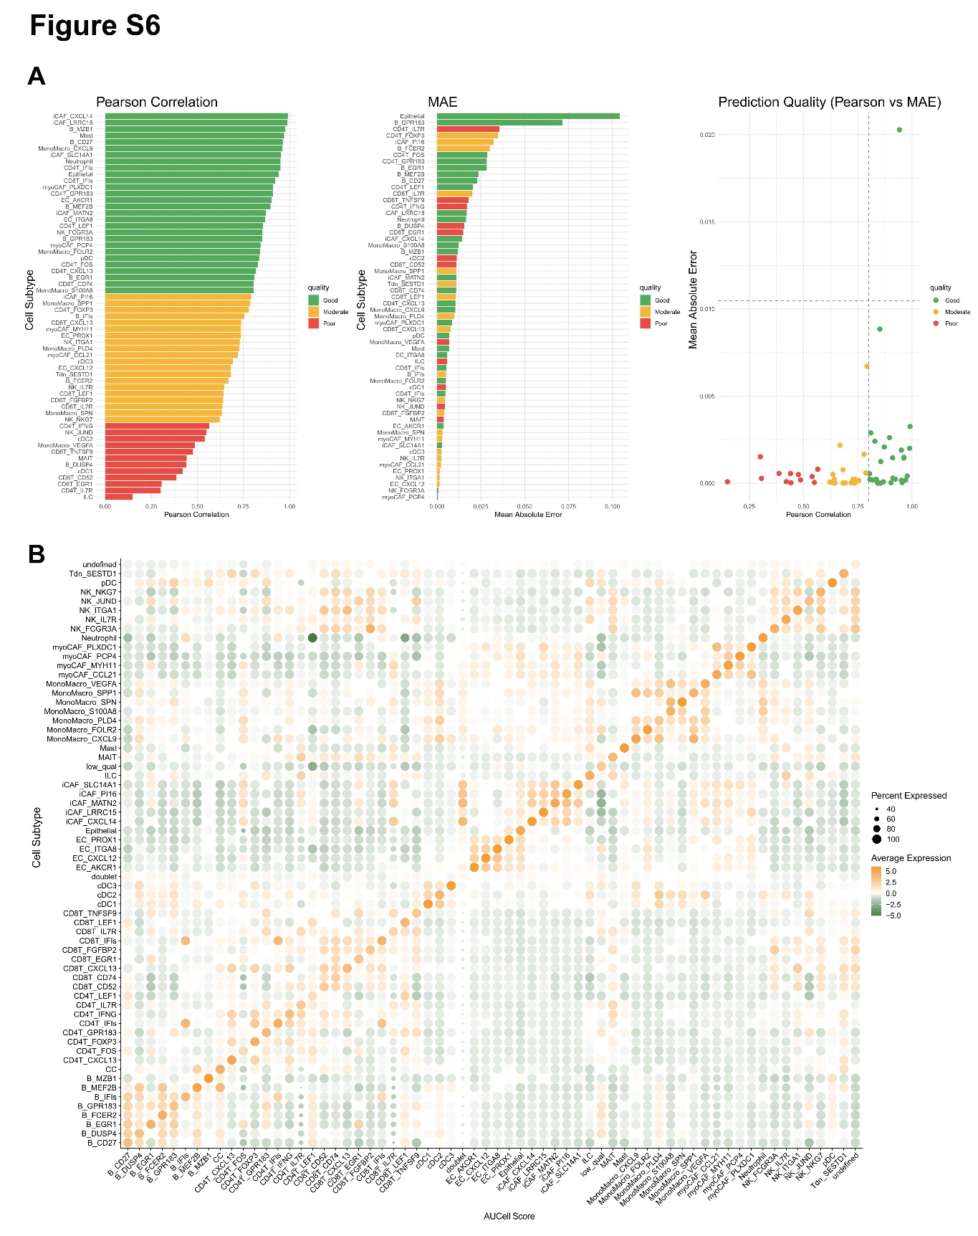
Figure S6. A. Pseudobulk expression profiles were generated from single-cell transcriptomes for each sample, and deconvolution was performed using BayesPrism. The consistency between predicted and true cell-type abundances was evaluated using Pearson correlation and MAE. B. Signature genes for each cell subpopulation were identified through differential expression analysis. AUCell was used to assess the specificity and enrichment of these gene signatures across individual cells. MAE, mean absolute error.
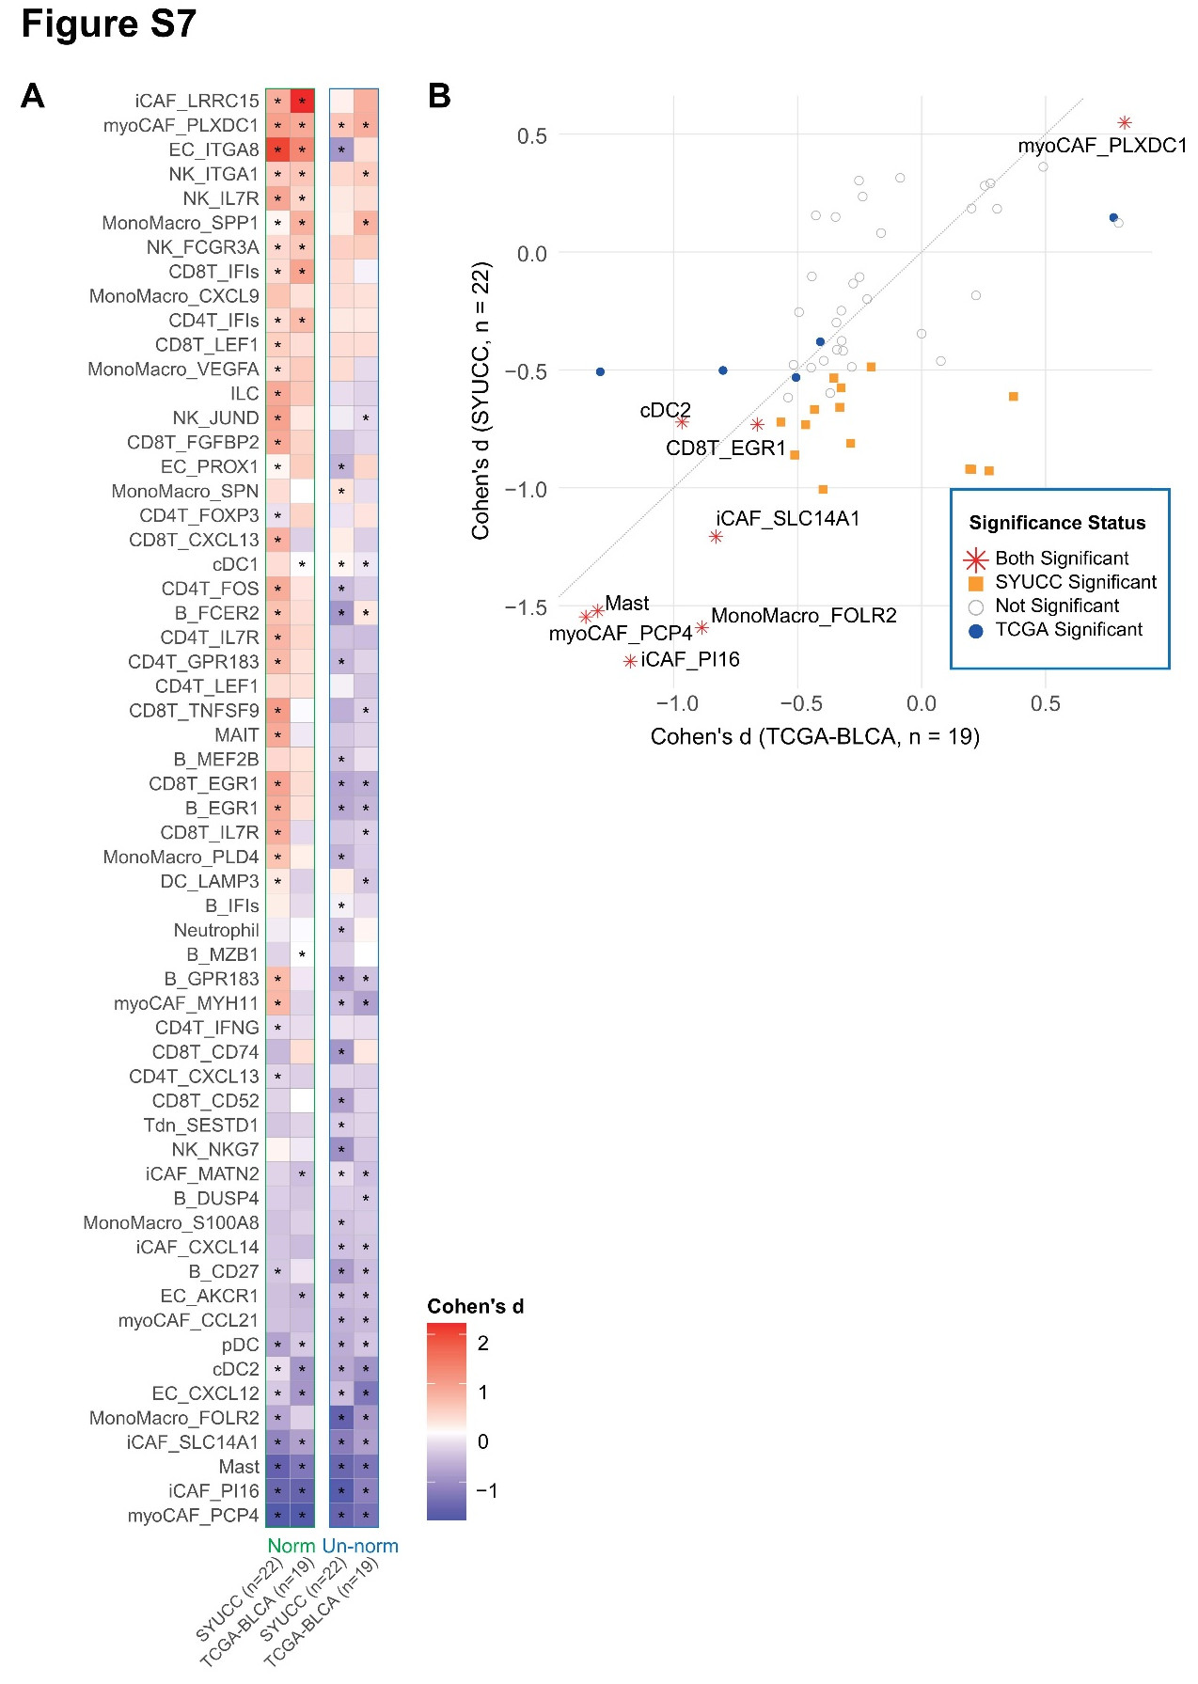
Figure S7. A. Heatmaps showing differences (quantified by Cohen’s d) in cell subtype proportions between tumor and adjacent tissues in SYUCC (n = 22) and TCGA-BLCA (n = 19), presented using both non-epithelial compartment-normalized (Norm) and unnormalized (Un-norm) values; B. Scatter plots further illustrating the results from (A), based on unnormalized proportions.
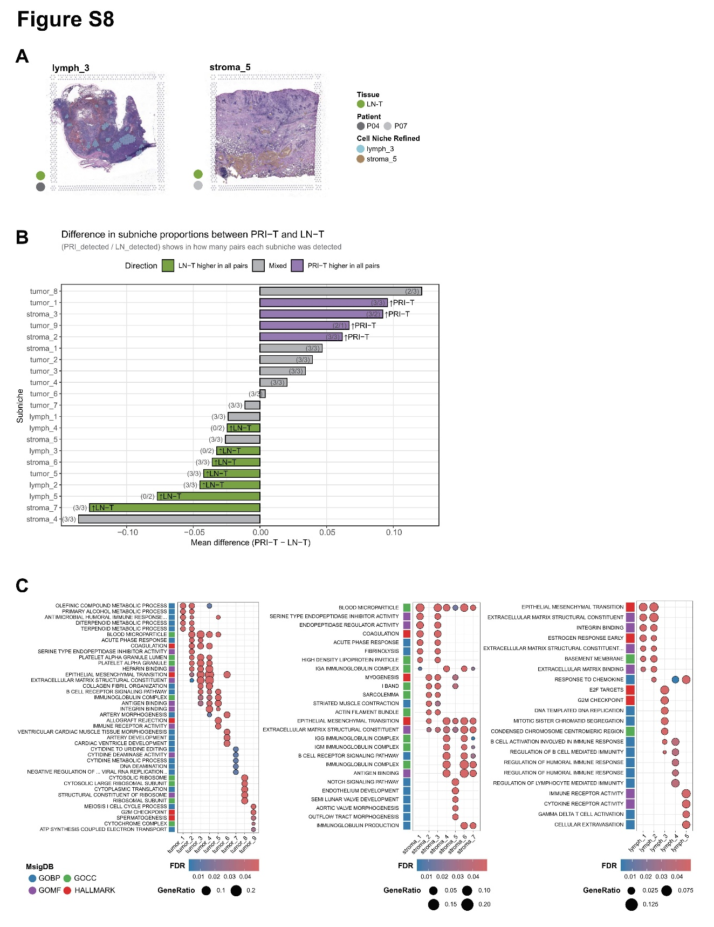
Figure S8. A. Typical GC structures in lymph_3 (upper), and vascular structures in stroma_5 (lower), all slides are 6.5 mm×6.5 mm; B. Mean differences in subniche proportions between RI-T and LN-T across paired samples. Positive values indicate higher abundance in PRI-T; negative values indicate higher abundance in LN-T. Bar colors denote consistent dominance: red = RI-T, blue = LN-T, gray = mixed. Numbers in parentheses (PRI_detected / LN_detected) show in how many corresponding tissues each subniche was detected. C. DEGs among subniches in tumor, stroma, and lymph were identified and subjected to ORA; GC, germinal center; DEGs, differentially expressed genes; ORA, over-representation analysis.
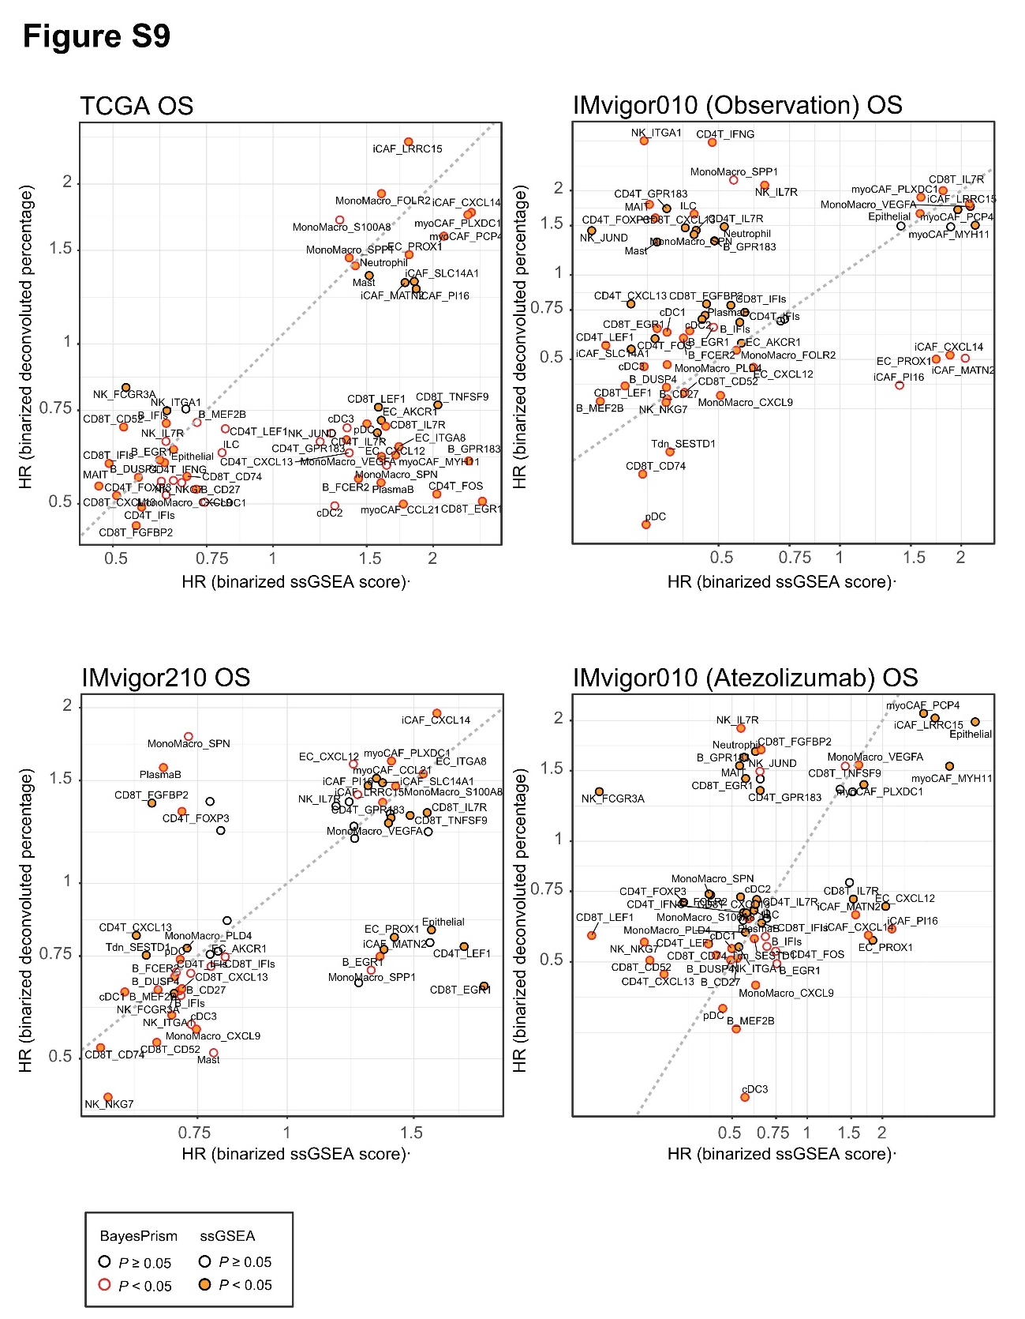
Figure S9. For each cell subtype, univariate Cox regression was performed to evaluate the HRs of both the gene score (ssGSEA) and the relative abundance ratio (BayesPrism). HR, hazard ratio; ssGSEA, single-sample Gene Set Enrichment Analysis.
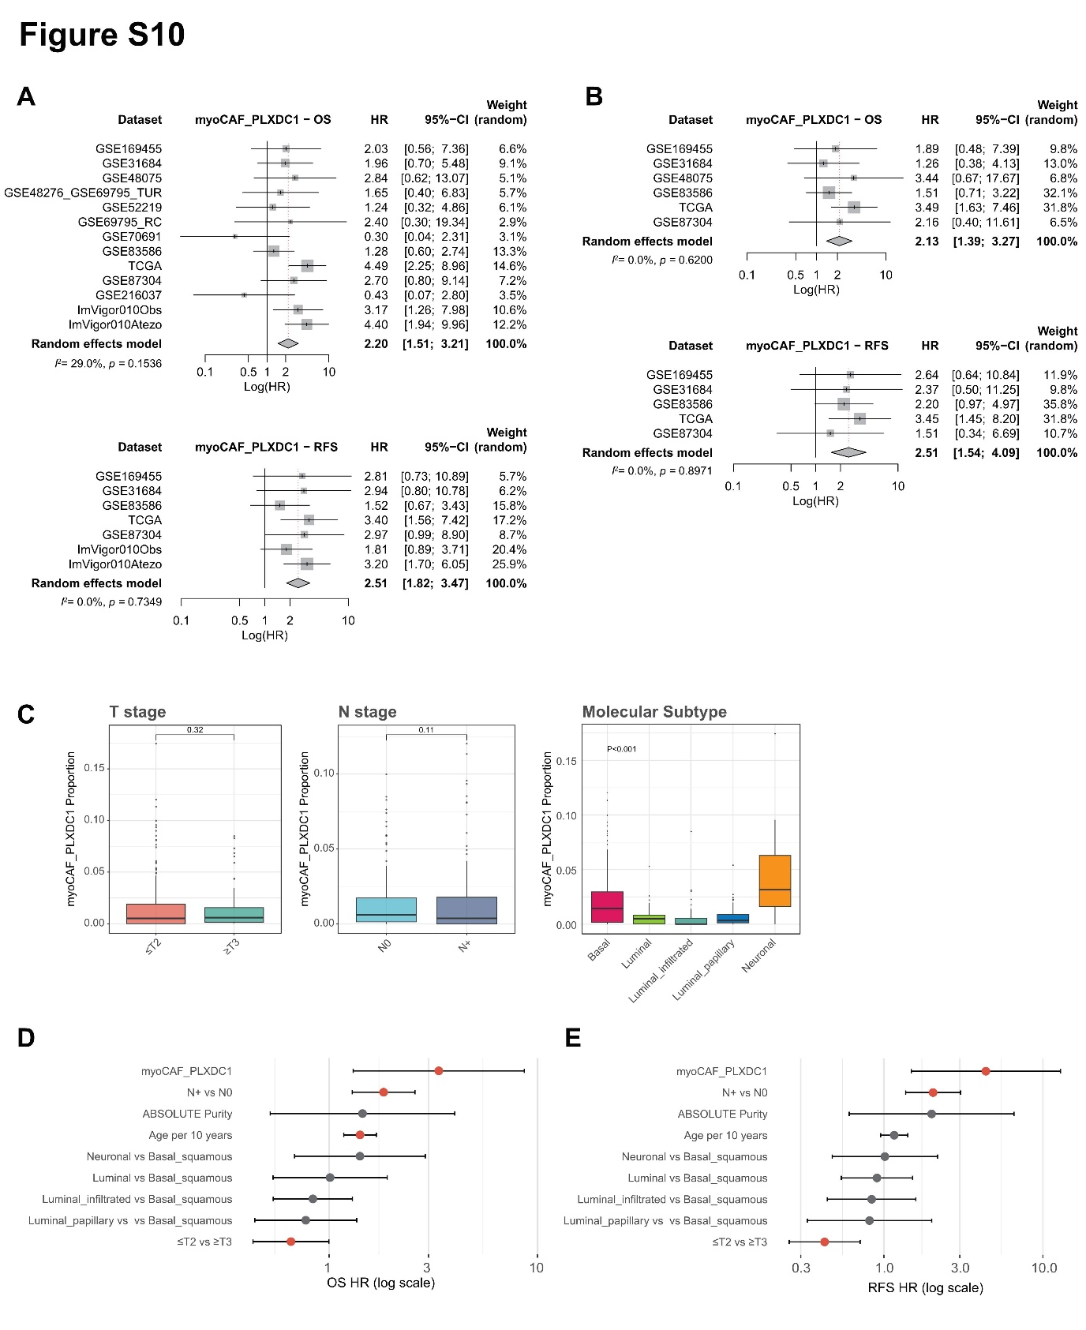
Figure S10. A. Meta-analysis of univariable HRs for gene signature scores of myoCAF_PLXDC1 with OS and RFS across 13 cohorts; B. Meta-analysis of multivariable-adjusted HRs for gene signature scores of myoCAF_PLXDC1 with OS and RFS across 6 cohorts; C. Boxplots comparing the abundance of myoCAF_PLXDC1 across different T and N stages and molecular subtypes in the TCGA-BLCA cohort; D. Forest plot showing multivariable-adjusted HR of myoCAF_PLXDC1 in the TCGA-BLCA cohort for OS and RFS. HR, hazard ratio; OS, overall survival; RFS, recurrence-free survival.
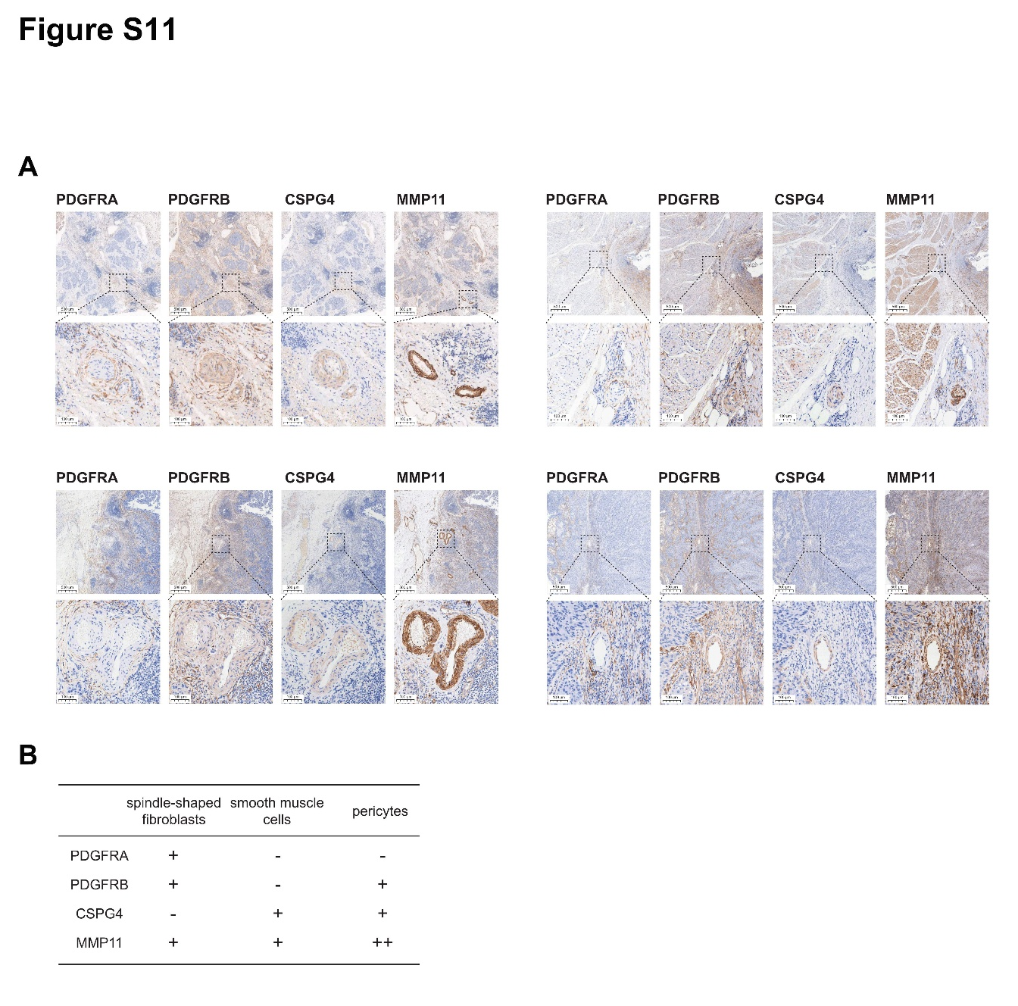
Figure S11. A-B. In situ expressions of PDGFRA, PDGFRB, CSPG4, and MMP11 detected by IHC in additional bladder cancer samples. IHC staining revealed three discernible stromal cell populations in bladder tissues: SMCs within the muscularis layer, spindle-shaped fibroblasts in the loose connective stroma, and pericytes surrounding vascular walls. PDGFRA was restricted to fibroblasts, whereas PDGFRB was detected in both fibroblasts and pericytes, but not in SMCs. CSPG4 stained pericytes and SMCs but was absent in fibroblasts. The PLXDC1 antibody yielded suboptimal staining (data not shown). MMP11 was expressed in all three stromal cell types, with the strongest signal in pericytes.

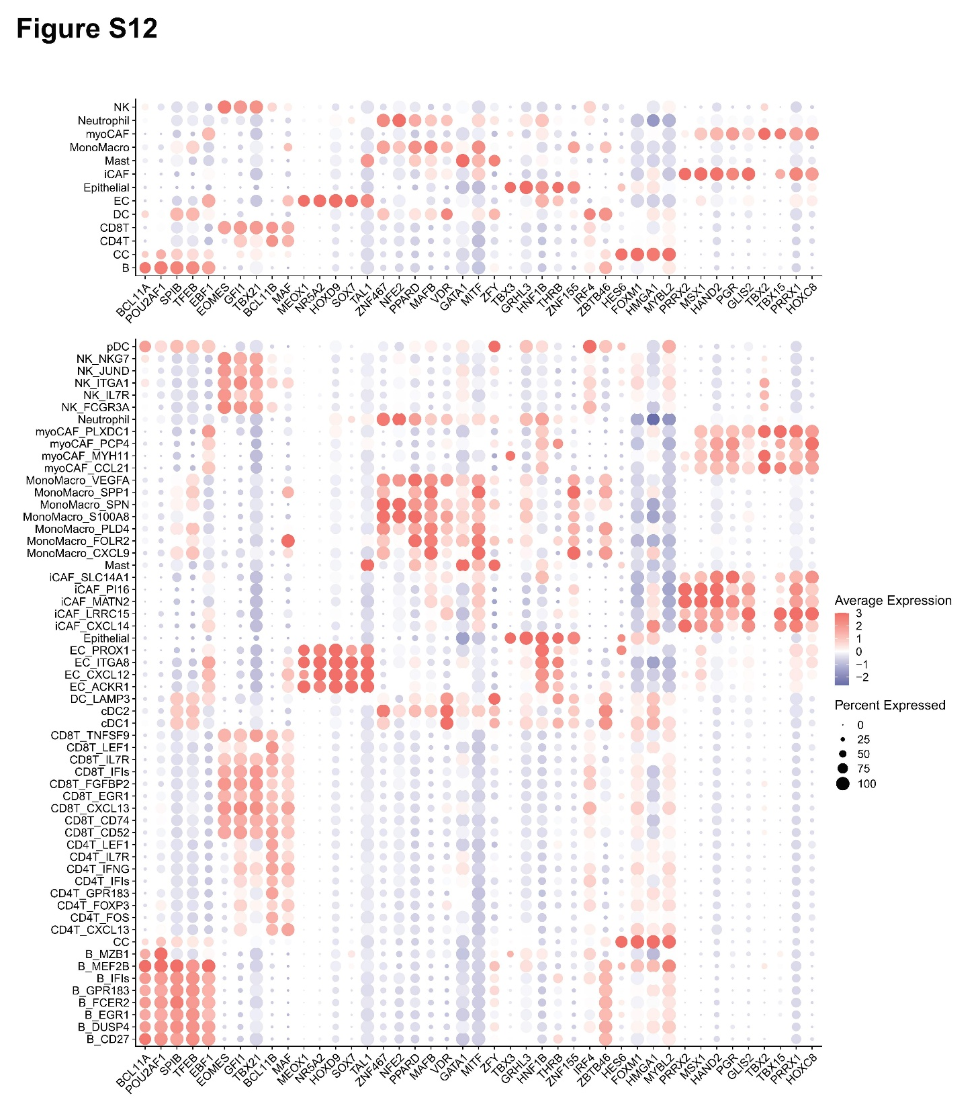
Figure S12. TF regulatory activities inferred using pySCENIC are shown for major cell lineages and their respective subtypes, providing insights into lineage-specific regulatory programs. TF, transcription factor.
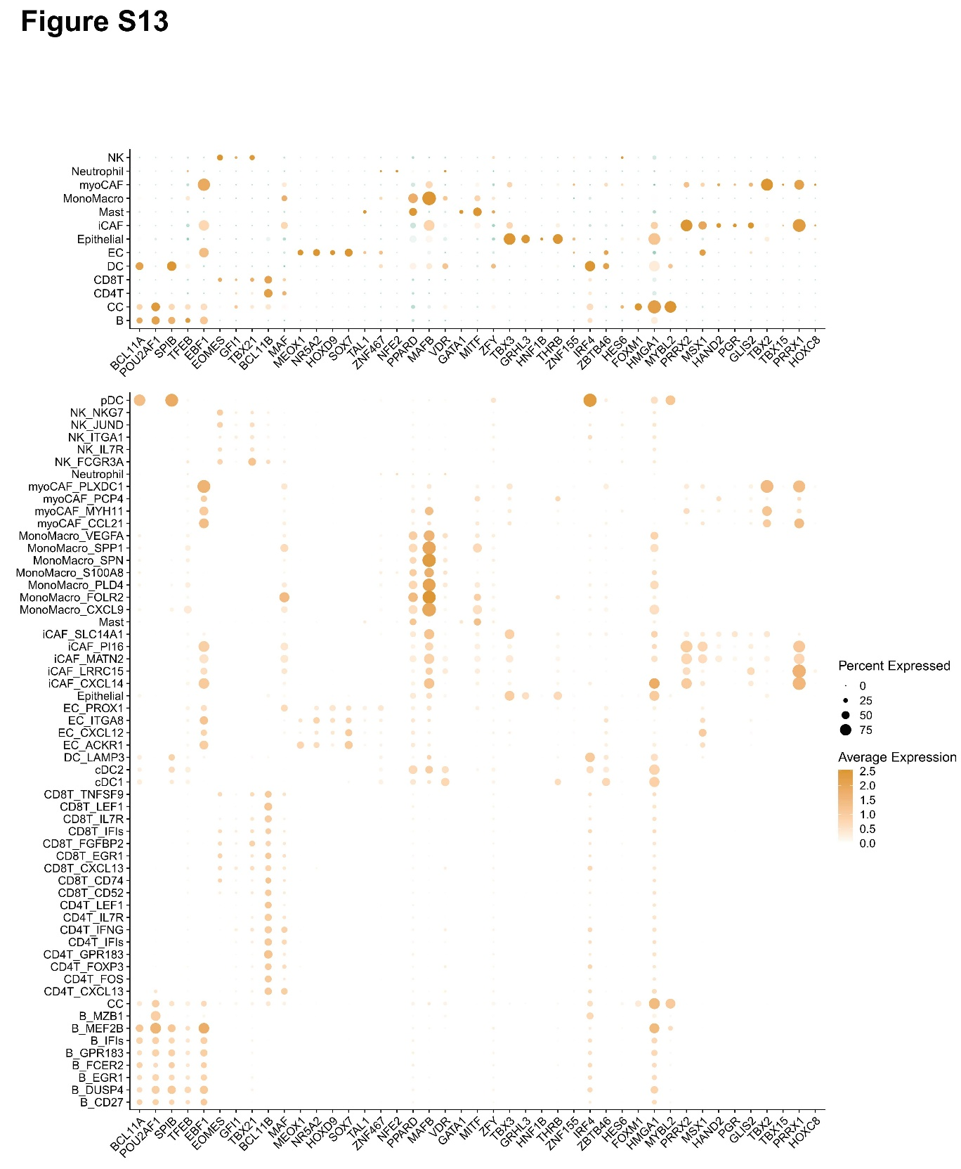
Figure S13. RNA expressions of TFs inferred using pySCENIC are shown for major cell lineages and their respective subtypes. TF, transcription factor.
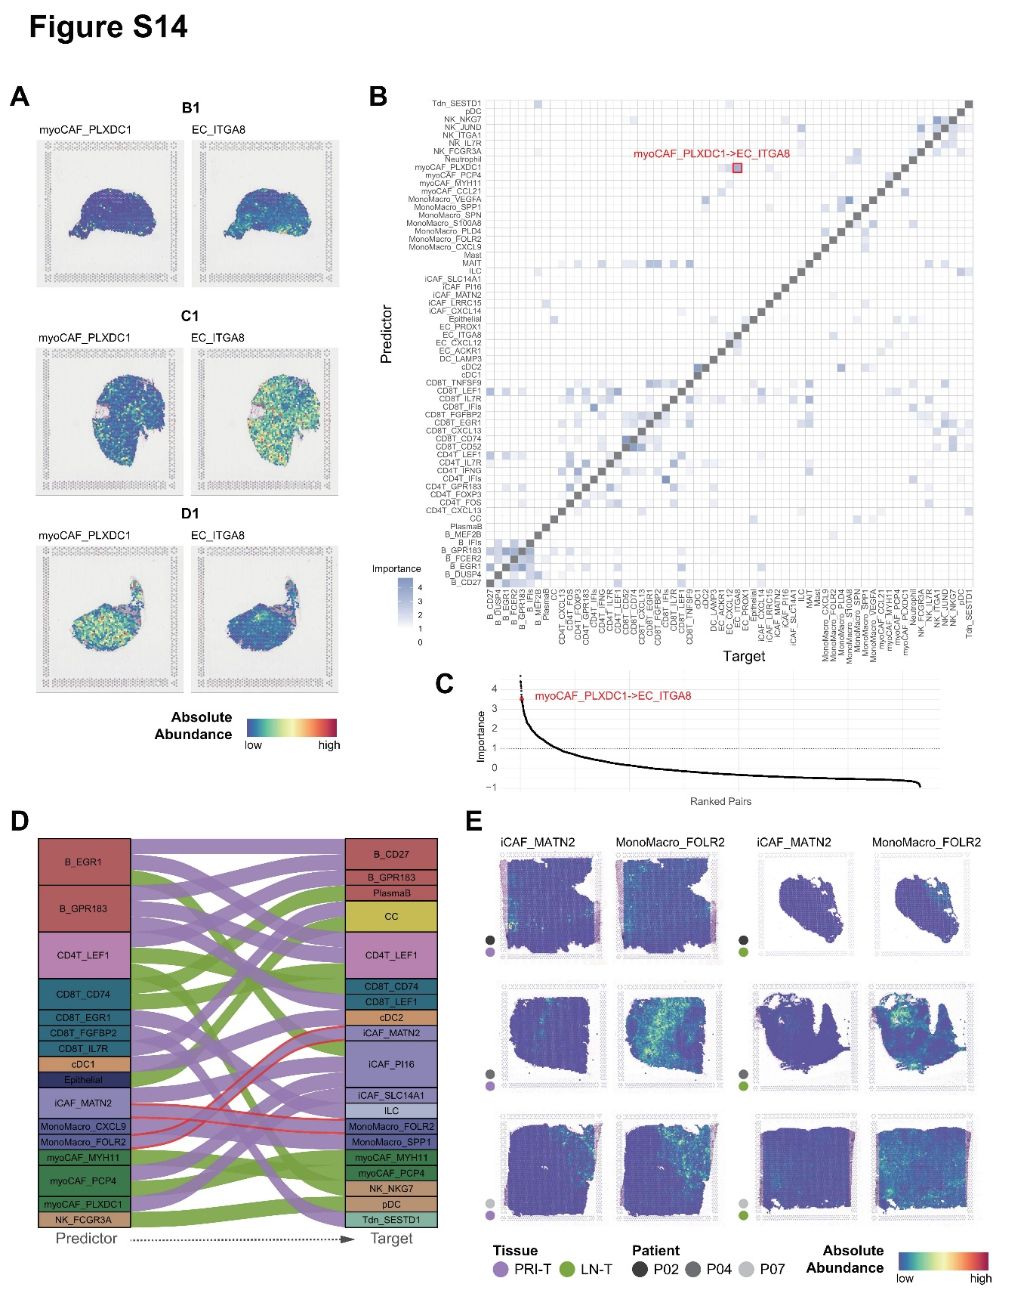
Figure S14. A. Spatial distribution of PLXDC1+ myoCAFs and ITGA8+ endothelial cells in an external spatial transcriptomic cohort of bladder cancer. Absolute cell-type abundances were inferred using cell2location; B. For the Etsaer et al. 2022 cohort, MistyR was applied to evaluate the ability of cell subtypes in the rows to predict the locations of cell subtypes in the columns, quantified by importance using the intraview. The the color of the grid indicates the aggregated Importance across four samples; C. All cell-cell pairs (n=3,660) were ranked by their aggregated importance from high to low, with the co-localization between myoCAF_PLXDC1 (predictor) and EC_ITGA8 (target) highlighted in red; D. Sankey plot illustrating primary- and metastasis-specific cell-cell colocalization relationships. Cell subtypes are color-coded according to their corresponding major cell lineages, as in Figure 1; E. in situ spatial plot showing the absolute abundance of iCAF_MATN2 and MonoMacro_FOLR2.
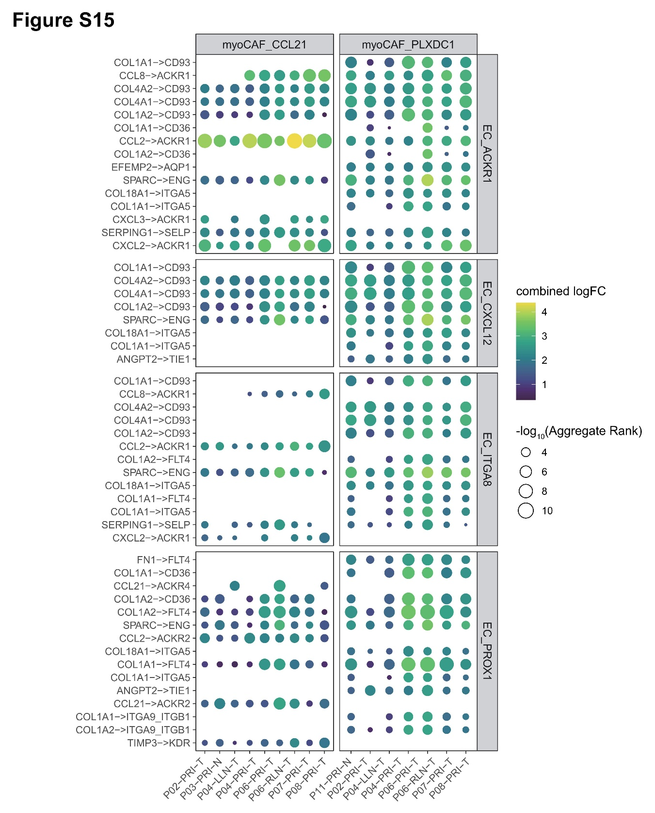
Figure S15. Dotplot showing interactions between myoCAF_CCL21/myoCAF_PLXDC1 and EC subtypes. myoCAFs were designated as source cells and ECs as target cells. The top 300 LIANA-predicted LRs with the lowest aggregate ranks were visualized, showing their strengths and aggregate ranks across samples. EC, endothelial cell.

