Supplemental Tables

Table S1 The siRNA sequences of si-CD155, si-NC and si-TEAD1

Name | Sence (5’-3’) | Anti-sense (5’-3’)
si-CD155 | UUCUCCGAACGUGUCACGUTT | AAGAUGAUGGCGUUACGGGTT
si-NC | UUCUCCGAACGUGUCACGUTT | ACGUGACACGUUCGGAGAATT
si-TEAD1 | GGAUCAGACUGCAAAGGAUTT | AUCCUUUGCAGUCUGAUCCTT

Name | Plasmid sequence
Vector | TACAGTGGGAGGTGGGAGTTTTTTAAGCAAGTAAAACC  TCTACAAATGTGGTATGGCTGATTATGATCTAGAGTCGC  GGCCGCATTGATATCAATGGCGCGCCGATACCGGTGAT  GGATCCCGGGCCCGCGGTACCGTCGACTGCAGAATTCT  CACTGGAGCTCCTGGGAGGCCTGCGCCAGGTGCCGGCT  CCGGCAGCAGATGGCAACGGCTGTCACGGCCCCTTCGC  TGGTGCTGCCTGTAGTGCTGACGTCCCGGCTCCTGACTA  CACACGTGTTGTCTACGGCGTAGGCCCCCAGGACGTGG  GAGGTCCCAGGGAGGGCACTGCAGCCAGTCAGGGTCCA  GCCCTCCTCGCAGGCCACGGTCACCTGCTCCTGAGGGGC  CGGGATTCCATGCTCCTTGACTTTGCATTCCAGACCTGG  GGCATGGCAGCAGGAAGCGTGGATGCTGGCCTCCCTGT  GGCCCACGCACTGGTTGGGCTGACCTCGTGGCCTCAGC  ACAGGCGGCTTGTGGGTGCCAAGGTCCTCCACCTCCCA  GTGGGAGCTGCAGCCTGTGAGGACGTGGCCCTGTTGGT  GGCAGTGGACACGGGTCCCCATGCTGGCCTCAGCTGGT  GGAGCTGTGTGGACGCTGCAGTTGGCCTGGGGTAGCAG  GCAGCACCTGGCAATGGCGTAGACACCCTCACCCCCAA  AAGCGTTGTGGGCCCGGCAGACCAGCTTGCCCCCTTGG

GCCTCCATGCGCTCGCCCCGCCGCTTCCCACTCCTGGAG

AAACTGGAGCAGCTCAGCAGCTCCTCATCTGGGGCGCA

GCGGGCGACGGCTGTGGCCATCCGTGTAGGCCCCGAGT

GTGCTGACCATACAGTCCTGCAAAACAGCTGCCAACCT

GCCCCATGGGTGCTGGGGGGCAGGGCGGCCACCAGGTT

GGGGGTCAGTACCCGCTGGTCCTCAGGGAACCAGGCCT

CATTGATGACATCTTTGGCAGAGAAGTGGATCAGTCTCT

GCCTCA

TGGCCGTTTTTGGCTTTTTTGTTAGACGAAGCTTGGGCT
CD155

(Human)

GCAGGTCGACTCTAGAGGATCCAACTTTGTGCCAACCG

GTCGCCACCATGGCCCGAGCCATGGCCGCCGCGTGGCC

GCTGCTGCTGGTGGCGCTACTGGTGCTGTCCTGGCCACC

CCCAGGAACCGGGGACGTCGTCGTGCAGGCGCCCACCC

AGGTGCCCGGCTTCTTGGGCGACTCCGTGACGCTGCCCT

GCTACCTACAGGTGCCCAACATGGAGGTGACGCATGTG

TCACAGCTGACTTGGGCGCGGCATGGTGAATCTGGCAG

CATGGCCGTCTTCCACCAAACGCAGGGCCCCAGCTATTC

GGAGTCCAAACGGCTGGAATTCGTGGCAGCCAGACTGG

GCGCGGAGCTGCGGAATGCCTCGCTGAGGATGTTCGGG

TTGCGCGTAGAGGATGAAGGCAACTACACCTGCCTGTT

CGTCACGTTCCCGCAGGGCAGCAGGAGCGTGGATATCT

GGCTCCGAGTGCTTGCCAAGCCCCAGAACACAGCTGAG

GTTCAGAAGGTCCAGCTCACTGGAGAGCCAGTGCCCAT

GGCCCGCTGCGTCTCCACAGGGGGTCGCCCGCCAGCCC

AAATCACCTGGCACTCAGACCTGGGCGGGATGCCCAAT

ACGAGCCAGGTGCCAGGGTTCCTGTCTGGCACAGTCAC

TGTCACCAGCCTCTGGATATTGGTGCCCTCAAGCCAGGT

GGACGGCAAGAATGTGACCTGCAAGGTGGAGCACGAG

AGCTTTGAGAAGCCTCAGCTGCTGACTGTGAACCTCACC

GTGTACTACCCCCCAGAGGTATCCATCTCTGGCTATGAT

AACAACTGGTACCTTGGCCAGAATGAGGCCACCCTGAC

CTGCGATGCTCGCAGCAACCCAGAGCCCACAGGCTATA

ATTGGAGCACGACCATGGGTCCCCTGCCACCCTTTGCTG

TGGCCCAGGGCGCCCAGCTCCTGATCCGTCCTGTGGACA

AACCAATCAACACAACTTTAATCTGCAACGTCACCAAT

GCCCTAGGAGCTCGCCAGGCAGAACTGACCGTCCAGGT

CAAAGAGGGACCTCCCAGTGAGCACTCAGGCATGTCCC

GTAACGCCATCATCTTCCTGGTTCTGGGAATCCTGGTTT

TTCTGATCCTGCTGGGGATCGGGATTTATTTCTATTGGT

CCAAATGTTCCCGTGAGGTCCTTTGGCACTGTCATCTGT

GTCCCTCGAGTACAGAGCATGCCAGCGCCTCAGCTAAT

GGGCATGTCTCCTATTCAGCTGTGAGCAGAGAGAACAG

CTCTTCCCAGGATCCACAGACAGAGGGCACAAGGTGAA

ATTCCTGTGGAATGTGTGTCAGTTAGGGTGTGGAAAGTC

CCCAGGCTCCCCAGCAGGCAGAAGTATGCAAAGCATGC

ATCTCAATTAGTCAGCAACCAGGTGTGGAAAGTCCCCA

GGCTCCCCAGCAGGCAGAAGTATGCAAAGCATGCATCT

CAATTAGTCAGCAACCATAGTCCCGCCCCTAACTCCGCC

CATC

Genes | Forward (5’-3’) | Reverse (5’-3’)
CD155 | GGTGGACGGCAAGAATGTGA | TATAGCCTGTGGGCTCTGGGTT
CD86 | CTGCTCATCTATACACGGTTACC | GGAAACGTCGTACAGTTCTGTG
TNF-α | TGGAGAAGGGTGACCGACTC | TGCCCAGACTCGGCAAAG
IL-6 | ACTCACCTCTTCAGAACGAATTG | CCATCTTTGGAAGGTTCAGGTTG
CD163 | ACGCGTGGAGGGAATATGTG | ATTGGTCCAGAGCCTTCTCC
TGF-β | TACCTGAACCCGTGTTGCTCTC | GTTGCTGAGGTATCGCCAGGAA
IL-10 | TCAAGGCGCATGTGAACTCC | GATGTCAAACTCACTCATGGCT
β-actin | GATTCCTATGTGGGCGAC | TTGTAGAAGGTGTGGTGCC

Matrix ID | Name | Score | Relative score | Sequence ID | Start | End | Strand | Predicted sequence
MA0090.2 | TEAD1 | 9.71142 | 0.922217260346 | SLC2A1 | 1416 | 1425 | - | CACATTCCCG
MA0090.2 | TEAD1 | 8.9742 | 0.907027452075 | SLC2A1 | 790 | 799 | + | GGAATTCCAT
MA0090.2 | TEAD1 | 8.26747 | 0.892466039612 | SLC2A1 | 1309 | 1318 | - | CGCCTTCCTC
MA0090.2 | TEAD1 | 8.16047 | 0.890261368527 | SLC2A1 | 1499 | 1508 | + | TACTTTCCAT
MA0090.2 | TEAD1 | 7.62171 | 0.879160554181 | SLC2A1 | 1355 | 1364 | - | TGCATACCCA
MA0090.3 | TEAD1 | 10.62 | 0.875338612796 | SLC2A1 | 1414 | 1426 | - | CCACATTCCCGTT
MA0090.2 | TEAD1 | 7.26167 | 0.87174228075 | SLC2A1 | 291 | 300 | - | TGCATTCTGG
MA0090.2 | TEAD1 | 7.20536 | 0.870582008214 | SLC2A1 | 1492 | 1501 | + | TAAATACTAC
MA0090.2 | TEAD1 | 6.87162 | 0.86370573108 | SLC2A1 | 1659 | 1668 | + | CGCATCCCAG
MA0090.2 | TEAD1 | 6.69954 | 0.860160059803 | SLC2A1 | 1638 | 1647 | + | AGCTTTCCAC
MA0090.2 | TEAD1 | 6.48914 | 0.855824983485 | SLC2A1 | 261 | 270 | - | TCAATTCCTG
MA0090.1 | TEAD1 | 10.2131 | 0.850775215188 | SLC2A1 | 1414 | 1425 | - | CACATTCCCGTT
Select the most likely combination sequence in the prediction (TACTTTCCAT).

Name

Target sequence

GLUT1
TGTAAACTGGTGCCATGAAGAAGGACCGTGATGGCCA

GGCTTGGCCCTTACTCCCTCCATGACAATTTCAGACAG

promoter-WT

ATGAGCAGGAGAGTGGCAGGGTGCAGGACTGGAGGAC

AAAAGACCAGAGGAGATGGAGGCCCTGCAGACAGCAG

GGGAGGGAAGGAGGATGAGGTGGTGTAGACAGCGGA

GTCAGCAGGACTTGGTCTGTCCAGGGGTGAGGAGAGA

GGTGGCCCAAGCTTTCCAGGCTGAGCATAGAGAGACC

ACAGGAATTGAAGCCTTGGGCAGGGGGGTGCCCAGAA

TGCACCTGCCTTCTGTTTCAGGGCTCCATACTCAACCA

AGGTGCCCCTCAGCCAGAACTGGACACATTGCCAGAG

AACTCCAGGGGTCATCTGGTCGGCTCAGCCTCCCGGTT

TCCGACAGACAGTAAGCCCACCATGACTCCCTCCATCG

GGAAAGGGACCCTCAAGACTTTGATCAGACCTTTGGAC

TGGGGGTCCTTCCCTTCACTGTGTCTCAAGTAAGGCAC

TGGTCTAGAGGAAATAAGGTGAAGTCAGATGATAGCA

ATACCACTACCAGTGCAGTGGCACATGCCTGCACTCCC

AGCTACTACGGAGGCTAAGGTGGGAGGATCACTTGAG

CCCAGGAGTTTGAGACCAGCATTTATTTATTTACTAAC

AGACTAAATAAATAAACCAACAATACCACCAACCAGT

AAATGAGAACTTCCATGCTAAACACTTCATGAGCTTAT

CTGGAAATTGCACCTCTCCTGATAGCAATGAGATTGGT

GTGGGAATTCCATTTACTCATAAGAAGACAGCCTCGGC

CGGGCTCAGTGGCTCACGCCTGTAATCCCAGTACTTTG

GGAGGCGAGGTGGGTGGATCACGAGGTCAAGAGTTCA

AGACCAGCCTGGCCAAAATGGTGAAACCCCGTCTCTAC

TAAAAATAAAAATAATTAGCCAGGGGTGATAGCGGGC

GCCTGTAATCCCAGCTACTCGGGAGGCTGAGGCAGAG

AACTGCTTGAATCCGGGAGGCGGAGGTTACAGTGAGC

CGAGATCGTGCCGCTGCACTCCAGCCTGGGCGACAGA

GCGAGACTCTGTCTGAGAAAAAAAAAAATTAAAGAAA

AAAACGAAAACAGCCTCACTGGCCAGGAACTCGCCCA

GGATCGCGGCCGGGCCAGTATACAGTTGAGCTGGTTCA

AACCCGAGGTCTATCATGTCCTTAATGTCCTATCATGTC

AGTCAGTTAGCCTGCCTTTCATATTTTCCACACTTACAG

GTCACCATAGACTCACCTGAACTGTGAGAAGTAGAGG

AAGGCGTCCCAGAGGAGGTGATTTTAAAGCCCAGGTTT

GAGATGGGTATGCATTTCCAGGCAAGAGAGCCCGGCC

GGTGCAAAAGCAAGGCTTGGCTCACAAACGGGAATGT

GGGGGGTGGAGACAGGGAAGGGAGAAGTCAATCCCTG

GGCAAGACCTCCTGGAGTCTCTCTAACAAATAAATACT

ACTTTCCATGCAGTAGACGCTGTTCTAAACACTTTACA

AATATTAACTCACTTGGTCTTTCTACAACCCTACGAGG

TGGTACTGTTACTATCCCTAGTGCACCGAAGTCACCCA

GCGGCCGAGTGAGAACTCCAGTCCAGCTTTCCACCCGC

TACTCCGCGCATCCCAGCTTGCCTTACAGCCGGGTACC

GGCTCCACCATTTTGCTAGAGAAGGCCGCGGAGGCTCA

GAGAGGTGCGCACACTTGCCCTGAGTCACACAGCGAA

TGCCCTCCGCGGTCCCAACGCAGAGAGAACGAGCCGA

TCGGCAGCCTGAGCGAGGCAGTGGTTAGGGGGGGCCC

CGGCCCCGGCCACTCCCCTCACCCCCTCCCCGCAGAGC

GCCGCCCAGGACAGGCTGGGCCCCAGGCCCCGCCCCG

AGGTCCTGCCCACACACCCCTGACACACCGGCGTCGCC

AGCCAATGGCCGGGGTCCTATAAACGCTACGGTCCGCG

CGCTCTCTGGC

TGTAAACTGGTGCCATGAAGAAGGACCGTGATGGCCA
GLUT1

promoter-MUT

GGCTTGGCCCTTACTCCCTCCATGACAATTTCAGACAG

ATGAGCAGGAGAGTGGCAGGGTGCAGGACTGGAGGAC

AAAAGACCAGAGGAGATGGAGGCCCTGCAGACAGCAG

GGGAGGGAAGGAGGATGAGGTGGTGTAGACAGCGGA

GTCAGCAGGACTTGGTCTGTCCAGGGGTGAGGAGAGA

GGTGGCCCAAGCTTTCCAGGCTGAGCATAGAGAGACC

AAGCCTTGGGCAGGGGGGTGCCCTGCCTTCTGTTTCAG

GGCTCCATACTCAACCAAGGTGCCCCTCAGCCAGAACT

GGACACATTGCCAGAGAACTCCAGGGGTCATCTGGTCG

GCTCAGCCTCCCGGTTTCCGACAGACAGTAAGCCCACC

ATGACTCCCTCCATCGGGAAAGGGACCCTCAAGACTTT

GATCAGACCTTTGGACTGGGGGTCCTTCCCTTCACTGT

GTCTCAAGTAAGGCACTGGTCTAGAGGAAATAAGGTG

AAGTCAGATGATAGCAATACCACTACCAGTGCAGTGG

CACATGCCTGCACTCCCAGCTACTACGGAGGCTAAGGT

GGGAGGATCACTTGAGCCCAGGAGTTTGAGACCAGCA

TTTATTTATTTACTAACAGACTAAATAAATAAACCAAC

AATACCACCAACCAGTAAATGAGAACTTCCATGCTAAA

CACTTCATGAGCTTATCTGGAAATTGCACCTCTCCTGAT

AGCAATGAGATTGGTGTGTTACTCATAAGAAGACAGCC

TCGGCCGGGCTCAGTGGCTCACGCCTGTAATCCCAGTA

CTTTGGGAGGCGAGGTGGGTGGATCACGAGGTCAAGA

GTTCAAGACCAGCCTGGCCAAAATGGTGAAACCCCGTC

TCTACTAAAAATAAAAATAATTAGCCAGGGGTGATAG

CGGGCGCCTGTAATCCCAGCTACTCGGGAGGCTGAGGC

AGAGAACTGCTTGAATCCGGGAGGCGGAGGTTACAGT

GAGCCGAGATCGTGCCGCTGCACTCCAGCCTGGGCGAC

AGAGCGAGACTCTGTCTGAGAAAAAAAAAAATTAAAG

AAAAAAACGAAAACAGCCTCACTGGCCAGGAACTCGC

CCAGGATCGCGGCCGGGCCAGTATACAGTTGAGCTGGT

TCAAACCCGAGGTCTATCATGTCCTTAATGTCCTATCAT

GTCAGTCAGTTAGCCTGCCTTTCATATTTTCCACACTTA

CAGGTCACCATAGACTCACCTGAACTGTGAGAAGTATC

CCAGAGGAGGTGATTTTAAAGCCCAGGTTTGAGATTTC

CAGGCAAGAGAGCCCGGCCGGTGCAAAAGCAAGGCTT

GGCTCACAGGGGTGGAGACAGGGAAGGGAGAAGTCAA

TCCCTGGGCAAGACCTCCTGGAGTCTCTCTAACAAAGC

AGTAGACGCTGTTCTAAACACTTTACAAATATTAACTC

ACTTGGTCTTTCTACAACCCTACGAGGTGGTACTGTTA

CTATCCCTAGTGCACCGAAGTCACCCAGCGGCCGAGTG

AGAACTCCAGTCCCCGCTACTCCGCTTGCCTTACAGCC

GGGTACCGGCTCCACCATTTTGCTAGAGAAGGCCGCGG

AGGCTCAGAGAGGTGCGCACACTTGCCCTGAGTCACAC

AGCGAATGCCCTCCGCGGTCCCAACGCAGAGAGAACG

AGCCGATCGGCAGCCTGAGCGAGGCAGTGGTTAGGGG

GGGCCCCGGCCCCGGCCACTCCCCTCACCCCCTCCCCG

CAGAGCGCCGCCCAGGACAGGCTGGGCCCCAGGCCCC

GCCCCGAGGTCCTGCCCACACACCCCTGACACACCGGC

GTCGCCAGCCAATGGCCGGGGTCCTATAAACGCTACGG

TCCGCGCGCTCTCTGGC

TEAD1, WT TTGGCTTTAAAGTGAATTTATCTTTAGTATGATAGTTAT

ATGAAAATTATAGGATTTGTGTGCAGAGAATTTTTTTA

TAAAGTGCTTTGTAAAAAAAAAAAAATGTATTCTAGCT

TTTGCGGTACATATGTGTGATAACTTTAATACCCATGA

CAGTTAAGTGCAATTATTTCATCACTCTAAAAATGCTA

TTTTTGTGTCAGTTCCTGCAGGTGTTTTCATGTCTTTGC

AAAGTGACACATTTTGATGCCTTCTTGATAAAGTGGTA

GACATTTTGTAGCTTTCTAGAAACTTTGTATTCATACGG

TATCAATGAAAAATAAAGAAAATGAAAGTGTGGG

TEAD1, MUT TTGGCTTTAAAGTGAATTTATCTTTAGTATGATAGTTAT

ATGAAAATTATAGGATTTGTGTGCAGAGAATTTTTTTA

TAAAGTGCTTTGTAAAAAAAAAAAAATGTATTCTAGCT

TTTGCGGTACATATGTGTGATAACTTTAATACCCATGA

CAGTTAAGTGCAATTATTTCATCACTCTAAAAATGCTA

TTTTTGTGTCAGTTCCTGCAGGTGTTTTCATGTCTTTGC

AAAGTGACACATTTTGATGCCTTCTTGATAAAGTGGTA

GACATTTTGTAGCTTTCTAGAAACTTTGTATTCATACGG

TATCAGCAGGGGGTAAAGAAAATGAAAGTGTGGG

 | Sence primer  Forward (5’-3’) | Anti-sense primer  Reverse (5’-3’)
GLUT1
 | AAAGCCCAGGTTTGAGATG | GGTTGTAGAAAGACCAAGTGAGT
ChIP primer

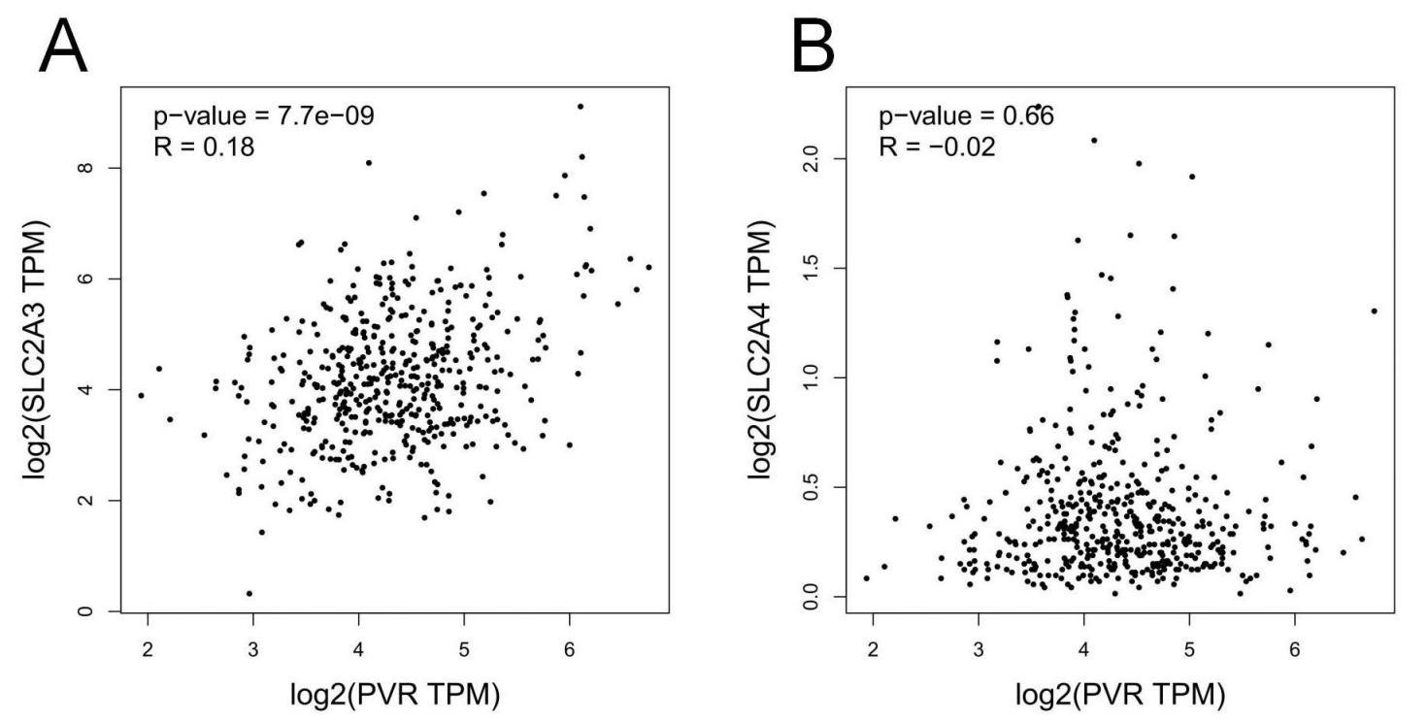

Fig. S1 A-B Bioinformatics analysis of the correlation between CD155 expression and

GLUT3/GLUT4 in lung adenocarcinoma.

Fig 1
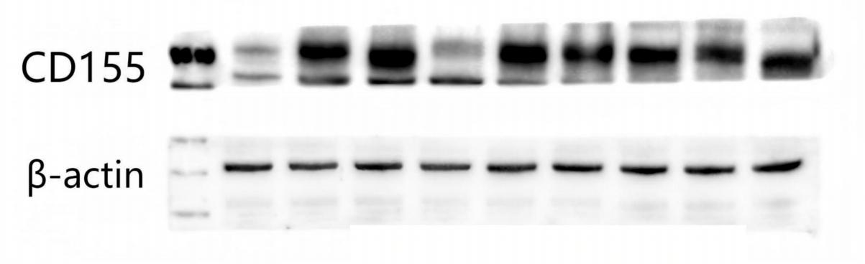

Fig 2B
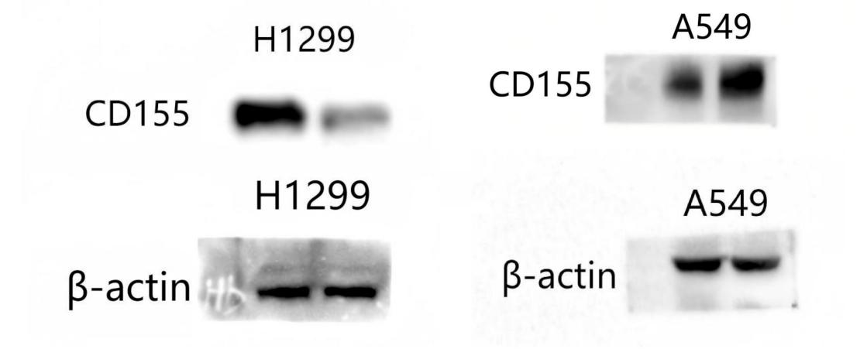

Fig 2G
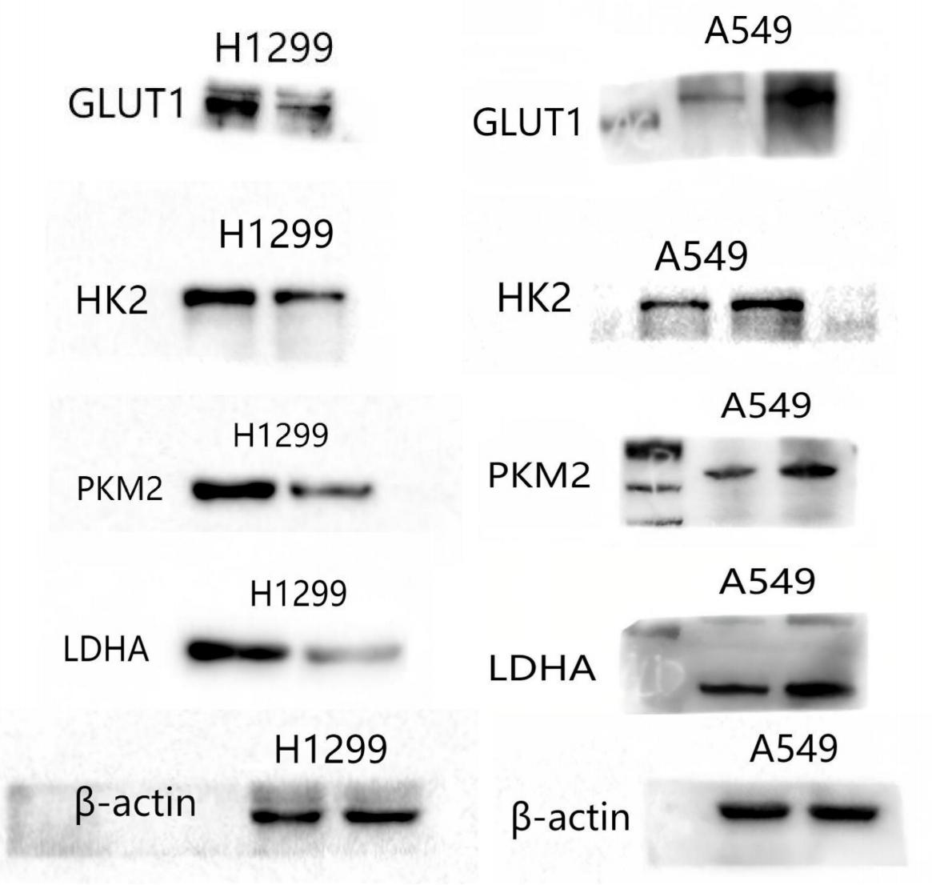

Fig 2L

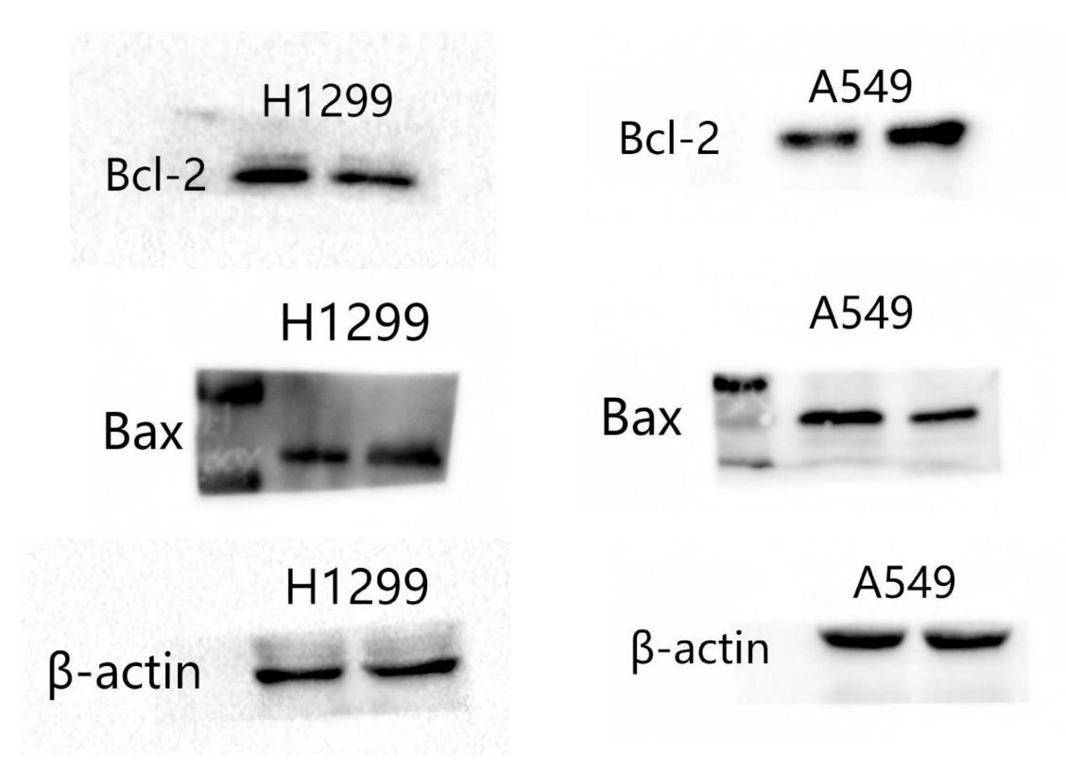

Fig 4B

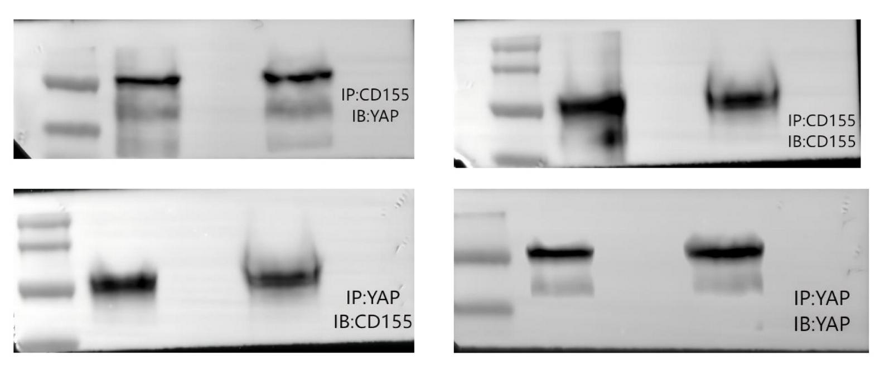

Fig 4C

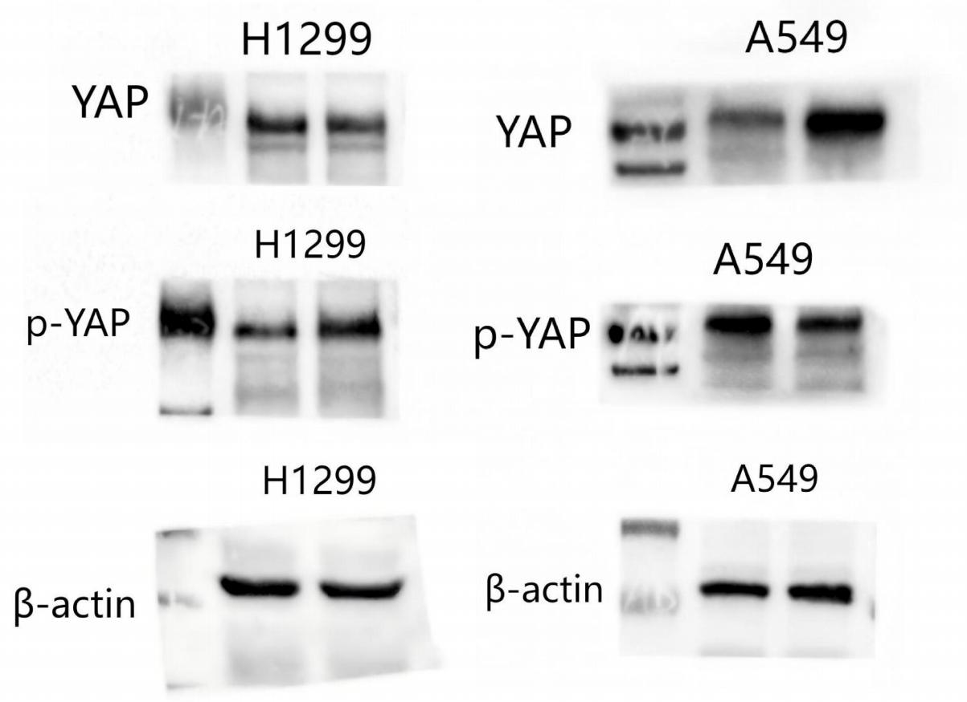

Fig 4D
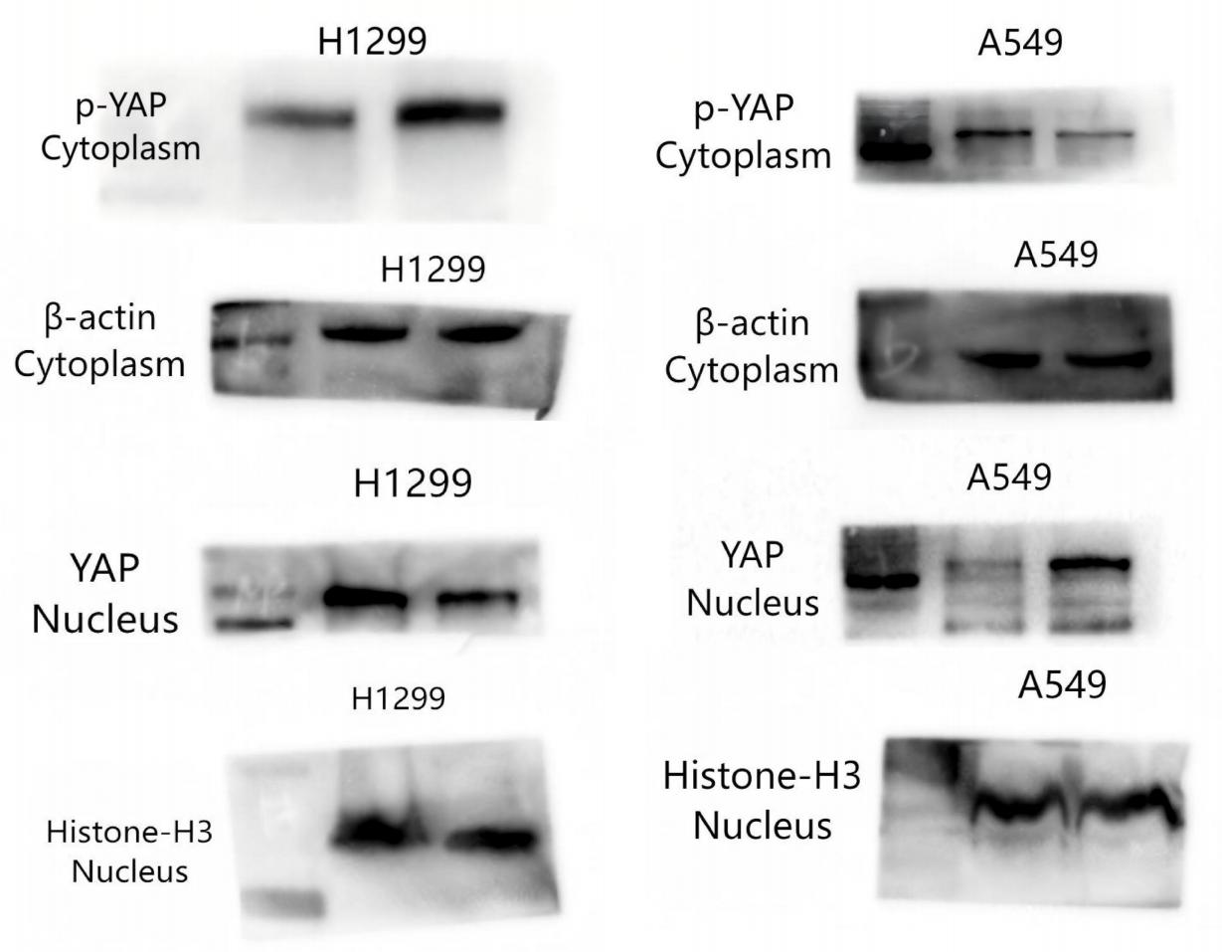

Fig 5E
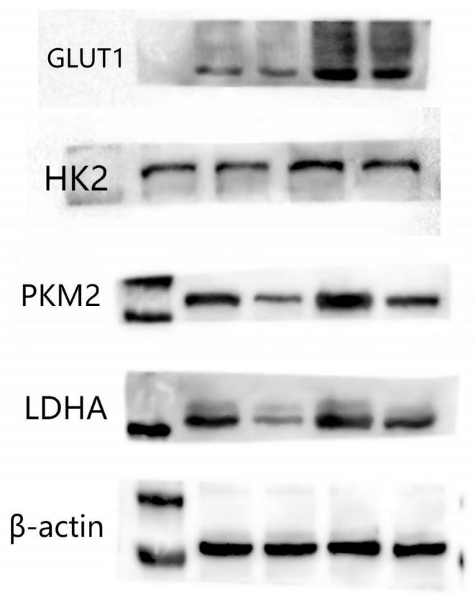

Fig 5J

