DMEM for Cell culture
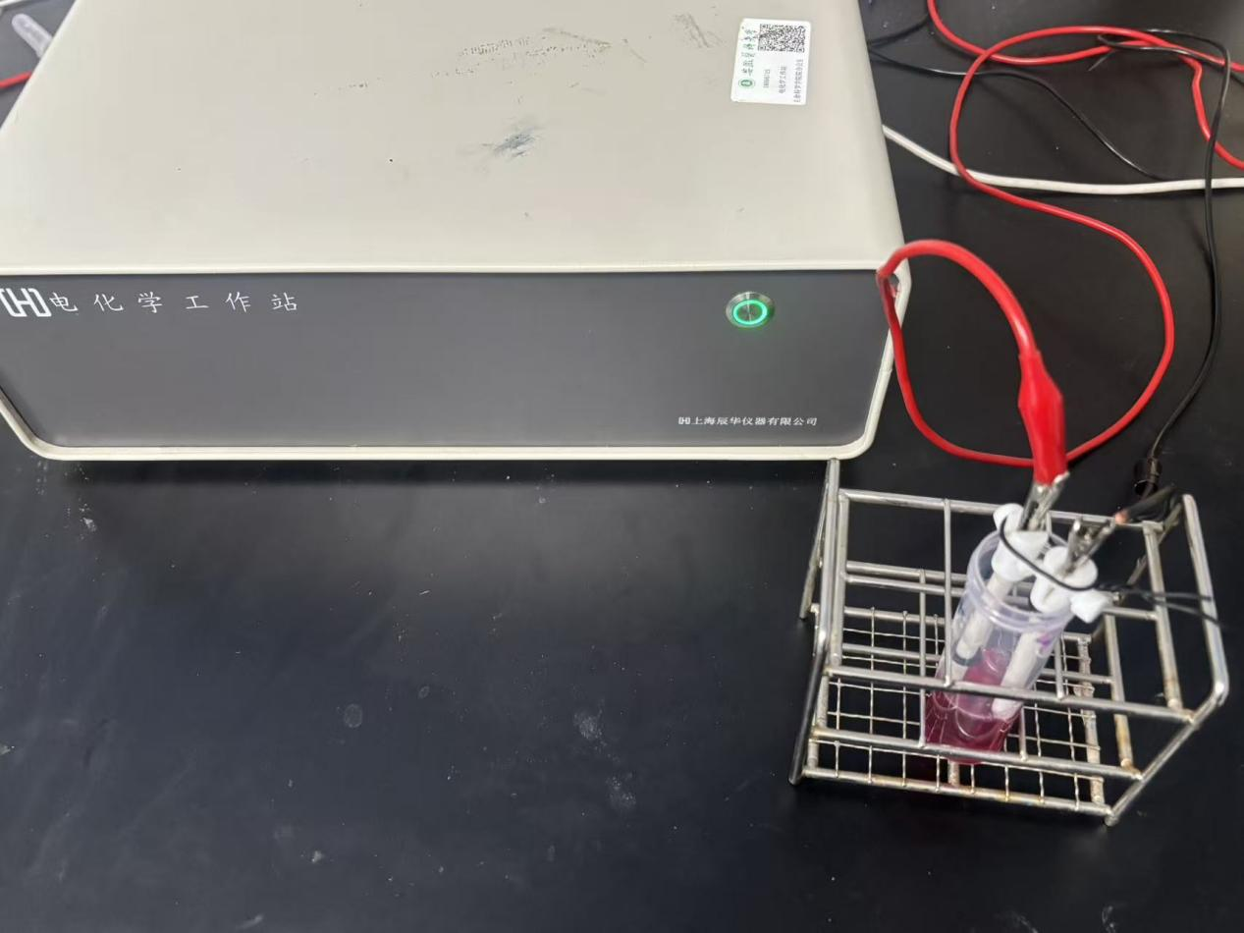

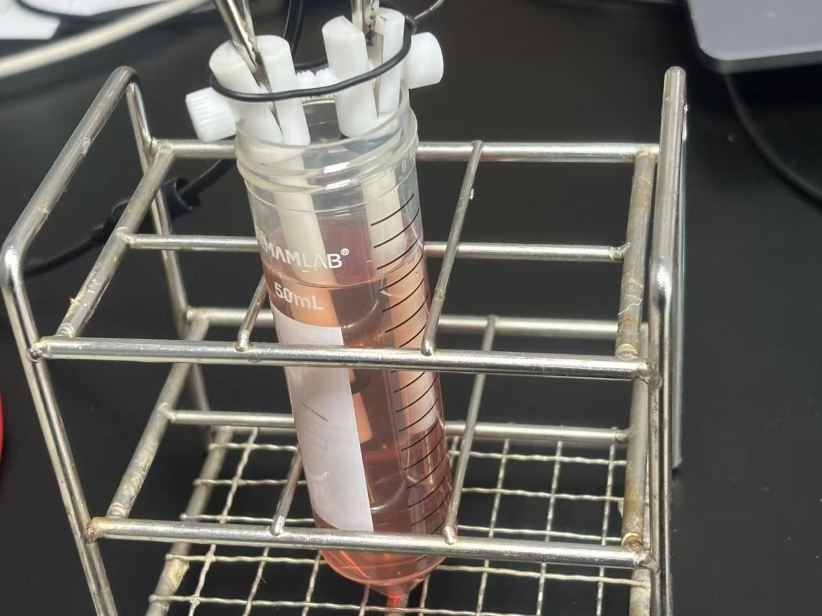

U-shaped bridge
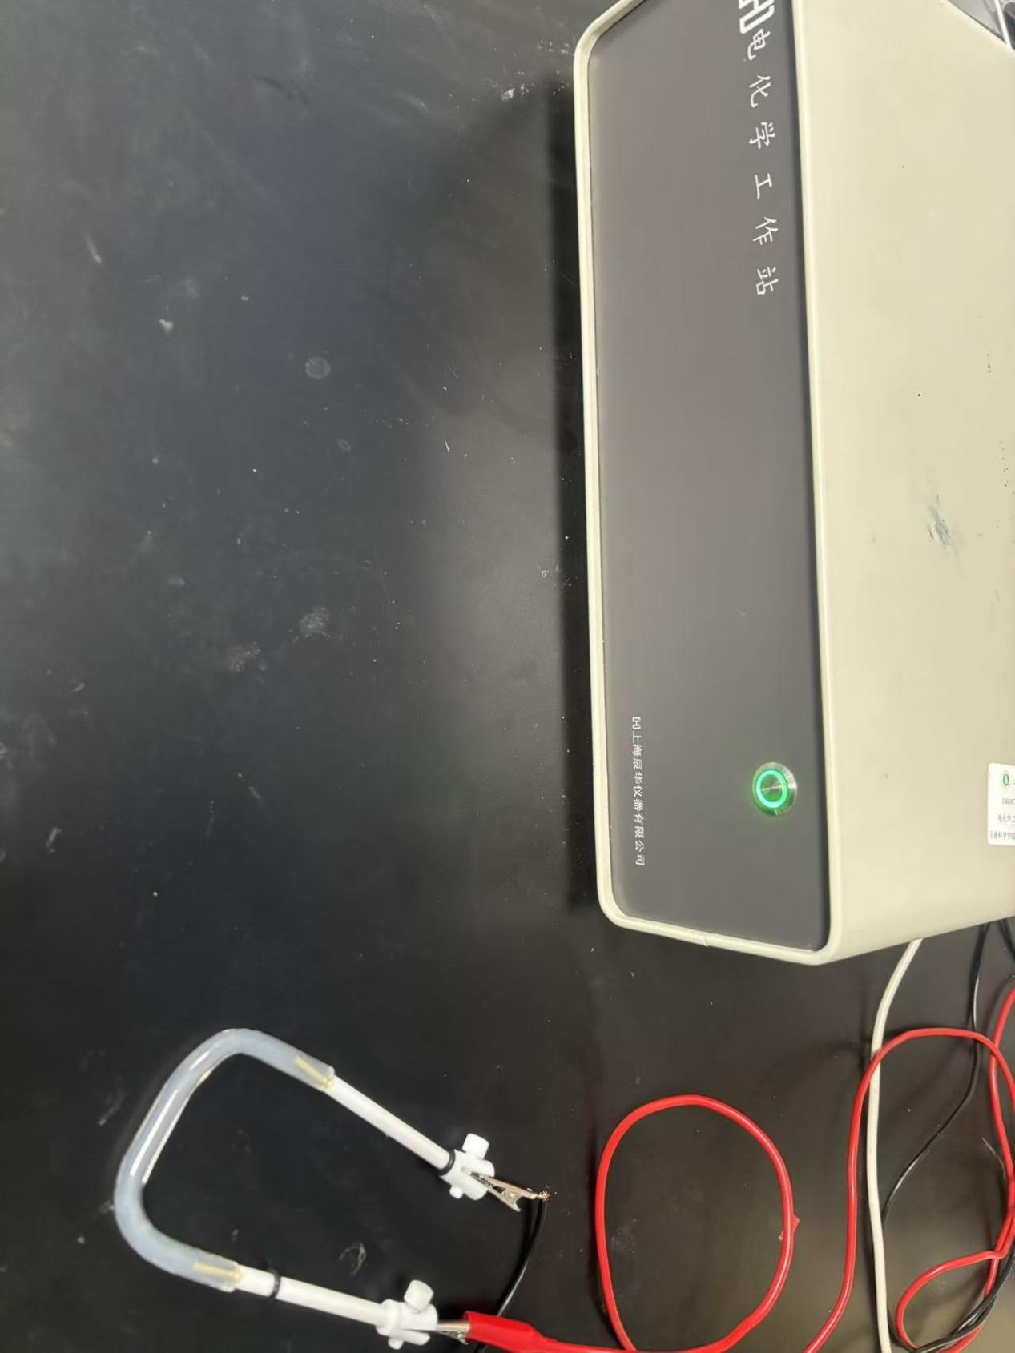
The U-shaped bridge and electrode interfaces using a CHI700F electrochemical workstation (CH Instruments, USA); when measured twice in series, the combined resistance was 5774.74 Ω. The resistance of the complete culture medium was 48.37 Ω. With 1 mA stimulation and 15 cm electrode spacing, the voltage drop across the culture medium was 48.4 mV, yielding an estimated electric field of ~0.32 mV/mm.

