Blank Tube
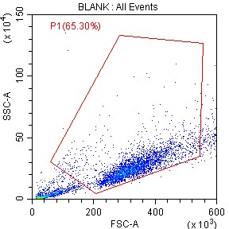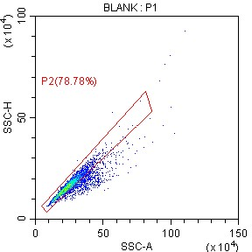

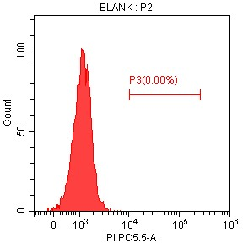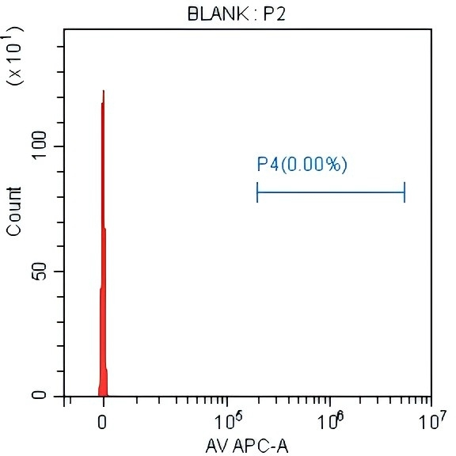
AV Tube
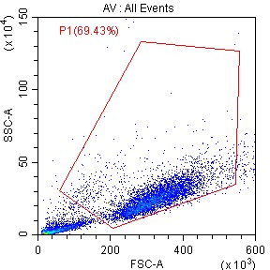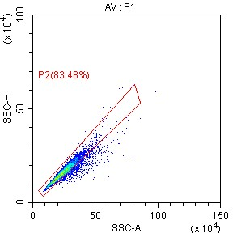

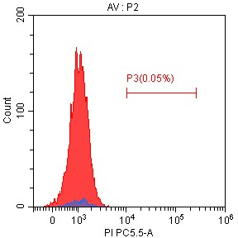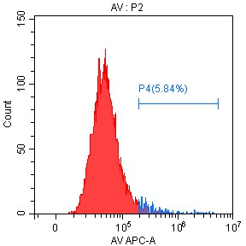
PI Tube
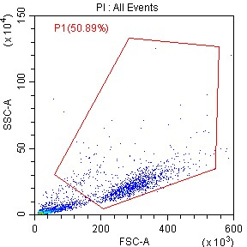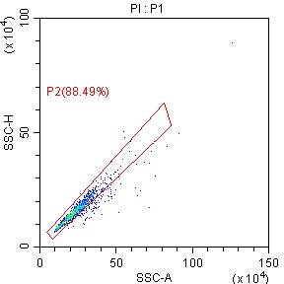
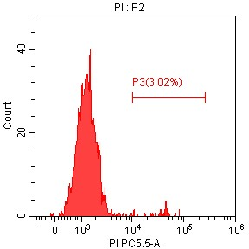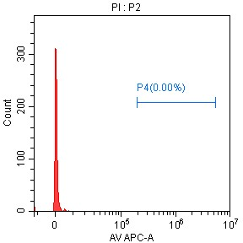
Test2-Con Tube
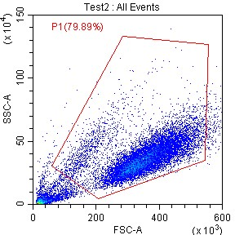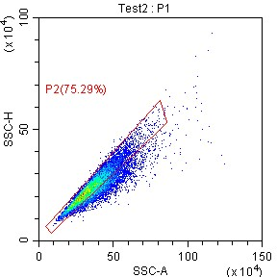
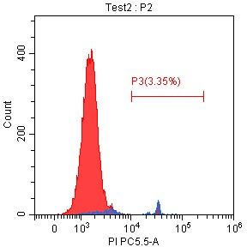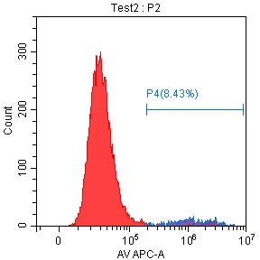
Apoptosis was assessed via Annexin V-AF647/7-AAD staining (Gooniebio, 100-103, Guangzhou, China) following the manufacturer's instructions and analyzed by flow cytometry. The culture medium was collected, and the medium from the culture chambers was transferred to a fresh centrifuge tube. Trypsin digestion solution was added to cover the adherent cells, which were subsequently incubated at room temperature until the cells detached. The collected culture medium was added to the cells, and the suspension was transferred to a centrifuge tube. The cells were subsequently centrifuged at 1500 rpm for 5 min, after which the supernatant was discarded. For staining, 100 μL of the cell suspension was transferred to a new EP tube, 5 μL of Annexin V-AF647 was added, and the mixture was gently mixed. Then, 5 μL of 7-AAD was added, and the mixture was mixed gently. The cells were incubated at room temperature in the dark for 15 min. After incubation, 400 μL of 1X binding buffer was added, and the cells were gently mixed. The stained samples were analyzed by flow cytometry within one hour. The maximum excitation/emission wavelengths for AF647 were 651/665 nm, and those for 7-AAD were 545/650 nm.
Gating strategy: P1 to define the main population, P2 to exclude doublets, the acquisition of 10000 events per sample.

