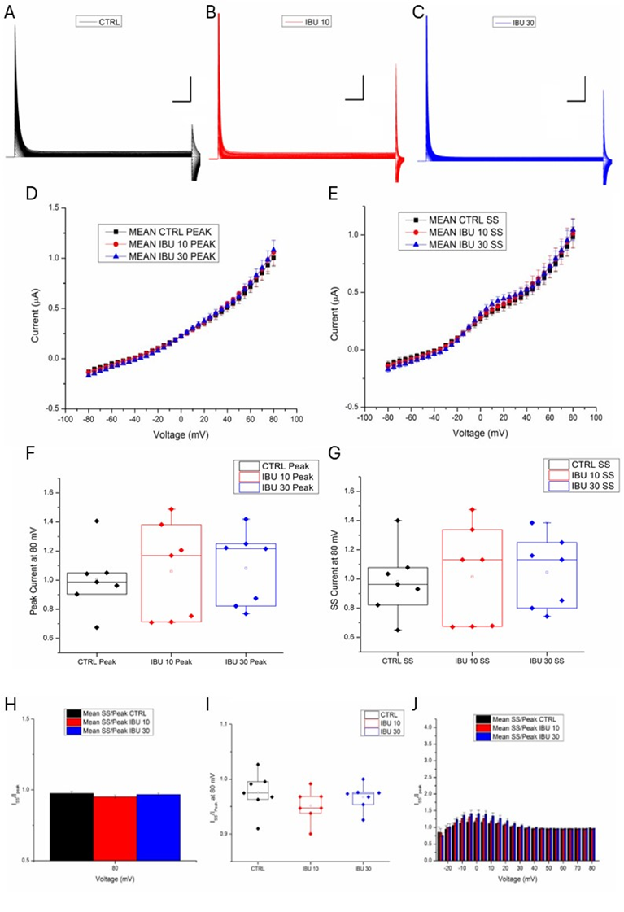
Supplementary Fig. 1 – Ibuprofen does not affect the endogenous membrane currents expressed by Xenopus oocytes
(A-C) Families of membrane currents recorded from oocytes injected with H₂O and performed in TEVC configuration under control conditions (A) and after the application of 10 μM IBU (B) and after the application of 30 μM IBU (C). Currents were elicited by voltage steps from -80 to +80 mV (∆V= 5 mV; holding potential -80 mV; Scale bars: 50 ms (x-axis) and 500 nA (y-axis) for each sample trace). (D) Peak currents as a function of voltage (IV relationships) calculated under control condition (closed squares), and after the application of 10 μM IBU (red circles) and after the application of 30 μM IBU (blue triangles). (E) Steady-state currents as a function of voltage (IV relationships) calculated under control condition (closed squares), and after the application of 10 μM IBU (red circles) and after the application of 30 μM IBU (blue triangles). (F) Box-plots of peak currents calculated at +80 mV under control condition (black diamonds), and after the application of 10 μM IBU (red diamonds) and after the application of 30 μM IBU (blue diamonds). (G) Box-plots of steady-state currents calculated at +80 mV under control condition (black diamonds), and after the application of 10 μM IBU (red diamonds) and after the application of 30 μM IBU (blue diamonds). (H) Bar graph of I_{steady-state} / I_{peak} calculated at +80 mV under control condition (black bar), and after the application of 10 μM IBU (red bar) and after the application of 30 μM IBU (blue bar). (I) Box-plots of I_{steady-state} / I_{peak} calculated at +80 mV under control condition (black diamonds), and after the application of 10 μM IBU (red diamonds) and after the application of 30 μM IBU (blue diamonds). (J) Plot of I_{steady-state} / I_{peak} calculated at from -30 to +80 mV under control condition (black bars), and after the application of 10 μM IBU (red bars) and after the application of 30 μM IBU (blue bars). Note that no statistically significant effect of the drug on endogenous currents was detected (t-test; Data are mean±SEM; n=8).

