Supplementary Methods
Colocalization
Based on shared loci from conjFDR results, we further performed Bayesian colocalization analyses using the R package coloc (version 5.2.1) for validation [1]. Colocalization analyses help verify if two traits with genetic links in the same genomic region share the same causal variant, serving as a complement to conjFDR by minimizing linkage disequilibrium bias and confirming if a causal effect stems from the same variant [2, 3]. This methodology is predicated on several key assumptions: 1) Each trait is influenced by no more than one causal genetic variant. 2) The potential of a genetic variant to be causal is independent across all variants analyzed. 3) The colocalization analysis encompasses all causal genetic variants, both genotyped and imputed. Based on these assumptions, the analysis considers five hypotheses: H0 posits no causal genetic variants for either trait; H1 identifies one causal variant for trait 1; H2 identifies one for trait 2; H3 posits separate causal variants for each trait within the same region; and H4 indicates a single causal variant affecting both traits [1].
We used default prior probability: p₁ = 1 × 10⁻⁴; p₂ = 1 × 10⁻⁴; p₁₂ = 1 × 10⁻⁵. p₁, p₂, and p₁₂ represent the prior probabilities that a SNP within the tested region significantly associates with the expression of the tested gene, the tested outcome, or both, respectively. In our analysis, variants ± 100 kb of the top SNP were included. Default priors were used for analysis. We evaluated the evidence of colocalization by posterior probability for hypothesis 4 (PP.H4), which indicated the presence of associations for both schizophrenia and immune-mediated diseases, driven by the same causal variant(s).
Associations with a posterior probability for hypothesis 4 (PP.H4) > 80% were considered significant evidence of colocalization. The R package LocusCompare was used to visualize colocalization results.
Gene mapping
To annotate high-confidence shared loci, positional and expression quantitative trait loci (eQTL) mapping were considered. For position mapping, the FUMA default window of 10kb distance from a gene was used. Databases from both brain and blood tissue were included for gene mapping using eQTLs. The eQTL databases included: GTEx v8 (for blood and brain), PsychENCODE, BRAINEAC, and eQTLGen. Genes that were identified by at least one of the two mapping procedures were defined as mapped to a particular locus.
Spatiotemporal gene expression trajectory analyses
To investigate developmental and regional expression patterns of mapped genes, we conducted a spatiotemporal brain expression trajectory analysis using mRNA-seq data from PsychENCODE Phase I, comprising 607 tissue samples from 41 postmortem brains spanning 8 postconceptional weeks (PCW) to 40 postnatal years (PY) [4]. Gene expression data were grouped into nine developmental windows and six brain regions: hippocampus (HIP), amygdala (AMY), cerebellar cortex (CBC), striatum (STR), mediodorsal nucleus of the thalamus (MD), and neocortex (NCX), as defined by PsychENCODE. Expression levels in reads per kilobase of transcript per million mapped reads (RPKM) were aggregated across subregions, log2-transformed, and regionally normalized. Smoothed LOESS curves were plotted to visualize expression trajectories [5, 6].
Genetic risk scores for validation
The UK Biobank is a large-scale biomedical database of over 500,000 individuals aged 39–73, recruited across the UK between 2006 and 2010 [7]. Linkage to primary care, hospital admissions, cancer registries, and death records enables investigation of a wide range of health outcomes. The use of UK Biobank data has been approved by its Research Ethics Committee, and all participants provided informed consent at the time of enrollment. The individual-level genotype and phenotype data are available through formal application to the UK Biobank (http://www.ukbiobank.ac.uk) under accession code 78795.
Among the 487,203 individuals with available genotype and phenotype data, we restricted analyses to those with consistent sex information and of European ancestry, excluded outliers based on heterozygosity and missingness, and removed individuals excluded during kinship inference. Individuals (N = 8,802) with any record of a schizophrenia diagnosis, other psychotic disorders, or a history of psychotic symptoms were excluded from further analyses, resulting in a final sample of 399,930 individuals.
Genetic risk scores (GRS) were calculated using summary statistics from the PGC schizophrenia GWAS as the discovery dataset [8], employing PRSice-2 and its PRSet function [9, 10]. There is no overlap between target and base data. Detailed information on genotyping and quality control for the UK Biobank data has been described previously [7]. SNPs with INFO scores < 0.8, minor allele frequency (MAF) < 0.01, as well as palindromic or duplicate SNPs, were excluded, resulting in a final set of 5,840,582 SNPs. We calculated the schizophrenia polygenic risk score (PRS), GO pathway-specific PRS (pPRS) for significantly enriched pathways, and gene-based GRS for high-confidence shared genes. Schizophrenia PRS were constructed using the standard thresholding + clumping method across ten p-value thresholds (p < 5e-08, p < 1e-06, p < 1e-04, p < 0.001, p < 0.01, p < 0.05, p < 0.1, p < 0.2, p < 0.5, and p < 1), using the European subset of the 1000 Genomes Project as the LD reference panel [11]. To enhance predictive power and reduce multiple testing, principal component analysis was applied to the ten PRS using R v4.3.1, and the first principal component (PRS-PC1) was standardized and used for downstream association analyses [12]. To avoid excluding SNPs within specific genes, no P-value filter was applied in pPRS calculation, while other PRSet parameters were kept at default, using the 1000 Genomes European subset as the LD reference panel [10, 13]. Only significantly enriched GO pathways of the mapped shared genes that were available in the Gene Set Enrichment Analysis (GSEA) database (https://www.gsea-msigdb.org/gsea/index.jsp) were included in the analysis. The gene-based GRS for high-confidence shared genes was derived following the same procedure used for pPRS calculation.
Outcomes were defined as coded diagnoses of eight immune-mediated diseases in hospital records at baseline or follow-up, based on the International Classification of Diseases, 10th Revision (ICD-10). Accordingly, we generated nine binary variables: one for each of the eight individual immune-mediated diseases, and one combined phenotype indicating the presence of any of the eight conditions. We performed logistic regression analyses (using glm() in R) for nine immune-mediated outcomes, adjusting for age, sex, UK Biobank assessment center (England, Scotland, or Wales), ten genetic principal components (PCs), body mass index (BMI), waist circumference, alcohol use, and smoking status [14]. Odds ratios (ORs) and 95% confidence intervals (CIs) were reported to estimate the risk associated with each unit increase in PRS-PC1. For outcomes that did not meet the 10 events-per-variable (EPV) criterion [15], Firth’s bias-reduced logistic regression was applied instead (using logistf() in R). Specifically, we examined: (1) the effect of schizophrenia PRS on each of the nine outcomes; (2) the effect of pPRS on the combined phenotype indicating the presence of any of the eight immune-mediated diseases; (3) the effect of gene-based GRS on the corresponding immune-mediated disease associated with each gene. Sensitivity analyses were conducted by (1) redefining the outcome to restrict controls to individuals without any of the eight immune-mediated diseases and cases to those without the other seven immune comorbidities, (2) using self-reported diagnoses as the outcome, and (3) requiring immune-mediated disease occurrence to be confirmed by both hospital records and self-reports.
All regression analyses were restricted to participants with complete data for all covariates included in the respective models. Multiple testing was corrected using the Bonferroni method, and two-tailed P-values < 0.05 were considered nominally significant.

Supplementary Figures
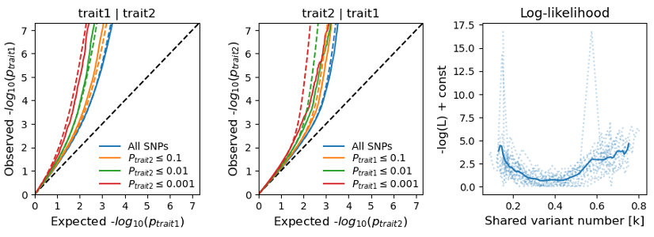
﻿Supplementary Fig 1. The polygenic overlap between schizophrenia and asthma. The conditional Q-Q plots reveal the cross-trait SNP enrichment, and the negative log-likelihood plot indicates the performance of the best model compared to the minimum and maximum models. Note: tarit1, schizophrenia; trait2, asthma.

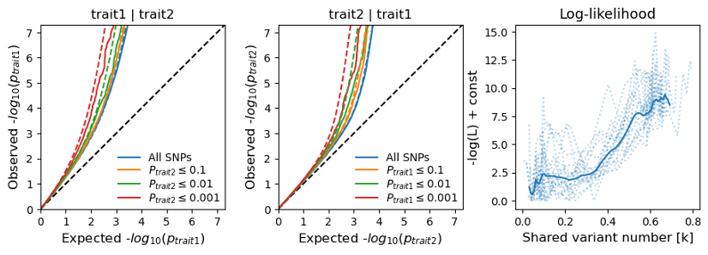
﻿Supplementary Fig 2. The polygenic overlap between schizophrenia and rheumatoid arthritis. The conditional Q-Q plots reveal the cross-trait SNP enrichment, and the negative log-likelihood plot indicates the performance of the best model compared to the minimum and maximum models. Note: tarit1, schizophrenia; trait2, rheumatoid arthritis.

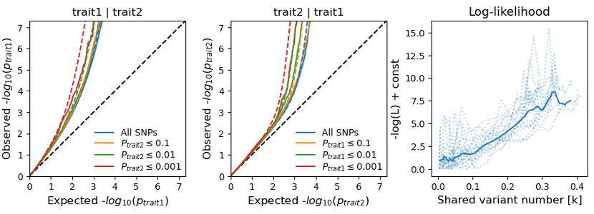
Supplementary Fig 3. The polygenic overlap between schizophrenia and ulcerative colitis. The conditional Q-Q plots reveal the cross-trait SNP enrichment, and the negative log-likelihood plot indicates the performance of the best model compared to the minimum and maximum models. Note: tarit1, schizophrenia; trait2, ulcerative colitis.

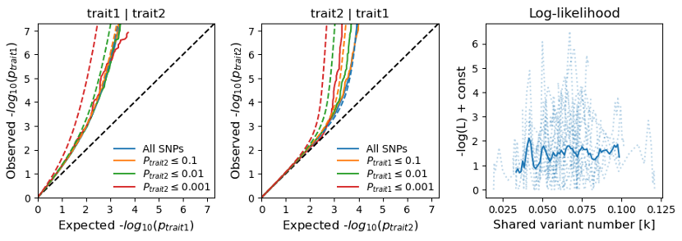
Supplementary Fig 4. The polygenic overlap between schizophrenia and type 1 diabetes. The conditional Q-Q plots reveal the cross-trait SNP enrichment, and the negative log-likelihood plot indicates the performance of the best model compared to the minimum and maximum models. Note: tarit1, schizophrenia; trait2, type 1 diabetes.

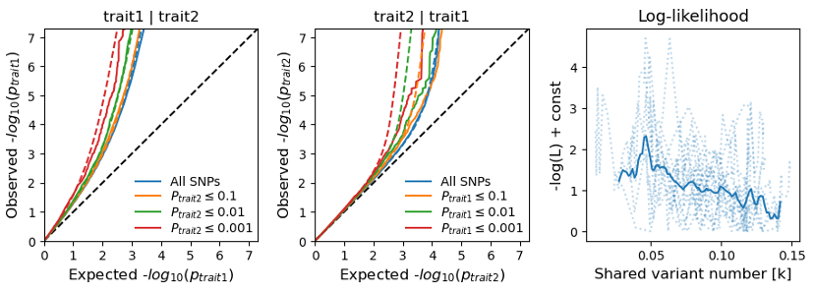
Supplementary Fig 5. The polygenic overlap between schizophrenia and Graves’ disease. The conditional Q-Q plots reveal the cross-trait SNP enrichment, and the negative log-likelihood plot indicates the performance of the best model compared to the minimum and maximum models. Note: tarit1, schizophrenia; trait2, Graves’ disease.

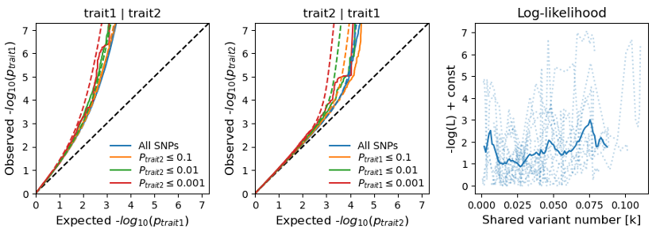
Supplementary Fig 6. The polygenic overlap between schizophrenia and Crohn’s disease. The conditional Q-Q plots reveal the cross-trait SNP enrichment, and the negative log-likelihood plot indicates the performance of the best model compared to the minimum and maximum models. Note: tarit1, schizophrenia; trait2, Crohn’s disease.

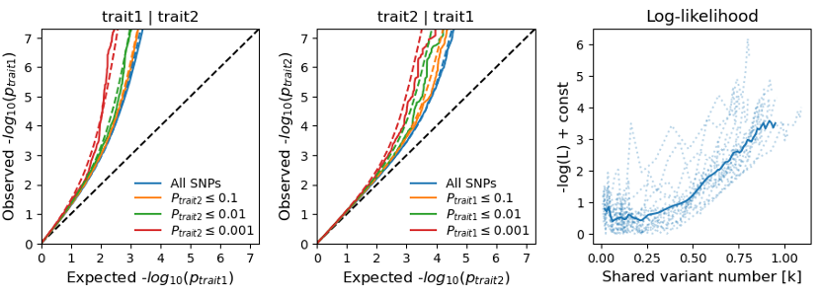
Supplementary Fig 7. The polygenic overlap between schizophrenia and allergic rhinitis. The conditional Q-Q plots reveal the cross-trait SNP enrichment, and the negative log-likelihood plot indicates the performance of the best model compared to the minimum and maximum models. Note: tarit1, schizophrenia; trait2, allergic rhinitis.

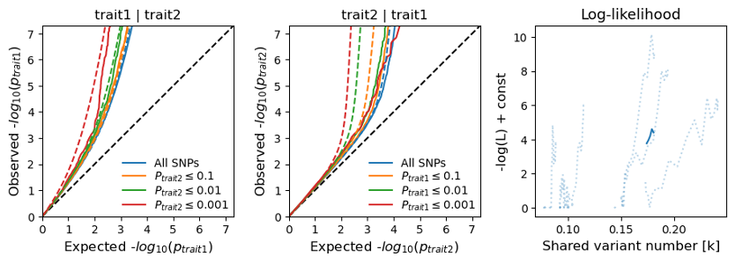
Supplementary Fig 8. The polygenic overlap between schizophrenia and systemic lupus erythematosus. The conditional Q-Q plots reveal the cross-trait SNP enrichment, and the negative log-likelihood plot indicates the performance of the best model compared to the minimum and maximum models. Note: tarit1, schizophrenia; trait2, systemic lupus erythematosus.

﻿Supplementary Fig 9. Manhattan plot showing the genetic associations for schizophrenia conditioned on each immune-mediated disease. Each point represents a SNP, and a point with the largest size indicates a lead SNP. The y-axis represents -log10-transformed condFDR values for each SNP, and the x-axis reflects the chromosomal position. The dashed line represents the threshold of condFDR = 0.01, and the color of the dots represents different immune-mediated diseases conditioned. Note: AR, allergic rhinitis; CD, Crohn’s disease; RA, rheumatoid arthritis; SLE, systemic lupus erythematosus; T1D, type 1 diabetes; UC, ulcerative colitis.

Supplementary Fig 10. Manhattan plot showing the genetic associations for immune-mediated disease conditioned on schizophrenia. Each point represents a SNP, and a point with the largest size indicates a lead SNP. The y-axis represents -log10-transformed condFDR values for each SNP, and the x-axis reflects the chromosomal position. The dashed line represents the threshold of condFDR = 0.01, and the color of the dots represents different immune-mediated diseases. Note: AR, allergic rhinitis; CD, Crohn’s disease; RA, rheumatoid arthritis; SLE, systemic lupus erythematosus; T1D, type 1 diabetes; UC, ulcerative colitis.

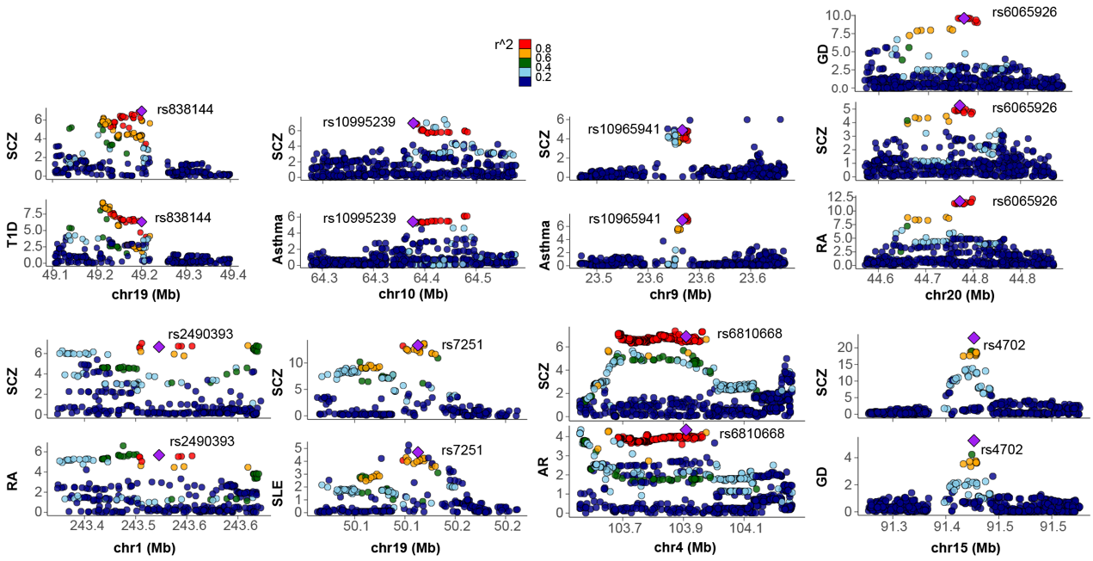
Supplementary Fig 11. LocusZoom plots of the shared loci with LAVA and colocalization evidence. These plots show the regional SNP associations for schizophrenia and immune-mediated diseases from the original GWAS summary data. The point with a diamond shape is the lead SNP, which has the highest posterior probability for H4 in the colocalization analysis, and other SNPs are colored according to their LD r² with the lead SNP. LAVA, local analysis of [co]variant association; SNP, single nucleotide polymorphism; SCZ, schizophrenia; SLE, systemic lupus erythematosus; RA, rheumatoid arthritis; CD, Crohn's disease; GD, Graves’ disease; UC, ulcerative colitis; AR, allergic rhinitis; T1D, type 1 diabetes

Reference
1. Giambartolomei C, Vukcevic D, Schadt EE, Franke L, Hingorani AD, Wallace C, et al. Bayesian test for colocalisation between pairs of genetic association studies using summary statistics. PLoS Genet. 2014;10:e1004383.
2. Zuber V, Grinberg NF, Gill D, Manipur I, Slob EAW, Patel A, et al. Combining evidence from Mendelian randomization and colocalization: Review and comparison of approaches. Am J Hum Genet. 2022;109:767–782.
3. Yang C, Fagan AM, Perrin RJ, Rhinn H, Harari O, Cruchaga C. Mendelian randomization and genetic colocalization infer the effects of the multi-tissue proteome on 211 complex disease-related phenotypes. Genome Med. 2022;14:140.
4. Li M, Santpere G, Imamura Kawasawa Y, Evgrafov OV, Gulden FO, Pochareddy S, et al. Integrative functional genomic analysis of human brain development and neuropsychiatric risks. Science. 2018;362:eaat7615.
5. Liu M, Wang L, Zhang Y, Dong H, Wang C, Chen Y, et al. Investigating the shared genetic architecture between depression and subcortical volumes. Nat Commun. 2024;15:7647.
6. Chen Y, Li W, Lv L, Yue W. Shared Genetic Determinants of Schizophrenia and Autism Spectrum Disorder Implicate Opposite Risk Patterns: A Genome-Wide Analysis of Common Variants. Schizophr Bull. 2024;50:1382–1395.
7. Bycroft C, Freeman C, Petkova D, Band G, Elliott LT, Sharp K, et al. The UK Biobank resource with deep phenotyping and genomic data. Nature. 2018;562:203–209.
8. Trubetskoy V, Pardiñas AF, Qi T, Panagiotaropoulou G, Awasthi S, Bigdeli TB, et al. Mapping genomic loci implicates genes and synaptic biology in schizophrenia. Nature. 2022;604:502–508.
9. Choi SW, O’Reilly PF. PRSice-2: Polygenic Risk Score software for biobank-scale data. Gigascience. 2019;8:giz082.
10. Choi SW, García-González J, Ruan Y, Wu HM, Porras C, Johnson J, et al. PRSet: Pathway-based polygenic risk score analyses and software. PLoS Genet. 2023;19:e1010624.
11. Choi SW, Mak TS-H, O’Reilly PF. Tutorial: a guide to performing polygenic risk score analyses. Nat Protoc. 2020;15:2759–2772.
12. Coombes BJ, Ploner A, Bergen SE, Biernacka JM. A principal component approach to improve association testing with polygenic risk scores. Genet Epidemiol. 2020;44:676–686.
13. Warren TL, Tubbs JD, Lesh TA, Corona MB, Pakzad SS, Albuquerque MD, et al. Association of neurotransmitter pathway polygenic risk with specific symptom profiles in psychosis. Mol Psychiatry. 2024;29:2389–2398.
14. Zhang R, Sjölander A, Ploner A, Lu D, Bulik CM, Bergen SE. Novel disease associations with schizophrenia genetic risk revealed in ~400,000 UK Biobank participants. Mol Psychiatry. 2022;27:1448–1454.
15. Peduzzi P, Concato J, Kemper E, Holford TR, Feinstein AR. A simulation study of the number of events per variable in logistic regression analysis. J Clin Epidemiol. 1996;49:1373–1379.

