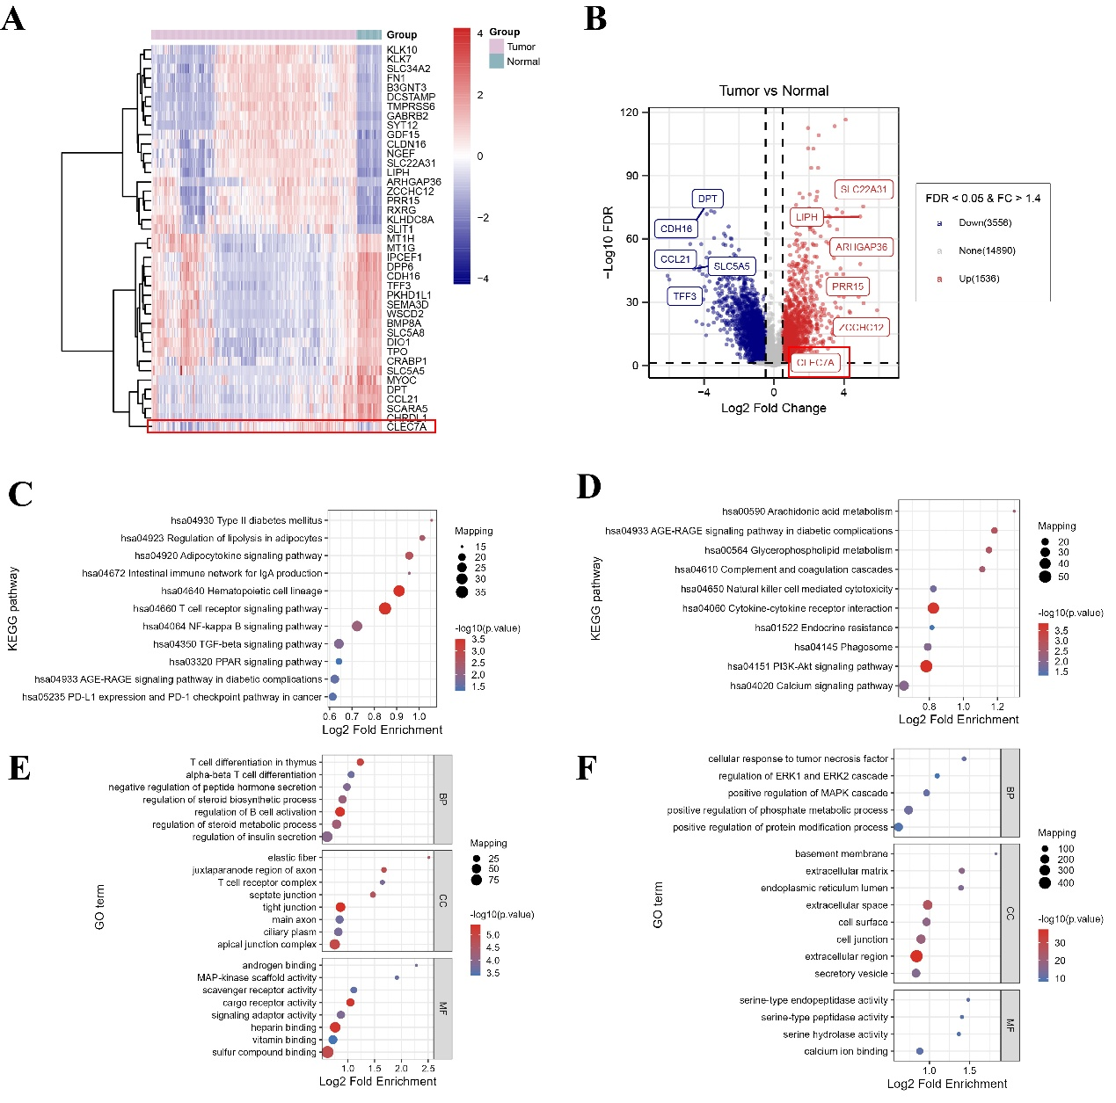
Figure S1. Transcriptomic profiling reveals Dectin-1 upregulation and immune–metabolic pathway alterations in thyroid cancer. (A) Heatmap of DEGs in tumor vs. adjacent normal tissues, showing increased CLEC7A (Dectin-1) in tumors. (B) Volcano plot highlighting significant upregulation of CLEC7A in thyroid cancer (FDR < 0.05, |log₂FC| > 1.4). KEGG enrichment of (C) downregulated genes and (D) upregulated genes. GO analysis of (E) downregulated genes and (F) upregulated genes.*P < 0.05; **P < 0.01; ***P < 0.001; ns, not significant.

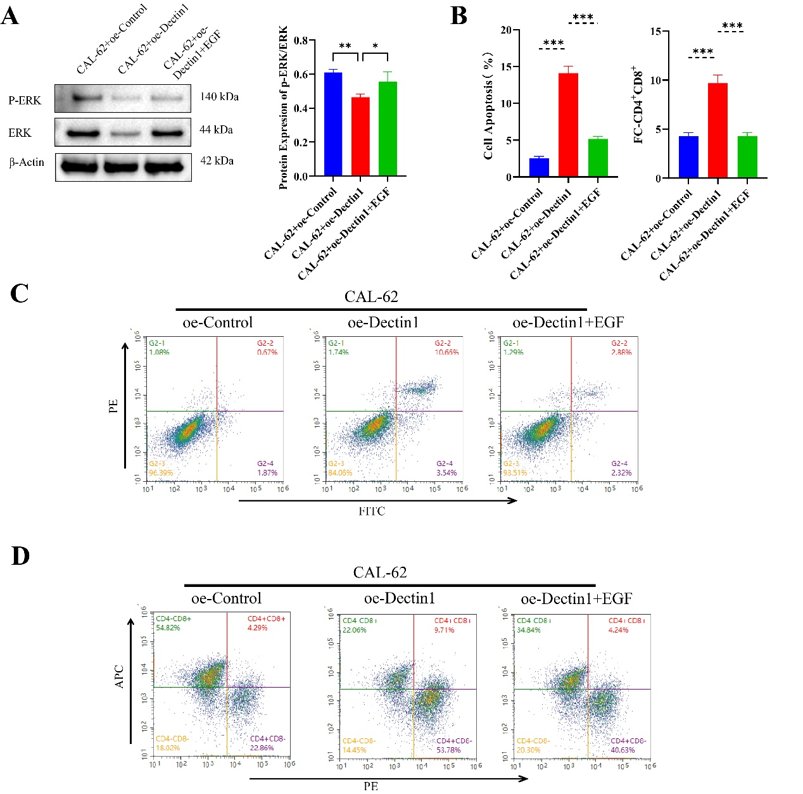
Figure S2 In vitro effects of Dectin-1/ERK signaling on tumor metabolism, proliferation, apoptosis, migration and macrophage polarization in the CAL-62-THP-1 co-culture system (A) Western Blot detection of ERK pathway activity (B) Flow cytometry statistical analysis bar chart. Flow cytometry of (C-D) apoptosis and CD4^+CD8^+ T cells. *P < 0.05; **P < 0.01; ***P < 0.001; ns, not significant.

Supplemental Table 1：
Gene name | siRNA sequence
Dectin-1 | GGAUAGCUGUUGUUUCAGA
IL-6 | GGAACUUCUUCAGGGUCUUTT
si-Control | TTCTCCGAACGTGTCACGT

Supplemental Table 2：
Gene name | Forward primer Sequence | Reverse primer Sequence
Dectin-1 | GCTATATCTATTCAGGGGCTCTC | ATTACCAAGCATAGGATTCCCA
IL-6 | TCTTGGGACTGATGTTGTTGAC | AGTGCATCATCGCTGTTCATAC
GLUT1 | TTCACTGTCGTGTCGCTGTTTG | TCACACTTGGGAATCAGCCCC
HK2 | CAAAGTGACAGTGGGTGTGG | GCCAGGTCCTTCACTGTCTC
PGK1 | AAGGTTAAAGCCGAGCCAGC | TCTGCAACTTTAGCTCCGCC
PKM2 | GGAGCGATCCCTCCAAAAT | GGCTGTTGTCATACTTCTCATGG
β-Actin | GCCATCTTTGATTGGAATGG | GGTGCCACAACCTTGATCTT

