Supplementary Table 1. lists subjects with age, gender for health controls, ME/CFS, and long COVID patients included in the RRC analysis. Illness length (in years) is provided for patient cohorts with impaired WHODAS cognitive scores for all cohorts. NaN denotes not available.
Subjects | Age | Sex | Duration of Illness | WHODAS Cognitive Score
HC (n=24)
1 | 38.1 | 1 | 0 | 1
2 | 33.2 | 2 | 0 | 1
3 | 21.7 | 1 | 0 | 2
4 | 36.5 | 2 | 0 | 1
5 | 25.4 | 2 | 0 | 7
6 | 43.3 | 1 | 0 | 10
7 | 22.2 | 2 | 0 | NaN
8 | 50.1 | 1 | 0 | 8
9 | 22.7 | 2 | 0 | 6
10 | 47.1 | 1 | 0 | 0
11 | 32.4 | 1 | 0 | 0
12 | 33.5 | 1 | 0 | 5
13 | 47.7 | 1 | 0 | 0
14 | 43.4 | 2 | 0 | 4
15 | 28.9 | 2 | 0 | 32
16 | 40.7 | 1 | 0 | 0
17 | 46.9 | 2 | 0 | 1
18 | 35.2 | 2 | 0 | 4
19 | 28.9 | 1 | 0 | 18
20 | 25.9 | 1 | 0 | 2
21 | 29.76 | 1 | 0 | 0
22 | 28.1 | 1 | 0 | 2
23 | 36.1 | 1 | 0 | 0
24 | 36.3 | 1 | 0 | 2
Long COVID (n=17)
25 | 49.1 | 1 | 0.75 | 35
26 | 64.3 | 2 | 0.25 | 45
27 | 45.5 | 1 | 0.17 | 20
28 | 31.3 | 1 | 0.58 | 25
29 | 40.8 | 2 | 0.16 | 50
30 | 43.6 | 1 | 0.25 | 80
31 | 62 | 2 | 0.33 | 50
32 | 32 | 1 | 2 | 25
33 | 19.6 | 1 | 0.5 | NaN
34 | 60.1 | 2 | 0.5 | 29.16
35 | 52 | 1 | 1 | 12.5
36 | 60 | 1 | 0.7 | 41.67
37 | 60.6 | 1 | 0.5 | 25
38 | 47.96 | 1 | 0.4 | 29.17
39 | 38.38 | 1 | 1.7 | NaN
40 | 48.23 | 1 | 1.2 | 16.6
41 | 30 | 2 | 2.7 | NaN
ME/CFS (n=27)
42 | 23.5 | 1 | 7 | 54.17
43 | 25.6 | 1 | 2 | 50
44 | 36.6 | 1 | 21 | 100
45 | 45.3 | 1 | 10 | 25
46 | 52.3 | 1 | 5 | 45.83
47 | 38.5 | 1 | 12 | 45.83
48 | 47.6 | 1 | 9 | 75
49 | 30.3 | 2 | 2 | 58.3
50 | 60.1 | 1 | 11 | 58.3
51 | 39 | 1 | 25 | 41.67
52 | 52.1 | 1 | 10 | 45.83
53 | 44.1 | 1 | 8 | 54.17
54 | 48.4 | 1 | 29 | 75
55 | 45.6 | 1 | 24 | 50
56 | 55.6 | 1 | 48 | 58.3
57 | 59.8 | 1 | 12 | 54.17
58 | 32 | 2 | 2 | 41.67
59 | 46.5 | 2 | 8 | 45.83
60 | 49 | 1 | 0.5 | 37.5
61 | 30 | 1 | 1.9 | 50
62 | 51.6 | 2 | 13 | NaN
63 | 43.6 | 2 | 24 | NaN
64 | 46.9 | 2 | 31 | 58.3
65 | 32.3 | 1 | 8 | 50
66 | 27.22 | 2 | 1.4 | NaN
67 | 36.64 | 1 | 8 | NaN
68 | 60.33 | 2 | 11.3 | NaN

Supplementary Figure 1. Illustrates connectome of 67 regions of interest used in the RRC analysis for long COVID, ME/CFS and healthy controls.

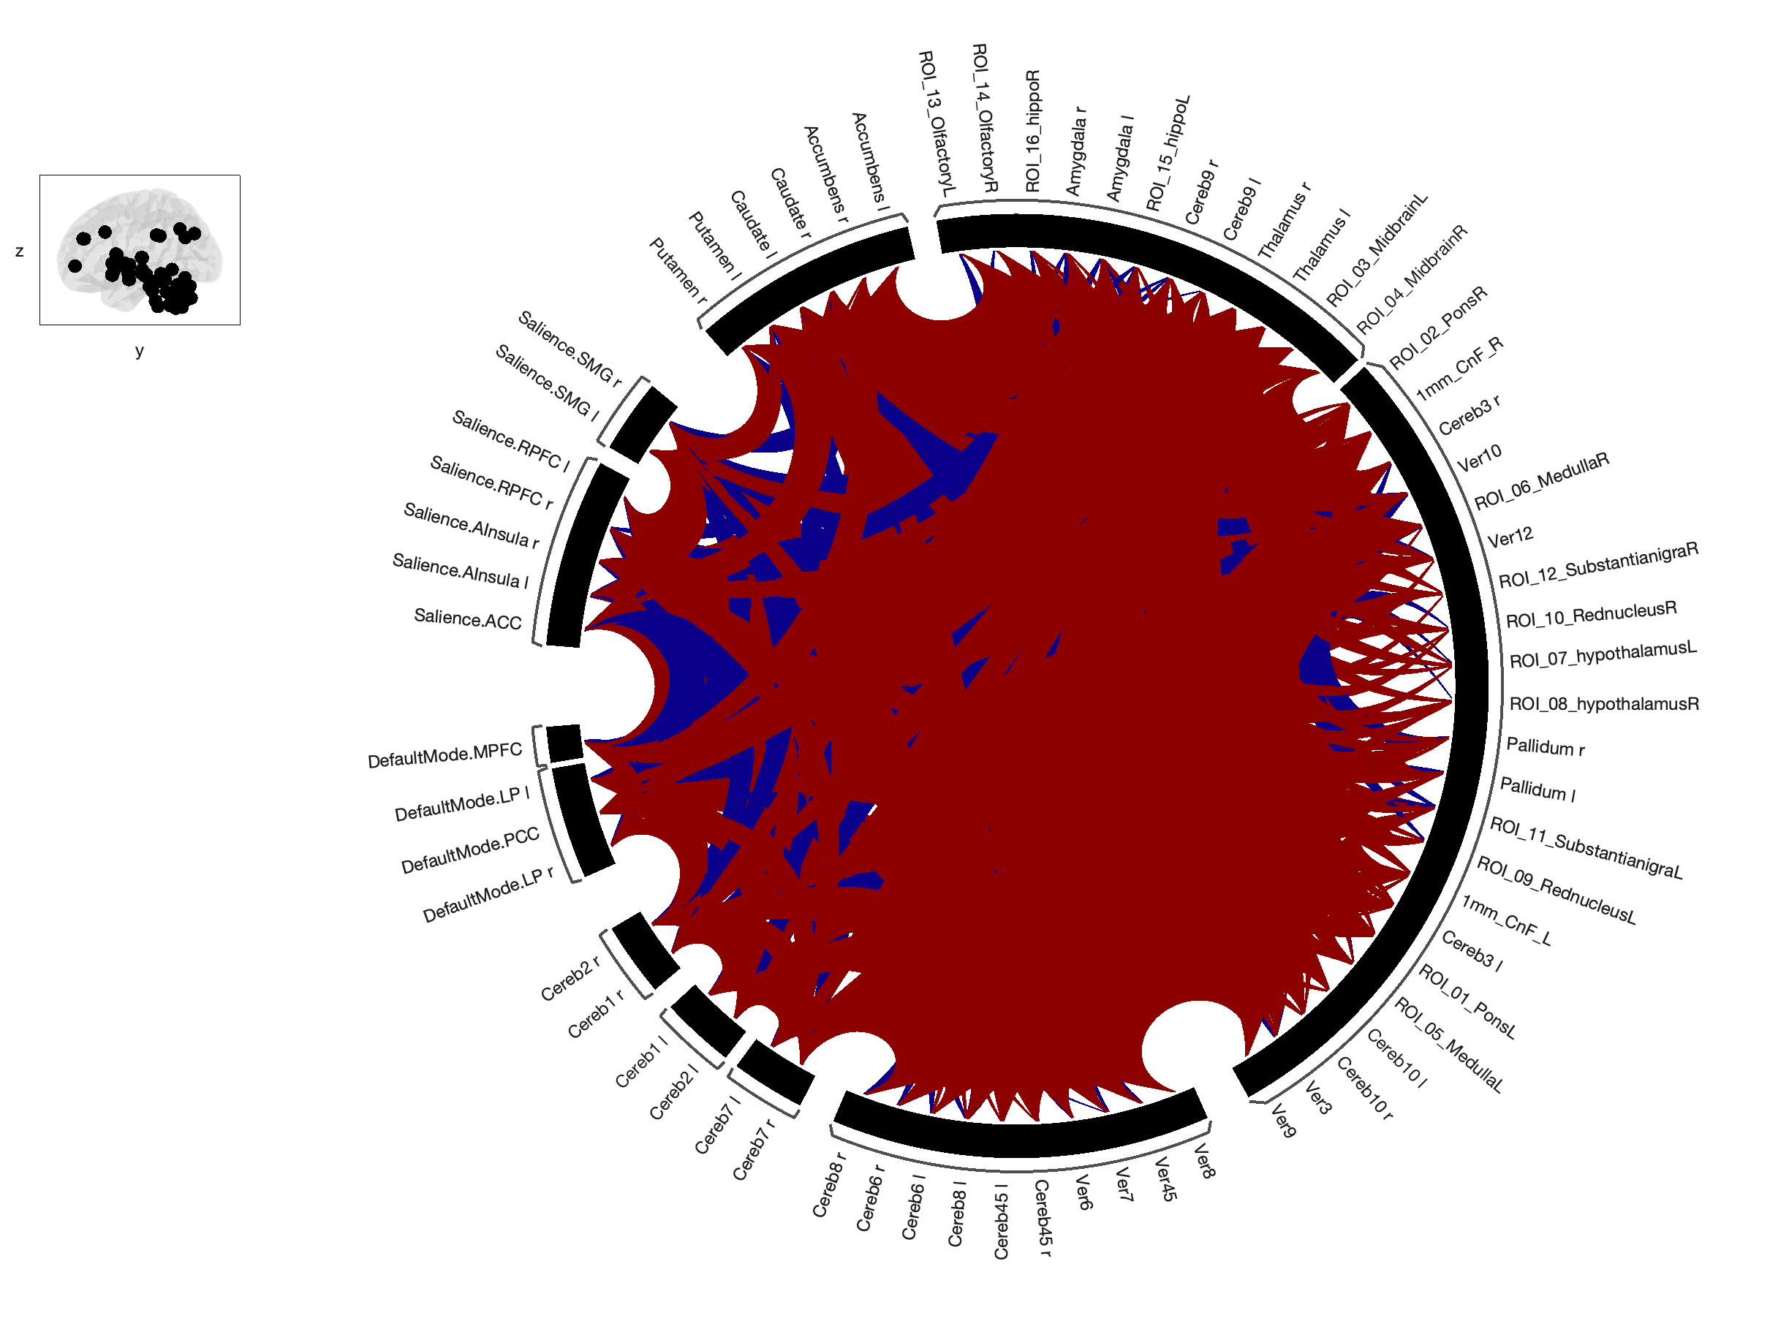

Supplementary Table 2. List of ROIs used to test functional connectivity for patients with long COVID, ME/CFS and healthy controls.
Regions of Interest | Abbreviations in Connectome
Default Mode Network
Medial Prefrontal Cortex  Lateral Parietal  Posterior Cingulate Cortex | DefaultMode.MPFC  DefaultMode.LP (l/r)  DefaultMode.PCC
Salience network
Rostro-PreFrontal Cortex  Supramarginal Gyrus  Anterior Cingulate Cortex  Anterior Insula | Salience.RPFC (l/r)  Salience.SMG (l/r)  Salience.ACC  Salience.AInsula (l/r)
Subcortical Regions
Cerebellum Crus 1  Cerebellum Crus 2  Cerebellum 3  Cerebellum 4 & 5  Cerebellum 6  Cerebellum 7b  Cerebellum 8  Cerebellum 9  Cerebellum10  Vermis 1 & 2  Vermis 3  Vermis 4 & 5  Vermis 6  Vermis 7  Vermis 8  Vermis 9  Vermis 10  Thalamus  Nucleus Caudate  Nucleus Putamen  Pallidum  Nucleus Accumbens  Amygdala  Cuneiform Nucleus  Pons  Midbrain  Medulla  Hypothalamus  Red Nucleus  Substantia Nigra  Olfactory  Hippocampus |  | Cereb1 (l/r)  Cereb2 (l/r)  Cereb3 (l/r)  Cereb4 5 (l/r)  Cereb6 (l/r)  Cereb7 (l/r)  Cereb8 (l/r)  Cereb9 (l/r)  Cereb10 (l/r)  Verm1 2  Ver3  Ver4 5  Ver6  Ver7  Ver8  Ver9  Ver10  Thalamus (l/r)  Caudate (l/r)  Putamen (l/r)  Pallidum (l/r)  Accumbens (l/r)  Amygdala (l/r)  1mm_CnF_L  1mm_CnF_R  ROI_01_PonsL  ROI_02_PonsR  ROI_03_MidbrainL  ROI_04_MidbrainR  ROI_05_MedullaL  ROI_06_MedullaR  ROI_07_hypothalamusL  ROI_08_hypothalamusR  ROI_09_RedNucleusL  ROI_10_RedNucleusR  ROI_11_SubstantiaNigraL  ROI_12_SubstantiaNigraR  ROI_13_OlfactoryL  ROI_14_OlfactoryR  ROI_15_hippoL  ROI_16_hippoR
L/R or l/r = left/right

Supplementary Figure 2. Correlation is significant between FC values and duration of illness in pwME/CFS for vermis 4&5 and right hippocampus (p=0.003) during Pre. x-axis shows distribution of duration of illness in years for pwME/CFS; y-axis shows FC values between seeds during Pre

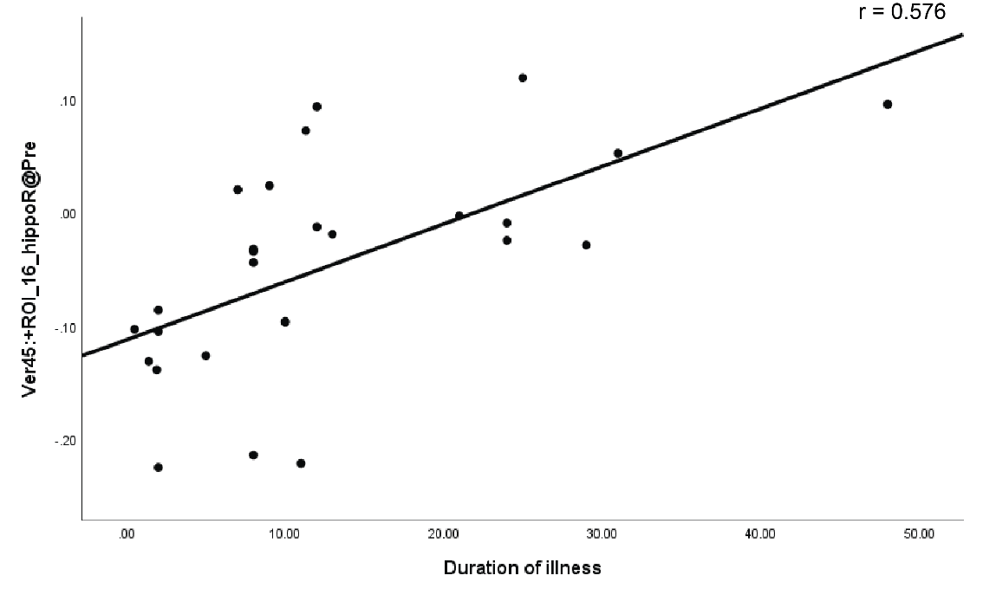

Supplementary Figure 3. Correlation is significant between FC values and duration of illness in pwME/CFS for right cerebellum 6 and right hippocampus (p=<0.001) during Pre. x-axis shows distribution of duration of illness in years for pwME/CFS; y-axis shows FC values between seeds during Pre

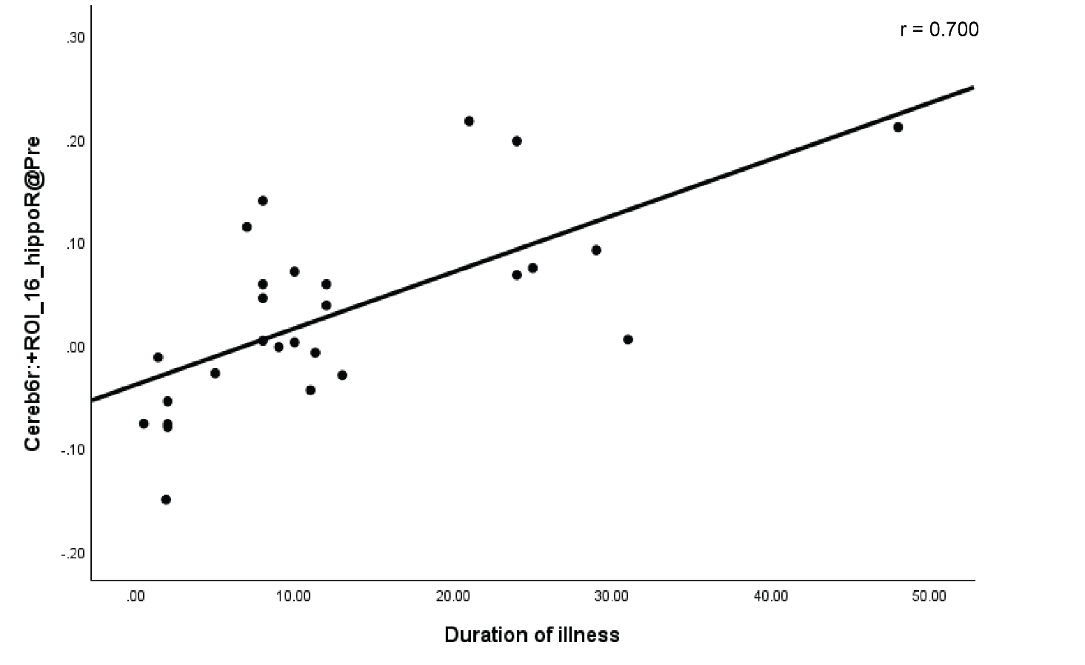

Supplementary Figure 4. Correlation is significant between FC values and duration of illness in pwME/CFS for vermis 4&5 and right hippocampus (p=0.004) during Post. x-axis shows distribution of duration of illness in years for pwME/CFS; y-axis shows FC values between seeds during Post

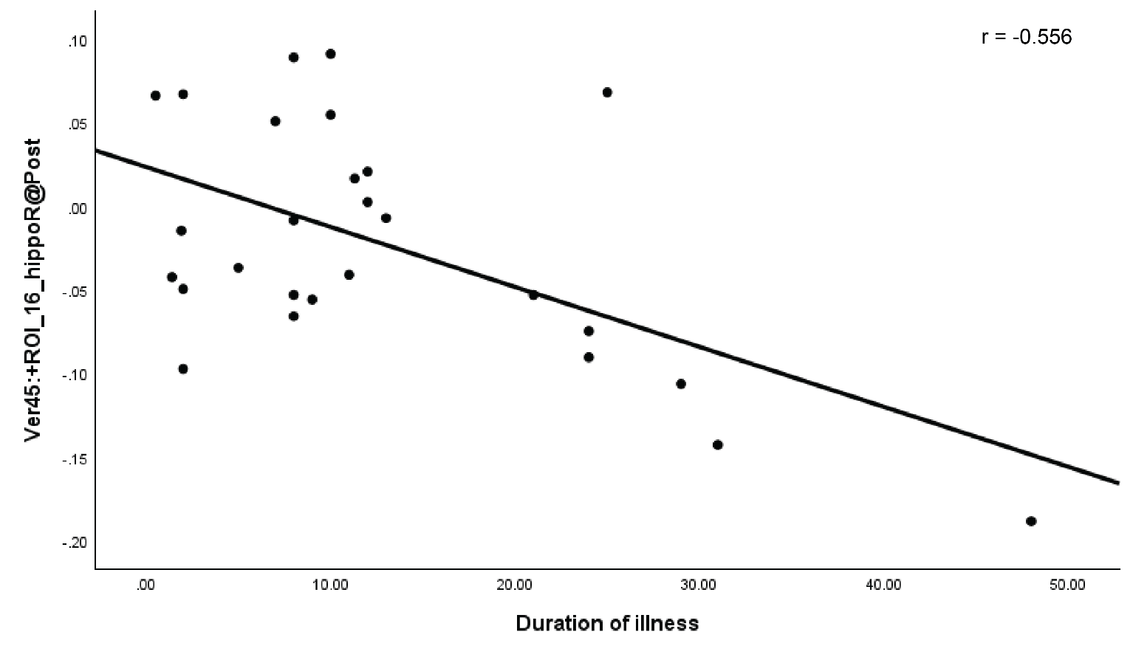

Supplementary Figure 5. Correlation is significant between FC values and cognitive scores in pwME/CFS for left caudate and cerebellum 6 right (p=<0.001) during Post. x-axis shows distribution of WHODAS cognitive scores for pwME/CFS; y-axis shows FC values between seeds during Post

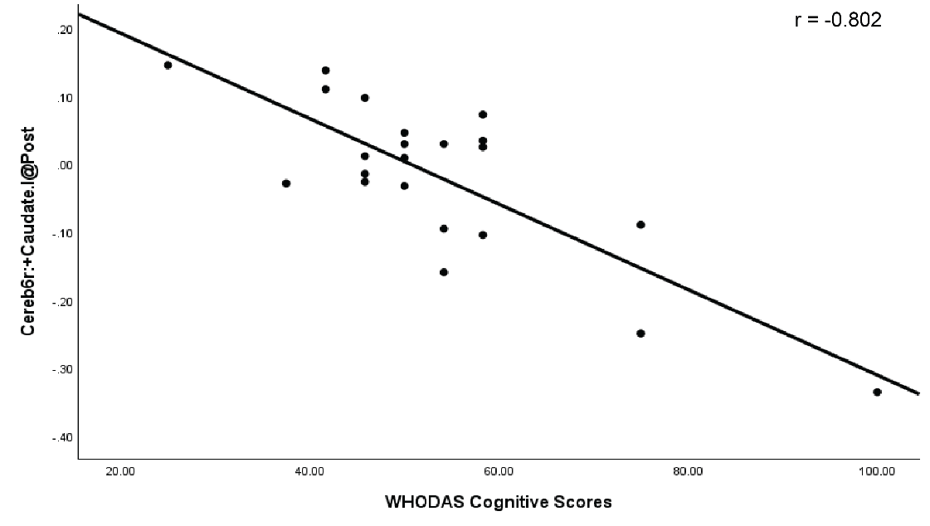

Supplementary Figure 6. Correlation is significant between FC values and cognitive scores in pwME/CFS for left SMG and right amygdala (p=<0.001) during Pre. x-axis shows distribution of WHODAS cognitive scores for pwME/CFS; y-axis shows FC values between seeds during Pre

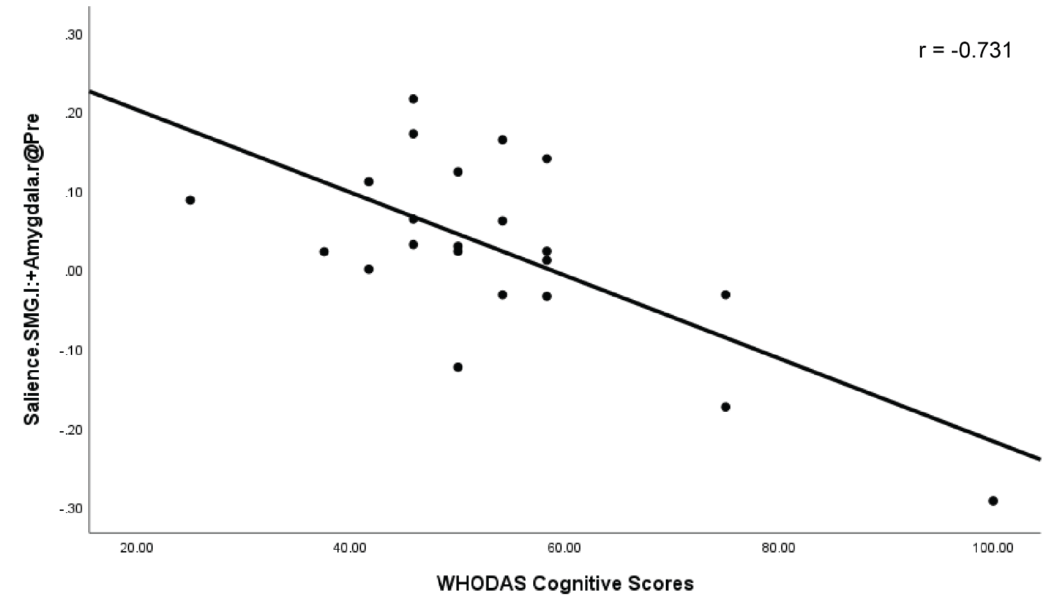

Supplementary Figure 7. Correlation is significant between FC values and cognitive scores in pwLC for left cerebellum 7 and right supramarginal gyrus (p=0.001) during Pre. x-axis shows distribution of WHODAS cognitive scores for pwLC; y-axis shows FC values between seeds during Pre

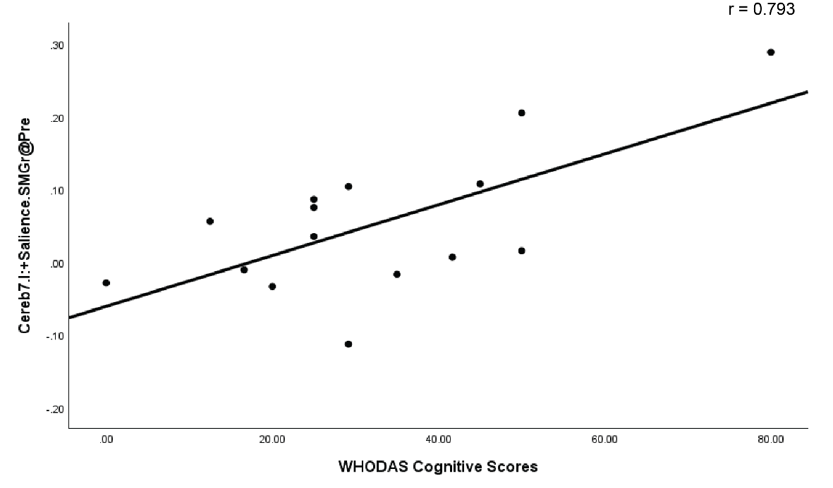

Supplementary Figure 8. Correlation is significant between FC values and cognitive scores in pwLC for left red nucleus and right supramarginal gyrus (p=0.001) during Pre. x-axis shows distribution of WHODAS cognitive scores for pwLC; y-axis shows FC values between seeds during Pre.

