Table S1. Visual Characteristics of Normal Subjects.
Subject | Sex | Age | Dominate  Eye | Optical Correction | Visual Acuity (logMAR)
N1 | M | 21 | OD | OS Plano | -0.10
 |  |  |  | OD Plano | -0.10
N2 | M | 18 | OD | OS -2.25 | 0
 |  |  |  | OD -2.00 | 0
N3 | F | 20 | OD | OS Plano | -0.15
 |  |  |  | OD Plano | -0.15
N4 | F | 23 | OD | OS Plano | -0.15
 |  |  |  | OD Plano | -0.10
N5 | M | 18 | OS | OS Plano | -0.15
 |  |  |  | OD Plano | -0.15
N6 | M | 19 | OD | OS -1.75 | -0.10
 |  |  |  | OD -2.00 | 0
N7 | F | 19 | OS | OS Plano | -0.15
 |  |  |  | OD Plano | -0.15
N8 | M | 18 | OD | OS Plano | 0
 |  |  |  | OD Plano | -0.10
N9 | M | 19 | OD | OS Plano | -0.10
 |  |  |  | OD Plano | -0.15
N10 | F | 20 | OD | OS Plano | -0.10
 |  |  |  | OD -1.25 | -0.10
F, female; M, male; OS, oculus sinister; OD, oculus dexter; logMAR, logarithm of the minimum angle of resolution.

Table S2. Mixed-design repeated measures ANOVA on the contrast sensitivity of first-order task
Items |  | Sphericity Test |  |  | ANOVA
 |  | df | χ² | p | df | F | p | η²ₚ
AE vs FE | Eye |  |  |  | 1 | 43.942 | <0.001 | 0.863
AE vs FE | Temporal Frequency | 14 | 34.213 | 0.004 | 2.082 | 68.459 | <0.001 | 0.907
AE vs FE | Eye × Temporal Frequency | 14 | 29.846 | 0.014 | 2.115 | 1.283 | 0.308 | 0.155
AE vs CE | Eye |  |  |  | 1 | 24.070 | <0.001 | 0.601
AE vs CE | Temporal Frequency | 14 | 55.431 | <0.001 | 2.170 | 114.277 | <0.001 | 0.877
AE vs CE | Eye × Temporal Frequency |  |  |  | 2.170 | 0.491 | 0.632 | 0.030
CE vs FE | Eye |  |  |  | 1 | 0.252 | 0.622 | 0.016
CE vs FE | Temporal Frequency | 14 | 33.911 | 0.002 | 2.891 | 328.667 | <0.001 | 0.954
CE vs FE | Eye × Temporal Frequency |  |  |  | 2.891 | 4.321 | 0.002 | 0.213
Note. df = degrees of freedom, F = F statistic, p = significance level, η²ₚ = partial eta squared. AE, FE, and CE denote amblyopic, fellow, and control eyes, respectively. For AE vs FE, it was treated as a within-subject factor, and because it had only two levels, the main effect of Eye was not subjected to a sphericity test. For AE vs CE and CE vs FE, Eye was a between-subject factor; therefore, sphericity was not tested. Temporal Frequency was a within-subject factor in all comparisons. As Mauchly’s test of sphericity was significant, the Greenhouse–Geisser correction was applied to the degrees of freedom and p-values for Temporal Frequency and the Eye × Temporal Frequency interaction. Reported F and p values are Greenhouse–Geisser–corrected.

Table S3. Mixed-design repeated measures ANOVA on the contrast sensitivity of second-order task with identical carriers
Items |  | Sphericity Test |  |  | ANOVA
 |  | df | χ² | p | df | F | p | η²ₚ
AE vs FE | Eye |  |  |  | 1 | 32.060 | 0.001 | 0.821
AE vs FE | Temporal Frequency | 9 | 22.704 | 0.009 | 1.567 | 21.127 | <0.001 | 0.751
AE vs FE | Eye × Temporal Frequency | 9 | 7.343 | 0.619 | 4 | 1.845 | 0.148 | 0.209
AE vs CE | Eye |  |  |  | 1 | 20.014 | <0.001 | 0.556
AE vs CE | Temporal Frequency | 9 | 36.326 | <0.001 | 1.786 | 55.448 | <0.001 | 0.776
AE vs CE | Eye × Temporal Frequency |  |  |  | 1.786 | 2.373 | 0.116 | 0.129
CE vs FE | Eye |  |  |  | 1 | 0.497 | 0.491 | 0.030
CE vs FE | Temporal Frequency | 9 | 29.729 | 0.001 | 1.860 | 88.908 | <0.001 | 0.847
CE vs FE | Eye × Temporal Frequency |  |  |  | 1.860 | 3.548 | 0.044 | 0.181
Note. df = degrees of freedom, F = F statistic, p = significance level, η²ₚ = partial eta squared. AE, FE, and CE denote amblyopic, fellow, and control eyes, respectively. For AE vs FE, it was treated as a within-subject factor, and because it had only two levels, the main effect of Eye was not subjected to a sphericity test. For AE vs CE and CE vs FE, Eye was a between-subject factor; therefore, sphericity was not tested. Temporal Frequency was a within-subject factor in all comparisons. As Mauchly’s test of sphericity was significant, the Greenhouse–Geisser correction was applied to the degrees of freedom and p-values for Temporal Frequency and the Eye × Temporal Frequency interaction. Reported F and p values are Greenhouse–Geisser–corrected.

Table S4. Mixed-design repeated measures ANOVA on the contrast sensitivity of second-order task with balanced carriers
Items |  | Sphericity Test |  |  | ANOVA
 |  | df | χ² | p | df | F | p | η²ₚ
AE vs FE | Eye |  |  |  | 1 | 1.066 | 0.336 | 0.132
AE vs FE | Temporal Frequency | 9 | 11.760 | 0.247 | 4 | 28.314 | <0.001 | 0.802
AE vs FE | Eye × Temporal Frequency | 9 | 20.877 | 0.017 | 1.436 | 1.668 | 0.234 | 0.192
AE vs CE | Eye |  |  |  | 1 | 1.029 | 0.325 | 0.060
AE vs CE | Temporal Frequency | 9 | 21.275 | 0.012 | 2.618 | 67.240 | <0.001 | 0.808
AE vs CE | Eye × Temporal Frequency |  |  |  | 2.618 | 3.873 | 0.020 | 0.195
CE vs FE | Eye |  |  |  | 1 | 1.126 | 0.727 | 0.008
CE vs FE | Temporal Frequency | 9 | 31.747 | <0.001 | 1.784 | 46.872 | <0.001 | 0.746
CE vs FE | Eye × Temporal Frequency |  |  |  | 1.784 | 1.935 | 0.115 | 0.108
Note. df = degrees of freedom, F = F statistic, p = significance level, η²ₚ = partial eta squared. AE, FE, and CE denote amblyopic, fellow, and control eyes, respectively. For AE vs FE, it was treated as a within-subject factor, and because it had only two levels, the main effect of Eye was not subjected to a sphericity test. For AE vs CE and CE vs FE, Eye was a between-subject factor; therefore, sphericity was not tested. Temporal Frequency was a within-subject factor in all comparisons. As Mauchly’s test of sphericity was significant, the Greenhouse–Geisser correction was applied to the degrees of freedom and p-values for Temporal Frequency and the Eye × Temporal Frequency interaction. Reported F and p values are Greenhouse–Geisser–corrected.

Table S5. Repeated measures ANOVA on average ratio of thresholds between the AE and FE of three tasks
Items | Sphericity Test |  |  | ANOVA
 | df | χ² | p | df | F | p | η²ₚ
First-order task
Temporal Frequency | 14 | 38.920 | <0.001 | 1.530 | 1.189 | 0.327 | 0.145
Second-order task with identical carriers
Temporal Frequency | 9 | 11.696 | 0.251 | 4 | 1.833 | 0.150 | 0.208
Second-order task with balanced carriers
Temporal Frequency | 9 | 18.997 | 0.031 | 1.437 | 0.940 | 0.392 | 0.118
Note. df = degrees of freedom, F = F statistic, p = significance level, η²ₚ = partial eta squared. Temporal Frequency was a within-subject factor. If Mauchly’s test of sphericity was significant, the Greenhouse–Geisser correction was applied to the degrees of freedom and p-values for Temporal Frequency. Reported F and p values are Greenhouse–Geisser–corrected.

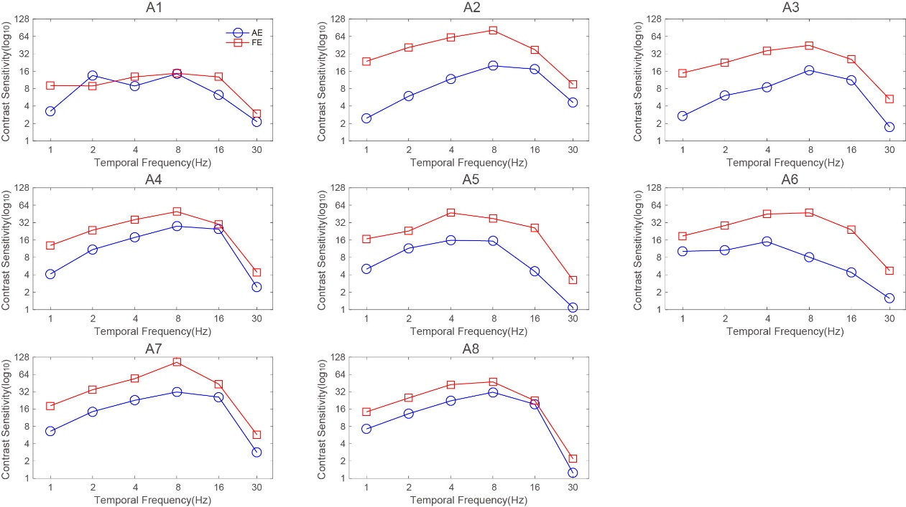
Fig. S1 individual contrast sensitivity for first-order temporal task of AE (Circles) and FE (Squares). The unit of contrast sensitivity is expressed in log₁₀ scale (log₁₀[1/contrast threshold]).

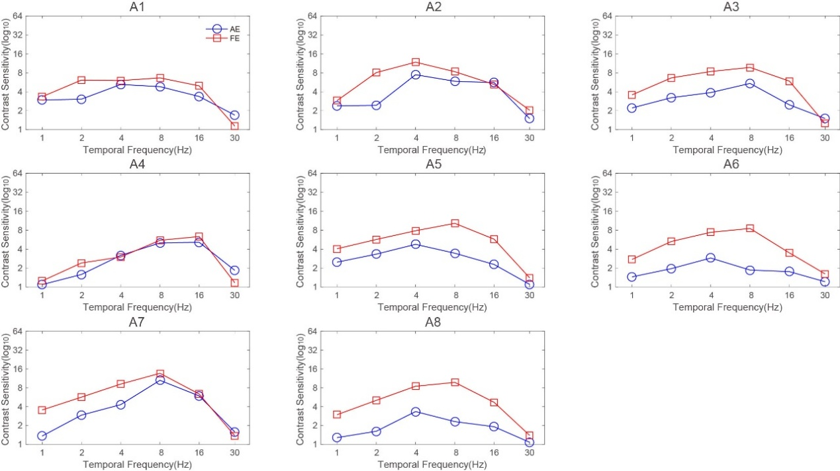
Fig. S2 Individual modulation sensitivity for second-order temporal task with identical carriers of AE (Circles) and FE (Squares). The unit of contrast sensitivity is expressed in log₁₀ scale (log₁₀[1/contrast threshold]).

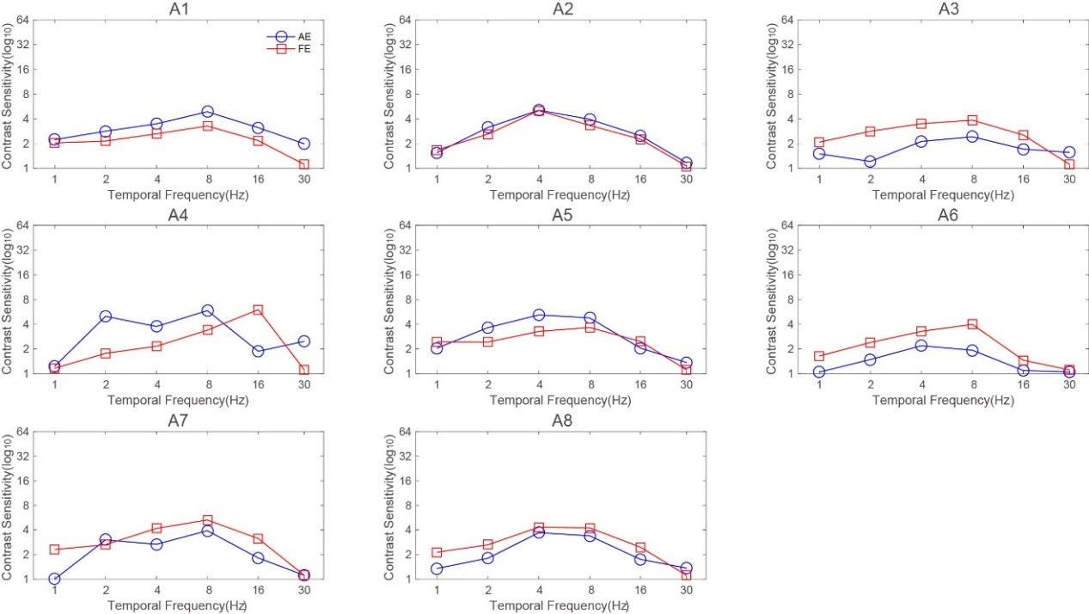
Fig. S3 Individual modulation sensitivity for second-order temporal task with balanced carriers of AE (Circles) and FE (Squares). The unit of contrast sensitivity is expressed in log₁₀ scale (log₁₀[1/contrast threshold]).

