Supporting information
Logic-Gated Fluorescent Biosensor Integrating Aptamer Recognition and Oxidative Cleavage-Responsive DNA Circuit for Myeloperoxidase Detection
Bo-Yu Shi^{a,1}, Jia-Mei Zhang^{a,1}, Si-Han Qinª, Han-Ye Yuanª, Jing Wang^{a*}
ª Department of Clinical Biochemistry and Molecular Diagnostics, College of Medical Technology, Tianjin Medical University, Tianjin, 300203, P. R. China

Experimental Section
Materials and reagents. Recombinant human myeloperoxidase (MPO, 80 kDa) was purchased from Bio-Techne R&D Systems and diluted to a concentration of 0.5–1 mg/mL using sterile deionized water. 4-Aminobenzoic acid hydrazide (4-ABAH), 3% hydrogen peroxide (H₂O₂) aqueous solution, hypoxanthine, xanthine oxidase, catalase, tert-butyl hydroperoxide (TBHP), bovine serum albumin (BSA), horseradish peroxidase (HRP), lactoperoxidase (LPO), NADPH, glucose oxidase, glutathione reductase, TAE (50X), TBE (10X) and loading buffer were obtained from Solarbio Science & Technology (Beijing, China). Other inorganic salts, such as NaCl, NaBr, NaI and NaSCN were purchased from Aladdin Chemistry Co. Lat. (Shanghai, China). The agarose and polyacrylamide gel electrophoresis were gotten from Tianjin Couple Biotechnology Company (Tianjin, China).

All reagents were of analytical grade, and RNase-free water was used throughout the experiments.
Probe design. DNA sequences were designed using the mfold software (https://www.unafold.org/) to minimize undesired secondary structures and cross-hybridization. Oligonucleotides were synthesized by GenScript Biotech (Nanjing, China) and purified by high-performance liquid chromatography (HPLC). Sequence details are provided in Table S1. DNA concentrations were determined using a NanoDrop 2000 spectrophotometer (Thermo Fisher Scientific) based on absorbance at 260 nm.
Buffer conditions. All DNA oligonucleotides were redissolved in phosphate-buffered saline (PBS, pH 7.4).
Preparation of Apt/T Duplex: The aptamer (Apt) and trigger strand (T) were mixed at a 1:1 molar ratio (final concentration: 100 nM each) in PBS buffer. The mixture was heated to 95 °C for 5 minutes, slowly cooled to 25 °C over 2 hours, and then stored at 4 °C overnight to form a stable Apt/T duplex.
MPO-Triggered Apt/T Release: The Apt/T duplex (100 nM) was incubated with various concentrations of MPO (0–50 ng/mL) in PBS buffer at 37 °C for 30 minutes. The release of T strand was monitored by measuring fluorescence recovery of the Cy3 fluorophore at excitation/emission wavelengths of 550/570 nm.
HOCl-Mediated Cleavage of pH2: The locked pH2 strand (100 nM) was treated with varying concentrations of HOCl (0–50 μM) in PBS buffer at 37°C for 20 min, followed by evaluating the cleavage efficiency using PAGE gel electrophoresis and monitoring fluorescence recovery at excitation and emission wavelengths of 550 nm and 570 nm, respectively.
Catalytic Hairpin Assembly (CHA) Reaction: For the catalytic hairpin assembly (CHA) reaction, the activated T strand (released from Apt) and the cleaved pH2 (after HOCl treatment) (100 nM each) were mixed with hairpin H1, a fluorophore-quencher (FQ) reporter (100 nM), and the MPO catalytic system including H₂O₂ (20 μM) and Cl⁻ (20 mM). The complete reaction mixture (FQ + H1 + pH2 + T + MPO + H₂O₂ + Cl⁻) was incubated in PBS buffer at 37°C for 60 min. Real-time fluorescence signals (λex = 550 nm, λem = 570 nm) were monitored to verify successful signal amplification via CHA.
Sensor Optimization: To perform sensor optimization, the following experimental procedures were carried out:
- pH Optimization: Prepare PBS buffer solutions with pH values ranging from 4.0 to 9.0. Assemble the complete sensing system containing FQ (100 nM), H1 (100 nM), pH2 (100 nM), T (100 nM), MPO (20 ng/mL), H₂O₂ (20 μM), and Cl⁻ (20 mM) in each buffer condition. Incubate the mixtures at 37°C for 60 minutes. Measure the fluorescence intensity at λex = 550 nm and λem = 570 nm.
- Temperature Optimization: Prepare sensing mixtures under optimal pH conditions. Incubate the samples at different temperatures (25°C, 30°C, 37°C, and 42°C) for 60 minutes. Record fluorescence intensity at the designated wavelengths.
- Substrate Concentration Optimization: Under optimized pH and temperature conditions, prepare reaction mixtures with varying Cl⁻ concentrations (0, 5, 10, 20, 30, 40, and 50 mM) and H₂O₂ concentrations (0, 10, 25, 50, 75, and 100 μM). Incubate the reactions at 37°C for 60 minutes and monitor fluorescence signals to assess the influence of substrate concentrations.
Specificity and Interference Tests: To evaluate the specificity and anti-interference capability of the sensor, a series of interference tests were performed. Solutions containing common potentially interfering substances, including bovine serum albumin (BSA), horseradish peroxidase (HRP), NADPH, catalase (CAT), glucose oxidase (GOx), xanthine oxidase and glutathione reductase (GR), were prepared at physiologically relevant concentrations. Each interfering substance was individually incubated with the complete sensing system (FQ, H1, pH2, T: 100 nM each; H₂O₂: 20 μM; Cl⁻: 20 mM) under the previously optimized conditions (pH 6.0, 37°C, 60 minutes). Following incubation, fluorescence intensity was recorded at λex = 550 nm and λem = 570 nm to assess the potential impact of each interferent on the sensing signal.
Analytical Performance and Calibration: To evaluate the analytical performance of the sensor, a standard calibration curve was generated by incubating the complete sensing system (FQ, H1, pH2, T: 100 nM each; H₂O₂: 20 μM; Cl⁻: 20 mM) with varying concentrations of MPO (0.5, 1, 2, 5, 10, 15, 20, and 30 ng/mL) under optimized conditions (pH 6.0, 37°C, 60 minutes). After incubation, the end-point fluorescence intensity was measured at λex = 550 nm and λem = 570 nm for each concentration. The resulting fluorescence values were plotted against MPO concentrations to construct a calibration curve. Linear regression analysis was performed to determine the regression equation and the correlation coefficient (R²). The limit of detection (LOD) was calculated based on the standard deviation of the blank and the slope of the calibration curve using the 3σ/k method.
MPO Inhibition Assay: To evaluate the dependency of the sensing signal on MPO enzymatic activity, an MPO inhibition assay was performed. MPO (20 ng/mL) was incubated with increasing concentrations of the MPO-specific inhibitor 4-aminobenzoic acid hydrazide (4-ABAH) ranging from 0 to 16 μM in PBS buffer at 37°C for 30 minutes. After the inhibition reaction, the complete sensing system—including FQ, H1, pH2, T: 100 nM each; H₂O₂: 20 μM; Cl⁻: 20 mM—was added to each mixture. The reactions were further incubated at 37°C for 60 minutes under optimal pH conditions. Fluorescence intensity was then measured at an excitation wavelength of 550 nm and an emission wavelength of 570 nm to assess the extent of signal reduction, thereby confirming the signal's dependence on MPO enzymatic activity.
Biological Sample Analysis: To assess the applicability of the sensor in complex biological matrices, recovery experiments were conducted using human serum, cell lysates, and saliva samples. Each biological sample was first diluted appropriately with PBS buffer (pH 6.0) to reduce matrix effects. Known concentrations of MPO (2.5, 10, and 20 ng/mL) were then spiked into the diluted samples. The complete sensing system—including FQ, H1, pH2, T: 100 nM each; H₂O₂: 20 μM; Cl⁻: 20 mM—was added to each spiked sample and incubated at 37°C for 60 minutes under optimized conditions. Following incubation, fluorescence intensity was measured at λex = 550 nm and λem = 570 nm. The measured MPO concentrations were calculated based on the standard calibration curve, and recovery rates along with relative standard deviations (RSD) were computed to evaluate the accuracy and precision of the sensor in biological matrices.
Long-term Stability Assessment: To evaluate the long-term stability of the sensor system, all sensor reagents (including FQ, H1, pH2, and T strand, 100 nM each) were stored at 4°C in dark conditions, both in the presence and absence of MPO. At predetermined time intervals (e.g., 0, 1, 2, 4, and 6 months), aliquots of the stored reagents were retrieved and used to assemble the complete sensing system under optimized conditions (pH 6.0, 37°C, 60 minutes). Fluorescence intensity was measured at λex = 550 nm and λem = 570 nm to monitor the response over time. The consistency of fluorescence output was compared across time points to assess the storage stability and performance reliability of the sensor over a six-month period.
Statistical analysis: The means ± standard deviations of independent runs were used to show all the data. To perform the statistical analysis, GraphPad Prism 9.0 was used. Unpaired Student’s t-tests or one-way analysis of variance were used for group comparisons. p values that were less than 0.05 were regarded as statistically significant. (*p < 0.05, **p < 0.01, ***p < 0.001, ****p < 0.0001).

Table S1. List of oligonucleotides used in this work.
Name | Sequence (left to right: 5' to 3')^{[a]}
Apt | CACCTAATACGACTCACTATAGCGGATCCGAAACGCTATTCGGATGGGGTTCCAGATACTAGAAAGAGCAA
T | CATCCGAATAGCGTTTCGGATC
H1 | GATCCGAAACGCTATTCGGATGCCATGTGTAGACATCCGAATAGCGTTTACTCCTAAG
H2 | TTCGGATGTCTACACATGGCATCCGAATAGCGCCATGTGTAG
pH2 | TTCGGATGTCTACACATGGCATCCGAATAGCGCCATGTGTAG*ACATCCGAA
F | TTACTCCTAAG-Cy3
Q | BHQ2-CTTAGGAGTAAACGCTA
Apt^{Cy3} | CACCTAATACGACTCACTATAGCGGATCCGAAACGCTATTCGGA/iCy3dT/GGGGTTCCAGATACTAGAAAGAGCAA
T^{BHQ2} | CATCCGAATAGCGTTTCGGATC-BHQ2
pH2^{Cy3} | Cy3-TTCGGATGTCTACACATGGCATCCGAATAGCGCCATGTGTAG*ACATCCGAA-Cy3
pH2^{Cy3/BHQ2} | BHQ2-TTCGGATGTCTACACATGGCATCCGAATAGCGCCATGTGTAG*ACATCCGAA-Cy3
T(mis) | CATCCGTATAGCGTATCGGATC
^{[a]} The code names for fluorophore and quencher modifications are according to Sangon Biotech. Modified nucleotides, *A: phosphorothioate (PS) versions of A. The underlined bases represent complementary regions.

Mechanism of HOCl-Induced Cleavage of Phosphorothioate-Modified DNA
Hypochlorous acid (HOCl) can specifically cleave nucleic acid strands containing phosphorothioate (PS) linkages. The underlying mechanism involves oxidative disruption of the sulfur atom in the P–S bond, ultimately leading to backbone cleavage. The P–S bond in phosphorothioate-modified nucleic acids is highly susceptible to oxidants such as HOCl. The reaction generally proceeds through the following steps:
- Attack of the sulfur atom by hypochlorous acid: HOCl is an electrophilic oxidant that preferentially targets sulfur atoms over oxygen atoms.
- Formation of sulfenic or sulfonic intermediates (S-oxides): HOCl oxidizes the P–S bond to generate unstable intermediates such as P–SO or P–SO₂, which may further oxidize to P–O.
- Cleavage via hydrolysis or β-elimination: The oxidized P–S bond becomes highly unstable, resulting in nucleic acid backbone cleavage and the formation of 3′-phosphate or similar terminal groups.

Figure S1. Schematic illustration of the oxidative cleavage mechanism of phosphorothioate (PS)-modified DNA strands by hypochlorous acid (HOCl).

Electrophoretic Analysis of MPO-Mediated Substrate Cleavage

Figure S2. Gel electrophoresis analysis of pH2^{FAM} cleavage in response to increasing MPO concentrations. Samples containing a fixed amount of pH2^{FAM} were incubated with varying concentrations of MPO (from left to right). The gel image shows two distinct bands corresponding to the intact strand (upper band) and the cleaved product (lower band). With increasing MPO concentration, the intensity of the cleaved band gradually increases, indicating efficient MPO-induced cleavage of the probe. These results confirm the dose-dependent responsiveness of the designed substrate to MPO. Condition: [pH2^{FAM}] = 2 μM, [H₂O₂] = [Cl⁻] = 100 μM; PB 6.0 buffer, 37 °C for 1 h, PAGE (10%).

Electrophoretic verification of the CHA reaction
Figure S3. Gel electrophoresis characterization of CHA reaction components. Polyacrylamide gel electrophoresis (PAGE, 10%) was performed to validate the assembly and activation of the catalytic hairpin assembly (CHA) reaction under various combinations of trigger (T), hairpin H1, and hairpin H2. Lanes 1–3 show the individual components: 20 bp ladder (lane 1), T (lane 2), H1 (lane 3), and H2 (lane 4). Lanes 5–7 represent negative controls or intermediate combinations: T + H1, H1 + H2, and T + H2, which show weaker or negligible hybridization products. Lane 8 (T + H1 + H2) and lane 9 (T + H1 + H2, higher T concentration) exhibit pronounced higher molecular weight bands, indicative of CHA product formation. These results confirm that only the presence of all three components, particularly T strand at sufficient concentration, effectively initiates the CHA cascade. Conditions: [T] = 0.01–0.1 μM; [H1] = [H2] = 1 μM; reaction in PBS buffer (pH 7.4) at 37 °C for 1 h; resolved via 10% native PAGE.

Table S2. Recovery analysis of MPO in real biological samples
Sample types | Spiked Concentration (ng/mL) | Measured Concentration (ng/mL) | Recovery (%) | RSD (%)
Serum | 5 | 5.32 | 106.42 | 3.12
 | 10 | 9.97 | 99.78 | 4.85
 | 15 | 15.02 | 100.18 | 4.27
Cell lysate | 5 | 5.18 | 103.70 | 3.85
 | 10 | 10.12 | 101.27 | 2.47
 | 15 | 15.15 | 101.03 | 2.34
Saliva | 5 | 5.01 | 100.28 | 2.18
 | 10 | 10.05 | 100.51 | 4.65
 | 15 | 15.08 | 100.57 | 3.81

Effect of halogenation substrates on MPO-mediated fluorescence response
Figure S4. Effect of halogenation substrates on MPO-mediated fluorescence response. Fluorescence intensity at 525 nm of the sensing system in the presence of different halogenation substrates for MPO: (a) NaCl (0–100 mM), (b) NaBr (0–200 μM), (c) NaSCN (10⁻⁶–10⁻¹ M), and (d) NaI (10⁻⁶–10⁻¹ M). Consistent with previous reports, chloride—present at high physiological concentrations—supports robust MPO-mediated signal generation under these conditions, whereas bromide, despite being a kinetically favorable MPO substrate, induces a non-monotonic fluorescence response at micromolar levels. In contrast, iodide and thiocyanate do not elicit comparable fluorescence enhancement, indicating that their corresponding MPO-derived oxidants are insufficient to efficiently activate the phosphorothioate-dependent cleavage step of the sensing system. MPO and H₂O₂ concentrations were fixed at 20 ng mL⁻¹ and 100 μM, respectively. Data are presented as mean ± s.d. (n = 5). Grey shading indicates the 95% confidence interval of the fitted trend where applicable.

Storage Stability Evaluation of the Biosensor
Figure S5. The biosensor was stored at 4 °C for 6 months, and its response to MPO was periodically tested. The green bars (with MPO) represent the signal response under MPO conditions, indicating that the biosensor maintained stable activity over time. The blue bars (without MPO) represent the blank group, which exhibited no significant increase in fluorescence, suggesting a stable background signal. These results demonstrate that the system has excellent storage stability and is suitable for long-term preservation and practical applications.

Table S3. Quantitative comparison of representative MPO detection strategies reported in recent literature.
Method / Strategy | Detection Target | Signal Readout | Linear Range | LOD | Assay Time | Key Limitation | Ref.
electrochemical immunosensor | MPO protein | DPV current response | 1 pg/mL – 100 ng/mL | 31.6 fg/mL | Real-time DPV monitoring (5 s sampling) | Antibody-dependent; nonspecific adsorption; device reproducibility | ¹
chronoamperometric magneto Immunosensor | MPO protein | Electrochemical current | 0.9-60 ng/mL | 0.4 ng/mL | 45 min | Magnetic bead handling; multiple wash steps | ²
PtAu nanoraspberry LFIA | MPO protein | Colorimetric strip + smartphone | 50–5000 ng/mL (log-linear) | 1.8 ng/mL | N/R | Semi-quantitative; matrix dependence | ³
ENIG PCB-based electrochemical sensor | MPO protein | Electrochemical readout | ~20–300 ng·mL⁻¹ | 15.79 ng/mL | ~15 min incubation + electrochemical readout | Biofouling; no activity discrimination | ⁴
fluorescence displacement biosensor | MPO protein | Fluorescence (aptamer displacement) | 0–180 ng/mL | 1 ng/mL | ~2 h (37 °C) | Aptamer-dependent; matrix effects | ⁵
CRISPR-assisted bioLUCas assay | MPO protein | Ratiometric bioluminescence | N/R | 1.19 ng/mL | ~60 min | Requires CRISPR reagents; full metrics not disclosed | ⁶
fluorescent probe | MPO activity | Fluorescence enhancement | N/R | 1.5 nM (HOCl) | ≤120 s | Indirect HOCl readout | ⁷
fluorescent assay | MPO activity | Fluorescence “turn-on” | 1–800 nM (HOCl) | 5.38 nM (HOCl) | N/R | HOCl scavenging by thiols | ⁸
NIR fluorescent probe (Cy7-NphS) | MPO activity | Fluorescence | 0-5.5 ng/mL | 42.74 and 125.94  ng/mL | N/R | ROS/RNS interference | ⁹
chemosensor 7-HCCO | MPO activity | Fluorescence | 0-120 ng/mL | 8 ng/mL | N/R | Measures activity only | ¹⁰
Smartphone origami-fluidic electrochemical sensor | MPO activity | Electrochemical | 0.5–5 U/mL | N/R | Rapid/portable | Activity unit not directly comparable | ¹¹
PC-UCNPs | MPO activity | Fluorescence | 10-200 ng/mL | 2.44 ng/mL | N/R | Activity-independent signal | ¹²
TDN-HCR | MPO activity | Fluorescence | 2-25 ng/mL | 0.6 ng/mL | Fast / one-pot | Activity-independent signal | ¹³
MHC-HCR | MPO activity | Fluorescence | 25 ng/mL – 2.5 µg/mL | 8.35 ng/mL | ~2 h (37 °C) | Long amplification time | ¹⁴
near-infrared fluorescent probe | MPO activity | fluorescence “turn-on” | NR | 3.69 × 10⁻³ U/mL | NR | Reported activity (U/mL) represents apparent MPO activity and varies with substrate, ionic strength, and SCN⁻. | ¹⁵
PS-DNA cleavage–triggered RCA | MPO activity | Label-free fluorescence (ThT–G4) after RCA | 1–400 ng/mL | 0.33 ng/mL | ~3 h total | Multistep enzymatic processing | ¹⁶
N-CNT electrode | MPO activity | Electrochemical signal | 100-210 ng/mL | 70 ng/mL | ~20 min (vs 3–4 h ELISA) | Requires electrochemical setup + calibration; detection performance depends on peroxide cycle conditions (SCN⁻/H₂O₂) | ¹⁷
Dual-amplified electrochemiluminescence (ECL) sandwich immunosensor | Anti-myeloperoxidase antibody | ECL intensity | 0.02–1000 pg·mL⁻¹ | 7.39 fg·mL⁻¹ | ~2 h | Targets anti-MPO antibodies (not MPO enzyme/activity); multi-step fabrication and incubation; relies on noble-metal nanozymes and dual coreactants, increasing system complexity | ¹⁸
This work | MPO, protein and activity | Fluorescence | 0.5–30 ng mL⁻¹ | 1.73 ng mL⁻¹ | ~60 min (37 °C) | Relies on MPO-generated HOCl and optimized redox conditions (Cl⁻, H₂O₂); | This work
Note: Direct comparison among different MPO detection strategies should be interpreted with caution, as most reported methods detect either MPO protein abundance or enzymatic activity alone, whereas the present dual-lock platform simultaneously requires aptamer binding and catalytic HOCl generation to generate a signal.
Secondary structures of DNA complexes
A pair of hairpin probes of H1 and H2 were rationally designed for specific T. The ideal secondary structures and corresponding thermodynamic parameters of H1, H2, T, H1/T duplex, and H1/ H2 duplex were analyzed by the UNAFold Web Server (http://www.unafold.org/) under the condition of buffer (pH 7.4) containing 100 mM NaCl, 10 mM MgCl₂ (Figure S1). The Gibbs free energy (ΔG) indicated the thermodynamic feasibility of the CHA process.
Table S4. Statistical Table of Thermodynamic State Parameters (ΔG, ΔH, ΔS) and Melting Point (Tm) Based on Different Combinations
Symbol | Thermodynamic Parameters | Melting Point
MPO Apt/T | ΔG = -26.2 ΔH = -183.4 ΔS = -506.7 | Tm = 71.4°C
H1/T | ΔG = -25.5 ΔH = -175.8 ΔS = -484.5 | Tm = 71.5°C
H2/T | ΔG = -8.8 ΔH = -69.4 ΔS = -195.5 | Tm = 40.8°C
H1/H2 | ΔG = -39.9 ΔH = -262.8 ΔS = -718.6 | Tm = 80.0°C
F/Q | ΔG = -8.7 ΔH = -76.3 ΔS = -218.0 | Tm = 40.0°C
Q/H1 | ΔG = -17.4 ΔH = -127.9 ΔS = -356.4 | T_{m} = 61.6°C
Apt/H1 | ΔG = -19.4 ΔH = -135.0 ΔS = -372.8 | Tm = 65.7°C
Apt/H2 | ΔG = -16.1 ΔH = -116.5 ΔS = -323.6 | T_{m} = 60.4°C
MPO Apt: Myeloperoxidase Aptamer
T: Trigger
H1: Hairpin 1
H2: Hairpin 2
F: Fluorophore
Q: Quencher
ΔG: Change in Gibbs Free Energy
ΔH: Change in Enthalpy
ΔS: Change in Entropy
Tm: Melting Temperature

MPO Apt/T
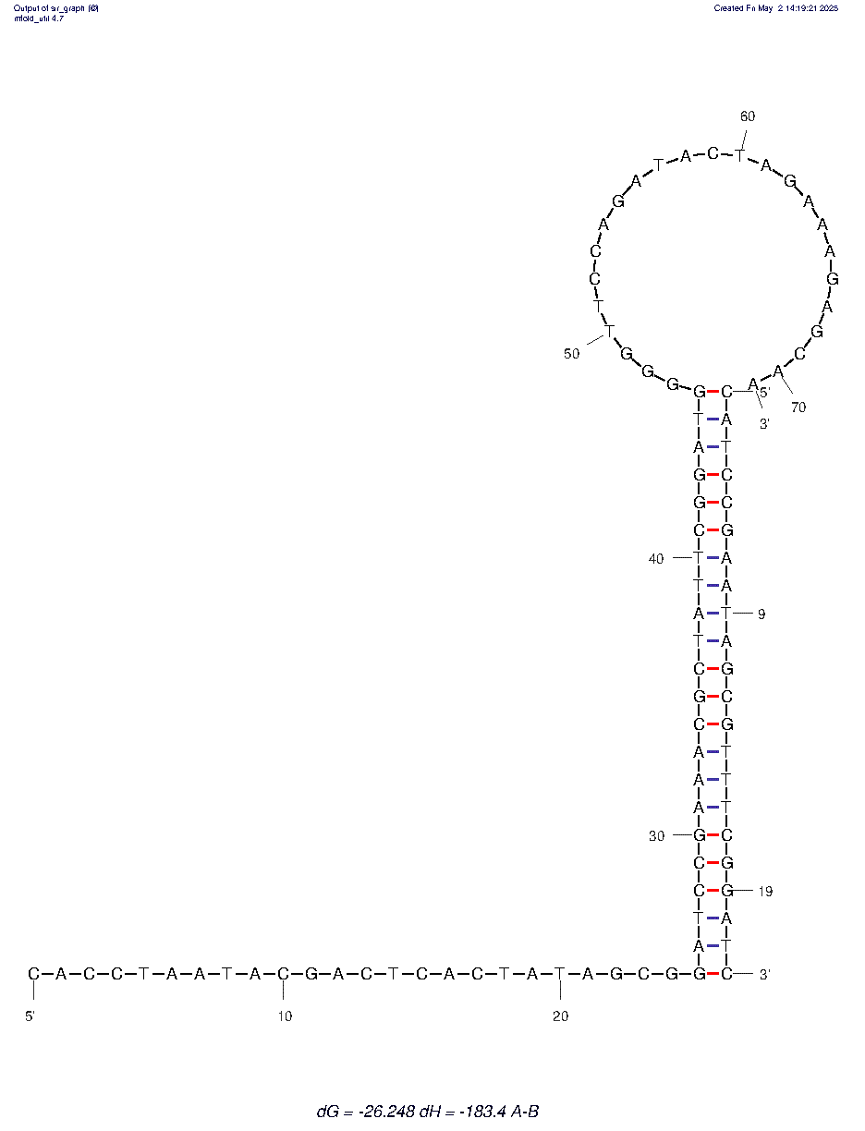
H1/T
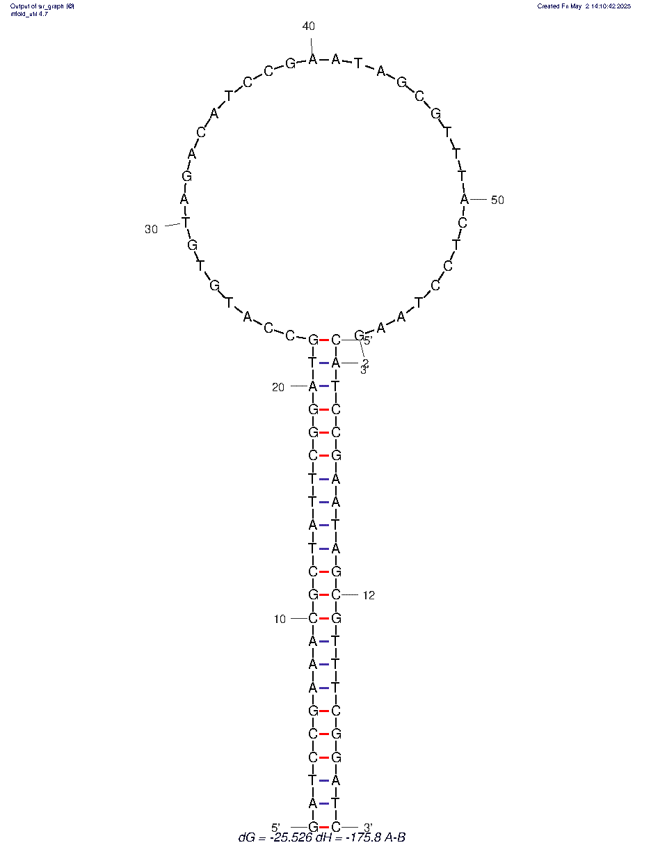
H2/T
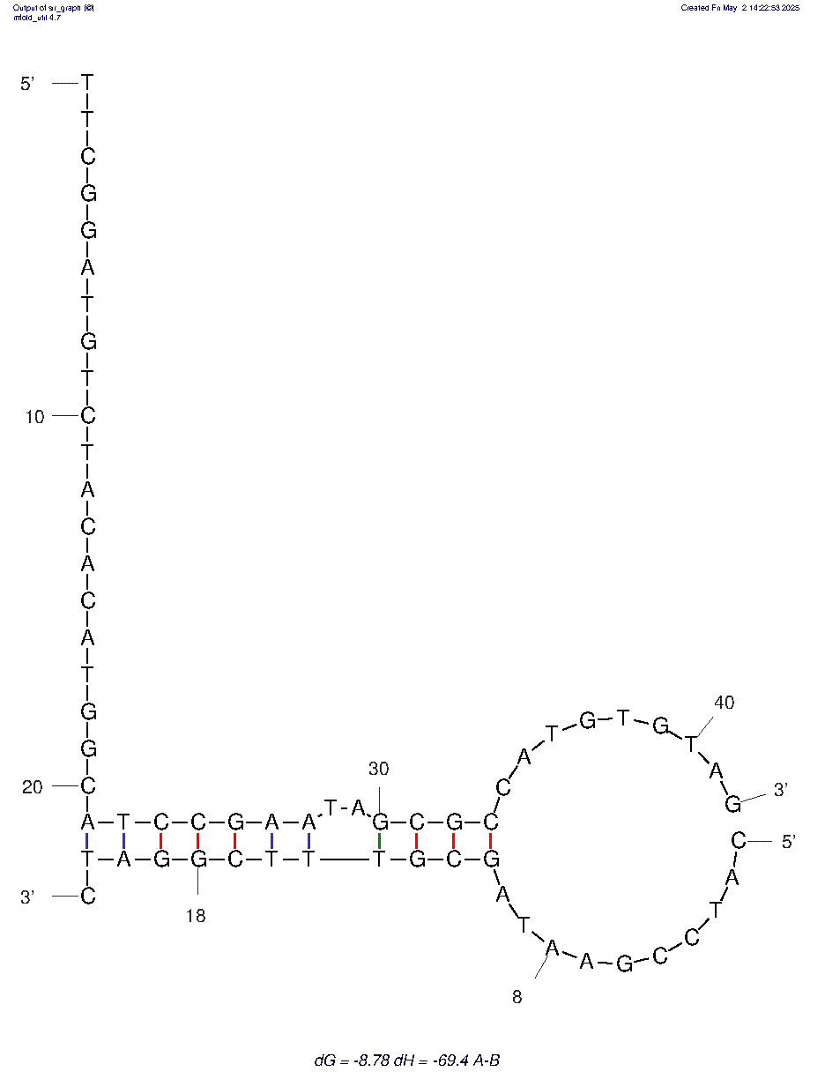
H1/H2
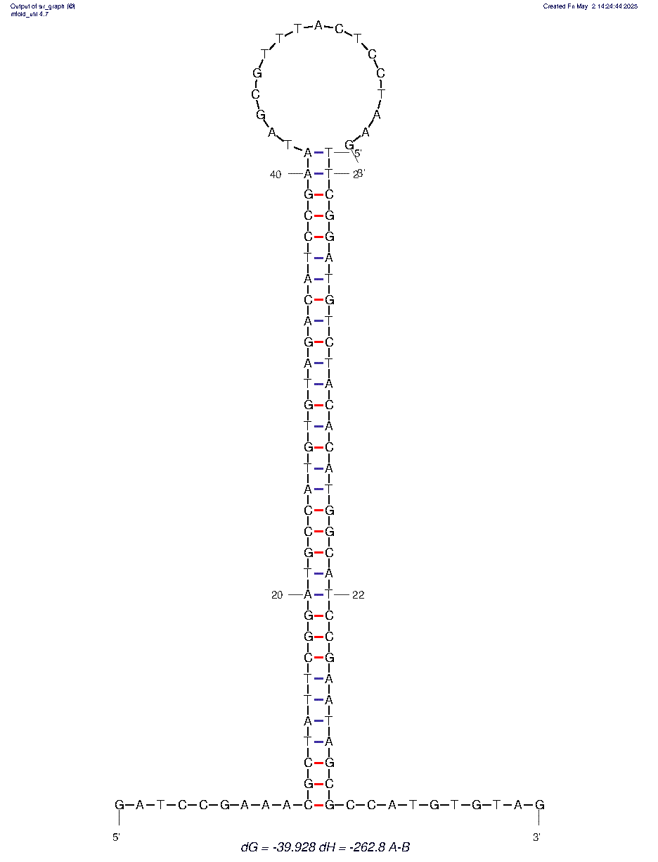

F/Q
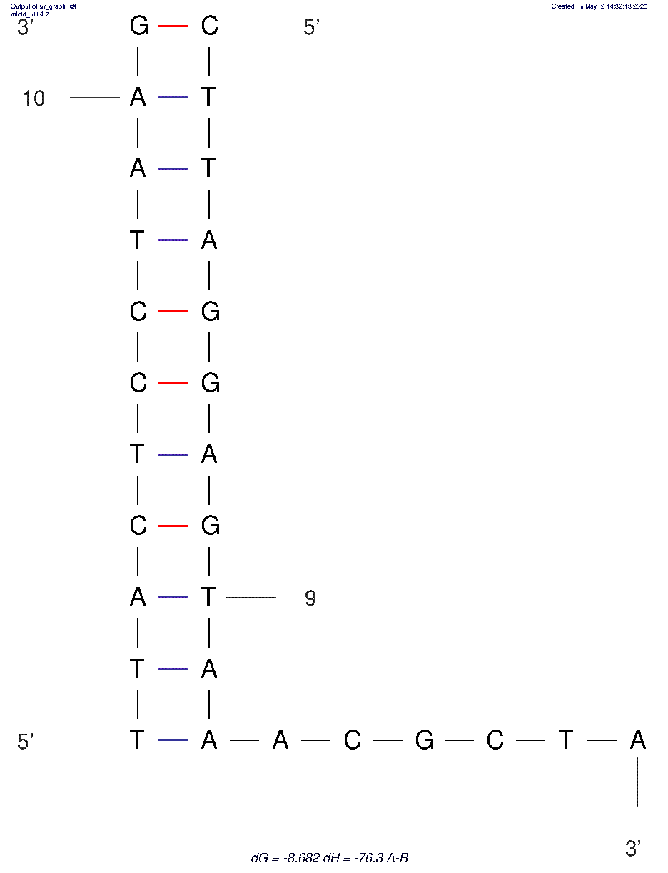
Q/H1
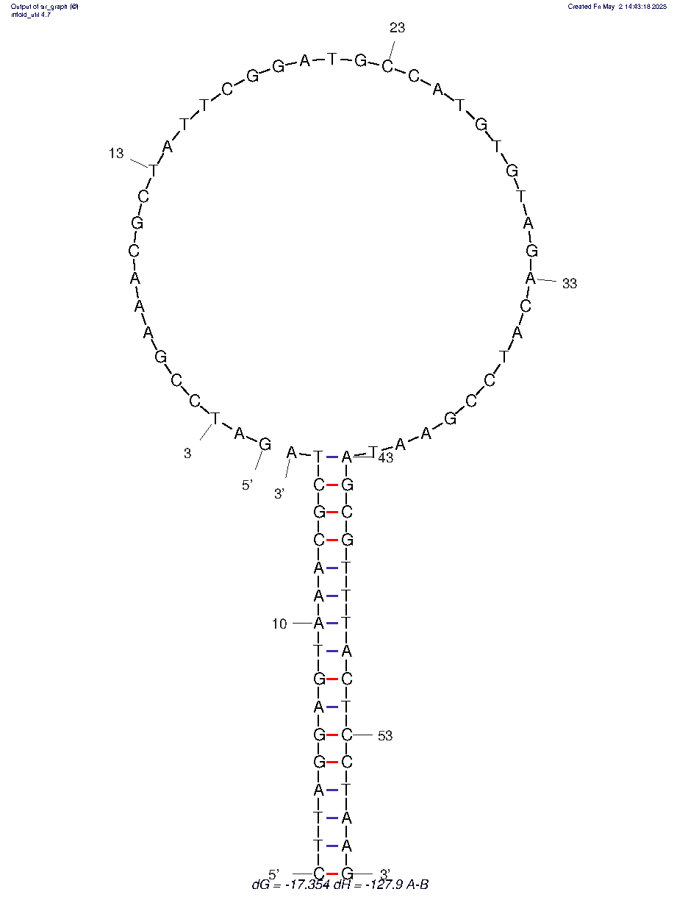
Apt/H1
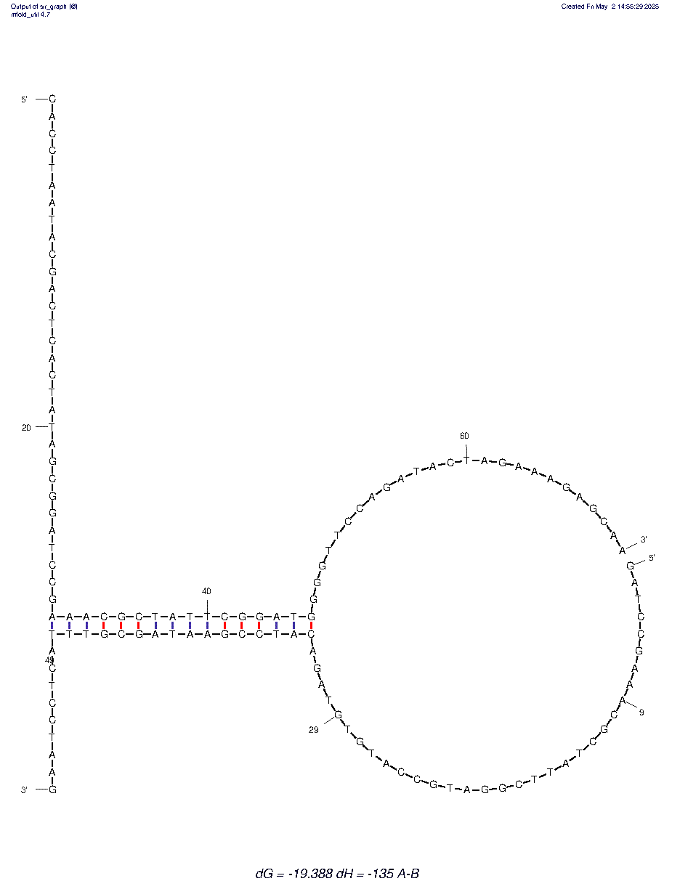
Apt/H2
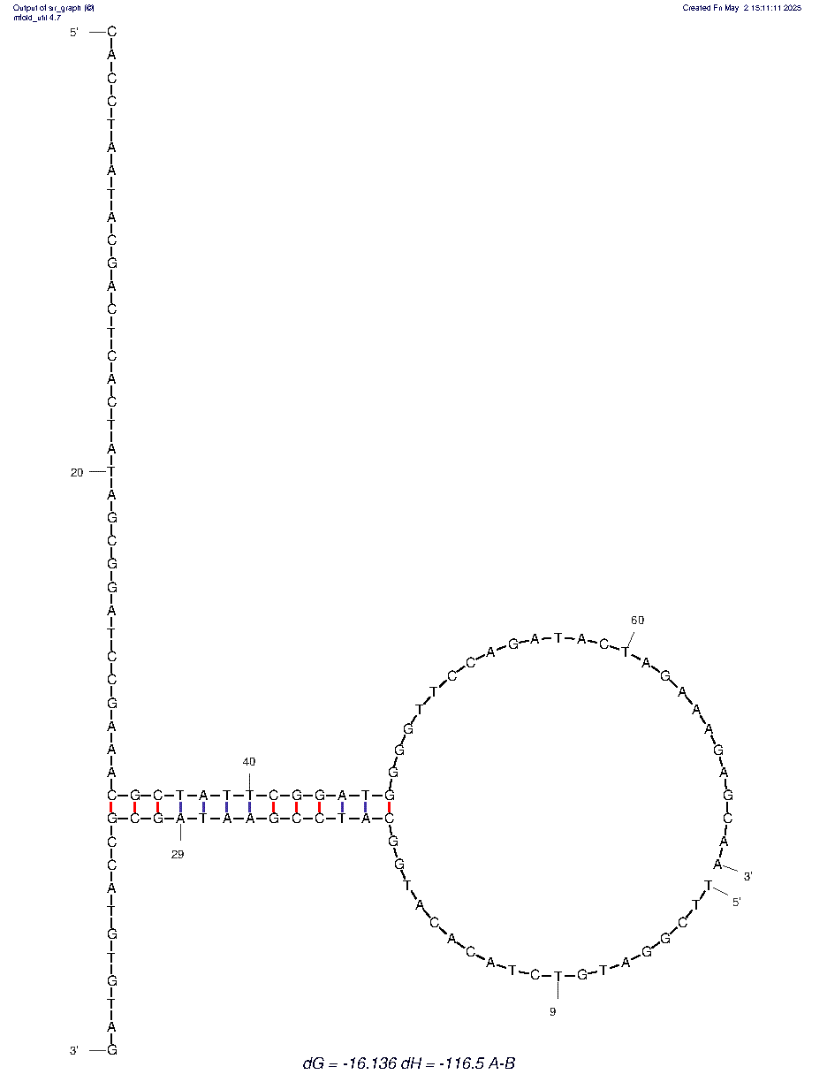
Figure S5. Secondary structures of DNA complexes, including MPO Apt/T, H1/T, H2/T, H1/H2, F/Q, Q/H1, Apt/H1, Apt/H2, and complementary duplexes, were predicted and analyzed using the mfold web server (https://www.unafold.org/).

References
1 Tao, Y. et al. Flexible Amperometric Immunosensor Based on Colloidal Quantum Dots for Detecting the Myeloperoxidase (MPO) Systemic Inflammation Biomarker. Biosensors 13, 255 (2023).
2 Barallat, J. et al. Chronoamperometric magneto immunosensor for myeloperoxidase detection in human plasma based on a magnetic switch produced by 3D laser sintering. Anal. Chem. 85, 9049-9056, doi:10.1021/ac401549d (2013).
3 Valero-Calvo, D., Bergua-Canudo, J. F. & de la Escosura-Muñiz, A. Use of bimetallic PtAu nanoraspberries as novel labels in lateral flow immunoassays: Application for a chronic wound biomarker detection. Sensors and Actuators B: Chemical 447, 138903, doi:https://doi.org/10.1016/j.snb.2025.138903 (2026).
4 Nandeshwar, R. & Tallur, S. Electrochemical detection of myeloperoxidase (MPO) in blood plasma with surface-modified electroless nickel immersion gold (ENIG) printed circuit board (PCB) electrodes. Biosensors & bioelectronics 246, 115891, doi:10.1016/j.bios.2023.115891 (2024).
5 Guo, J.-Y. et al. One-step screening of myeloperoxidase aptamer using porous PEG hydrogel. Advanced Composites and Hybrid Materials 8, 244, doi:10.1007/s42114-025-01319-9 (2025).
6 Zhao, X. et al. Versatile bioluminescence CRISPR/Cas platform for point-of-care detection of biomarkers in whole blood. Science China Chemistry, doi:10.1007/s11426-025-2839-0 (2025).
7 Mi, L., Niu, C., Chen, J., Han, F. & Ji, X. Development of an activatable far-red fluorescent probe for rapid visualization of hypochlorous acid in live cells and mice with neuroinflammation. Volume 12 - 2024, doi:10.3389/fchem.2024.1355238 (2024).
8 Xu, J., Zhou, X., He, H., Li, S. & Ma, C. A turn-on fluorescence strategy for hypochlorous acid detection based on DNAzyme-assisted cyclic signal amplification. Spectrochimica Acta Part A: Molecular and Biomolecular Spectroscopy 303, 123243, doi:https://doi.org/10.1016/j.saa.2023.123243 (2023).
9 Tian, F. et al. A HClO-specific near-infrared fluorescent probe for determination of Myeloperoxidase activity and imaging mitochondrial HClO in living cells. Biosens. Bioelectron. 86, 68-74, doi:10.1016/j.bios.2016.06.039 (2016).
10 Stocker, P., Cassien, M., Vidal, N., Thetiot-Laurent, S. & Pietri, S. A fluorescent homogeneous assay for myeloperoxidase measurement in biological samples. A positive correlation between myeloperoxidase-generated HOCl level and oxidative status in STZ-diabetic rats. Talanta 170, 119-127, doi:10.1016/j.talanta.2017.03.102 (2017).
11 Permpoka, K. et al. Smartphone-enabled 3D origami-fluidic paper-based electrochemical detection of myeloperoxidase activity for assessing wound infection. Sensors and Actuators B: Chemical 398, 134712, doi:https://doi.org/10.1016/j.snb.2023.134712 (2024).
12 You, Y. et al. Rational Modulation of the Luminescence of Upconversion Nanomaterials with Phycocyanin for the Sensing and Imaging of Myeloperoxidase during an Inflammatory Process. Anal. Chem. 92, 5091-5099, doi:10.1021/acs.analchem.9b05468 (2020).
13 Wang, J. et al. Oxidative Cleavage-Based Three-Dimensional DNA Biosensor for Ratiometric Detection of Hypochlorous Acid and Myeloperoxidase. Anal Chem 93, 16231-16239, doi:10.1021/acs.analchem.1c04113 (2021).
14 Hu, Z. et al. Site-Specific Scissors Based on Myeloperoxidase for Phosphorothioate DNA. J Am Chem Soc 143, 12361-12368, doi:10.1021/jacs.1c06370 (2021).
15 Tian, F. et al. A HClO-specific near-infrared fluorescent probe for determination of Myeloperoxidase activity and imaging mitochondrial HClO in living cells. Biosensors and Bioelectronics 86, 68-74, doi:https://doi.org/10.1016/j.bios.2016.06.039 (2016).
16 Liu, B. et al. Rolling-Circle-Amplification-Assisted DNA Biosensors for Sensitive and Specific Detection of Hypochlorous Acid and Myeloperoxidase. Chemistry 5, 1454-1464 (2023).
17 Bekhit, M. & Gorski, W. Electrochemical Assays and Immunoassays of the Myeloperoxidase/SCN(-)/H2O2 System. Anal. Chem. 91, 3163-3169, doi:10.1021/acs.analchem.8b05855 (2019).
18 Yang, W. et al. Multi-function PtCo nanozymes/CdS nanocrystals@graphene oxide luminophores and K(2)S(2)O(8)/H(2)O(2) coreactants-based dual amplified electrochemiluminescence immunosensor for ultrasensitive detection of anti-myeloperoxidase antibody. Journal of nanobiotechnology 19, 225, doi:10.1186/s12951-021-00968-4 (2021).

