Supplementary Figure 1.
GDF15 upregulated CXCR4 expression in ARP-1 cells. Western blotting analysis demonstrated that GDF15 enhanced CXCR4 protein expression in ARP-1 cells in a concentration-dependent manner (**P < 0.01; ****P < 0.0001 versus NC group). All data are shown as mean ± SD from three independent experiments, each performed in triplicate.
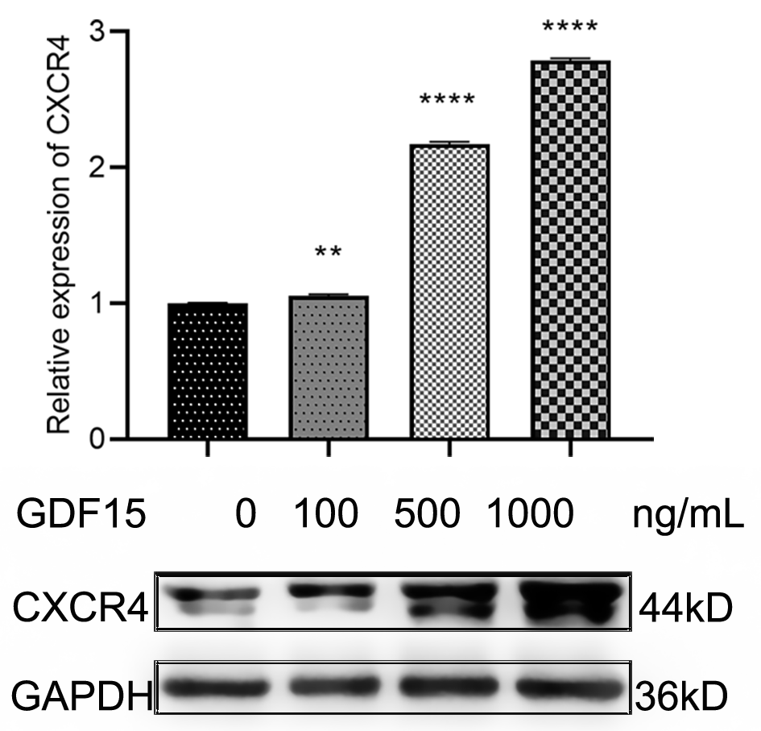

Supplementary Figure 2.
GDF15 activated Akt signaling in ARP-1 cells. Western blotting revealed that GDF15 treatment increased phosphorylation of Akt (p-Akt) in ARP-1 cells in a dose-dependent manner (***P < 0.001, ****P < 0.0001 versus NC group). All data are presented as mean ± SD from three independent experiments, each conducted in triplicate.
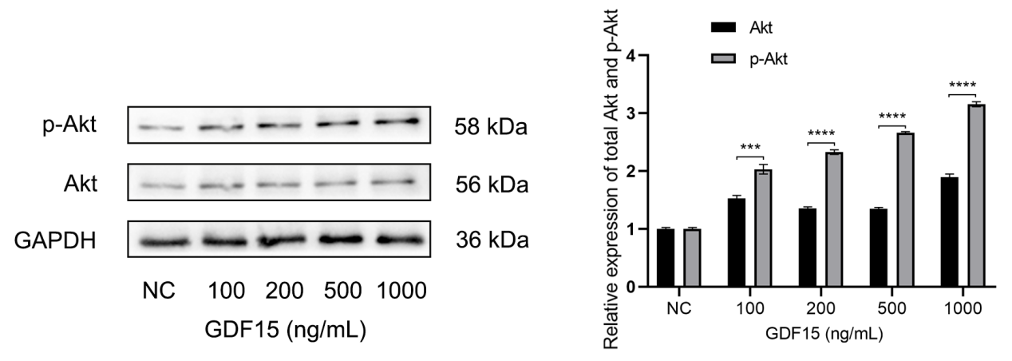

Supplementary Figure 3. Based on qPCR analysis, GFRAL mRNA of MM cells showed positive expression relative to the endogenous control GAPDH mRNA. (Group 1-4 are technical replicates normalized to GAPDH mRNA levels, with Group 1 serving as the reference group).

Supplementary Fig 4. Western blot analysis revealed positive expression of GFRAL protein in MM cells.

