Full uncropped Blots images
Figure 2O-LIF | Figure 2O-PCNA | Figure 2O-GAPDH
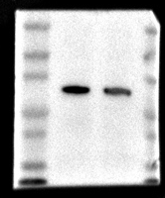

Supplementary Figure 3G-LIF | Supplementary Figure 3G-PCNA | Supplementary Figure 3G-GAPDH
