Supplementary Figure 1, Immunofluorescence co-staining of inflammatory factors and β1-integrin. Inflammatory factors (red), β1-integrin (green), and cell nuclei (blue). Scale bar=50 μm. e, remnant lens epithelial cells/lens cells; lc, lens capsule.

Supplementary Figure 2, Immunofluorescence co-staining of inflammatory factors and CD11b. Inflammatory factors (red), CD11b (green), and cell nuclei (blue). Scale bar=50/10μm. e, remnant lens epithelial cells/lens cells; lc, lens capsule.

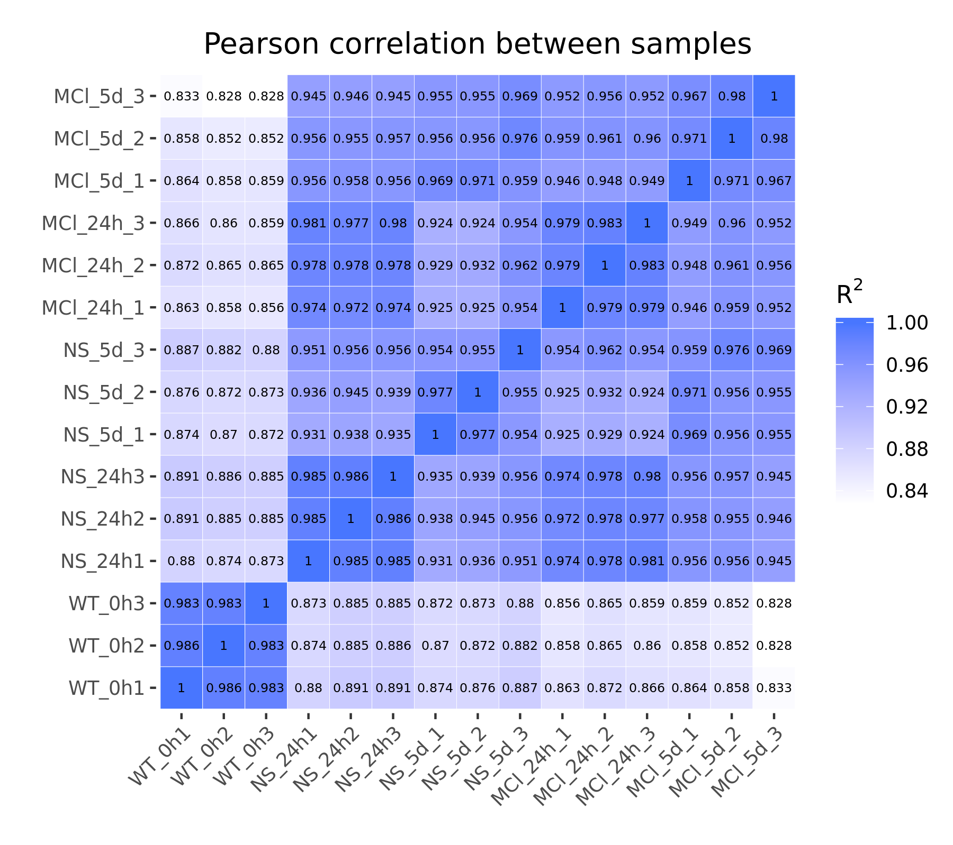
Supplementary Figure 3, Pearson correlation analysis of five sample groups (NS-0h, NS-24h, NS-5d, MCL-24h, MCL-5d).

