Supplementary Material
DKC1: a robust prognostic factor and potential therapeutic target in Multiple Myeloma
Sun C., Cheng L., Li A., Han Y., Wang Y., Xiao J., Guo Y., Zhang W., Sun L., Xu D., Kong D., Jiang Y., Zheng C
Supplementary Figures
Figure S1. DKC1 mRNA expression in plasma cell disorders. A Comparison of DKC1 mRNA expression between PCL and MM patients, based on integrated analysis of GSE164701, GSE164703, and GSE164706 datasets. B DKC1 mRNA expression in MM patients compared to healthy controls, assessed by qPCR. Abbreviations: plasma cell leukemia (PCL); multiple myeloma (MM).
Figure S2 Nomogram and calibration plot of OS and PFS for MM patients. A Nomogram predicting 1-, 2-, and 3-year OS for MM patients. B Calibration plot of the OS nomogram at 1, 2, and 3 years. C Nomogram predicting 1-, 2-, and 3-year PFS for MM patients. D Calibration plot of the PFS nomogram at 1, 2, and 3 years. Abbreviations: overall survival (OS); progression-free survival (PFS); albumin (ALB).
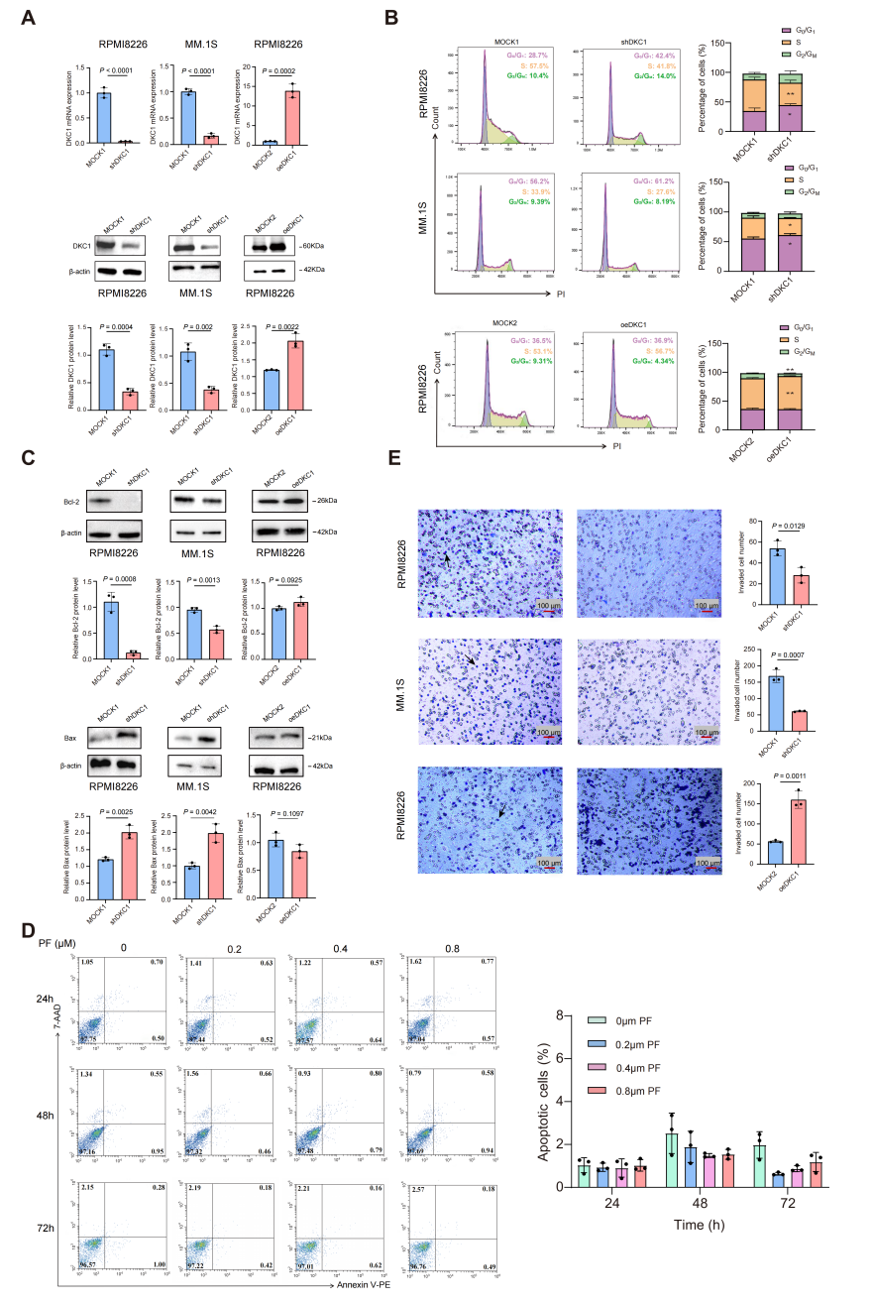
Figure S3 Molecular and functional analyses of DKC1 expression in MM Cells and PF treatment on PBMCs from MM patients. A RT-qPCR and Western blot validation of DKC1 knockdown and overexpression in MM cell lines. B Cell cycle distribution after DKC1 knockdown or overexpression, using flow cytometry. ** and * in the top panel indicate P = 0.0018 and P = 0.0354 at the S and G0/G1 phases, respectively; * and * in the middle panel denote P = 0.0163 and P = 0.0264 at the S and G0/G1 phases, respectively; and ** and ** in the bottom panel correspond to P = 0.0034 and P = 0.0026 at the S and G2/M phases, respectively. C Representative Western blots showing expression levels of the protein Bcl-2 and Bax. β-actin was used as a loading control. Quantification of band intensities normalized to β-actin is shown alongside. D Apoptosis analysis of PBMCs after PF treatment for 24, 48, and 72 h. E Transwell invasion assay of DKC1 knockdown and overexpression cells versus their respective controls (scale bar = 100 µm). Arrows indicate purple invading cells. Data are presented as mean ± SD from three independent experiments, each with three technical replicates (wells) for qPCR. Abbreviations: pyrazofurin (PF); Peripheral blood mononuclear cells (PBMCs).
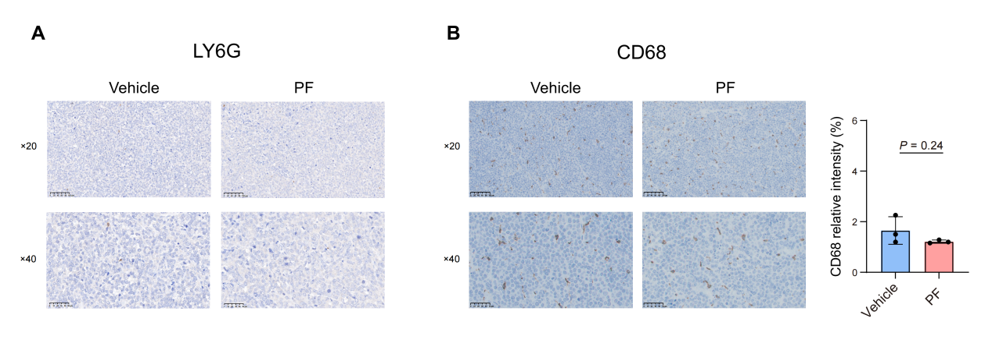
Figure S4 IHC staining of CD68 and Ly6G in Vehicle and PF groups. A,B Ly6G staining (A) and CD68 staining (B) in Vehicle and PF groups at ×20 (scale bar = 100 µm) and ×40 (scale bar = 50 µm) magnification. Data were obtained from 3 mice per group.

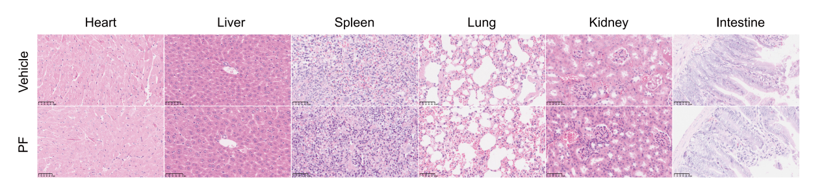
Figure S5 H&E-staining demonstrating that pyrazofurin (PF) treatment does not cause damage to the internal organs (heart, liver, spleen, lung, kidney, and intestine) of mice (scale bar = 50 µm).
Figure S6 KEGG pathway analysis identifying downregulated and upregulated pathways.

Figure S7 Predicted potential interaction sites between DKC1 and ATF5 mRNA based on AlphaFold3.
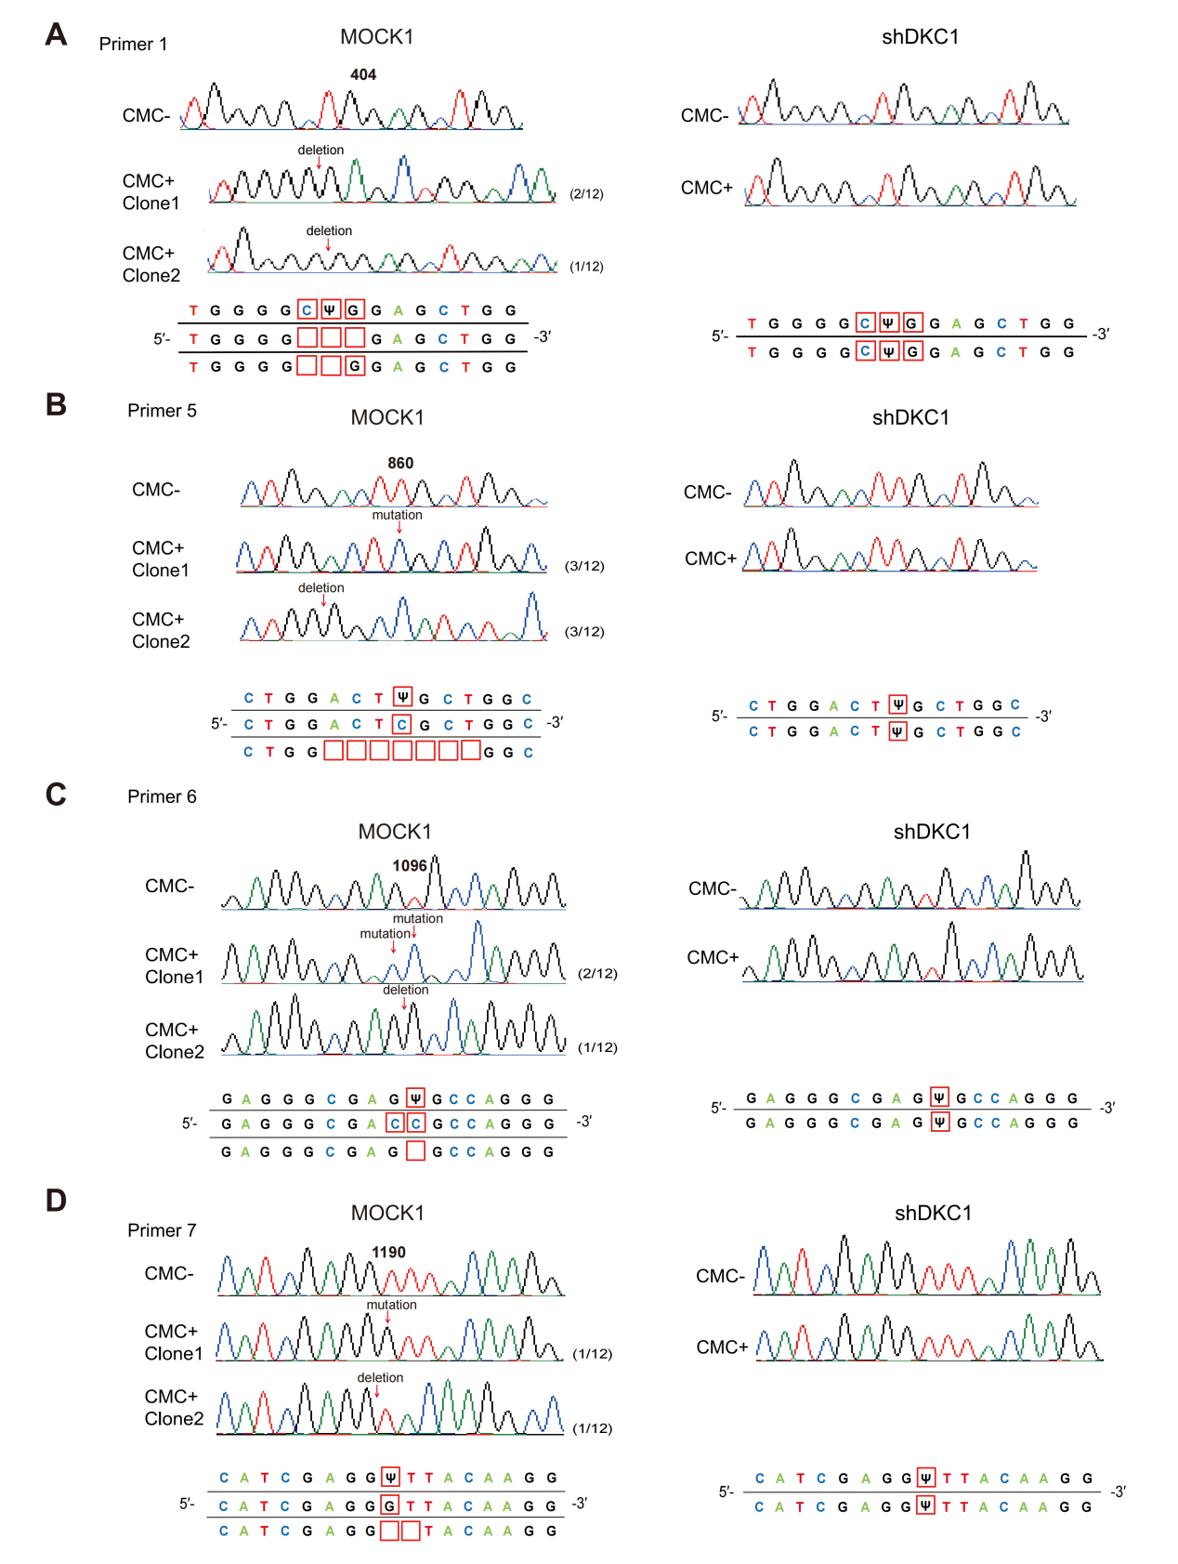Figure S8 Ψ site detection in MOCK1 and shDKC1 RPMI8226 cells within primer 1, 5, 6, and 7 regions. A-D Deletion or mutation frequencies at and around positions 404 (A, primer 1), 860 (B, primer 5), 1096 (C, primer 6), and 1190 (D, primer 7) in MOCK1 and shDKC1 cells. Abbreviations: pseudouridine (Ψ); N-cyclohexyl-N'-(2-morpholinoethyl) carbodiimide (CMC).
Figure S9 Western blot analysis of Bcl-2 and Bax protein expression levels in RPMI8226 and MM.1S cells across different groups. A-F Expression of Bcl-2 and Bax in RPMI8226 (A-C) and MM.1S (D-F) cells from the MOCK1, shDKC1, and shDKC1+oeATF5 groups, with β-actin as the loading control: (A, D) representative western blots; (B, E) quantification of Bcl-2; (C, F) quantification of Bax. G-I Expression of Bcl-2 and Bax in RPMI8226 cells from the MOCK2, oeDKC1, and oeDKC1+shATF5 groups, with β-actin as the loading control: (G) representative western blots; (H) quantification of Bcl-2; (I) quantification of Bax. Data are presented as mean ± SD, from 3 independent experiments.

Supplementary Tables
Table S1. Primers for RT-qPCR assays.
Gene | Forward Primer (5'→3') | Reverse Primer (5'→3')
DKC1 | ATGGCGGATGCGGAAGTAAT | CCACTGAGACGTGTCCAACT
ATF5 | CTGGCTCCCTATGAGGTCCTTG | GAGCTGTGAAATCAACTCGCTC
GAPDH | AACGGATTTGGTCGTATTGGG | CCTGGAAGATGGTGATGGGAT

Table S2. Primers covering the full-Length coding sequence of ATF5 (7 Pairs) .
Gene | Forward Primer (5'→3') | Reverse Primer (5'→3')
ATF5-1 | TCACTCCTGGCGACCCTG | AGTTTCCCATAGTCTACGAGCCAT
ATF5-2 | GCTGGGATGGCTCGTAGACT | TCAACTCGCTCAGTCATCCAG
ATF5-3 | TGGCAGGTGATGGCTTCTCT | CCATAGCTTCCAGGTCAGGTG
ATF5-4 | CTATGGCCTCCCTCCTCAAG | GCCAGCAAGTCCAGAGTATCC
ATF5-5 | CCCCTGTCTTGGATACTCTGG | CGAGAAGGTTGAGGTGGAGAA
ATF5-6 | CTACCCACATCCTGCCACCA | GACTCTGCCCGTTCCTTCAG
ATF5-7 | GGAATCGCGAGCTGAAGGAAC | CTGAAGACCAGCCCCCAGAAG

Table S3. Characteristics of MM patients.
Characteristics | Median (range) (N = 10)
Age (years) | 64.5 (50-92.5)
Sex
Male | 5 (50%)
Female | 5 (50%)
ISS stage
Stage II | 3 (30%)
Stage III | 7 (70%)
White blood cell count (×10⁹/L) | 6.065 (0.52-18.84)
Lymphocyte count (×10⁹/L) | 1.515 (0.33-2.88)
Platelet count (×10⁹/L) | 176.5 (41-231)
Hemoglobin level (g/L) | 74.5 (57-100)
Albumin (g/L) | 34.4 (26.8-43.1)
Beta2-microglobulin (mg/L) | 6.12 (2.35-16.53)
Disease status
Newly diagnosed | 8 (80%)
Previously treated | 2 (20%)

Table S4. RT-qPCR cycle threshold (Ct) values obtained with primers targeting the coding sequence region of the ATF5 gene in CMC-treated (CMC+) and untreated (CMC-) groups.
Groups | Primer 1  Region: 382-467 | Primer 2  Region: 438-593 | Primer 3  Region: 551-682 | Primer 4  Region: 677-866 | Primer 5  Region: 835-965 | Primer 6  Region: 974-1145 | Primer 7  Region: 1114-1264
CMC+ (Ct value ± SD) | 23.458 ± 0.015 | 27.255 ± 0.436 | 32.558 ± 0.742 | 35.071 ± 0.827 | 22.690 ± 0.160 | 26.389 ± 0.689 | 25.728 ± 0.252
CMC- (Ct value ± SD) | 20.655 ± 0.290 | 25.546 ± 0.328 | 33.743 ± 0.215 | 34.281 ± 0.394 | 19.305 ± 0.066 | 22.864 ± 0.064 | 20.856 ± 0.106
ΔCt = Ct (CMC+) − Ct (CMC−) | 2.803 ± 0.290 | 1.709 ± 0.546 | -1.185 ± 0.773 | 0.790 ± 0.916 | 3.385 ± 0.173 | 3.525 ± 0.691 | 4.872 ± 0.273

