Supplementary material of Western blots
SW62000
SW4800
NCM460
RKO
HT29

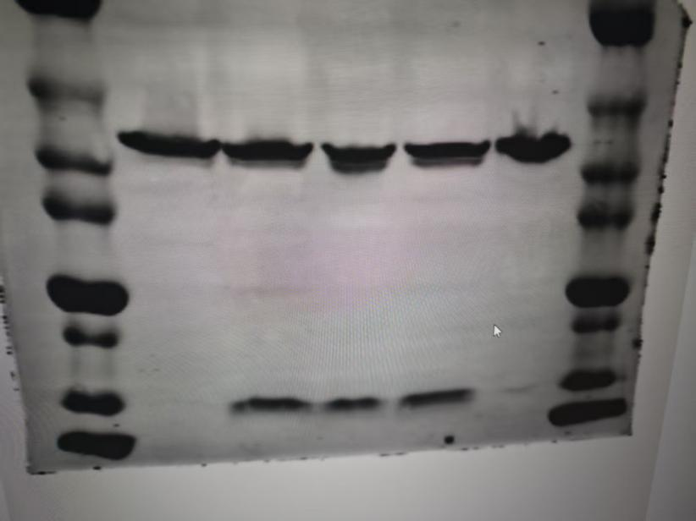
β-actin
IFITM1
40kda
50kda
35kda
25kda
20kda
15kda
10kda
70kda
The original Western blots file of Figure.4A

