Supplementary materials

Table S1
Saliva
term | Df | SumOfSqs | R2 | F | Pr(>F)
Disease status | 1 | 1.9212238539989 | 0.0327495221366402 | 6.93701591019167 | 0.0001
Gender | 1 | 0.269012565226057 | 0.00458563583913849 | 0.971331082075823 | 0.4615
Age | 1 | 0.210942758364169 | 0.00359576762501266 | 0.761656830288759 | 0.8892
BMI | 1 | 0.280510423671709 | 0.00478163037090847 | 1.01284671639642 | 0.3837
Hospital site | 1 | 0.318967514360795 | 0.0054224477441335 | 1.1516960041025 | 0.100
TNM | 1 | 0.239976441305618 | 0.00409068092739545 | 0.86648954932724 | 0.6872
Residual | 199 | 55.4235462128725 | 0.950196763100905 | NA | NA
Total | 205 | 58.6641797697998 | 1 | NA | NA
Gastric juice
term | Df | SumOfSqs | R2 | F | Pr(>F)
Disease status | 1 | 2.35926002434435 | 0.0334643817370227 | 7.14051435930138 | 0.0001
Gender | 1 | 0.273409725156287 | 0.00387811742615658 | 0.827499321103301 | 0.8158
Age | 1 | 0.259128549780133 | 0.0036755493753654 | 0.784276049065082 | 0.8868
BMI | 1 | 0.470801888068819 | 0.00667798120693558 | 1.42492459815906 | 0.0377
Hospital site | 1 | 0.441275062299662 | 0.0062661058846552 | 1.33556310355615 | 0.127
TNM | 1 | 0.315801072661706 | 0.00447940775474694 | 0.955800577619821 | 0.521
Residual | 200 | 66.3809545539568 | 0.941558456615118 | NA | NA
Total | 206 | 70.5006308762678 | 1 | NA | NA
Gastric mucosa
term | Df | SumOfSqs | R2 | F | Pr(>F)
Disease status | 1 | 3.14763339757997 | 0.0377464756238978 | 7.44545649383597 | 0.0001
Gender | 1 | 0.464557793819212 | 0.00557098531670512 | 1.09887156662293 | 0.272
Age | 1 | 0.342542981797859 | 0.00410778152325843 | 0.810256007006931 | 0.786
BMI | 1 | 0.507894665995337 | 0.00609068185775395 | 1.20138121613115 | 0.174
Hospital site | 1 | 0.506968708586256 | 0.00608362450303504 | 1.19918378328992 | 0.139
TNM | 1 | 0.431557373647101 | 0.00517524369172342 | 1.02081190667058 | 0.392
Residual | 184 | 77.7876474913526 | 0.941308831986661 | NA | NA
Total | 190 | 83.3888024127783 | 1 | NA | NA
Table S1. The combined effect of demographic variables on β diversity
Table S2
beta.binary_jaccard.adonis2
term | Df | SumOfSqs | R2 | F |  | Pr(>F)
Disease status | 4 | 22.300757563747 | 0.105568927023694 | 18.0237778472437 |  | 0.001
Gender | 1 | 0.338619113580677 | 0.00160297946777105 | 1.09470643058876 |  | 0.214
Age | 1 | 0.323601632501749 | 0.00153188863780399 | 1.04615709462687 |  | 0.309
BMI | 1 | 0.392734223822458 | 0.00185915346130752 | 1.26965272510614 |  | 0.073
Hospital site | 1 | 0.392745894398826 | 0.00186077347464698 | 1.26994402668929 |  | 0.072
TNM | 1 | 0.392040873202177 | 0.0018558712283688 | 1.26741122321734 |  | 0.081
Residual | 593 | 183.429208728905 | 0.868330355816939 | NA |  | NA
Total | 603 | 211.243575098019 | 1 | NA |  | NA
beta.bray_curtis.adonis2
term | Df | SumOfSqs | R2 |  | F |  | Pr(>F)
Disease status | 4 | 32.1786634020122 | 0.155350703332613 |  | 28.3240134306746 |  | 0.001
Gender | 1 | 0.342634952206396 | 0.00165415760582124 |  | 1.20636421306494 |  | 0.185
Age | 1 | 0.21941373745085 | 0.00105927576941233 |  | 0.772521539355643 |  | 0.799
BMI | 1 | 0.450141783928416 | 0.00217317425087034 |  | 1.58487899567625 |  | 0.053
Hospital site | 1 | 0.459421179233518 | 0.00220522166032091 |  | 1.60824610465541 |  | 0.052
TNM | 1 | 0.381015255943936 | 0.00183944830933049 |  | 1.34149527490606 |  | 0.113
Residual | 593 | 168.425525606548 | 0.813117174422672 |  | NA |  | NA
Total | 603 | 207.135614527062 | 1 |  | NA |  | NA
beta.euclidean.adonis2
term | Df | SumOfSqs | R2 |  | F |  | Pr(>F)
Disease status | 4 | 1533508496.26989 | 0.110185434359488 |  | 18.9065012323761 |  | 0.001
Gender | 1 | 18898912.6029091 | 0.00135792198030773 |  | 0.932012611046098 |  | 0.472
Age | 1 | 11669001.3126297 | 0.000838439422605749 |  | 0.575464663507162 |  | 0.877
BMI | 1 | 30647028.5040913 | 0.0022020459330775 |  | 1.51137886380328 |  | 0.104
Hospital site | 1 | 32802366.2146912 | 0.0023569109517008 |  | 1.61767079549004 |  | 0.100
TNM | 1 | 25167671.5044098 | 0.00180834395327813 |  | 1.24116068080895 |  | 0.232
Residual | 593 | 12024574604.1421 | 0.863988024173479 |  | NA |  | NA
Total | 603 | 13917524627.3179 | 1 |  | NA |  | NA
Table S2. β Diversity Multifactor Analysis of Variance Based on binary Jaccard, bray Curtis and Euclidean Distance

Figure S1
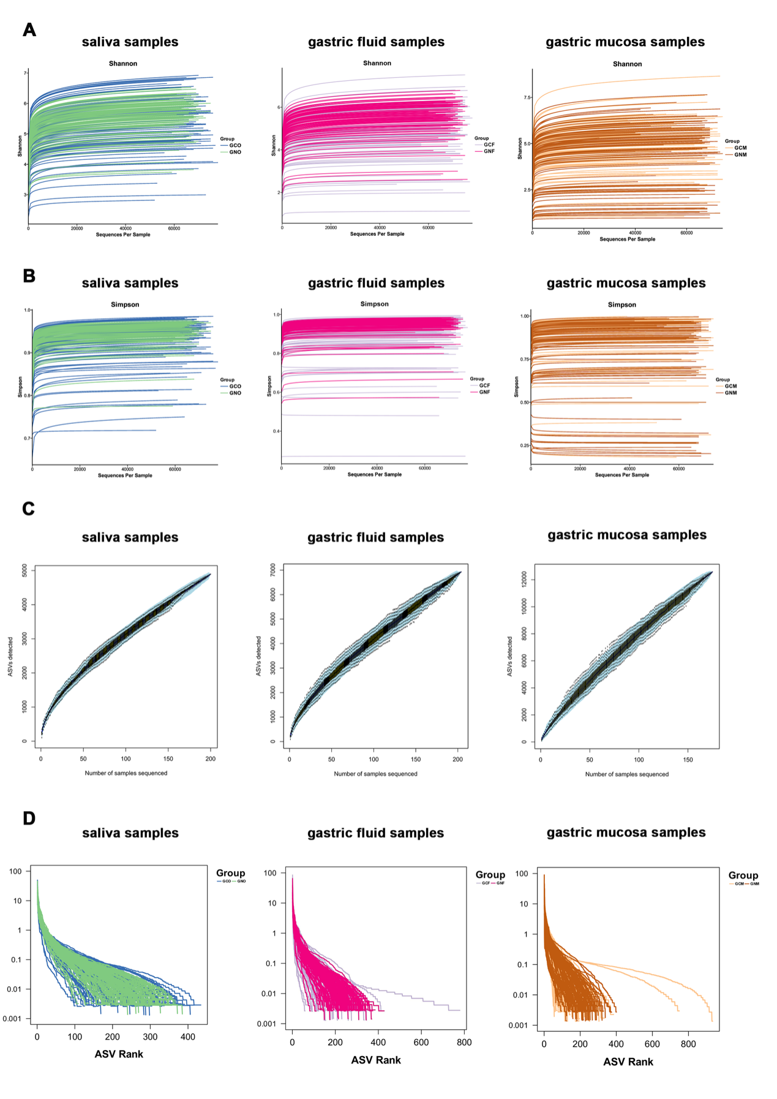
Figure S1. Rarefaction curves, species accumulation curves, and graded abundance curves of three sample types of the GC and NC groups.

(A) Rarefaction curves of salivary (left), gastric fluid (middle), and gastric mucosal samples (right) from GC and NC groups based on the Shannon index were analyzed to show the stability of the sequencing data.
(B) Rarefaction curves of salivary (left), gastric fluid (middle), and gastric. mucosal samples (right) from GC and NC groups based on the Simpson index were analyzed to show the stability of the sequencing data.
(C) The accumulation curves between the sequencing depth of all salivary (left), gastric fluid (middle), and gastric mucosal samples (right), and detected number of observed species (ASVs).
(D) Graded abundance curves showing the evenness of microbiota groups, with salivary (left), gastric fluid (middle), and gastric mucosal samples (right).

Figure S2
Figure S2. α and β diversity based on 16S rRNA microbial sequence data from age subgroups.

(A-B) The Wilcoxon signed-rank test was employed to compare α-diversity indices (including Simpson's index, Shannon index, and Chao 1 index) within the <60 years (A) and ≥60 years age groups (B) respectively. “*”, “**”, “***” respectively representing p < 0.05, p < 0.01, p < 0.001, ns: not significant.
(C-D) Weighted UniFrac PCoA revealed statistically significant differences between the GC and NC groups in both saliva (left), gastric fluid (center), and gastric mucosa (right) samples across both age cohorts: <60 years (C) and ≥60 years (D) (PERMANOVA p=0.001).
(E-F) The NMDS analysis revealed statistically significant differences between the GC and NC groups in both saliva (left), gastric fluid (centre), and gastric mucosa (right) samples across both age cohorts: <60 years (E) and ≥60 years age groups (F).

Figure S3
Figure S3. NMDS analysis of 16S rRNA microbial sequence data based on demographic variables
(A-C) Incorporating gender (A), BMI (B) and TNM stage (C) as covariates, NMDS analysis revealed statistically significant differences between the GC and NC groups in all three sample types: saliva (left), gastric fluid (centre), and gastric mucosa (right).

Figure S4
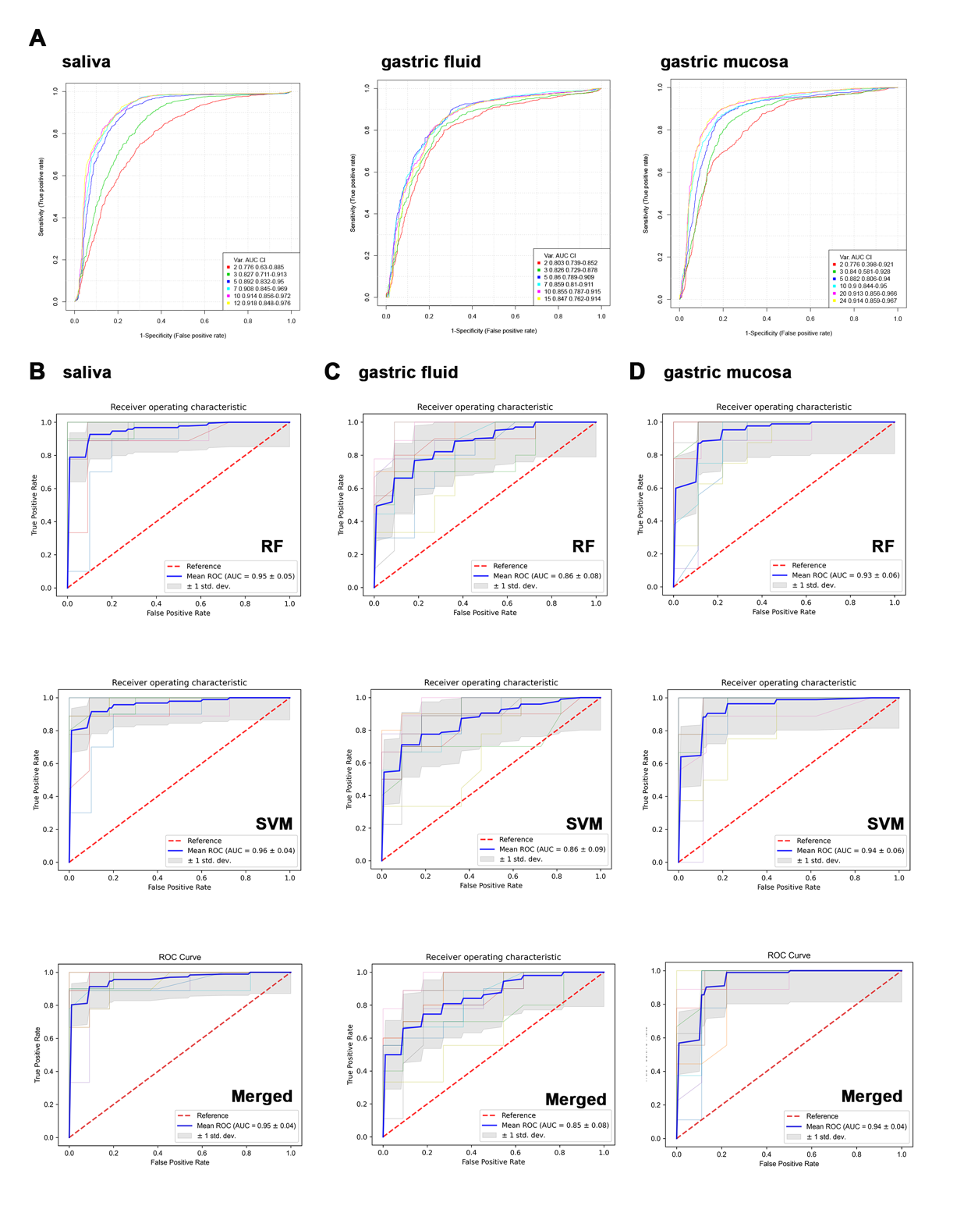
Figure S4. Evaluation of established diagnostic microbial classifiers for differentiating GC and NC in the training cohort.

(A)ROC curves showing the diagnostic performance of different models in SVM algorithm-based machine learning analysis.
(B) ROC curve showing the diagnostic performance of microbial classifier was calculated by RF analysis, SVM analysis, and combining RF-SVM analysis using the genus-level bacterium to segregate GC patients from controls based on salivary samples.
(C) ROC curve showing the diagnostic performance of microbial classifier was calculated by RF analysis, SVM analysis, and combining RF-SVM analysis using the genus-level bacterium to segregate GC patients from controls based on gastric fluid samples.
(D) ROC curve showing the diagnostic performance of microbial classifier was calculated by RF analysis, SVM analysis, and combining RF-SVM analysis using the genus-level bacterium to segregate GC patients from controls based on gastric mucosal samples.

Figure S5
Figure S5. Evaluation of established diagnostic microbial classifiers for differentiating GC and NC in the training cohort.

- Contribution levels of microbiome genera identified by the random forest algorithm for gastric cancer diagnosis.
(B) The ROC curve demonstrates the diagnostic performance based on the random forest model.
(C-I) The ROC curve demonstrates the diagnostic performance of the random forest model across the following subgroups: saliva (C), gastric fluid (D), gastric mucosa (E), male (F), female (G), individuals < 60 years old (H), and those ≥ 60 years old (I).

Figure S6
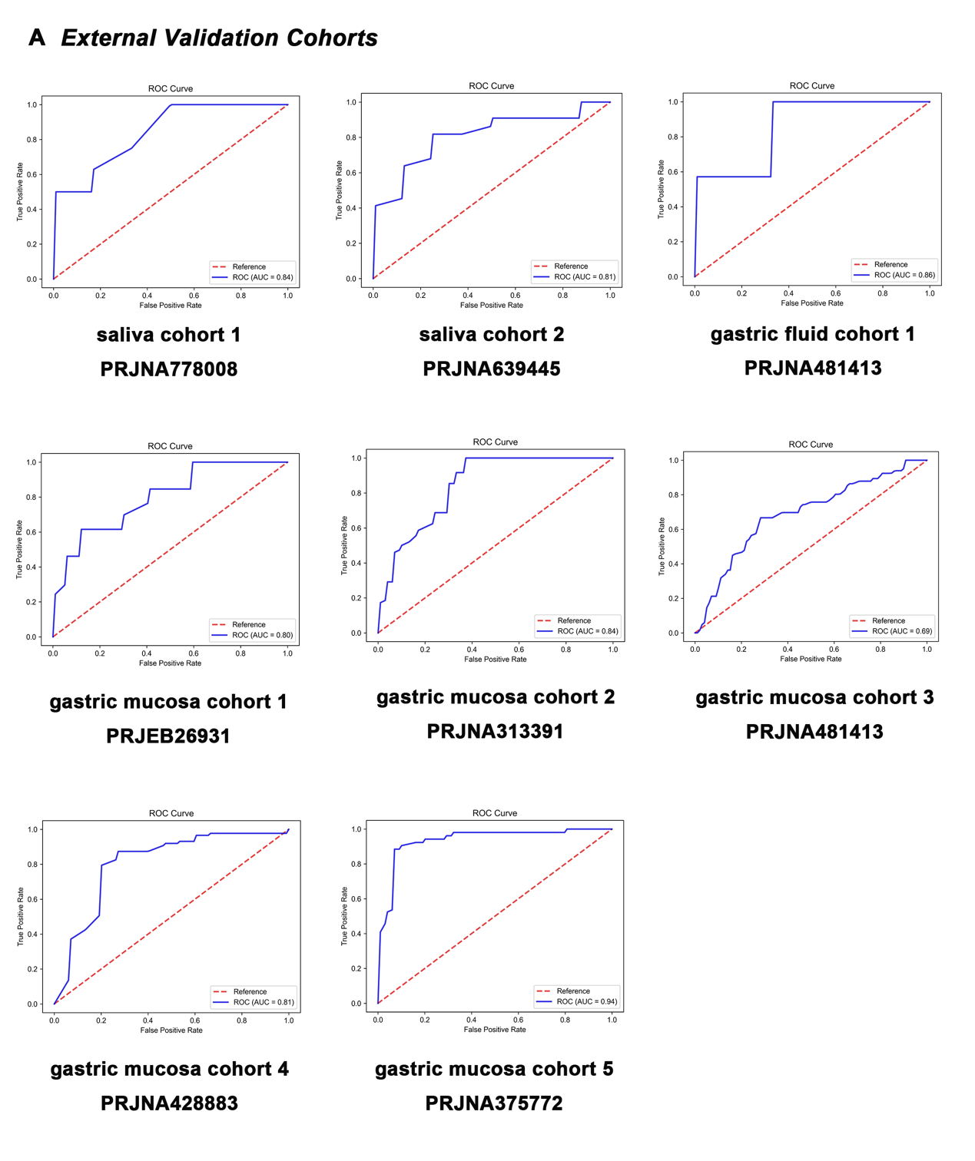Figure S6. Evaluation of established diagnostic microbial classifiers for differentiating GC and NC in the validation cohorts.

(A) ROC curves demonstrating salivary, gastric fluid, and gastric mucosal classifiers’ diagnostic performance in the external validation cohorts.

Figure S7
Figure S7. Evaluating the diagnostic efficacy of an established microbial classifier in distinguishing H. pylori negativity and gastric cancer from precancerous lesions within the validation cohort

(A) ROC curves demonstrating the diagnostic performance of gastric fluid and gastric mucosa classifiers in an external validation cohort negative for H. pylori infection.
(B) ROC curves for the gastric mucosa classifier distinguishing gastric cancer (GC) from healthy control (HC), GC from chronic gastritis (CG), and GC from intestinal metaplasia (IM) within the PRJEB26931 external validation cohort.

