Figure. S1 In vitro culture embryos assessment of TRIM7 knockdown effects during early mouse embryonic development. (A) In vitro culture of PN5-stage embryos: Comparison of control morpholino and TRIM7 Morpholino treatments at 7.5 μM and 10 μM concentrations (B) Statistical analysis of in vitro developmental outcomes in control and TRIM7 morpholino-treated embryos at different concentrations

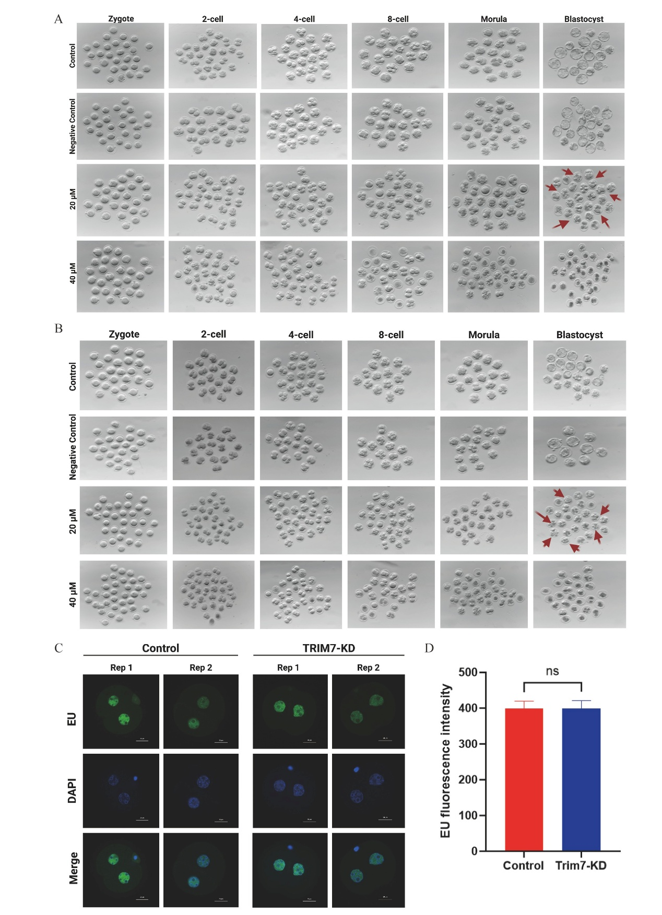
Figure S2. Independent validation of TRIM7 knockdown by siRNA microinjection and electroporation, and assessment of nascent transcription by EU labeling (A) Dose-dependent effects of TRIM7 siRNA microinjection on mouse embryo development. Control and negative control (NC) embryos developed to the blastocyst stage. Embryos injected with 20 µM TRIM7 siRNA arrested at the 8-cell stage, while 40 µM TRIM7 siRNA caused severe toxicity, with most embryos died at the 2-cell stage. n=30 embryos per group. (B) TRIM7 siRNA electroporation causes developmental arrest in mouse embryos. Control and negative control (NC) embryos developed normally to the blastocyst stage following electroporation. Embryos electroporated with TRIM7 siRNA exhibited a marked arrest at the 8-cell stage, phenocopying the results from TRIM7 morpholino and microinjection. n = 30 embryos per group. (C) Representative immunofluorescence images of 5-ethynyl uridine (5-EU) incorporation in control and TRIM7-KD late 2-cell embryos. Nuclei are stained with Hoechst (blue). (D) Quantification of 5-EU fluorescence intensity shows no significant difference between groups. ± Data means SEM (n=20 embryos per group, three independent experiments); unpaired two-tailed Student’s t-test, GraphPad Prism;n.s.

Figure S3. Single-cell transcriptomic analysis of 8-cell stage mouse embryos and late 2-cell stage scRNA seq and proteomics integrated analysis (A) Volcano plot showing differentially expressed genes (DEGs); X-axis: log_ fold change, Y-axis: -log__. (B) STRING network analysis of lysosomal pathway gene interactions. (C) Lysosomal pathway and its mechanism diagram. (D) DEG plot displays differentially expressed genes (|log2 fold change| > 1.5, adjusted p < 0.05) between groups. (E) KEGG pathway enrichment analysis of late 2-cell stage scRNA and proteomic data analysis reveals significant pathways affected by TRIM7 depletion in the late 2-cell stage embryos. (F) GO Ontology analysis shows gene and protein enrichment on the x-axis (rich factors) and their corresponding p-values and counts on the y-axis, highlighting key disrupted biological processes in TRIM7-depleted embryos.

Figure S4. Functional profiling of differential proteins in control and TRIM7 morpholino-treated 8-cell mouse embryos. (A) KEGG enrichment analysis reveals significant functional alterations associated with TRIM7 Knockdown. (B) GO enrichment analysis reveals key molecular functions and biological processes affected by TRIM7 deficiency during the 8-cell stage. (C) Reactome pathway mapping indicates broad proteomic changes consistent with impaired early embryonic progression

Table S1 : qRT-PCR validation of lysosomal pathway genes primers for Late 2-cell stage embryo
Gene Name | Forward Primer | Reverse Primer
CTSL | GAACCCAACTGTAGCAGCAAGAACC | CCCATTCACTTCCCCAGCTGTTCTT
CTSA | ACCAGAAGATGGAGGTGCAGCGC | ACCATGTGTCCGGCACCCTTGA
HexA | GAGAGTATGTGGACAGCACCAACCT | GCTCACAACGGAAATGCGACAAACG
Sgsh | CGACCCTCAGGATGTGATGGTGCCC | CAGCACAOCAGCACCTCGCAGC
ap1s1 | ATCCTGGACGAGTTTCTGATGGGTG | GACACTGCGCGGCGACTCATCCTCC
m6pr | TGGGGTTCTTTTATACACGGCAGACT | GCGCAACAAAGATGCAACATCAG
Mcoln1 | ATGGTGCTGAGCCTCTTCATTGC | CCACGACGGAACTTGCCAGATG
Ap1m1 | GACCGCACCATCTCCTTCATCC | TTGACCGCCGCTTGAACTGG
Gapdh | CACGGCAAATTCAACGGCACAG | TCGCTCCTGGAAGATGGTGATGG

Table S2 : qRT-PCR validation of lysosomal pathway genes primers for 8-cell stage embryo
Gene Name | Forward Primer | Reverse Primer
Ctsd | CCTCCTGGCTTCGTCCTCCTCC | CCGCCCACCTCCGTCATAGTC
Mcoln1 | ATGGTGCTGAGCCTCTTCATTGC | CCACGACGGAACTTGCCAGATG
Acp2 | GGATTTCCTTCGCCTCACAGAGC | GGAGCCACAGACAGCCAATGC
Acp5 | CACGATCCAGCGACAAGAGG | CATACCAGGGGATTTGCGAAGG
Atp6v0d1 | GCGGGCTGATGACTATGAACAGG | CGGTCCTCCAGGGTCTTGTCTC
Ppt2 | GCAACTACTCACGATCCTCAC | GCAGTGGCATTGGGATGGTCTC
Atp6ap1 | TCCTGCCCTGCTGCTCATCC | GCTGCGGTGTAAGGGACATCTC
Gga2 | CATGGGGAGCAGGATTGG | CAGCACCTCAGGGCATAAAGG
GAPDH | CACCAAATTCAACGCACAG | TCGCTCCTGGAAGATGGGATGG
Pla2g15 | GTGCGTGTCCCTGGCTTTGG | GGAGCACCTCGAACGTCTTCAC
Smpd1 | CAACCAGCAGGAGGCACAC | GGCAGGCATCCATCTGGAAG

Beta-actin
Control-Lc3b & Trim7-Kd-Lc3b & Rescue-Lc3b
Control-Trim7 & Trim7-KD

