Figure legends
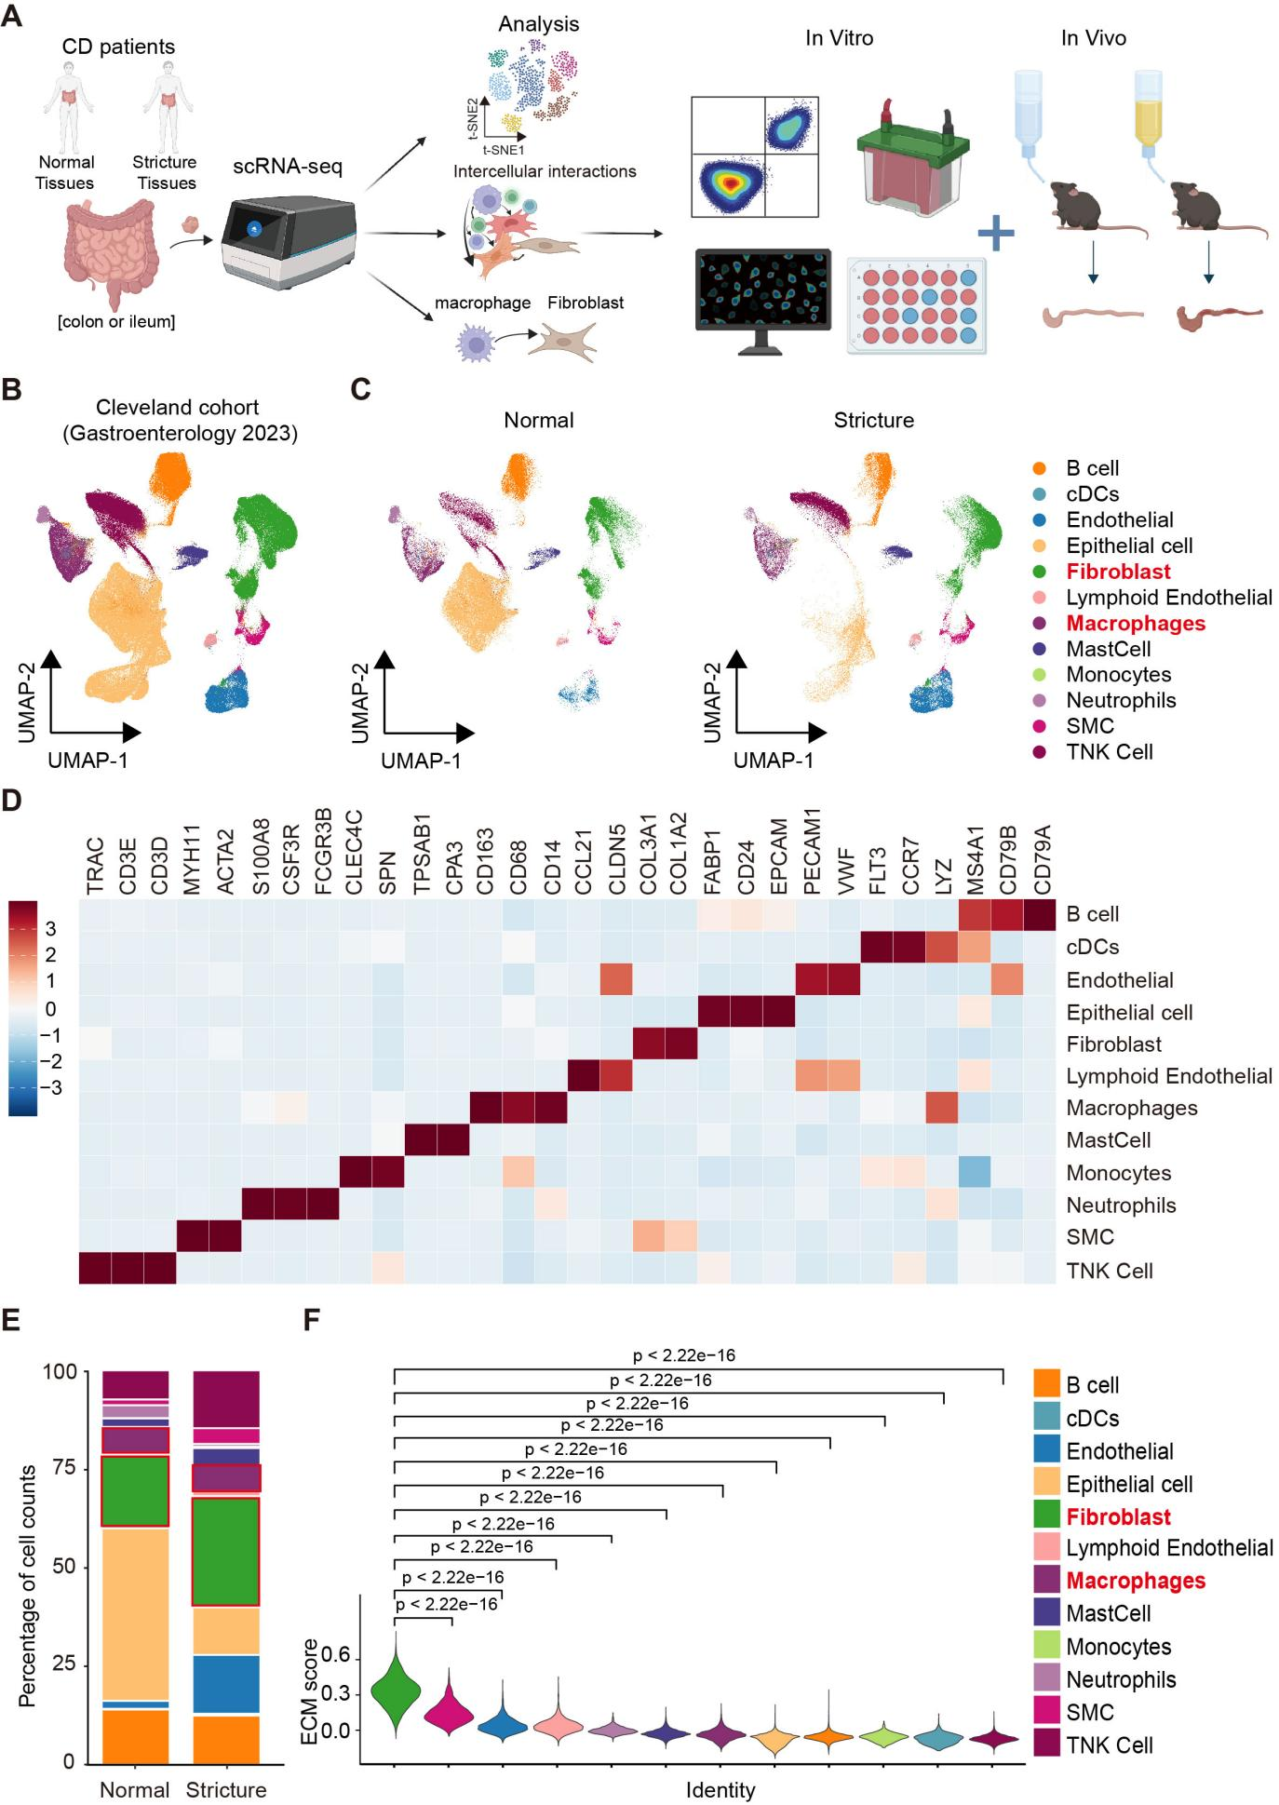
Figure 1. The cellular landscape of normal and stricture (intestinal fibrosis) tissues in CD patients. (A). The analysis process and experimental design of this study. (B-C). Uniform manifold approximation and projection (UMAP) plots showing 12 major cell types in all samples (B) and normal, stricture tissues (C) of CD patients from the Cleveland cohort (Gastroenterology, 2023). (D). Heatmap depicting the relative expression (Z score) of representative markers of indicated cell types. (E). Bar graph showing the percentage of major cell types in normal and stricture samples from CD patients. (F). Violin plots indicating the extracellular matrix (ECM) signature score of each cell type from fibrotic tissues of CD patients. Statistical differences were determined by Kruskal-Wallis test with Dunn’s post-hoc test (F), *p<0.05, **p<0.01, and ***p<0.001.

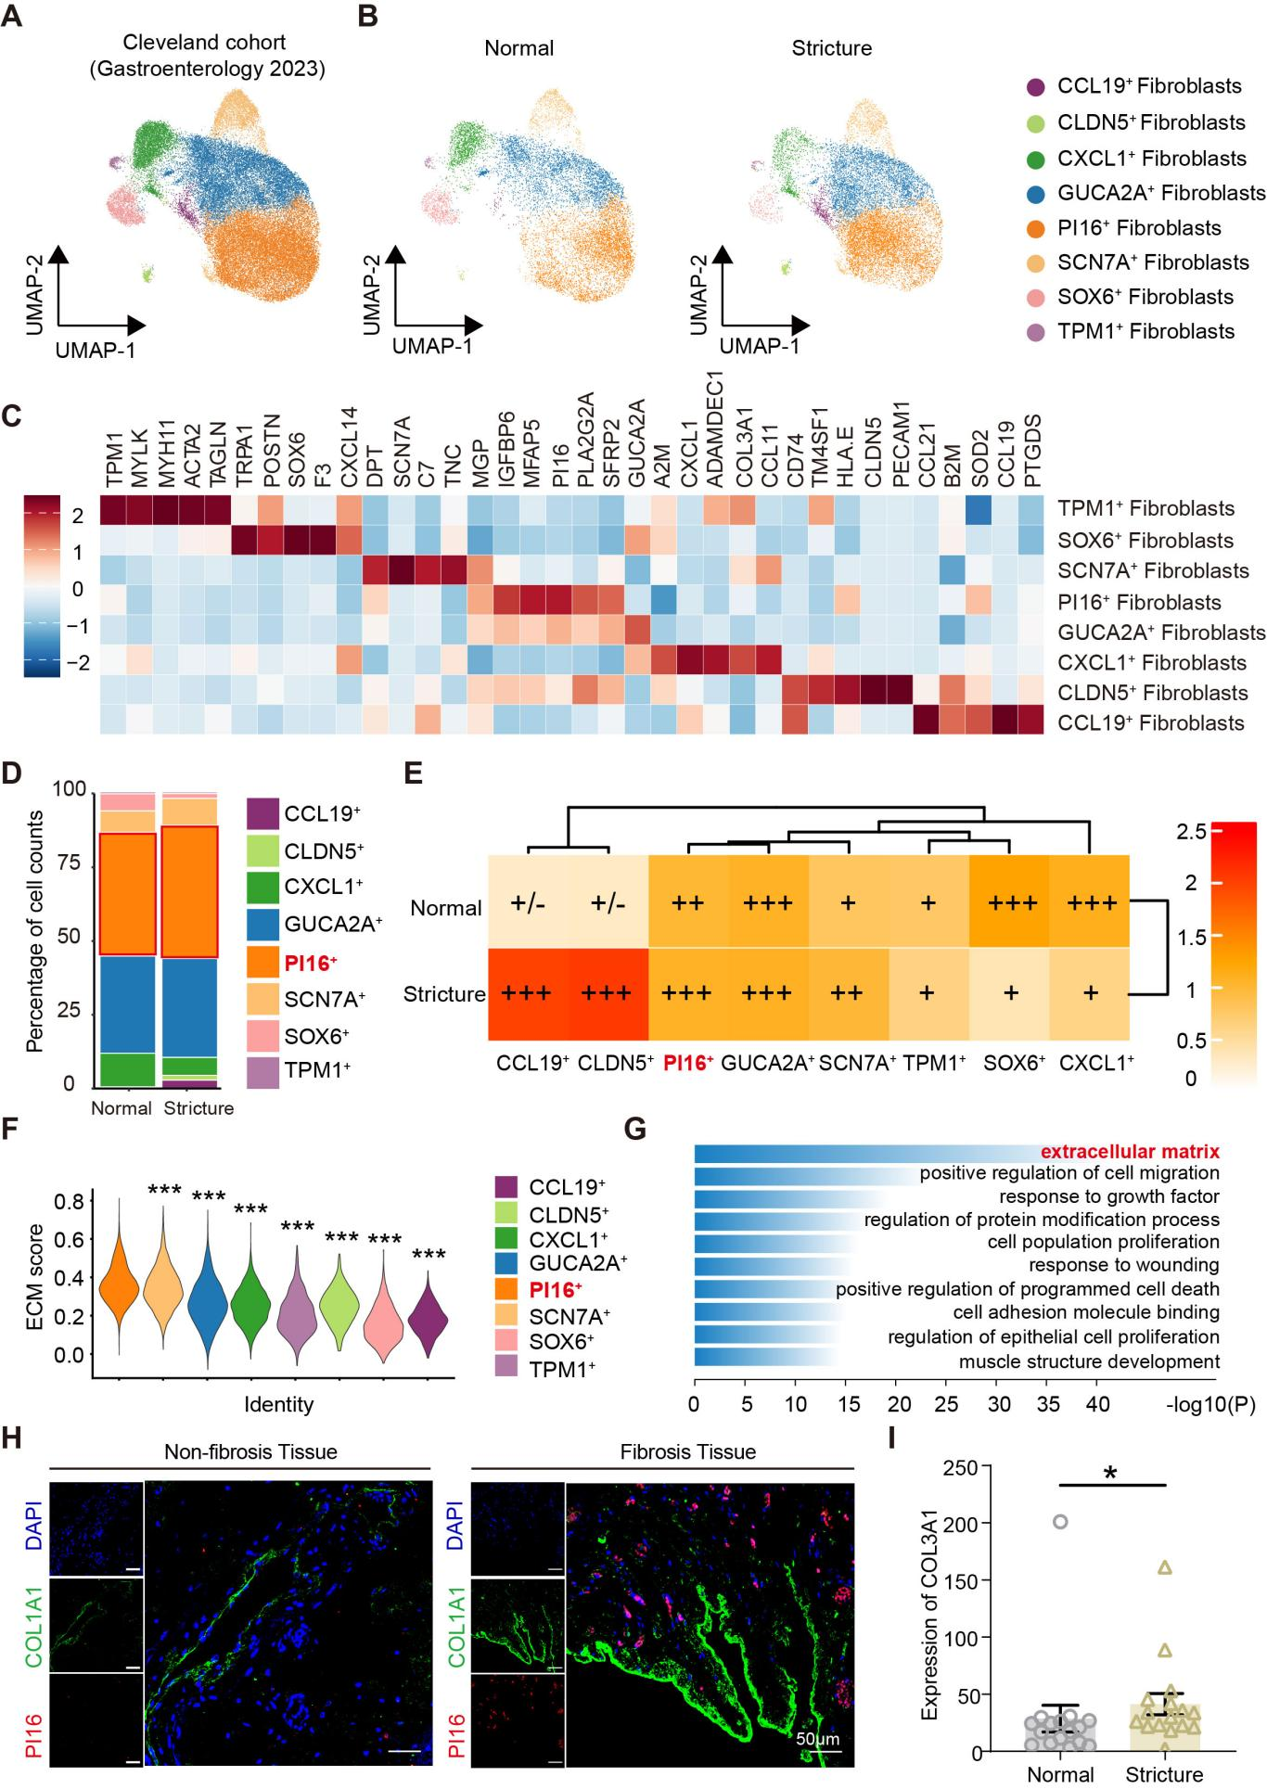 Figure 2. Heterogeneity of fibroblast subtypes in intestinal fibrosis of CD patients. (A-B). UMAP plots of subclustered fibroblasts in all samples (A) and normal, stricture tissues (B) of CD patients from the Cleveland cohort (Gastroenterology, 2023). (C). Heatmap showing the relative expression (Z score) of representative markers in each fibroblast subpopulation. (D). Bar graph demonstrating the percentage of each fibroblast subtype in normal and stricture samples of CD patients. (E). Heatmap depicting tissue distribution of each fibroblast subtype. Ro/e denotes the ratio of observed to expected cell number. +++, Ro/e>1; ++, 0.8<Ro/e≤1; +, 0.2≤Ro/e≤0.8; +/-, 0<Ro/e<0.2; -, Ro/e= 0. (F). Violin plots indicating the ECM signature score of each fibroblast subtype. (G). Gene Ontology (GO) enrichment analysis results of genes specifically expressed in PI16⁺ fibroblasts. (H). The immunofluorescence staining of PI16 and COL1A1 in non-fibrotic and fibrotic intestinal tissues (original magnification, 20×). DAPI (blue), PI16 (red) and COL1A1 (green), scale bar 50 μm. (I). The average expression level of COL3A1 in PI16⁺ fibroblasts from normal and stricture samples of CD patients in the scRNA-seq data. The data were represented as mean ± SD. Statistical differences were determined by Kruskal-Wallis test with Dunn’s post-hoc test (F) or Mann-Whitney tests (I), *p<0.05, **p<0.01, and ***p<0.001.

Figure 3. Identification of profibrotic macrophage subtypes in fibrotic tissues of CD patients. (A). Violin plots showing profibrotic signature score of 12 major cell types from fibrotic tissues of CD patients. (B-C). UMAP plots of subclustered macrophages in all samples (B) and normal, stricture tissues (C) of CD patients from the Cleveland cohort (Gastroenterology, 2023). (D). Heatmap indicating the relative expression (Z score) of representative markers in each macrophage subtype. (E). Bar graph demonstrating the percentage of each macrophage subtype in normal and stricture samples of CD patients. (F). Heatmap depicting tissue distribution of each macrophage subtype. Ro/e denotes the ratio of observed to expected cell number. +++, Ro/e>1; ++, 0.8<Ro/e≤1; +, 0.2≤Ro/e≤0.8; +/-, 0<Ro/e<0.2; -, Ro/e= 0. (G). Violin plots illustrating profibrotic signature score of each macrophage subtype from fibrotic tissues of CD patients. (H). Heatmap demonstrating the correlation between the percentages of indicated macrophage subsets and all fibroblast subsets across all samples. Statistical differences were determined by Kruskal-Wallis test with Dunn’s post-hoc test (A, H), *p<0.05, **p<0.01, and ***p<0.001.

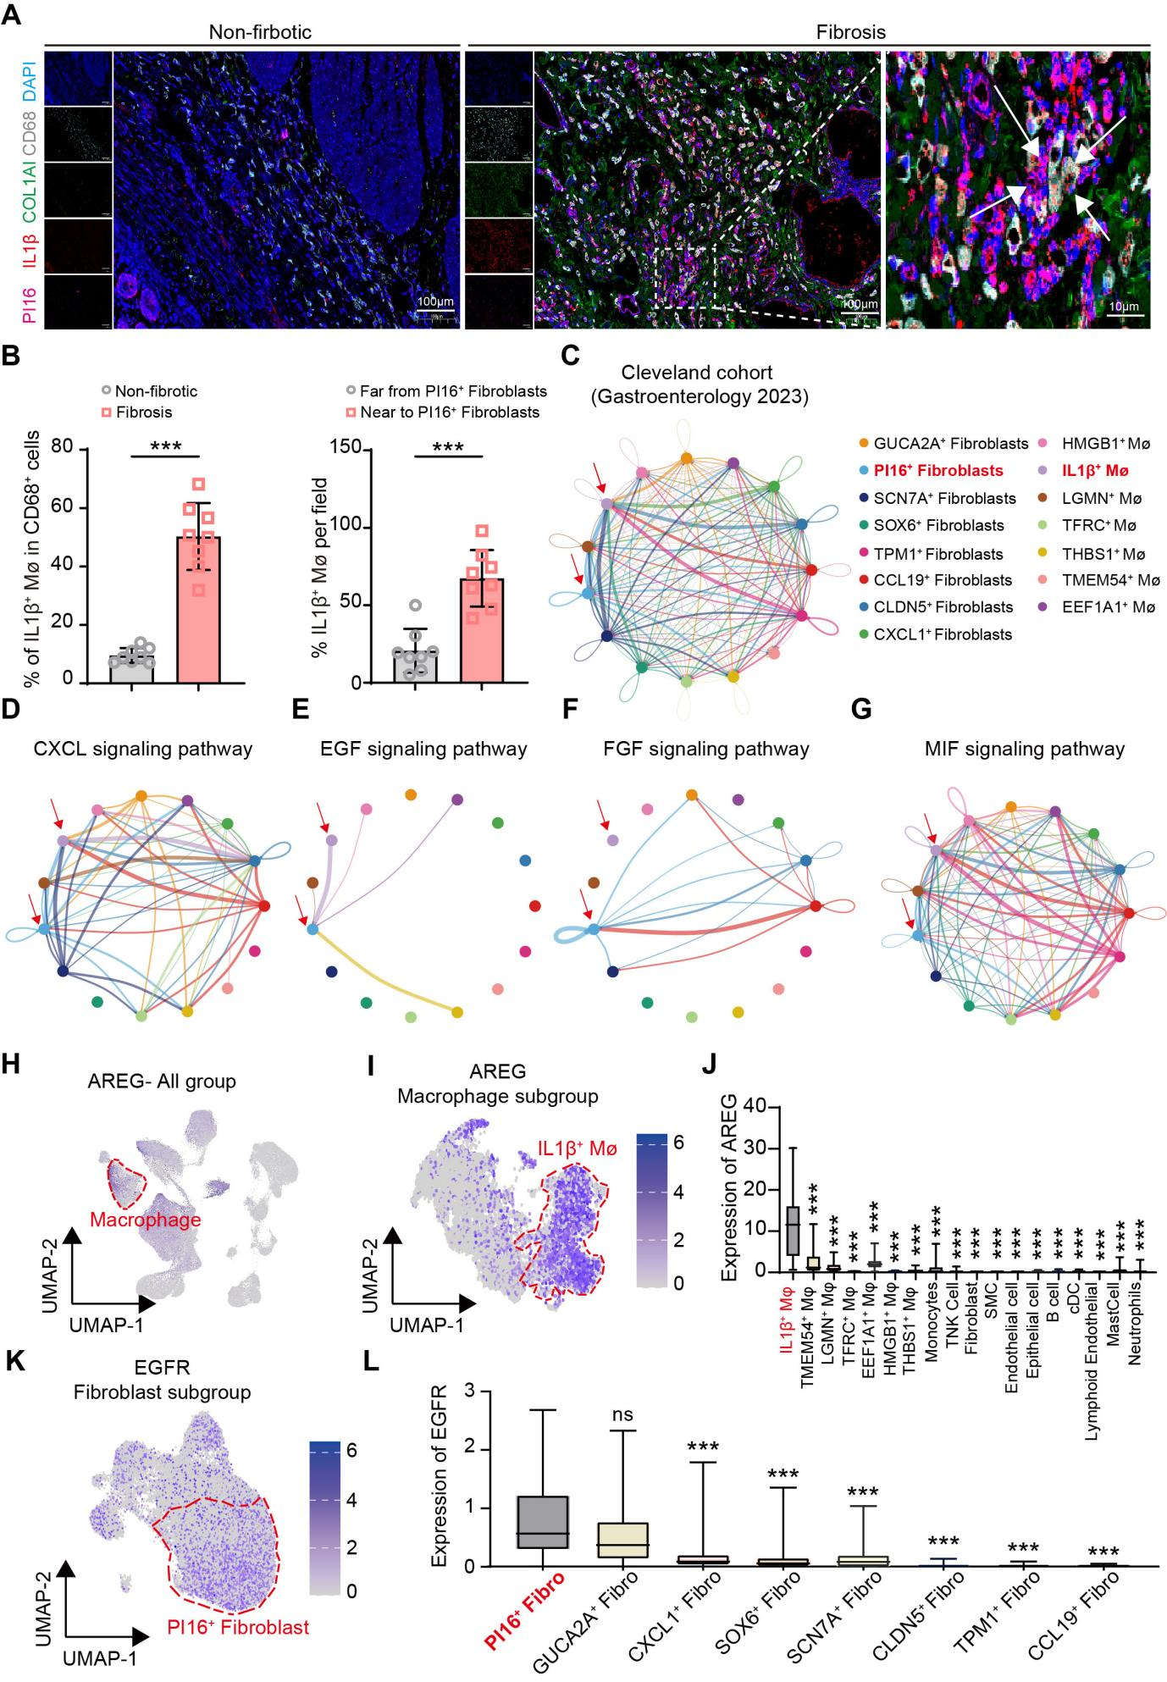
Figure 4. The interaction between IL1β⁺ macrophages and PI16⁺ fibroblasts in fibrotic tissues of CD patients. (A). Representative multiplex immunofluorescence (mIF) staining of stricture (right) and non-stricture (left) intestinal tissue in CD patients (original magnification, 20×). DAPI (blue), IL1β (red), PI16 (purple), COL1A1 (green) and CD68 (white), scale bar: 100 μm. (B). Quantification of mIF staining: Left, abundance of CD68⁺IL1β⁺ macrophages per area between non-stricture versus stricture tissues. Right, nearest-neighbor distances between CD68⁺IL1β⁺ macrophages and PI16⁺ fibroblasts in fibrotic tissues of CD patients. (C). The circle plot demonstrating showing the number of cellular interactions between indicated macrophage subtypes and subclustered fibroblasts. Line thickness indicates more communication probability. (D-G) The circle plots showing cell-cell communication network between macrophage subtypes and subclustered fibroblasts mediated by C-X-C motif chemokine ligand (CXCL), epidermal growth factor (EGF), fibroblast growth factor (FGF) and macrophage migration inhibitory factor (MIF) signaling pathways. (H-I). Feature plots illustrating the expression of amphiregulin (AREG) in all cell types (H) and different macrophage subtypes (I). The average gene expression is shown by point color. (J). Box plots showing the expression of AREG in indicated macrophage subtypes. (K). Feature plots illustrating the expression of amphiregulin (EGFR) in different fibroblasts subtypes (I). The average gene expression is shown by point color. (L). Box plots showing the expression of EGFR in indicated macrophage subtypes. Statistical differences were determined by Kruskal-Wallis test with Dunn’s post-hoc test (J, L), *p<0.05, **p<0.01, and ***p<0.001.

Figure 5. IL1β⁺ macrophages promote proliferation and movement of intestinal fibroblasts through AREG. (A-B). Representative flow cytometry plots and statistical analysis of IL1β⁺ macrophages in normal and fibrotic mucosa samples from CD patients. (C). Bar graph showing AREG level in supernatants of IL1β⁻ or IL1β⁺ macrophage culture media as determined by ELISA. (D). Immunoblot of COL1A1 in primary human intestinal fibroblasts under different co-culture conditions. si, siAREG, AR37, AREG neutralizing antibody. (E). Representative flow cytometry plots of PI16⁺ fibroblasts grown under different conditions in co-culture. (F) Flow cytometry analysis revealed that the proportion of ILβ⁺ macrophages varied under different co-culture conditions. Statistical differences were determined by t tests. (G). The primary human fibroblasts were co-cultured with indicated condition in transwell inserts. Scale bar, 100 μm. (H). Bar graph showing the statistics of transwell results. (I). Representative images of scratch wounds from primary human fibroblasts monolayers under different co-culture conditions. Scale bar, 200 μm. (J). Bar graph demonstrating quantitative statistical results of wound healing assay. (K). IF staining of Ki67 in human intestinal fibroblasts under different co-culture conditions. Scale bar, 50 μm. (L). Bar graph depicting the percentage of Ki67 fibroblasts from indicated groups. The data were represented as mean ± SD. Statistical differences were determined by student’s t-test (B, C, F, H, J, L), *p<0.05, **p<0.01, and ***p<0.001.

Figure 6. Identification and characterization of fibroblast and macrophage subclusters in mouse intestinal single-cell data. UMAP plots of subclustered fibroblasts in all samples (A) and normal, stricture intestinal tissues (B) of chronic dextran sulfate sodium (DSS) colitis model from the Dankook University cohort (Communications Biology 2024). (C). Bar graph demonstrating the percentage of each fibroblast subtype in normal and stricture samples of mouse intestinal tissues. (D). Violin plots indicating the ECM signature score of each fibroblast subtype. (E). Gene Ontology (GO) enrichment analysis results of genes specifically expressed in Pi16⁺ fibroblasts. (F-G). UMAP plots of subclustered macrophages in all samples (F) and normal, stricture tissues (G) of chronic DSS colitis model from the Dankook University cohort (Communications Biology 2024). (H). Bar graph demonstrating the percentage of each macrophages subtype in normal and stricture samples of mouse intestinal tissues. (I). Heatmap showing transcriptional similarity between human and mouse fibroblast subclusters. (J). Correlation heatmap showing the association between fibroblast and macrophages subcluster. The data were represented as mean ± SD. Statistical differences were determined by Kruskal-Wallis test with Dunn’s post-hoc test (D) or Mann-Whitney tests (I, J), *p<0.05, **p<0.01, and ***p<0.001.

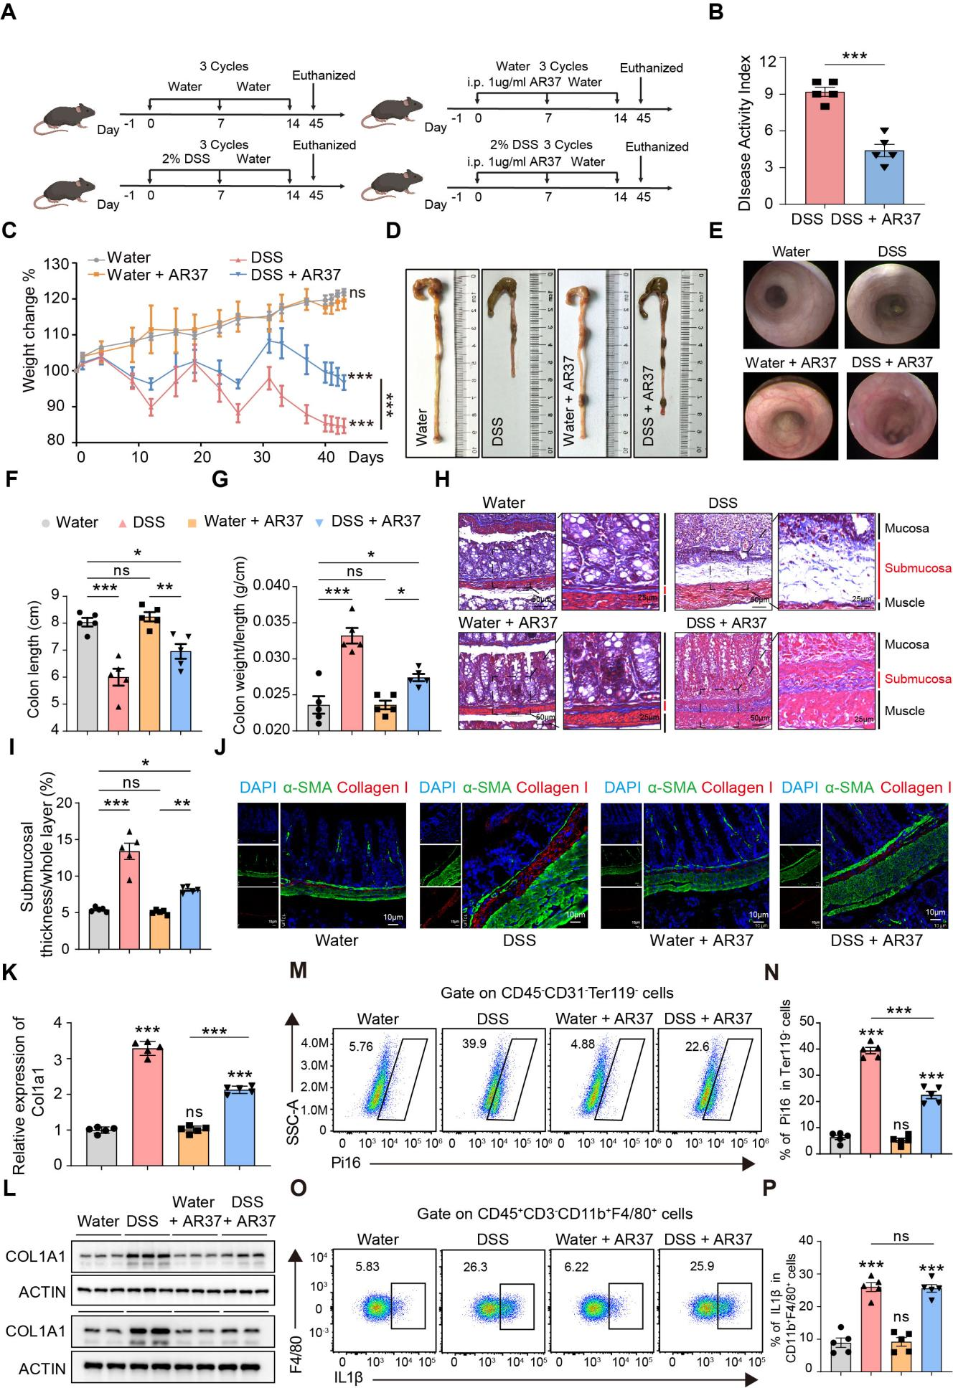
Figure 7. Targeting AREG inhibits fibroblast activation and attenuates experimental intestinal fibrosis. (A-K). Wild type C57BL/6 mice (n=5/group) were treated with 3 cycles of DSS to induce chronic intestinal fibrosis. Within each cycle, mice received 2.0% DSS for 7 days and regular drinking water for another 7 days. These mice were administrated with PBS or AREG neutralizing antibody AR37 at indicated time points. (A-E). Graphic overview of the design for the mouse model (A). Body weight changes (B), disease activity index (C), representative colon images (D) and coloscopy images (E) for mice from indicated groups. (F-G). Bar graph showing colon length and ratio of colon length to colon weight in mice from indicated groups. (H). Representative Masson staining images of colon tissues from indicated groups. (I). Quantification of the average thickness of submucosal fibrosis tissues in mice from indicated groups. (J) Representative IF staining of α-SMA and Col1a1 in colon tissues from indicated mice. (K). Immunoblot of Col1a1 in colon tissues from indicated mice. (L). RT-qPCR analysis for Col1a1 RNA level in primary mouse intestinal fibroblasts from indicated mice. (M-N). Representative flow cytometry plots and statistical analysis of IL1β⁺ macrophages in normal and fibrotic mucosa samples from indicated mice. (O-P). Representative flow cytometry plots and statistical analysis of Pi16⁺ fibroblasts in normal and fibrotic mucosa samples from indicated mice. The data were represented as mean ± SD. Statistical differences were determined by student’s t-test (B). Cohorts in the bar charts were compared with every other group by one-way ANOVA with Tukey’s post hoc analysis, *p<0.05, **p<0.01, and ***p<0.001.

Figure S1. The cellular landscape of normal and stricture tissues in CD patients from MGH cohort. (A-B). UMAP plots showing 13 major cell types in all samples (A) and normal, stricture tissues (B) of CD patients from the MGH cohort (SCP2959, Nature Genetics, 2025). (C). Heatmap showing the relative expression (Z score) of representative markers of indicated cell types. (D). Bar graph demonstrating the percentage of major cell types in normal and stricture samples from CD patients. (E). Violin plots illustrating ECM signature score of indicated cell types from fibrotic tissues of CD patients. Statistical differences were determined by Kruskal-Wallis test with Dunn’s post-hoc test (E), *p<0.05, **p<0.01, and ***p<0.001.

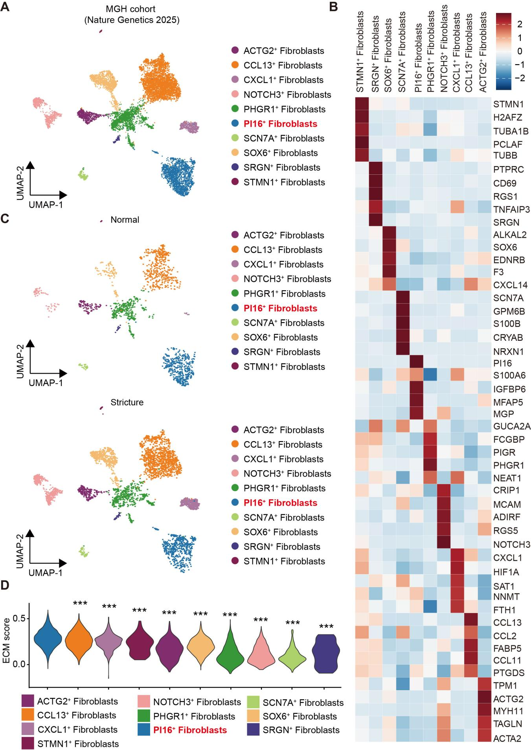
Figure S2. The heterogeneity of fibroblast subtypes in intestinal fibrosis of CD patients from MGH cohort. (A-B). UMAP plots of 10 fibroblast subtypes in all samples (A) and normal, stricture tissues (B) of CD patients from the MGH cohort (SCP2959, Nature Genetics, 2025). (C). Heatmap showing the relative expression (Z score) of representative markers in indicated fibroblast subpopulation. (D). Violin plots indicating the ECM signature score of indicated fibroblast subtype. Statistical differences were determined by Kruskal-Wallis test with Dunn’s post-hoc test (D), *p<0.05, **p<0.01, and ***p<0.001.

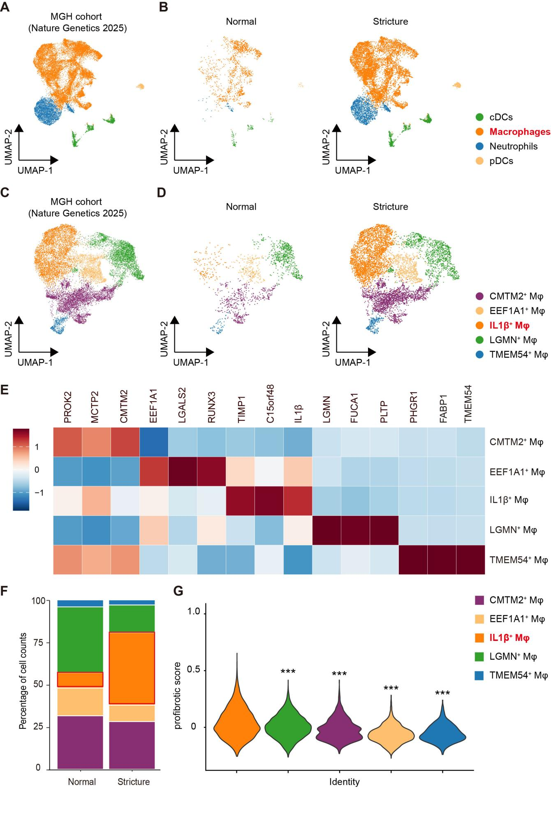
Figure S3. Identification of profibrotic macrophage subtypes in fibrotic tissues of CD patients from MGH cohort. (A-B). UMAP plots of macrophages, neutrophils, dendritic cells (DCs) in all samples (A) and normal, stricture tissues (B) of CD patients from the MGH cohort (SCP2959, Nature Genetics, 2025). (C-D). UMAP plots of 5 macrophage subtypes in all samples (C) and normal, stricture tissues (D) of CD patients. (E). Heatmap indicating the relative expression (Z score) of representative markers in indicated macrophage subtypes. (F). Bar graph showing percentage of indicated macrophage subtypes in normal and stricture samples of CD patients. (G). Violin plots illustrating profibrotic signature score of indicated macrophage subtypes from fibrotic tissues of CD patients. Statistical differences were determined by Kruskal-Wallis test with Dunn’s post-hoc test (G), *p<0.05, **p<0.01, and ***p<0.001.

Figure S4. Cell-cell interaction between indicated macrophage subtypes and subclustered fibroblasts. (A). Bubble plots showing the ligand–receptor interaction between indicated macrophage subtypes and subclustered fibroblasts in CD patients from Cleveland cohort (Gastroenterology, 2023). (B-G) The circle plots showing cell-cell communication network between macrophage subtypes and subclustered fibroblasts mediated by Vascular Endothelial Growth Factor (VEGF), Cyclophilin A (CypA), Galectin, Vascular Cell Adhesion Molecule (VCAM), Visfatin, Thrombospondin (THBS) signaling pathway.
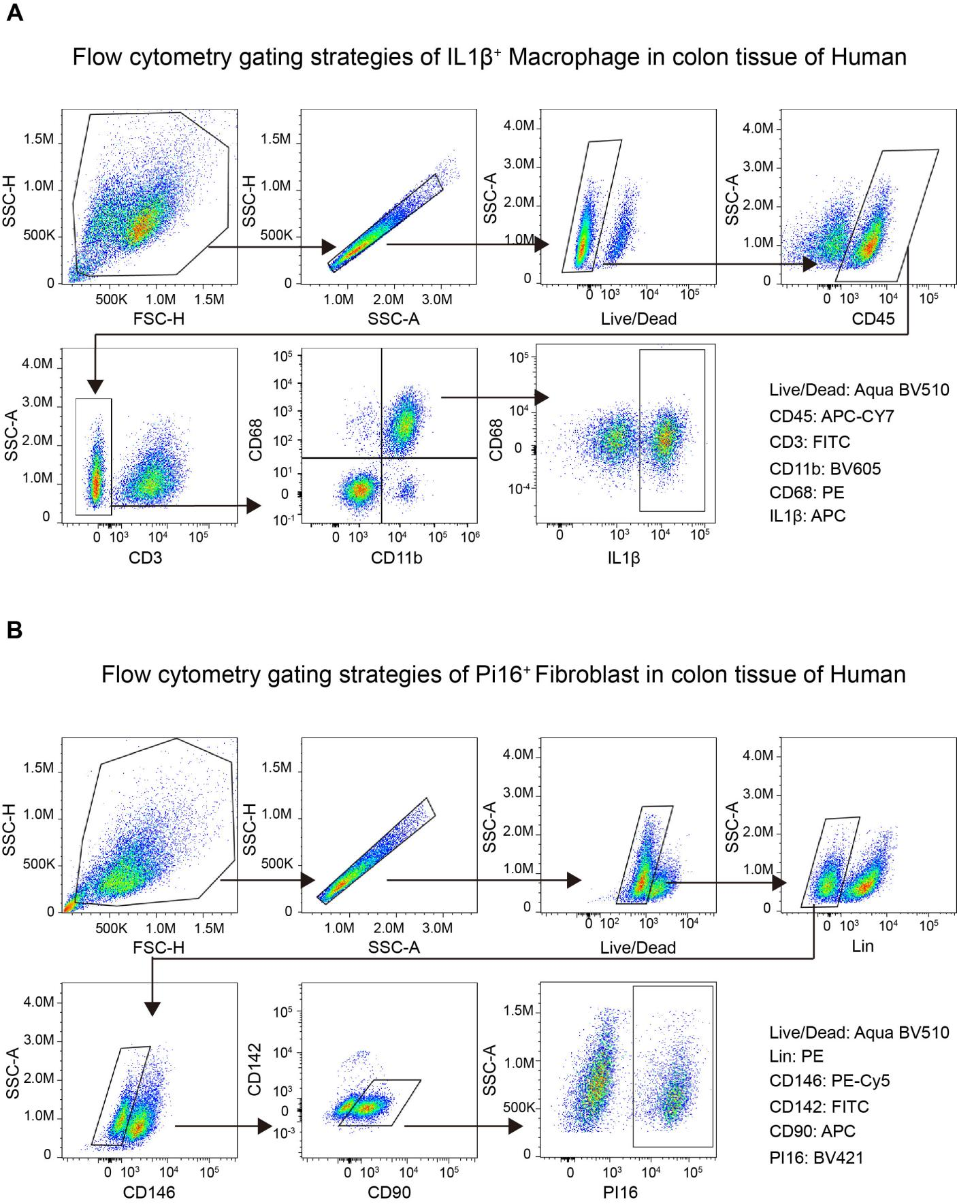
Figure S5. Flow cytometry gating strategy for IL1β⁺ macrophages and PI16⁺ fibroblasts in colon tissues of patients. (A). Representative gating strategy used to identify IL1β⁺ macrophages in intestinal tissues. (B). Representative gating strategy for the identification of PI16⁺ fibroblasts in colon tissue.
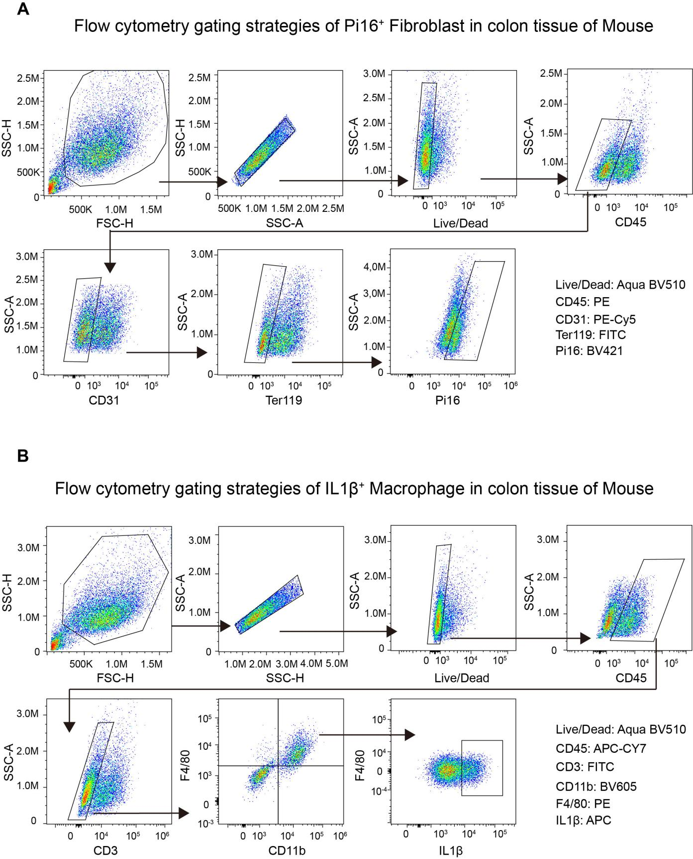
Figure S6. Flow cytometry gating strategy for Il1β⁺ macrophages and Pi16⁺ fibroblasts in colon tissues of mice. (A). Representative gating strategy for the identification of Pi16⁺ fibroblasts in colon tissue. (B). Representative gating strategy used to identify Il1β⁺ macrophages in intestinal tissues.

