Butyrate-producing Eubacterium rectale inhibits gastric carcinogenesis and augments the efficacy of immunotherapy

Wei Gao^{1,2,3}, Jiani Xiong^{1,2}, Guangfeng Wu^{1,2}, Yuhuang Chen⁴, Xiaoyan Lin³

¹Departments of Medical Oncology, Fujian Cancer Hospital, Fuzhou, Fujian, 350014, PR China.
²Clinical Oncology School of Fujian Medical University, Fuzhou, Fujian, 350014, PR China.
³Department of Medical Oncology, Fujian Medical University Union Hospital, No.29, Xinquan Road, Gulou District, Fuzhou, Fujian 350001, PR China.
⁴Department of Gastroenterology, Lianjiang County General Hospital，Fuzhou，Fujian 350500, PR China.

*Correspondence: Xiaoyan Lin, E-mail: 0591linxiaoyan@sina.com

Contents
Supplementary Table S1
Supplementary Table S2
Supplementary Fig. S1
Supplementary Fig. S2
Supplementary Fig. S3
Supplementary Fig. S4
Supplementary Fig. S5
Supplementary Fig. S6
Supplementary Fig. S7
Supplementary Fig. S8
Supplementary Fig. S9
Supplementary Fig. S10
Supplementary Text 1

Supplementary Table S1. Baseline clinical characteristics of 30 patients with GC recruited in this study.
Feature | level | Number of patients | Proportion (%)
Age | <60 | 13 | 43.3
 | ≥60 | 17 | 56.7
Gender | Female | 13 | 43.3
 | Male | 17 | 56.7
ECOG PS | 0 | 2 | 6.7%
 | 1 | 28 | 93.4
primary lesion | cardia | 7 | 23.3
 | gastric body | 5 | 16.7
 | gastric antral carcinoma | 8 | 26.7
 | other | 10 | 33.3
metastatic sites | hepatic metastasis | 7 | 23.3
 | Peritoneal metastasis | 14 | 46.7
 | Distant lymph node metastasis | 21 | 70.1
 | bone metastasis | 2 | 6.7
The number of metastatic sites | ≤2 | 13 | 46.7
 | ≥3 | 16 | 53.3
Lauren subtyping | intestinal type | 17 | 56.7
 | diffuse type | 11 | 36.7
 | mixed type | 2 | 6.6
CPS score | <1 | 10 | 33.3
 | 1-5 | 15 | 50.0
 | >5 | 5 | 16.7
ECOG PS, Eastern Cooperative Oncology Group Performance Status. CPS, combined positive score.

Supplementary Table S2. Evaluation criteria for the efficacy of chemotherapy combined with immunotherapy in patients with gastric cancer.
Response | Criteria
CR | The target lesion completely disappeared and persisted for ≥4 weeks
PR | The total diameter of the target lesions is reduced by ≥30%
SD | The changes of the target lesion are between those of PR and PD
PD | The total diameter of the target lesions increases by ≥20% or new lesions appear
CR, complete response; PR, partial response; SD, stable disease; PD, progressive disease.

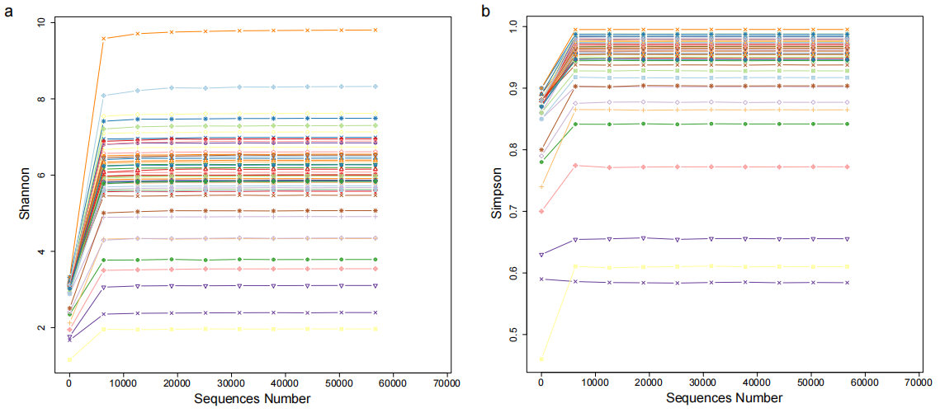
Supplementary Fig. S1. Rarefaction curves of alpha diversity indices. Rarefaction curves were generated by randomly subsampling sequences to evaluate the sufficiency of sequencing depth. (a) Curves based on the Shannon diversity index. (b) Curves based on the Simpson diversity index. The plateauing of all curves demonstrates that the sequencing effort comprehensively captured the microbial diversity within each sample, and further sequencing would yield minimal new diversity.

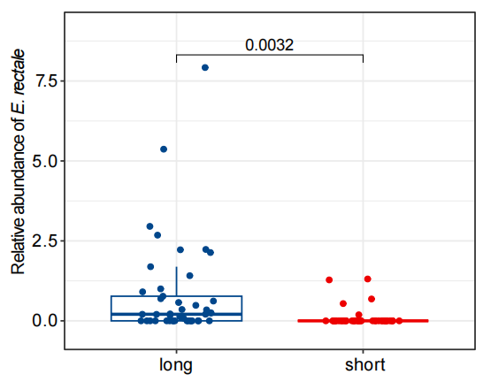
Supplementary Fig. S2. Boxplot showing the difference in the relative abundance of E. rectale between two groups based on the median PFS.
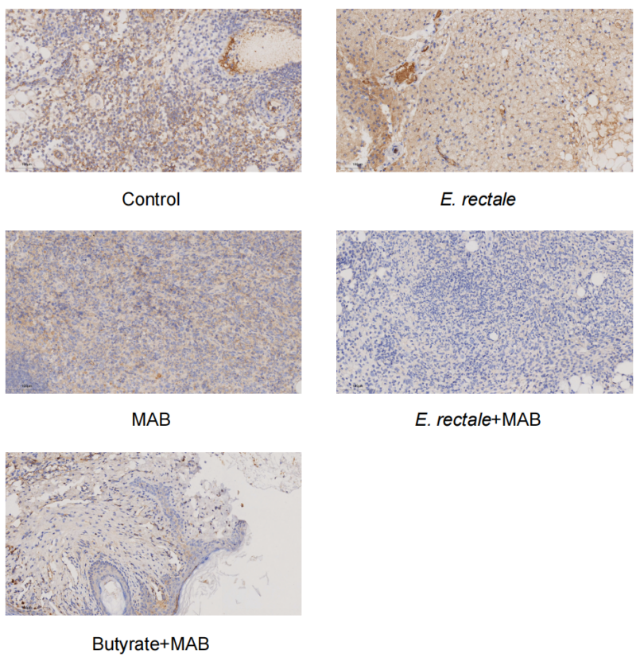
Supplementary Fig. S3. Representative images of immunohistochemical analysis of PD-L1 protein expression in five groups.

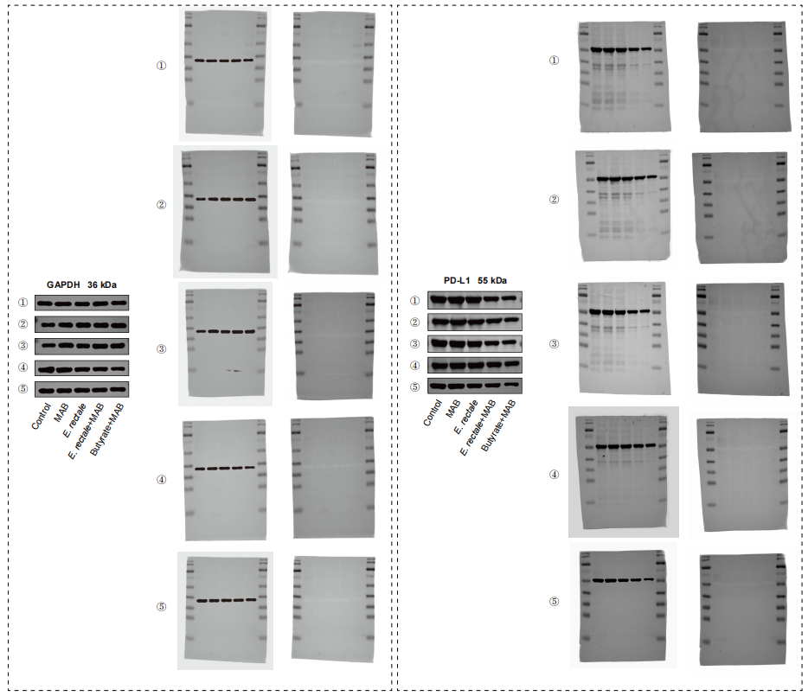
Supplementary Fig. S4. Uncropped gels for Western Blots in Figure 2d.
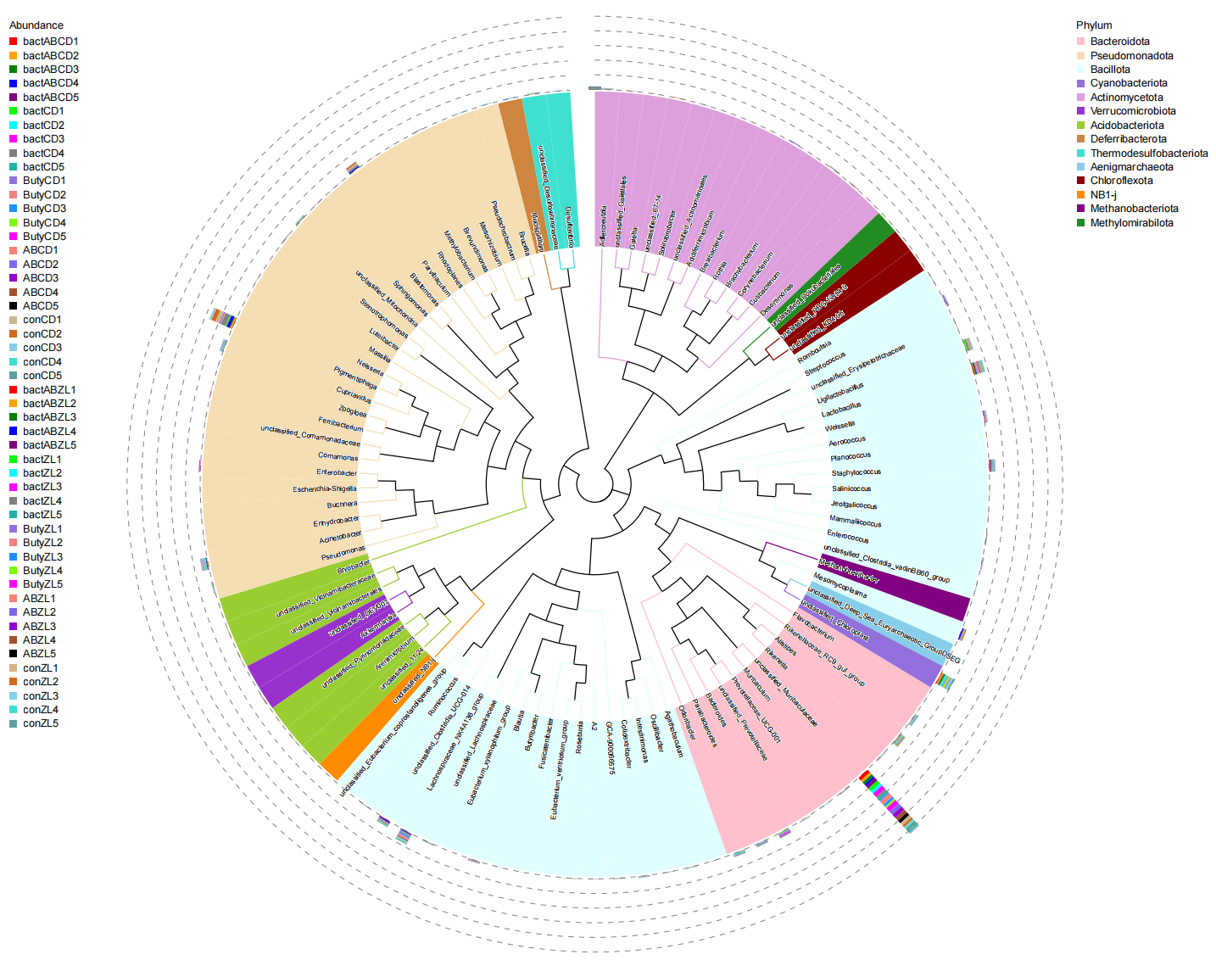
Supplementary Fig. S5. Phylogenetic tree of gut microbiota and intratumoral microbiota in mice. The color indicates the phylum to which this genus belongs. The outer columns indicate the abundance of this genus in each sample.

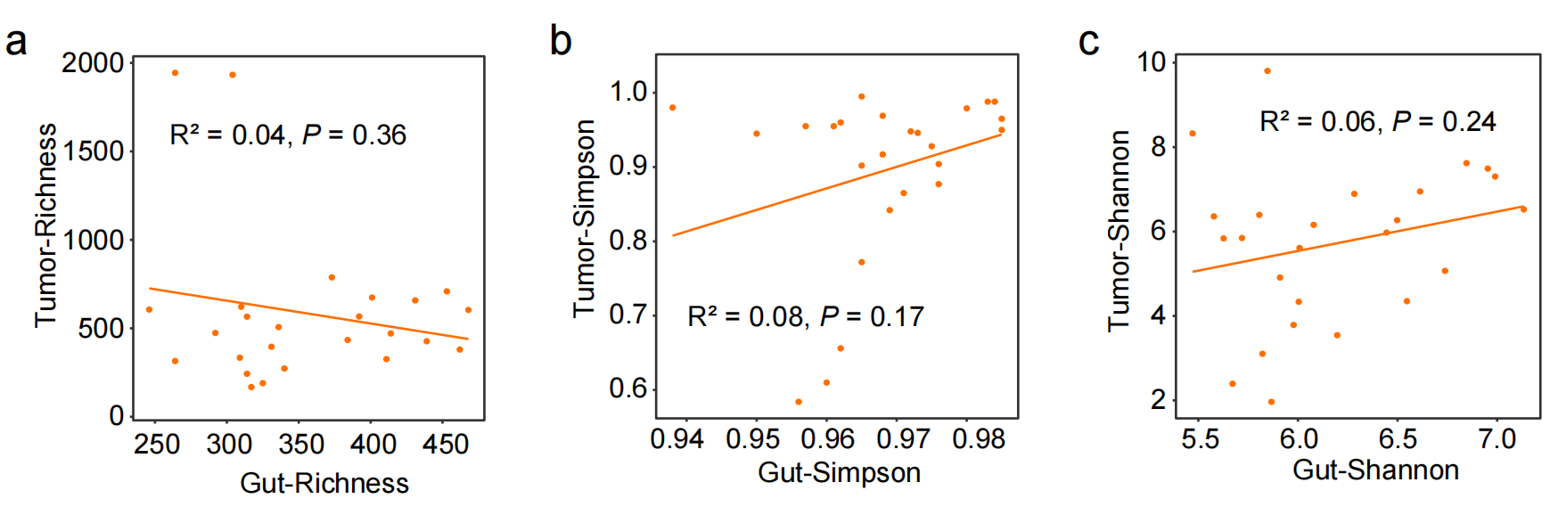
Supplementary Fig. S6. Linear regression analysis showing the correlation between alpha diversity of gut microbiota and intratumoral microbiota. (a) Richness; (b) Simpson; (c) Shannon.

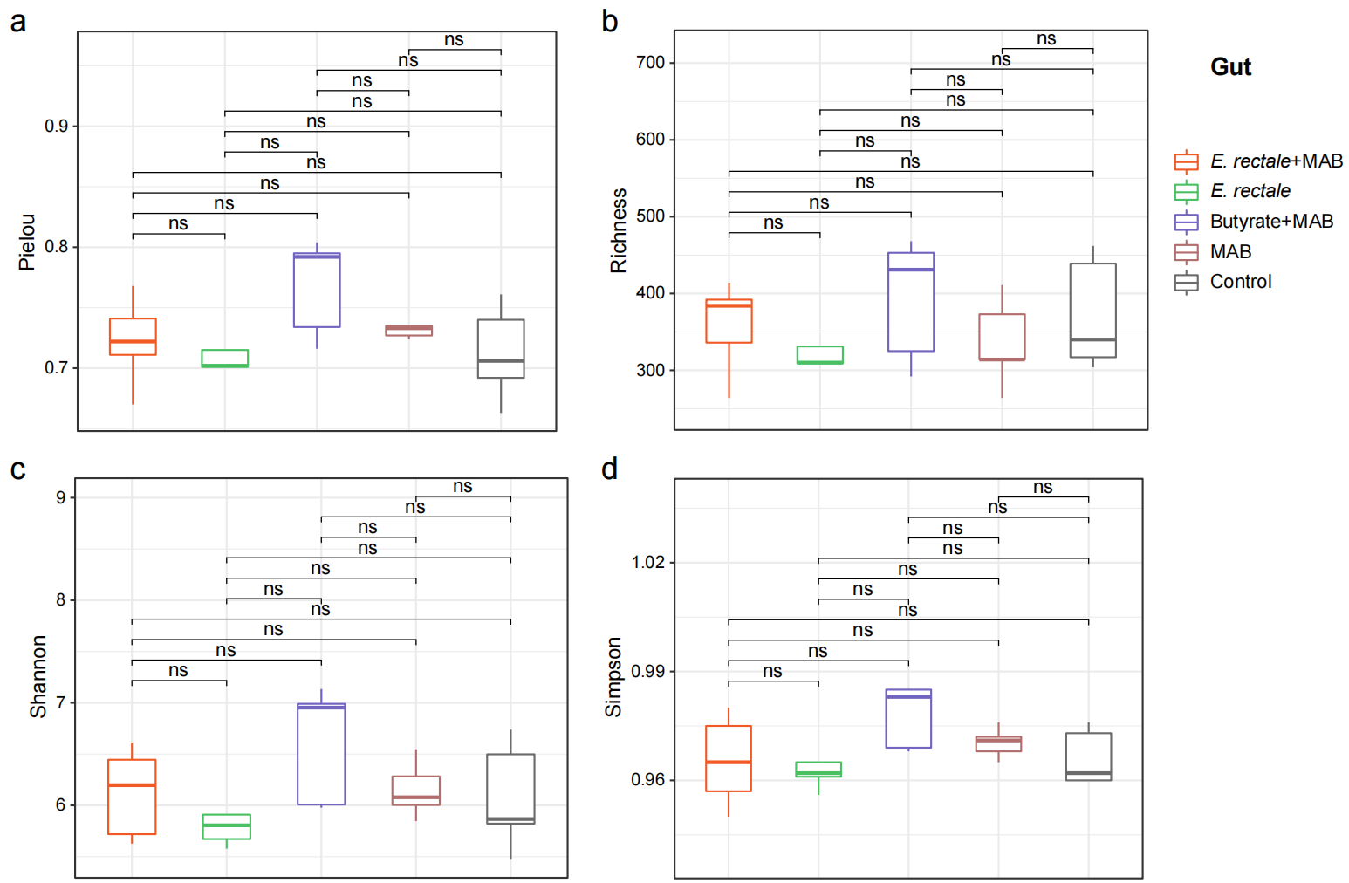
Supplementary Fig. S7. Boxplots showing the differences in alpha diversity of gut microbiota among the five groups. (a) Pielou; (b) Richness; (c) Shannon; (d) Simpson. ns, not significant.
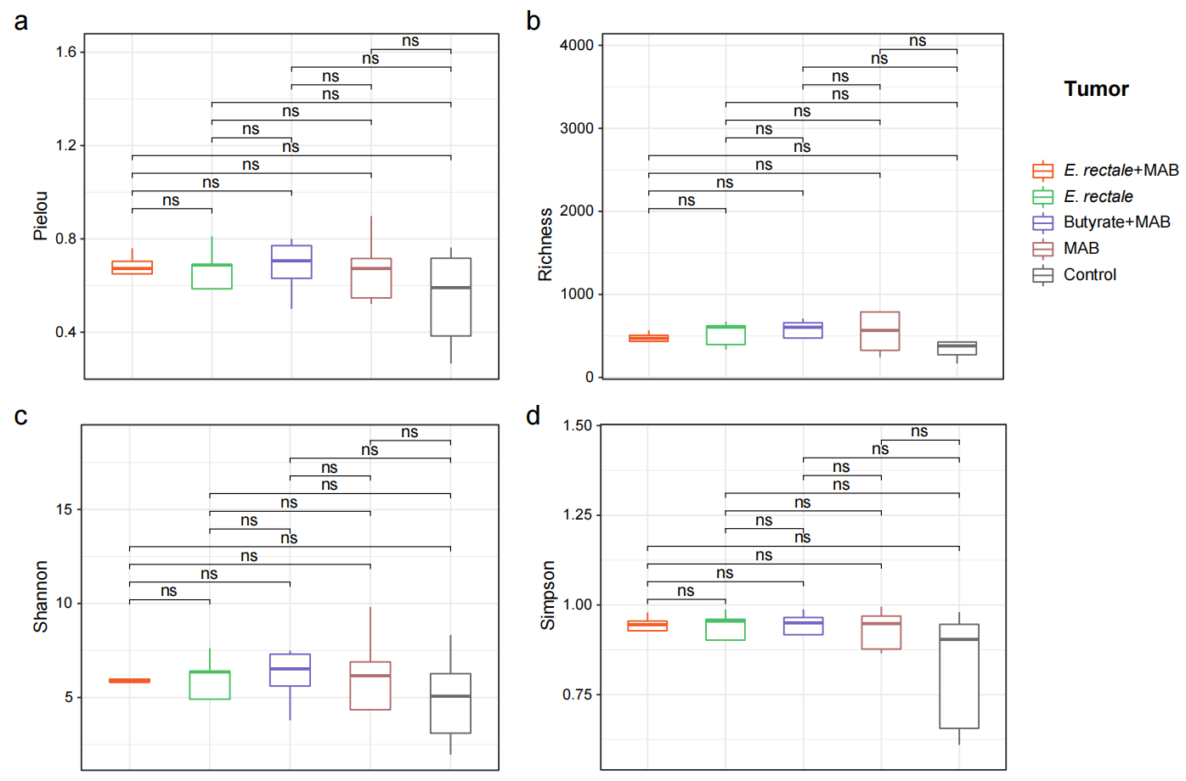
Supplementary Fig. S8. Boxplots showing the differences in alpha diversity of intratumoral microbiota among the five groups. (a) Pielou; (b) Richness; (c) Shannon; (d) Simpson. ns, not significant.

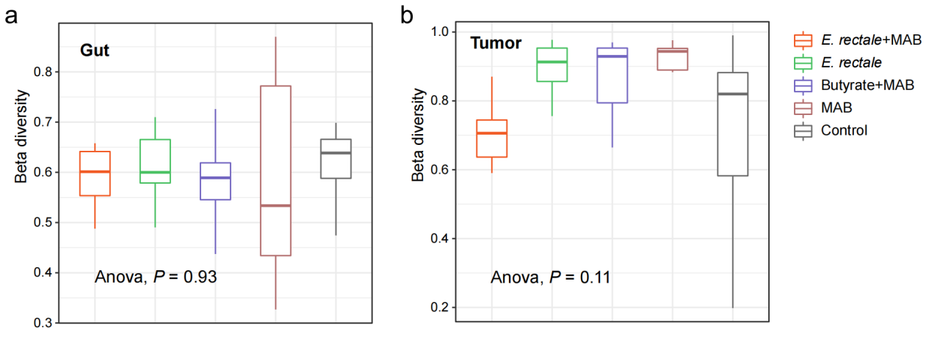
Supplementary Fig. S9. Boxplots showing the differences in beta diversity of microbiota among the five groups. (a) Gut microbiota; (b) Intratumoral microbiota. Beta diversity was measured by the Bray-Curtis dissimilarity index.

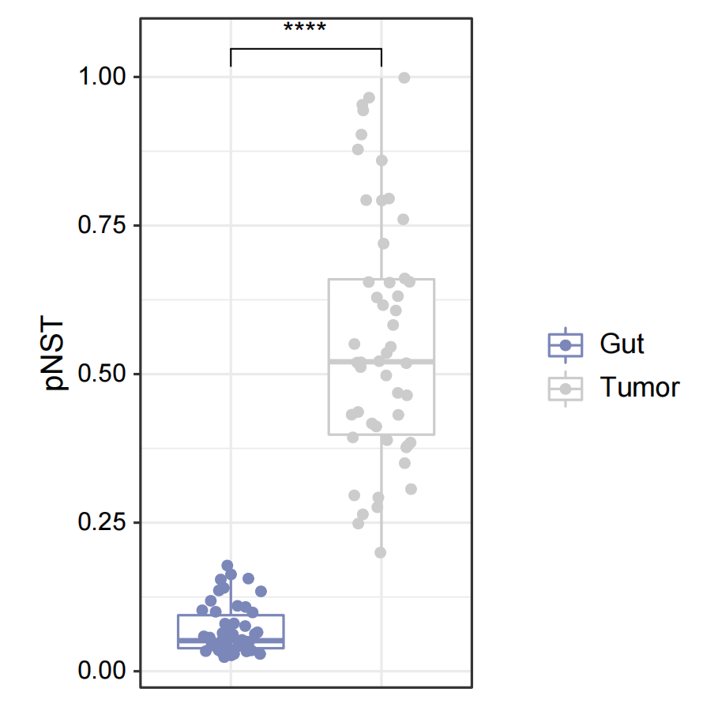
Supplementary Fig. S10. Boxplot showing the difference in phylogenetic normalized stochasticity ratio (pNST) between the gut microbiota and intratumoral microbiota.

Supplementary Text 1
Quality control and taxonomic annotation
Paired- end reads were assigned to samples based on their unique barcode and truncated by cutting off the barcode and primer sequence. Paired-end reads were merged using FLASH (V1.2.11, http://ccb.jhu.edu/software/FLASH/), which was designed to merge paired end reads when at least some of the reads overlap the reads generated from the opposite end of the same DNA fragment, and the splicing sequences were called raw tags. Quality filtering on the raw tags were performed using the fastp (Version 0.23.1 ) software to obtain high-quality Clean Tags.
The tags were compared with the reference database (Silva database, https://www.arb-silva.de/) to detect chimera sequences, And the effective tags were obtained by removing the chimera sequences with the vsearch package ( V2.16.0, https://github.com/torognes/vsearch).
For the Effective Tags obtained previously, denoise was performed with DADA2. Species annotation was performed using QIIME2 software. The annotation database is Silva Database.

