SUPPLEMENTARY MATERIALS
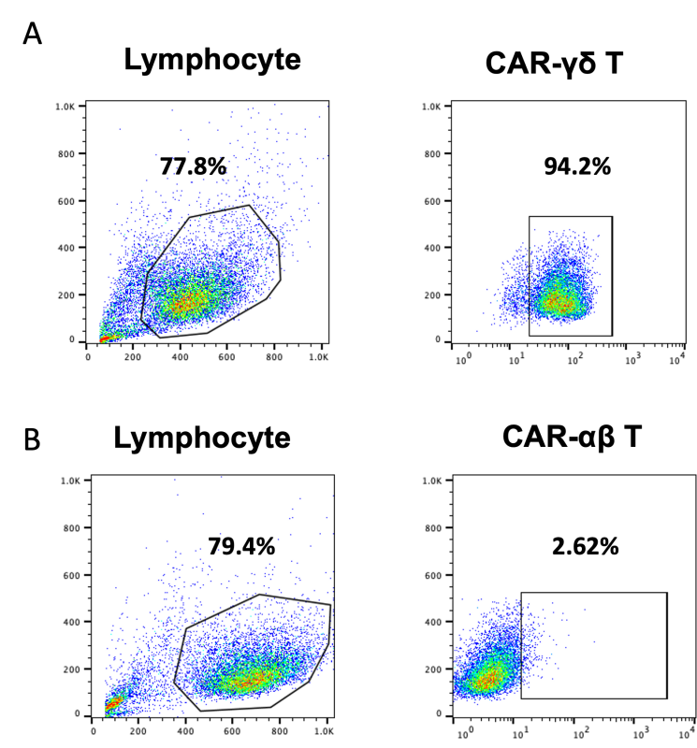
Figure S1. Flow cytometric analysis of CAR-T cell product purity and gating strategy. (A) Gating strategy and representative analysis for B7-H3 CAR-γδ T cells. Cells were first gated on the lymphocyte population based on forward and side scatter (FSC/SSC). Subsequently, live single cells were identified using viability dye and FSC-H vs. FSC-A parameters. The final gate shows the high purity of the engineered product, with 94.2% of cells being TCRγδ⁺ and CAR⁺. (B) Parallel gating strategy applied to the B7-H3 CAR-αβ T cell product from the same donor. Using the same sequential gating approach, only 2.62% of cells were found to be TCRαβ⁺ and CAR⁺ within the lymphocyte gate, confirming minimal cross-contamination of αβ T cells in the γδ T cell expansion culture.

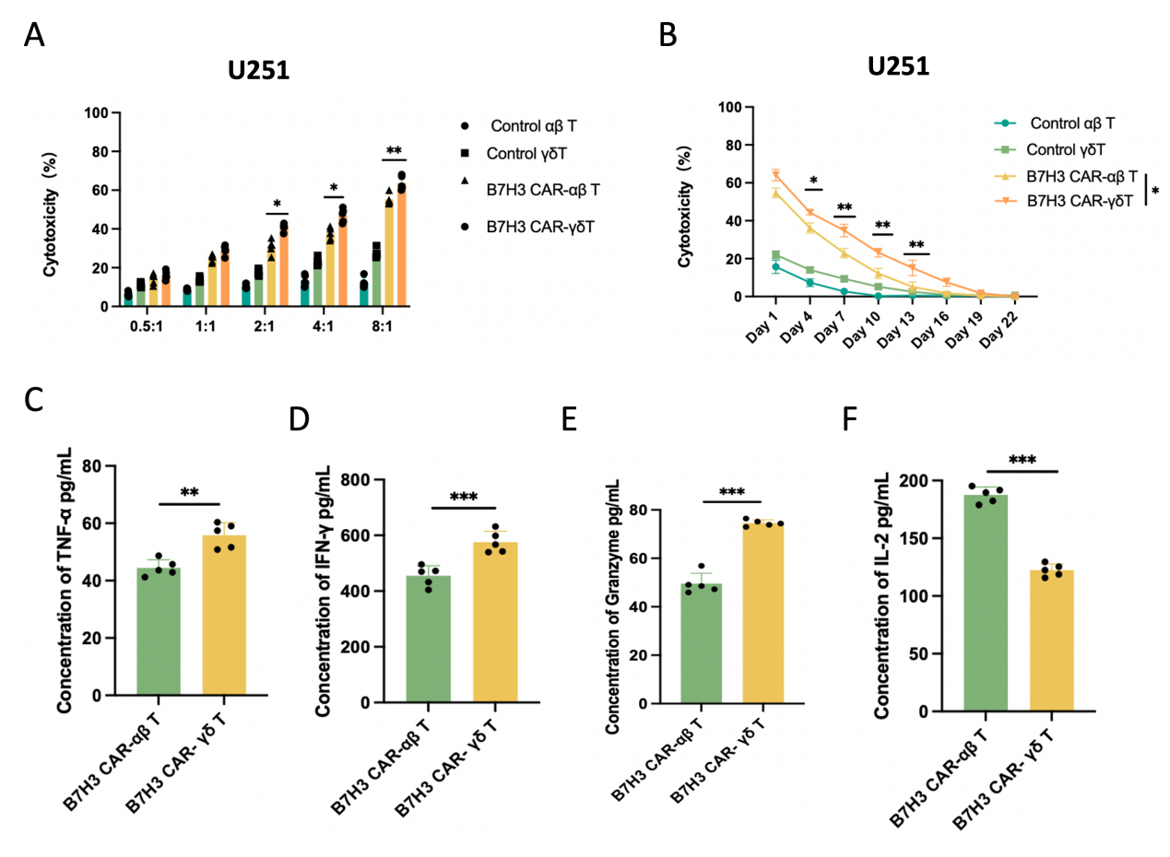
Figure S2. B7-H3 CAR-γδ T cells enhance anti-tumor cytotoxicity of cells in vitro. (A) B7-H3 CAR-αβ T cells and B7-H3 CAR-γδ T cells were co-cultured with U251 cells at different E/T ratios (from 0.5:1 to 8:1). Cytotoxicity was measured by the LDH release assay after 20 h of incubation. (B) B7-H3 CAR-αβ T cells and B7-H3 CAR-γδ T cells were co-cultured with multiple rounds of U251 cells (E/T ratios 4:1). Long-term cytotoxicity was measured by the LDH release assay. (C-F) ELISA data showing the quantification of cytokines (TNF-α, IFN-γ, granzyme, and IL-2) in the supernatants after B7-H3 CAR-αβ T cells and B7-H3 CAR-γδ T cells were co-cultured with U251 cells at an E:T ratio of 8:1 for 20 h. Data shown are mean ± SD (n = 5). *p < 0.05, **p < 0.01, ***p < 0.001, and ****p < 0.0001 (two-way ANOVA). Not significant (ns).

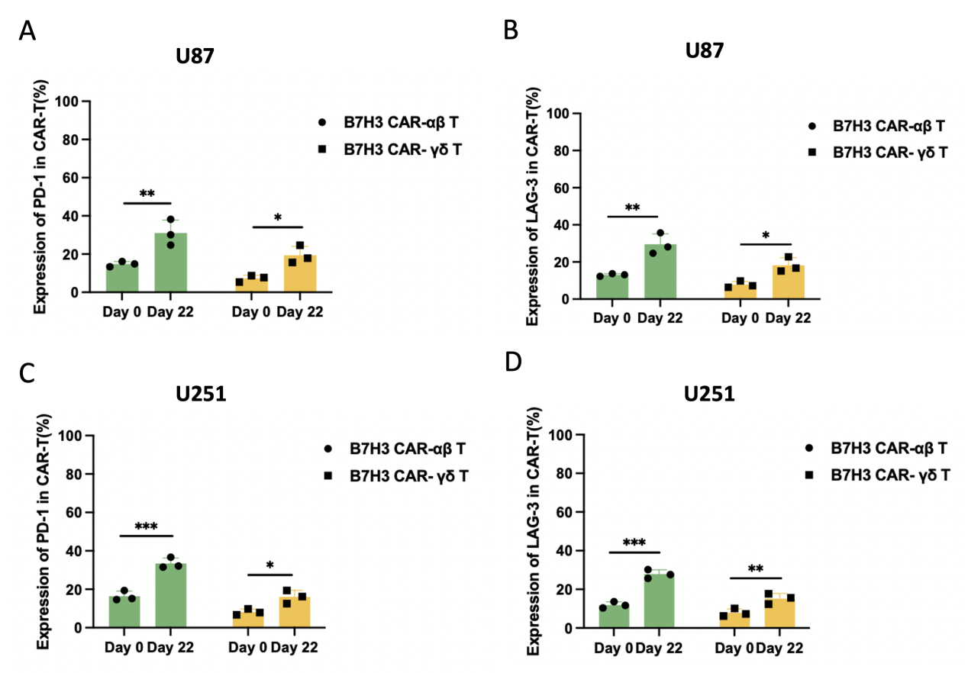
Figure S3. CAR-γδ T cells exhibit a more exhaustion-resistant phenotype than CAR-αβ T cells following prolonged antigen exposure in vitro. (A-B) The percentage of PD-1-positive cells and LAG-3 cells within B7-H3 CAR-αβ T cells and B7-H3 CAR-γδ T cells at the start (Day 0) and end (Day 22) of the long-term co-culture with U87. (C-D) The percentage of PD-1-positive cells and LAG-3 cells within B7-H3 CAR-αβ T cells and B7-H3 CAR-γδ T cells at the start (Day 0) and end (Day 22) of the long-term co-culture with U251.

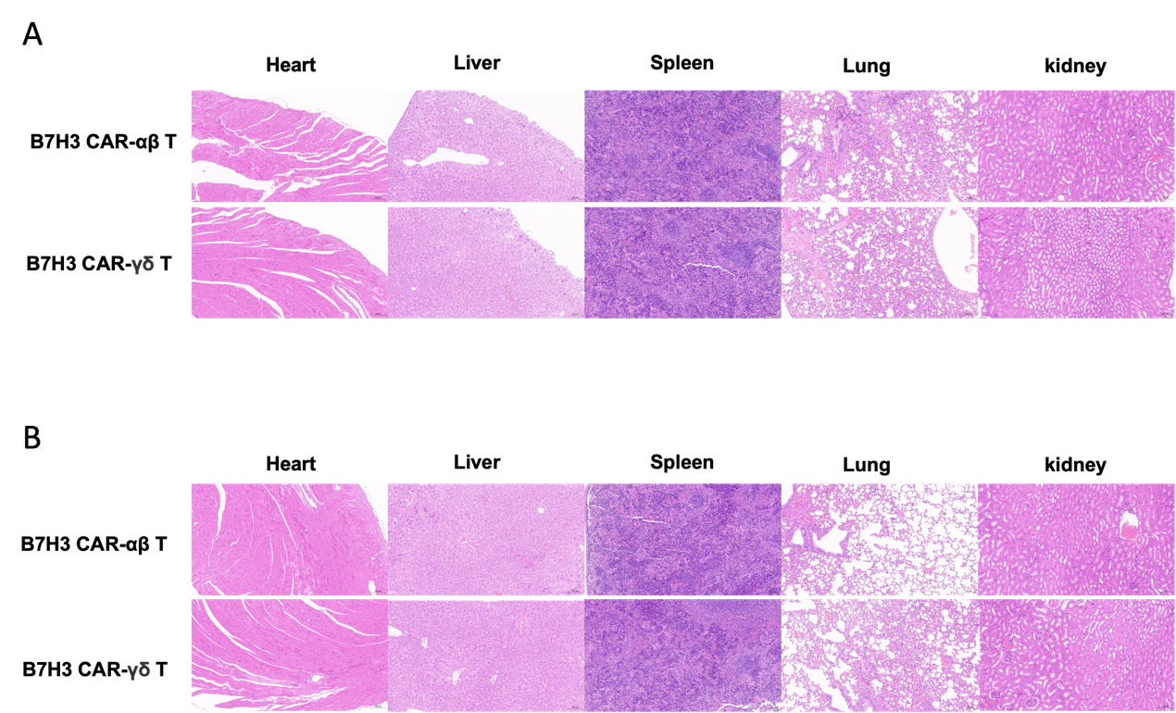
Figure S4. Biosafety validation of B7-H3 CAR-γδ T cells and B7-H3 CAR-αβ
T cells. (A) Hematoxylin and eosin (H&E) staining of tissue from the major organs after animals were sacrificed after B7-H3 CAR-γδ T cell treatment (100×). (B) H&E staining of tissues from the major organs after animals were sacrificed after B7-H3 CAR-αβ T cell treatment (100×).

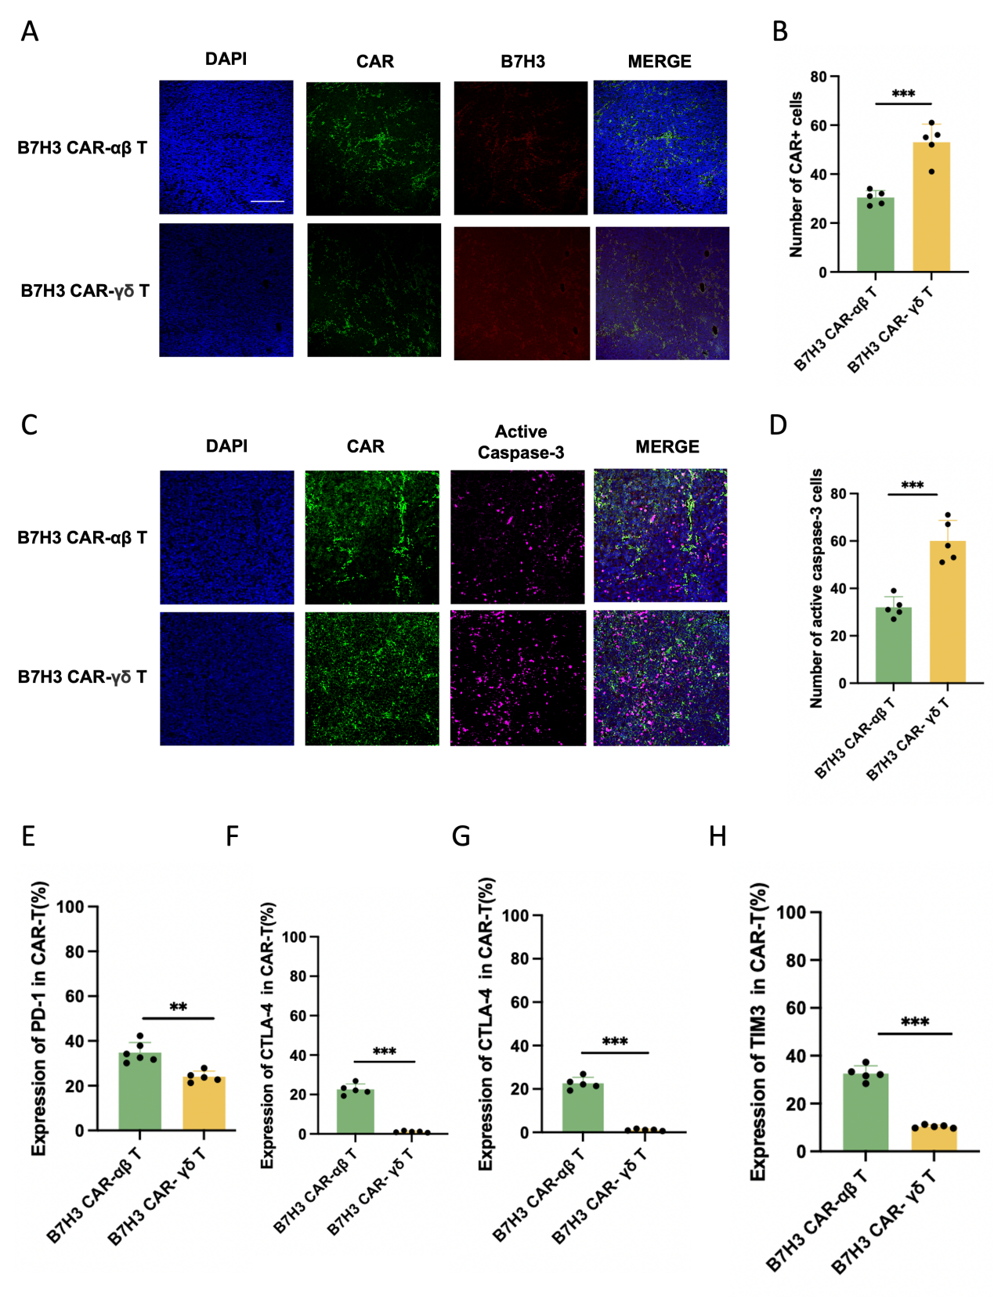
Figure S5. The potential mechanism associated with B7-H3 CAR-γδ T cell cytotoxicity. (A) B7-H3 CAR-γδ T cells and B7-H3 CAR-αβT cells infiltrating into tumors were detected using anti-GFP monoclonal antibodies in U251 cells. (B) Quantitative analysis of EGFP+ cells in tumor tissues in U251 cells. (C) Expression of active caspase-3 was detected by immunofluorescence in U251 cells. (D) Quantitative analysis of active caspase-3 in tumor tissues in U251 cells. (E-H) B7-H3 CAR+ T cells were stained with antibodies targeting PD-1, CTLA-4, and LAG-3, respectively in U87 cells. Data shown are mean ± SD (n = 5). *p < 0.05, **p < 0.01, ***p < 0.001, and ****p < 0.0001 (two-way ANOVA). Not significant (ns). The bar represents 100 µm.

