No | Supplementary | Title | Page
1 | Figure 1 | The flowchart for the cohorts used in this study. | 1
2 | Figure 2 | The workflow of quality supervision in digital cytological analysis | 2
3 | Figure 3 | Diagnostic model evaluation | 3
4 | Table1 | WSI level performances for diagnostic model of bone marrow metastasis in neuroblastoma | 3
5 | Table 2 | Univariable and multivariable Cox proportional hazards regression analysis in neuroblastoma patients | 4
6 | Figure 4 | Artificial intelligence features associated with hematological parameters of erythroid and platelet | 5
7 | Figure 5 | The differential analysis of hematological parameters in neuroblastoma prognosis | 6

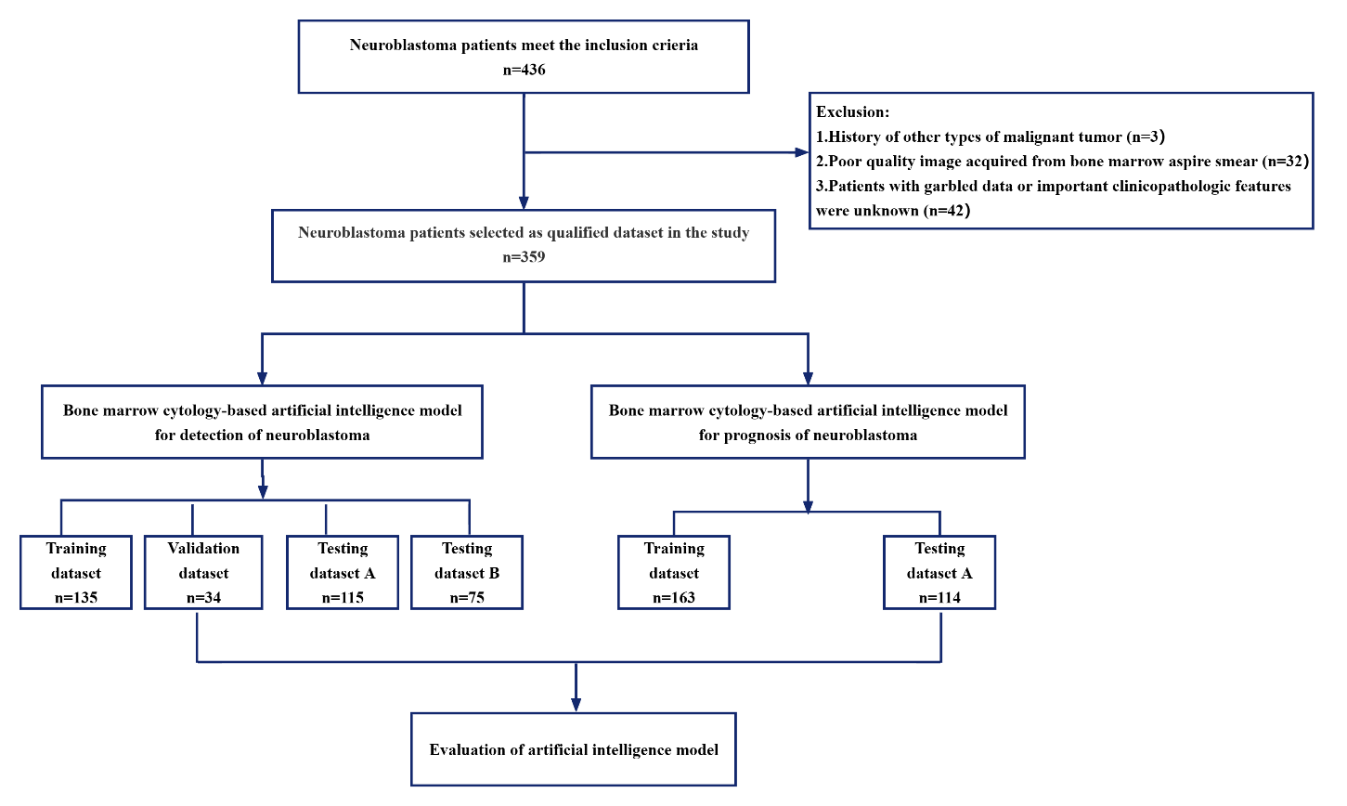

Supplementary Figure 1. The flowchart for the cohorts used in this study.

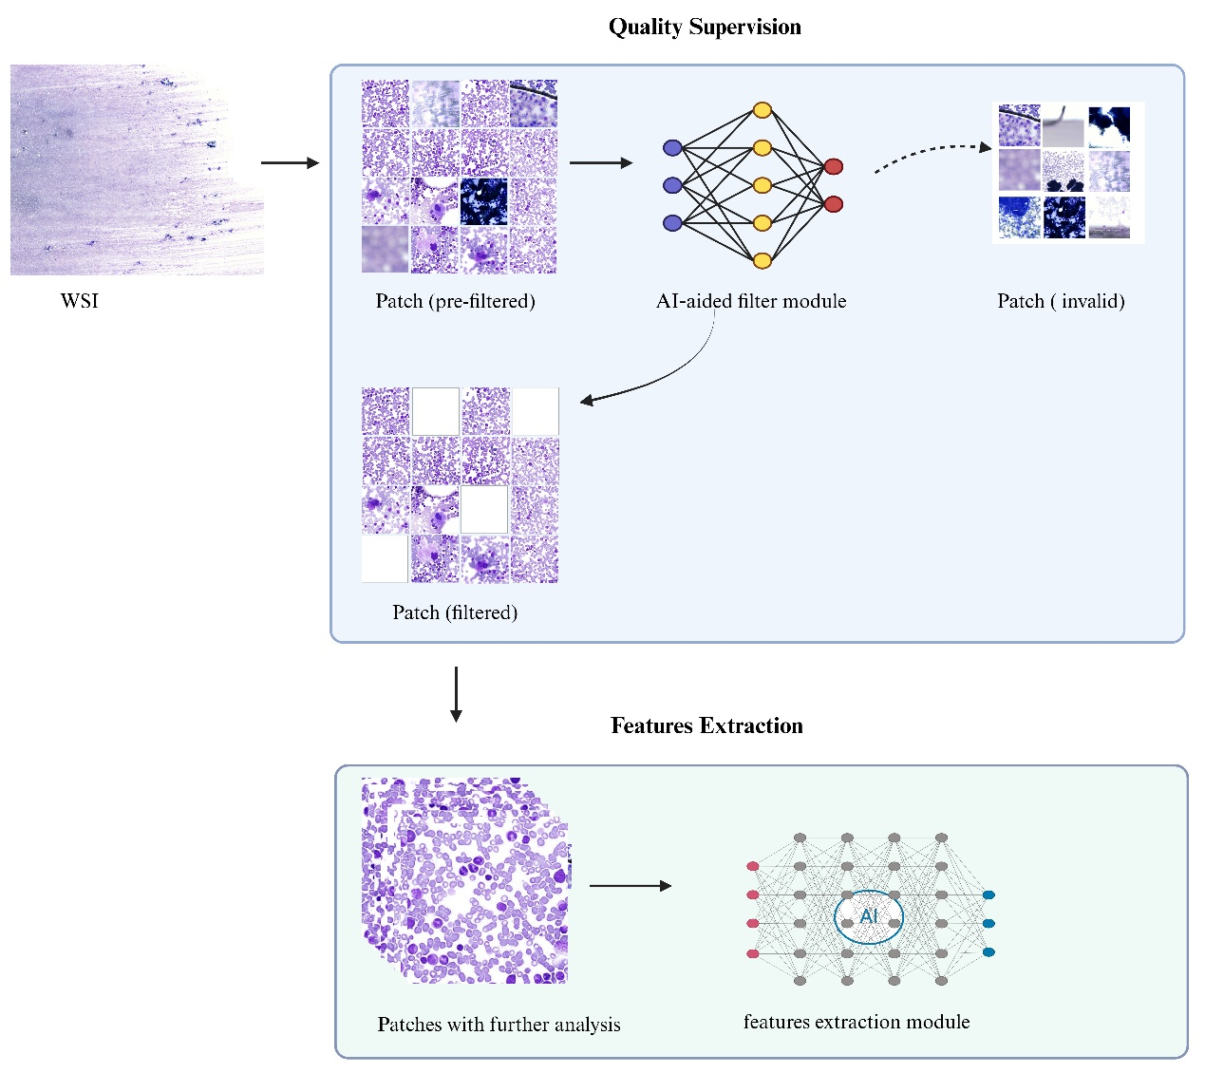
Supplementary Figure 2. The workflow of quality supervision in digital cytological analysis
The quality supervision module evaluates the quality of bone marrow digital cytological images before feature extraction, the cMIL system proceeded with further analysis by including only the high-quality patches (filtered patches) for feature extraction.

Supplementary Figure 3. Diagnostic model evaluation
(A) The LASSO method to screen features. (B) Regression cross-validation curves of LASSO. (C) The WSI-level AUC for the metastasis state of bone marrow in internal validation dataset and external testing datasets. (D) The decision curve analysis (DCA) of the diagnostic model in internal validation dataset. (E) The decision curve analysis (DCA) of the diagnostic model external testing dataset A. (F) The decision curve analysis (DCA) of the diagnostic model in external testing dataset B.

Supplementary Table 1. WSI level performances for diagnostic model of bone marrow metastasis in neuroblastoma
Model | Cohort | AUC (95% CI) | Accuracy |  | Sensitivity | Specificity | PPV | NPV | Recall | F1
MLP | Validation | 0.924 (0.775 - 1.000) |  | 0.941 | 0.833 | 1 | 1 | 0.917 | 0.833 | 0.909
 | Testing A | 0.826 (0.741 - 0.911) |  | 0.817 | 0.689 | 0.9 | 0.816 | 0.818 | 0.689 | 0.747
 | Testing B | 0.795 (0.684 - 0.906) |  | 0.813 | 0.821 | 0.809 | 0.719 | 0.884 | 0.821 | 0.767
WSI whole slide image, MLP multilayer perceptron.

Supplementary Table 2. Univariable and multivariable Cox proportional hazards regression analysis in neuroblastoma patients
 | Univariate analysis |  | Multivariate analysis
Variable | Hazard ratio (95% CI) | p value | Hazard ratio (95% CI) | p value
Age (year) | 1.057 (0.969-1.154) | 0.211
Sex
Male | Reference
Female | 1.500 (0.695-3.236) | 0.302
Primary lesion
Adrenal gland (%) | Reference
Posterior peritoneum (%) | 1.045 (0.451-2.420) | 0.918
Mediastinum (%) | 0.197 (0.025-1.541) | 0.122
Others (%) | 1.550 (0.422-5.690) | 0.509
Grade
1 | Reference
2 | 0.979 (0-5599.406) | 0.996
3 | 0.979 (0-12462.271) | 0.996
4 | 65.753 (0.036-120282.006) | 0.275
MYCN amplification
Negative
Positive | 5.533 (2.534-12.078) | <0.001 | 4.187 (1.836-9.55) | 0.001
Bone marrow cytology
Percentage of Granulocyte
<40% | Reference
≥40% | 0.528 (0.242-1.152) | 0.109
Percentage of Lymphocyte
<20% | Reference
≥20% | 0.262 (0.109-0.630) | 0.003
Percentage of Monocyte
<4% | Reference
≥4% | 0.404 (0.170-0.962) | 0.041
Percentage of Erythroid
<20% | Reference
≥20% | 0.716 (0.328-1.559) | 0.399
Peripheral blood features
White blood cell
<7×10⁹/L | Reference
≥7×10⁹/L | 0.694 (0.314-1.532) | 0.366
Percentage of Neutrophils
<45% | Reference
≥45% | 2.366 (1.027-5.451) | 0.043 | 2.239 (0.936-5.355) | 0.070
Percentage of Lymphocyte
<40% | Reference
≥40% | 0.593 (0.272-1.291) | 0.188
Percentage of Monocyte
<5% | Reference
≥5% | 1.437 (0.495-4.175) | 0.505
Percentage of Eosinophils
<2% | Reference
≥2% | 0.436 (0.194-0.979) | 0.044
Percentage of Basophils
<1% | Reference
≥1% | 1.524 (0.457-5.084) | 0.493
Neutrophils absolute count
<3.4×10⁹/L | Reference
≥3.4×10⁹/L | 1.229 (0.564-2.677) | 0.604
Lymphocyte absolute count
<3.1×10⁹/L | Reference
≥3.1×10⁹/L | 0.387 (0.155-0.969) | 0.043
Monocyte absolute count
<0.5×10⁹/L | Reference
≥0.5×10⁹/L | 0.961 (0.441-2.095) | 0.921
Red blood cell
<4×10¹²/L | Reference
≥4×10¹²/L | 0.359 (0.156-0.826) | 0.016
Haemoglobin
<100g/L | Reference
≥100g/L | 0.324 (0.149-0.706) | 0.005
Mean corpuscular volume
<82fl | Reference
≥82fl | 0.820 (0.377-1.785) | 0.617
Platelet
<300×10⁹/L | Reference
≥300×10⁹/L | 0.588 (0.262-1.321) | 0.199
Mean platelet volume
< 9fl | Reference
≥9fl | 1.304 (0.547-3.113) | 0.549
NSE
<230ng/mL | Reference
≥230ng/mL | 7.435 (3.292-16.795) | <0.001 | 3.293 (1.369-7.919) | 0.008
Bone marrow cytology Score
Low | Reference
High | 6.174 (2.586-14.738) | <0.001 | 3.439 (1.341-8.818) | 0.010

Supplementary Figure 4. Artificial intelligence features associated with hematological parameters of erythroid and platelet
The correlation between bone marrow cytology features generated by the cMIL model and the characteristics of erythroid and platelet: (A) erythroid precursor observed in bone marrow, (B) red blood cells numbers in peripheral blood, (C) hemoglobin concentrations in peripheral blood, (D) platelets numbers in peripheral blood. (E) the interaction loop of the digital cytology features across the erythroid and platelet.
Supplementary Figure 5. The differential analysis of hematological parameters in neuroblastoma prognosis
(A) Box plot of hematopoietic cell composition in bone marrow. (B) Box plot of white cell composition in peripheral blood. (C) Box plot of white cell population in peripheral blood.
Low: low risk group, High: high risk group.

