Table S1. Elements of blood test
element
White blood cell count
Red blood cell count
Hemoglobin
Hematocrit
MCV
MCH
MCHC
Platelet count
Neutrophils
Eosinophils
Basophils
Lymphocytes
Monocytes
Uric acid
Total cholesterol
Triglycerides
HDL cholesterol
LDL cholesterol
Total protein
Albumin
Total bilirubin
LDH
AST
ALT
ALP
Gamma-glutamyl transferase (GGT)
Cholinesterase
Pancreatic amylase
Creatinine
Blood urea nitrogen
Sodium
Potassium
Chloride
Calcium
CRP

Table S2. Features extracted from chest X-ray images using TorchXray
Features
Atelectasis
Consolidation
Infiltration
Pneumothorax
Edema
Emphysema
Fibrosis
Effusion
Pneumonia
Pleural thickening
Cardiomegaly
Nodule
Mass
Hernia
Lung lesion
Fracture
Lung opacity
Enlarged cardiomediastinum

Table S3 Performance comparison between TabPFN and traditional machine learning models for ALM prediction within the multimodal model.
Step2-model in multimodal model | Internal validation |  |  | External validation
 | RMSE, kg | MAE, kg | Correlation Coefficient | RMSE, kg | MAE, kg | Correlation Coefficient
TabPFN | 1.23 (1.18 - 1.29) | 0.96 (0.91 - 1.02) | 0.958 (0.951 - 0.964) | 1.87 (1.83 - 1.91) | 1.41 (1.38 - 1.45) | 0.930 (0.925 - 0.935)
ExtraTreesRegressor | 1.27 (1.19-1.35) | 1.00 (0.935-1.06) | 0.956 (0.950-0.961) | 2.02 (1.95-2.09) | 1.48 (1.44-1.53) | 0.916 (0.908-0.923)
LGBMRegressor | 1.29 (1.21-1.36) | 1.00 (0.943-1.06) | 0.954 (0.948-0.960) | 2.08 (2.02-2.15) | 1.58 (1.53-1.62) | 0.912 (0.905-0.919)
RandomForestRegressor | 1.26 (1.19-1.33) | 1.00 (0.941-1.06) | 0.956 (0.950-0.962) | 2.04 (1.97-2.10) | 1.52 (1.48-1.57) | 0.912 (0.905-0.919)
XGBRegressor | 1.37 (1.28-1.45) | 1.05 (0.981-1.12) | 0.948 (0.941-0.955) | 2.12 (2.06-2.18) | 1.62 (1.57-1.66) | 0.902 (0.894-0.910)
GradientBoostingRegressor | 1.25 (1.18-1.32) | 0.98 (0.924-1.04) | 0.957 (0.951-0.962) | 2.07 (2.01-2.13) | 1.59 (1.55-1.63) | 0.919 (0.912-0.925)
Ridge | 1.29 (1.22-1.36) | 1.02 (0.965-1.09) | 0.954 (0.948-0.959) | 2.69 (2.53-2.87) | 1.86 (1.80-1.92) | 0.861 (0.842-0.879)
BayesianRidge | 1.28 (1.21-1.35) | 1.02 (0.961-1.08) | 0.955 (0.949-0.960) | 2.57 (2.43-2.73) | 1.81 (1.76-1.87) | 0.872 (0.854-0.887)
LinearRegression | 1.31 (1.24-1.38) | 1.04 (0.977-1.10) | 0.953 (0.946-0.958) | 2.87 (2.69-3.07) | 1.97 (1.90-2.03) | 0.849 (0.829-0.869)
AdaBoostRegressor | 1.41 (1.34-1.48) | 1.15 (1.09-1.21) | 0.945 (0.938-0.952) | 2.02 (1.96-2.08) | 1.52 (1.47-1.56) | 0.910 (0.903-0.916)
ElasticNet | 1.56 (1.48-1.64) | 1.28 (1.22-1.36) | 0.933 (0.923-0.941) | 2.59 (2.22-3.05) | 1.75 (1.69-1.82) | 0.857 (0.814-0.893)
RMSE, root mean square error; MAE, mean absolute error.
Values in parentheses are 95% confidence intervals, calculated using the bootstrap method.

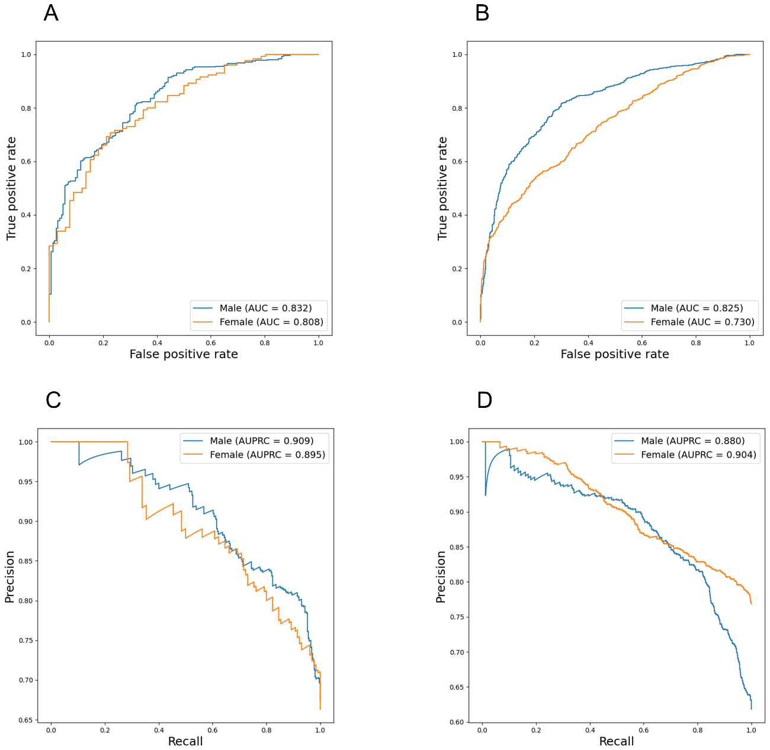
Figure S1. Performance of the TabPFN-multimodal model stratified by sex. Receiver Operating Characteristic (ROC) curves are shown for the (A) internal and (B) external validation sets. Precision-Recall (PR) curves are shown for the (C) internal and (D) external validation sets. In each panel, the blue line represents the male cohort, and the orange line represents the female cohort. The corresponding Area Under the ROC Curve and Area Under the PR Curve values are indicated within each plot.
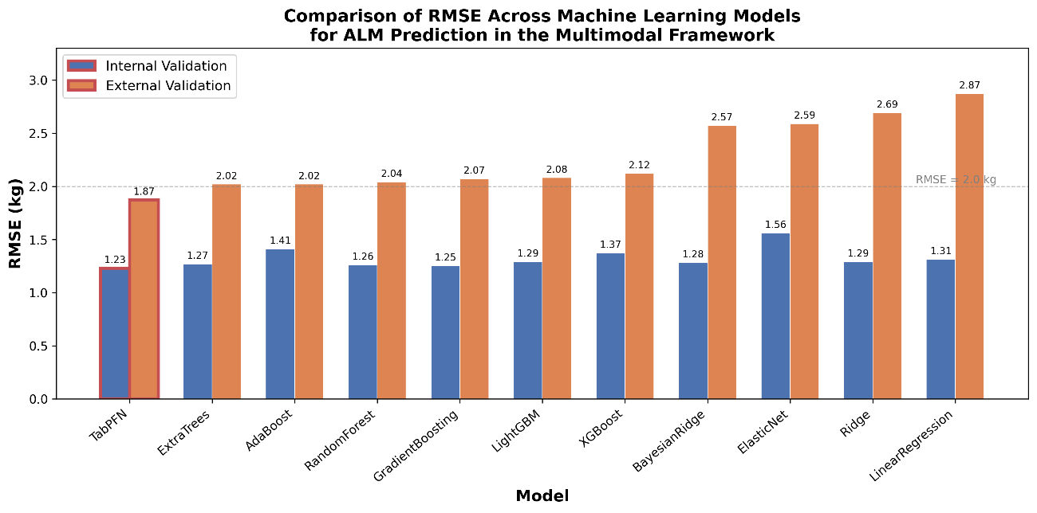
Figure S2. Comparison of root mean square error (RMSE) across TabPFN and 10 traditional machine learning models for appendicular lean mass prediction within the multimodal framework. Blue bars represent internal validation performance and orange bars represent external validation performance. RMSE values (kg) are shown above each bar. All models were evaluated using PyCaret (version 3.3.2) as alternatives to TabPFN in Step 2 of the multimodal architecture. Models are sorted by external validation RMSE in ascending order. The dashed line indicates RMSE = 2.0 kg.

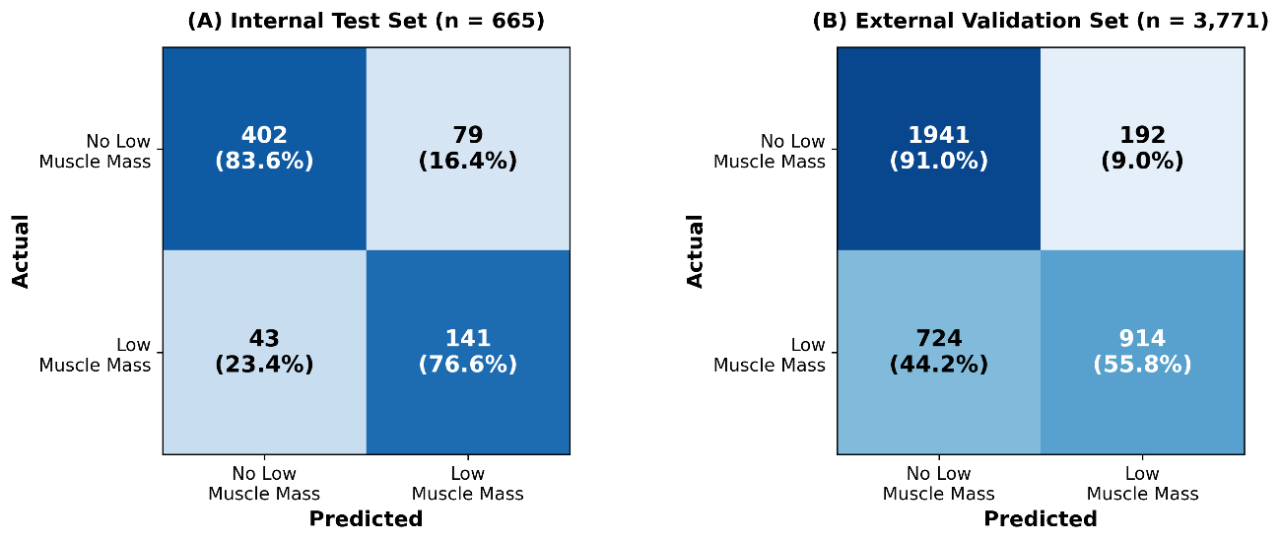
Figure S3. Confusion matrices of the TabPFN-multimodal model for low muscle mass detection based on AWGS criteria. (A) Internal test set (n = 665) and (B) external validation set (n = 3,771). Each cell shows the number of observations and the row-wise percentage in parentheses. Rows represent the actual classification and columns represent the predicted classification. Low muscle mass was defined as skeletal muscle index <7.0 kg/m² in males and <5.4 kg/m² in females.

