Supplementary Materials
Mesenchymal Stem cell therapy with GHRH receptor analogue resolves post-stroke vasogenic edema via modulating AQP4 and mitochondria-ER crosstalk
Aishika Datta, Bijoyani Ghosh, Anita Kumari, Gautam Karmarkar, Ushmita Mukherjee, Akshada Dubey, Anirban Barik, Ankit Singh, Nikita Malik, Deepaneeta Sarmah, Andrew Victor Schally, Medhi Wangpaichitr, Wei Sha, Dileep R Yavagal, Pallab Bhattacharya

Uncropped immunoblots

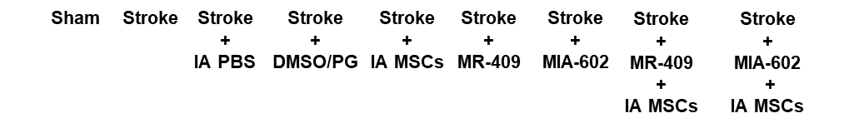
β actin (42 kD)
SENP3 (65 kD)
DRP-1 (78 kD)
GRP75 (75 kD)
DRP-1
tagged dynabeads
SUMO 2/3 on DRP-1
100 kD
150 kD
250 kD
75 kD
50 kD

AQP4- M1 (32 KD)
AQP4-M23 (30 kD)

FIS1 (21 kD)

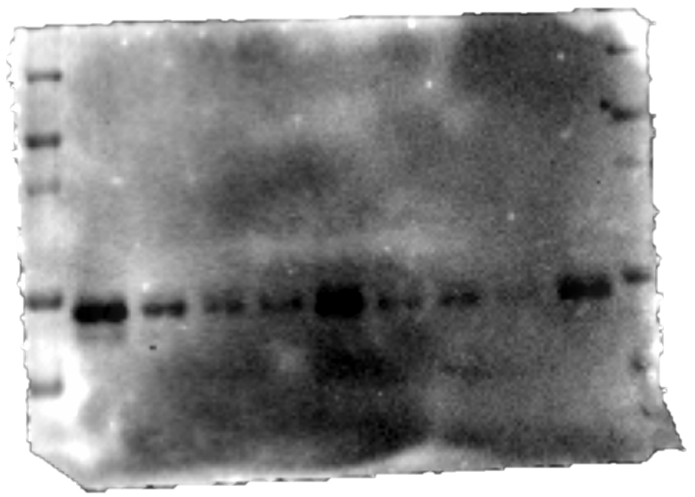
250 kD
SUMO 2/3 on DRP-1
150 kD
100 kD
75 kD
50 kD
DRP-1 tagged dynabeads

