S100P Mediates IL-13/ATF4-Driven Epithelial Barrier Dysfunction in Eosinophilic Asthma: A Potential Biomarker and Therapeutic Target
Supplemental Table
Table S1
Sequence of si-S100P (Homo)
Name | Sense Strand | Antisense Strand
siRNA-59 | ACGGAACUAGAGACAGCCATT | UGGCUGUCUCUAGUUCCGUTT
siRNA-150 | AGCUCAAGGUGCUGAUGGATT | UCCAUCAGCACCUUGAGCUTT
siRNA-211 | CCGUGGAUAAAUUGCUCAATT | UUGAGCAAUUUAUCCACGGTT
siRNA-298 | CACGUCUGCCUGUCACAAGTT | CUUGUGACAGGCAGACGUGTT

Table S2
Candidate drug predicted using DsigDB.
 | P-Value | Combined Score | Genes
Salbutamol | 0.001 | 133525.545 | S100P
Dobutamine | 0.001 | 131975.023 | S100P
Simvastatin | 0.002 | 128549.420 | S100P
Terbutaline | 0.002 | 127326.105 | S100P
Minocycline | 0.002 | 122117.066 | S100P
Fenoterol | 0.002 | 121662.498 | S100P
Diltiazem | 0.002 | 120356.527 | S100P
(-)-isoprenaline | 0.003 | 118735.697 | S100P
Orciprenaline | 0.003 | 114844.470 | S100P
Astemizole | 0.005 | 105032.151 | S100P
Tonzonium bromide | 0.007 | 97679.545 | S100P
506-26-3 | 0.002 | 119530.059 | S100P
Gossypol | 0.004 | 112131.598 | S100P
Celastrol | 0.011 | 88371.923 | S100P

Supplemental Figures
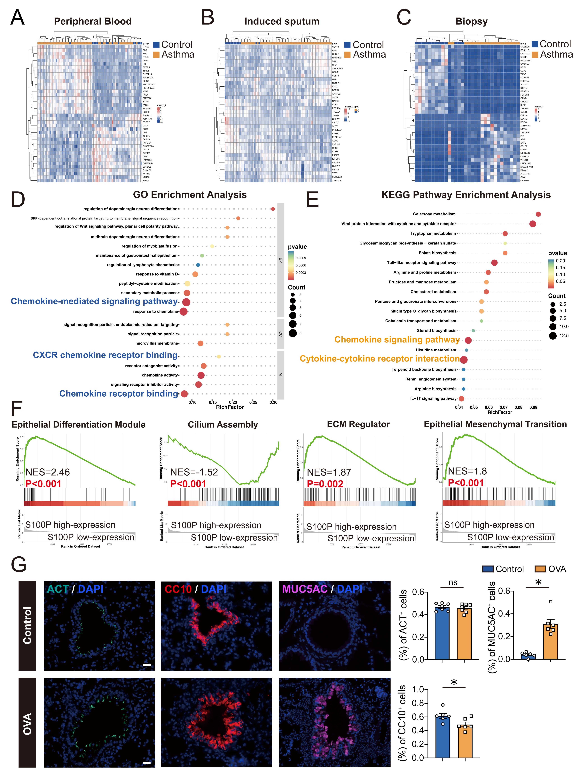
Fig. S1 Imbalanced S100P expression coincides with chemokine signaling activation and an altered epithelial phenotype. (A-C) Heatmap displaying differentially expressed genes (DEGs) across three independent asthma datasets (GSE256534, GSE137268, GSE147878). (D, E) GO and KEGG enrichment analyses were performed on DEGs identified through S100P expression-based stratification analysis in GSE85567. (F) GSEA of bronchial epithelium stratified by S100P expression levels (high vs low). (G) Immunofluorescence staining of ACT, CC10, and MUC5AC in lung tissues of OVA-induced asthmatic mice. (Magnification: 400×; scale bar: 20 µm). Data are presented as mean ± SEM. *P<0.05, ns: no significant.
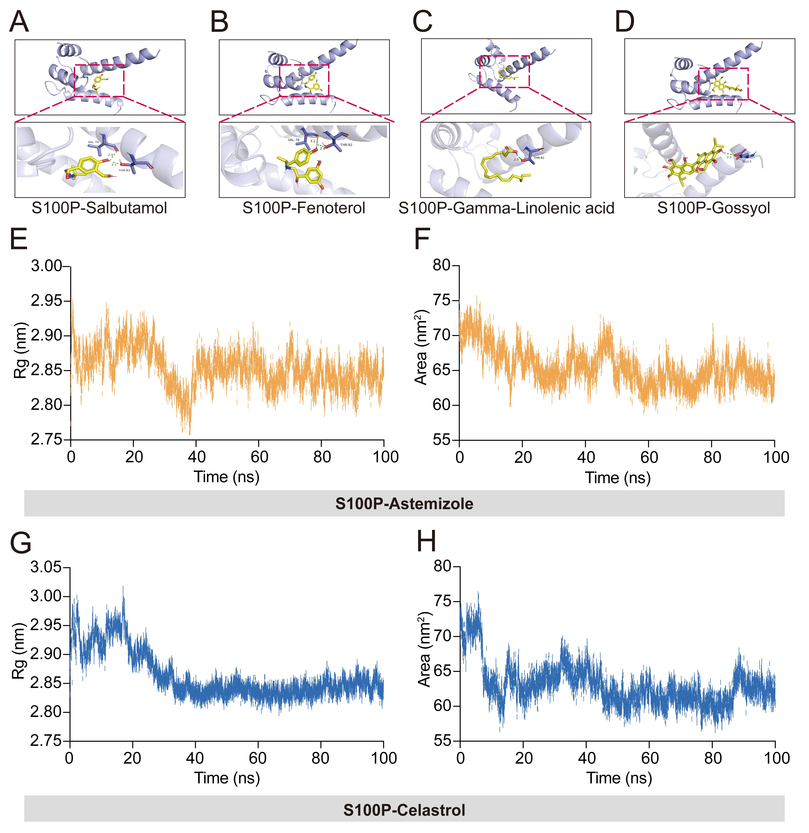
Fig. S2 Molecular docking reveals candidate compound binding to S100P. (A-D) Molecular docking results of S100P with salbutamol, fenoterol, gamma-Linolenic acid, gossyol. (E, F) Molecular dynamics simulations (100 ns) results of S100P with astemizole. (G, H) Molecular dynamics simulations (100 ns) results of S100P with celastrol.

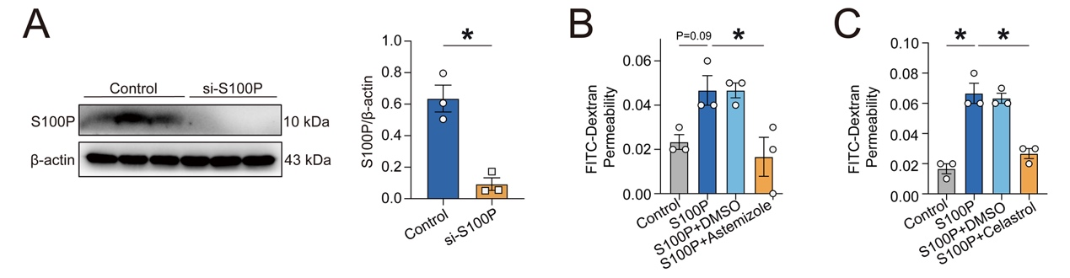
Fig. S3 (A) Validation of S100P knockdown in 16HBE cells. Representative western blots and quantitative analysis of S100P protein expression in 16HBE cells transfected with si-S100P (siRNA-298), n=3. (B-C) FITC-dextran permeability assays in 16HBE cells treated with recombinant S100Pin the presence or absence of candidate compounds for 24 h. Fluorescence intensity was measured after 24 h of treatment, n=3. Data are presented as mean ± SEM. *P < 0.05 vs Control.

