Supplementary figures
Figure S1. Example of MRI with HCC. The red mask is the demonstration of ROIs placement on the axial phase, Venous phase and Delayed phase image.

Figure S2. Workflow for clinical-radiomics model development.
(A) MRI image acquisition and manual segmentation of regions of interest (ROIs) were performed on contrast-enhanced arterial phase, delayed phase, venous phase images.
(B) Radiomic features were extracted from the segmented tumor regions, including intensity, shape, texture, and wavelet-transformed features.
(C) Feature selection was conducted using the least absolute shrinkage and selection operator (LASSO) regression.
(D) Construction of the clinical-radiomics model by integrating selected radiomic features with clinical variables.

Figure S3. Radiomics features were extracted by Pyradiomics software.
(A) The categories of radiomics features.
(B) The p value of Z-score normalization radiomics features obtained from independent sample t test.

Figure S4. The treatment response and survival analysis between training and validation cohorts.
(A) Treatment response in different cohorts.
(B and C) The Kaplan-Meier curves of OS and PFS between training and validation cohorts based on treatment response.

Figure S5. ROC curves analysis and comparison of ML radiomics models in predicting the response to LPI treatment for patients with unresectable HCC in the training and validation sets.
(A) ROC curves of the ML radiomics models in the training cohort.
(B) ROC curves of the ML radiomics models in the validation cohort.

Figure S6. Survival prognosis analysis for patients with HCC receiving treatment between response and non-response groups.
(A) The Kaplan-Meier curves of PFS between response and non-response groups in the entire cohorts.
(B) The Kaplan-Meier curves of PFS between response and non-response groups in the training cohorts.
(C) The Kaplan-Meier curves of OS between response and non-response groups in the validation sets.
(D) The Kaplan-Meier curves of OS between response and non-response groups in the entire cohorts.
(E and F) The Kaplan-Meier curves of OS between response and non-response groups in the training and validation cohorts.

Figure S7. Kaplan-Meier curves for progression-free survival (PFS) in the lenvatinib subgroup, stratified by the combined clinical-radiomics model risk score.
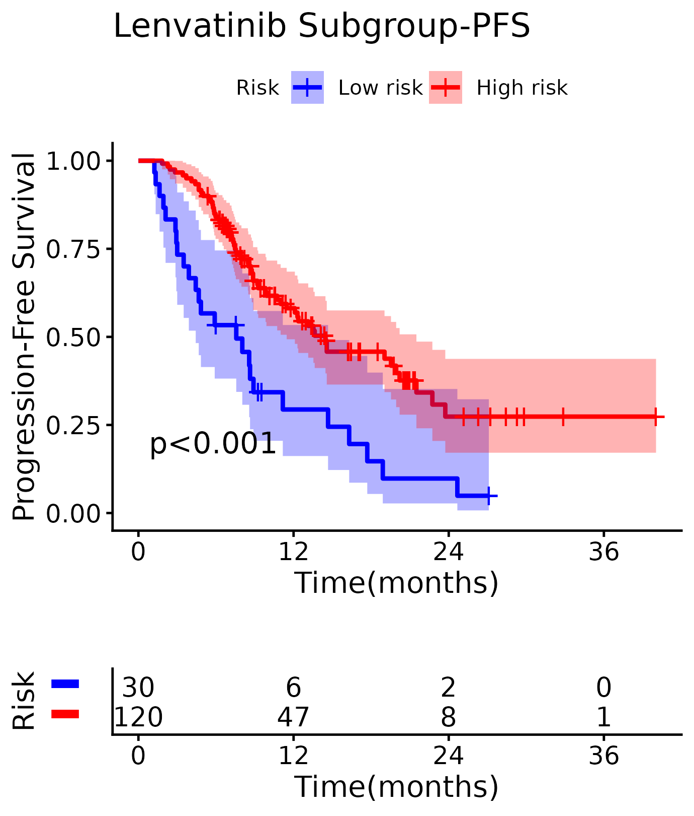

Figure S8. Kaplan-Meier curves for overall survival (OS) in the lenvatinib subgroup, stratified by the combined clinical-radiomics model risk score.

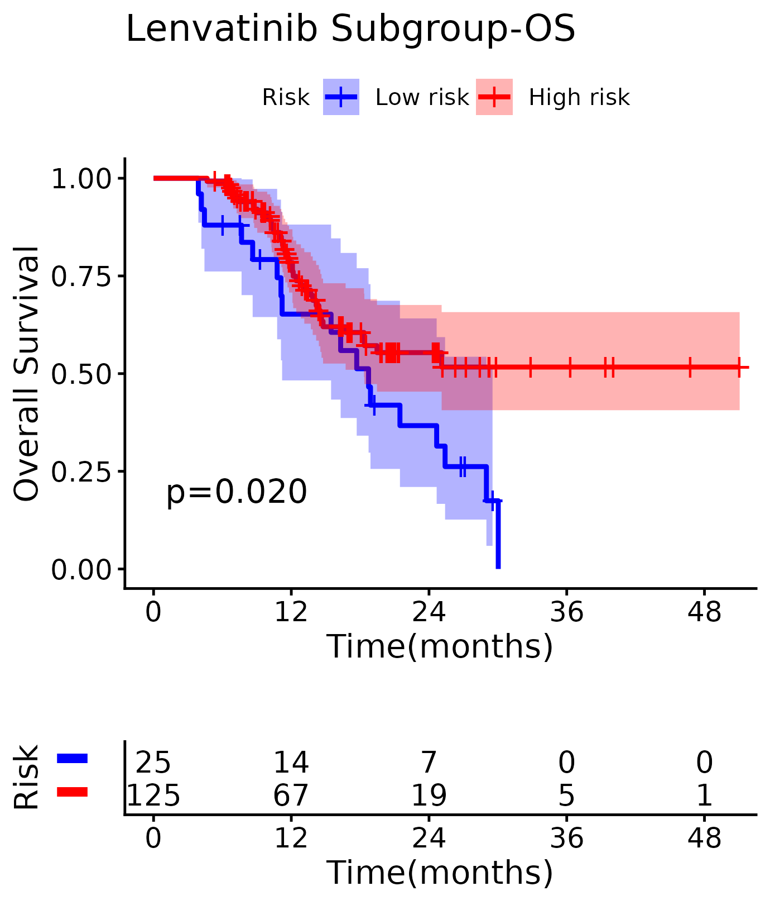

Figure S9. Kaplan-Meier curves for progression-free survival (PFS) in the non-lenvatinib subgroup, stratified by the combined clinical-radiomics model risk score.

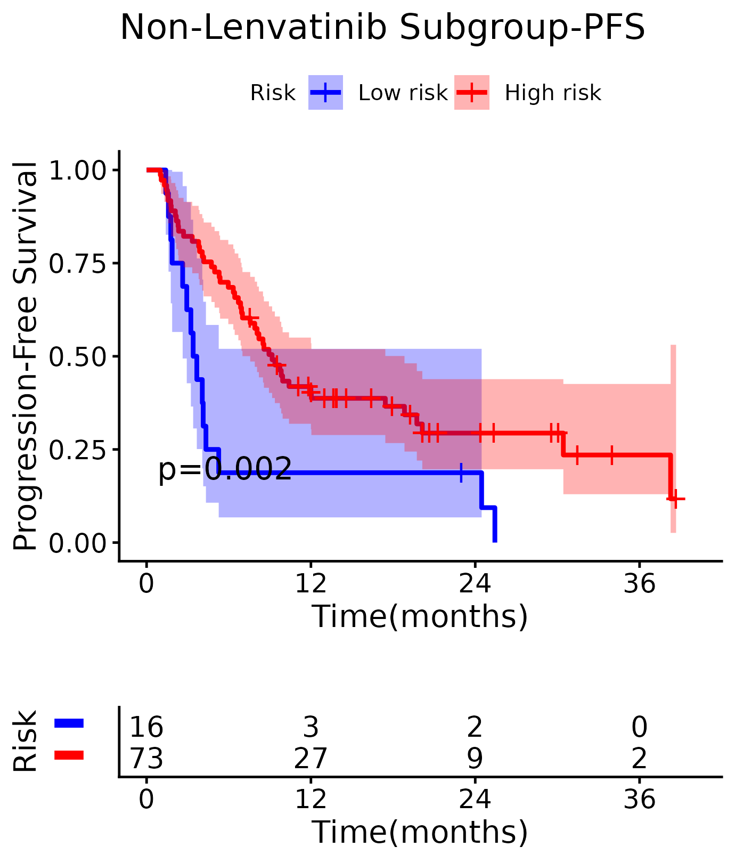

Figure S10. Kaplan-Meier curves for overall survival (OS) in the non-lenvatinib subgroup, stratified by the combined clinical-radiomics model risk score.

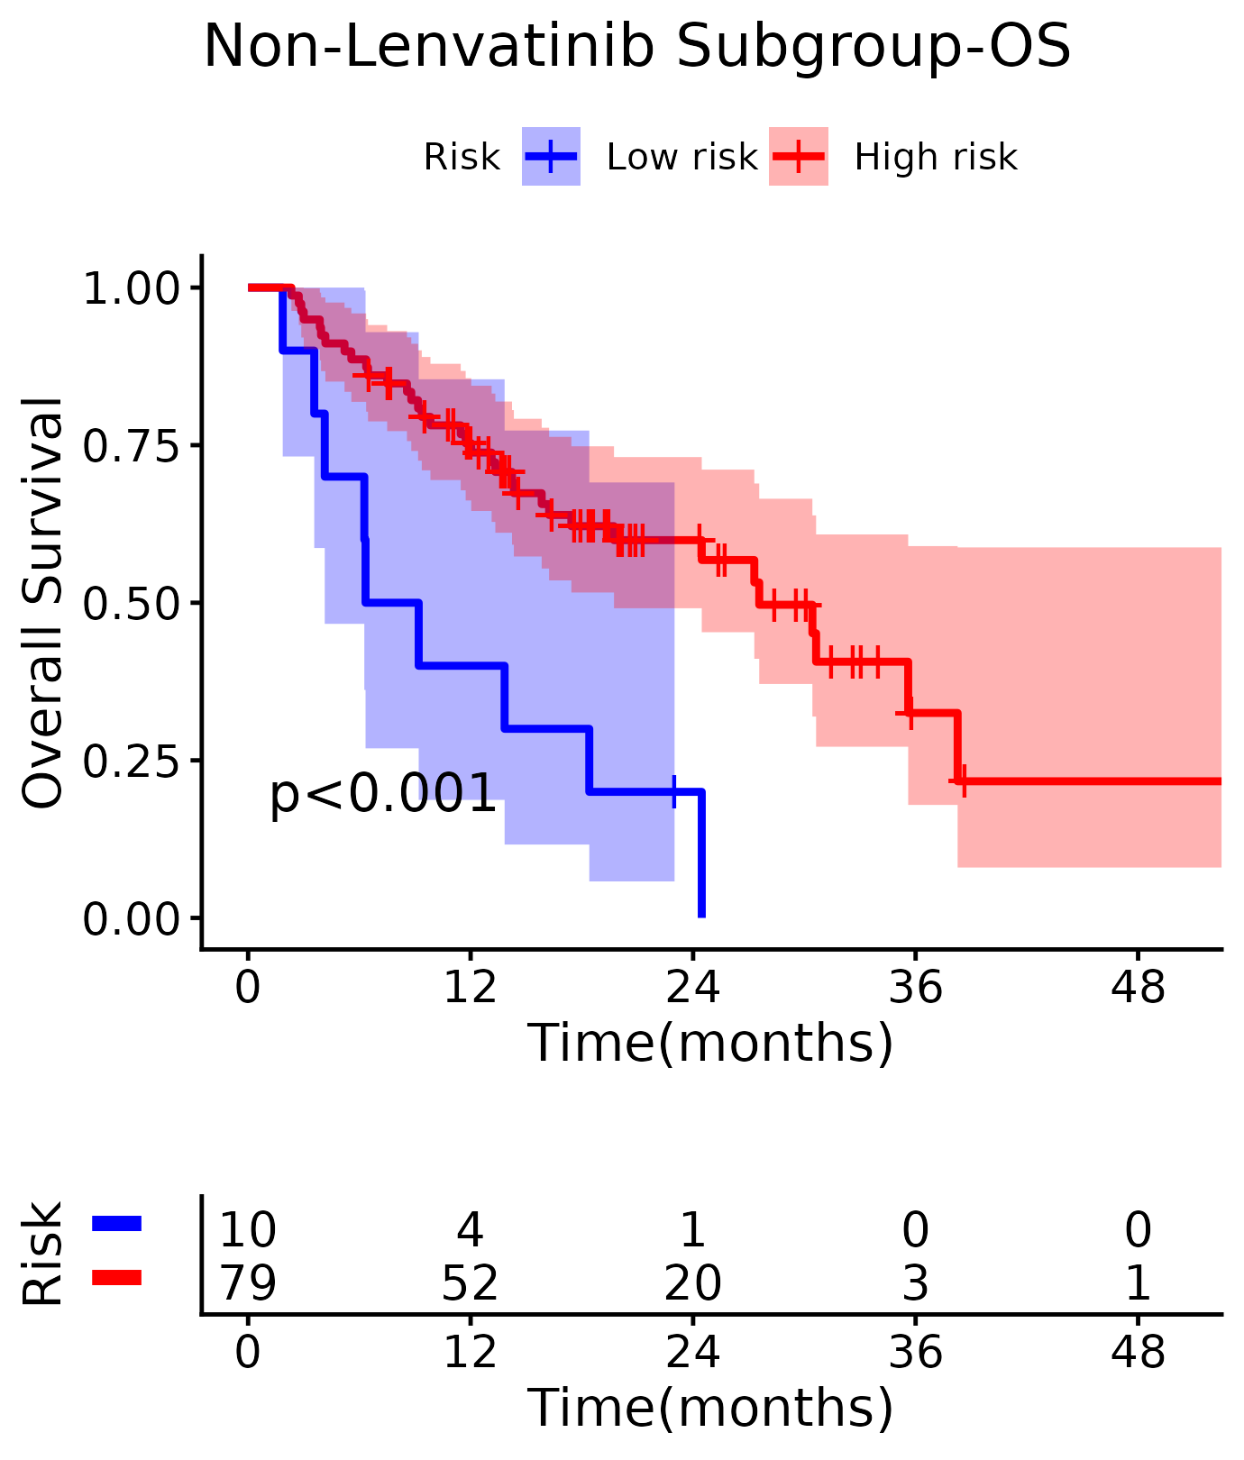
Supplementary Tables
Table S1. Tumor responses for patients with HCC receiving TKIs plus PD-1 inhibitors and interventional treatment according to mRECIST criteria
Tumor Response | n (%), mRECIST (n=239)
Complete response | 15 (6.28)
Partial response | 161 (67.36)
Stable disease | 26 (10.88)
Progressive disease | 37 (15.48)
Objective response rate | 73.66%
Disease control rate | 84.52%

Table S2. Comparison of Interventional and Systemic Treatment Regimens Between Training and Validation Cohorts

Variables | Training (n=191) | Validation (n=48) | P
Interventional therapy, n (%)
TACE | 114 (59.7%) | 32 (66.7%) | 0.471
TACE+HAIC | 77 (40.3%) | 16 (33.3%)
Immunotherapy, n (%)
Atezolizumab | 19 (9.9%) | 7 (14.6%) | 0.275
Camrelizumab | 38 (19.9%) | 11 (22.9%)
Nivolumab | 1 (0.5%) | 2 (4.3%)
Pembrolizuma | 25 (13.1%) | 4 (8.3%)
Sintilimab | 84 (44.0%) | 20 (41.7%)
Tislelizumab | 24 (12.9%) | 4 (8.3%)
Targeted Therapy, n (%) |  |  | 0.880
Anlotinib | 3 (9.9%) | 1 (9.9%)
Apatinib | 11 (9.9%) | 4 (9.9%)
Bevacizumab | 22 (9.9%) | 8 (9.9%)
Donafenib | 21 (9.9%) | 5 (9.9%)
Lenvatinib | 122 (9.9%) | 28 (9.9%)
Sorafenib | 12 (9.9%) | 2 (9.9%)

Table S3. Comparison of Cohorts Between Training and Validation Cohorts

Variables | Training cohort (N=191) |  |  |  | Validation cohort (N=48)
 |  | Non-response (N=45) | Response (N=146) | P | Non-response (N=18) | Response (N=30) | P
Cohort n (%) |  |  |  | 0.144 |  |  | 0.393
Sun-Yat Sen University |  | 42 (93.3%) | 124 (85.0%) |  | 17 (88.9%) | 26 (96.7%)
ShenZhen |  | 3 (6.7%) | 22 (15.0%) |  | 1 (11.1%) | 4 (3.3%)

Table S4. Comparison of Interventional and Systemic Treatment Regimens Between Responders and Non-Responders
Variables | Response (N=176) | Non-response (N=63) | P
Interventional therapy, n (%) |  |  | 0.364
TACE | 104 (59.1%) | 42 (66.7%)
TACE+HAIC | 72 (40.9%) | 21 (33.3%)
Immunotherapy, n (%)
Atezolizumab | 15 (8.5%) | 11 (17.5%) | 0.331
Camrelizumab | 34 (19.3%) | 15 (23.8%)
Nivolumab | 2 (1.1%) | 1 (1.6%)
Pembrolizumab | 23 (13.1%) | 6 (9.5%)
Sintilimab | 79 (44.9%) | 25 (39.7%)
Tislelizumab | 23 (13.1%) | 5 (7.9%)
Targeted Therapy, n (%) |  |  | 0.010
Anlotinib | 1 (0.6%) | 3 (4.8%)
Apatinib | 11 (6.3%) | 4 (6.3%)
Bevacizumab | 17 (9.7%) | 13 (20.6%)
Donafenib | 16 (9.1%) | 10 (15.9%)
Lenvatinib | 121 (68.8%) | 29 (46.0%)
Sorafenib | 10 (5.7%) | 4 (6.3%)

Table S5. Multivariable logistic regression analysis of the variables with statistical differences in univariate comparison in the entire cohort

Clinical Feature | Univariate |  | Multivariate
 | Odds ratio | P | Odds ratio | P
 | (95% CI) | P | (95% CI) | P
Inferior Vena Cava Tumor Thrombus(Yes vs No) | 0.425 (0.189-0.958) | 0.039 | 0.464 (0.198-1.083) | 0.052
HBeAg status (Positive vs Negative) | 0.347 (0.178-0.677) | 0 | 0.356(0.179-0.711) | 0.001
Lenvatinib use (Yes vs No) | 2.80( 1.431-4.649) | 0 | 2.491(1.359-4.569) | 0.003

Table S6. Pre-scores of predict models between non-response group and response group in training and validation cohorts

Cohort | Model | Non-response | Response | P value
Training cohort  (N=191) | Clinical | 0.70 (0.14) | 0.78 (0.11) | 0.001
Training cohort  (N=191) | Radiomics | 0.31 (0.35) | 0.90 (0.14) | <0.001
Training cohort  (N=191) | Combined | 0.29 (0.35) | 0.91 (0.14) | <0.001
Validation cohort  (N=48) | Clinical | 0.70 (0.14) | 0.78 (0.12) | 0.059
Validation cohort  (N=48) | Radiomics | 0.66 (0.39) | 0.91 (0.15) | 0.017
Validation cohort  (N=48) | Combined | 0.64 (0.40) | 0.91 (0.18) | 0.013

Table S7. Logistic regression analysis of the radiomics score combined with treatment variables for predicting treatment response (3-month objective response).
Variable | Coefficient | SE | OR | 95% CI Lower | 95% CI Upper | P value
(Intercept) | -7.3812 | 1.4928 | 0.001 | 0 | 0.012 | 0
rscore | 11.3201 | 1.8227 | 82458.644 | 2316.145 | 2935665.351 | 0
LenvatinibLenvatinib Yes | 0.5188 | 0.699 | 1.68 | 0.427 | 6.612 | 0.458
Immunotherapy.DrugCamrelizumab | 0.5545 | 1.0473 | 1.741 | 0.224 | 13.561 | 0.5965
Immunotherapy.DrugNivolumab | 11.7612 | 1455.3979 | 128178.97 | 0 | Inf | 0.9936
Immunotherapy.DrugPembrolizumab | 0.1236 | 1.1971 | 1.132 | 0.108 | 11.821 | 0.9177
Immunotherapy.DrugSintilimab | 0.1376 | 0.9515 | 1.147 | 0.178 | 7.408 | 0.8851
Immunotherapy.DrugTislelizumab | 1.4474 | 1.3419 | 4.252 | 0.306 | 58.999 | 0.2808
InterventionTACE_HAIC | -0.6607 | 0.592 | 0.517 | 0.162 | 1.648 | 0.2645
Note: The radiomics score (rscore) was the only statistically significant predictor. None of the treatment variables (targeted therapy type, immunotherapy drug, or interventional procedure type) reached statistical significance (all P > 0.25). DeLong test comparing radiomics-only vs. radiomics + treatment model: training: Z = −1.046, P = 0.296; validation: Z = 0.650, P = 0.516.

Table S8. The performance of radio models constructed by nine ML predicting the response to TKI plus PD-1 inhibitors and interventional therapy in patients with unresectable HCC in the training and validation cohorts.
Model name | Cohort | Accuracy | AUC | 95% CI | Sensitivity | Specificity | PPV | NPV | Precision | Recall | F1 | Threshold
LR | Training | 0.686 | 0.787 | 0.713-0.861 | 0.630 | 0.867 | 0.939 | 0.419 | 0.939 | 0.630 | 0.754 | 0.824
LR | Validation | 0.813 | 0.765 | 0.610-0.920 | 1.000 | 0.529 | 0.769 | 1.000 | 0.769 | 1.000 | 0.870 | 0.633
NaiveBayes | Training | 0.717 | 0.732 | 0.648-0.815 | 0.705 | 0.756 | 0.904 | 0.442 | 0.904 | 0.705 | 0.792 | 0.911
NaiveBayes | Validation | 0.729 | 0.757 | 0.602-0.913 | 0.667 | 0.833 | 0.870 | 0.600 | 0.870 | 0.667 | 0.755 | 0.974
SVM | Training | 0.911 | 0.891 | 0.819-0.963 | 0.925 | 0.867 | 0.957 | 0.780 | 0.957 | 0.925 | 0.941 | 0.774
SVM | Validation | 0.688 | 0.748 | 0.602-0.894 | 0.600 | 0.833 | 0.857 | 0.556 | 0.857 | 0.600 | 0.706 | 0.795
KNN | Training | 0.560 | 0.778 | 0.713-0.843 | 0.425 | 1.000 | 1.000 | 0.349 | 1.000 | 0.425 | 0.596 | 1.000
KNN | Validation | 0.563 | 0.638 | 0.483-0.793 | 0.400 | 1.000 | 0.800 | 0.455 | 0.800 | 0.400 | 0.533 | 1.000
RandomForest | Training | 0.911 | 0.930 | 0.882-0.978 | 0.938 | 0.822 | 0.945 | 0.804 | 0.945 | 0.938 | 0.942 | 0.702
RandomForest | Validation | 0.813 | 0.790 | 0.648-0.932 | 0.867 | 0.722 | 0.839 | 0.765 | 0.839 | 0.867 | 0.852 | 0.839

Table S9. Interaction analysis between radiomics signature and lenvatinib use for treatment response, progression-free survival, and overall survival.
Endpoint | Interaction Term | OR/HR | 95% CI Lower | 95% CI Upper | P value | LR test P
Treatment response (Logistic) | rscore x Lenvatinib | 4511.52 | 1.222 | 16661788.648 | 0.045 | 0.025
PFS (Cox) | rscore x Lenvatinib | 0.955 | 0.268 | 3.405 | 0.943 | -
OS (Cox) | rscore x Lenvatinib | 1.042 | 0.24 | 4.531 | 0.956 | -
Note: The interaction between radiomics score and lenvatinib use was statistically significant for treatment response prediction (OR = 4511.5, P = 0.045) but not for PFS (HR = 0.955, P = 0.943) or OS (HR = 1.042, P = 0.956), indicating that the radiomics signature's prognostic value for survival outcomes is consistent and independent of lenvatinib use.

Table S10. Sensitivity analysis of radiomics model performance across lenvatinib and non-lenvatinib subgroups.
Analysis | N (Train) | N (Test) | AUC (Train) | 95% CI (Train) | AUC (Test) | 95% CI (Test) | DeLong P
Full cohort-Radiomics | 191 | 48 | 0.93 | 0.882-0.978 | 0.79 | 0.648-0.932 | Ref
Full cohort-Radiomics+Lenvatinib | 191 | 48 | 0.935 | 0.889-0.981 | 0.823 | 0.702-0.944 | 0.329
Lenvatinib subgroup | 122 | 28 | 0.947 | 0.879-1 | 0.811 | 0.605-1 | Subgroup
Non-lenvatinib subgroup | 69 | 20 | 0.905 | 0.829-0.981 | 0.776 | 0.566-0.986 | Subgroup
Note: The radiomics model maintained robust discriminative performance in both the lenvatinib subgroup (AUC: 0.947/0.811) and the non-lenvatinib subgroup (AUC: 0.905/0.776). DeLong test comparing the unadjusted radiomics-only model with the lenvatinib-adjusted model showed no significant difference (training P = 0.329, validation P = 0.191).

Table S11. Performance of prediction models for predicting the response in the training and validation datasts in SYSU cohorts

Cohort | Model | Accuracy | AUC | 95% CI | Sensitivity | Specificity | PPV | NPV | F1 | Youden index
Training cohort | Clinical | 0.723 | 0.661 | 0.566-0.755 | 0.452 | 0.815 | 0.452 | 0.815 | 0.452 | 0.72
(N=166) | Radiomics | 0.898 | 0.924 | 0.872-0.976 | 0.81 | 0.927 | 0.791 | 0.935 | 0.8 | 0.713
 | Combined | 0.886 | 0.94 | 0.897-0.982 | 0.881 | 0.887 | 0.725 | 0.957 | 0.796 | 0.806
Validation cohort | Clinical | 0.674 | 0.706 | 0.559-0.854 | 0.471 | 0.808 | 0.615 | 0.7 | 0.533 | 0.832
(N=43) | Radiomics | 0.791 | 0.79 | 0.648-0.932 | 0.765 | 0.808 | 0.722 | 0.84 | 0.743 | 0.92
 | Combined | 0.721 | 0.803 | 0.677-0.929 | 0.588 | 0.808 | 0.667 | 0.75 | 0.625 | 0.851

Table S12. The comparison of the performance of different prediction models using Delong test in the training and validation cohorts.

Cohort | Model comparison | Z | P value
Training cohort  (N=191) | Clinical Model vs Radiomics Model | -4.665 | <0.001
Training cohort  (N=191) | Clinical Model vs Combined Model | -5.581 | <0.001
Training cohort  (N=191) | Radiomics Model vs Combined Model | -1.426 | 0.207
Validation cohort  (N=48) | Clinical Model vs Radiomics Model | -0.938 | 0.348
Validation cohort  (N=48) | Clinical Model vs Combined Model | -1.482 | 0.138
Validation cohort  (N=48) | Radiomics Model vs Combined Model | -0.412 | 0.68

Table S13. The relative HRs with 95% CIs, cut-off points, C-indexes and corresponding 95% CIs of Combined model in predicting PFS and OS for training and validation cohorts

Time | Model | Cohort | Cut-off point | HR | HR 95%CI | P value | C-index ±SE | C-index 95% CI
PFS | Radiomics | Training cohort | 0.537 | 2.628 | 1.684-4.101 | 0.001 | 0.568±0.020 | 0.529-0.606
PFS | Radiomics | Validation cohort | 0.161 | 2.022 | 1.002-4.077 | 0.045 | 0.618±0.450 | 0.530-0.706
OS | Radiomics | Training cohort | 0.536 | 2.236 | 1.339-3.732 | 0.002 | 0.560±0.026 | 0.508- 0.611
OS | Radiomics | Validation cohort | 0.086 | 2.347 | 0.789-6.980 | 0.114 | 0.586±0.049 | 0.491-0.682
PFS | Combined | Training cohort | 0.191 | 2.097 | 1.433-3.068 | 0.001 | 0.605±0.024 | 0.557-0.652
PFS | Combined | Validation cohort | 0.212 | 2.969 | 1.383-6.377 | 0.003 | 0.640±0.042 | 0.556-0.723
OS | Combined | Training cohort | 0.432 | 2.074 | 1.294- 3.324 | 0.002 | 0.577±0.029 | 0.519- 0.634
OS | Combined | Validation cohort | 0.022 | 4.534 | 1.054-19.494 | 0.026 | 0.617±0.041 | 0.535-0.697

Table S14. The detailed information of PFS prediction for Radiomics model and Combined model between high- and low-risk groups in the training and validation sets

Value | Radiomics model |  | Radiomics model |  | Combined model |  | Combined model
Value | Training set |  | Validation set |  | Training set |  | Validation set
Value | Low risk | High risk | Low risk | High risk | Low risk | High risk | Low risk | High risk
n | 166 | 25 | 31 | 17 | 139 | 52 | 36 | 12
events | 92 | 25 | 19 | 15 | 75 | 42 | 24 | 10
Median PFS | 13.13 | 5.27 | 7.47 | 3.67 | 13.5 | 5.6 | 7.47 | 3.37
Median PFS, 95%CI | 10.40-19.0 | 3.23-8.90 | 6.20 -NA | 2.27-20.1 | 10.73-19.9 | 4.07-11.2 | 6.20-NA | 1.57-NA
6 months PFS rate, % | 80.1% | 44.0% | 67.7% | 29.4% | 85.60% | 48.10% | 66.70% | 16.70%
12 months PFS rate, % | 52.7% | 24.0% | 43.7% | 23.5% | 54.70% | 33.20% | 42.90% | 16.70%

Table S15. The detailed information of OS prediction for Radiomics model and Combined model between high- and low-risk groups in the training and validation sets

Value | Radiomics model |  | Radiomics model |  | Combined model |  | Combined model
Value | Training set |  | Validation set |  | Training set |  | Validation set
Value | Low risk | High risk | Low risk | High risk | Low risk | High risk | Low risk | High risk
n | 166 | 25 | 16 | 32 | 155 | 36 | 13 | 35
events | 60 | 20 | 4 | 18 | 54 | 26 | 2 | 20
Median OS | 30.4 | 17.7 | NA | 15.5 | 30.4 | 18.4 | NA | 14.5
Median OS, 95%CI | 19.47-NA | 8.63-29 | 14.3-NA | 13.8-NA | 19.7-NA | 9.2-25.4 | NA-NA | 13.8-NA
6 months OS rate, % | 94.6% | 80.0% | 100% | 93.8% | 96.10% | 77.80% | 100% | 94.30%
12 months OS rate, % | 76.5% | 56.0% | 93.3% | 70.0% | 77.60% | 57.60% | 100.00% | 69.10%

