Supplementary Materials (Methods and Data) for

Identification of Novel Reproducible Combinatorial Genetic Risk Factors for Myalgic Encephalomyelitis in the DecodeME Patient Cohort and Commonalities with Long COVID

Supplementary Methods

Basic DecodeME Dataset QC
We first filtered the variants to include only bi-allelic SNPs that overlapped with our dataset of potential controls from UKB. We then filtered by missingness (removing all individuals with >2% of SNPs missing and all SNPs that are missing from >2% of samples). Additional QC included filtering SNPs that significantly deviate from Hardy-Weinberg Equilibrium (p < 10⁻¹²), removing SNPs with minor allele frequency < 0.01, and filtering participants with close relatedness. Finally, we removed all SNPs independently flagged by the DecodeME project team as having low quality genotype calls during QC (DecodeME, 2025). Participants were assigned to ancestral populations using NCBI’s GRAF-pop tool (1), and any participants not assigned to GRAF-pop’s “white” subgroup were removed.
After QC, we retained 12,753 cases across the four DecodeME cohorts (Table 1). The fraction of participants flagged as non-European and removed by GRAF-pop (6.9%) is significantly larger than the percentage of participants with self-reported European ancestry in the GWAS study design (3.5%) (2). This is likely in part due to the relatively low number of ancestry-specific genetic markers employed by GRAF-pop that are included on the UKB Axiom array and survived QC in our datasets. Reduced sampling of ancestry specific markers can cause GRAF-pop to incorrectly assign some participants with European ancestry to ‘Hispanic’ or ‘other’ populations, while maintaining high population assignment accuracy among patients flagged as ‘European’ (3). Use of GRAF-pop may have led to removal of some case samples that could have been used, but the loss of statistical power associated with fewer samples is preferable to less conservative options which can potentially lead to identification of signatures not directly linked to disease.

Description of PrecisionLife® Combinatorial Analytics Platform
We used the PrecisionLife combinatorial analytics platform to identify combinations of SNP-genotypes (i.e., disease signatures) that are significantly associated with ME case/control status. This platform incorporates two main phases: a mining phase which employs a deterministic algorithm to identify candidate disease signatures, and a validation phase which employs statistical approaches to evaluate which candidate disease signatures are significantly associated with the phenotype of interest.
In the mining phase, the PrecisionLife combinatorial analytics platform identifies disease signatures over ‘layers’ of increasing combinatorial complexity, i.e., singletons, pairs, triplets etc. A SNP would typically be represented by its base index and its genotype (usually encoded ordinally as {0, 1, 2} for homozygous major allele, heterozygous minor allele, homozygous minor allele respectively). The platform can represent many different encodings (including alternate genotypes, extended genetic models, polyploidy, and quantitative values) if required by the dataset being analyzed.
In each layer, tested disease signatures are ranked by properties including odds ratio and Z-score. These properties are then used to select combinations which are passed into the next layer where they are used as the foundations of higher-order disease signatures. During layers 2-5, SNP-genotypes are only added to a lower layer base signature if they improve the association with disease (as measured by Z-score and/or odds ratio) relative to the base disease signature. In this manner combinations of SNP-genotypes that have high odds ratios, low p-values (p < 0.05 after FDR correction) and high prevalence (> 5%) in cases are prioritized for being selected as candidate disease signatures. The mining process is then repeated using the same parameters over 1000 or more permutations of the genotype data matched with randomly shuffled case:control labels.
In the validation phase, the output of the original mining run is compared to the output of the fully random permutation runs, which represent the null hypothesis. The properties of disease signatures from the mining run and their associated networks (where a network is defined as the set of signatures containing a specific SNP-genotype) are compared to the properties of the signatures and networks generated during random permutations. Statistical tests with appropriate multiple testing FDR corrections (using Benjamini-Hochberg) are used to identify candidate disease signatures whose properties are significantly different from the properties of signatures identified in the random permutations. Candidate disease signatures that do not pass this test are classified as potential false positives and eliminated.
The PrecisionLife platform can be run in case-control or quantitative trait modes, and hypothesis-free or seeded in a hypothesis-driven fashion. The disease signatures output by running in a traditional hypothesis-free case-control mode (as in this study) represent combinations of SNP genotypes that are significantly enriched in cases relative to controls, but where quantitative phenotypes such as drug response, efficacy, or side effect severity are available, signatures that strongly correlate with these metrics can be identified.
More information on the PrecisionLife combinatorial analytics platform, including illustrated schematics and further validation options, can be found in previous publications employing this technology (4–6).

Identification and Removal of Batch Effects
Initial QC removal of batch effects focused on DecodeME Batch 1 (Cohort F), which was the first set of DecodeME patient data available for analysis, merged with UKB Discovery controls (Cohort B) as described in Materials and Methods. We first ran GWAS on the merged dataset using PLINK 1.9 (7)and removed any SNPs that achieved statistical significance at a stringent threshold of p < 1x10⁻⁸.
The logic behind this decision was that previous GWAS studies in similar sized datasets found no replicable significant single-SNP genetic associations with ME (8), and therefore any strong associations were more likely to represent batch effects from merging. Nearby SNPs that should be in linkage disequilibrium (LD) to the significant SNPs did not show strong associations with disease, resulting in absence of the multi-SNP peaks in the GWAS Manhattan plot that would be expected for true SNP-diseases associations. Such patterns strongly imply batch-specific genotyping errors affecting a single SNP. We further confirmed that none of the identified outlier SNPs were associated with strong effect sizes in a GWAS for the UKB cohort described below (Cohort C+E), consistent with them being likely batch effects.
Combinatorial analysis is an iterative process and can therefore be more sensitive than GWAS to relatively rare genotyping errors that are restricted to either cases or controls. Such rare errors often have relatively small impacts on GWAS summary statistics and do not result in significant deviation from Hardy-Weinberg equilibrium, so they cannot be detected using conventional methods for filtering batch effects. However, in a combinatorial analysis, they manifest as rare multi-SNP haplotypes that have very strong odds ratios and highly significant p-values of association (9).
For example, consider a scenario in which 5% of cases and 0% of controls are improperly assigned a heterozygous (‘1’) genotype due to incorrect genotype calling of the SNP in a sample of cases. This SNP is in perfect linkage disequilibrium (LD) with a nearby SNP B in the genome, such that the minor allele of the former is always co-associated with the minor allele of the latter in the broad population. However, the batch-specific genotyping error results in 5% of cases who are improperly assigned the non-existing haplotype A1-B0, which in turn is strongly and significantly associated with the disease phenotype. Combinatorial analysis is intended to identify such relatively rare combinations of SNP-genotypes with strong effect sizes, so it is important to ensure that these are associated with true biological signal.
After applying the PrecisionLife combinatorial analytics platform to the initial Discovery dataset comprised of DecodeME Batch 1 cases (Cohort F) merged with UKB Discovery controls (Cohort B), we identified over 60,000 signatures that occurred at extremely elevated frequency in cases relative to controls. All signatures contained at least two SNPs that were co-located in the same genetic region (‘LD haplotypes’) consistent with the abnormal LD patterns that are expected to arise from batch-specific misgenotyping (9). We also observed a small set of SNPs that occurred at high frequency in the signatures, often found in combination with different co-located SNPs. Again, none of these extreme disease associations were present in the UKB cohort.
For each LD haplotype, we filtered the SNP with the strongest odds ratio in the PLINK GWAS described above, under the assumption that it is more likely to represent the misgenotyped variant in a pair. In this manner, we identified and removed 161 suspected ‘batch-effect’ SNPs. Although we did not have access to genotyping clustering data, the DecodeME team confirmed via manual inspection of genotyping plots that a sample of SNPs selected in this manner all exhibited problematic patterns of genotype clustering assignments, suggesting that the approach is effective at identifying and removing genotyping error batch effects.
Next, we ran a combinatorial analysis on the filtered dataset and again detected disease signatures containing novel LD haplotypes that had disease associations that were lower than those observed in the initial analysis but still highly elevated.
Because all possible combinations of SNPs cannot be evaluated, the PrecisionLife combinatorial analytics platform identifies the optimal search space with the strongest likelihood of identifying significant disease associations. Removing the initial set of mis-genotyped SNPs allowed the platform’s search algorithm to test novel combinatorial signatures featuring these weaker batch effects. We identified and removed 56 additional likely mis-genotyped SNPs from LD haplotypes as described above. This process was repeated until the combinatorial analysis returned zero signatures that contained a pair of SNPs from the same genomic locus.
We applied the same QC pipeline to DecodeME Batches 2+3 (Cohort G+H), identifying and removing an additional 16 potentially mis-genotyped SNPs based on the presence of haplotype signatures in the output of the combinatorial analysis. For these batches, we also removed any SNPs not included in the QCed merged Batch 1 dataset (Cohort B+F).
To identify novel batch effects, we also conducted pairwise batch vs. batch analyses using both GWAS and combinatorial analytics. First, we conducted a PLINK GWAS with batch number as the ‘case-control’ phenotype of interest and removed any GWAS-significant SNPs (p < 5x10⁻⁸). We then applied the same iterative approach described above to flag and remove any SNPs that resulted in identification of disease signatures in a batch vs. batch combinatorial analysis. In this manner, we identified and removed a further 739 SNPs from all DecodeME cohorts that were likely associated with DecodeME batch-specific artefacts.
After pooling and randomly re-splitting cases from DecodeME Batches 2 & 3 (Cohort G) and merging with UKB Discovery controls (Cohort B) as described above, we again conducted combinatorial analysis on each split to confirm that we had successfully removed potential batch effects from the data.
Manhattan plots of the Analysis 1 Discovery, Refinement, and Test DecodeME datasets are shown in Supplementary Figures 1-3. Pair plots of the top 5 genetic PCs in Test dataset are included in Supplementary Figure 4. Each PC exhibits strong overlap between cases and controls rather than disjoint clusters as would be expected for batch-specific artifacts (10). PC1 was significantly correlated with case-control status (p=0.006 in the logistic regression analysis described in the main manuscript), but we hypothesize that this likely represents a correlation between ME prevalence and the fine-scale population structure observed within White European cohorts in UKB (11).

Dataset Imputation
Over 14% of the SNPs present in the Analysis 1 Discovery dataset (Cohort B+F) were not present in either the Analysis 1 Refinement (Cohort C+G) or Test (Cohort D+H) datasets due to filtering of poor-quality SNP calls either during the original genotyping or removal of batch effects during this study. As a result, 46% of the identified disease signatures could not be refined or validated using available genotype data because they contained at least one of these missing SNPs.
Imputation of the missing SNP genotypes based on the Haplotype Reference Consortium (HRC) reference panel (12) was performed using Beagle v5.4 (27Feb25.75f) (13) on a merged DecodeME dataset comprised of Batches 1 through 3 (Case Cohorts F+G+H and Control Cohorts B+C+D).Although genotype data was available for UKB controls, we opted to impute their genotypes for any SNPs that were missing from the DecodeME case data. This allowed us to avoid potential technological artifacts that could manifest as differences in SNP frequencies between cases and controls when only one of the two groups are imputed.
To manage computational constraints, the dataset was split into three random subsets containing participants from each batch and further divided into per-chromosome VCF files for chromosomes 1-22. Imputed genotypes in UKB controls were cross-referenced against imputed genotype data from UKB, showing discordance rate of 1.5%. Post-imputation processing included conversion to PLINK2 binary format, filtering variants based on their presence in DecodeME, removing duplicates, and merging subsets. The final imputed dataset was resplit into original batch structures while preserving sample order and phenotype information for downstream genetic association analyses.
We did not perform imputation on the Discovery datasets due to the compounding nature of genotyping errors in a combinatorial context. For example, a mean SNP genotyping error of 2% implies that nearly 10% of participants will be improperly assigned with respect to a five-SNP disease signature. Such errors can result in reduced efficiency of the platform’s heuristic search algorithm’s ability to identify disease signatures.

Calculation of Genetic PCs
Genetic PCs were calculated for the validation dataset using principal component analysis (PCA) implemented in PLINK 1.9. Before calculating PCs, we first performed LD-pruning using the command --indep-pairwise 50 5 0.2. We then removed sex-linked SNPs, SNPs with minor allele frequency less than 0.05, and SNPs located within the low recombination MHC region (chr6:28,477,797-33,448,354). We opted not to include more PCs to avoid spurious results that can result from including many PCs in the analysis (14).

Analytical Pipeline – Signature Refinement
We first refined the output of the combinatorial analyses using a dataset comprised of 1,985 self-reported ME cases from UKB’s Pain Questionnaire (Cohort E) and 112,824 UKB controls (Cohort C). This case cohort, which was previously used to identify disease signatures, is described in more detail in (4). Although phenotyping in UKB is not as robust as DecodeME, this step allows us to remove potential batch effects from merging cases and controls from different datasets as they will not be reflected in disease associations in the unmerged UKB cohort.
The Refinement process first entailed running a ‘strong components’ test that identifies and removes SNP-genotypes within a disease signature if they do not improve the signature’s association with risk. That is, for each signature, we only retained a component SNP-genotype if removing it resulted in a signature with a weaker odds ratio in the Refinement dataset. We conducted this analysis in the full UKB Refinement cohort and using a 5-fold subsampling approach where we removed 20% of the samples to ensure repeated robustness of the strong components results. Only SNP-genotypes that were repeatedly associated with increased risk across all 5 folds of the test were retained, outputting a list of ‘strong component’ disease signatures.
Next, we removed all strong component disease signatures that had an odds ratio less than 1 in the UKB cohort (Cohort C+E). Some strong component signatures were comprised of a set of SNP-genotypes that were also incorporated within at least one higher-layer signature (e.g., the signature A-B-C is contained within the signature A-B-C-D). We identified all such pairs and tested whether participants with the lower-layer signature but not higher-layer signatures (e.g., the signature A-B-C but not A-B-C-D) have odds ratios less than or equal to 1. If so, then we considered the lower-layer signature to be ‘redundant’ to the higher-layer signature and removed the former from the list of refined signatures.
Finally, we ‘expanded’ the set of refined signatures to capture alternative genotypes that are also associated with disease. For example, the combinatorial analytics platform may only report signatures that have a heterozygous (‘1’) genotype at a causal SNP even though the homozygous minor allele (‘2’) genotype has a stronger effect size (i.e., odds ratio). This reflects the greater statistical power for validating disease associations for the more common 1 genotype signatures relative to the rare 2 genotype signatures. Alternatively, the platform may only report signatures with a 2 genotype but not signatures with a 1 genotype if the latter have smaller but still biologically relevant effect sizes relative to the 0 genotype. Incorporating these biologically important alternative genotypes into the set of signatures allows us to capture a broader spectrum of disease biology.
To expand the set of signatures we first evaluated a ‘dominant’ genetic model which substituted 1 genotypes for 2 genotypes in the refined signatures and vice versa and then evaluated the odds ratios of the expanded signatures in both the original Discovery dataset (Cohort B+F or B+G) and the UKB Refinement dataset (Cohort C+E). Expanded disease signatures with odds ratios greater than 1 in both datasets were added to the set of refined disease signatures. We then did a similar analysis for a ‘recessive’ genetic model where 0 genotypes were substituted for 1 genotypes and vice versa.
Next, we took the set of signatures that passed the Refinement pipeline in UKB and applied an identical Refinement approach using the appropriate DecodeME Refinement dataset (Cohort G+C or F+C). Finally, we checked that the set of signatures resulting from Refinement in UKB and DecodeME were still associated with ME (odds ratio > 1) in the corresponding Discovery dataset (Cohort B+F or B+G) and removed any that were not.
Generation of Phenotype Features from DecodeME Questionnaire Data
Phenotypic variables were derived from selected responses in DecodeME questionnaires 1 and 2, encompassing symptoms, comorbidities and illness severity. A total of 39 features covering 17 symptoms and 22 comorbidities were generated (Extended Tables 7-8).
Symptoms were reported via single- and multiple-choice questions. For multiple-choice symptom items, a continuous score was calculated by summing selected symptoms. In some cases, related symptoms from different questions were grouped. These scores were dichotomized using the median or third quartile to classify patients into mild (0) and severe (1) symptoms groups. For single-choice symptom questions, binary severity scores were assigned. For example, illness severity was derived from questionnaire 1 data where 0 was assigned to Q29_3 (Mild) and 1 (Severe) was assigned to Q29_4, Q29_5 & Q29_6.
Infection status at symptom onset (Q25) was categorized (e.g., glandular fever, COVID-19, other infection, none, unknown) and then simplified into a binary variable indicating presence (1) or absence (0) of infection. Other comorbidities (questionnaire 1: Qid129x, questionnaire 2 :Q33-x) were reported as “active,” “not active,” or “I don’t have this condition.” These were converted into binary form by grouping “active” and “not active” together to identify individuals that have the condition (1) and patient that don’t have the condition (0).

Machine Learning Model for ME
We first trained a heavily regularized XGBoost model using 10-fold cross validation to predict ME case/control status in a merged dataset of 10,569 cases from DecodeME Batches 1-3 (Case Cohorts F+G+H) and 21,138 UKB controls (for a 1:2 case:control ratio), including 587,174 SNPs (after SNP imputation). The model AUROC was 0.96 on the Train set and 0.57 on the Test set (mean over 10 folds).
Within each of the 10 folds we obtained the feature importances of every SNP for each sample in the test set and calculated the mean feature importance for each SNP across samples. We then ranked SNPs in each fold by mean feature importance and calculated its median ranking across the 10 folds. SNPs were mapped to a list of 19,146 autosomal protein-coding genes using a conservative approach: a variant was assigned to a gene if it is located within its cis-region (gene borders with 1kbp padding on each side). All variants that are not located within a cis-region of any protein-coding gene were assigned a ‘dummy gene’ annotation.
We conducted two analyses to test whether the genes associated with long COVID are also assigned high feature importances in the ML model for ME.
First, we tested whether genes associated with each long COVID cohort are broadly enriched in the set of top ranked SNPs in the ML model for ME. For each gene set, we identified the median and top 25th percentile ranks of all SNPs in the ML model for ME mapping to those genes (where top 25th percentile rank corresponds to the SNPs with the top 25% feature weights). We randomly selected the same number of genes from the full set of protein-coding genes and calculated the median and top 25th percentile rank for SNPs mapping to the random set of genes. We repeated that process 10,000 times to identify a distribution of median and top 25th percentile ranks under the null hypothesis. We used this to assign p-values of randomly observing median and top 25th percentile ranks comparable to the observed values for each gene set.
For comparison, we conducted similar enrichment analyses using SNPs mapping to 1097 genes found in a UKB combinatorial analyses of endometriosis patients and 133 genes found in a UKB combinatorial analysis of coronary artery disease. The dataset and output of the combinatorial analysis for endometriosis are described in [NO_PRINTED_FORM] (15). For coronary artery disease, we conducted a combinatorial analysis of 499,639 SNPs for 13,435 UKB cases and 26,865 UKB controls who satisfy the criteria listed in Supplementary Table 10.
We also identified key long COVID genes that also were very strongly linked to ME in the ML model. For each fold, we identified the set of ‘high-feature-importance’ ME genes corresponding to the top 20 ranked SNPs, after excluding SNPs assigned to the ‘dummy gene’ category. We then pooled the sets of high-feature importance genes across all folds and checked for overlap with the genes associated with each long COVID cohort.
For each gene overlap result, we again used a permutation-based approach to assign p-values. First, we randomly selected k genes from the full set of protein-coding genes, where k is the number of genes associated with the long COVID cohort. We then identified how many of those random genes overlapped with the set of high-feature importance genes from the ML model for ME.
This approach was again repeated 10,000 times to generate a distribution of gene overlap under the null hypothesis and the p-value is equal to the percent of permutations in which k or more overlapping genes were identified. We opted to apply a permutation-based approach to assign p-values rather than a binomial likelihood calculation because genes have unequal probabilities of being assigned a top rank in the ML model due to different numbers of SNPs per gene represented in the QCed genotype data.
Length-matched Permutation Test for Long COVID Gene Overlap
We performed an enrichment analysis to assess the overlap between double validated signatures and long COVID genes using a length-matched permutation test to account for potential gene length bias. Approximately 20,000 protein coding genes were used as background gene set which was partitioned into three bins of based on gene lengths defined by length cutoffs at 50 and 250 kb: [0,50), [50, 250), and ≥ 250 kb.
Random gene sets of exactly the same size as the set of ME genes mapped to double-validated signatures were drawn from the background gene set in 10,000 iterations to match the gene length distribution of each bin, thereby generating an empirical, length-adjusted null distribution. p-values were calculated for each gene length bin to assess enrichment of long COVID gene overlap with ME genes in comparison to the length-matched random gene permutations.
Pathway Enrichment
Pathway enrichment analysis was performed using the enrich function implemented in the gseapy (16,17) package which tests whether query gene sets are significantly over-represented in the input gene list relative to a background gene universe using a hypergeometric test. Enrichment was assessed across three biological process and pathway databases: Gene Ontology (GO) (18), Reactome (19) , and WikiPathways (20). Enrichment results were ranked using an enrichment score, calculated as the product of the log-transformed p-value and a z-score that quantifies deviation from the expected overlap under random sampling. p-values were adjusted for multiple testing using false discovery rate correction and pathways with an adjusted p-value lower than 0.05 were reported as significant.
Functional characterization of candidate core genes
To gain a deeper understanding of the biological relevance of the candidate core genes, we performed a hypothesis-driven characterization of the genes to explore their potential roles within the context of biological processes implicated in ME from previous studies, including our UKB ME study (4,21,22). Five functional groups selected for this analysis were neurological processes, inflammation or autoimmunity, innate immunity, energy metabolism and mitochondrial dysfunction. Each functional group was defined by a set of manually curated Gene Ontology (GO) terms (Extended Table 10), with genes assigned to groups based on the presence of their constituent GO terms or their descendants. This approach was employed to understand the functional context of the candidate core genes and their potential relevance to disease biology using available annotations, rather than perform additional functional enrichment.
Tissue Expression Analysis
Tissue expression patterns for the candidate core genes were analyzed using consensus transcript expression levels from Human Protein Atlas (HPA) (23) and GTEx (24) across 40 tissues, excluding tissues from reproductive organs. Genes with consensus normalized expression (nTPM) ≥ 1 were considered expressed. For each tissue, we tested whether the candidate core genes were over-represented relative to a background of other protein-coding genes using hypergeometric test. Fold enrichment for each tissue was calculated as the ratio of candidate core gene proportion to proportion of background genes in each tissue and p-values were adjusted for multiple testing using the Benjamini-Hochberg FDR correction. Additionally, tissue expression patterns for each functional group for the candidate core genes were also performed independently to characterize their tissue-specific expression patterns.

Supplementary Results

Signature Discovery and Refinement
As explained in the main text, we conducted two complementary analyses of the DecodeME dataset, swapping the cohorts of participants used for Discovery and Refinement.

Analysis 1
We initially identified 150,683 disease signatures for ME comprised of 4,209 unique autosomal SNPs in our initial combinatorial analysis of the Analysis 1 Discovery dataset (Cohort B+F) (Supplementary Table 3).
Applying the signature Refinement pipeline to the set of initial signatures returned 43,816 signatures comprised of 3,679 SNPs that were consistently associated with increased odds of ME in the UKB Refinement dataset (Cohort C+E) (‘UKB-Refined signatures’) (Supplementary Table 3). The substantial reduction in the number of signatures after applying the Refinement pipeline does not imply that the disease signatures output by the combinatorial analysis fail to replicate in bulk. A key aim of this Refinement step is to identify the core set of most reproducible SNPs and multi-SNP combinations that are shared across disease signatures. As a result, each Refined signature typically corresponds to multiple signatures from the original output.
Further refinement in the Analysis 1 DecodeME Refinement dataset (Cohort C+G) resulted in a set of 12,463 signatures, comprised of 2,748 SNPs mapped to 1,001 protein-coding genes, that were consistently associated with increased odds of ME in multiple DecodeME cohorts and UKB (see Supplementary Table 4 for the number of SNPs in the combinations). We refer to these as ‘double-refined signatures’.
Ignoring genotypes, these signatures represent 11,463 combinations of SNPs. 1,576 signatures were removed from the analysis during this Refinement step because they were missing at least one SNP that could not be reliably imputed in the Analysis 1 DecodeME Refinement dataset (Cohort C+G). 31% of the double-refined Analysis 1 signatures have odds ratios greater than 1.1 in the Analysis 1 Refinement dataset, with a maximum odds ratio = 2.22 and mean and median odds ratios = 1.09 (Supplementary Figure 5).

Analysis 2
Initial combinatorial analysis of the Analysis 2 Discovery dataset (Cohort B+G) identified 95,916 signatures comprised of 8,101 unique SNPs (Supplementary Table 3). This represents fewer signatures but more SNPs than the combinatorial analysis for Analysis 1 even though the Analysis 2 Discovery dataset included nearly 15% fewer SNPs than the Analysis 1 Discovery dataset.
Refining the Analysis 2 signatures in the UKB Refinement (Cohort C+E) and the DecodeME Analysis 2 Refinement (Cohort C+F) datasets output 9,963 double-refined signatures (Supplementary Table 3), comprised of 5,008 unique SNPs, mapped to 1,647 protein-coding genes that are consistently associated with increased odds of ME in multiple DecodeME cohorts and UKB.
Ignoring genotypes, these signatures represent 9,048 combinations of SNPs. 39% of the double-refined Analysis 2 signatures have odds ratios greater than 1.1 in the DecodeME Analysis 2 Refinement dataset (Cohort C+F), with a maximum odds ratio = 2.55, mean odds ratio = 1.10, and median odds ratio = 1.11 (Supplementary Figure 5).

Overlap between Analysis 1 and Analysis 2
The double-refined signatures from Analysis 1 and Analysis 2 shared 201 SNPs, including 15 identical signatures common to both. In total, 337 genes map to at least one double-refined signature from both analyses, 76 of which mapped to shared SNPs. We did not observe any significant differences when comparing the odds ratios of the shared signatures or SNPs to signatures and SNPs that were identified in one analysis.
We hypothesize that the relative lack of overlap between the results of Analysis 1 and Analysis 2 primarily reflects a combination of the relatively limited sizes of the Discovery datasets and the highly complex disease biology of ME. Under the omnigenic disease model the subcomponents of the larger gene regulatory network that are most important for disease vary by patient and by cohort based on the presence/absence of genetic and environmental confounders.
This has been hypothesized to explain the well characterized pattern in which the effect sizes (i.e., odds ratios) of SNPs for complex chronic diseases in a GWAS context vary considerably between different cohorts (25). That is, SNPs are generally consistently positively associated with disease, but the relative ranks of SNPs often vary widely across cohorts except for SNPs with the strongest effect sizes. This inconsistency is magnified when datasets are small and the observed effect sizes for a sample are more likely to randomly deviate from the mean effect sizes in the larger population. Indeed, the GWAS Manhattan plots for the Analysis 1 Discovery, Refinement, and Test datasets exhibit little overlap in terms of SNP effect sizes (Supplementary Figures 1-3).
The variance in effect sizes for SNPs across cohorts has important consequences for overlap between the output of two combinatorial analyses. When identifying disease signatures, it is only computationally feasible to test a tiny fraction of the total possible combinations of SNP genotypes. The PrecisionLife platform overcomes this challenge by employing a deterministic heuristic algorithm to identify the ‘combinatorial search space’ which offers the greatest potential for identifying significant disease associations during each layer. If the relative ranks of effect sizes for SNPs vary substantially between cohorts, then the optimal combinatorial search space identified by the disease signature mining algorithm during each run can be quite different, resulting in different sets of SNPs and genes.
Lack of overlap between combinatorial analysis can also reflect the common pattern from GWAS in which effect sizes of significant SNPs are inflated in the original cohort relative to replication cohorts, a phenomenon called “winner’s curse” (26).
Because genetic associations rely on a small sample of the larger population, the observed effect size of a genetic feature will almost never be exactly equal to the true biological effect size – sometimes the observed feature will be randomly over-represented in cases (resulting in an observed effect size larger than the true effect size) and sometimes it will be randomly over-represented in controls (resulting in an observed effect size smaller than the true effect size). Applying a minimum p-value threshold favors features with effect sizes that have been the most strongly inflated by random sampling effects. When the effect sizes of these SNPs are later measured in a second dataset, the observed effect size is expected to continue to reflect the biological association of the SNP with disease but without the same inflation due to random sampling.
This same dynamic also affects the disease signature mining algorithm in a combinatorial analysis – the mining algorithm favors features that are simultaneously biologically associated with disease and randomly over-represented in cases in the sample relative to the larger population. The former is expected to replicate across cohorts but the subset of biologically important features that are also subject to random effect size inflation will not, resulting in different ‘optimal’ search spaces between runs.
If the number of genes biologically related to disease is small (or if a small subset of genes have strong effect sizes), then the combinatorial search spaces explored by the mining algorithm are expected to be similar across cohorts resulting in high overlap in output. But when the number of genes related to disease is very large and the effect sizes of features are similar, as these results suggest for ME, the relative importance of genes is expected to vary randomly between cohorts increasing the likelihood that combinatorial analyses will identify different sets of features. This is especially true in relatively small datasets, as the statistical likelihood of encountering relatively large differences between the observed and true effect sizes is inversely correlated with dataset size.
Importantly, lack of overlap between the output of two combinatorial analyses does not imply that the disease signatures identified in one cohort are not associated with disease in the second cohort - merely that they are expected to have lower effect sizes in the second cohort relative to the disease signatures that were identified in that cohort. The refinement process ensures that signatures and SNPs are correlated with disease in both cohorts even if they were only identified in one combinatorial analysis.
The predictive performance of the pooled set of double-refined disease signatures derived from Analysis 1 and Analysis 2 is significantly better than the predictive performance using either set of signatures individually. This demonstrates that both analyses provide important and novel insight into the biology of ME, and that a planned analysis of the full pooled DecodeME population (when available) may generate further associations.

Limitations of the Analysis
Genetic association studies entail comparing DecodeME participants (cases) to a secondary dataset (in this case UKB) comprised of healthy controls who do not have ME. However, the often infection mediated nature of ME poses challenges for all genetic association studies as some samples included in the healthy controls likely have high genetic susceptibility to developing ME, but have not been exposed to a triggering infection or other causal factor that might have led to ME, or they may have substantial protective genes despite facing these triggers. ME’s highly polygenic and heterogenous nature also poses challenges both due to missed and misdiagnosis. ME cases in UKB were identified based on self-reported non-disease specific survey response data, which can improperly conflate patients with ME with patients affected by chronic fatigue unrelated to ME.
Such mis-phenotyping in both cases and controls works to reduce the difference between cases and controls and may potentially result in improper removal of biologically relevant signatures and SNPs during the Refinement process. Mis-phenotyping therefore reduces the number of features detected and the level of reproducibility that can be observed between cohorts.
The highly conservative QC approach used to identify and remove potential batch effects may have filtered biologically important SNPs from the dataset as well. Notably, we flagged any linkage disequilibrium (LD) haplotype that occurred in an identified disease signature as a potential artefact of batch effects, which removed 900 SNPs from the analysis. However, we have previously identified multiple disease signatures containing LD haplotypes when conducting combinatorial analyses of other diseases where cases and controls were drawn from the same dataset and therefore shouldn’t be subject to strong batch effects (5,e.g., 15).
LD haplotypes can be correlated with disease when they represent pairs of SNPs subject to intra-locus epistasis, e.g., between a SNP that alters a protein’s structure and one that modifies expression of the protein-coding gene. Alternatively, LD haplotypes can be correlated with disease when they act as reliable proxies for nearby causal variants that are absent from the dataset.
Unfortunately, the perfect correlation between case-control status and dataset source in the source dataset prevents us from distinguishing LD haplotype signatures that are artefacts of batch effects from LD haplotype signatures that reflect disease biology. We therefore opted to remove any potentially mis-genotyped SNPs as we believed that the potential scientific consequences of Type I error (false positives) in this study are more severe than Type II error (false negatives).
SNP imputation introduces another potential source of error in the Refinement analysis. Unfortunately, this was necessary to evaluate the full set of disease signatures identified in Analysis 1 as many Batch 1 SNPs (Case Cohort F) were missing from the DecodeME Batch 2+3 datasets (Case Cohorts G and H). Some of these missing SNPs were filtered during batch-specific QC conducted as part of this study. However, many were absent from the original DecodeME genotyping data presumably due to removal of poorly genotyped SNPs in the DecodeME SNP calling pipeline. In general, we expect that genotyping errors should cause reduced reproducibility of signatures, resulting in improper removal or retention of disease signatures and component SNP-genotypes during the Refinement pipeline, as well as reduced predictivity for the set of disease signatures in the Test dataset.
Phenotype Analysis of Candidate Core Genes
We investigated whether specific patient subgroups defined by gene status were associated with the phenotypic features assessed in this study. In total, phenotype association analysis was performed across 259 patient subgroups defined by candidate core genes and 39 phenotypes, resulting in many gene-phenotype combinations.
Due to the high multiple-testing burden, no association passed the false discovery rate threshold. However, applying additional filtering based on p-value, confidence intervals and effect size highlighted 11 gene-phenotype pairs across 7 phenotypes that showed the strongest interactions (see Extended Table 4).
Notably, several of the top-ranked gene-phenotype pairs identified are consistent with previously reported biology links. For example, association between genes such as NTRK3, TPH2 and ACTR3C and depression- or mood-related phenotypes align with prior evidence implication neurotrophins signaling and serotonergic pathways in affective disorders (27–29). Similarly, an association between PPMN1 and illness severity was observed which is consistent with broader evidence of mitochondrial and metabolic dysregulation contributing to symptom burned in ME (30).
These top-ranked gene-phenotype pairs represent the most prominent associations observed in the dataset and are reported for exploratory and hypothesis-generating purposes.
TLR3 patient subgroup
To examine potential phenotype associations with TLR3 patient subgroup, cases with TLR3-associated disease signatures were analyzed in the Test dataset comprising of Batch 2+3 split 2 cases (Cohort H). No statistically significant associations with any clinical phenotypes were detected for the TLR3 patient subgroup, however, 22 binary phenotypes showed modest associations with 95% CI < 0.5 (see Supplementary Figure 11, Extended Table 6 for results and Extended Table 9 for phenotype definitions).
Among these, self-reported symptoms for sleep problems (OR = 1.14) and pain (OR = 1.08) were over-represented (OR > 1) while comorbidity of CNS indications (OR = 0.8) and female sex (OR = 0.8) phenotypes were under-represented (OR < 1). Given the modest effect sizes, these findings serve primarily as an illustrative example of our analytical approach and should not be interpreted as clinically significant findings. The inherent subjectivity and fluctuating nature of self-reported symptoms and self-comorbidities limits both the statistical power in clinical characterization analysis and the interpretability of these types of associations.
Hypothesis-driven Functional Analysis of Candidate Core Genes
To better understand the functional context of the candidate core genes and their potential role in ME, we used a hypothesis-driven approach to characterize the genes based on literature-derived biological processes relevant to ME. More than 50% of the candidate core genes were linked to energy metabolism, followed by neurological processes (13.1%), inflammation or autoimmunity (10%), mitochondrial dysfunction (9.7%) and innate immunity (5.8%) (Supplementary Figure 8, Extended Tables 11-12). In total, 52 genes were mapped to more than one functional group, with highest gene overlap between energy metabolism and inflammation or autoimmunity (Supplementary Table 12) The neurological process and energy metabolism groups were modestly enriched (Fold Enrichment > 1) compared to background gene set and only the neurological process group demonstrated significant enrichment after multiple-testing correction (Extended Table 12).
Ontology-based gene functional analyses are inherently subject to literature bias and incomplete gene annotations, which can result in under-representation of biological mechanisms, particularly those that are novel and less studied. Despite these limitations, this hypothesis-driven analysis enables us to investigate the relative representation of different functional groups within them and explore the potential biological relevance of the genes to this study.
Tissue Expression Profile of Candidate Core Genes
Tissue enrichment analysis of the candidate core genes identified eight central nervous system tissues, out of 40 tissues, where over 76% of the candidate core genes showed significant expression enrichment (p < 0.05) compared to background genes (Supplementary Figure 9, Extended Table 13). These tissues included cerebral cortex, hypothalamus, midbrain, hippocampal formation, basal ganglia, spinal cord, amygdala and retina. This aligned with enrichment of nervous system and neurological pathways within the candidate core genes.

References for Supplementary Methods and Results
1. Jin Y, Schäffer AA, Sherry ST, Feolo M. Quickly identifying identical and closely related subjects in large databases using genotype data. PLoS One. 2017 Jun 13;12(6):e0179106.
2. DecodeME. Initial findings from the DecodeME genome-wide association study of myalgic encephalomyelitis/chronic fatigue syndrome. medRxiv. 2025 Aug 8;
3. Jin Y, Schaffer AA, Feolo M, Holmes JB, Kattman BL. GRAF-pop: A fast distance-based method to infer subject ancestry from multiple genotype datasets without principal components analysis. G3 Genes|Genomes|Genetics. 2019 Aug 1;9(8):2447–61.
4. Das S, Taylor K, Kozubek J, Sardell J, Gardner S. Genetic risk factors for ME/CFS identified using combinatorial analysis. J Transl Med. 2022 Dec 14;20(1):598.
5. Taylor K, Pearson M, Das S, Sardell J, Chocian K, Gardner S. Genetic risk factors for severe and fatigue dominant long COVID and commonalities with ME/CFS identified by combinatorial analysis. J Transl Med. 2023 Nov 1;21(1):775.
6. Das S, Pearson M, Taylor K, Bouchet V, Møller GL, Hall TO, et al. Combinatorial analysis of phenotypic and clinical risk Factors associated with hospitalized COVID-19 patients. Front Digit Health. 2021 Jul 8;3.
7. Purcell S, Neale B, Todd-Brown K, Thomas L, Ferreira MAR, Bender D, et al. PLINK: A tool set for whole-genome association and population-based linkage analyses. The American Journal of Human Genetics. 2007 Sep;81(3):559–75.
8. Dibble JJ, McGrath SJ, Ponting CP. Genetic risk factors of ME/CFS: a critical review. Hum Mol Genet. 2020 Sep 30;29(R1):R117–24.
9. Lee SH, Nyholt DR, Macgregor S, Henders AK, Zondervan KT, Montgomery GW, et al. A simple and fast two‐locus quality control test to detect false positives due to batch effects in genome‐wide association studies. Genet Epidemiol. 2010 Dec 22;34(8):854–62.
10. Reese SE, Archer KJ, Therneau TM, Atkinson EJ, Vachon CM, de Andrade M, et al. A new statistic for identifying batch effects in high-throughput genomic data that uses guided principal component analysis. Bioinformatics. 2013 Nov 15;29(22):2877–83.
11. Cook JP, Mahajan A, Morris AP. Fine-scale population structure in the UK Biobank: implications for genome-wide association studies. Hum Mol Genet. 2020 Sep 29;29(16):2803–11.
12. Haplotype Reference Consortium. A reference panel of 64,976 haplotypes for genotype imputation. Nat Genet. 2016 Oct 22;48(10):1279–83.
13. Browning BL, Zhou Y, Browning SR. A one-penny imputed genome from next-generation reference panels. The American Journal of Human Genetics. 2018 Sep;103(3):338–48.
14. Grinde KE, Browning BL, Reiner AP, Thornton TA, Browning SR. Adjusting for principal components can induce collider bias in genome-wide association studies. PLoS Genet. 2024 Dec 16;20(12):e1011242.
15. Sardell J, Das S, Møller G, Sanna M, Chocian K, Taylor K, et al. Identification and validation of novel combinatorial genetic risk factors for endometriosis across multiple UK and US patient cohorts. medRxiv. 2025 Aug 15;
16. Fang Z, Liu X, Peltz G. GSEApy: a comprehensive package for performing gene set enrichment analysis in Python. Bioinformatics. 2023 Jan 1;39(1).
17. Reimand J, Isserlin R, Voisin V, Kucera M, Tannus-Lopes C, Rostamianfar A, et al. Pathway enrichment analysis and visualization of omics data using g:Profiler, GSEA, Cytoscape and EnrichmentMap. Nat Protoc. 2019 Feb 21;14(2):482–517.
18. Aleksander SA, Balhoff J, Carbon S, Cherry JM, Drabkin HJ, Ebert D, et al. The Gene Ontology knowledgebase in 2023. Genetics. 2023 May 4;224(1).
19. Milacic M, Beavers D, Conley P, Gong C, Gillespie M, Griss J, et al. The Reactome Pathway Knowledgebase 2024. Nucleic Acids Res. 2024 Jan 5;52(D1):D672–8.
20. Agrawal A, Balcı H, Hanspers K, Coort SL, Martens M, Slenter DN, et al. WikiPathways 2024: next generation pathway database. Nucleic Acids Res. 2024 Jan 5;52(D1):D679–89.
21. Arron HE, Marsh BD, Kell DB, Khan MA, Jaeger BR, Pretorius E. Myalgic Encephalomyelitis/Chronic Fatigue Syndrome: the biology of a neglected disease. Front Immunol. 2024 Jun 3;15.
22. Annesley SJ, Missailidis D, Heng B, Josev EK, Armstrong CW. Unravelling shared mechanisms: insights from recent ME/CFS research to illuminate long COVID pathologies. Trends Mol Med. 2024 May;30(5):443–58.
23. Thul PJ, Lindskog C. The human protein atlas: A spatial map of the human proteome. Protein Science. 2018 Jan 10;27(1):233–44.
24. Aguet F, Anand S, Ardlie KG, Gabriel S, Getz GA, Graubert A, et al. The GTEx Consortium atlas of genetic regulatory effects across human tissues. Science (1979). 2020 Sep 11;369(6509):1318–30.
25. Mathieson I. The omnigenic model and polygenic prediction of complex traits. The American Journal of Human Genetics. 2021 Sep;108(9):1558–63.
26. Forde A, Hemani G, Ferguson J. Review and further developments in statistical corrections for Winner’s Curse in genetic association studies. PLoS Genet. 2023 Sep 18;19(9):e1010546.
27. Ciccone DS, Natelson BH. Comorbid illness in women with chronic fatigue syndrome: A test of the single syndrome hypothesis. Psychosom Med. 2003 Mar;65(2):268–75.
28. Feng Y, Vetró Á, Kiss E, Kapornai K, Daróczi G, Mayer L, et al. Association of the neurotrophic tyrosine kinase receptor 3 ( NTRK3 ) gene and childhood-onset mood disorders. American Journal of Psychiatry. 2008 May;165(5):610–6.
29. Gao J, Pan Z, Jiao Z, Li F, Zhao G, Wei Q, et al. TPH2 gene polymorphisms and major depression – a meta-analysis. PLoS One. 2012 May 31;7(5):e36721.
30. Syed AM, Karius AK, Ma J, Wang P yuan, Hwang PM. Mitochondrial dysfunction in myalgic encephalomyelitis/chronic fatigue syndrome. Physiology. 2025 Jul 1;40(4):319–28.

Supplementary Figures
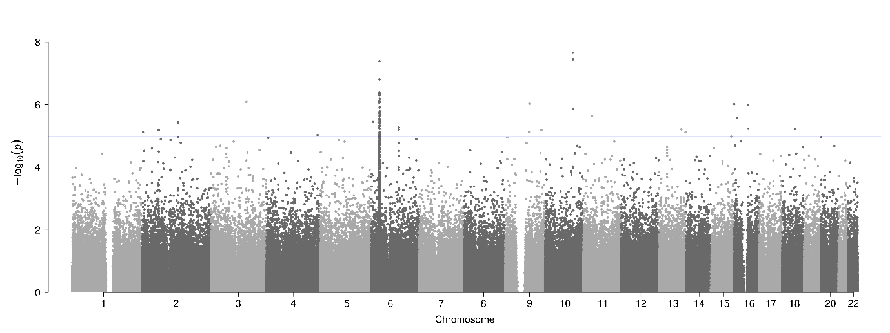
Supplementary Figure 1. Manhattan plot generated using PLINK of genome-wide p-values of association for the Analysis 1 Discovery dataset comprised of 3,405 cases from DecodeME Batch 1 (Cohort F), 38,903 controls for UKB (Cohort B) and 408,873 SNPs. The horizontal blue and red lines represent the genome-wide significance values of p < 1x10⁻⁵ and p < 5x10⁻⁸ respectively.
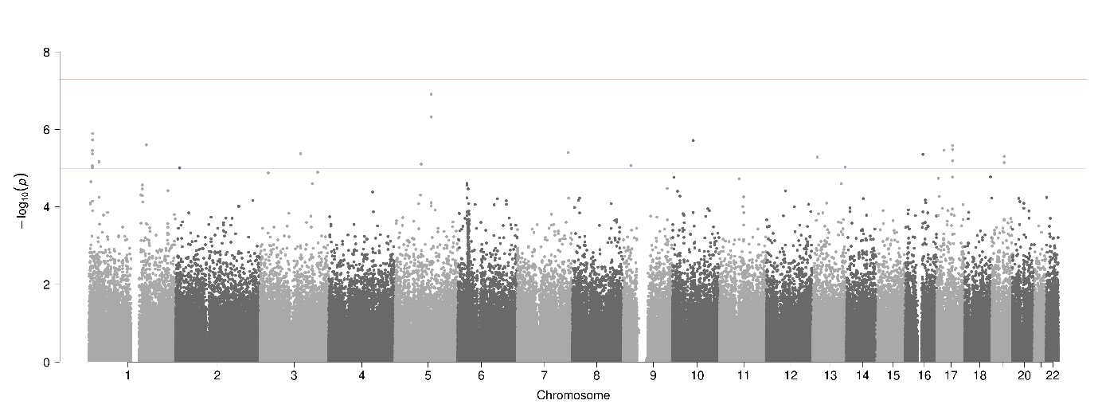
Supplementary Figure 2. Manhattan plot generated using PLINK of genome-wide p-values of association for the Analysis 1 Refinement dataset comprised of 3,585 cases from DecodeME Batches 2+3 (Cohort G), 107,409 UKB controls (Cohort C) and 349,734 SNPs. The horizontal blue and red lines represent the genome-wide significance values of p < 1x10⁻⁵ and p < 5x10⁻⁸ respectively.
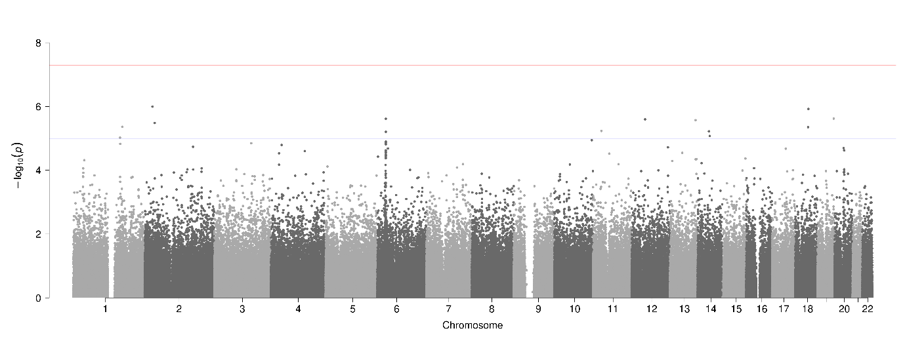
Supplementary Figure 3. Manhattan plot generated using PLINK of genome-wide p-values of association for the Test dataset comprised of 3,579 cases from DecodeME Batches 2+3 (Cohort H), 107,619 UKB controls (Cohort D) and 350,014 SNPs. The horizontal blue and red lines represent the genome-wide significance values of p < 1x10⁻⁵ and p < 5x10⁻⁸ respectively.
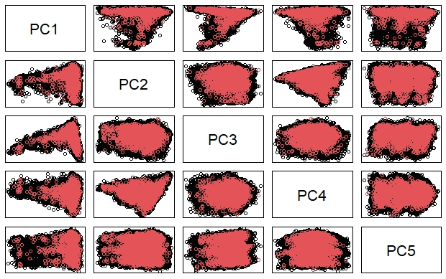
Supplementary Figure 4. Pair plot for top 5 genetic principal components in the study Test Dataset. Red points are ME cases from DecodeME. Black points are controls from UKB.
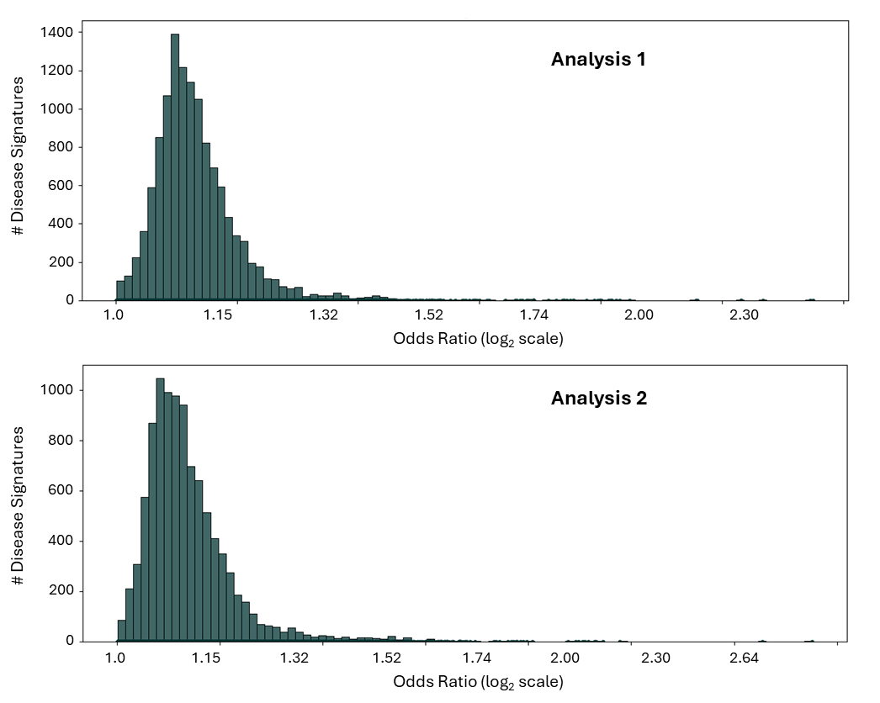
Supplementary Figure 5. Distribution of odds ratios of double-refined signatures. a) Odds ratios of double-refined signatures from Analysis 1 in Analysis 1 DecodeME Refinement dataset (Cohort C+G). b) Odds ratios of double-refined signatures from Analysis 2 in Analysis 2 DecodeME Refinement dataset (Cohort C+F).

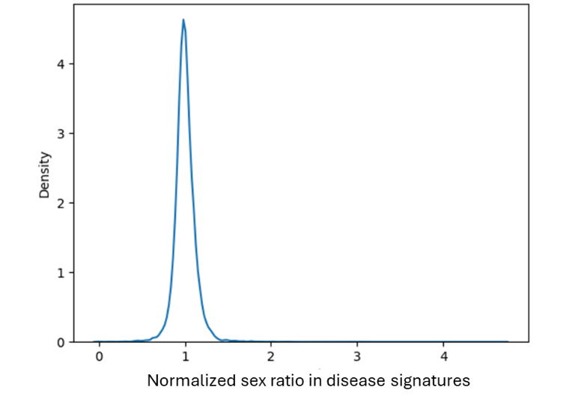
Supplementary Figure 6. Density plot of the sex ratio (#males : #females) for each disease signature normalized by the total male and female counts across 20,496 disease signatures. Ratio=1 indicates that the signature occurs at equal frequencies in both sexes.

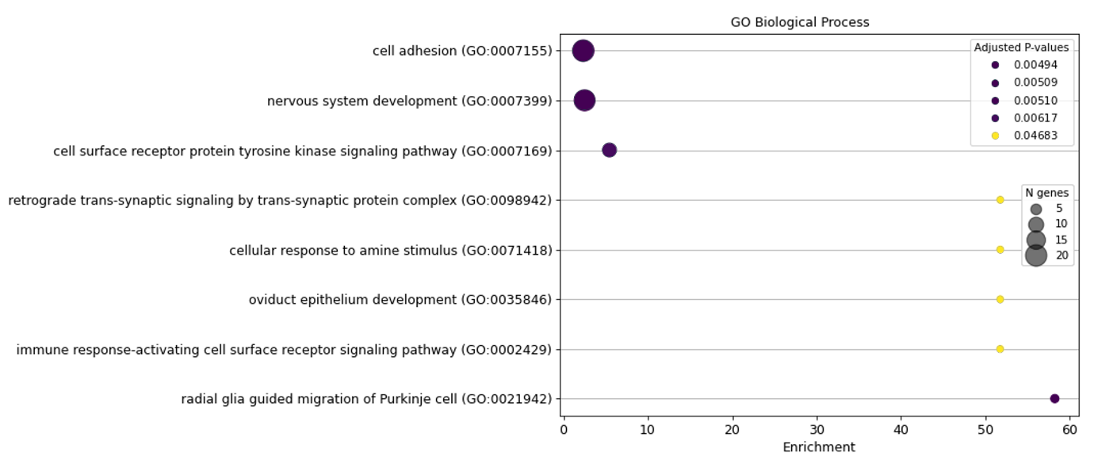
(a)
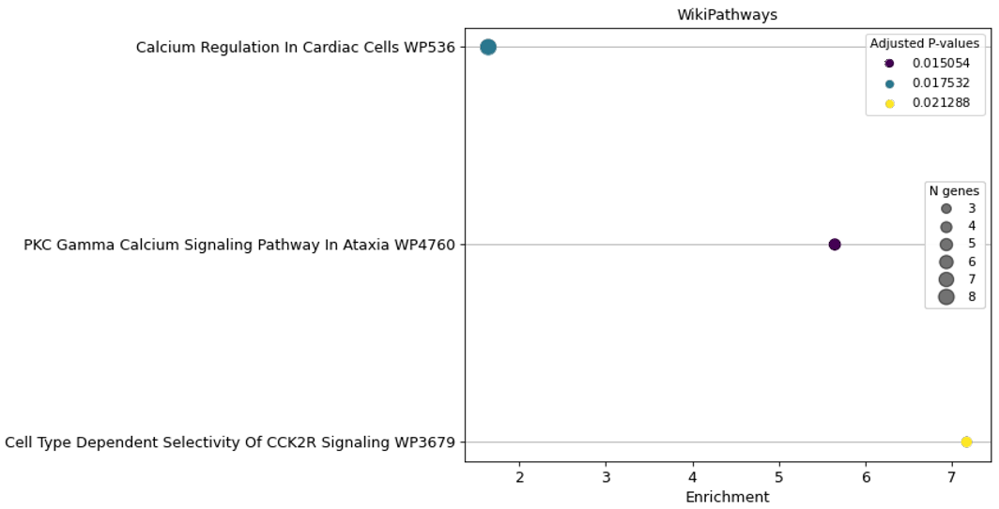
(b)
Supplementary Figure 7. Dotplots showing significant gene set enrichment results for biological processes using (a) Gene Ontology and (b) WikiPathways for 259 candidate core genes mapped to disease signatures identified in this study. Each dot in the plot represents an enriched gene set representing a biological process or pathway. The y-axis lists pathway names, and the x-axis indicates the enrichment score, reflecting the strength of over-representation of the gene set in the input list. Dot size corresponds to the number of genes associated with each gene set and the dot color denotes the adjusted p-value, with darker colors indicating higher statistical significance.
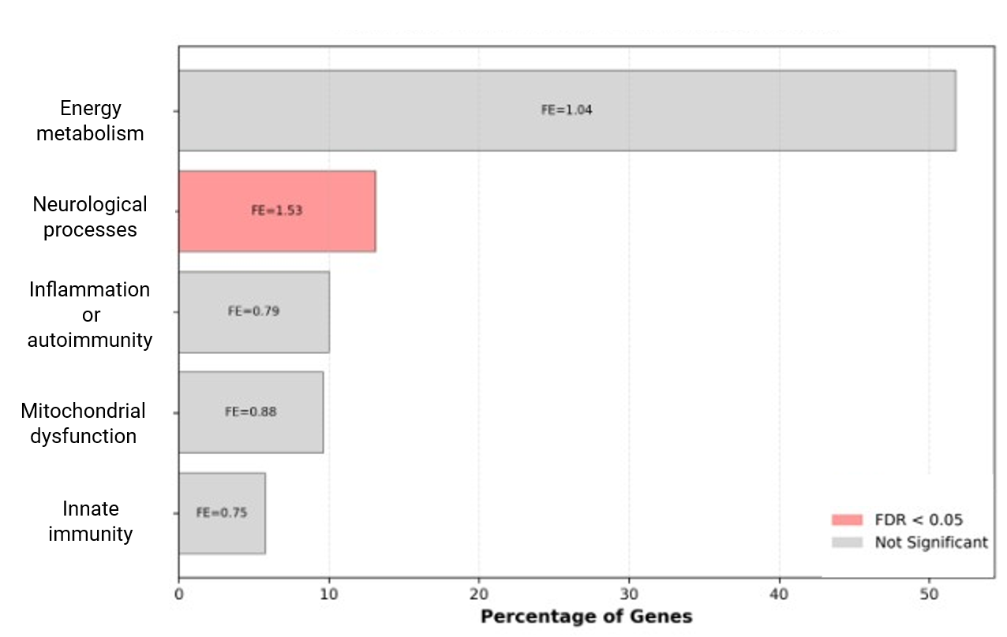
Supplementary Figure 8. Functional characterization of candidate core genes identified in this study. The horizontal bar plot shows the percentage of candidate core genes (n=259) assigned to different functional groups implicated in prior ME/CFS studies. Fold enrichment (FE) and p values for the functional groups were calculated using hypergeometric test in comparison with a background gene set of protein-coding genes.
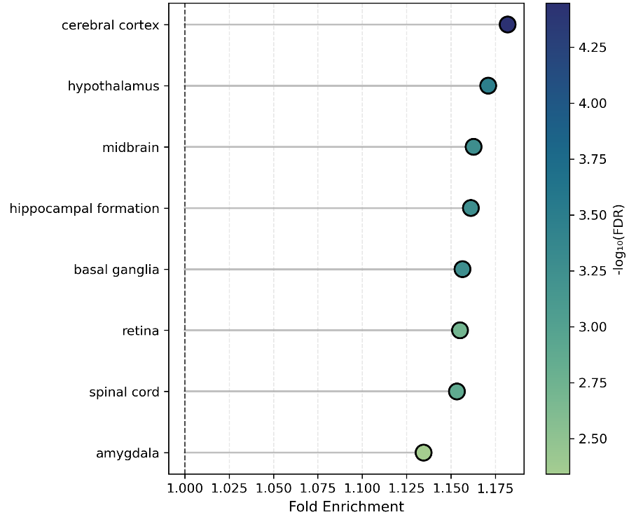
Supplementary Figure 9. Lollipop plot showing fold enrichment for the 8 significantly enriched tissues among the candidate core genes. Enrichment analysis was performed using consensus gene transcript expression levels from Human Protein Atlas and GTEx using hypergeometric test with Benjamini-Hochberg FDR correction.

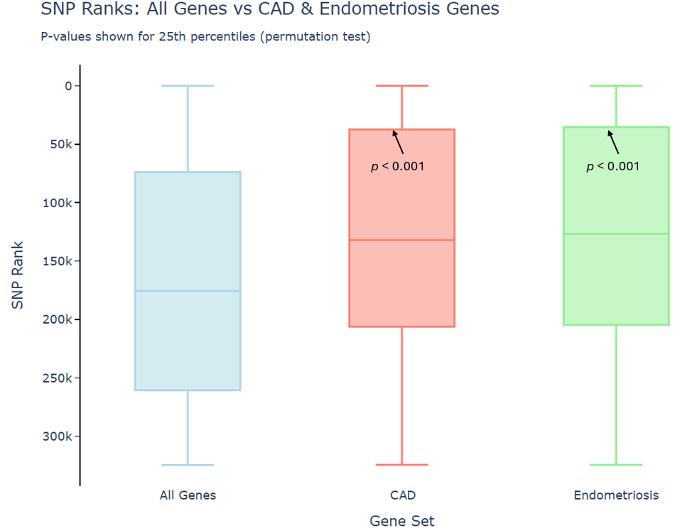
Supplementary Figure 10. SNP ranks in the ML model for ME for all SNPs assigned to autosomal protein-coding genes (left) and SNPs assigned to genes associated with coronary artery disease (CAD) and endometriosis in UKB. Higher SNP ranks (i.e. higher positions on the y-axis) denote high feature importance in the ML model. Boxes represent the top 25th and bottom 25th percentile ranks for SNPs assigned to each gene set with solid line denoting median SNP rank. p-values are the probability of randomly observing a top 25th percentile SNP rank that high based on 10,000 gene subsets of equivalent size randomly sampled from the full list of autosomal protein-coding genes.

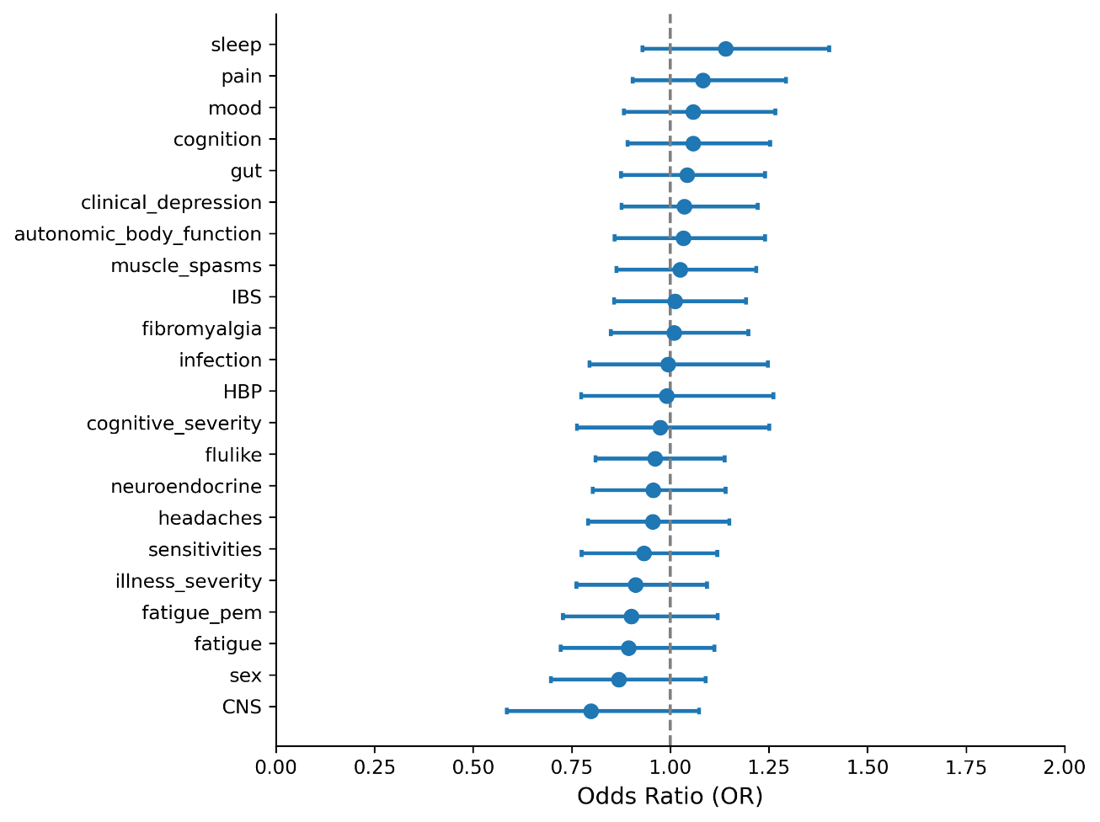
Supplementary Figure 11. Forest plot showing odds ratios (ORs) of TLR3 gene-associated signatures with 22 comorbidity phenotypes (coded as 0 when absent and 1 when active or not active). Detailed definitions of these phenotypes are listed in Extended Table 9. Points indicate ORs, horizontal lines denote 95% confidence intervals lower than 0.5 and the dashed vertical line denotes OR=1. None of the phenotype associations were significant.

Supplementary Tables

Supplementary Table 1. Number of female and male cases in DecodeME cohorts used in this study, broken down by batch.
ME Cohort | # Total cases | # Female Cases (%) | # Male Cases (%)
DecodeME Batch 1  (Cohort F) | 3405 | 2767 (81.3%) | 638 (18.7%)
DecodeME Batch 2 total | 4349 | 3685 (84.7%) | 664 (15.8%)
DecodeME Batch 3 total | 4238 | 3595 (84.8%) | 643 (15.2%)
DecodeME Batch 2+3 Split 1  (Cohort G) | 3585 | 3032 (84.6%) | 553 (15.4%)
DecodeME Batch 2+3 Split 2 (Test)  (Cohort H) | 3579 | 3031 (84.7%) | 548 (15.3%)

Supplementary Table 2. UK Biobank control selection criteria for the study.
Data Type | ICD-10 / UKB Data Field ID | Description
HES / primary care | G93.3 | Postviral fatigue syndrome
HES / primary care | R53.x | Malaise and fatigue
HES / primary care | G47.x | Sleep disorders
HES / primary care | M79.7 | Fibromyalgia
Self-reported | 20002 | Chronic fatigue syndrome
Self-reported | 120009 | Ever had fibromyalgia syndrome?
Self-reported | 120010 | Ever had Chronic Fatigue Syndrome or Myalgic Encephalitis?
Self-reported | 120040 | Fatigue severity over the past week = severe/moderate
Self-reported | 120114 | Persistent or recurrent tiredness, weariness, or fatigue > 6 months
Self-reported | 120120 | Exercise brings on fatigue
Self-reported | 120122 | Fatigue interferes with physical functioning
Self-reported | 120123 | Fatigue causes frequent problems
Self-reported | 120124 | Fatigue prevents sustained physical functioning
Self-reported | 120125 | Fatigue interferes with carrying out certain duties or responsibilities
Self-reported | 120126 | Fatigue is among three most disabling symptoms
Self-reported | 120127 | Fatigue interferes with work, family or social life
Primary care | Xa01F | Chronic fatigue syndrome Myalgic encephalomyelitis ME Myalgic encephalomyelitis Myalgic encephalomyelitis syndrome Postviral fatigue syndrome PVFS - Postviral fatigue syndrome CFS
Primary care | F286. | Chronic fatigue syndrome Myalgic encephalomyelitis Myalgic encephalomyelitis ME - Myalgic encephalomyelitis Myalgic encephalomyelitis syndrome Postviral fatigue syndrome PVFS - Postviral fatigue syndrome PVFS - Postviral fatigue syndrome CFS - Chronic fatigue syndrome
Primary care | F2860 | Mild chronic fatigue syndrome
Primary care | F2861 | Moderate chronic fatigue syndrome
Primary care | F2862 | Severe chronic fatigue syndrome
Primary care | XaPom | Mild chronic fatigue syndrome
Primary care | XaPon | Moderate chronic fatigue syndrome
Primary care | XaPoo | Severe chronic fatigue syndrome
Primary care | XaPeC | Activity management for chronic fatigue syndrome Activity management for myalgic encephalopathy
Primary care | 8Q1.. | Activity management for chronic fatigue syndrome Activity management for myalgic encephalopathy
Primary care | XaR7C | Referral to chronic fatigue syndrome specialist team Referral to myalgic encephalomyelitis specialist team
Primary care | XaRAz | Referral for chronic fatigue syndrome activity management Referral for myalgic encephalopathy activity management
Primary care | 8HkW. | Referral to chronic fatigue syndrome specialist team Referral to myalgic encephalomyelitis specialist team

Supplementary Table 3. Table showing the number of significant SNP networks and core genes count at different case prevalence thresholds. In this study, a case prevalence threshold of 20% was selected for biological interpretation and pathway enrichment analysis.
Case Prevalence Threshold (%) | No. of significant SNP networks | Core gene count
> 10% | 1694 | 330
> 20% | 1352 | 259
> 30% | 1050 | 148
> 40% | 745 | 50

Supplementary Table 4. Public data sources used for annotating SNPs and genes in the PrecisionLife platform.
Annotation Type | Data Sources
Genomic Context | Ensembl¹, Entrez², gnomAD³, HaploReg⁴
Encoded Protein Structure and Function | Uniprot⁵, InterPro⁶, PDBe-KB⁷
SNP-Disease or Trait Association | dbSNP⁸, GWAS Catalog⁹, PharmGKB¹⁰, Open Targets¹¹
Gene-Disease or Trait Association | Open Targets¹¹, PHAROS¹², Mouse Genome Informatics¹³, Human Phenotype Ontology¹⁴, OMIM¹⁵
Gene Tissue/Cell Expression | Human Protein Atlas¹⁶, GTEx¹⁷, Expression Atlas¹⁸
Pathways or MoA | Gene Ontology¹⁹, Reactome²⁰, WikiPathways²¹
Drugs and Chemical Compounds | Global Data²², ChEMBL²³, DrugBank²⁴, PubChem²⁵

Supplementary Table 5. Case/control criteria used to identify UKB cohort for combinatorial analysis of coronary artery disease.
CAD Case Inclusion Criteria
- Individuals who were between 40-69 years at the time of UKB recruitment (Datafield 21022)
- CAD diagnosis must satisfy any one of the following:
- Individuals with any of the following codes:
  - ICD-10 codes in Hospital Episode Statistics (HES, Datafield 41270)
    - I21 (acute myocardial infarction)
    - I22 (subsequent myocardial infarction)
    - I23 (certain current complications following acute myocardial infarction)
    - I24.1 (Dressler's syndrome)
    - I25.2 (old myocardial infarction)
  - OPCS4 codes in Operative procedures (Datafield 41272)
    - K40.* (Saphenous vein graft replacement of coronary artery)
    - K41.* (Other autograft replacement of coronary artery)
    - K45.* (Connection of thoracic artery to coronary artery)
    - K49.1 (Percutaneous transluminal balloon angioplasty of one coronary artery)
    - K49.2 (Percutaneous transluminal balloon angioplasty of multiple coronary artery)
    - K49.8 (Other specified transluminal balloon angioplasty of coronary artery)
    - K49.9 (Unspecified transluminal balloon angioplasty of coronary artery)
    - K50.2 (Percutaneous transluminal coronary thrombolysis using streptokinase)
    - K75.* (Percutaneous transluminal balloon angioplasty and insertion of stent into coronary artery)
  - Self-reported codes
    - 1075 (heart attack/myocardial infarction) in Non-cancer illness code (Datafield 20002)
    - Self-report of heart attack or myocardial infarction in Vascular/heart problems diagnosed by doctor (Datafield 6150)
  - Self-reported Operation codes (Datafield 20004)
    - 1070 (coronary angioplasty (ptca) +/- stent)
    - 1095 (coronary artery bypass grafts (cabg))

CAD Controls Inclusion / Exclusion Criteria
Inclusion criteria:
- Gender-matched, oldest possible individuals
- Individuals who were between 40-69 years at the time of UKB recruitment (Datafield 21022)
- European genetic ancestry

Exclusion criteria:
- Remove individuals that meet any of the above criteria for case diagnosis
- Remove individuals with family history of heart disease reported in:
  - Illnesses of mother (Datafield 20110)
  - Illnesses of father (Datafield 20107)
  - Illnesses of siblings (Datafield 20111)

Supplementary Table 6. Number of signatures and component SNPs from the initial DecodeME combinatorial analyses, after Refinement in a UKB cohort, and after further Refinement in an independent DecodeME cohort. Core genes were selected based on association with ME and case prevalence in a DecodeME Refinement dataset.
Analysis | # Initial signatures  (# SNPs) | # UKB-refined signatures  (# SNPs) | # Double-refined signatures  (# SNPs) | # Genes mapping to double-refined signatures
Analysis 1 | 150,683  (4,209) | 43,816  (3,679) | 12,463  (2,915) | 1,001
Analysis 2 | 95,916  (8,101) | 31,612  (7,229) | 9,963  (5,008) | 1,647
Combined Results | -- | -- | 22,411  (7,555) | 2,311

Supplementary Table 7. Number of SNPs in combinatorial disease signatures identified in this study.
No. of SNPs in Combination | No. of Double-Refined  Signatures
1 | 610
2 | 13,117
3 | 7,223
4 | 1,461
Total | 22,411

Supplementary Table 8. Gene overlap (n=14) between disease signatures identified in this study and DecodeME 2025 study²⁶ (including both Tier 1, Tier 2 and the gene linked to chronic pain). Five Tier 1 lead genes that map to the 8 GWAS significant loci reported by DecodeME are shown in bold. All genomic positions in the table are in GRCh37.
Gene | DecodeME Association | Locus | Disease signature count for SNP
BTN2A2 | GWAS-1- Tier 1 lead | 6p22.2 | 33
CA10 | GWAS-1- Tier 1 lead | 17q22 | 1
CA10 | GWAS-1- Tier 1 lead | chr17q22 | 2
CA10 | GWAS-1- Tier 1 lead | chr17q22 | 1
CSE1L | GWAS-1 Tier 1 lead | chr20q13.13 | 160
OLFM4 | GWAS-Infection- Tier 1 lead | 13q14.3 | 7
SUDS3 | GWAS-2- Tier 1 lead | chr17q24.23 | 116
ABT1 | GWAS-1 - Tier 1 other | 6p22.2 | 44
DARS2 | GWAS-1 – Tier 1 other | chr1q25.1 | 14
DCC | Other - chronic pain | 18q21.2 | 10
DCC | Other - chronic pain | 18q21.2 | 30
DCC | Other - chronic pain | 18q21.2 | 132
DCC | Other - chronic pain | 18q21.2 | 55
DCC | Other - chronic pain | 18q21.2 | 55
DCC | Other - chronic pain | chr18q21.2 | 2
DCC | Other - chronic pain | chr18q21.2 | 1
DCC | Other - chronic pain | chr18q21.2 | 1
DCC | Other - chronic pain | chr18q21.2 | 1
DDX27 | GWAS-1 Tier 1 other | chr20q13.13 | 67
HFE | GWAS-1 - Tier 1 other | chr6p22.2 | 3
TRIM38 | GWAS-1 - Tier 1 other | chr6p22.2 | 2
TRIM38 | GWAS-1 - Tier 1 other | chr6p22.2 | 5
VSIG10 | GWAS-2- Tier 1 other | chr12q24.23 | 6
ZNFX1 | GWAS-1 Tier 1 other | chr20q13.13 | 67
ZNF322 | GWAS-1 - Tier 1 other | chr6p22.2 | 4
ZNF322 | GWAS-1 - Tier 1 other | chr6p22.2 | 6

Supplementary Table 9. List of 102 genes identified in double-refined signatures for ME and previous Sano GOLD long COVID study (Severe, Fatigue Dominant or General sub cohort analyses). 76 of these genes were reproduced in the All of Us long COVID cohort^{,28}.
Gene | Long COVID cohort  in Sano Genetics GOLD study | Reproduced in All of Us  long COVID cohort
ADAM12 | General | Yes
ADAMTS9 | General | Yes
ADGRL2 | General | Yes
ANKS1B | General | Yes
ANO4 | General | Yes
ASIC2 | General | Yes
CACNA2D3 | General | Yes
CACNB2 | General | Yes
CAMTA1 | General | Yes
CDH12 | General | Yes
CDH13 | General | Yes
CDK14 | Fatigue Dominant | Yes
CGNL1 | General | Yes
CLCN6 | Severe | Yes
CPVL | General | Yes
CREB5 | General | Yes
CSGALNACT1 | General | Yes
CSMD2 | General | Yes
DENND1A | General | Yes
DISC1 | General | Yes
DPP6 | General | Yes
ERBB4 | General | Yes
EYA1 | General | Yes
F13A1 | General | Yes
FGF12 | General | Yes
GABBR2 | General | Yes
GUCY1A2 | Severe, Fatigue Dominant | Yes
HMGCLL1 | General | Yes
HPN | Fatigue Dominant | Yes
JAKMIP2 | Fatigue Dominant, General | Yes
KCNMA1 | General | Yes
KIF26B | General | Yes
KRT86 | General | Yes
MAPK9 | Fatigue Dominant | Yes
MSR1 | General | Yes
MTMR7 | General | Yes
MYO3B | Severe | Yes
NELL1 | General | Yes
OPCML | General | Yes
PACRG | General | Yes
PCDH9 | Severe | Yes
PDZD2 | General | Yes
POR | Fatigue Dominant | Yes
PPP1R16B | Severe | Yes
PRODH | Severe | Yes
RBFOX1 | Severe | Yes
RIMS2 | General | Yes
RRBP1 | Fatigue Dominant | Yes
RYR2 | General | Yes
RYR3 | General | Yes
SCUBE1 | General | Yes
SEL1L | General | Yes
SLC25A21 | General | Yes
SLC38A4 | General | Yes
SMARCA2 | General | Yes
SNTG1 | General | Yes
SNX31 | General | Yes
SORCS2 | Severe | Yes
SOX5 | Severe | Yes
ST8SIA1 | General | Yes
SUCLA2 | General | Yes
SYN3 | Fatigue Dominant | Yes
TACR1 | General | Yes
TBXAS1 | General | Yes
TENM3 | Severe | Yes
TNIK | Fatigue Dominant | Yes
TRIM9 | General | Yes
TRPM3 | General | Yes
TSPAN5 | General | Yes
TTC39C | General | Yes
USH2A | General | Yes
USP30 | General | Yes
XKR3 | General | Yes
ZNF385D | General | Yes
ZNF577 | General | Yes
ZNF71 | General | Yes
ADAM28 | General
ADIPOQ | Severe
CCDC149 | Severe
CNTN4 | Fatigue Dominant
COL27A1 | General
DLC1 | Severe
DSCAML1 | Severe
FAM53B | General
KLF12 | Fatigue Dominant
MAML2 | General
NAV3 | General
NLGN1 | Fatigue Dominant
PCSK2 | Severe, Fatigue Dominant
PITPNC1 | Fatigue Dominant
PLXNA2 | Fatigue Dominant
PRKG1 | General
PSMB9 | General
PTPRD | Fatigue Dominant
RADIL | General
SPTBN5 | Fatigue Dominant
SYNPR | General
TAP1 | General
TIAM2 | General
TNS1 | Fatigue Dominant
WWOX | Fatigue Dominant
ZMIZ1 | Severe

Supplementary Table 10. Results of length-matched permutation test used to assess enrichment of long COVID genes across three gene length bins for 2311 genes mapping to double-refined ME signatures. Enrichment in all gene length bins is significant (p < 0.017) after Bonferroni multiple-testing correction (shown in bold).
Gene length bins (kb) | Background gene count | ME  gene count  (n=2311) | Overlap of long COVID genes (n=102) | Mean expected overlap across 10,000 random permutations | p value
<= 50 | 13723 | 692 | 10 | 2.20 | 0.0002
50 - 250 | 5579 | 1061 | 33 | 18.23 | 0.0004
> 250 | 1034 | 558 | 59 | 43.21 | 0.0003

Supplementary Table 11. Overlap between genes associated with long COVID and the 97 ‘top-ranked’ genes from a machine learning model for ME (i.e., genes that map to the top 20 ranked SNPs in at least one fold).
Long COVID phenotype | # of Long COVID genes | # Genes overlapping with ML model for ME | p-value for enrichment | Overlapping genes
Fatigue-Dominant | 34 | 3 | 0.001 | MAPK9, NLGN1, PTPRD
Severe | 38 | 1 | 0.18 | GPC6
General | 153 | 2 | 0.19 | MYOCD, OPCML

Supplementary Table 12. Overlap of candidate core genes between different functional groups implicated in prior ME/CFS studies.
Mechanism of Action (MoA) | Inflammation & autoimmunity | Innate immunity | Mitochondrial dysfunction | Neurological processes
Energy metabolism | 19 | 13 | 18 | 18
Inflammation & autoimmunity |  | 10 | 3 | 4
Innate immunity |  |  | 3 | 3
Mitochondrial dysfunction |  |  |  | 2

References for Supplementary Tables
- Martin FJ, Amode MR, Aneja A, et al. Ensembl 2023. Nucleic Acids Res. 2023 Jan 6;51(D1):D933-D941. doi: 10.1093/nar/gkac958.
- Brown, G.R., Hem, V., Katz, K.S., Ovetsky, M., Wallin, C., Ermolaeva, O., Tolstoy, I., Tatusova, T., Pruitt, K.D., Maglott, D.R. and Murphy, T.D., 2015. Gene: a gene-centered information resource at NCBI. Nucleic Acids Research, 43(D1), pp.D36-D42.
- Gudmundsson, S., Singer‐Berk, M., Watts, N.A., Phu, W., Goodrich, J.K., Solomonson, M., Genome Aggregation Database Consortium, Rehm, H.L., MacArthur, D.G. and O'Donnell‐Luria, A., 2022. Variant interpretation using population databases: Lessons from gnomAD. Human Mutation, 43(8), pp.1012-1030.
- Ward, L.D. and Kellis, M., 2016. HaploReg v4: systematic mining of putative causal variants, cell types, regulators and target genes for human complex traits and disease. Nucleic Acids Research, 44(D1), pp.D877-D881.
- UniProt Consortium, 2019. UniProt: a worldwide hub of protein knowledge. Nucleic Acids Research, 47(D1), pp.D506-D515.
- Paysan-Lafosse, T., Blum, M., Chuguransky, S., Grego, T., Pinto, B.L., Salazar, G.A., Bileschi, M.L., Bork, P., Bridge, A., Colwell, L. and Gough, J., 2023. InterPro in 2022. Nucleic Acids Research, 51(D1), pp.D418-D427.
- PDBe-KB consortium. PDBe-KB: a community-driven resource for structural and functional annotations. Nucleic Acids Res. 2020 Jan 8;48(D1):D344-D353. doi: 10.1093/nar/gkz853.
- Bhagwat, M., 2010. Searching NCBI's dbSNP database. Current Protocols in Bioinformatics, 32(1), pp.1-19.
- Buniello, A., MacArthur, J.A.L., Cerezo, M., Harris, L.W., Hayhurst, J., Malangone, C., McMahon, A., Morales, J., Mountjoy, E., Sollis, E. and Suveges, D., 2019. The NHGRI-EBI GWAS Catalog of published genome-wide association studies, targeted arrays and summary statistics 2019. Nucleic Acids Research, 47(D1), pp.D1005-D1012.
- Barbarino, J.M., Whirl‐Carrillo, M., Altman, R.B. and Klein, T.E., 2018. PharmGKB: a worldwide resource for pharmacogenomic information. Wiley Interdisciplinary Reviews: Systems Biology and Medicine, 10(4), p.e1417.
- Ochoa, D., Hercules, A., Carmona, M., Suveges, D., Gonzalez-Uriarte, A., Malangone, C., Miranda, A., Fumis, L., Carvalho-Silva, D., Spitzer, M. and Baker, J., 2021. Open Targets Platform: supporting systematic drug–target identification and prioritisation. Nucleic Acids Research, 49(D1), pp.D1302-D1310.
- Kelleher, K.J., Sheils, T.K., Mathias, S.L., Yang, J.J., Metzger, V.T., Siramshetty, V.B., Nguyen, D.T., Jensen, L.J., Vidović, D., Schürer, S.C. and Holmes, J., 2023. Pharos 2023: an integrated resource for the understudied human proteome. Nucleic acids research, 51(D1), pp.D1405-D1416.
- Eppig, J.T., Smith, C.L., Blake, J.A., Ringwald, M., Kadin, J.A., Richardson, J.E. and Bult, C.J., 2017. Mouse Genome Informatics (MGI): resources for mining mouse genetic, genomic, and biological data in support of primary and translational research. Systems Genetics: Methods and Protocols, pp.47-73.
- Köhler, S., Gargano, M., Matentzoglu, N., Carmody, L.C., Lewis-Smith, D., Vasilevsky, N.A., Danis, D., Balagura, G., Baynam, G., Brower, A.M. and Callahan, T.J., 2021. The human phenotype ontology in 2021. Nucleic Acids Research, 49(D1), pp.D1207-D1217.
- Amberger, J.S., Bocchini, C.A., Schiettecatte, F., Scott, A.F. and Hamosh, A., 2015. OMIM. org: Online Mendelian Inheritance in Man (OMIM®), an online catalog of human genes and genetic disorders. Nucleic Acids Research, 43(D1), pp.D789-D798.
- Digre, A. and Lindskog, C., 2021. The human protein atlas—spatial localization of the human proteome in health and disease. Protein Science, 30(1), pp.218-233.
- GTEx Consortium, 2020. The GTEx Consortium atlas of genetic regulatory effects across human tissues. Science, 369(6509), pp.1318-1330.
- Papatheodorou, I., Fonseca, N.A., Keays, M., Tang, Y.A., Barrera, E., Bazant, W., Burke, M., Füllgrabe, A., Fuentes, A.M.P., George, N. and Huerta, L., 2018. Expression Atlas: gene and protein expression across multiple studies and organisms. Nucleic Acids Research, 46(D1), pp.D246-D251.
- Huntley, R.P., Sawford, T., Mutowo-Meullenet, P., Shypitsyna, A., Bonilla, C., Martin, M.J. and O'Donovan, C., 2015. The GOA database: gene ontology annotation updates for 2015. Nucleic Acids Research, 43(D1), pp.D1057-D1063.
- Jassal, B., Matthews, L., Viteri, G., Gong, C., Lorente, P., Fabregat, A., Sidiropoulos, K., Cook, J., Gillespie, M., Haw, R. and Loney, F., 2020. The Reactome pathway knowledgebase. Nucleic Acids Research, 48(D1), pp.D498-D503.
- Martens, M., Ammar, A., Riutta, A., Waagmeester, A., Slenter, D.N., Hanspers, K., A. Miller, R., Digles, D., Lopes, E.N., Ehrhart, F. and Dupuis, L.J., 2021. WikiPathways: connecting communities. Nucleic Acids Research, 49(D1), pp.D613-D621.
- GlobalData Pharma Market Data and Insights available from https://www.globaldata.com/industries-we-cover/pharmaceutical/ Accessed 6 Sep 2025.
- Gaulton, A., Bellis, L.J., Bento, A.P., Chambers, J., Davies, M., Hersey, A., Light, Y., McGlinchey, S., Michalovich, D., Al-Lazikani, B. and Overington, J.P., 2012. ChEMBL: a large-scale bioactivity database for drug discovery. Nucleic Acids Research, 40(D1), pp.D1100-D1107.
- Wishart, D.S., Feunang, Y.D., Guo, A.C., Lo, E.J., Marcu, A., Grant, J.R., Sajed, T., Johnson, D., Li, C., Sayeeda, Z. and Assempour, N., 2018. DrugBank 5.0: a major update to the DrugBank database for 2018. Nucleic Acids Research, 46(D1), pp.D1074-D1082.
- Kim, S., Thiessen, P.A., Cheng, T., Yu, B., Shoemaker, B.A., Wang, J., Bolton, E.E., Wang, Y. and Bryant, S.H., 2016. Literature information in PubChem: associations between PubChem records and scientific articles. Journal of Cheminformatics, 8, pp.1-15.
- Genetics Delivery Team, Boutin, T., Bretherick, A.D., Dibble, J.J., Ewaoluwagbemiga, E., Northwood, E., Samms, G.L., Vitart, V., Project and Cohort Delivery Team, Almelid, Ø. and Baker, T., 2025. Initial findings from the DecodeME genome-wide association study of myalgic encephalomyelitis/chronic fatigue syndrome. medRxiv, pp.2025-08.
- Taylor, K., Pearson, M., Das, S., Sardell, J., Chocian, K. and Gardner, S., 2023. Genetic risk factors for severe and fatigue dominant long COVID and commonalities with ME/CFS identified by combinatorial analysis. Journal of translational medicine, 21(1), p.775.
- Sardell, J., Pearson, M., Chocian, K., Das, S., Taylor, K., Strivens, M., Gupta, R., Rochlin, A. and Gardner, S., 2025. Reproducibility of genetic risk factors identified for long COVID using combinatorial analysis across US and UK patient cohorts with diverse ancestries. Journal of Translational Medicine, 23(1), p.516.

