Figure 6E.
143B
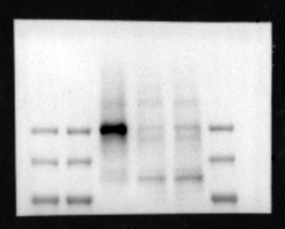
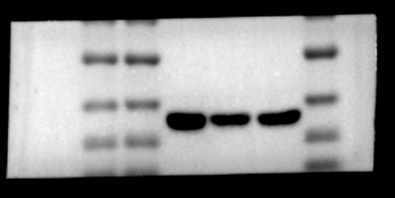

HOS
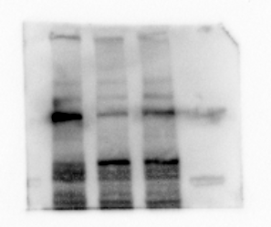
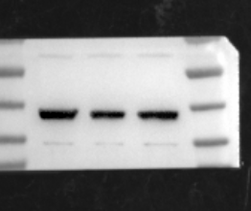

Figure 6H.
143B-0H
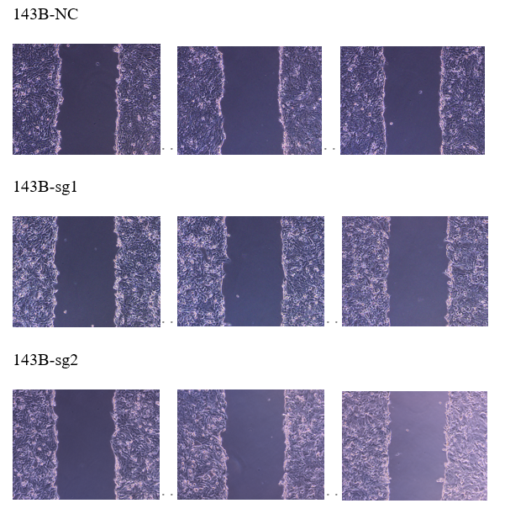
143B-24H
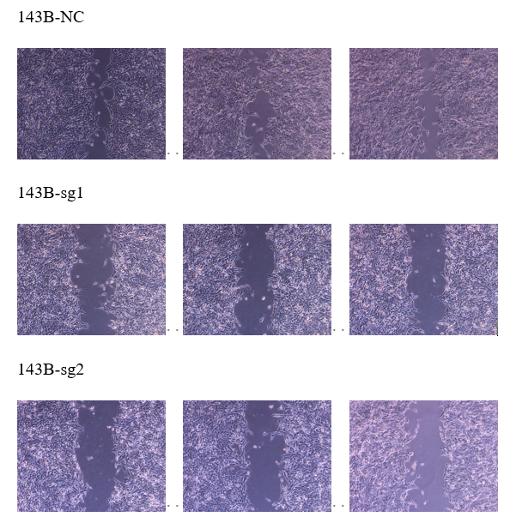

Figure 6K
HOS-0H
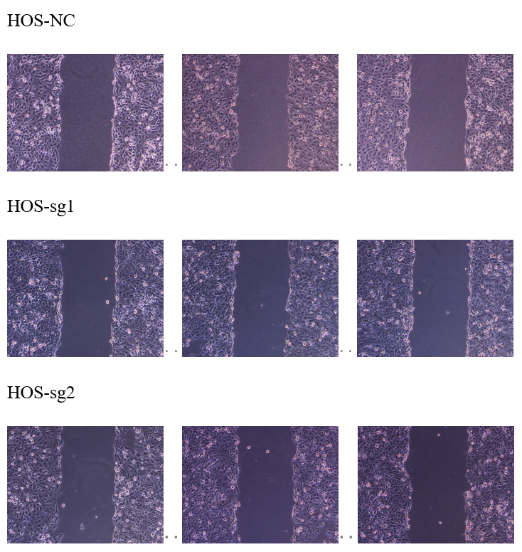
HOS-24H
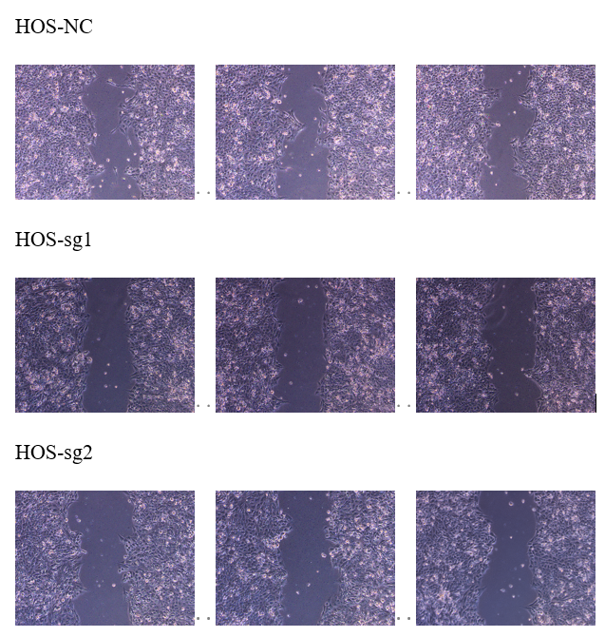

Figure 6M
143B sgNC
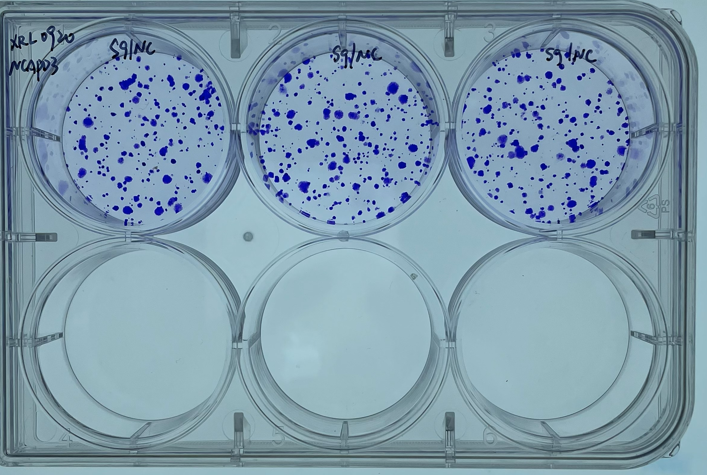
143B sg1 sg2
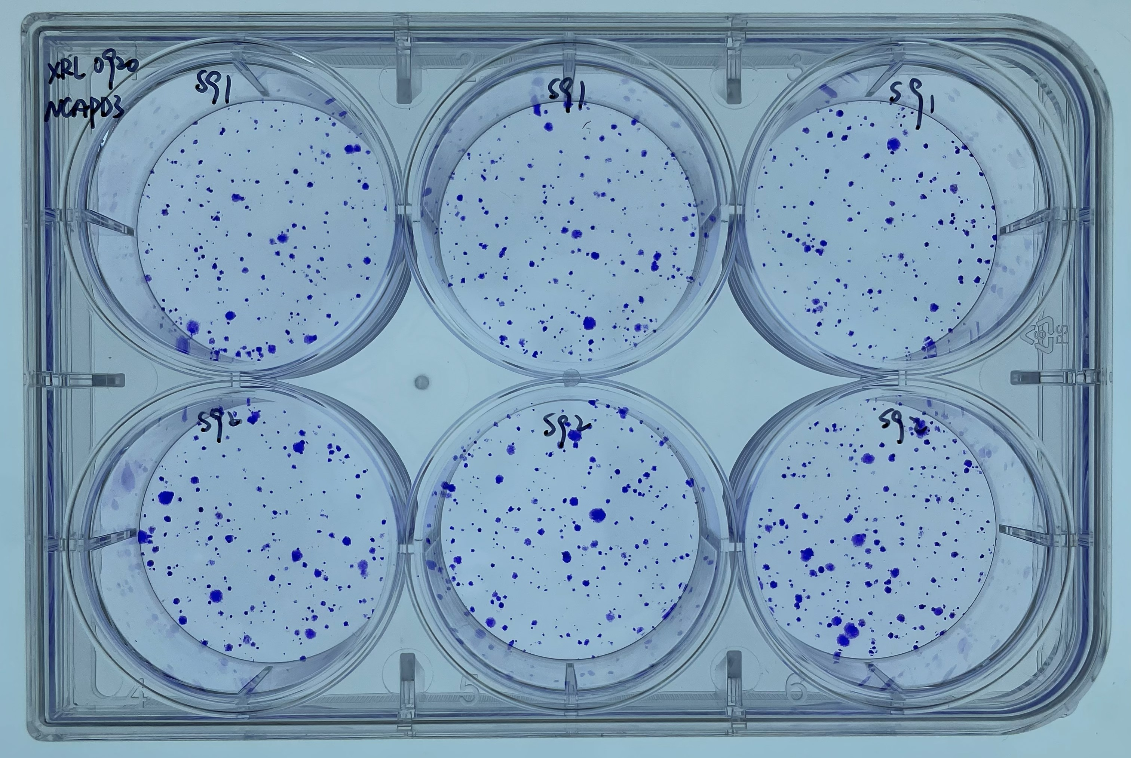
HOS sgNC sg1
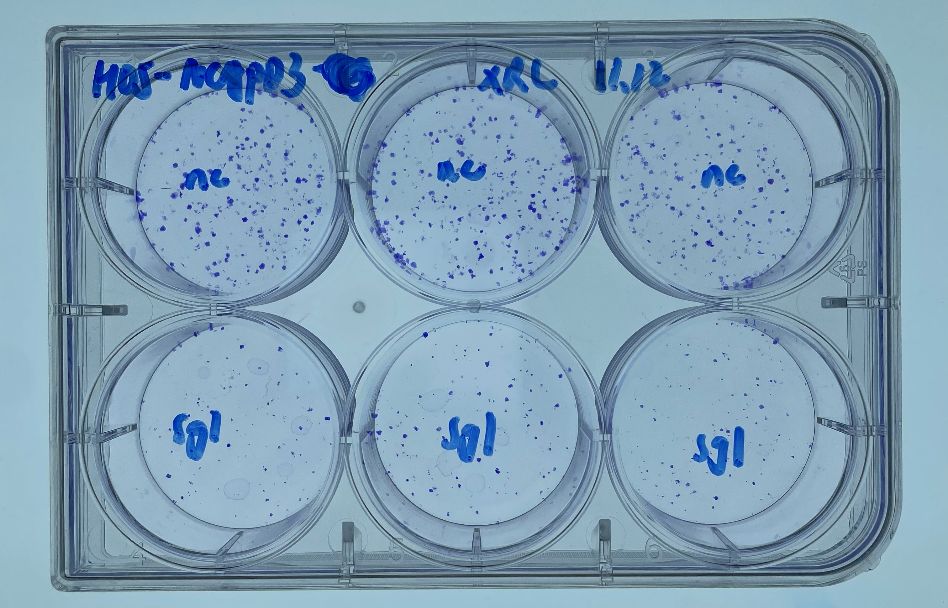
HOS sgNC sg2
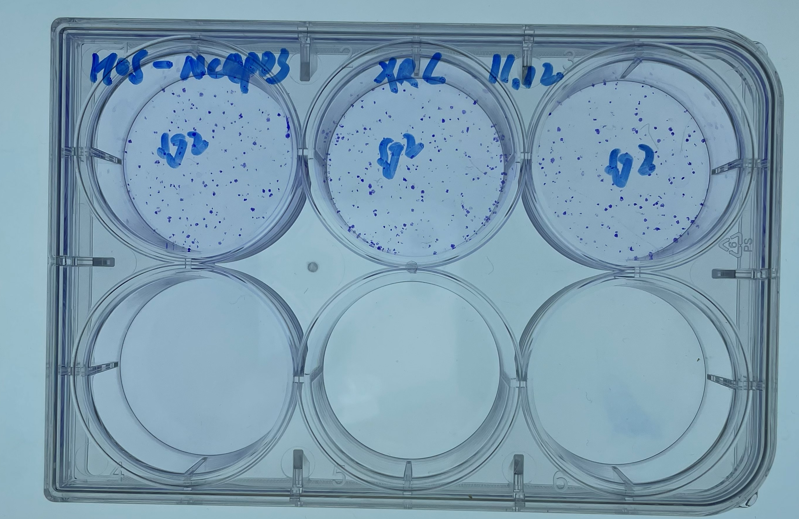

Figure 7A.
siControl | NCAPD3 | 21.790
siControl | NCAPD3 | 21.661
siControl | NCAPD3 | 21.672
siNCAPD3 #1 | NCAPD3 | 21.983
siNCAPD3 #1 | NCAPD3 | 21.847
siNCAPD3 #1 | NCAPD3 | 21.770
siNCAPD3 #2 | NCAPD3 | 22.903
siNCAPD3 #2 | NCAPD3 | 23.243
siNCAPD3 #2 | NCAPD3 | 22.812
siControl | GAPDH | 17.127
siControl | GAPDH | 16.933
siControl | GAPDH | 16.911
siNCAPD3 #1 | GAPDH | 15.671
siNCAPD3 #1 | GAPDH | 15.778
siNCAPD3 #1 | GAPDH | 15.898
siNCAPD3 #2 | GAPDH | 16.054
siNCAPD3 #2 | GAPDH | 15.963
siNCAPD3 #2 | GAPDH | 15.985

Figure 7 B&C.
siControl | GAPDH | 17.225
siControl | GAPDH | 17.279
siControl | GAPDH | 17.229
siNCAPD3 #1 | GAPDH | 17.273
siNCAPD3 #1 | GAPDH | 17.231
siNCAPD3 #1 | GAPDH | 17.176
siNCAPD3 #2 | GAPDH | 16.579
siNCAPD3 #2 | GAPDH | 16.557
siNCAPD3 #2 | GAPDH | 16.712
siControl | cd206 | 31.436
siControl | cd206 | 31.711
siControl | cd206 | 31.161
siNCAPD3 #1 | cd206 | 32.404
siNCAPD3 #1 | cd206 | 32.929
siNCAPD3 #1 | cd206 | 32.755
siNCAPD3 #2 | cd206 | 31.787
siNCAPD3 #2 | cd206 | 31.991
siNCAPD3 #2 | cd206 | 31.583
siControl | tgfb | 22.701
siControl | tgfb | 22.686
siControl | tgfb | 22.660
siNCAPD3 #1 | tgfb | 23.897
siNCAPD3 #1 | tgfb | 24.062
siNCAPD3 #1 | tgfb | 23.931
siNCAPD3 #2 | tgfb | 24.414
siNCAPD3 #2 | tgfb | 24.423
siNCAPD3 #2 | tgfb | 24.463
siControl | il-10 | 29.217
siControl | il-10 | 29.089
siControl | il-10 | 29.039
siNCAPD3 #1 | il-10 | 30.387
siNCAPD3 #1 | il-10 | 30.945
siNCAPD3 #1 | il-10 | 30.723
siNCAPD3 #2 | il-10 | 30.437
siNCAPD3 #2 | il-10 | 30.909
siNCAPD3 #2 | il-10 | 30.640
siControl | tnfa | 23.357
siControl | tnfa | 23.450
siControl | tnfa | 23.405
siNCAPD3 #1 | tnfa | 22.769
siNCAPD3 #1 | tnfa | 22.757
siNCAPD3 #1 | tnfa | 22.744
siNCAPD3 #2 | tnfa | 21.662
siNCAPD3 #2 | tnfa | 21.634
siNCAPD3 #2 | tnfa | 21.808
siControl | cd86 | 27.980
siControl | cd86 | 27.900
siControl | cd86 | 27.979
siNCAPD3 #1 | cd86 | 25.637
siNCAPD3 #1 | cd86 | 25.541
siNCAPD3 #1 | cd86 | 25.445
siNCAPD3 #2 | cd86 | 25.779
siNCAPD3 #2 | cd86 | 25.159
siNCAPD3 #2 | cd86 | 25.178
siControl | cd80 | 26.688
siControl | cd80 | 26.703
siControl | cd80 | 26.695
siNCAPD3 #1 | cd80 | 25.101
siNCAPD3 #1 | cd80 | 24.877
siNCAPD3 #1 | cd80 | 24.881
siNCAPD3 #2 | cd80 | 24.832
siNCAPD3 #2 | cd80 | 25.001
siNCAPD3 #2 | cd80 | 24.897
siControl | il-1b | 31.622
siControl | il-1b | 31.462
siControl | il-1b | 31.554
siNCAPD3 #1 | il-1b | 30.694
siNCAPD3 #1 | il-1b | 30.864
siNCAPD3 #1 | il-1b | 30.811
siNCAPD3 #2 | il-1b | 29.110
siNCAPD3 #2 | il-1b | 29.214
siNCAPD3 #2 | il-1b | 28.950

Figure 7D.
siControl | NCAPD3 | 22.330
siControl | NCAPD3 | 22.620
siControl | NCAPD3 | 22.776
siNCAPD3 #1 | NCAPD3 | 22.912
siNCAPD3 #1 | NCAPD3 | 22.870
siNCAPD3 #1 | NCAPD3 | 23.000
siNCAPD3 #2 | NCAPD3 | 23.114
siNCAPD3 #2 | NCAPD3 | 23.131
siNCAPD3 #2 | NCAPD3 | 23.006
siControl | GAPDH | 16.118
siControl | GAPDH | 16.027
siControl | GAPDH | 16.000
siNCAPD3 #1 | GAPDH | 15.782
siNCAPD3 #1 | GAPDH | 15.645
siNCAPD3 #1 | GAPDH | 15.649
siNCAPD3 #2 | GAPDH | 15.854
siNCAPD3 #2 | GAPDH | 15.764
siNCAPD3 #2 | GAPDH | 15.724

Figure 7E.
group | marker | CT value
siControl | cd86 | 26.723
siControl | cd86 | 26.370
siControl | cd86 | 27.030
siNCAPD3 #1 | cd86 | 25.113
siNCAPD3 #1 | cd86 | 25.141
siNCAPD3 #1 | cd86 | 25.174
siNCAPD3 #2 | cd86 | 25.510
siNCAPD3 #2 | cd86 | 25.583
siNCAPD3 #2 | cd86 | 25.498
siControl | cd80 | 25.989
siControl | cd80 | 26.200
siControl | cd80 | 26.118
siNCAPD3 #1 | cd80 | 24.891
siNCAPD3 #1 | cd80 | 24.940
siNCAPD3 #1 | cd80 | 25.087
siNCAPD3 #2 | cd80 | 24.958
siNCAPD3 #2 | cd80 | 24.917
siNCAPD3 #2 | cd80 | 25.032
siControl | il-1b | 30.245
siControl | il-1b | 30.840
siControl | il-1b | 30.298
siNCAPD3 #1 | il-1b | 29.494
siNCAPD3 #1 | il-1b | 29.603
siNCAPD3 #1 | il-1b | 29.712
siNCAPD3 #2 | il-1b | 28.968
siNCAPD3 #2 | il-1b | 28.736
siNCAPD3 #2 | il-1b | 29.370
siControl | tnfa | 23.455
siControl | tnfa | 23.484
siControl | tnfa | 23.543
siNCAPD3 #1 | tnfa | 22.898
siNCAPD3 #1 | tnfa | 22.901
siNCAPD3 #1 | tnfa | 22.903
siNCAPD3 #2 | tnfa | 21.777
siNCAPD3 #2 | tnfa | 21.865
siNCAPD3 #2 | tnfa | 21.885
siControl | GAPDH | 17.225
siControl | GAPDH | 17.279
siControl | GAPDH | 17.229
siNCAPD3 #1 | GAPDH | 17.273
siNCAPD3 #1 | GAPDH | 17.231
siNCAPD3 #1 | GAPDH | 17.176
siNCAPD3 #2 | GAPDH | 16.579
siNCAPD3 #2 | GAPDH | 16.557
siNCAPD3 #2 | GAPDH | 16.712

Figure 7F.
group | marker | CT value
siControl | cd206 | 31.314
siControl | cd206 | 30.879
siControl | cd206 | 30.456
siNCAPD3 #1 | cd206 | 32.547
siNCAPD3 #1 | cd206 | 31.701
siNCAPD3 #1 | cd206 | 32.449
siNCAPD3 #2 | cd206 | 31.257
siNCAPD3 #2 | cd206 | 31.631
siNCAPD3 #2 | cd206 | 32.046
siControl | il-10 | 29.870
siControl | il-10 | 29.791
siControl | il-10 | 29.547
siNCAPD3 #1 | il-10 | 30.735
siNCAPD3 #1 | il-10 | 30.843
siNCAPD3 #1 | il-10 | 30.226
siNCAPD3 #2 | il-10 | 31.109
siNCAPD3 #2 | il-10 | 30.736
siNCAPD3 #2 | il-10 | 31.482
siControl | tgfb | 22.766
siControl | tgfb | 22.601
siControl | tgfb | 23.223
siNCAPD3 #1 | tgfb | 24.236
siNCAPD3 #1 | tgfb | 24.154
siNCAPD3 #1 | tgfb | 24.481
siNCAPD3 #2 | tgfb | 23.593
siNCAPD3 #2 | tgfb | 23.107
siNCAPD3 #2 | tgfb | 23.136
siControl | GAPDH | 17.476
siControl | GAPDH | 17.690
siControl | GAPDH | 17.466
siNCAPD3 #1 | GAPDH | 17.632
siNCAPD3 #1 | GAPDH | 17.693
siNCAPD3 #1 | GAPDH | 17.319
siNCAPD3 #2 | GAPDH | 17.283
siNCAPD3 #2 | GAPDH | 17.537
siNCAPD3 #2 | GAPDH | 17.283

Figure 7G
THP-1-siControl
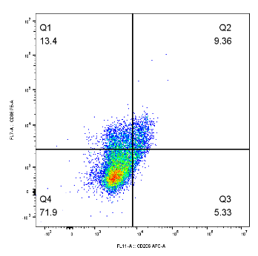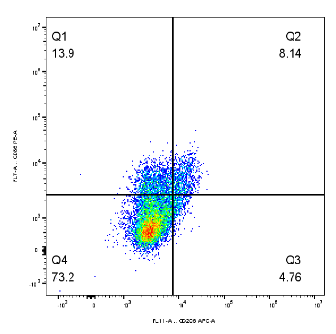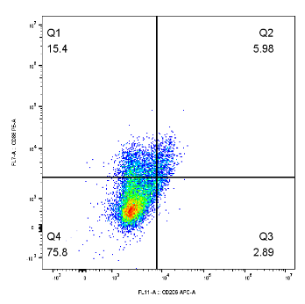
THP-1-siNCAPD3 #1
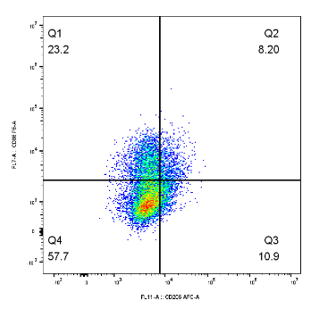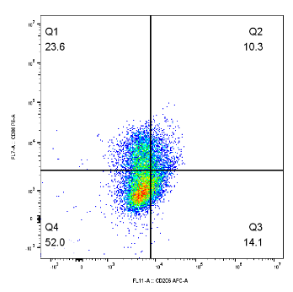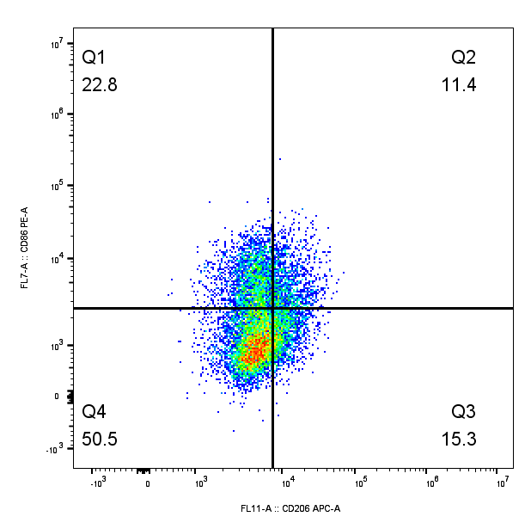
RAW-siControl
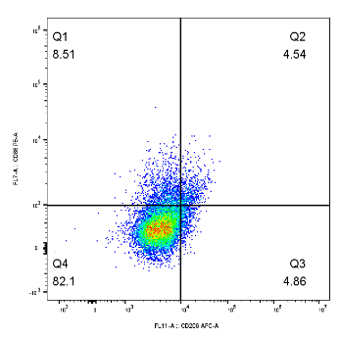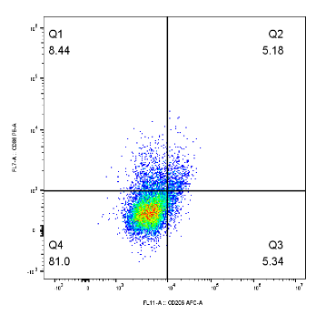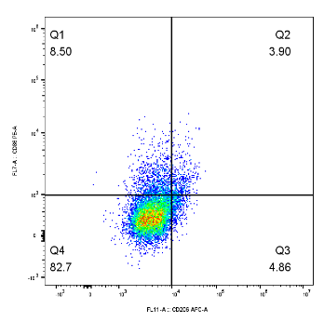
RAW-siNCAPD3 #1
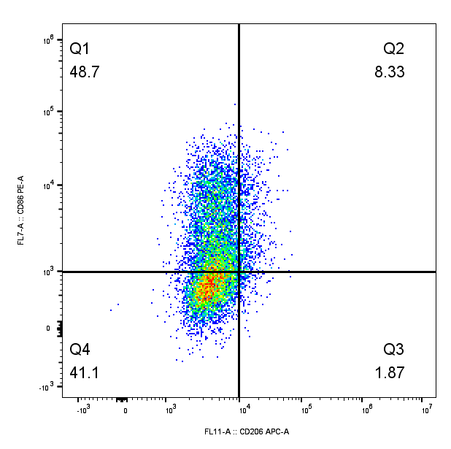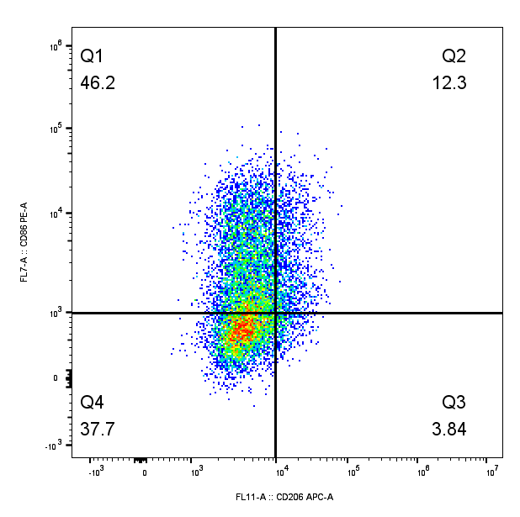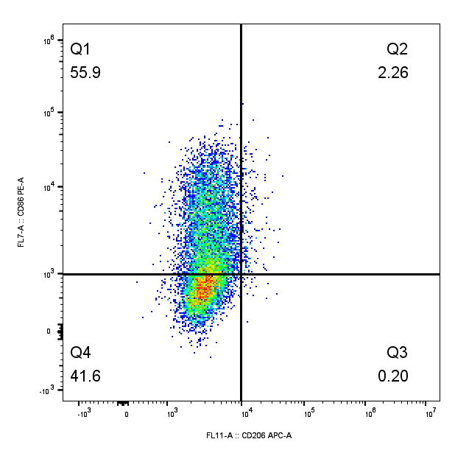

Figure 8A-B
143B | THP-1-siNC |  |  | THP-1-siNCAPD3 #1 |  |  | THP-1-siNCAPD3 #2 |  |  | BLANK
DAY0 | 0.2858 | 0.3076 | 0.3138 | 0.2889 | 0.2958 | 0.3034 | 0.2942 | 0.2974 | 0.3048 | 0.2117
DAY1 | 0.5603 | 0.5578 | 0.5287 | 0.4975 | 0.4615 | 0.4819 | 0.4381 | 0.4433 | 0.4394 | 0.1955
DAY2 | 0.9681 | 0.8952 | 0.9783 | 0.8677 | 0.8941 | 0.9158 | 0.7898 | 0.773 | 0.8255 | 0.1943
DAY3 | 1.8034 | 1.7913 | 1.7956 | 1.3882 | 1.3611 | 1.4038 | 1.2883 | 1.3521 | 1.3366 | 0.2057
DAY4 | 2.4222 | 2.4563 | 2.4921 | 2.224 | 2.2118 | 2.2533 | 2.1104 | 2.1731 | 2.176 | 0.2078
DAY5 | 2.6897 | 2.677 | 2.6663 | 2.2536 | 2.3253 | 2.2623 | 2.2794 | 2.2407 | 2.2615 | 0.2045
K7M2 | RAW-1-siNC |  |  | RAW-siNCAPD3 #1 |  |  | RAW-siNCAPD3 #2 |  |  | BLANK
DAY0 | 0.333 | 0.341 | 0.3381 | 0.3225 | 0.3275 | 0.3248 | 0.3333 | 0.3285 | 0.3271 | 0.2101
DAY1 | 0.5062 | 0.4902 | 0.5259 | 0.4535 | 0.4476 | 0.4523 | 0.4247 | 0.4291 | 0.4175 | 0.2067
DAY2 | 0.844 | 0.7959 | 0.8028 | 0.7249 | 0.6847 | 0.7019 | 0.6342 | 0.6466 | 0.6612 | 0.2012
DAY3 | 1.4235 | 1.3663 | 1.388 | 0.8632 | 0.9299 | 0.9118 | 0.7702 | 0.7476 | 0.8007 | 0.2167
DAY4 | 1.94 | 1.9484 | 1.9452 | 1.5487 | 1.4939 | 1.5346 | 1.4509 | 1.4583 | 1.3972 | 0.2104
DAY5 | 2.5077 | 2.5082 | 2.4678 | 2.2919 | 2.3262 | 2.2316 | 1.9912 | 2.0208 | 2.0935 | 0.2109

Figure 8C
143B
Control
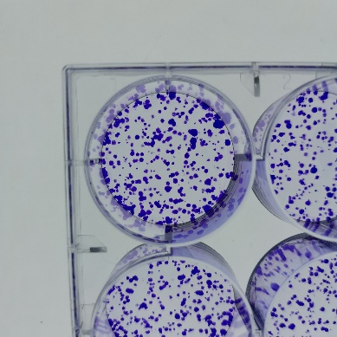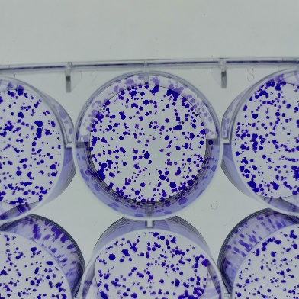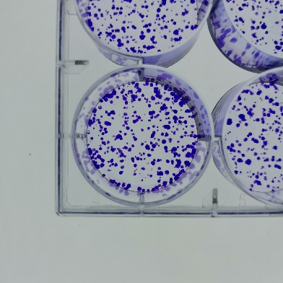
S1
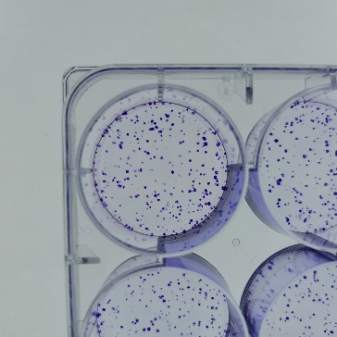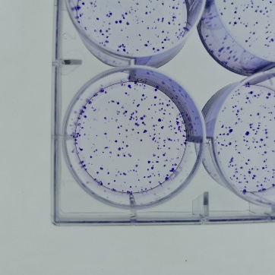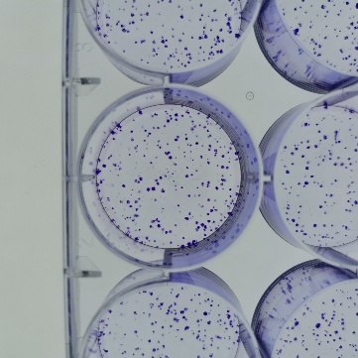
S2
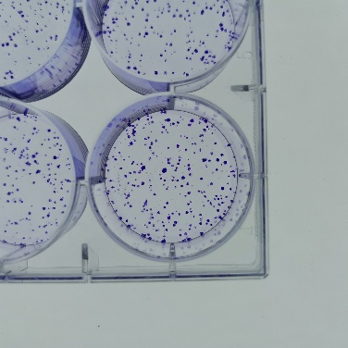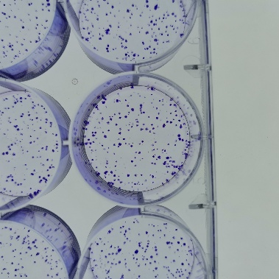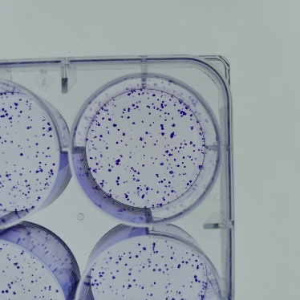

K7M2
Control
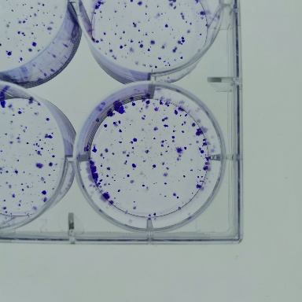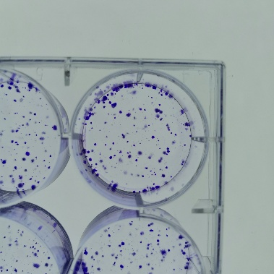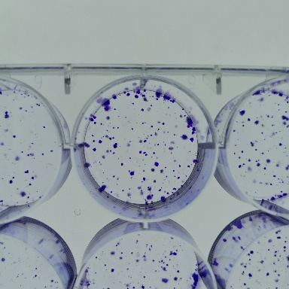
S1
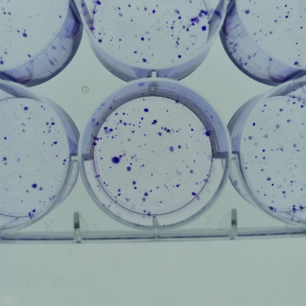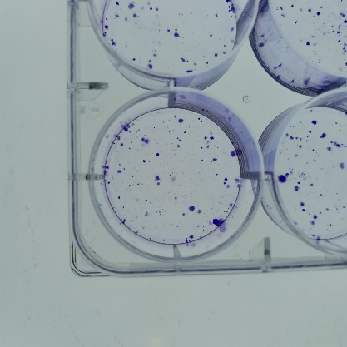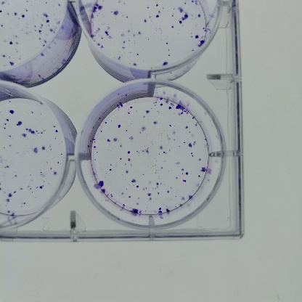

S2
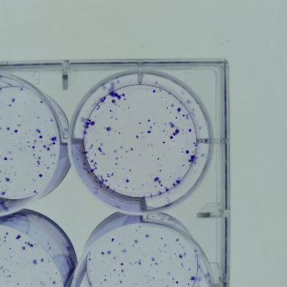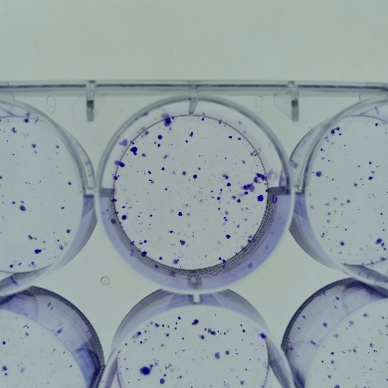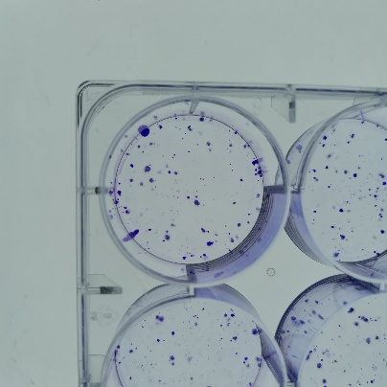

Figure 8D
143B-siNCAPD3-THP-1
Control
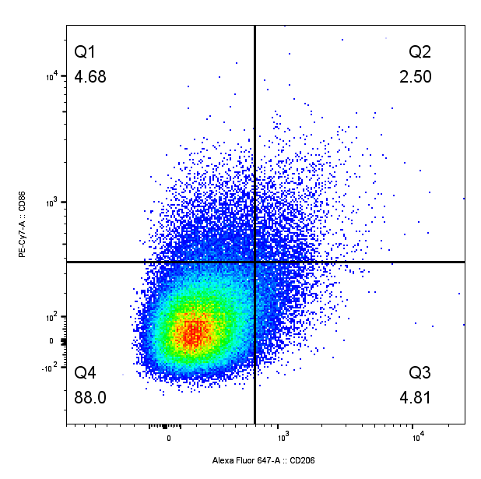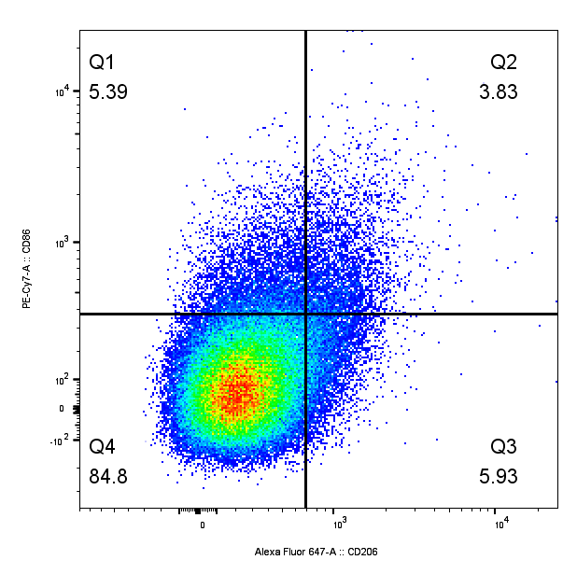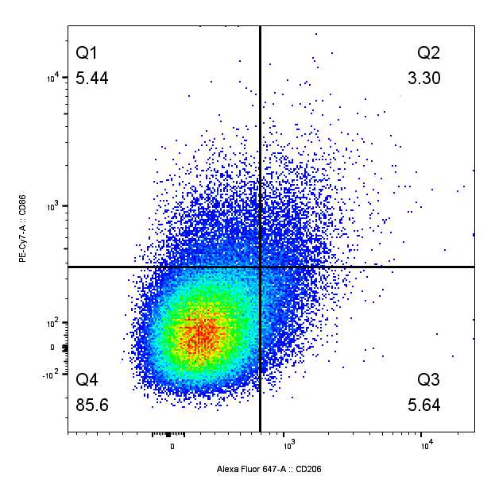
S1
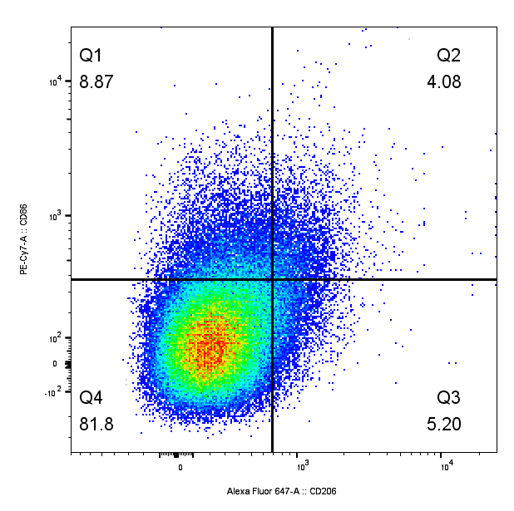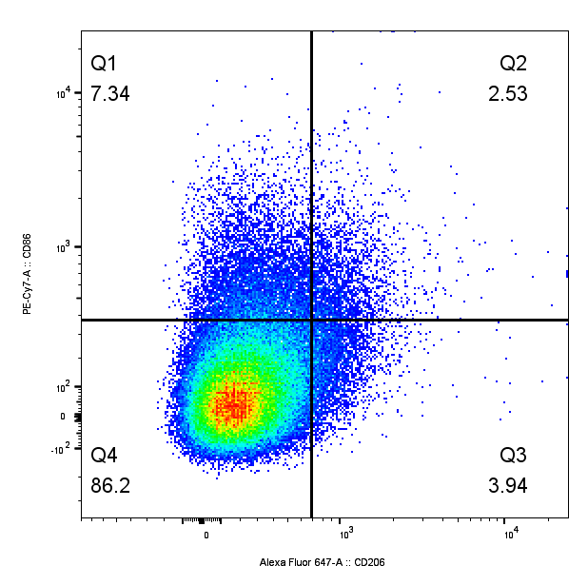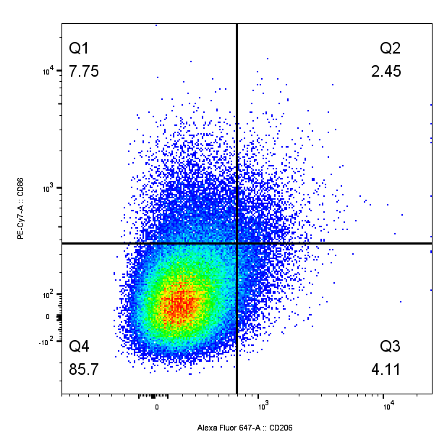
K7M2-siNCAPD3-RAW
Control
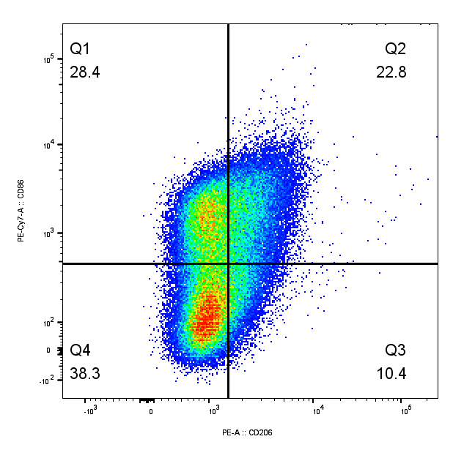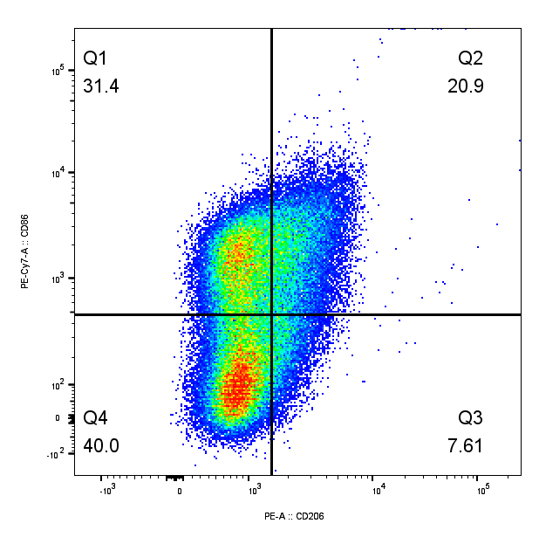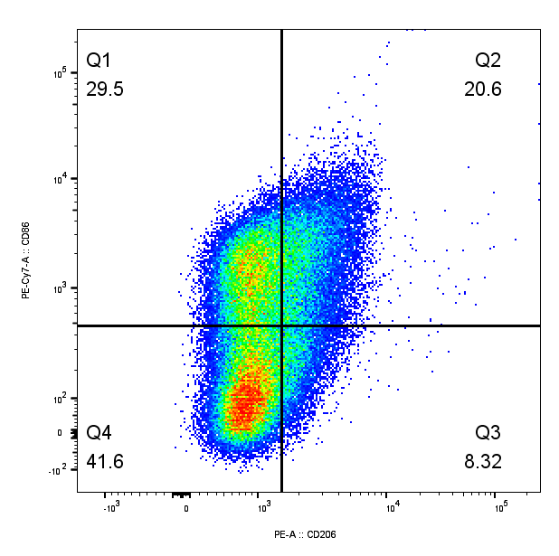
S1
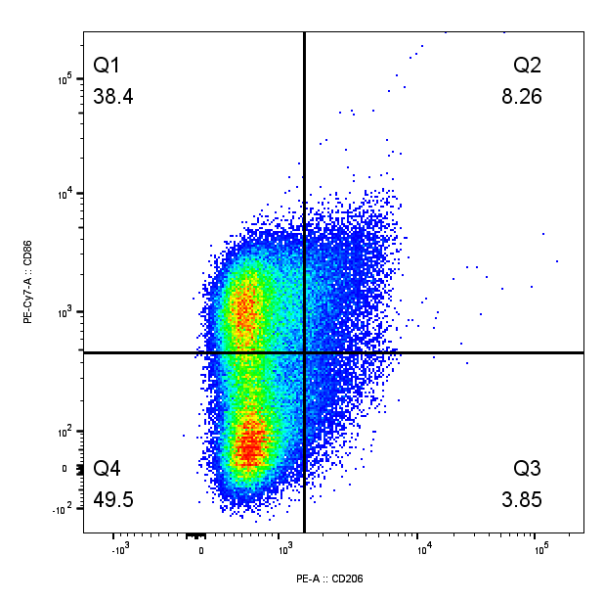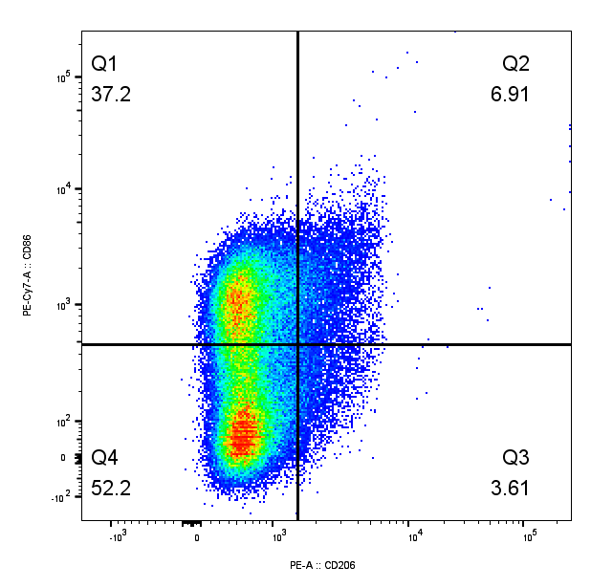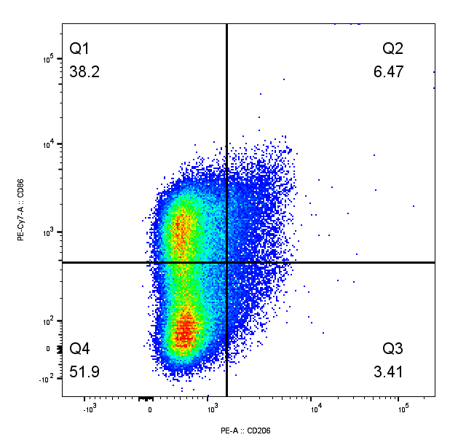

Figure 8E
143B-siNCAPD3
P-AKT
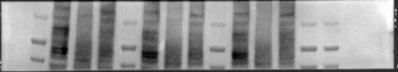
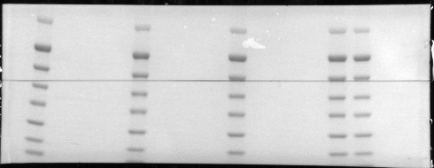
60KDa
37KDa

AKT
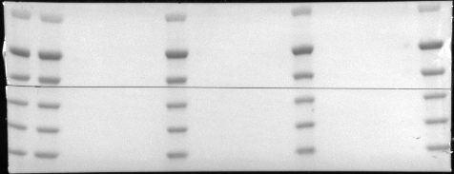
60KDa
37KDa

Figure 8F

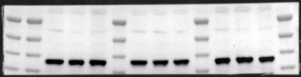
γH2AX
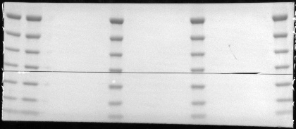
37KDa
16KDa

Figure S3C
143B
Control—0H
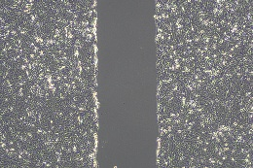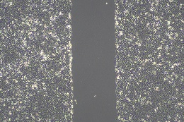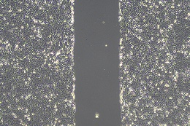
S1-0H
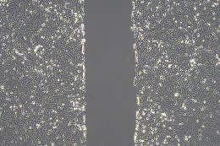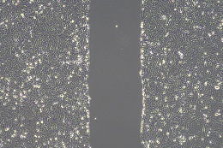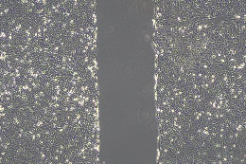
S2-0H
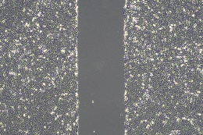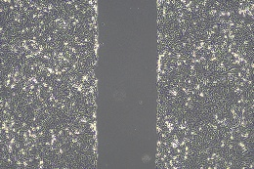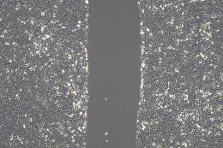

Control-24H
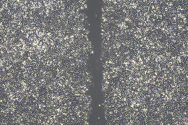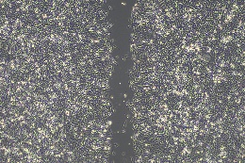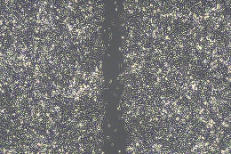
S1-24H
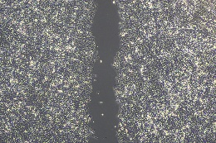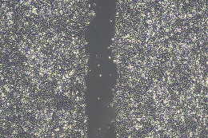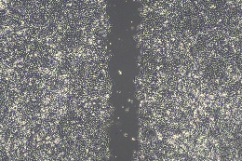
S2-24H
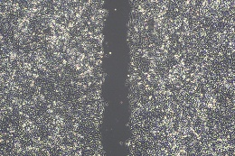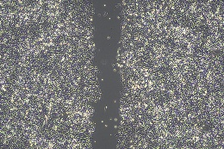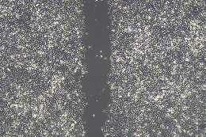

Figure S3A
143B-siNCAPD3
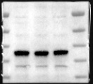
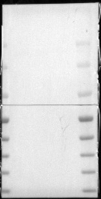
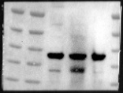
37KDa
165KDa
K7M2- siNCAPD3
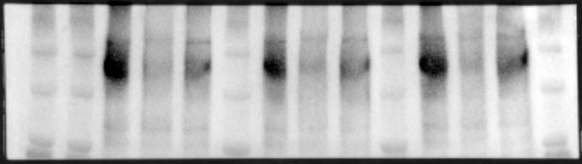
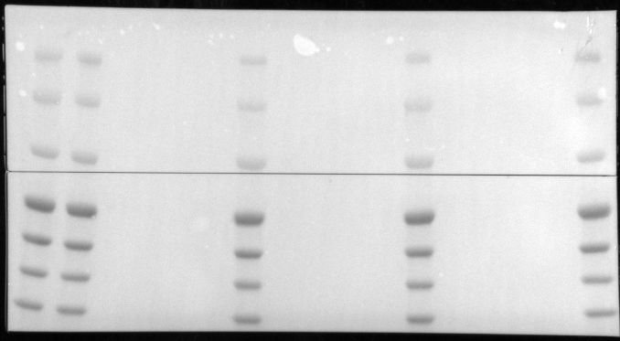
165KDa

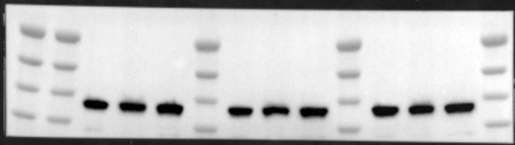
37KDa

THP-1-siNCAPD3
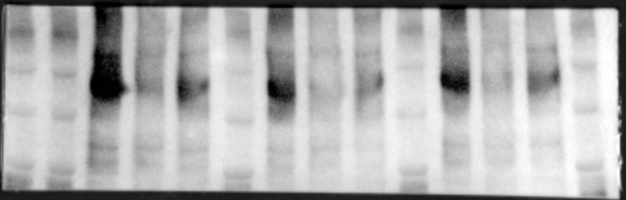
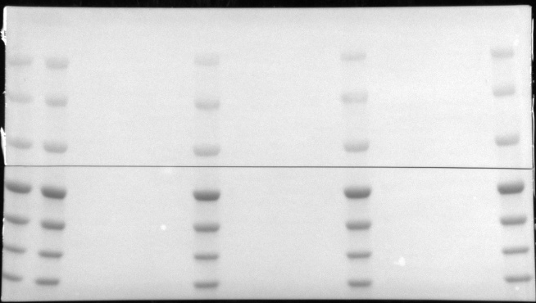
165KDa

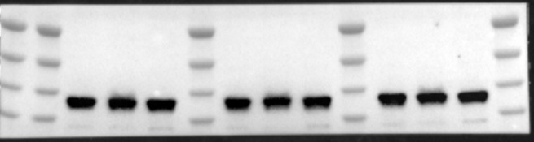
37KDa

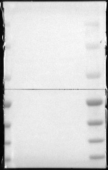
RAW-siNCAPD3
165KDa

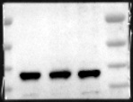
37KDa

Figure S3B
THP-1-si-NCAPD3
CD86
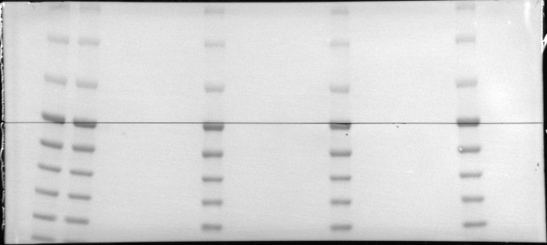
85KDa
37KDa
RAW-si-NCAPD3
CD86
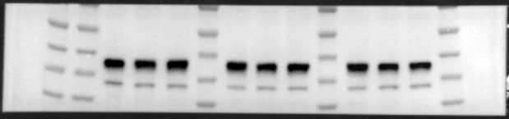
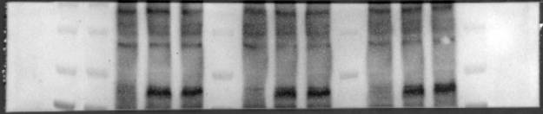
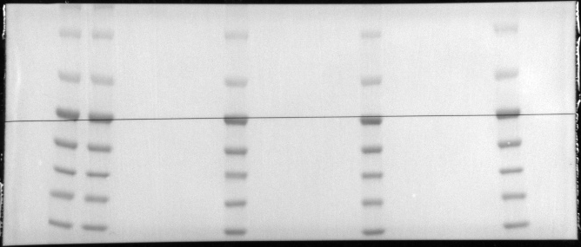
85KDa
37KDa

