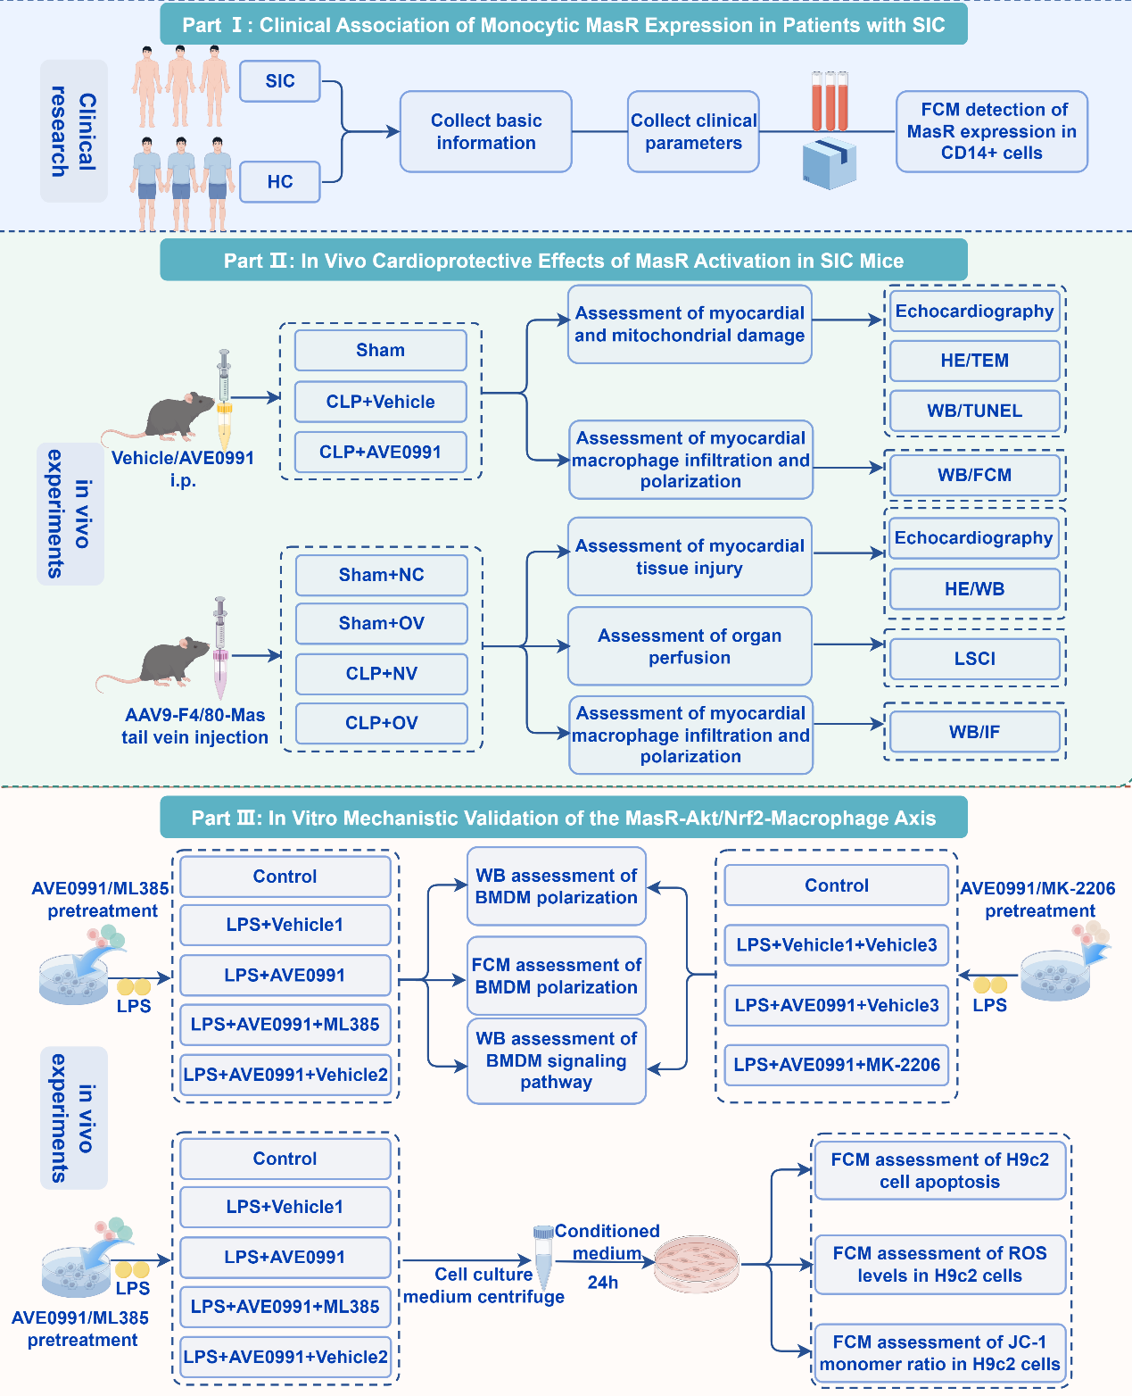
Fig S1. Study design flowchart. Part Ⅰ: Clinical Association of Monocytic MasR Expression in Patients with SIC. Part Ⅱ: In Vivo Cardioprotective Effects of MasR Activation in SIC Mice. Part Ⅲ: In Vitro Mechanistic Validation of the MasR-Akt/Nrf2-Macrophage Axis.

