Supplementary materials
Title: SNHG12 Drives Gastric Cancer Progression by Activating the Wnt/β-Catenin–Mediated Serine Synthesis Pathway
Authors: Nianjie Zhang¹, Taolang Li², Kunming Wen³✉
Author affiliations:
- Department of Gastrointestinal Surgery, Second Affiliated Hospital of Zunyi Medical University, Zunyi, Guizhou 563000, China
2. Department of Thyroid and Breast Surgery, Affiliated Hospital of Zunyi Medical University, Zunyi, Guizhou 563000, China
3. Department of Gastrointestinal Surgery, Zunyi First People’s Hospital / Third Affiliated Hospital of Zunyi Medical University, Zunyi, Guizhou 563000, China
*Corresponding author:Kunming Wen (email: 381224619@qq.com).Department of Gastrointestinal Surgery, Zunyi First People’s Hospital / Third Affiliated Hospital of Zunyi Medical University, Zunyi, Guizhou 563000, China.

Table. S1 si Primer sequence
Primer Name | Upstream/Downstream Primer | Primer Sequence (5’-3’)
SNHG12-560 | Forward primer (5′–3′) | GAUUCAUGUUACAUGUAAATT
SNHG12-560 | Reverse primer (5′–3′) | UUUACAUGUAACAUGAAUCTT
SNHG12-360 | Forward primer (5′–3′) | GGAUGACUGACUUAGUCUATT
SNHG12-360 | Reverse primer (5′–3′) | UAGACUAAGUCAGUCAUCCTT
SNHG12-712 | Forward primer (5′–3′) | CUUCAGAGGUGAUCAAUAATT
SNHG12-712 | Reverse primer (5′–3′) | UUAUUGAUCACCUCUGAAGTT
NC | Forward primer (5′–3′) | UUCUCCGAACGUGUCACGUTT
NC | Reverse primer (5′–3′) | ACGUGACACGUUCGGAGAATT

Table. S2 RT-qPCR Primer sequence
Primer Name | Upstream/Downstream Primer | Primer Sequence (5’-3’)
GAPDH | Forward primer (5′–3′) | TGTTGCCATCAATGACCCCTT
GAPDH | Reverse primer (5′–3′) | CTCCACGACGTACTCAGCG
PHGDH | Forward primer (5′–3′) | AGAAGCTCTGGGGACACTGA
PHGDH | Reverse primer (5′–3′) | CCAGCATTCTTCAGGGATGT
PSAT1 | Forward primer (5′–3′) | ACTTCCTGTCCAAGCCAGTGGA
PSAT1 | Reverse primer (5′–3′) | CTGCACCTTGTATTCCAGGACC
SHMT2 | Forward primer (5′–3′) | GCCTCATTGACTACAACCAGCTG
SHMT2 | Reverse primer (5′–3′) | ATGTCTGCCAGCAGGTGTGCTT
MTHFD1 | Forward primer (5′–3′) | CGCACACCTGAATGTCAACTCC
MTHFD1 | Reverse primer (5′–3′) | CGTGGATGTCTCCAGTCAAGTG
PSPH | Forward primer (5′–3′) | GACAGCACGGTCATCAGAGAAG
PSPH | Reverse primer (5′–3′) | CGCTCTGTGAGAGCAGCTTTGA
SNHG12 | Forward primer (5′–3′) | CGAGATGGTGGTGAATGTGGC
SNHG12 | Reverse primer (5′–3′) | TCAGTCTTGATGGGACCGTTTT

Table. S3 Main antibody
Antibody Name | Brand | Catalog No. | Species | Protein Size | Dilution Ratio
β-catenin | Wuhan Sanyi | 66379-1-Ig | Rabbit Polyclonal | 92 kDa | WB : 1:5000  IHC : 1:1000
Wnt3a | Wuhan Sanyi | 26744-1-AP | Rabbit Polyclonal | 42 kDa | WB : 1:1000  IHC : 1:100
PSAT1 | Wuhan Sanyi | 20180-1-AP | Rabbit Polyclonal | 40kDa | WB : 1:5000  IHC : 1:200
SHMT2 | Wuhan Sanyi | 1099-1-AP | Rabbit Polyclonal | 55kDa | WB : 1:1000  IHC : 1:100
PHGDH | Wuhan Sanyi | 14719-1-AP | Rabbit Polyclonal | 57kDa | WB : 1:3000  IHC : 1:100
H3 | PTM BIO | PTM-1002RM | Rabbit Polyclonal | 15kDa | WB : 1:3000
GAPDH | Seville | GB11002-100 | Mouse Polyclonal | 37kDa | WB : 1:3000
β-actin | Seville | GB15003-100 | Mouse Polyclonal | 42kDa | WB : 1:3000
β-Tubulin | Seville | GB152667-100 | Rabbit Polyclonal | 54 kDa | WB：1:2000
Ki-67 | Wuhan Sanyi | 27309-1-AP | Rabbit Polyclonal | 359 kDa | IHC：1:5000

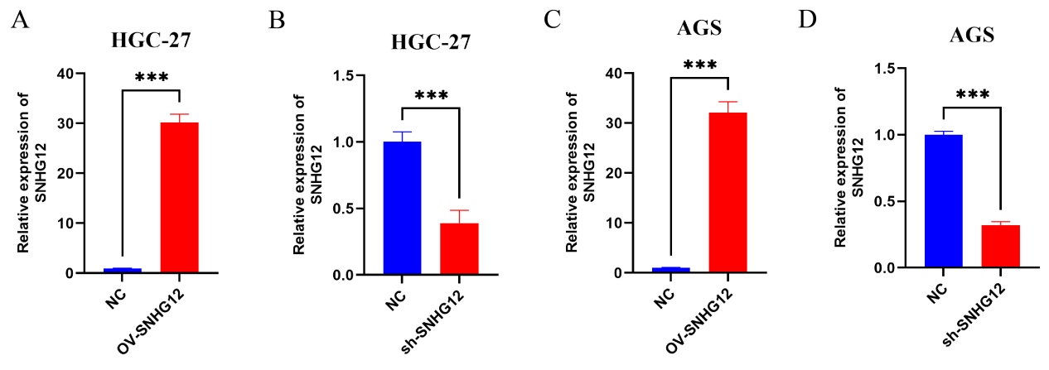
Supplementary Fig S1. Validation of SNHG12 overexpression and knockdown efficiency in gastric cancer cells.
(A–D) RT-qPCR analysis of SNHG12 expression in HGC-27 and AGS cells following transfection with the SNHG12 overexpression plasmid (OV-SNHG12) or shRNA targeting SNHG12 (sh-SNHG12). The results showed that OV-SNHG12 significantly increased SNHG12 expression, whereas sh-SNHG12 markedly reduced its expression. Data are presented as mean ± standard deviation (SD). ***P < 0.001.

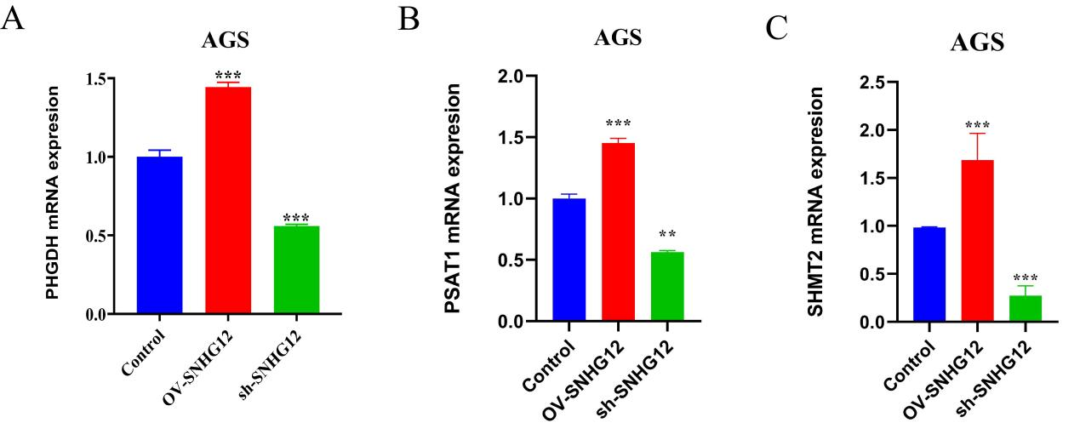
Supplementary Fig S2. SNHG12 modulates the mRNA expression of PHGDH, PSAT1, and SHMT2 in AGS cells.
(A–C) RT-qPCR analysis showing the mRNA expression levels of PHGDH (A), PSAT1 (B), and SHMT2 (C) in AGS cells after SNHG12 overexpression or silencing.
Data are presented as mean ± standard deviation (SD) from three independent experiments. Statistical significance was assessed by Student’s t-test or one-way ANOVA with Tukey’s post hoc test, as appropriate. **P < 0.01, ***P < 0.001.

