Supplementary file 1
Multi-omics Mapping Identifies a C/EBPβ-S100a4⁺ Macrophage Axis as a Therapeutic Target in Acute Spinal Cord Injury
Haojue Wang^{1*}, Haoran Wu^{2*}, Zhixuan Li^{3*}, Yiming Huo^{3,4*}, Bo Li², Wanghui Liu¹, Xiao Zhai^{1#}, Kai Chen^{1,2#}, Yang Liu^{2#}
¹Department of Orthopedics, Shanghai Changhai Hospital, Shanghai 200433, China;
²Department of Orthopedics, Shanghai Changzheng Hospital, Shanghai 200433, China;
³National Key Laboratory of Immunity and Inflammation, Institute of Immunology, Naval Medical University, Shanghai, China;
⁴Department of Human Anatomy, Naval Medical University, Shanghai 200433, China.
* Haojue Wang, Haoran Wu, Zhixuan Li and Yiming Huo contributed equally to this article and were marked as co-first author.
#Corresponding email: drzhaixiao@126.com (Xiao Zhai), spine_kai@smmu.edu.cn (Kai Chen); lyspinesurgery@163.com (Yang Liu)

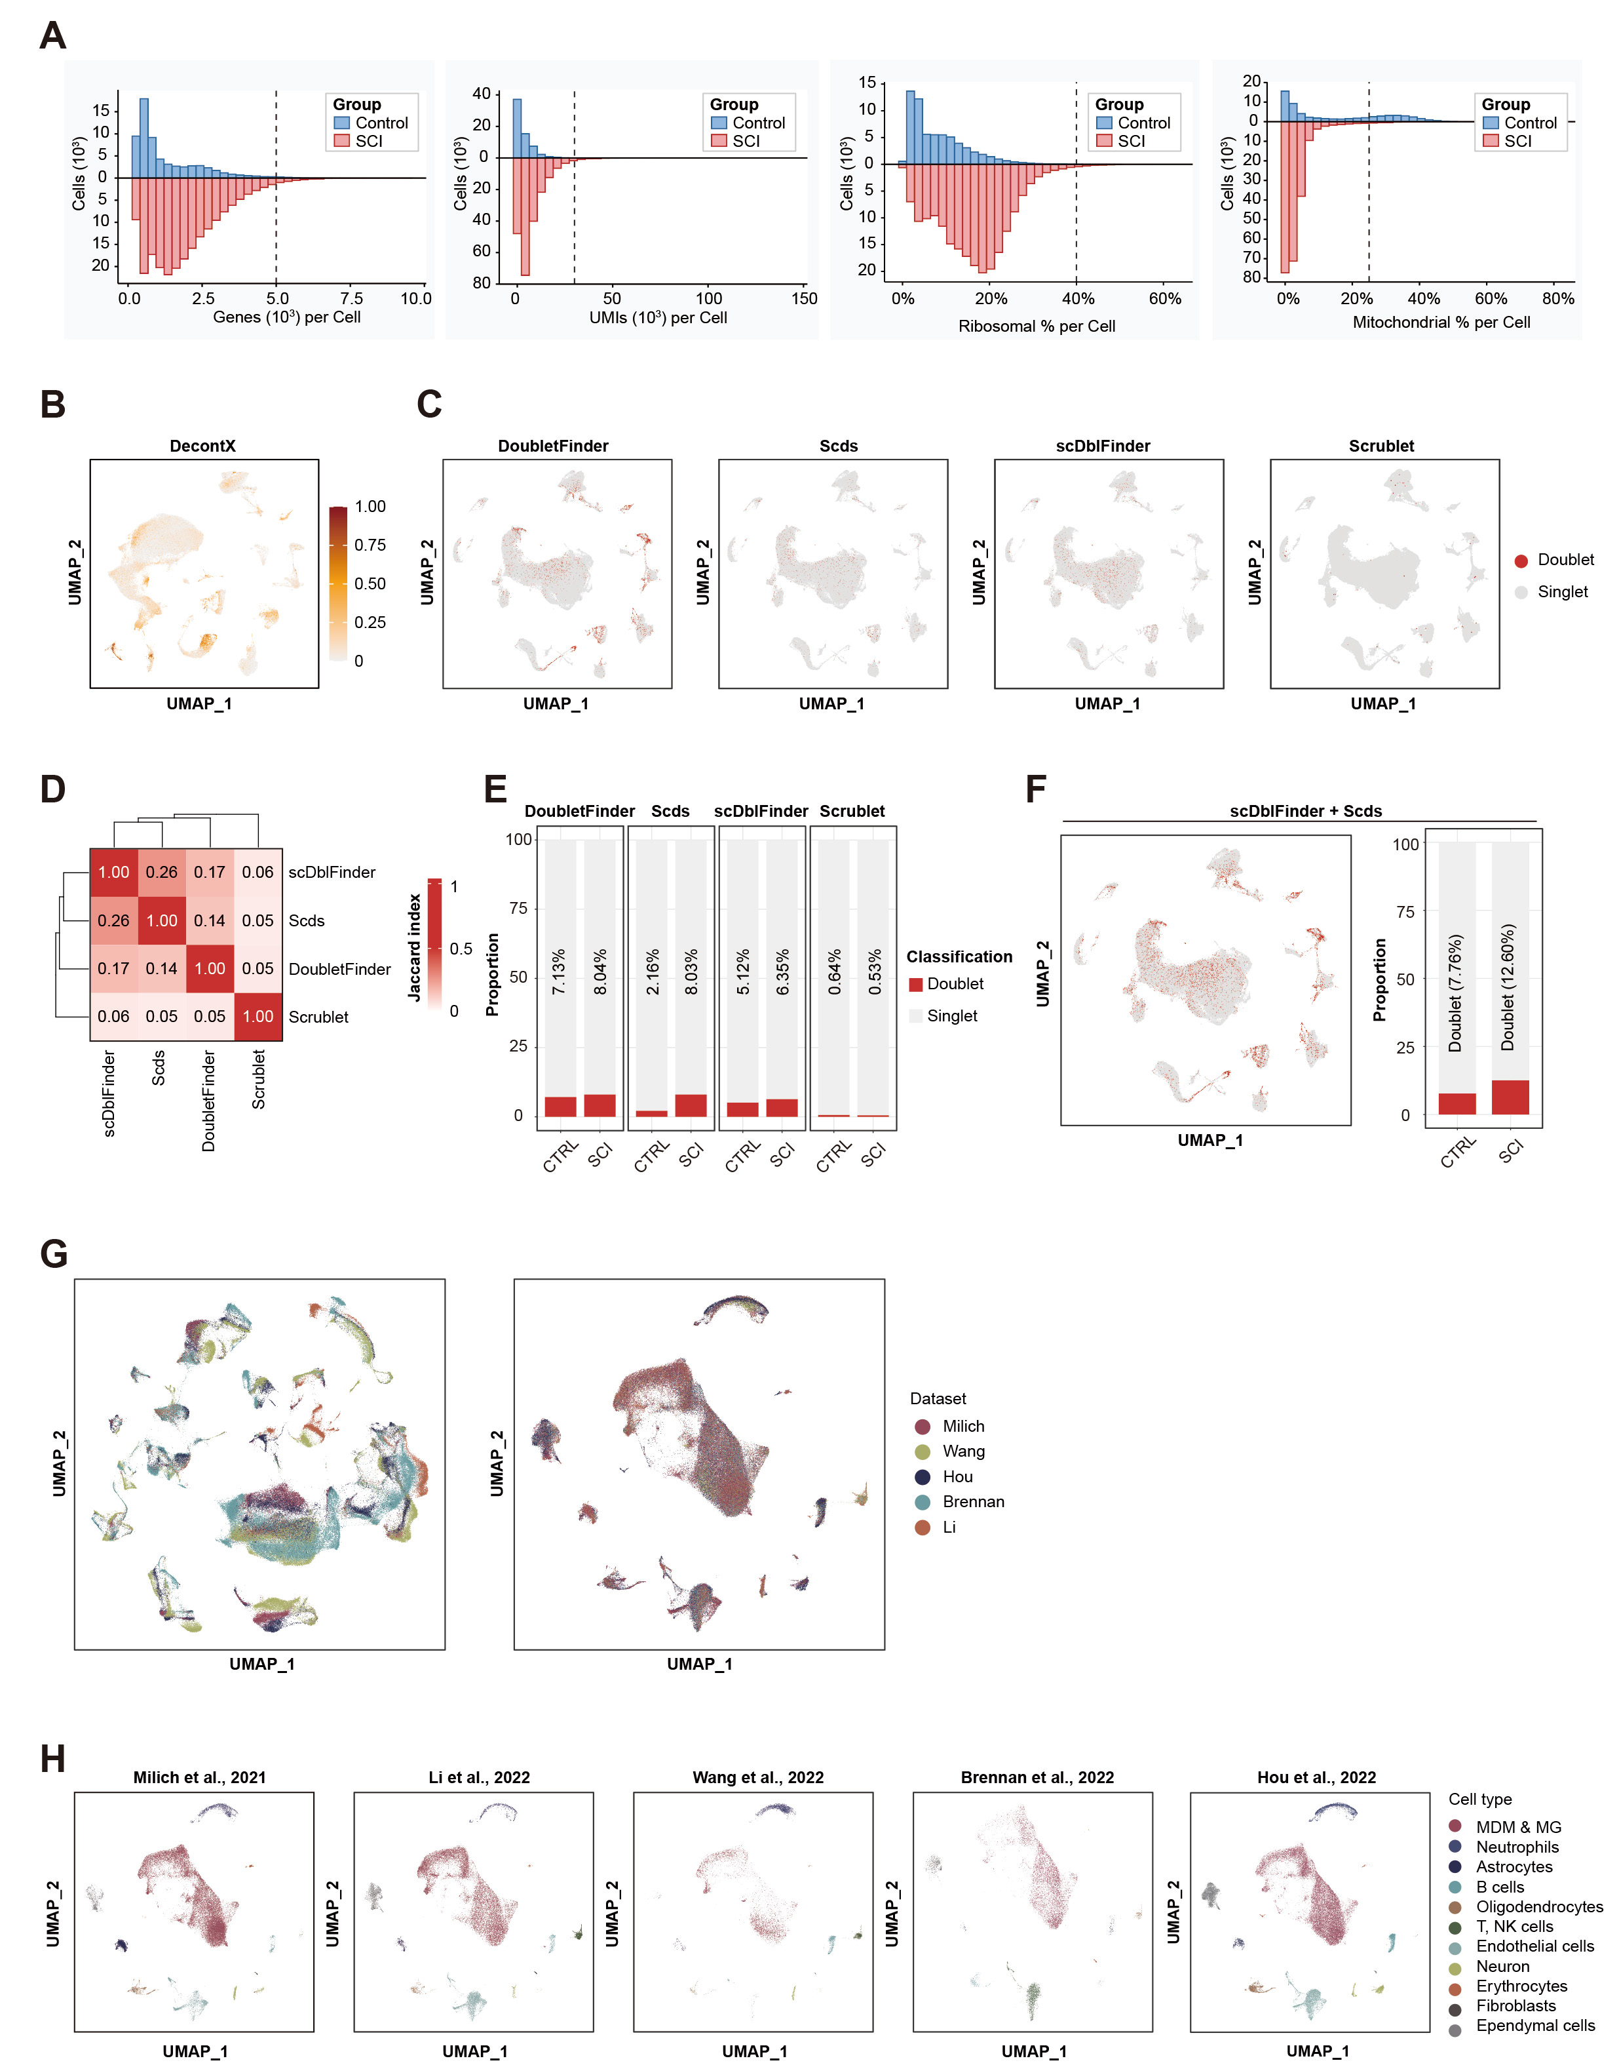
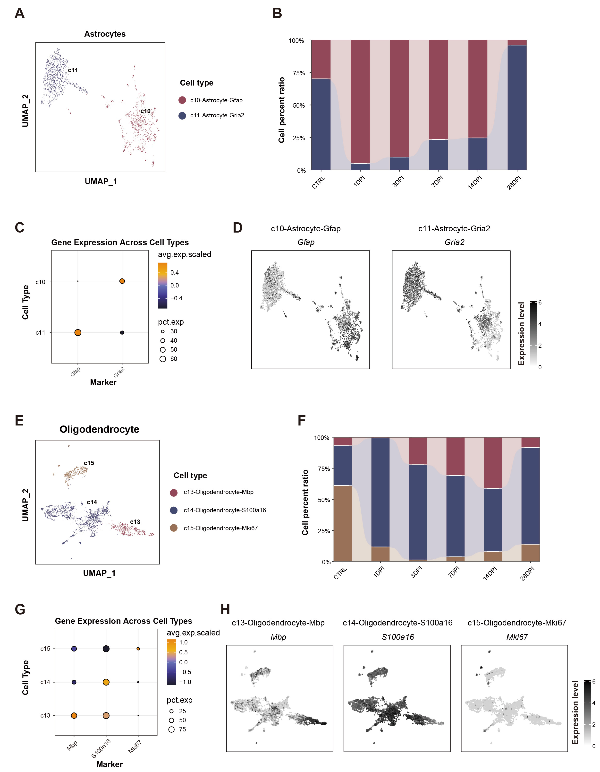
Figure S1. Quality control, doublet detection, and dataset integration. (A) Histograms of quality control metrics for the integrated single-cell dataset. (B) Removal of ambient RNA contamination using the DecontX algorithm. (C-F) Detection of doublet cells using multiple algorithms. (C) UMAP projections of doublet classification results from four different methods. (D) Jaccard index heatmap comparing the concordance between these doublet-calling results. (E) Bar plot of the proportion of cells identified as doublets by each algorithm. (F) Final consensus doublet detection (ScDblFinder and Scds) showing the UMAP plot and proportion of identified doublets. (G) Integration of multiple datasets using Harmony. The UMAP visualizes the dataset-specific batch effects before integration (left) and their successful removal after integration (right). (H) UMAP plots showing the origin of cells from individual contributing studies after integration.
Figure S2. Characterization of astroglial and oligodendroglial responses to spinal cord injury. (A) UMAP visualization of astrocyte subsets. (B) Bar plot showing the proportional abundance of each astrocyte subset across time points. (C) Dot plot of canonical marker genes for each astrocyte subset. (D) UMAP feature plots displaying the spatial expression patterns of key astrocyte subset markers. (E) UMAP visualization of oligodendrocyte lineage subsets. (F) Bar plot quantifying the proportional changes of each oligodendrocyte subset over time. (G) Dot plot of marker genes defining the oligodendrocyte subsets. (H) UMAP feature plots illustrating the expression patterns of key oligodendrocyte lineage markers.
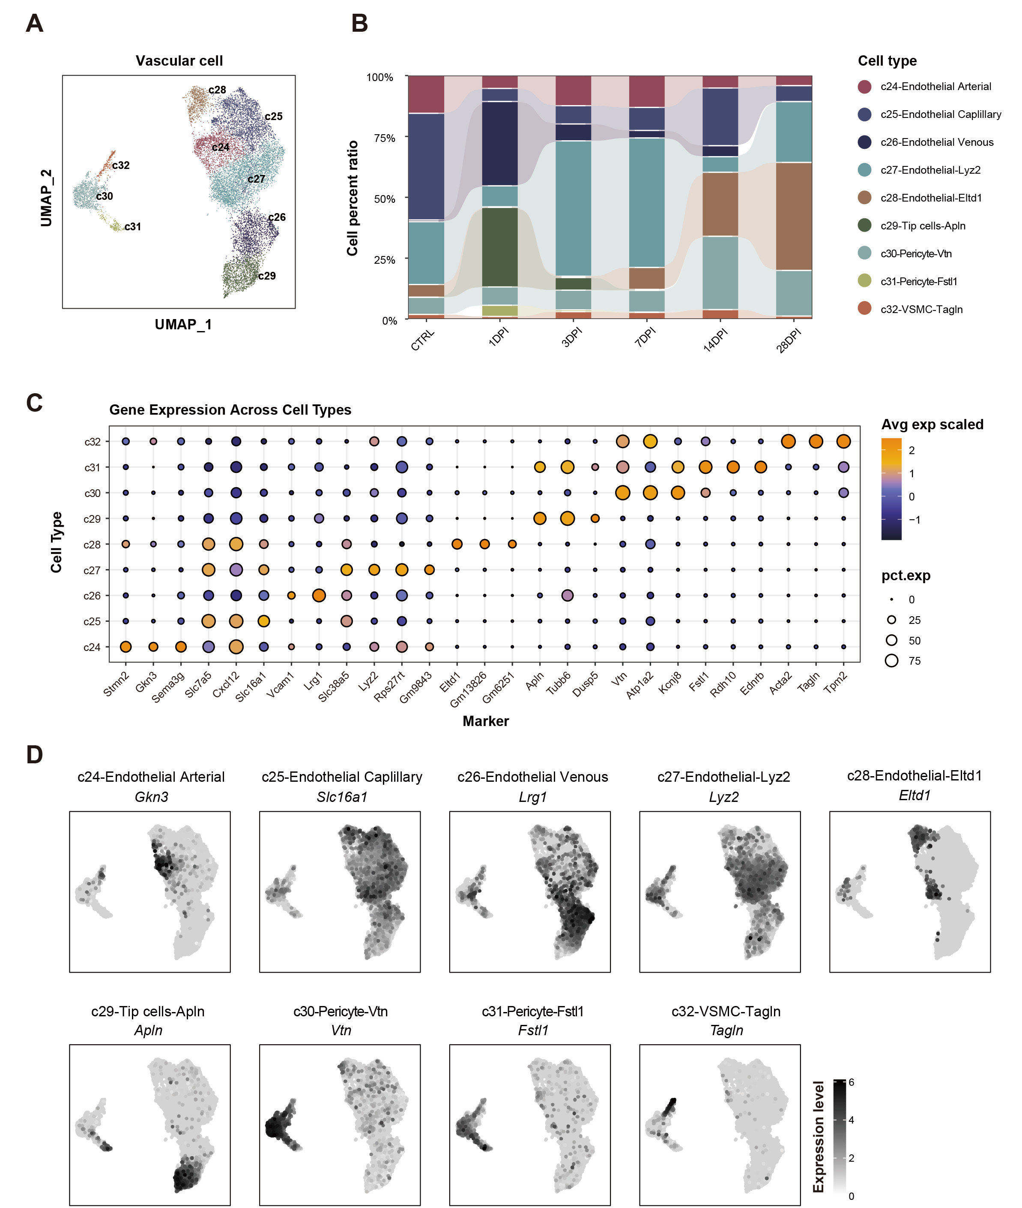
Figure S3. Dynamics of the vascular compartment in response to spinal cord injury. (A) UMAP visualization of endothelial cell and pericyte subsets. (B) Bar plot showing the proportional changes of each vascular subset across time points. (C) Dot plot of marker genes defining the identity of each vascular cell subset. (D) UMAP feature plots displaying the expression patterns of key vascular markers.

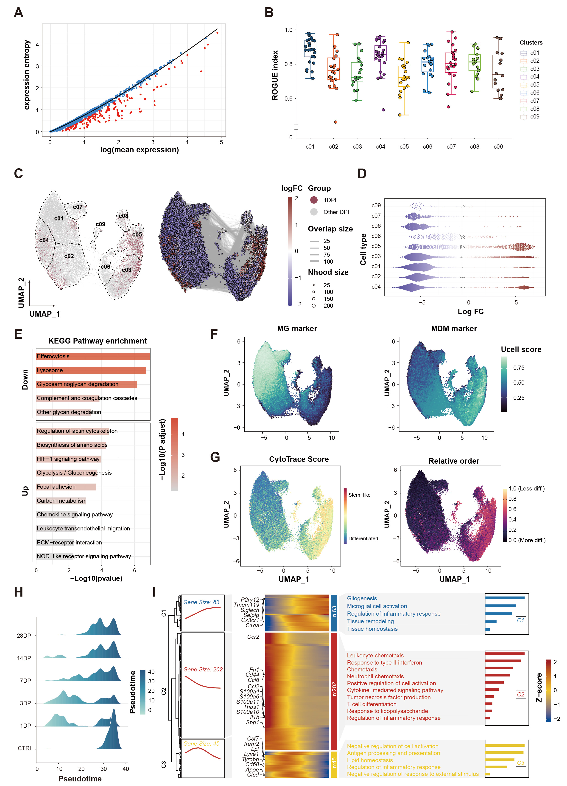
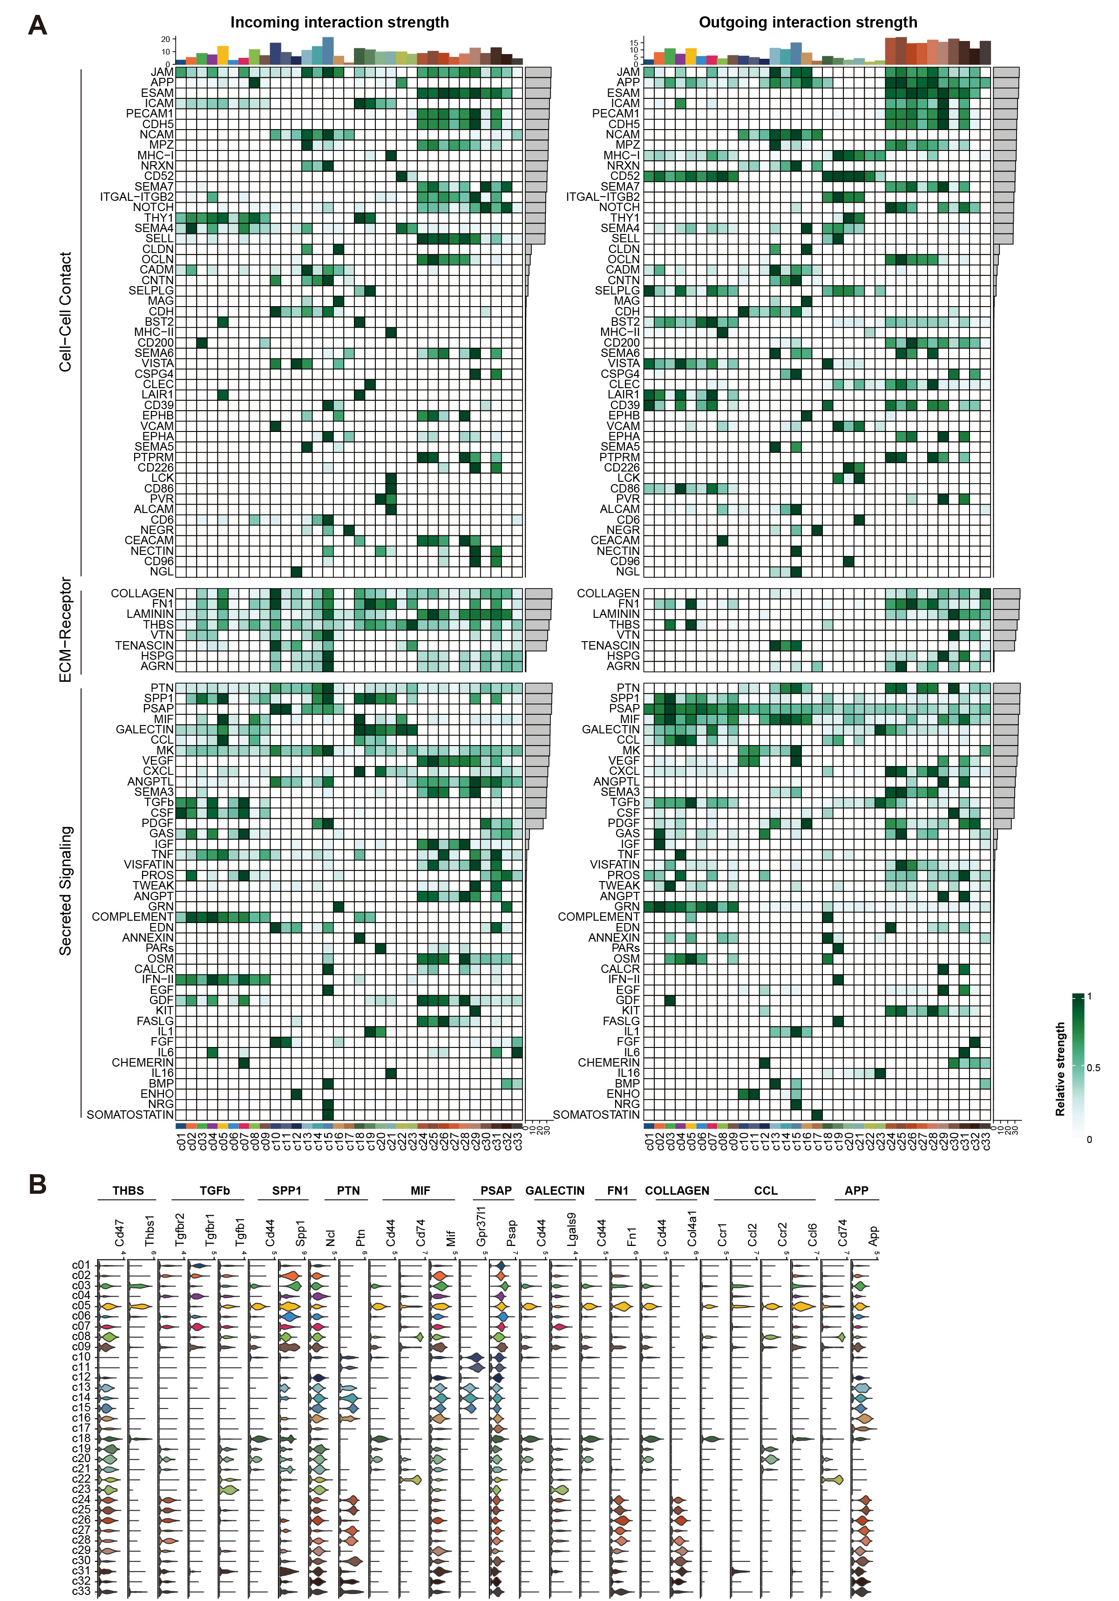
Figure S4. Validation of c05 subset identity and dynamic features. (A) ROGUE S-E plot based on the expression entropy model. (B) ROGUE purity scores for each myeloid subset, with higher scores. (C) MiloR analysis for temporal differential abundance. Left: UMAP embedding of myeloid cells colored by experimental time point (1 dpi vs. all others). Right: Significant neighborhoods identified by differential abundance testing, with red indicating neighborhoods significantly enriched specifically at 1 dpi (log₂FC > 0). (D) Beeswarm plot visualization of the significant neighborhood graph from MiloR. (E) KEGG pathway enrichment of DEGs specifically up- or down-regulated in the c05 subset. (F) UCell scores for canonical microglial and macrophage marker genes across myeloid subsets. (G) CytoTRACE scores and ranking for myeloid subsets, with higher scores indicating an earlier differentiation state. (H) Density ridge plot showing the distribution of cells from each time point along the Monocle3 pseudotime trajectory. (I) Heatmap of pseudotime-correlated DEGs clustered by expression patterns, with corresponding GO enrichment for each cluster.
Figure S5. Global signaling activity and c05-associated ligand-receptor expression. (A) Heatmap of outgoing and incoming interaction strengths for all identified signaling pathways. (B) Violin plots showing the expression levels of key ligand and receptor genes from c05-associated pathways across all cell subsets.
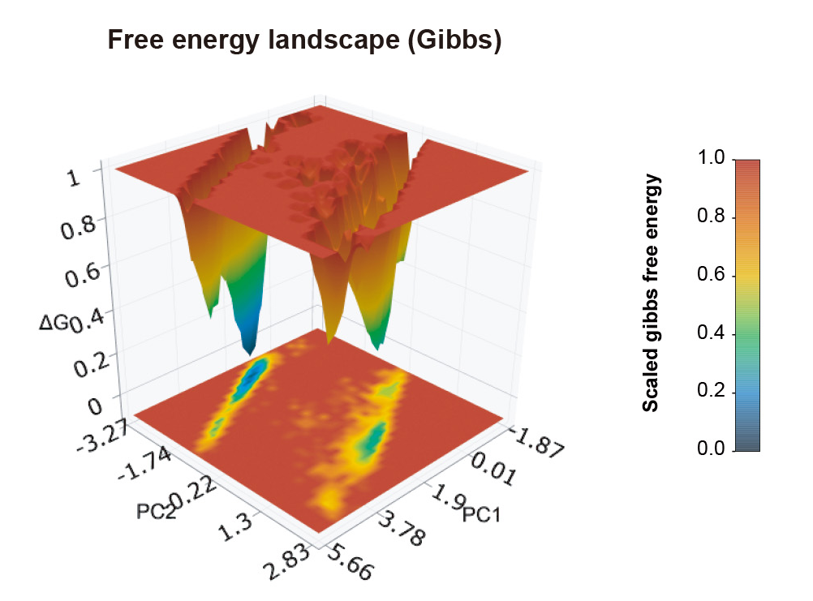
Figure S6. Free energy landscape of the C/EBPβ protein derived from the simulation.
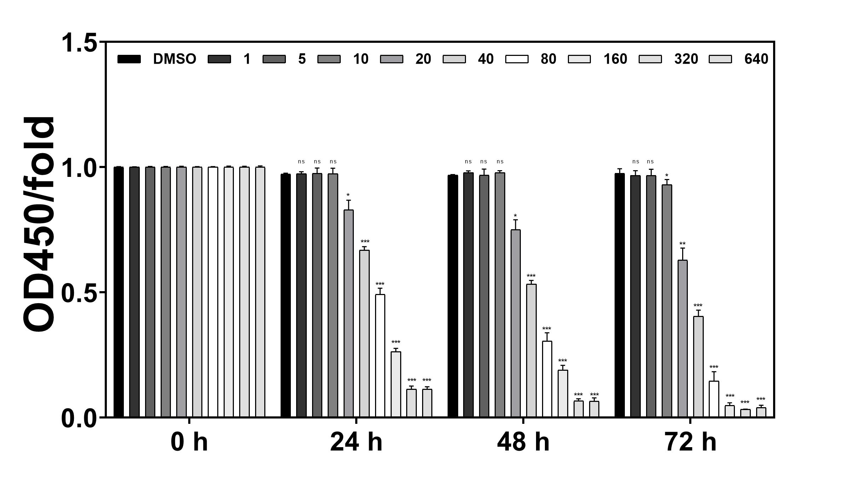
Figure S7. CCK-8 assay to select optimal concentration of baicalein.

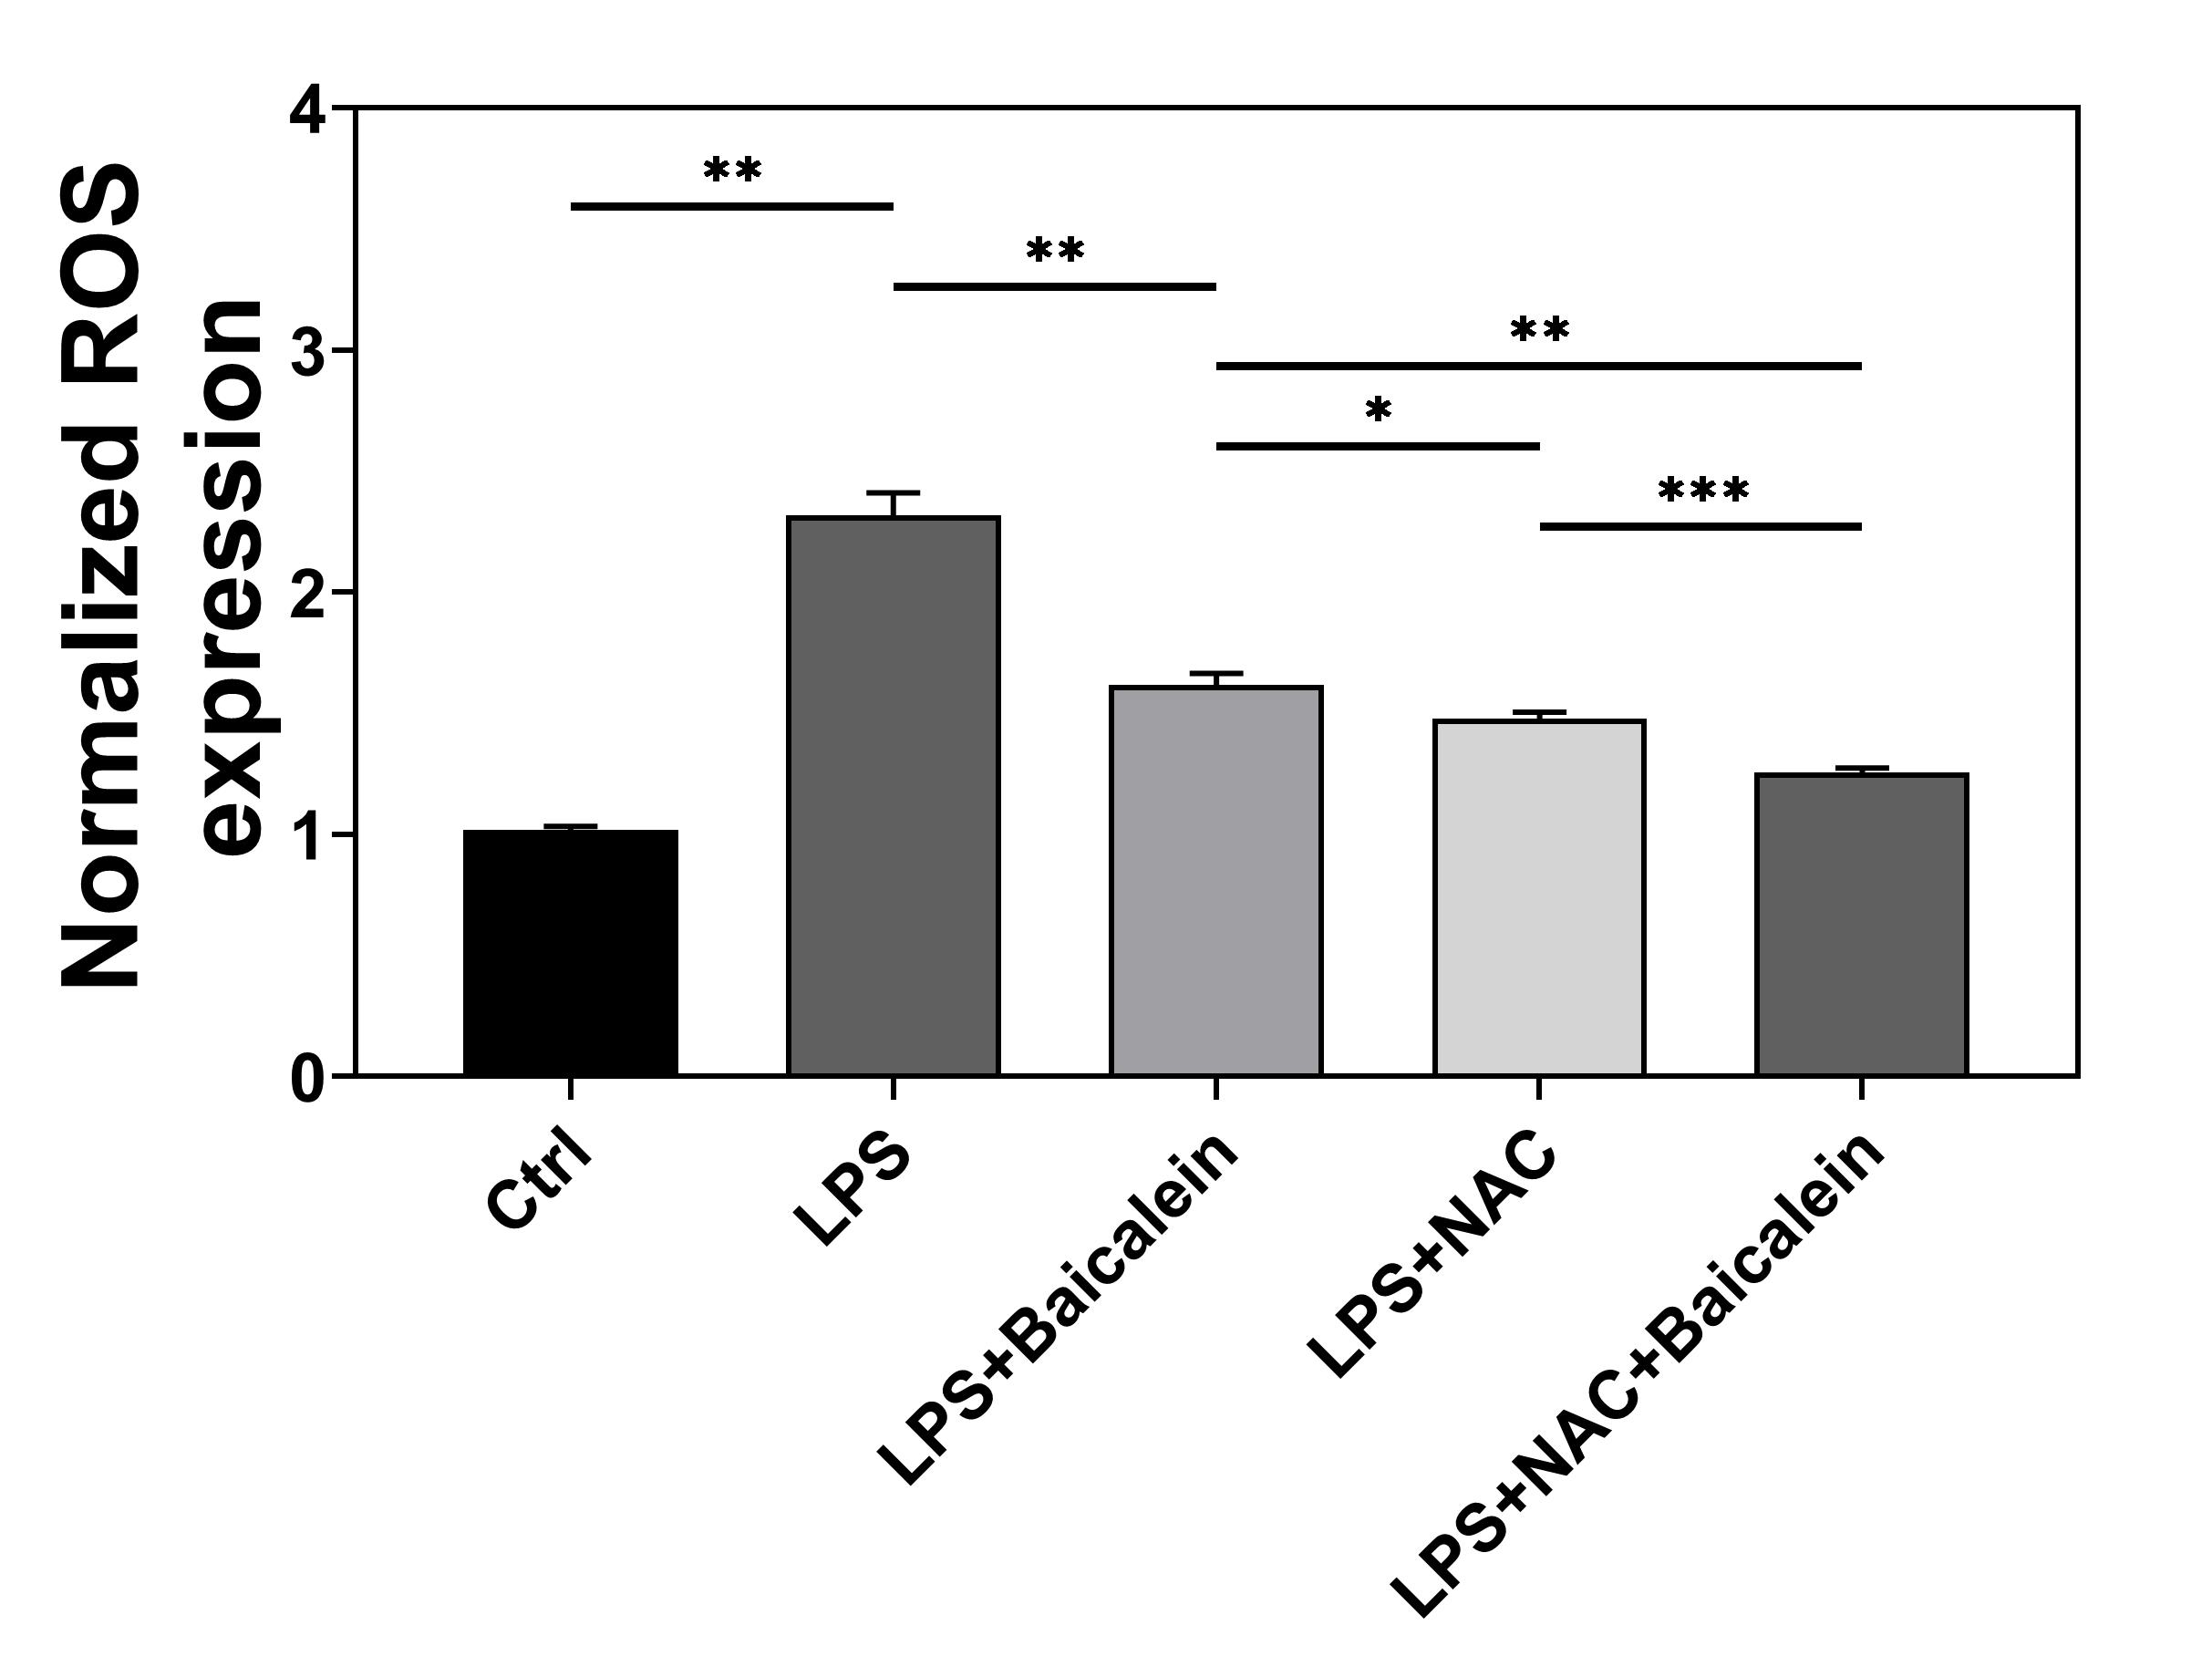
Figure S8. Intracellular ROS measurement by flow cytometry.

