Supplementary file 2
Multi-omics reconstruction identifies a C/EBPβ-regulated S100a4⁺ macrophage program associated with acute neuroinflammation after spinal cord injury
Haojue Wang¹*, Haoran Wu²*, Zhixuan Li³*, Yiming Huo⁴, Bo Li², Wanghui Liu¹, Xiao Zhai^{1#}, Kai Chen^{1,2#}, Yang Liu^{2#}
¹Department of Orthopedics, Shanghai Changhai Hospital, Shanghai 200433, China;
²Department of Orthopedics, Shanghai Changzheng Hospital, Shanghai 200433, China;
³The International Cooperation Laboratory on Signal Transduction, Eastern Hepatobiliary Surgery Hospital, Shanghai, China;
⁴Department of Human Anatomy, Naval Medical University, Shanghai 200433, China.
* Haojue Wang, Haoran Wu, Zhixuan Li and Yiming Huo contributed equally to this article and were marked as co-first author.
#Corresponding email: drzhaixiao@126.com (Xiao Zhai), spine_kai@smmu.edu.cn (Kai Chen); lyspinesurgery@163.com (Yang Liu)

CETSA
Ctrl
Baicalein

ChIP-qPCR
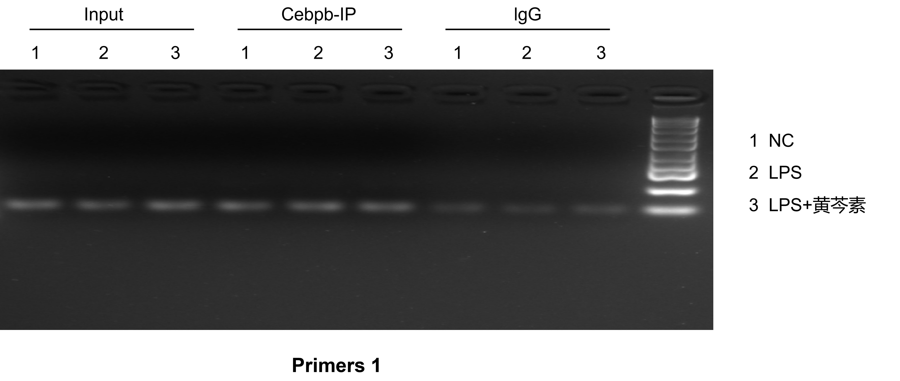

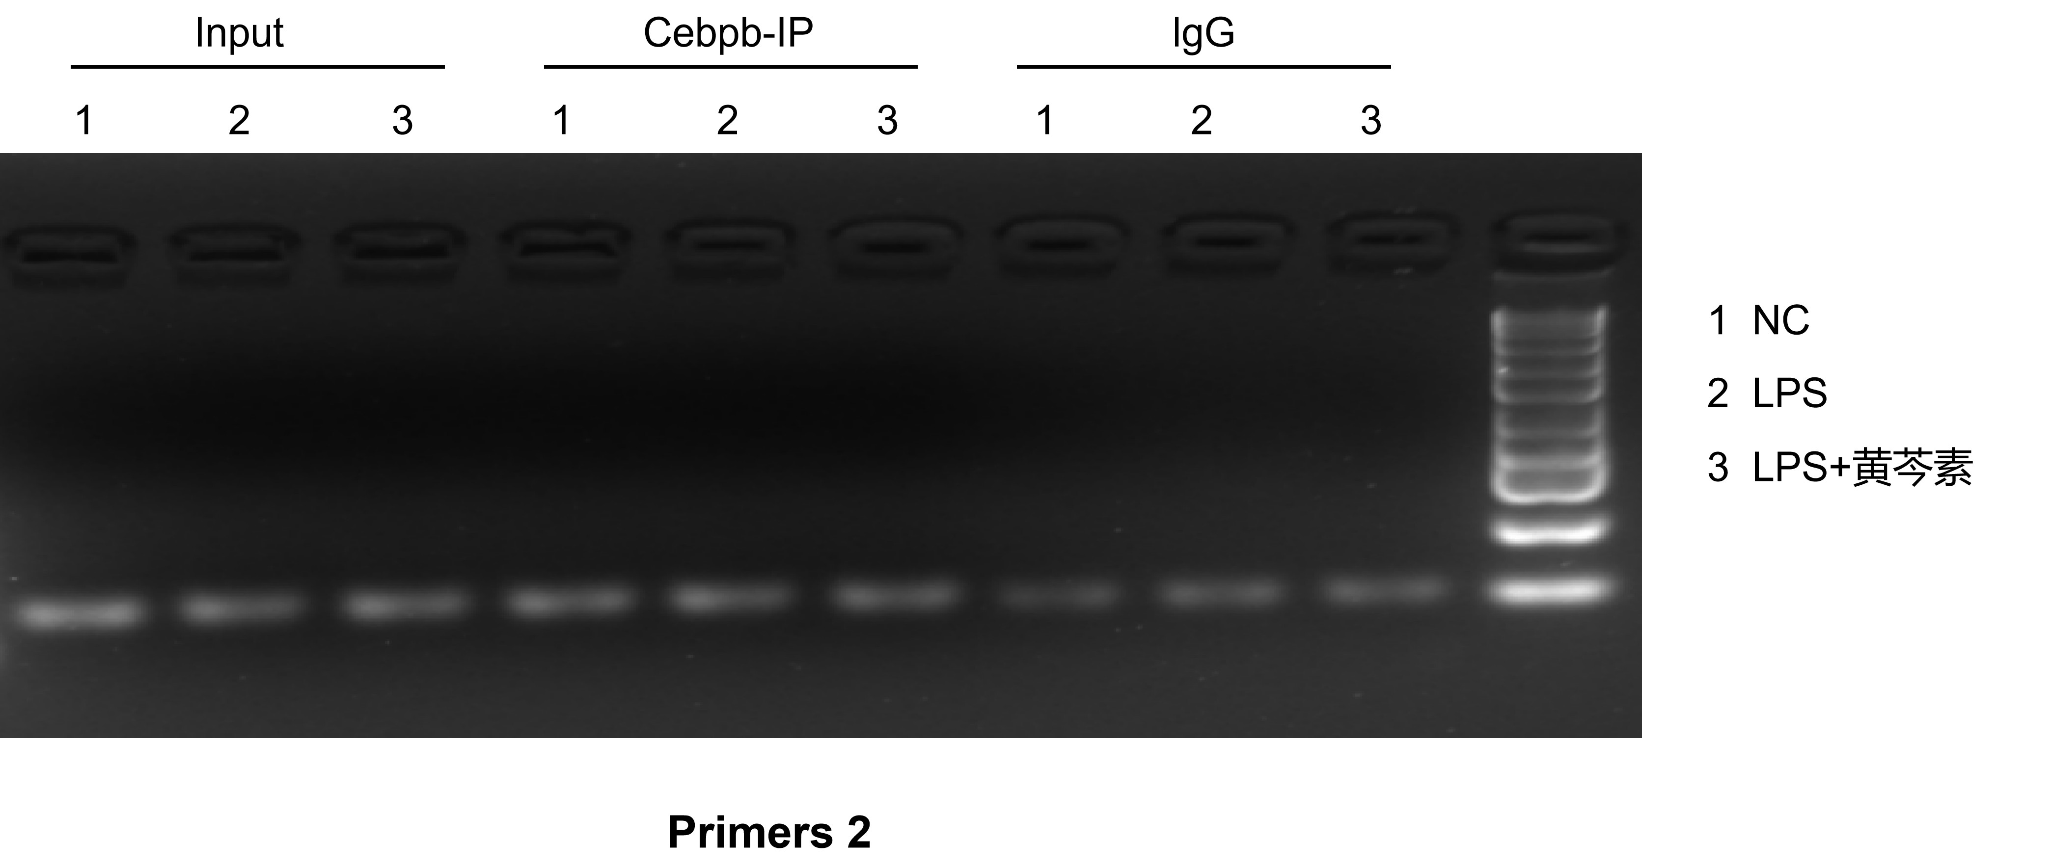

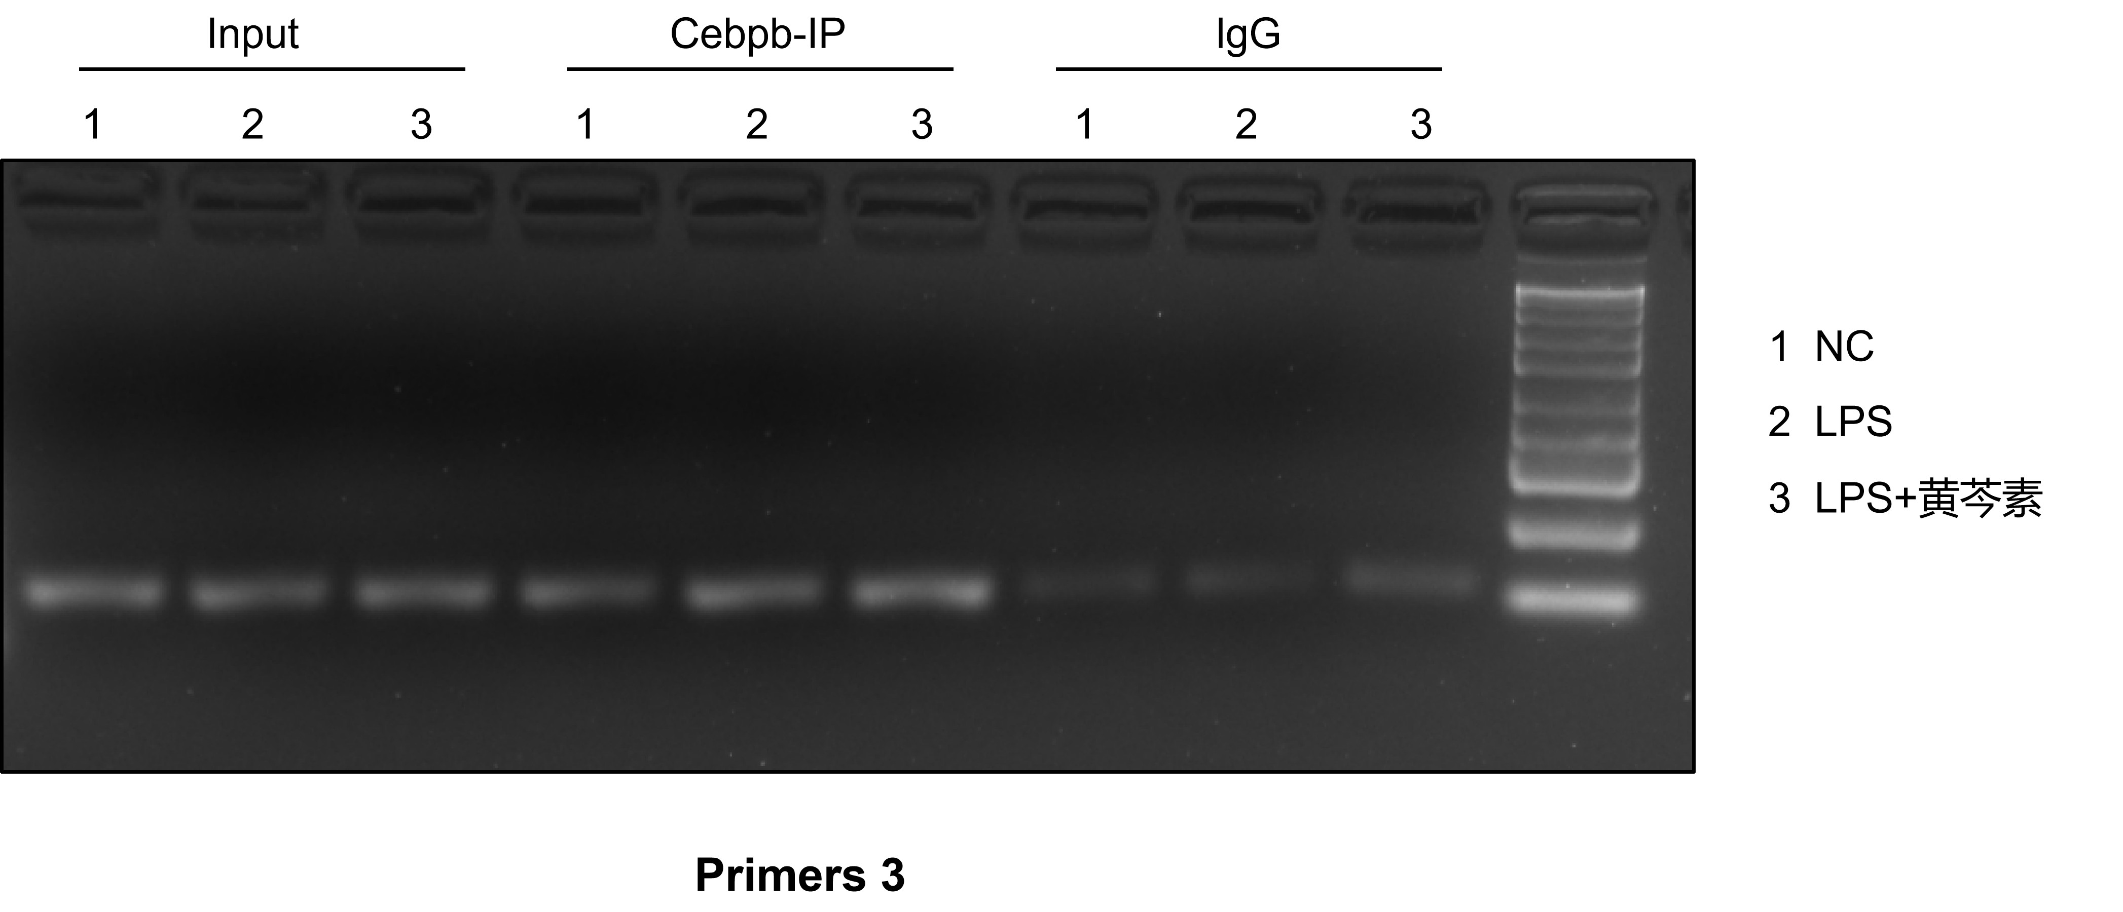

LPS+Baicalein nucleocytoplasmic protein extraction and western blotting
Nucleus C/EBPβ Nucleus H3

Cytoplasm C/EBPβ Cytoplasm GAPDH

LPS+NAC+Baicalein nucleocytoplasmic protein extraction and western blotting
Nucleus C/EBPβ Nucleus H3

Cytoplasm C/EBPβ Cytoplasm GAPDH

Western blot analysis
C/EBPβ S100A4 β-Actin

CD86 GSDMD IL-1β
NLRP3 β-Actin

Caspase-1 ACS
p-P65 β-Actin

