Table 1 Baseline characteristics of patients with CTEPH and healthy controls
 | CTEPH（n=32） | Control（n=20） | P value
Basic Information
Female | 21 | 9 | 0.08
Age (years) | 62.5±9.33 | 60.5±4.57 | 0.09
BMI (kg/m²) | 22.11±2.81 | 21.01±2.22 | 0.14
Complete Blood Count (CBC)
White Blood Cell Count (×10⁹/L) | 6.19±1.69 | 6.33±1.47 | 0.76
Neutrophil Count (×10⁹/L） | 3.85±1.21 | 3.5±1.29 | 0.33
Lymphocyte Count (×10⁹/L） | 1.69±0.74 | 2.27±0.53 | <0.01*
Monocyte Count (×10⁹/L） | 0.37±0.21 | 0.35±0.13 | 0.94
Hemoglobin (g/L） | 133±17.27 | 149±14.61 | 0.02*
Platelet Count (×10⁹/L） | 217.5±91.45 | 260.5±37.15 | 0.01*
Blood Biochemistry
Total Protein (g/L) | 75.52±3.67 | 76.13±3.52 | 0.55
Albumin (g/L） | 40.11±3.92 | 48.02±2.22 | <0.01*
Total Bilirubin (μmol/L) | 13.13±4.06 | 13.63±4.29 | 0.68
Alanine Aminotransferase (U/L) | 15.85±9.47 | 14.5±9.96 | 0.63
Aspartate Aminotransferase (U/L) | 19.55±13.57 | 18.45±4.19 | 0.25
Uric Acid (μmol/L) | 305.1±61.46 | 372.8±60.65 | 0.05*
Creatinine (μmol/L) | 65±19.2 | 62.9±14.3 | 0.73
Blood Glucose (mmol/L) | 5.66±1.53 | 6.02±1.16 | 0.29
Blood Urea Nitrogen (mmol/L) | 4.85±1.29 | 4.65±1.38 | 0.12
Other Blood Indicators
C-Reactive Protein (mg/L) | 3.51±4.07 | 4.33±2.18 | 0.63
N-terminal pro-brain natriuretic peptide (pg/mL) | 354.85±2129.37 | 82±69.89 | <0.01*
Right Heart Catheterization
Right Atrial Pressure (mmHg) | 10.88±4.74 | - | -
Mean Pulmonary Artery Pressure (mmHg) | 54.91±19.54 | - | -
Pulmonary Artery Wedge Pressure (mmHg) | 10.66±3.48 | - | -
Pulmonary Vascular Resistance (Wood) | 6.48±4.54 | - | -
Cardiac Output (L/min) | 5.71±1.49 | - | -
Cardiac Index (L/(min·m²)) | 3.56±1.01 | - | -
NYHA Functional Classification
Class I | 2 | - | -
Class II | 27 | - | -
Class III | 3 | - | -
Class IV | 0 | - | -

Table 2 Mediation analysis of the effects of MCP-1 and CD16⁺ monocyte subsets on hemodynamic parameters in patients with CTEPH.
Mediating Variable |  | Potential Pathways | Exposure-Mediator (a) |  | Mediator-Outcome (b) |  | Indirect Effect (a*b) | Total Effect (c) | Direct Effect (c') | Proportion Mediated (%) | Bootstrap 95% CI
CD16⁺ monocyte proportion | MCP-1→CD16⁺ monocyte proportion→PVR |  |  | 0.036 (p=0.064) |  | 0.827 (p<0.001) | 0.030 | 0.026 | -0.004 (p=0.773) | 115.38 | [0.004, 0.073]
CD16⁺ monocyte proportion | MCP-1→CD16⁺ monocyte proportion→mPAP |  |  | 0.036 (p=0.064) |  | 2.858 (p<0.001) | 0.102 | 0.033 | -0.069 (p=0.348) | 309.1 | [0.017, 0.265]
MCP-1 concentration | CD16⁺ monocyte proportion→MCP-1→PVR |  |  | 3.084 (p=0.064) |  | -0.004 (p=0.773) | -0.011 | 0.815 | 0.827 (p<0.001) | - | [-0.104, 0.045]
MCP-1 concentration | CD16⁺ monocyte proportion→MCP-1→mPAP |  |  | 3.084 (p=0.064) |  | -0.069 (p=0.348) | -0.213 | 2.645 | 2.858 (p<0.001) | - | [-0.953, 0.114]
Table 3 Clinical baseline characteristics of patients with acute pulmonary thromboembolism
 | APE-1 | APE-2 | APE-3 | APE-4 | APE-5
Basic Information
Gender | Male | Male | Female | Male | Female
Age (years) | 60 | 35 | 66 | 60 | 49
BMI (kg/m²) | 17.30 | 32.65 | 30.39 | 20.76 | 20.00
Smoking history | Yes | NO | NO | NO | NO
Vital Signs and Other Important Clinical Parameters (at admission)
Systolic blood pressure (mmHg) | 110 | 129 | 161 | 126 | 101
Diastolic blood pressure (mmHg) | 71 | 86 | 79 | 72 | 62
Heart rate (beats/min) | 77 | 82 | 80 | 89 | 89
Respiratory rate (breaths/min) | 18 | 36 | 34 | 26 | 24
Arterial oxygen saturation (%) | 85.5 | 73.29 | 79.14 | 77.85 | 59.7
Oxygenation index (cmH₂O/mmHg) | 131.54 | 192.87 | 239.82 | 108.13 | 66.33
Body temperature（°C） | 36.5 | 37.0 | 36.7 | 36.5 | 37.2
Consciousness status | Comatose | Conscious | Conscious | Conscious | Conscious
Risk Factors and Comorbidities for Venous Thromboembolism
History of venous thromboembolism | - | - | Yes | Yes | Yes
Chronic heart failure or coronary heart disease | - | - | Yes | - | -
Cancer or myeloproliferative disease | - | - | - | Yes | -
Diabetes | - | - | - | - | -
Hypertension | - | - | Yes | Yes | -
Chronic liver disease | - | - | - | - | -
Renal insufficiency | - | - | - | - | -
Chronic inflammation and autoimmune disease | - | - | - | - | -
Recent surgery or trauma (past 30 days) | - | - | - | - | -
Recent immobilization (past 30 days) | - | - | - | - | -
Chronic obstructive pulmonary disease (COPD) | - | - | Yes | - | Yes
Hormone therapy | - | - | - | - | -
Pregnancy or puerperium | - | - | - | - | -
Complete Blood Count (CBC)
White Blood Cell Count (×10⁹/L) | 7.7 | 8.11 | 4.82 | 7.1 | 7.31
Neutrophil Count (×10⁹/L） | 6.87 | 6.05 | 2.36 | 5.66 | 6.51
Lymphocyte Count (×10⁹/L） | 0.59 | 1.48 | 1.96 | 0.85 | 0.43
Monocyte Count (×10⁹/L） | 0.17 | 0.54 | 0.3 | 0.44 | 0.29
Hemoglobin (g/L） | 113 | 138 | 110 | 104 | 154
Platelet Count (×10⁹/L） | 266 | 210 | 243 | 227 | 130
Blood Biochemistry
Total Protein (g/L) | 76.3 | 73.1 | 77.3 | 73.8 | 75.1
Albumin (g/L） | 30.5 | 36.2 | 36 | 33.9 | 34.9
Total Bilirubin (μmol/L) | 6.5 | 14.5 | 9.2 | 8.6 | 8.1
Alanine Aminotransferase (U/L) | 19.5 | 141.1 | 23.3 | 23.5 | 2.8
Aspartate Aminotransferase (U/L) | 26.4 | 45.6 | 17.5 | 16.6 | 12.8
Uric Acid (μmol/L) | 272.5 | 265.3 | 263.8 | 307.6 | 380
Creatinine (μmol/L) | 62 | 69 | 46 | 116 | 63
Blood Glucose (mmol/L) | 6.6 | 4.6 | 5.3 | 6.7 | 8.3
Blood Urea Nitrogen (mmol/L) | 6.83 | 4.67 | 6.62 | 7.28 | 11.17
Other Blood Indicators
C-reactive protein (mg/L) | 94.18 | 25.81 | 6.05 | 48.32 | 100.54
N-terminal pro-brain natriuretic peptide (pg/mL) | 1322.9 | 186.9 | 161.6 | 2384.7 | 8894.9
Hypersensitive troponin (ng/mL) | 0.0162 | 0.0112 | 0.0657 | 0.0193 | 0.0657
D-dimer (mg/L) | 2.25 | 6.66 | 3.66 | 10.37 | 3.17
sPESI Score | 1 | 1 | 2 | 1 | 2
Comprehensive Risk Stratification | Intermediate-high risk | Intermediate-high risk | Intermediate-high risk | Intermediate-high risk | Intermediate-high risk

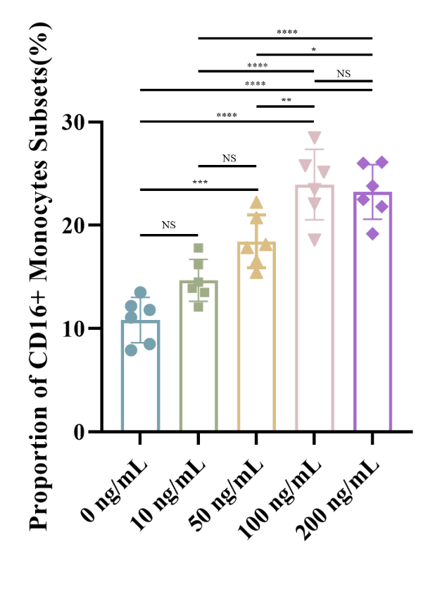
Figure 1: Dose-response effect of MCP-1 on CD16⁺ monocyte expansion in vitro. Healthy donor PBMCs (n = 6 independent biological replicates) were stimulated with a concentration gradient of recombinant human MCP-1 (0, 10, 50, 100, and 200 ng/mL) for 24 hours. The bar graph illustrates the proportion of the CD16⁺ subset within the total monocyte population, demonstrating a clear dose-dependent expansion that peaks and plateaus at the optimal concentration of 100 ng/mL. Data are presented as mean ± SD. Statistical significance was determined using one-way ANOVA followed by appropriate post hoc tests; *p < 0.05, **p < 0.01, ***p < 0.001, ****p < 0.0001, NS = not significant (For the comprehensive visual gating strategy and representative flow cytometry pseudo-color plots, please refer to the "Flow Cytometric Analysis of Monocyte Subsets" subsection in the Methods and Figure 1A of the main text).

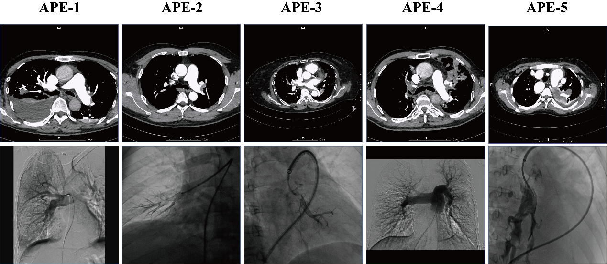
Figure 2: Imaging findings in patients with acute pulmonary embolism. the top row shows CTPA images from five patients with acute pulmonary embolism; the bottom row presents corresponding digital subtraction angiography (DSA) images.

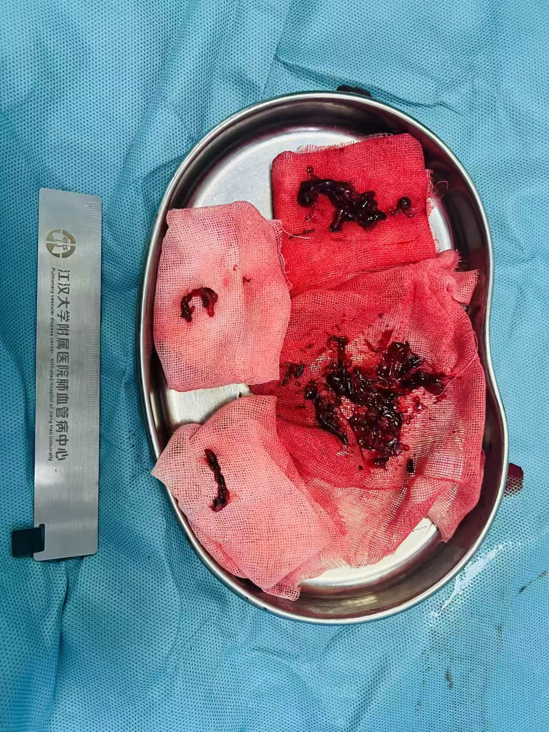
Figure 3: Gross appearance of fresh thrombi aspirated via catheter from patients with acute pulmonar y thromboembolism.

Table 4 Quality control metrics of Single-cell RNA sequencing
Sample | APE-1 | APE-2 | APE-3 | APE-4 | APE-5
Cell number | 3662 | 6772 | 3086 | 3870 | 7009
Raw Reads | 313358812 | 341982024 | 297781173 | 373585191 | 291719828
Valid Read (%) | 88.44 | 89.08 | 88.99 | 86.01 | 87.03
Q30 of Barcodes (%) | 95.90 | 96.63 | 96.21 | 94.71 | 96.28
Q30 of UMIs (%) | 95.85 | 96.19 | 96.13 | 95.43 | 97.59

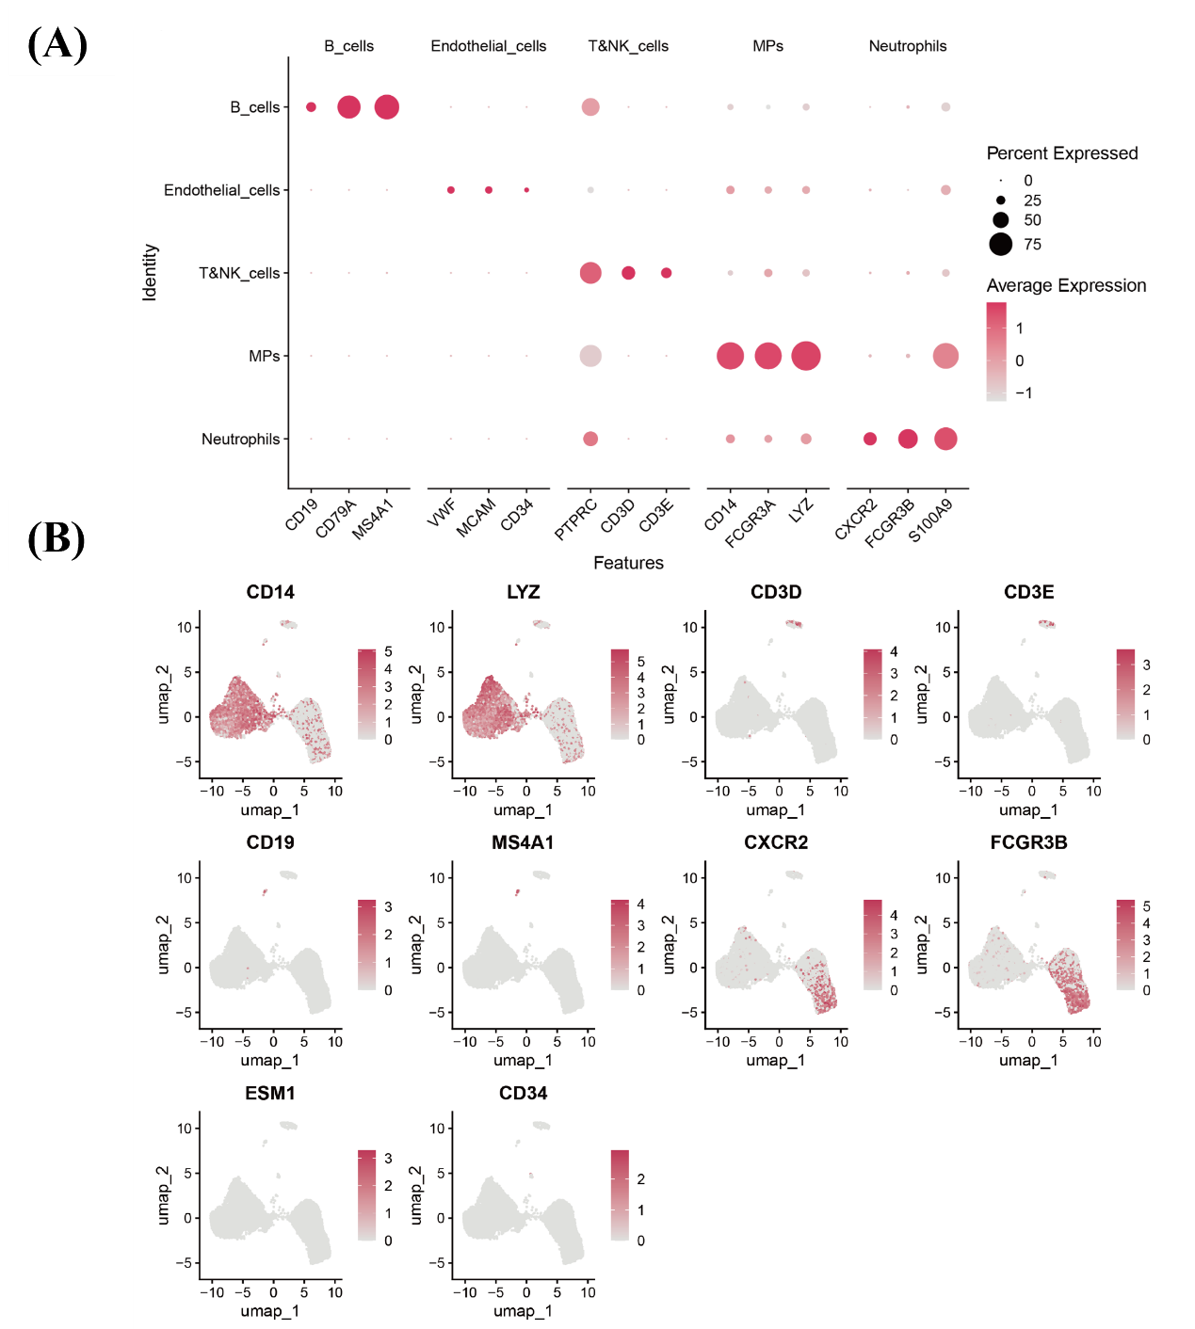
Figure 4A: Bubble plot displaying marker genes of the annotated five major cell types (NK/T cells, monocytes/macrophages, B cells, neutrophils, and endothelial cells).
Figure 4B: UMAP plots showing the expression patterns of representative marker genes for five major cell types (NK/T cells, monocytes/macrophages, B cells, neutrophils, and endothelial cells).

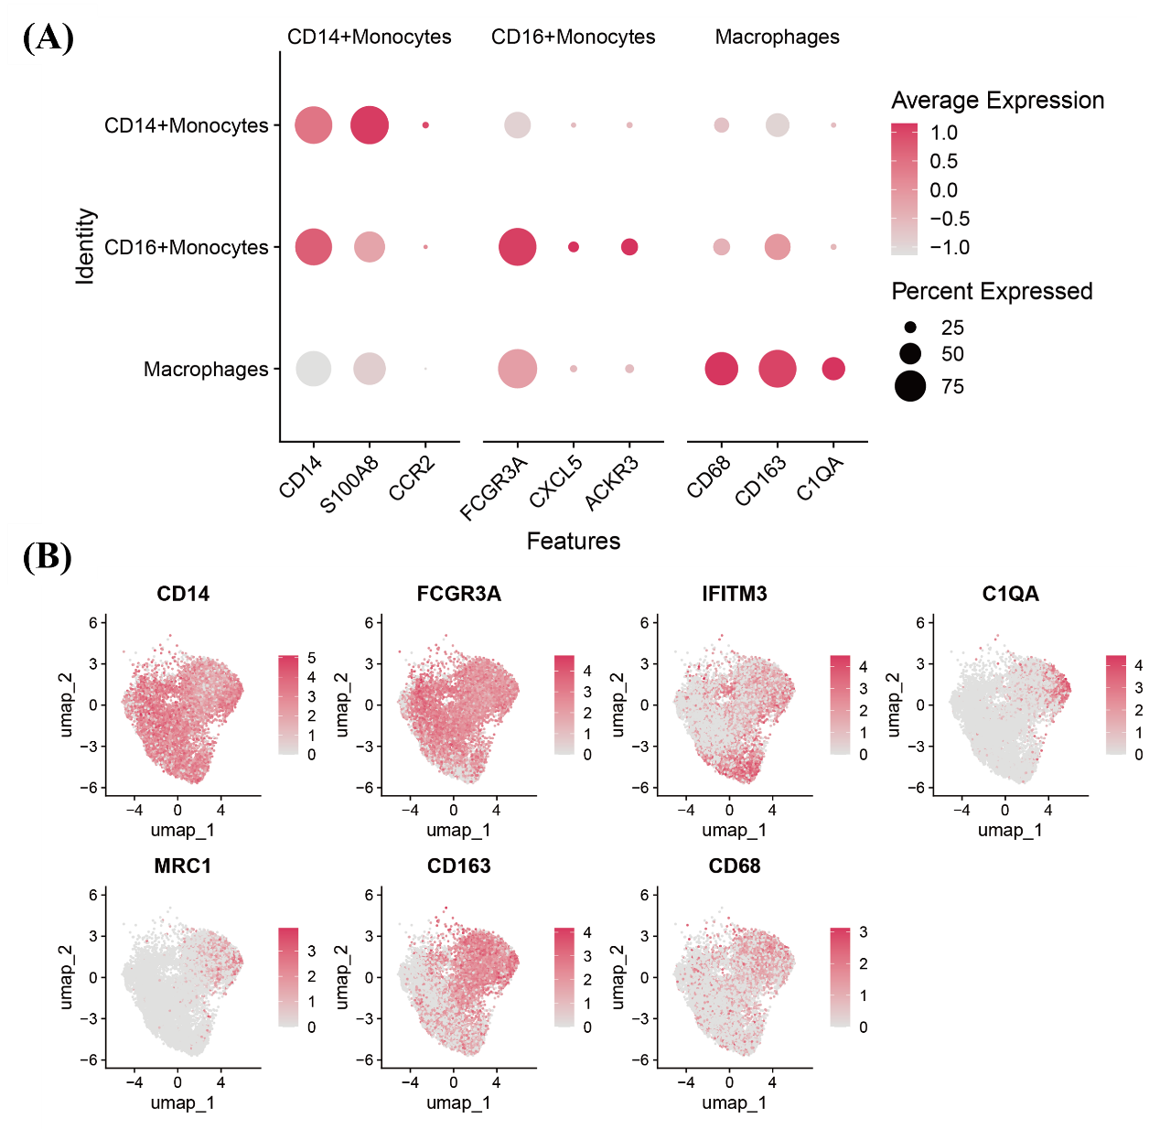
Figure 5A: Bubble plot displaying marker genes of the three annotated monocyte/macrophage subsets.
Figure 5B: UMAP plots showing the expression patterns of representative marker genes for CD14⁺ monocytes, CD16⁺ monocytes, and macrophages.
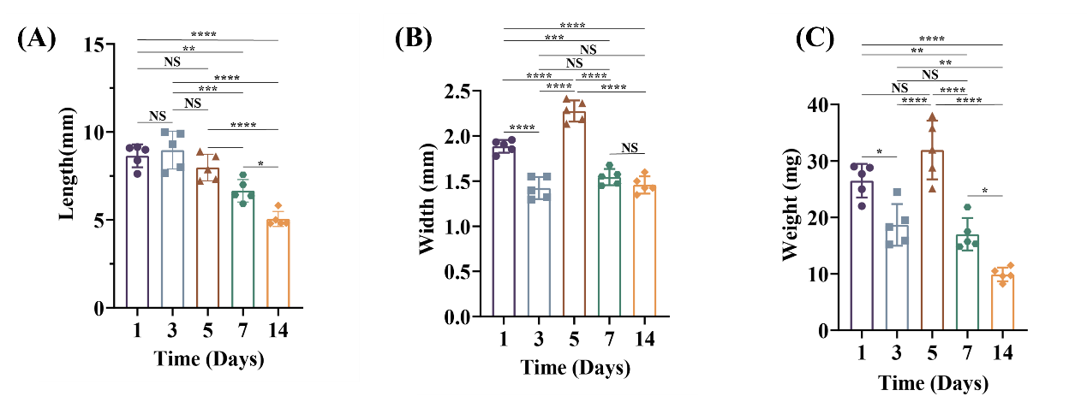
Figure 6: Quantitative analysis of thrombi in the mouse inferior vena cava ligation model. (A) Temporal trend of thrombus length. (B) Temporal trend of thrombus width. (C) Temporal trend of thrombus weight. NS p> 0.05; *p < 0.05; **p < 0.01; ***p < 0.001; ****p < 0.0001.

