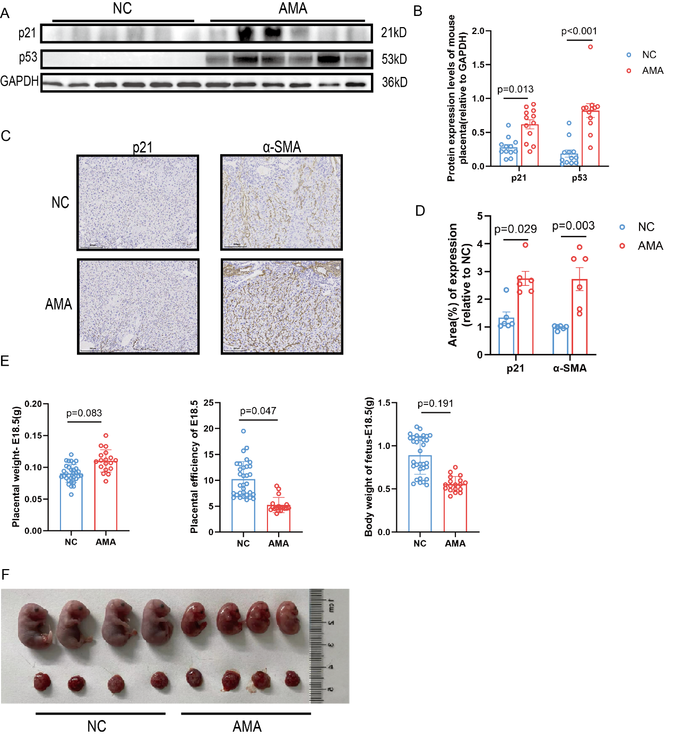
Figure S1. AMA mouse placentas exhibit accelerated senescence characteristics (A) Representative Western blot analysis of p21 and p53 in placental tissues from normal control (NC) and AMA mice. (B) Statistical quantification of p21 and p53 protein densities from the Western blot analysis in (A) (n = 6 dams per group). (C) Representative immunohistochemistry images showing senescence markers in murine placental tissues. Scale bar = 200 μm. (D) Statistical quantification of the immunohistochemical staining in (C) (n = 6 dams per group). (E) Statistical analysis and corresponding morphological comparisons of placental weight, fetal length, fetal weight, and placental efficiency. (F) Representative images of fetuses and their corresponding placentas. Data are presented as mean ± SEM. (B) and (D), Student's t-test; (E), Linear mixed-effects (LME) models with the individual dam as a random effect.

Figure S2. Human placental RNA-Seq analysis and validation of Grem1 expression in mouse placentas (A) KEGG pathway enrichment analysis of RNA-Seq data displaying the top 20 enriched pathways (NC: n = 20; AMA: n = 22). (B) Number of DEGs within the significantly enriched pathways. (C) Representative images of Western blot analysis of GREM1 protein levels in placental tissues from AMA and control mice. (D) RT-qPCR analysis of Grem1 mRNA expression levels in murine placental tissues (n = 6 dams per group). (E) Statistical quantification of GREM1 protein densities from the Western blot in (C) (n = 6 dams per group). Data are presented as mean ± SEM. (D) and (E), Student's t-test.
Figure S3. BMP4 and GREM1 treatment modulates doxorubicin induced senescence in HTR-8/SVneo cells (A) Statistical quantification of protein densities for senescence-associated markers (p16, p21, p53, BCL2, and γ-H2AX) in the DOX-induced senescence model, corresponding to the Western blot in Fig. 4B (n = 3 independent biological replicates). (B) Statistical quantification of protein densities for the indicated markers in HTR-8/SVneo cells treated with rhGREM1 or BMP4 in the presence or absence of DOX, corresponding to the Western blot in Fig. 4C (n = 3 independent biological replicates). (C) Representative images of Western blot analysis of senescence-associated markers in HTR-8/SVneo cells treated with rhGREM1. (D) Statistical quantification of the protein densities from the Western blot in (C) (n = 3 independent biological replicates). Data are presented as mean ± SEM. (A), (B), and (D), One-way ANOVA with Tukey multiple comparison test.

Figure S4. BMP-SMAD signaling mediates GREM1 induced dysfunction and senescence in HTR-8/SVneo cells (A) Statistical quantification of protein densities for BMP-SMAD signaling pathway components in GREM1-overexpressing HTR-8/SVneo cells, corresponding to the Western blot in Fig. 5A (n = 3 independent biological replicates). (B) Statistical quantification of protein densities for BMP-SMAD pathway components in GREM1-overexpressing HTR-8/SVneo cells following treatment with the agonist sb4, corresponding to the Western blot in Fig. 5B (n = 3 independent biological replicates). Data are presented as mean ± SEM. (A) and (B), One-way ANOVA with Tukey multiple comparison test.

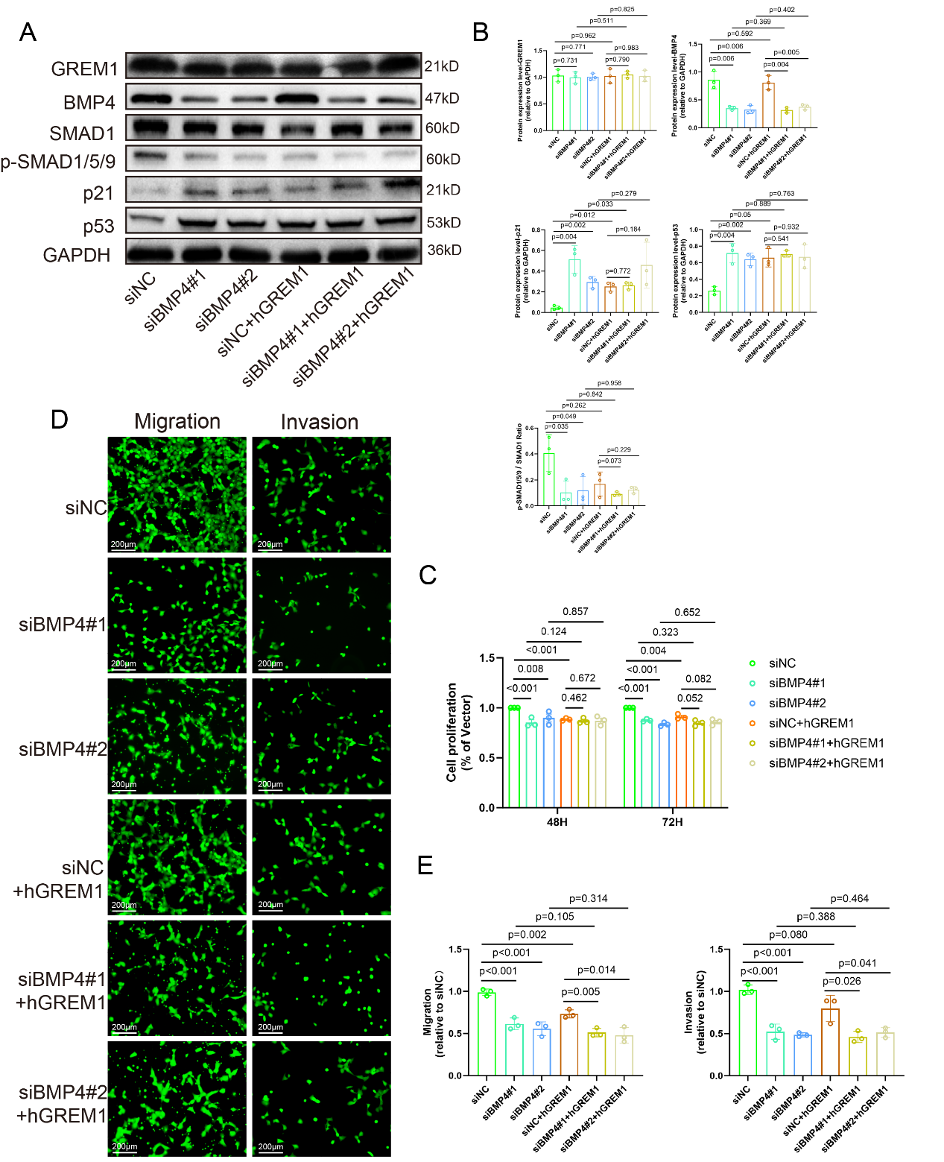
Figure S5. GREM1 induces senescence in HTR-8/SVneo cells by blocking the protective effect of BMP4 (A) Representative images of Western blot analysis of BMP-SMAD signaling components and classic senescence markers in HTR-8/SVneo cells following siRNA-mediated BMP4 knockdown (KD) and treatment with hGREM1 (300 ng/mL). (B) Densitometric quantification of the Western blot results shown in (A) (n = 3 independent biological replicates). (C-E) Statistical quantification of cell proliferation (C), migration (D), and invasion (E) in BMP4-KD HTR-8/SVneo cells treated with or without rhGREM1 (n = 3 independent biological replicates). Representative images of migration and invasion assays are shown. Scale bar = 200 μm. Data are presented as mean ± SEM. (B–E), One-way ANOVA with Tukey multiple comparison test.

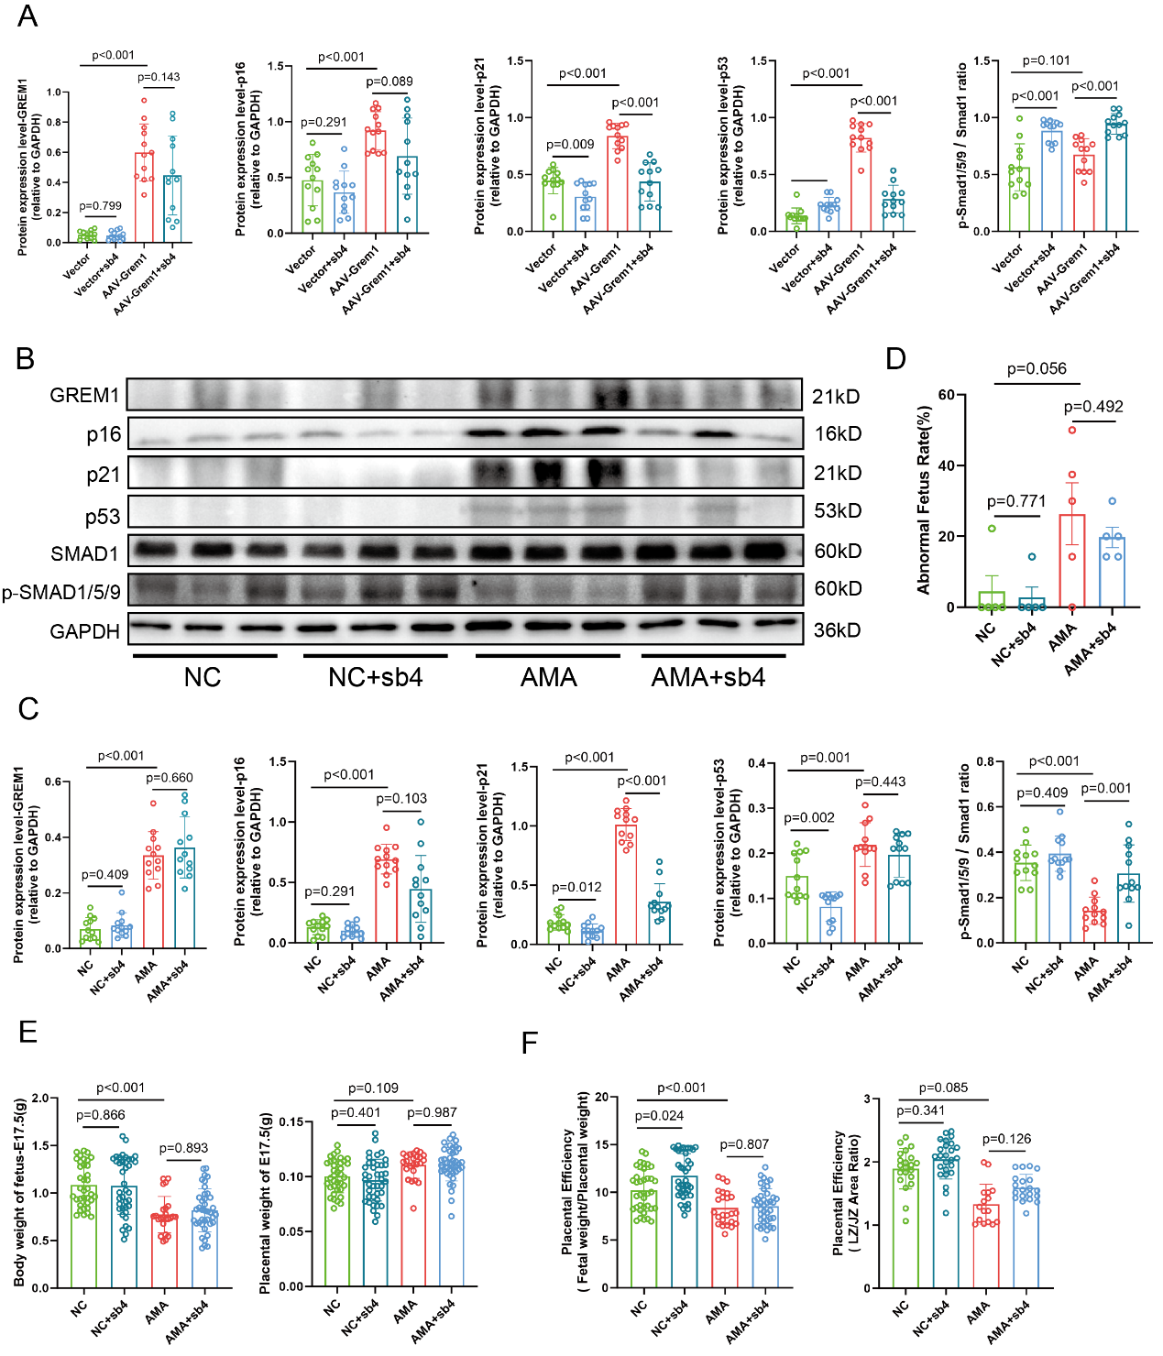
Figure S6. Pharmacological activation of the BMP-SMAD pathway via sb4 partially rescues the AMA phenotype (A) Statistical quantification of protein densities for senescence-associated markers and components of the BMP-SMAD signaling pathway in murine placental tissues, corresponding to the Western blot in Fig. 6B (n = 6 dams per group). (B) Representative images of Western blot analysis of BMP-SMAD pathway components and classic senescence markers in control and AMA mice following tail vein injection of sb4. (C) Statistical quantification of protein densities from the Western blot in (B) (n = 6 dams per group). (D) Statistics of abnormal fetal outcomes including embryo resorption and hemorrhage observed during tissue collection (n = 6 dams per group). (E) Statistical analysis of fetal and corresponding placental weights across all experimental groups. (F) Statistics of placental efficiency evaluated by fetal-to-placental weight ratios and the area ratio of LZ/JZ. Data are presented as mean ± SEM. (A), (C), and (D), One-way ANOVA with Tukey multiple comparison test; (E) and (F), Linear mixed-effects (LME) models with the individual dam as a random effect.

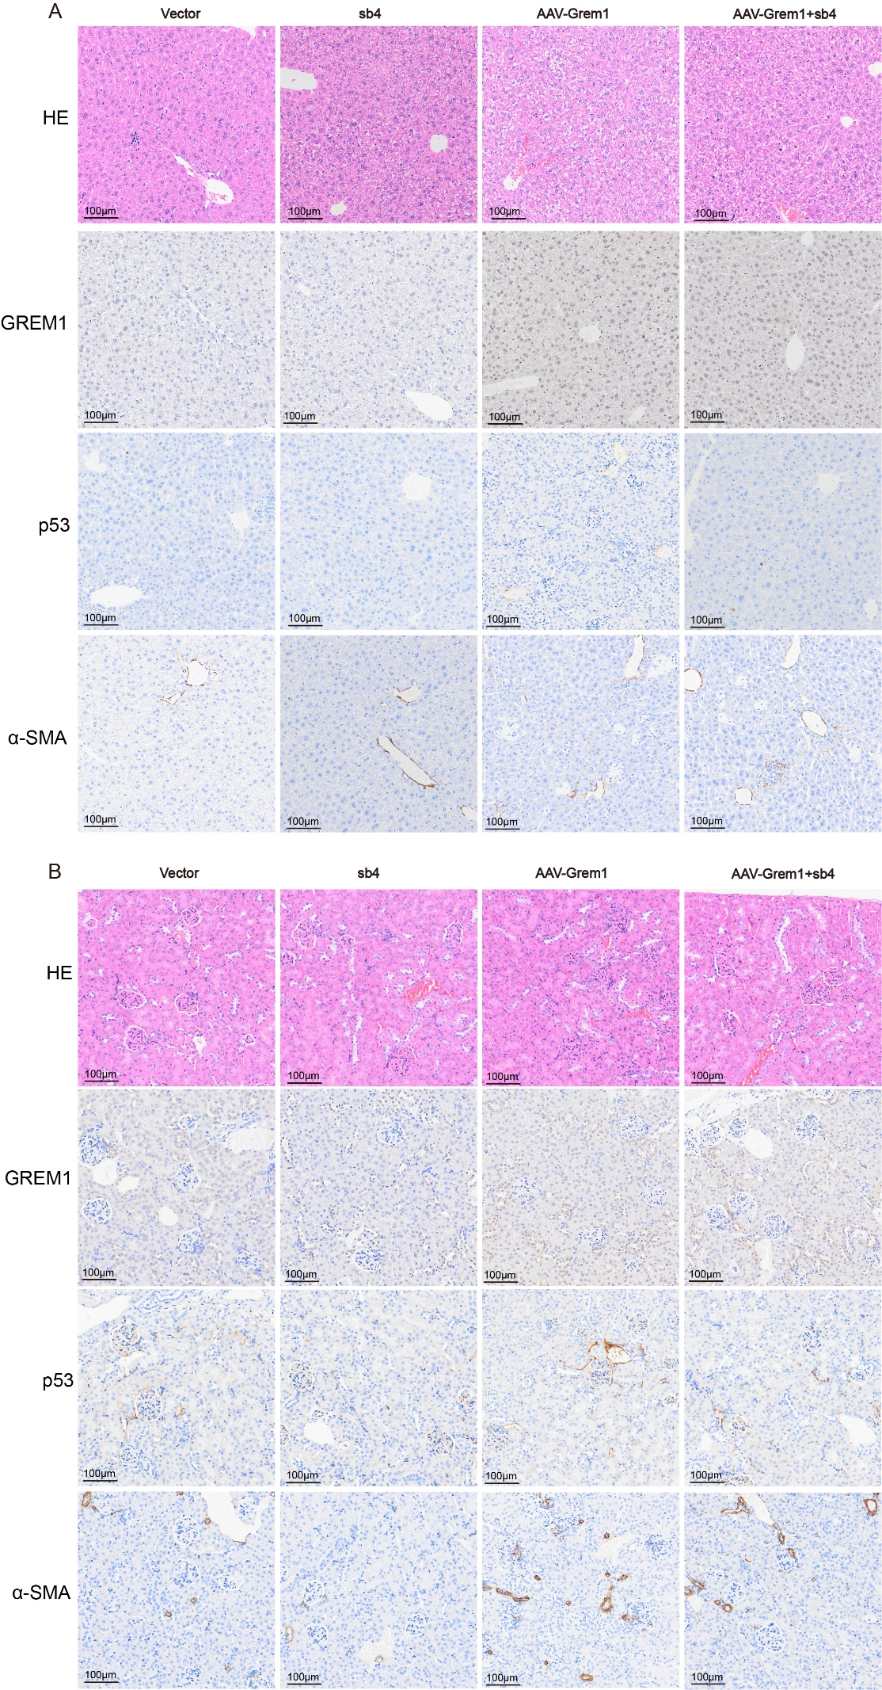
Figure S7. Histological and immunohistochemical evaluation of maternal liver and kidney tissues (A) Representative images of H&E staining and immunohistochemical detection of GREM1, p53, and α-SMA in maternal liver tissues from the Vector, sb4, AAV-Grem1, and AAV-Grem1+sb4 groups. (B) Representative images of H&E staining and immunohistochemical detection of GREM1, p53, and α-SMA in maternal kidney tissues across the indicated groups.Scale bars = 100 μm.

TABLE S1: Reagents and Primer sequences
Reagent or resource | Source | Identifier | Concentration
Antibodies
p16 | abcam | ab51243 | 1:2000
p21 | abcam | ab109520/ ab188224 | 1:2000  1:3000
p53 | abcam | ab26 | 1:3000
BCL2 | abcam | ab182858 | 1:3000
α-SMA | Cell Signaling Technology | # 19245 | 1:1000
GREM1 | abcam  Cell Signaling Technology | ab22138  #4383 | 1:1000  1:1000
γ-H2AX | abcam | ab81299 | 1:3000
BMP4 | abcam | ab39973 | 1:3000
SMAD1 | Cell Signaling Technology | #6944 | 1:1000
p-SMAD1/5/9 | Cell Signaling Technology | #13820 | 1:1000
GAPDH | Cell Signaling Technology | #2118 | 1:10000
Chemicals and recombinant proteins
Doxorubicin hydrochloride | MedChemExpress | HY-15142
BMP signaling agonist sb4 | MedChemExpress | HY-124697
GREM1 | R&D Systems | 5190-GR
BMP4 | R&D Systems | 314-BP
Critical commercial assays
Cell Senescence β-Galactosidase Staining Kit | MedChemExpress | HY-K1089
Primers
 | Forward | Reverse
GREM1 | GGGAGCCCTGCATGTGAC | GAAGCGGTTGATGATGGTGC
IL-1β | TCGCCAGTGAAATGATGGCT | GGTCGGAGATTCGTAGCTGG
IL-6 | CCACCGGGAACGAAAGAGAA | GAGAAGGCAACTGGACCGAA
MMP9 | GGACAAGCTCTTCGGCTTCT | TCGCTGGTACAGGTCGAGTA
COL1A1 | GCTCGTGGAAATGATGGTGC | ACCCTGGGGACCTTCAGAG
ID1 | AATCCGAAGTTGGAACCCCC | GATCTGGATCTCACCTCGGC
GAPDH | GGAGCGAGATCCCTCCAAAAT | GGCTGTTGTCATACTTCTCATGG

