Supplemental data

Supplemental methods
Weight measurement
Measurements were conducted at the same time of day (to minimize diurnal variation) at each specified time point: -D3, D0, D1, D3, D5, D7, D14, and D21.

Immunocytochemistry staining
Spinal cord samples were fixed in 4% PFA and then embedded in OCT compound for subsequent sectioning. Each tissue section was incubated with primary antibodies (GFAP, ABclonal, China, A19058; GAP-43, ABclonal, China, A16857) overnight at 4°C, followed by incubation with secondary antibodies (HRP Donkey Anti-Rabbit IgG (H+L), ABclonal, China, AS038; FITC Goat Anti-Rabbit IgG (H+L), ABclonal, China, AS011) away from light for 1 h at room temperature. Images were acquired via an LX7 fluorescence microscope (Olympus, Japan).

Supplemental results
Table S1. Correlation coefficients between various parameters and principal components (F1–F4)
 | F1 | F2 | F3 | F4
Weight | 0.847 | 0.046 | 0.107 | 0.000
BBB score | 0.980 | 0.004 | 0.004 | 0.012
SLE  (hypointense) | 0.140 | 0.799 | 0.018 | 0.042
SLE  (hyperintense) | 0.353 | 0.447 | 0.163 | 0.037
Lesion size | 0.828 | 0.065 | 0.048 | 0.060
Neuron density | 0.780 | 0.189 | 0.017 | 0.014
TNF-α | 0.706 | 0.069 | 0.226 | 0.000
IL-6 | 0.768 | 0.175 | 0.029 | 0.029
IL-1β | 0.067 | 0.018 | 0.811 | 0.105
IntDen/Area  (GFAP) | 0.967 | 0.031 | 0.001 | 0.001
IntDen/Area  (GAP-43) | 0.381 | 0.340 | 0.197 | 0.082

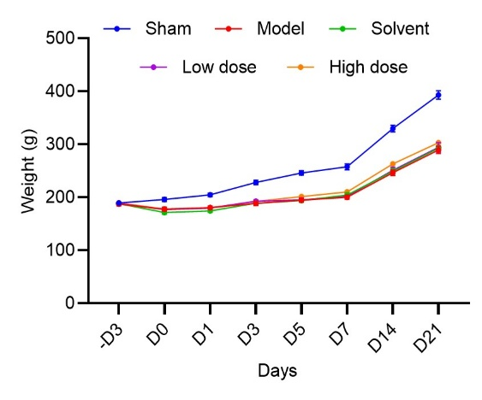
Fig. S1 Changes in the body weights of the rats in the different groups over time. Body weights of rats in the Sham, Model, Solvent, Low-dose, and High-dose groups were recorded from –D3 to D21 at the indicated time points.

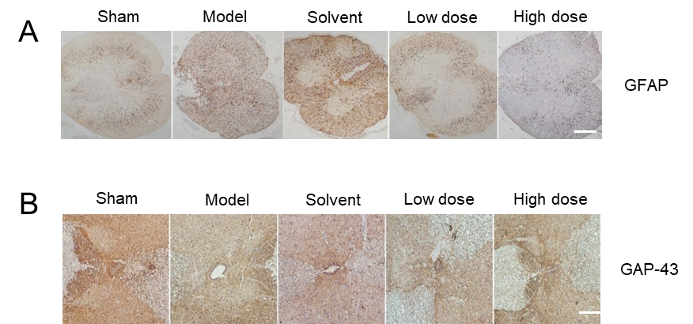
Fig. S2 Immunohistochemical analysis of GFAP and GAP-43 expression in spinal cord tissues. (A) Immunohistochemical staining was performed to determine the expression levels of GFAP in spinal cord tissues from each group. (B) Immunohistochemical staining was performed to determine the expression levels of GAP-43 in spinal cord tissue sections from different treatment groups.
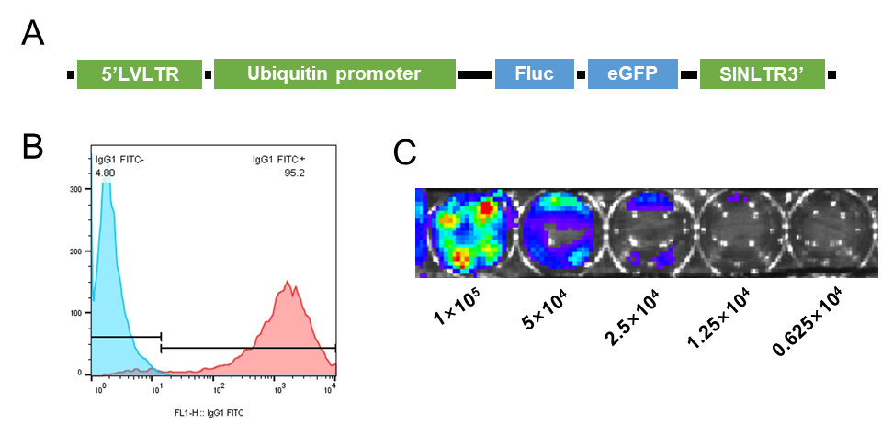
Fig. S3 The dynamic metabolism of UC-MSCs in vivo. (A) Illustration of the lentivirus-mediated dual-fluorescence reporter construct (pLV-Fluc-eGFP). Fluc and GFP were used for BLI and green fluorescent protein imaging, respectively. (B) Flow cytometry analysis of UC-MSCs transduced with the lentivirus. The blue histogram represents the isotype control (IgG1 FITC-), and the red histogram shows the proportion of cells positive for the relevant marker (IgG1 FITC+), with 95.2% of the cells being positive, indicating efficient transduction. Live images of cultured UC-MSCs with luci (C) expression at a series of cell density gradients in vitro.

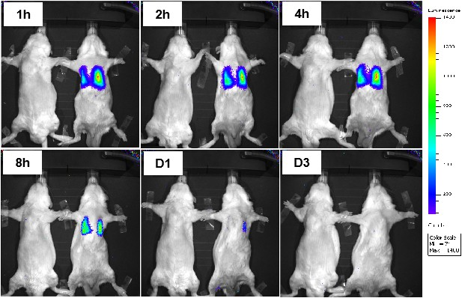
Fig. S4 Determination of lung cell retention rate after intravenous injection of UC-MSCs. In vivo bioluminescence imaging of UC-MSCs in rats at 1 h, 2 h, 4 h, 8 h, D1, and D3 postadministration (left: negative control; right: UC-MSC-treated).

