Supplementary Material

Supplementary Figure 1
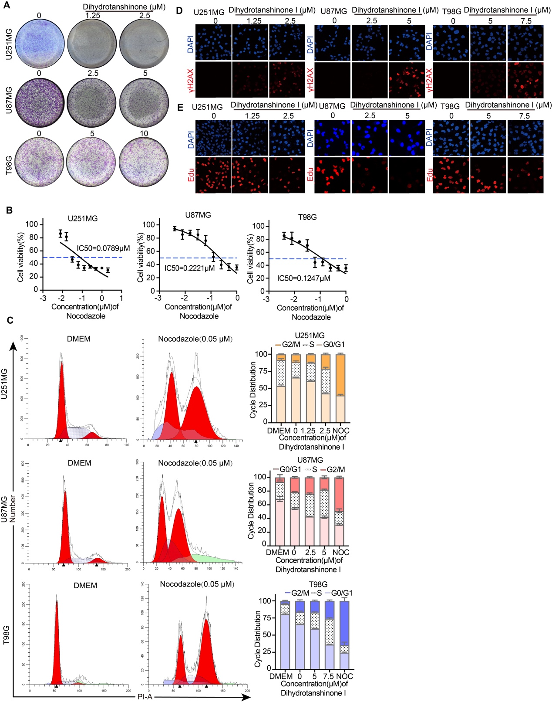
Supplementary Figure 1. DHT significantly inhibited the tumorigenic activity of glioma cells. (A) Transwell assay revealed that DHT markedly inhibited glioma cell invasion in a dose-dependent manner. Representative images of whole Transwell fields are shown. (B) The IC₅₀ values of nocodazole was 0.0789 μM in U251MG, 0.221 μM in U87MG, and 0.1247 μM in T98G cells, respectively. (C) Cell cycle distribution analysis using flow cytometry. Serum starvation (DMEM only) and nocodazole treatment were employed to synchronize cells at the G0/G1 and G2/M phases, respectively. The DHT treatment demonstrated a marked increase in the percentage of cells in the S phase in comparison to that of the control group. (D) Immunofluorescence analysis of DSBs in glioma cells following DHT treatment. Nuclei were counterstained with DAPI (blue), and DSB foci were visualized via labeling of the γH2AX subunit (red). Scale bar =100 µm. (E) Proliferative activity was assessed by EdU incorporation assay. Red fluorescence is indicative of EdU-positive proliferating cells, while DAPI stains all nuclei. Scale bar =100 µm.

Supplementary Figure 2
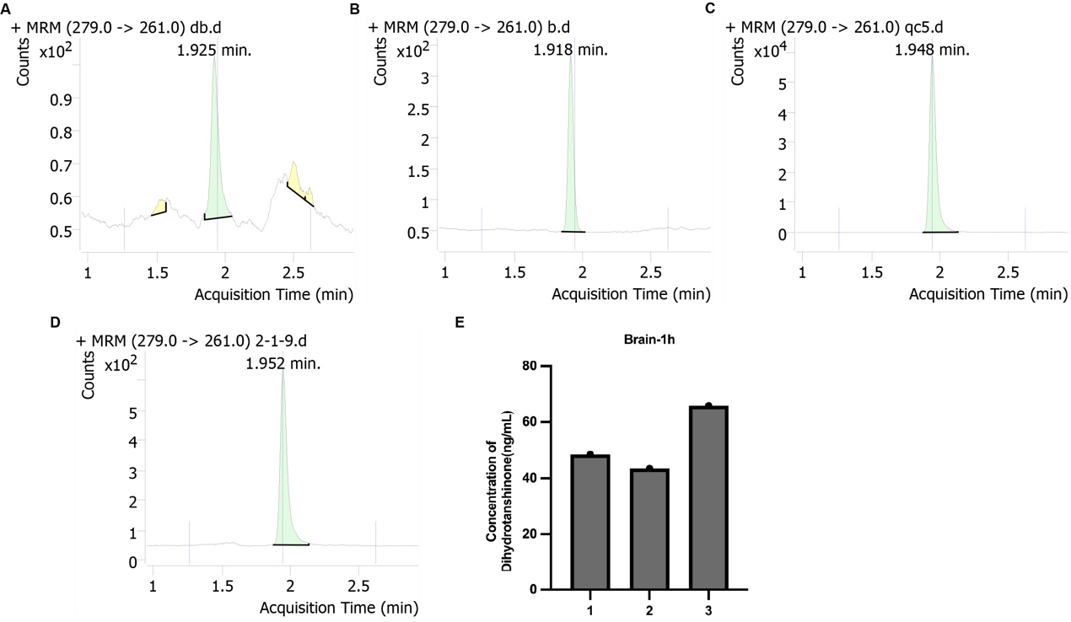
Supplementary Figure 2. Pharmacokinetics of DHT in rats. (A) Blank plasma; (B) Blank plasma spiked with the internal standard (loratadine); (C) Medium quality control sample spiked with DHT and internal standard; (D) Representative MRM chromatogram of a rat plasma sample collected 1 hour after oral administration of DHT. (E) Detection of DHT in rat brain tissue 1 h after oral gavage administration.

Supplementary Figure 3
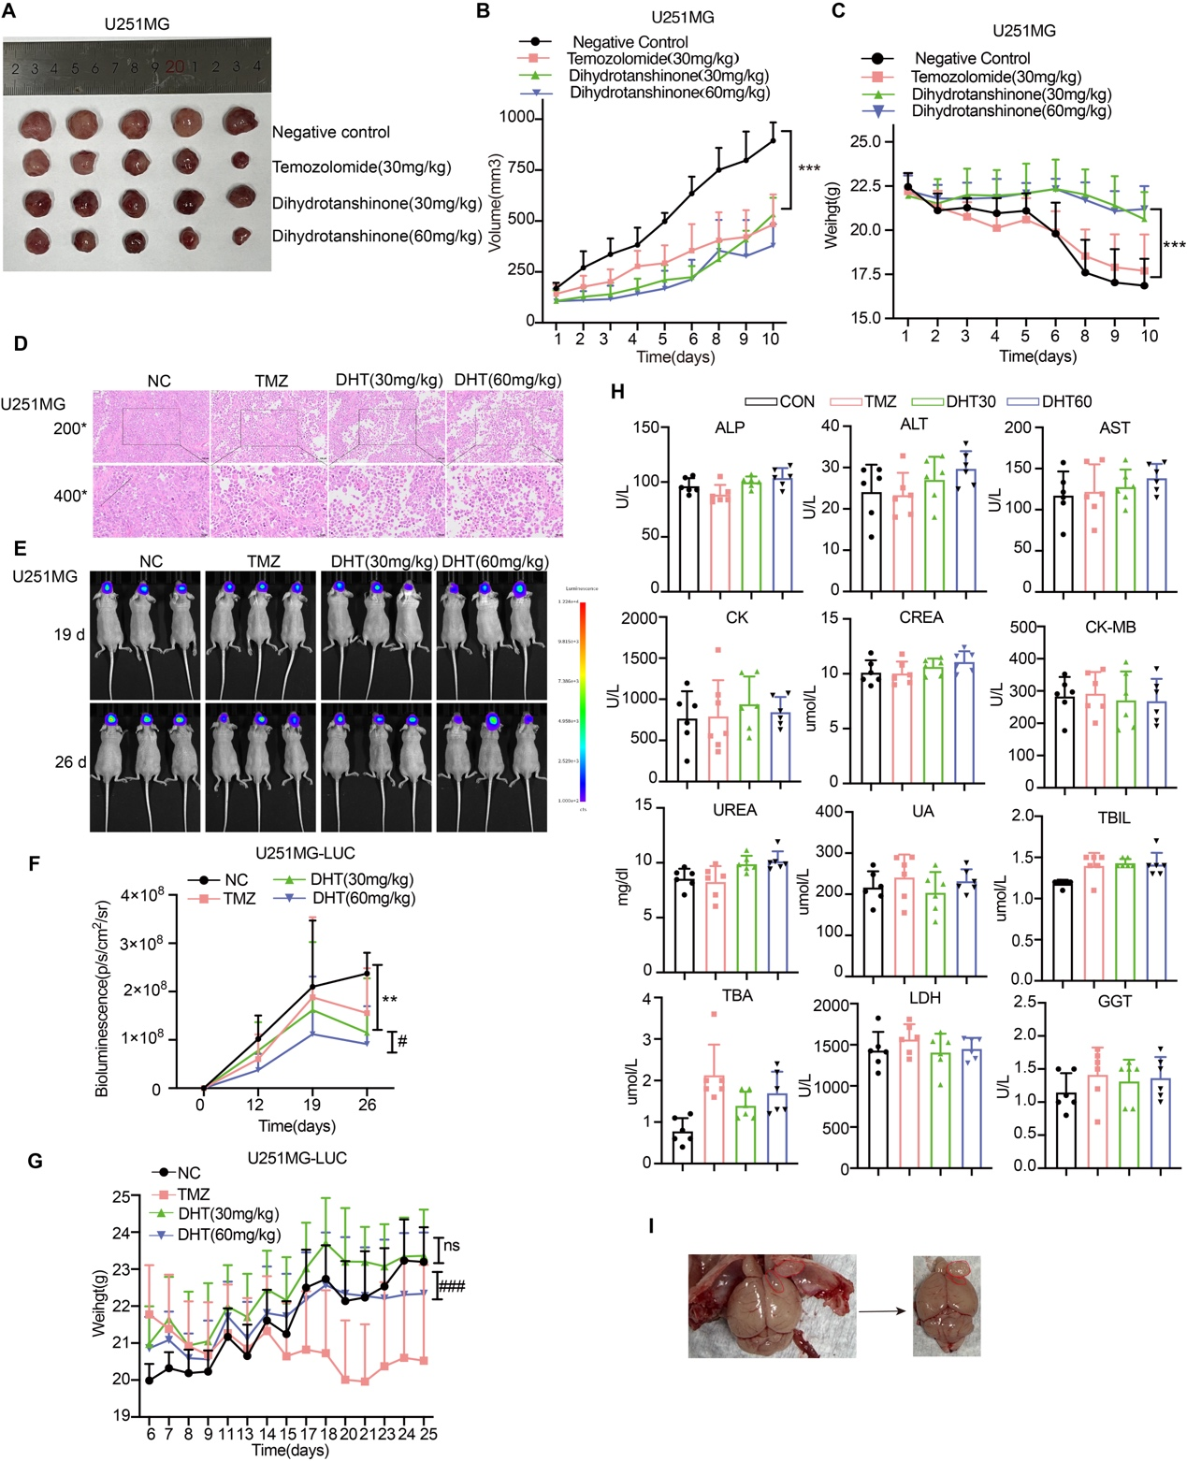
Supplementary Figure 3. DHT suppressed glioma progression in vivo. (A-C) Oral administration of DHT significantly inhibited glioma growth in U251MG xenograft-bearing nude mice, with DHT (60 mg/kg) exerting stronger inhibitory effects compared with DHT (30 mg/kg) (n=6). **p<0.01 (NC vs DHT 30 mg/kg), #p<0.05 (DHT 30 mg/kg vs DHT 60 mg/kg). (D) H&E staining of xenograft tumor sections demonstrated that DHT treatment significantly promoted tumor cell necrosis and apoptosis. Scale bars: 50 μM or 100 μM. (E-F) Representative bioluminescence images and quantitative analysis of U251MG-LUC tumor-bearing mice on days 19 and 26 (NC, n=6; TMZ, n=4; DHT 30 mg/kg, n=6; DHT 60 mg/kg, n=6). **p<0.01 (NC vs DHT 30 mg/kg), #p<0.05 (DHT 30 mg/kg vs DHT 60 mg/kg). (G) Body weight curves of U251MG-LUC tumor-bearing mice during the 25-day treatment period (NC, n=6; TMZ, n=4; DHT 30 mg/kg, n=6; DHT 60 mg/kg, n=6), #p<0.05 (DHT 30 mg/kg vs DHT 60 mg/kg), ns = not significant. (H) Serum biochemical profiles of U251MG-LUC tumor-bearing mice, including hepatic, renal, and myocardial function markers. (I) Macroscopic view of brain tissue sections. The red dashed lines indicate the intracranial tumor region. Tumors were tightly adhered to the meninges and were easily detached together with the meninges during dissection.

Supplementary Figure 4
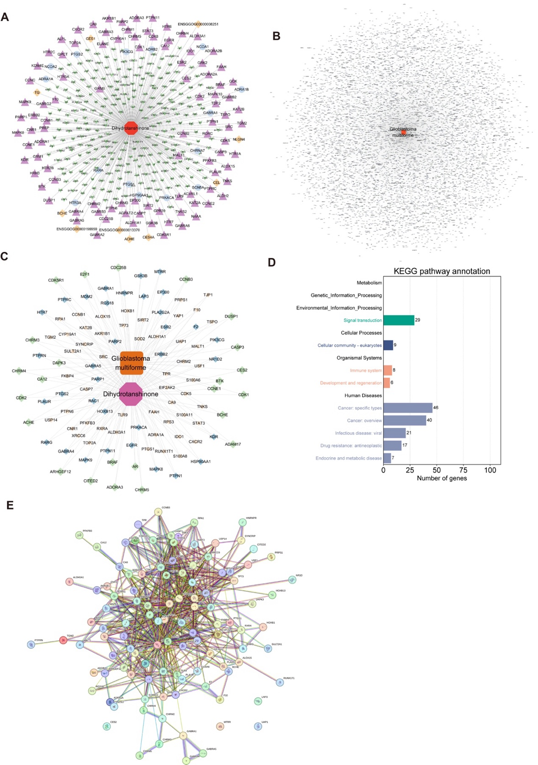
Supplementary Figure 4. Network pharmacology-based prediction of DHT targets in glioma. (A) A total of 109 putative targets of DHT were predicted using online databases. (B) Online database analyses identified 8,044 glioma-associated targets. (C) Intersecting analysis revealed 109 overlapping targets between DHT and glioma. (D) KEGG pathway enrichment analysis of the 109 targets, presented according to secondary classification of signaling pathways. (E) PPI network of the 109 shared targets was constructed using the STRING database.

