Single-cell and spatial analyses reveal endothelial–macrophage inflammatory crosstalk in dry age-related macular degeneration

Yujie Chen^{#1}, Chuling Liu^{#1}, Jinghan Chen^{#1}, Yimin Huang^{2,3}, Guiping Pan⁴, Pan Wang⁴, Yishan Hu¹, Lin Chen^{*5}, Yuxi Zhang^{*6,7} and Yan Wang^{*4}

¹Medical School, Shenzhen University, Shenzhen, China;
²Nanfang Hospital, Southern Medical University, Guangzhou, Guangdong, China;
³The First School of Clinical Medicine, Southern Medical University, Guangzhou, Guangdong, China; ⁴Department of Ophthalmology, South China Hospital, Medical School, Shenzhen University, Shenzhen, China;
⁵Department of Anesthesiology, Southern University of Science and Technology Hospital, Guangdong, China
⁶State Key Laboratory of Multi-organ Injury Prevention and Treatment, National Clinical Research Center of Kidney Disease, Division of Nephrology, Nanfang Hospital, Southern Medical University, Guangzhou, China;
⁷Guangdong Provincial Key Laboratory of Renal Failure Research, Guangdong Provincial Institute of Nephrology, Guangzhou, China

#These authors contributed equally.

*To whom correspondence should be addressed:

Lin Chen (2016746832@qq.com), Yuxi Zhang (Yyyuxi15014629273@163.com), or Yan Wang (ykwy1976@163.com).

Supplementary Tables
Supplementary Table S1. Mouse Publicly available single-cell and spatial transcriptomics datasets

Sequencing Technologies | GEO Sample | PMID | Mouse characteristics |  |  | Modeling methods
scRNA-seq |  |  | Strain/Sex |  | Age
 | GSM6914767 | 36821388 | C57BL/6J | female | 10-12 weeks | Control
 | GSM7677901 | 37858232 | C57BL/6J | female | 10-12 weeks | Control
 | GSM8372459 | 39141700 | C57BL/6J | / | 6-8 weeks | Control
Visium
 | GSM7916290 | 40251274 | C57BL/6J | male | 8 weeks | Control
 | GSM7916287 |  |  |  |  | PD1D rep1
 | GSM7916291 |  |  |  |  | PD1D rep2
 | GSM7916288 |  |  |  |  | PD3D rep1
 | GSM7916292 |  |  |  |  | PD3D rep2
 | GSM7916289 |  |  |  |  | PD5D rep1
 | GSM7916293 |  |  |  |  | PD5D rep2

Supplementary Table S2. Human Publicly available single-cell datasets

Sequencing Technologies | GEO Sample | PMID | Human characteristics |  | Phenotype | Sample region
scRNA-seq |  |  | Sex | Age
 | GSM6432161 | 36645183 | Female | 52 years old | HR | Macula
 | GSM5676877 | 35784369 | Male | 58 years old | HR | Macula
 | GSM7220251 | / | / | / | HR | Macula
 | GSM7220253 | / | / | / | HR | Periphery
 | GSM7220257 | / | / | / | HR | Periphery
 | GSM7220263 | / | / | / | HR | Macula
 | GSM7220265 | / | / | / | HR | Periphery
 | GSM7473528 | / | / | / | HR | Periphery
 | GSM7220259 | / | / | / | dAMD | Macula
 | GSM7220261 | / | / | / | dAMD | Periphery
 | GSM6173965 | / | Female | 76 years old | HR | Macula
 | GSM6173983 | / | Male | 84 years old | HR | Periphery
 | GSM6173985 | / | Female | 88 years old | HR | Macula
 | GSM6173987 | / | Female | 88 years old | HR | Periphery
 | GSM6173973 | / | Female | 91 years old | dAMD | Macula
 | GSM6173975 | / | Female | 91 years old | dAMD | Periphery

Supplementary Figures

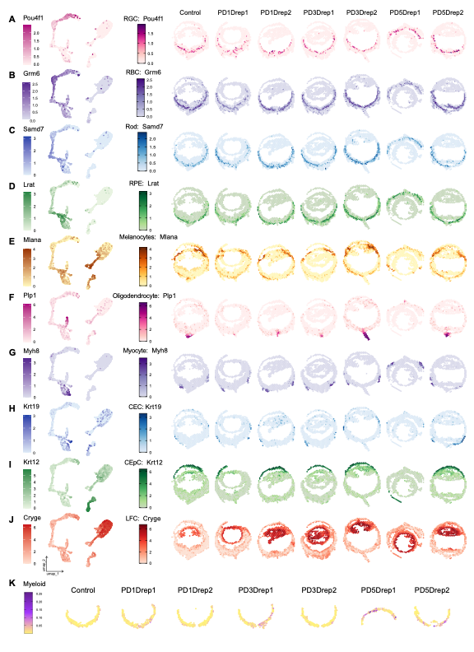
Figure S1. Spatial region annotation. (A)–(J) Panels A–J show the expression distribution of marker genes representing cell types in each spatial region. Left: UMAP feature plots; right: spatial feature plots. (A) The ganglion cell layer (GCL) mainly consists of retinal ganglion cells (RGCs), with the marker gene Pou4f1 shown. (B) The bipolar cell layer (BCL) mainly contains retinal bipolar cells (RBCs), with the marker gene Grm6 shown. (C) The photoreceptor layer (PRL) specifically includes rod photoreceptors, with the marker gene Samd7. (D) The RPE/choroid region specifically includes retinal pigment epithelium (RPE), with the marker gene Lrat. (E) The iris/ciliary body region contains abundant melanocytes, which are also present in the choroid, with the marker gene Mlana. (F) The optic nerve head specifically includes oligodendrocytes forming myelin, with the marker gene Plp1. (G) Extraocular muscles mainly consist of muscle cells, with the marker gene Myh8. (H) The conjunctiva specifically includes conjunctival epithelial cells (CEC), with the marker gene Krt19. (I) The cornea specifically includes corneal epithelial cells (CEpC), with the marker gene Krt12. (J) The lens specifically includes lens fiber cells (LFC), with the marker gene Cryge. (K) Spatial feature plots show the myeloid cell type scores inferred by RCTD for BCL, PRL, and RPE/choroid regions across seven samples.

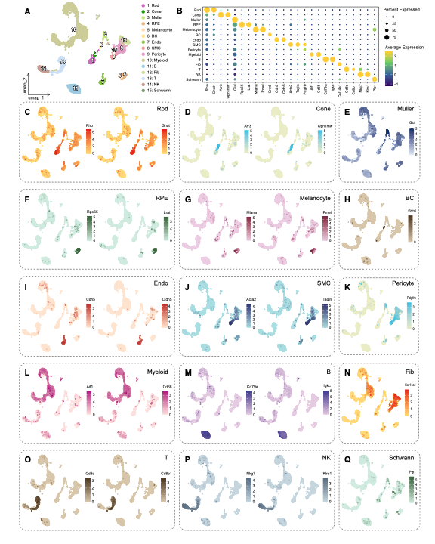Figure S2. Annotation of spatial reference mouse single-cell dataset. (A) UMAP plot showing diverse cell lineages from the mouse bipolar cell layer (BCL), photoreceptor layer (PRL), and RPE/choroid tissue, with different cell types identified, including rod photoreceptors (Rod), cone photoreceptors (Cone), retinal pigment epithelial cells (RPE), melanocytes, bipolar cells (BC), endothelial cells (Endo), smooth muscle cells (SMC), pericytes, myeloid cells, B cells (B), fibroblasts (Fib), T cells (T), natural killer (NK) cells, and Schwann cells. (B) Bubble plot showing the expression patterns of marker genes across different ocular regions in the spatial transcriptomics data. The color of each point represents the average expression level of the gene in the region, while the size reflects the proportion of spatial spots expressing the gene. (C)–(Q) UMAP feature plots from panels C to Q display the expression of marker genes for each cell type in the same order as in (A), validating the annotation accuracy.

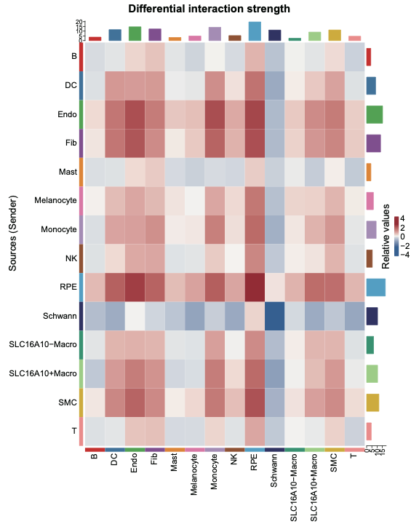
Figure S3. Heatmap of differential interaction strengths between cell types. Rows (Y-axis) represent signaling (sender) cells, and columns (X-axis) represent receiving cells. Different colors indicate the direction and magnitude of changes in interaction strength in dAMD. Red (positive values) indicates significantly increased communication strength of the sender cell in dAMD. Blue (negative values) indicates significantly decreased communication strength in the experimental group. White/light gray indicates no significant difference, with interaction strength remaining largely unchanged.

